COMPANY LOGO

DATE OF NOTICE

Road Closure Notification – Change of Access
Access means the way you can walk, ride or drive to or from a place
Location of Works: | e.g. 27 The Outlook, Glen Waverley
How will access change: | e.g. The Outlook closed between Townsend St & Michael Av
Dates of Works: | Start Date to End Date
Times of Works: | Start Time to End Time
Contingency Date/s: | Should works be unable to proceed on any of the above dates, the works will be completed on the following dates:  Start Date to End Date & Start Time to End Time
Work Activity: | e.g. Power Line Works, Concrete Pour, Road Reinstatement, Tower Crane Erection/Removal, Water Tapping
Council Application Number: | xxxx

Things you should know about our works and how they may impact you:

Pedestrian arrangements (include how pedestrians will access the area if safe to do so)
Bicycle arrangements (remove if not applicable)
Vehicle Access (include how vehicles will access the area)
Parking arrangements (must include if parking will be reduced and if residents can continue to park their cars in the area or need to make alternative arrangements)
Property access arrangements (must include if access will be maintained and how)
Expected truck or heavy vehicle activity – (remove if not applicable)

Works Location

We will do works here: Access will change here:

(Select the map below and paste your map in its place. Arrows and boxes are movable.)
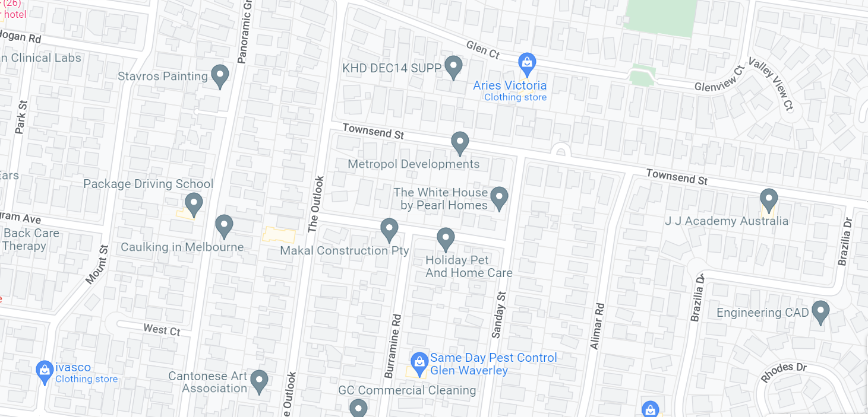

Contact Details

Name from Company
04XX XXX XXX
email@company
City of Monash
9518 3555
mail@monash.vic.gov.au

