VICTORIAN CIVIL AND ADMINISTRATIVE TRIBUNAL
planning and environment DIVISION
planning and environment LIST | vcat reference No. P651/2019  Permit Application no.TPA/49889
CATCHWORDS
Section 82 of the Planning & Environment Act 1987; Monash Planning Scheme; General Residential Zone Schedule 2; Multiple dwellings; Policy; Neighbourhood Character; Parking; Traffic

APPLICANT | Melissa Bell
responsible authority | Monash City Council
RESPONDENT | Chaengi Gow
SUBJECT LAND | 11 Wandoo Court, Wheelers Hill
WHERE HELD | Melbourne
BEFORE | Katherine Paterson, Member
HEARING TYPE | Hearing
DATE OF HEARING | 23 September 2019
DATE OF ORDER | 12 November 2019
CITATION | Bell v Monash CC [2019] VCAT 1782

Order
- Pursuant to clause 64 of Schedule 1 of the Victorian Civil & Administrative Tribunal Act 1998 the permit application is amended by changing the name of the permit applicant to:
Chaengi Gow
- In application P651/2019 the decision of the responsible authority is varied.
- In planning permit application TPA/49889 a permit is granted and directed to be issued for the land at 11 Wandoo Court, Wheelers Hill in accordance with the endorsed plans. The permit allows the construction of three dwellings on a lot.
- The Tribunal directs that planning permit TPA/49889 must contain the conditions set out in Notice of Decision TPA/49889 issued by the responsible authority on 15 March 2019 with the following modifications:
  - Condition 7 is amended to read:
7 Prior to the commencement of buildings and works a report prepared by a suitably qualified arborist must be submitted to the satisfaction of the responsible authority. When approved, the report will be endorsed and will form part of this permit. The report must be consistent with Australian Standard AS4970-2009 Protection of Trees on Development Sites and:
(a) Identify the species, height, diameter at breast height (DHB), tree protection zone and structural root zone of the trees located on the adjoining properties within two metres of the subject site (including those overhanging the site);
(b) A calculation of the encroachment into the Tree Protection Zone of each tree;
(c) Details of any design changes or construction techniques necessary to ensure the long term survival of the trees;
(d) Details of any tree protection measures needed during the construction phase of the development.
The endorsed arborist report must be implemented to the satisfaction of the responsible authority.
  - A new condition is included as follows:
1(c) Any design changes necessary to ensure the health and viability of neighbouring and street trees as detailed in the arborist report endorsed under condition 7 of this permit.

Katherine Paterson
Member

Appearances
For applicant | Ms Melissa Bell, in person.
For responsible authority | Ms Alexandra Wade, Town Planner, Monash City Council
For respondent | Ms Morgan Livingstone, Town Planner, Song Bowden Planning.

Information
Description of proposal | The construction of three double storey dwellings on the land. Dwellings one and two will contain four bedrooms and dwelling three will contain two. Each dwelling has been provided with a garage accessed via an existing crossover to Wandoo Court. The architectural style of the dwellings incorporates pitched tiled roofs, face brick work at the lower level and rendered lightweight walls at the upper levels.
Nature of proceeding | Application under section 82 of the Planning and Environment Act 1987 – to review the decision to grant a permit.
Planning scheme | Monash Planning Scheme
Zone and overlays | General Residential Zone Schedule 2
Permit requirements | Clause 32.08-6 – Construct two or more dwellings on a lot
Land description | The subject site has an area of 842 square meters and is located at the end of Wandoo Court. It is currently occupied by a single storey detached brick dwelling with associated outbuildings and garden.
Tribunal inspection | 26 September 2019 between 6:30 am and 7:20 am

Reasons

What is this proceeding about?
- Chaengi Gow wishes to construct three dwellings on land at 11 Wandoo Court, Wheelers Hill.
- Ms Bell objects to the proposed development. Since the court was established in 1968 the court has only been developed with single dwellings. If approved, this development would be the first three dwelling development in the street.
- Ms Bell submits that the court is not suitable for medium density housing due to capacity of the court to accommodate the additional traffic and demand for on street parking generated by the proposal.
- She questions the inclusion of the site within ‘Garden City Suburbs Northern Section E’ in Monash housing policies and is concerned that the setbacks of the proposed development are inconsistent with the character of the area.

What are the key issues?
- Having considered all the submissions and evidence and inspected the subject land and its locality I am of the opinion that the key issues in this proceeding are:
- Is the construction of three dwellings on this site supported by planning policy?
- Is the proposal respectful of the neighbourhood character?
- Does the proposal provide adequate car parking?
- Will the proposal unreasonably affect the amenity of the area through increased traffic?

Summary of findings
- I have decided to grant a permit for the following reasons”
- The development of three dwellings on this site is supported by planning policy;
- The proposal is an acceptable response to the neighbourhood character of the area;
- The parking arrangements meet the requirements of Clause 52.06 of the planning scheme.
- Whilst the proposal will generate an increase in traffic, I am satisfied that this may be comfortably absorbed in the road network.
My reasons follow.

Is the construction of three dwellings on this site supported by planning policy?
- Clause 16.01-2R of the Monash Planning Scheme seeks to facilitate increased housing in established areas to create a city of 20 minute neighbourhoods close to existing services, jobs and public transport.
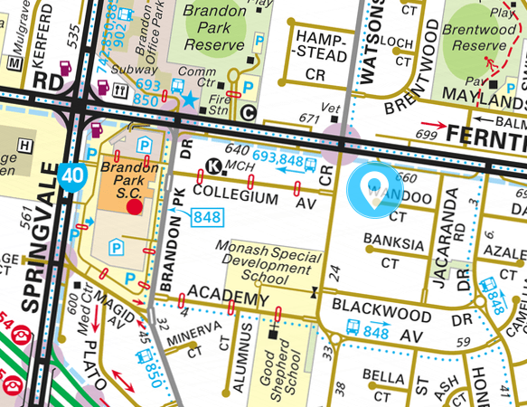
- As can be seen from the above extract from Melways Online, the subject site is located 700 metres (a 9 minute walk) from the Brandon Park Shopping Centre, which is identified as a major activity centre within Plan Melbourne. Nearby public transport is in the form of buses which link the site with Belgrave, Oakleigh and Dandenong. The nearest bus stop is located 350 metres away from the site in Ferntree Gully Road. It is a site that is strongly supported by state and regional planning policy for medium density housing.

Local Planning Policy
- Clause 21.01-1 estimates that the population of Monash is expected to increase by over 26,000 to over 215,000 by 2031. The rising population has resulted in an increase in the number of households and it is estimated that this will drive demand for at least 10,000 new dwellings over the period between 2016-2031.
- As one method of meeting the housing needs of the municipality, medium rise development is directed towards the Brandon Park Major Activity Centre by Clause 21.04-3. On land outside of the activity centres, such as the subject site, development is expected to be low rise.
- The directions specified in the local policy framework are reflected in the inclusion of the site within the General Residential Zone Schedule 2, the purposes of which include:
- To encourage a diversity of housing types and housing growth particularly in locations offering good access to services and transport.
- I find that the development of three double storey dwellings on this site is generally consistent with the local policy framework.

Monash Housing Strategy
- The Monash Housing Strategy was adopted by Council in October 2014 and is referenced within Local Planning Policy.
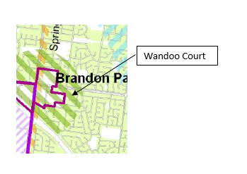
- The plan places the site within the Category 2 Accessible Areas, as well as Category 8 – Garden City Suburbs. The strategy indicates that, lower density units and town house developments are expected to be within accessible areas and even apartment forms of housing may be acceptable at the interface with activity centres. I find that the development of three double storey dwellings on this site is consistent with the Monash Housing Strategy.

Amendment C125 (part 2)
- Amendment C125 originally proposed to include the subject site within a General Residential Zone Schedule 4 (GRZ4). The planning panel for the amendment recommended that this zone be combined with the proposed General Residential Zone Schedule 3 (GRZ3), with a revised schedule.
- Council agreed with the combining of the GRZ3 and GRZ4 zones but did not agree with all of the Panel’s recommendations with respect to the content of the schedule. The adopted schedule, which is now before the Minister for Planning for final approval, has altered the Panel’s recommendations for front setbacks, landscaping, private open space and front fences.
- On the 25 February 2018 the Minister for Planning wrote to Monash City Council advising that Amendment C125 would be split into two parts. Part 1 has been approved and gazetted. Part 2, which included the revised General Residential Zone, required further work;
I consider Part 2 requires further strategic work on the council's application of the GRZ. The adopted GRZ features a 9-metre-high discretionary building height control. This approach is no longer possible due to changes to the Victoria Planning Provisions introduced by VC110. Consequently, the council should review the application of the zone. In locations where the council is trying to maintain lower-scale residential development and character, the NRZ may be more appropriate. In other locations, such as in and around activity and neighbourhood centres, accessible areas and along boulevards where the council's housing strategy is identifying the need for further growth, a GRZ or even a RGZ may be more appropriate. Therefore under Section 32 of the Act, I direct the council to give more notice of Amendment C125 (Part 2) where it seeks to change the zone from GRZ to NRZ or GRZ to RGZ and comply again with sections 21 to 31, which relate to all matters after the giving of notice.
- On 27 March 2018, Monash City Council requested that the Minister approve Part 2 of the amendment as previously adopted by Council. The Tribunal is unaware if there have been any further discussions between Council and the Minister for Planning as to the proposed amendment, and in particular the proposed GRZ3. Given the circumstances of the amendment, I find I cannot consider the proposal to rezone the land to GRZ3 as seriously entertained, and I have not given the proposed zoning any weight in my decision.

Is the proposal respectful of the neighbourhood character?
- The purposes of the GRZ2 also encourage development that respects the neighbourhood character of the area.
- Clause 55.02-1 states that design of medium density developments should respect the existing neighbourhood character or contributes to a preferred neighbourhood character.
- Clause 22.01 of the Monash Planning Scheme contains the residential development and character policy. The policy divides the municipality into various character precincts, with the subject site included within Precinct E. The current character of the precinct is described as follows:
This area is characterised by a variety of building types. Most are one and two storey 1970’s and 1980’s brick veneer single and double fronted villas. A range of brick colours are used but the palette is often consistent within neighbourhoods. The roofs are varied but in most areas have low pitched hip forms.
- Ms Bell questioned why Wandoo Court has been included within the precinct as it was established within the 1960s, earlier than the time period expressed in the character statement.
- Clause 21.04-1 of the scheme dates housing within Precinct E as ‘post 1965’, whereas the map to the Clause, as shown in the map below dates the precinct from 1955.
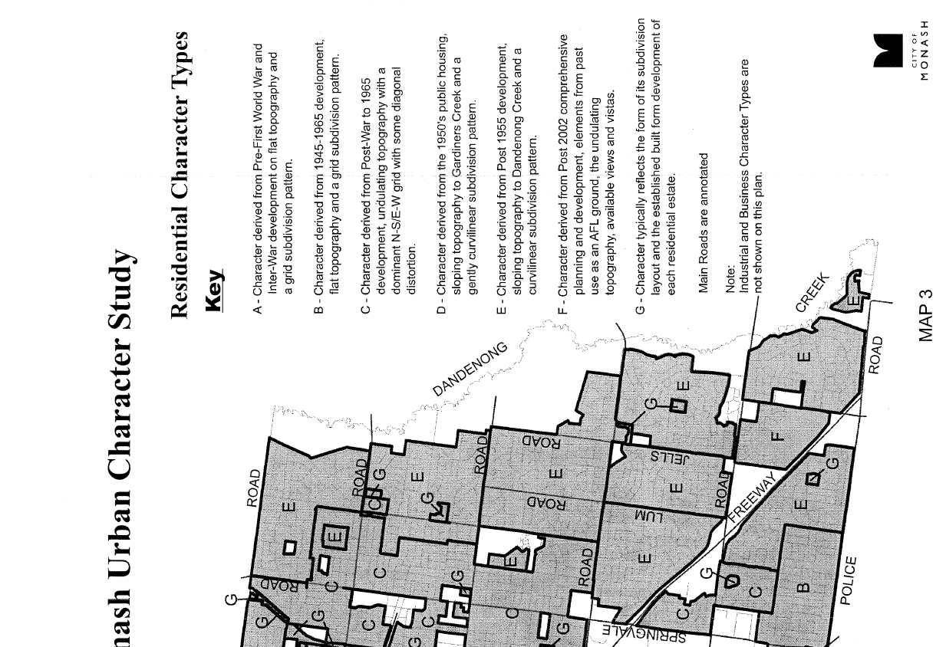
- Areas included within Precinct E are generally areas east of Springvale Road. Housing within this large area would date from a wide variety of time periods, with the overwhelming majority occurring post war. To my mind, the focus should not be on whether the age of the housing stock is correctly identified by the policy, rather it should be on whether this proposal is consistent with the preferred character statement for the precinct, which is:
The urban character of this area will evolve within a landscape that has a large number of native trees spread throughout both the public and private domain providing an overhead canopy visually unifying the diverse built-form of some neighbourhoods and providing a strong relationship with the semi-natural landscape of Dandenong Creek.
Dwellings will be designed to sympathetically integrate with any existing native trees and shrubs on, or adjacent to, the development site and relate in form and siting to the topography of the Character Type. Architecture of contemporary excellence that is energy efficient and sustainable will be encouraged. Building scale, height and bulk will be generally similar within neighbourhoods.
Large scale contrasts between buildings will be discouraged except where existing trees and shrubs soften the junction between buildings or where there is a gradated change in scale.
Setbacks will be varied in many neighbourhoods but will be consistent within individual streets and will be sufficiently generous to enable the development of significant native tree canopy and vegetation. The main unifying element will be the canopy of native trees in both the public and private domain. Most gardens will be open to the street with no walls or fences, allowing the soft naturalistic qualities of most neighbourhoods to be retained. Large walls and fences will be discouraged except where they are already a visually dominant streetscape element.
The soft quality of the street that is derived in part from the nature strips will be maintained by ensuring that there is only one single crossover per lot frontage.
Planting will generally enable filtered views of the architecture and engender a sense of visual continuity with the street and adjacent properties.
- The preferred character statement is supported by variations to the GRZ2 which requires a front setback of 7.6 metres and at least 75 square metres of private open space per dwelling. The proposal complies with these requirements, which will enable the planting of native canopy trees as desired by the character statement. I note that conditions of the Notice of Decision have required the preparation, implementation and maintenance of a landscaping plan, which I consider to be appropriate.
- The plans indicate that the proposed buildings may affect the health and viability of neighbouring trees, particularly those located within 12 Wandoo Court and trees located close to the western boundary of the site within 10 Wandoo Court. I have therefore required an arborist report which details any design changes or construction methods necessary to ensure the health and viability of the neighbouring trees as conditions of permit.
- With respect to the overall style of the development, I find that the architectural style and layout of the dwellings will be a comfortable fit within the streetscape, particularly due to the choice of roof pitch and materials such as face brick work. Conditions on the permit require the building to be constructed substantially of brick or brick veneer in accordance with the restrictive covenant that applies to the land, which will further ensure that the development is consistent with the character of the area.

Does the proposal provide adequate car parking?
- The application proposes to provide a single garage for dwelling three and a double garage for dwellings one and two. Whilst I am satisfied that the provision is consistent with the requirements of the scheme for dwellings one and two, I share Council’s and Ms Bell’s concerns that the one car space may not be adequate for dwelling three, as the layout of this dwelling includes a retreat which could easily be converted to a third bedroom:
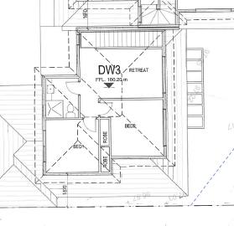
- Condition 1(b) of the Notice of Decision requires a reconfiguration of this level to avoid the retreat area, which I consider is appropriate to ensure that this dwelling is a two bedroom dwelling, and therefore only requires one car space under the provisions of the scheme.
- As this proposal is for three dwellings, Clause 52.06 does not require the provision of a visitor space for the development, and as such visitors will be required to park on street when visiting the site.
- Ms Bell raised concern that whilst the visitor car space will easily be accommodated within Wandoo Court, she was concerned that if more medium density developments are established within the court, this would lead to an increase in on street parking, similar to that currently experienced in Banksia Court.
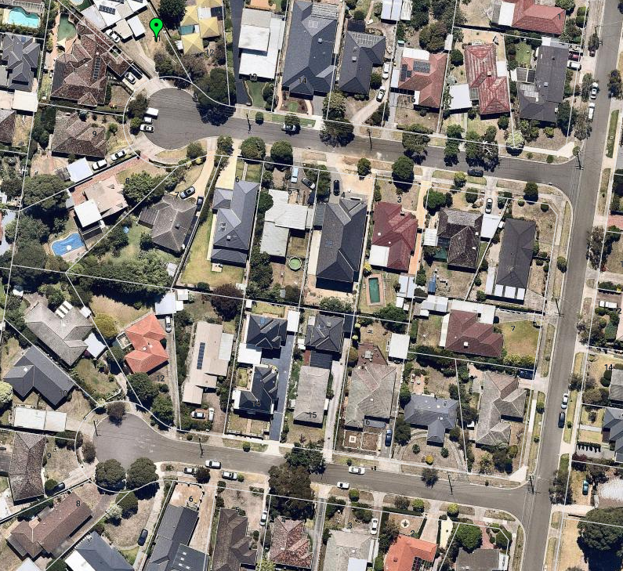
- The above Nearmap image, taken on Saturday 23 February 2019 indicates that Banksia Court does experience a greater level of on street parking than Wandoo Court. This was confirmed in my early morning site inspection, where I observed a waste collection vehicle operating through Banksia Court. I observed that even with vehicles parked on both sides of the street, the waste collection vehicle was still able to manoeuvre through the court to access the rubbish bins. Whilst I have no doubt there are occasions when the truck has had to honk its horn to request residents to move a parked vehicle, parking restrictions have not been put in place within the court, indicating that this is not a regular problem. With respect to this proposal, I am satisfied that the need for an additional visitor space will be able to be comfortably accommodated within Wandoo Court.

Will the proposal unreasonably affect the amenity of the area through increased traffic?
- Based on the road design standards provided at Clause 56.06-8 of the scheme, Wandoo Court would fall under the definition of a ‘Level 1 Access Place’ which has a design capacity of 1000 to 2000 vehicles per day.
- During the hearing I was provided with a letter dated 13 February 2019 which indicates that in 2016 Blackwood Drive, located to the south of Wandoo Court, carried approximately 1,447 vehicles per day, as a result of this road being used by motorists to avoid congestion on Ferntree Gully Road. Wandoo Court would carry substantially less vehicles per day, as it is a court and not a through road and therefore would not carry vehicles seeking to avoid Ferntree Gully Road. Using a conservative figure of 10 vehicles per day per dwelling, Wandoo Crescent would currently accommodate approximately 180 vehicles per day. As such I am satisfied that the court is not operating at or even close to design capacity.
- Using the Road and Traffic (RTA) publication “Guide to Traffic Generating Developments” Council calculated that the proposed three dwellings would generate between 14 to 18 daily trips per day. I am satisfied based on the information before me that the court can accommodate this increase in traffic without significantly affecting the amenity of the neighbourhood.

Conclusion
- For the reasons given above, the decision of the responsible authority is varied. A permit is granted subject to conditions.

Katherine Paterson
Member

The submissions and evidence of the parties, any supporting exhibits given at the hearing and the statements of grounds filed have all been considered in the determination of the proceeding. In accordance with the practice of the Tribunal, not all of this material will be cited or referred to in these reasons.
https://online.melway.com.au/melway/ retrieved 30 October 2019
Plan Melbourne 2017-2050: Metropolitan Planning Strategy (Department of Environment, Land, Water and Planning, 2017), listed as a background document to Clauses 10 to 19 of the scheme at Clause 72.08
Clause 22.01-4
Clause 52.06
Extract from drawing number TP04 prepared by Bello Design group dated 20 December 2018
http://maps.au.nearmap.com/ retrieved 12 November 2019

