VICTORIAN CIVIL AND ADMINISTRATIVE TRIBUNAL
planning and environment LIST | vcat reference No. P501/2020  Permit Application no. TPA/51158

APPLICANT | Dr Julia Claire Wood
responsible authority | Monash City Council
RESPONDENTS | Helen and John Clements, John & Margot Hillel, Friends of Damper Creek Reserve (Inc)
SUBJECT LAND | 28B Park Road  MOUNT WAVERLEY VIC 3149
HEARING TYPE | Hearing
DATE OF HEARING | 1 March 2021
DATE OF ORDER | 23 March 2021
CITATION | Wood v Monash CC [2021] VCAT 254

Order
1 In application P501/2020 the decision of the responsible authority is set aside.
2 In planning permit application TPA/51158 a permit is granted and directed to be issued for the land at 28B Park Road Mount Waverley in accordance with the endorsed plans and the conditions set out in Appendix A. The permit allows:
- Additions and alterations to an existing dwelling on a lot less than 500 square metres

Jane Tait
Member

Appearances
For Dr Julie Wood | Mr Daniel Bowden, town planner, Song Bowden Planning
For Monash City Council | Mr Gerard Gilfedder, town planner, Currie and Brown
For Helen and John Clements | In person
For John and Margot Hillel | In person
For Friends of Damper Creek Reserve | Mr Doug Scott

Information
Description of proposal | To construct ground and first floor additions to an existing dwelling on a lot less than 500 square metres. The works include:  - Replacement of a ground floor west elevation kitchen window;  - Replacement of a first floor east elevation bathroom window with clear glazing;  - Construction of a ground floor deck with access from the living room;  - Construction of a first floor addition to bedroom 1; and  - Construction of a first floor terrace with access from the extended floor area of bedroom 1.
Nature of proceeding | Application under section 77 of the Planning and Environment Act 1987 – to review the refusal to grant a permit.
Planning scheme | Monash Planning Scheme
Zone and overlays | Neighbourhood Residential Zone Schedule 2 (NRZ2)  Vegetation Protection Overlay Schedule 1 (VPO1)
Permit requirements | Clause 32.09-5 – Construction and extension of one dwelling on a lot in a NRZ2 less than 500 square metres
Land description | The subject site is located on the east side of Park Road, Mount Waverley. It has an 8.8 metre frontage, depth of 45.72 metres and site area of 403 square metres.  The site is occupied by a two storey attached dwelling that is one of a pair with 28A Park Road. The dwelling is set back approximately 9.4 metres from the frontage and 1-2.3 metres from the south boundary at ground floor level.  The ground floor includes living areas, study, bedroom, en-suite, kitchen and living room. The first floor includes two bedrooms and bathroom.  The dwelling includes a single garage and tandem car space in the driveway.  Abutting land uses includes 28A Park Road that is located to the north of the site. Directly south is single storey detached house at 30 Park Road. The east boundary of the site abuts Damper Creek Reserve.
Tribunal inspection | An unaccompanied site inspection was conducted after the hearing.

Reasons

What is this proceeding about?
- Dr Wood (the ‘applicant’) is proposing to construct additions and alterations to an existing dwelling on a lot less than 500 square metres at 28B Park Road, Mount Waverley. Monash City Council (the ‘Council’) refused to grant a planning permit and the applicant has requested the Tribunal review this decision.
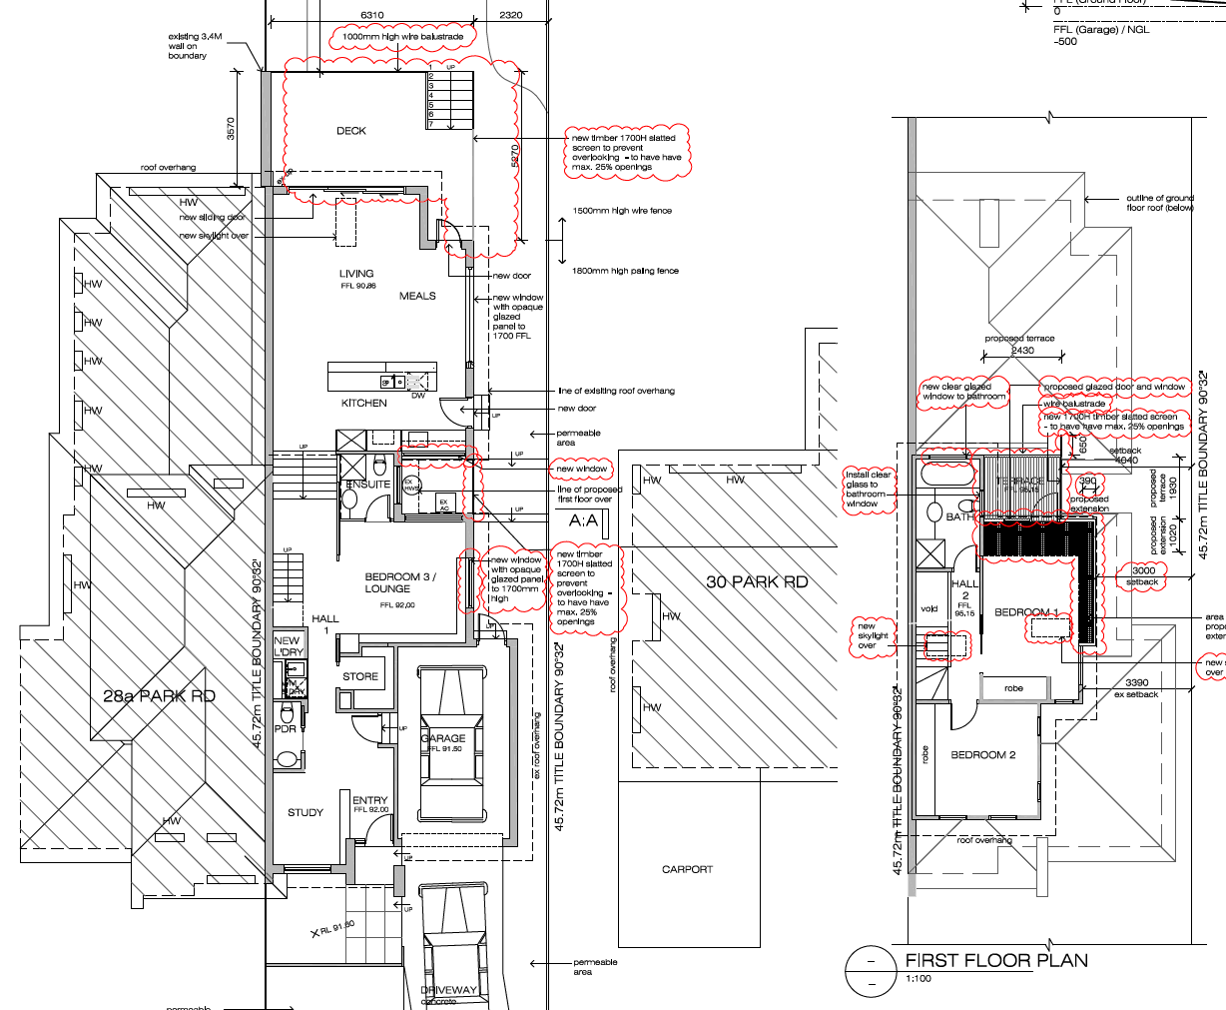
TP2 – Ground Floor TP2 First Floor
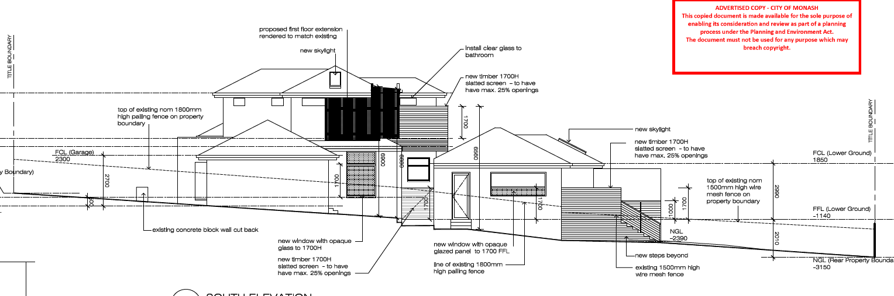
TP2 -South Elevation
- Council argues the development does not achieve a proper neighbourhood character outcome or ensures the amenity of neighbouring properties. The grounds are that the proposal is inconsistent with the neighbourhood character objectives of the planning scheme and objectives of Clause 54 relating to design detail, north facing windows, overlooking, overshadowing and energy efficiency. It also refused the application on grounds the proposal is contrary to the VCAT decision for Planning Permit (TPA/33895) for the development of the two dwellings and Council’s decision (TPA/4989) for alterations and additions to the dwelling on the subject site.
- The applicant submits the development is a reasonable planning outcome that strikes an appropriate balance of providing positive changes that will benefit internal amenity of the dwelling whilst successfully managing character and external amenity impacts. She says the proposal will not result in unreasonable off-site amenity impacts and the design is in keeping with the neighbourhood character objectives relating to the creek interface.
- The respondents support Council’s grounds of refusal and include the adjoining owner/occupiers to the south (the ‘Clements’) and nearby residents of Damper Creek, including the Friends of Damper Creek Reserve Inc. The Clements submit that they were satisfied with the outcome of the previous Tribunal decision and consider the additions will result in a return of their previous concerns relating to overlooking, visual bulk, overshadowing and loss of sunlight. The Friends of Damper Creek Reserve argue the development will adversely impact the unique environs of Damper Creek.

What are the key issues?
- Having considered the submissions and inspected the subject land, neighbouring property to the south and creek environs, I find the following key issues in this matter are the:
- Planning history;
- Repeat Appeal;
- Zoning and policy context;
- Physical context;
- Minor works;
- First floor addition and terrace; and
- Ground floor deck.
- The main issue is whether internal amenity benefits sought by the applicant outweigh the amenity impacts to the south and the neighbourhood character impacts on the creek environs. I will examine various components of the proposed works separately and refer to the comments made in the previous Tribunal decision.
- I have decided to set aside the decision of Council and direct a permit be issued subject to deletion of the first floor deck and ground floor deck. My reasons follow.

planning history
- TPA/33895 was issued for the construction of two double storey dwellings and removal of vegetation at the direction of the Tribunal in Vanderhelm v Monash CC [2007] VCAT 1611 (‘Vanderhelm’). The subject site is the southern half of the site that contains one of the attached dwellings.
- A second application, TPA/49895 was issued in December 2019 for additions and alterations to an existing dwelling on a lot less than 500 square metres. This permit approved works including a small ground floor deck/landing with access from the living room. The application initially included a first floor terrace and additions to bedroom 1 but these were deleted from the proposal by the applicant.

Repeat appeal
- Council refused this application as it was contrary to the Tribunal’s findings in Vanderhelm that resulted in a permit being granted subject to several amendments including the removal of decking at ground level.
- There are a series of well-established guiding principles regarding ‘repeat appeals’ that the Tribunal is required to consider when an application is like a proposal that was previously the subject of a Tribunal decision. These are referred to as the ‘Reichert Principles’ that were outlined in Reichert v Banyule City Council. The principles to consider when reviewing an application for a similar proposal that has been the subject of previous Tribunal findings include whether there are:
- significant changes in the application itself;
- changes in the circumstances of the land and its surrounds;
- changes in planning policy; and/or
- changes in the interpretation of the facts or law relevant to the Tribunal’s consideration.
- Deputy President Dwyer made the following comments about repeat appeals in Sprut Pty Ltd v Stonnington CC [2012] VCAT 167:
Secondly, irrespective of whether the repeat appeal is in the nature of a ‘classic’ or ‘correcting’ repeat appeal, the role of the Tribunal is not to determine whether the proposal before it would have satisfied the earlier (and perhaps differently constituted) Tribunal, nor to summarily determine the matter solely by reference to the Reichert principles. This is a sometimes misunderstood notion. As Amoco itself indicated, the role of the Tribunal is to still consider the new application before it on its merits but, in doing so, to give great weight to the Tribunal’s decision on the earlier application having regard to the usual principles that have evolved for this purpose .
- Council argues the planning process should not be used to undertake a development that is inconsistent with the original permit. It says:
There is also potential concern that the application has the capability of undermining the planning permit process whereby agreed outcomes or outcomes that were known at the time the original permit was assessed and issued by the Tribunal and agreed to should be enforced and complied with unless extenuating circumstances can be demonstrated.
- Council and the respondents submit the concerns raised by the Member in the previous application about bulk, loss of privacy and daylighting are still relevant as there has been no change of circumstances that warrants overturning of the original Tribunal decision.
- The applicant submits the original proposal is not a barrier to prevent future applications being made. She says Council and the objectors consider the previous decision draws a ‘line in the sand’ and that any further alterations cannot be considered. She submits the correct approach is to assess the application on its merits against the planning scheme, with limited weight afforded to the previous decision.
- In terms of the Reichert principles for consideration of repeat appeals, this application is for alterations and additions to the existing dwelling whereas the previous proposal before then Member Martin was for two dwellings. Therefore, Clause 54 applies instead of Clause 55. I also note that despite 13 years elapsing, there has been minimal change to the physical context of the site, except for the construction of the two dwellings and installation of solar panels on the roof of 30 Park Road.
- However, there have been changes to the planning scheme since the application was originally considered by that Tribunal. This includes the introduction of the Neighbourhood Residential Zone (NRZ2) and local policies relating to the Creek Environs at Clauses 21.04 and 22.01. I will discuss the policy implications in my findings below.
- I agree with the applicant that the original findings of the Tribunal are not a barrier to prevent consideration of future applications. I have read the previous decision and note then Member Martin exercised a cautious approach with respect to amenity impacts and neighbourhood character. My consideration of this application is consistent with this approach. However, I must also consider the application on its merits against the planning scheme as I find it now.

Zoning and policy context
- Since the previous application was considered by the Tribunal the subject site has changed from a Residential 1 Zone to NRZ2 in accordance with Amendment C125. This zone is applicable to Creek Abuttal Areas and Clause 1.0 to the schedule contains the following neighbourhood character objectives:
- To emphasise the visual dominance of landscaping, particularly along the interfaces with the creek corridors.
- To ensure new development transitions down in scale towards the creeks, respecting and reinforcing the natural topography.
- To respect and enhance the existing character and functions of the open spaces along the creek corridors.
- The zone also contains several variations to Clause 54 standards including Standard A10 – Side and Rear Setbacks, Standard A5 – Site Coverage and Standard A6 – Permeability. The zone also contains decision guidelines that I will discuss further below.
- The relevant local polices are found at Clause 21.04 that identifies the site falls within Category 7 – Creek Environs on Map 3 – Residential Development Framework Plan. Clause 21.04-3 contains objectives to protect and contribute to the special character of the creek environs and conserve the treed environment and maintain and enhance the garden city character of the municipality.
- Clause 22.01- Residential Development and Character Policy nominates the subject site in a Creek Abuttal Area. The preferred future character says this neighbourhood will be defined by its spacious garden setting and taller canopy trees. It says there will be larger setbacks from the creek to provide for planting and vegetation will dominate streetscapes as buildings will be recessive and normally hidden from view behind large canopy trees. It says this area will continue to provide for lower scale residential development.
- The above policy context reinforces the importance of retaining the open landscape character of the creek environment. I consider the additions will not significantly change the impact of the two storey dwelling on the creek environs and streetscape provided the ground and first floor terrace are removed. I will discuss my reasons in relation to each component of the proposal further below.

the Physical context
- The respondents emphasised the importance of Damper Creek as a passive recreational and environmental asset in the municipality. They note this area has special environmental value which is acknowledged in the NRZ2. Based on my site inspection, I agree the subject site and neighbouring properties have a unique character due to their interface with the Damper Creek reserve. I observed the rear of some dwellings are screened by mature canopy trees in rear yards and within the reserve and some have open boundary treatments that blend into the reserve. However, I also note that some properties have open back yards that increase their exposure to the creek reserve.
- The height of the existing two storey dwelling is partially reduced in the streetscape due to the slope of the land towards the creek. The vegetation in the rear yard of the subject site and reserve provide a backdrop to the dwelling.
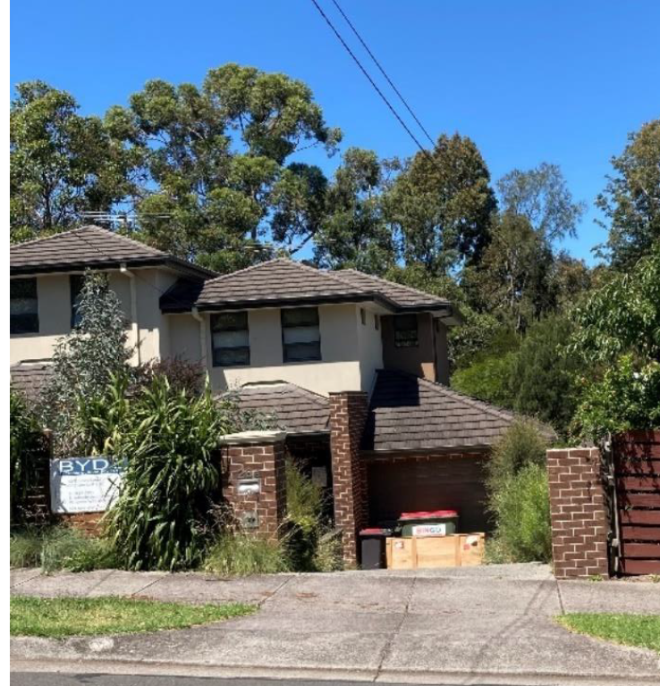
Location of first floor addition
Council submission - Figure 3 – From Park Road.

Minor works
- The works include a new first floor east elevation bathroom window, a ground floor south elevation window to bedroom 3 and ground floor west elevation kitchen window. I agree with the applicant that these works are uncontroversial as a new 1700mm high timber slatted screen is to be provided across the light court and opaque glass is provided to 1700mm to prevent unreasonable overlooking into 30 Park Road. The inclusion of clear glazing to the first floor bathroom window is acceptable as it is a non-habitable room and views will be over the rear yard of the subject site. These changes do not have any significant amenity or neighbourhood character implications.

First floor addition and terrace
- The application includes an extension to bedroom 1 by increasing the width by 390mm and length by 1020mm. It is also proposed to construct a terrace (1930mm long) with access from this room. This feature is screened by a 1700mm timber screen in the south elevation.
- The expansion of the bedroom and terrace raise issues about the building scale in the neighbourhood, visual bulk impacts and overshadowing of the dwelling to the south at 30 Park Road that I will discuss these impacts separately below.

Building Scale
- It is policy at Clause 22.01-3 to minimise the impact of the scale and massing of development and provide setbacks that maintain the open spacious character and separation between dwellings. The policy also states the built form and scale of development should:
- Respect the height, scale and massing of existing dwellings in the neighbourhood.
- Ensure taller buildings incorporate sufficient articulation, including recessed upper levels, to respect the prevailing scale of the adjoining dwellings and the neighbourhood.
- Council argues the addition is contrary to the above policy directions as it does not minimise bulk and mass of the building. The respondents agree and say the first floor deck will be intrusive facing the creek reserve.
- The applicant submits the first floor addition is designed to improve the functionality and useability of the dwelling. She says bedroom 1 is modest in size and the addition will increase the width from 2.8 metres to 3.2 metres to allow circulation around the bed. She submits the additions provide further articulation of the southern wall which is only 3.8 metres long, and the render will match the existing dwelling. She also says the terrace is designed to take advantage of the views of Damper Creek and the screening is respectful of this context.
- Having inspected the site, I find that a 390mm increase in width of the addition will have minimal impact on the streetscape character as the addition is located beneath the existing eaves line. I note the first floor retains articulation in the façade as the addition is set back 3 metres from the south boundary. Therefore, I am satisfied there is sufficient articulation of the upper level to be an acceptable response in this neighbourhood.
- The other issue is the perception of building scale from the adjoining creek reserve. The first floor terrace is proposed to be se tback approximately 23 metres from the rear boundary and the addition is setback 25 metres. The terrace will match the setback of the existing of the existing bathroom. Therefore, the addition and terrace will result in additional built form closer to the creek reserve as well as increasing the width of the upper level.
- I find the additional first floor area will not have any significant visual impact from the adjoining reserve. I have come to this conclusion as the addition is to be set back over 23 metres from the rear boundary and there are numerous taller canopy trees in the rear yard of the subject site and reserve that will filter views to the east.
- However, I have concerns about the terrace. At present the upper level is a discrete, recessive feature when viewed from the adjoining parkland. I consider the inclusion of the deck and associated screening will increase the scale of the upper level to become a more dominant form when viewed from the creek environs. I will therefore require the deck to be removed from the proposal. I also have concerns about the impact of the deck on the visual amenity of residents at 30 Park Road that I will discuss further below.

Visual Bulk Impacts
- The decision guidelines of the NRZ2 provide guidance on side and rear setbacks and recommend to:
Minimise the impact of visual bulk to neighbouring properties, through suitable setbacks from adjacent secluded private open space to enable the provision of screening trees and scaling down of building form to the adjoining properties.
- The issue of amenity was a matter of interest for then Member Martin. He commented:
With respect to potential amenity impacts on the No. 30 property, I indicated that I did have some existing concerns about the potential privacy impacts and visual bulk implications for the No. 30 property.
- Council argues the proposal does not provide appropriate articulation or is respectful of the scale of the adjoining dwelling at 30 Park Road. The Clements also say the terrace will reduce the amenity of this unique section of the reserve.
- Based on my site inspection I concluded the addition and terrace will be clearly visible from the Clements’ rear yard and paved entertaining area. I acknowledge the terrace is set back 4.04 metres from the south boundary and there is some screen landscaping growing along the common boundary and in the Clements’ rear yard. However, the additional building length and terrace will be a bulky intrusion facing their adjoining rear yard, particularly given the slope to the south. This built form will not recede but dominate the backyard character.
- Currently the existing first floor steps away from the south boundary. I find the inclusion of the terrace will reduce this level of articulation and increase the scale and massing of the dwelling when viewed from the south. This is contrary to the decision guidelines of the NRZ2 that encourage housing to visually recede into a continuous backdrop of canopy trees and to avoid dominant upper storeys.
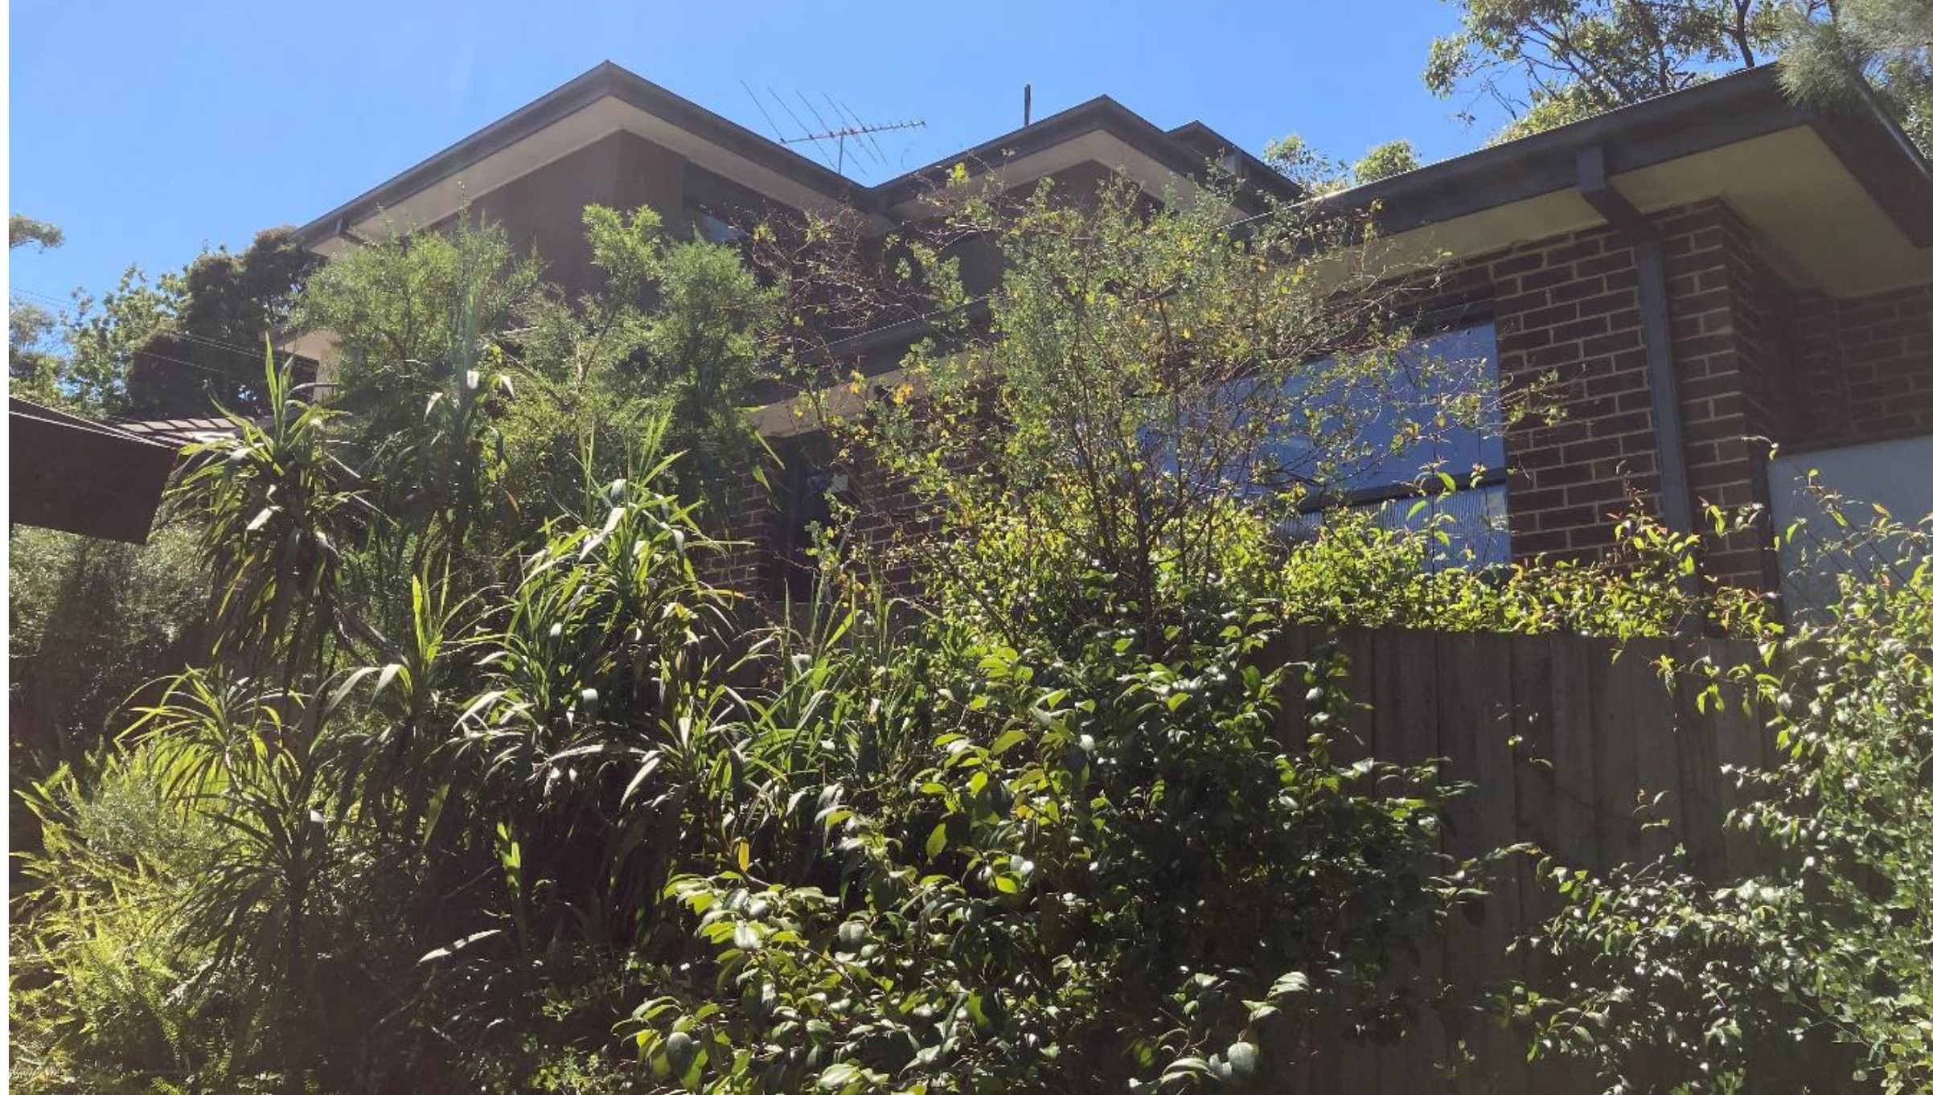 Source: Council submission – Figure 27 – view from rear yard of 30 Park Road
Location of addition and terrace
- To address this concern, I will delete the first floor terrace as a condition on the permit. This will remove the built form that is clearly visible from across the adjoining rear yard and entertaining area of the dwelling that is located at a lower level than the subject site.
- In terms of the increased length of the bedroom, I am satisfied the addition will respect the height, scale and massing of dwellings in this area. I find the addition will not result in a dominant built form facing the adjoining rear yard as it will be set back approximately 1.7 metres from the rear of 30 Park Road and 3 metres from the south boundary.
- The Clements are concerned about the visual impact of the addition when viewed from their lounge room window. This window is part of a larger living area that provides northern light and outlook. Having viewed the existing dwelling from the lounge room window I note the existing dwelling is an imposing structure visible from this window. I do not consider a reduction in setback by 390mm will significantly change the outlook from this room.
- The Clements submit there will be views from the terrace through the slatted screen down into their dwelling. I am satisfied the provision of the 1700mm high screen on the south elevation of the terrace will limit views into habitable room windows and secluded private open space. This measure is in accordance with Standard A15 – Overlooking.

Overshadowing and Daylighting
- The Clements argue the addition and terrace will reduce the amount of daylight entering the three north facing habitable room windows. They say this will impact the energy efficiency properties of the dwelling. They submit these issues are exacerbated by the difference in ground levels between the properties their land is approximately 2 metres lower than the subject site.
- The applicant argues the height and setback of the addition and terrace achieves compliance with the Standard A13 – North Facing Windows, in addition to Standard A10 – Side and Rear Setbacks.
- I observed there is a significant difference in ground levels between the subject site and 30 Park Road. This increases the height of the existing dwelling when viewed from Clements’ north facing windows and northern setback. It also impacts the amount of daylight and sunlight entering these windows.
- Whilst I understand the Clements are concerned that there will be greater impacts if the wall is closer to the south boundary, I consider compliance with the standards indicates an adequate level of amenity is provided for the adjoining dwelling.
- Clause 32.09-13 requires consideration of the impact of overshadowing on existing roof top solar energy systems on adjoining lots. Standard A7 – Energy Efficiency Protection states that buildings should be sited and designed to ensure the performance of existing rooftop solar energy systems on dwellings on adjoining lots are not unreasonably reduced.
- The Clements have twelve solar panels contained in two strings at the peak on the west side of the roof. They say these panels were installed in mid-2015 and are located on this section of the roof for maximum solar access. I note the panels were installed after the original permit was approved by the Tribunal.
- Council and the Clements argue that the overshadowing of two panels at 9.00am at the winter solstice will significantly impact the operation of their solar system. They also questioned the accuracy of the cross-section diagram on TP3 Revision 4 as it does not show the ground level of their dwelling which is significantly lower than the subject site.
- Standard A7 seeks to ensure the performance of solar panels are not unreasonably reduced. The decision guidelines require consideration of the existing amount of solar access to abutting properties and the extent to which existing roof top solar panels are overshadowed by existing structures.
- Shadow diagrams show there is no overshadowing of the panels at the Equinox throughout the day. However, they show there will be some shading of two panels at 9.00am in winter from the screen of the terrace. At 12 noon, five solar panels are overshadowed by the existing dwelling.
- The applicant submits the panels are overshadowed by existing vegetation in winter and there is limited sunlight available at this time. She also submitted a diagram of the roof that showed the angle of the sun in winter would not reach the west facing panels on the roof.
- Council and the respondents expressed concerns about this diagram as it was not dimensioned. I agree and find it unhelpful given the lack of context and dimensions. I will therefore give it little weight in my assessment.
- I find the addition will not unreasonably reduce the efficiency of the solar panels at 30 Park Road. I have come to this conclusion as the additional shadow impacts are restricted to 9am in winter only. I consider that as the addition will not overshadow the panels at other times of the year when there is greater access to sunlight, the efficiency of the solar energy system is not unreasonably impacted. I also note that removal of the terrace will further reduce shadows over the panels at 9am.

Ground floor deck

Built form
- The proposal includes the construction of a 3.57 metre wide ground floor deck abutting the living room with a 5.27 metre long privacy screen along the south side.
- The decision guidelines in the NRZ2 require consideration on whether the built form complements the landscaped setting by including the following features:
- A built form that is sufficiently recessed and articulated, as viewed from the creek reservation and neighbouring properties, to reduce visual bulk and ensure the vegetation provides the more dominant element as viewed from the creekland reserve, the street and adjoining properties.
- Housing that visually recedes into a continuous backdrop of canopy trees, avoiding dominant upper storeys and tall roof forms, resulting in visually intrusive built form and large, blank walls.
- The Tribunal made the following observations regarding the Damper Creek interface:
In relation to “neighbourhood character”, in essence I indicated that my site inspection had confirmed that both the Park Road streetscape and the rear interface with the Damper Creek Reserve each involved a somewhat compromised situation already, which in practice provides a greater degree of flexibility for potential new infill development such as is proposed here. However, I acknowledged that if one observes the rear section of the row of dwellings on which the appeal site forms part, this row of dwellings consistently involves the dwellings being set well back from the rear boundary.
- However, the determination also made the following comments:
With respect to the eastern interface with the Damper Creek Reserve, I am satisfied that it would be a more acceptable visual bulk outcome for the two proposed rear decks to be removed and replaced with ordinary ground level paving. Removal of these rear decks seems a good outcome, in terms of reducing the visual impact of the rear of the new development, when viewed from the backyards of the No. 26 and the No. 30 properties, or if any member of the public is standing in the reserve and looking into the appeal site from the rear.
- The respondents say the environmental significance of the creek reserve is enhanced by the backyard gardens of the properties that adjoin it, particularly at the southern end of Park Road where the creek is near the property boundaries. They submit the previous Tribunal decision specified a setback of the built form from the rear boundary and mandated a planting scheme which complemented the revegetation in the reserve. They argue the proposal ignores the original Tribunal ruling by intruding into this setback and thus reduces the area available for vegetation and contribution to the environmental value of the reserve.
- The applicant advised that there is a lack of connectivity to the private open space. She says the extent of the proposed deck is limited to match the existing party wall and the primary open space remains largely unchanged. She submits the deck will significantly improve connectivity and useability of the rear yard without unreasonable impacting the neighbours.
- The applicant argues there will not be any unreasonable neighbourhood character impacts given the extent of change proposed. She says the deck will only extend to the extent of the end of the existing wing wall and it will not change the existing extent of overlooking.
- I inspected the rear yard of the subject site and note the sense of openness at the rear of properties in the vicinity of the subject site. This is due to the extent of vegetation that blends into the creek reserve and the absence of structures and paving. I also note the subject site and other properties have low height cyclone fencing along the side and rear boundaries which enhances this sense of openness and allows uninterrupted views across the rear yards.
- However, I also observed the rear yards of other properties further north of the subject site had minimal landscaping which was a stark contrast to the adjoining parkland. This results in the two storey dwellings commanding the vistas from the reserve.
- I am concerned the construction of the deck with associated screening will push the built form closer to the creek. Whilst the structure is set back over 11 metres from the reserve, I find it is inconsistent with the rear yards of existing dwellings nearby that have ground level paving/entertaining areas that are set within a landscaped setting. I acknowledge there are some larger houses nearby that have elevated decks (i.e. 20 and 22 Park Road) but these examples demonstrate the importance of nestling dwellings into the landscape so the built form visually recedes into a continuous backdrop of canopy trees.
- I also note the latest endorsed plans for Permit TPA 49895 addresses the issue of connectivity as a new glazed door provides direct access from the living room.
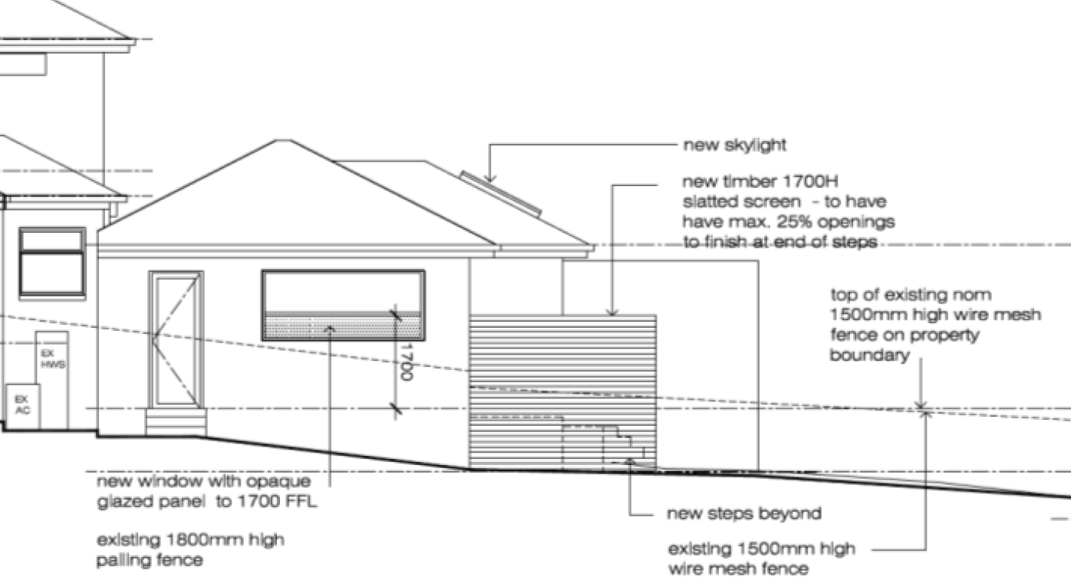
South Elevation plan approved in TPA 49895
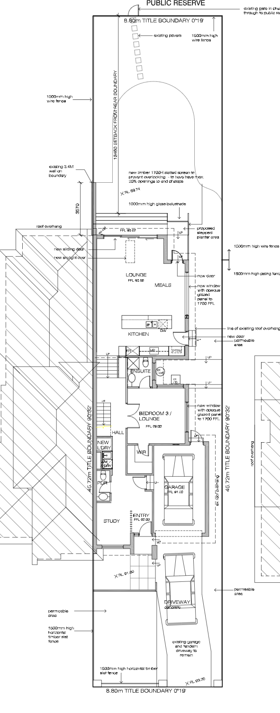
New landing and access from the living room
Approved ground floor plan
- The stairs and glazed door currently provide access to the existing paved area adjacent to the living room. I note this paving is on a slope which would affect its useability. I consider this could easily be remedied by levelling/paving this area to provide a useable space, without the need for additional structures on the land.
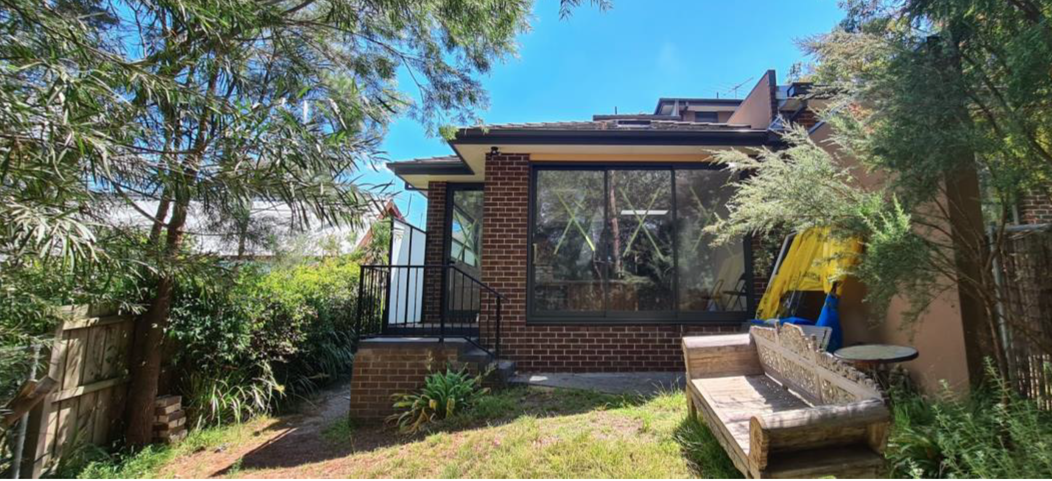
- I therefore agree with the findings of the previous Tribunal member that removal of the deck will reduce the visual impact on the adjoining rear yards and views from the adjoining creek reserve. I will delete the ground floor deck as a condition on the permit and require reinstatement of the stair access as shown on the previously endorsed plans.

Overlooking
- Council and the Clements argue the proposed ground floor deck is approximately one metre above ground level and will be an intrusive element at the rear of the site. They are concerned there will be overlooking from the deck into their rear yard which is exacerbated by the steep slope of the land. They also submit there will be views through the slatted screen into their paved entertaining area.
The existing conditions include uninterrupted views across the rear yards due to the presence of low height cyclone fencing along the side and rear boundaries. Therefore, I consider some viewing between properties is inevitable to maintain the special character of the creek environs. However, I am satisfied the lattice screen on the south side of the deck that is part of the existing approved plan will restrict unreasonable views into the Clements’ rear yard.

What conditions are appropriate?
- Other conditions were discussed at the hearing and any changes to the permit conditions contained in Appendix A of this order reflect those discussions plus further consideration by the Tribunal.

Conclusion
- For the reasons given above, the decision of the Responsible Authority is set aside. A permit is granted subject to conditions.

Jane Tait
Member

Appendix A – Permit Conditions

Permit Application No | TPA/51158
Land | 28B Park Road  MOUNT WAVERLEY VIC 3149

What the permit allowS
In accordance with the endorsed plans:
- Additions and alterations to an existing dwelling on a lot less than 500 square metres

Conditions

Amended Plans
- Before the development starts, a copy of plans drawn to scale and dimensioned must be submitted to and approved by the responsible authority. When approved, the plans will be endorsed and will then form part of the permit. The plans must be generally in accordance with the plans by Paul Delany Architects (TP1 Revision 4 dated 14 Jan 2020, TP2 Revision 5 dated 14 Jan 2020, TP3 Revision 4 dated 16 Dec 2019, TP4 Revision 5 dated 14 Jan 2020, TP5 Revision 5 dated 14 Jan 2020, TP6 Revision 5 dated 14 Jan 2020) but modified to show:
  - A notation to specify south facing bedroom 3/lounge window and south facing meals area window to be labelled as “non-openable fixed obscured glazing (not film) to 1.7m above finished floor level”
  - Ground floor timber screen extended east to be in line with the end of the new steps
  - Deletion of the ground floor deck and reinstatement of the landing, stairs and screening in accordance with the endorsed plans for TPA/49895.
  - Deletion of the first floor terrace and replacement of the sliding door in the east elevation with a window.

No Alteration or Changes
- The development as shown on the endorsed plans must not be altered without the prior written consent of the responsible authority.

Tree Protection
- No building material, demolition material or earthworks shall be stored or stockpiled under the canopy line of any tree to be retained on the subject land and surrounding land during the construction period of the development hereby permitted.
Adequate measures must be implemented to ensure the extent of works is to have regard to minimise any adverse impact to existing vegetation on adjoining properties and the Damper Creek Reserve. Adequate tree protection measures must be implemented to the satisfaction of the responsible authority.

Completion of Buildings and Works
- Once the development has started it must be continued and completed to the satisfaction of the responsible authority.

Permit Expiry
- This permit will expire in accordance with section 68 of the Planning and Environment Act 1987, if one of the following circumstances applies:
  - The development has not started before two (2) years from the date of issue.
  - The development is not completed before four (4) years from the date of issue.
In accordance with section 69 of the Planning and Environment Act 1987, the responsible authority may extend the periods referred to if a request is made in writing before the permit expires, or within six months of the permit expiry date, where the development allowed by the permit has not yet started; or within 12 months of the permit expiry date, where the development has lawfully started before the permit expires.

– End of conditions –

The submissions and any supporting exhibits given at the hearing and the statements of grounds filed have all been considered in the determination of the proceeding. In accordance with the practice of the Tribunal, not all of this material will be cited or referred to in these reasons.
Reichhard v Banyule City Council [2012] VCAT 1675.
Sprut Pty Ltd [pt 17].
Council submission –para 8.7.
At Cl 32.09, Sch 2.
Vanderhelm v Monash CC [2007] - para 13.
Cl 7.0, Sch 2, Cl 32.09.
Vanderhelm v Monash CC [2007] – para 12.
Ibid – para 24.

