VICTORIAN CIVIL AND ADMINISTRATIVE TRIBUNAL
planning and environment DIVISION
planning and environment LIST | vcat reference No. P1802/2019  Permit Application no. TPA/49847
CATCHWORDS
Section 77 of the Planning & Environment Act 1987; Monash Planning Scheme; General Residential Zone Schedule 3; Vegetation Protection Overlay Schedule 1; Planning Policy; Neighbourhood Character; Design; Traffic; Internal Amenity; External Amenity

APPLICANT | Ping Hung Chan
responsible authority | Monash City Council
SUBJECT LAND | 34 White Street Mount Waverley
WHERE HELD | Melbourne
BEFORE | Katherine Paterson, Member
HEARING TYPE | Hearing
DATE OF HEARING | 3 February 2020
DATE OF ORDER | 30 April 2020
CITATION | Chan v Monash CC [2020] VCAT 526

Order
- Pursuant to clause 64 of Schedule 1 of the Victorian Civil & Administrative Tribunal Act 1998 the permit application is amended by changing the name of the permit applicant to:
Ping Hung Chan
- Pursuant to clause 64 of Schedule 1 of the Victorian Civil & Administrative Tribunal Act 1998, the permit application is amended by substituting for the permit application plans, the following plans filed with the Tribunal:
- Prepared by: | Allan A Armstrong and Associates
- Drawing numbers: | 1 to 9 inclusive
- Dated: | 12 December 2019
- In application P1802/2019 the decision of the responsible authority is set aside.

- In planning permit application TPA/49847 a permit is granted and directed to be issued for the land at 34 White Street Mount Waverley in accordance with the endorsed plans and the conditions set out in Appendix A. The permit allows the construction of two dwellings on a lot.

Katherine Paterson
Member

Appearances
For applicant | Mr Andrew Gray, Town Planner, Planning and Property Partners
For responsible authority | Mr David De Giovanni, Town Planner, David De Giovanni Town Planning

Information
Description of proposal | Construction of two side by side dwellings. The proposed dwellings are to be two storeys with a basement car park for each dwelling, accessed via separate crossovers to White Street. The architectural style of the dwellings incorporates pitched roof forms and brick facades.
Nature of proceeding | Application under section 77 of the Planning and Environment Act 1987 – to review the refusal to grant a permit.
Planning scheme | Monash Planning Scheme
Zone and overlays | General Residential Zone Schedule 3, Vegetation Protection Overlay Schedule 1
Permit requirements | Clause 32.08-6 – Construct two dwellings on a lot
Land description | The subject site has an area of 805 square metres and contains a single storey brick and weatherboard dwelling, associated outbuildings and garden plantings.
Tribunal inspection | 5 February 2020
Cases referred to | Dore v City of Monash [2000] VCAT 790 (31 March 2000)

Reasons

What is this proceeding about?
- Ping Hung Chan wishes to construct two ‘side-by-side’ dwellings on land at 34 White Street Mount Waverley. Following Council’s refusal of the application, he has requested that the Tribunal review this matter.
- Council refused the application for a number of reasons, but their primary concern is that the scale of the proposed development is simply too ‘intense’ for this location, and consider that the design of the proposal contrary to the landscape and neighbourhood character of the area. Finally, they are concerned that the proposed layout will provide a poor level of internal amenity for the future occupants of the dwellings.

What are the key issues?
- Having considered all the submissions and evidence and inspected the subject land and its locality I am of the opinion that the key issues in this proceeding are:
- Does planning policy support the construction of a two storey ‘side- by-side’ development on this site?
- Is the proposal respectful of the neighbourhood character?
- Will the proposal provide a reasonable level of internal amenity for the future occupants of the dwellings?
- I have decided to grant a permit for the following reasons:
- The subject site is within an area that is supported by planning policy for more intensive forms;
- With the changes I have made, I am satisfied that the proposal is an acceptable response to the neighbourhood character of the area; and
- The proposal will provide a comfortable home for the future occupants of the dwellings.
My reasons follow.

procedural issues
- Following the hearing, Amendment VC168 to the Monash Planning Scheme was gazetted on 11 February 2020. As the amendment made a number of changes to the planning policy framework, the Tribunal found it was appropriate to invite the parties, had they wished to do so to make a further written submission on any implications for the proposed development. In response, submissions were received from the responsible authority and the applicant for review. The Tribunal has taken these submissions into account in this decision.

Does planning policy support the construction of a two storey ‘side-by-side’ development on this site?

Planning Policy Framework
- It is state planning policy to create mixed-use neighbourhoods at varying densities, including through the development of urban-renewal precincts that offer more choice in housing, create jobs and opportunities for local businesses and deliver better access to services and facilities.
- Plan Melbourne 2017-2050, a reference document at Clause 11.01-1S, provides an indicative map of land included within the Monash National Employment and Innovation Cluster (NEIC). The subject site is located on the outer edge of the NEIC, as shown in the extract from Plan Melbourne 2017-2050:
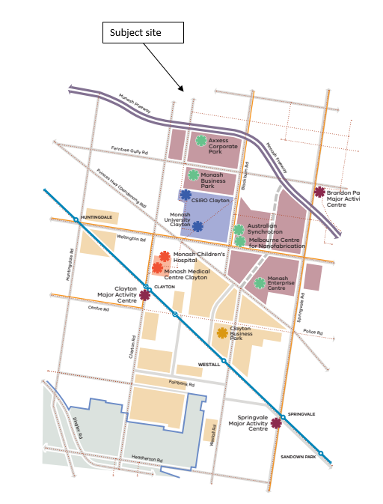
- In addition, Plan Melbourne 2017-2050 identifies the Mount Waverley Activity Centre, located approximately 550 metres from the subject site, as a Major Activity Centre.
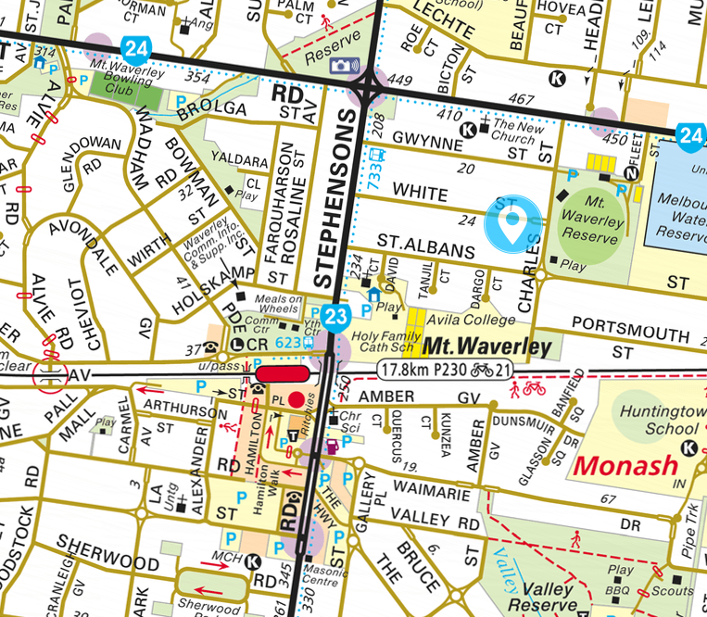
- Clause 16.01-2R seeks to facilitate increased housing in established areas to create a city of 20 minute neighbourhoods close to existing services, jobs and public transport. Key locations for land consolidation include:
- Areas designated as National Employment and Innovation Clusters.
- Metropolitan activity centres and major activity centres.
- Areas near existing and proposed railway stations that can support transit-oriented development.
- The subject site which is located at the edge of a NEIC and within 550 metres (a seven minute walk) of a major activity centre that includes a train station is clearly supported by the planning policy framework for more intensive housing forms.

Local Planning Policy
- Clause 21.01-1 states:
The City of Monash is one of Melbourne's most populous municipalities, with an estimated 189,000 residents in 2016. The population is expected to increase by over 26,000 to over 215,000 by 2031.
The rising population has resulted in an increase in the number of households and it is estimated that this will drive demand for at least 10,000 new dwellings over the period 2016-2031.
- To guide the location of the additional housing within Monash, Clause 21.04-1 has divided the municipality into various categories, with the subject site included within an accessible area, due to its proximity to the Mount Waverley Major Activity Centre, as shown below in the extract of the residential development framework map:
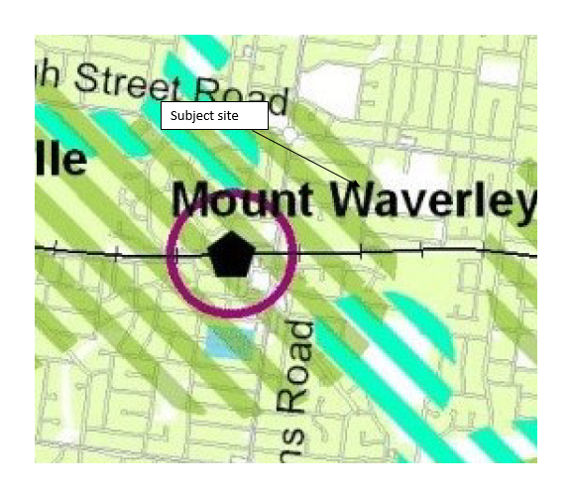
- The Monash Planning Scheme is relatively silent on the built form outcomes sought for the accessible areas, which is recognised in the list of identified further strategic work for the planning scheme provided at Clause 21.04 which includes:
Preparing urban design principles and built form guidelines for the boulevards (Springvale Road and Princes Highway) and the accessible areas around activity centres.
- The Monash Housing Strategy 2014 a reference documents at Clause 21.04, provides the following guidance as to the built form outcomes expected within the accessible areas:
- Transition in residential density from the interface with surrounding residential areas to the boundary of the Activity Centre.
- Lower density unit and townhouse style developments. at the interface with surrounding residential areas.
- Potential for apartment development in context with the scale of development of the Activity Centre, at the interface with the Activity Centre subject to careful design.
- On larger sites, in suitable locations, increased density may be appropriate, subject to careful design and the provision of appropriate landscaped setbacks.
- I find that the construction of two double storey ‘side by side’ townhouse dwellings to be consistent with the built form outcomes expected within the accessible areas of the municipality.

Is the proposal respectful of the neighbourhood character?
- Clause 55.02-1 of the scheme seeks to ensure that the design of medium density housing either respects the existing neighbourhood character of an area or contributes towards a preferred character.
- The subject site is included within the General Residential Zone Schedule 3 (GRZ3), the purposes of which include:
- To encourage development that respects the neighbourhood character of the area.
- To encourage a diversity of housing types and housing growth particularly in locations offering good access to services and transport.
- The GRZ3 contains a number of neighbourhood character objectives including:
- To support new development that contributes to the preferred garden city character through well landscaped and spacious gardens that include canopy trees.
- To promote the preferred garden city character by minimising hard paving throughout the site by limiting the length and width of accessways and limiting paving within open space areas.
- To support new development that minimises building mass and visual bulk in the streetscape through generous front and side setbacks, landscaping in the front setback and breaks and recesses in the built form.
- To support new development that locates garages and carports behind the front walls of buildings.
- These objectives are supported by a number of variations to the Standards of Clause 55. Council conceded that the application complies with the varied standards.
- Clause 22.01 ‘Residential development and character policy’ of the scheme has divided the municipality into various character types, with the subject site included within the Garden City Suburbs Northern Areas, which has the following preferred neighbourhood character statement:
Although there will be changes to some of the houses within this area, including the development of well-designed and sensitive unit development and, on suitable sites, some apartment development, these will take place within a pleasant leafy framework of well-vegetated front and rear gardens and large canopy trees.
Setbacks will be generous and consistent within individual streets. Building heights will vary between neighbourhoods. Neighbourhoods with diverse topography and a well-developed mature tree canopy will have a larger proportion of two storey buildings. In the lower, less wooded areas, buildings will be mainly low rise unless existing vegetation or a gradation in height softens the scale contrast between buildings. New development will complement the established buildings through consistent siting, articulated facades and use of materials. New development will consider energy efficiency and sustainability principles. Long expanses of blank wall will be avoided, particularly when adjacent to public parks, reserves and other open space areas, where the building should address the public area.
Architecture, including new buildings and extensions, will usually be secondary in visual significance to the landscape of the area when viewed from the street. New development will be screened from the street and neighbouring properties by well planted gardens that will ensure the soft leafy nature of the street is retained.
Gardens will consist of open lawns, planted with a mix of native and exotic vegetation and trees.
Existing mature trees and shrubs will be retained and additional tree planting within streets and private gardens will add to the tree canopy of the area.
Buildings will be clearly visible through these low garden settings, and non-existent or transparent front fences. Additional vehicle crossovers will be discouraged.
The built-form will be visually unified by well-planted front gardens that contain large trees and shrubs and street tree planting. Trees within lots to be redeveloped will be retained wherever possible to maintain the established leafy character.
Landscape elements such as remnant indigenous vegetation and the large old coniferous wind-rows will be retained until trees are no longer healthy or safe.
- Council submitted the design response did not reflect the neighbourhood character of the area and was critical of the following aspects of the design response:
- The combination of the two driveways, which have a width of four metres, and the inclusion of two pedestrian paths;
- The side walls of the basement which range in height from 1.5 to 1.8 metres;
- Narrow planting zone between the driveway and the side fence
- Front porches including the stairs
- Semi-basement design;
- Presentation of the garage doors to the street;
- Limited recession between ground and upper levels;
- Box like design;
- The first floor central wing wall; and
- Limited transition to other dwellings in the street.
I will consider each aspect in turn.

Two driveways and proposed pedestrian paths
- The application proposes to utilise an existing crossover and construct an additional crossover to create access to the dwellings. This is a departure from the preferred character statement for the area which states:
Additional vehicle crossovers will be discouraged.
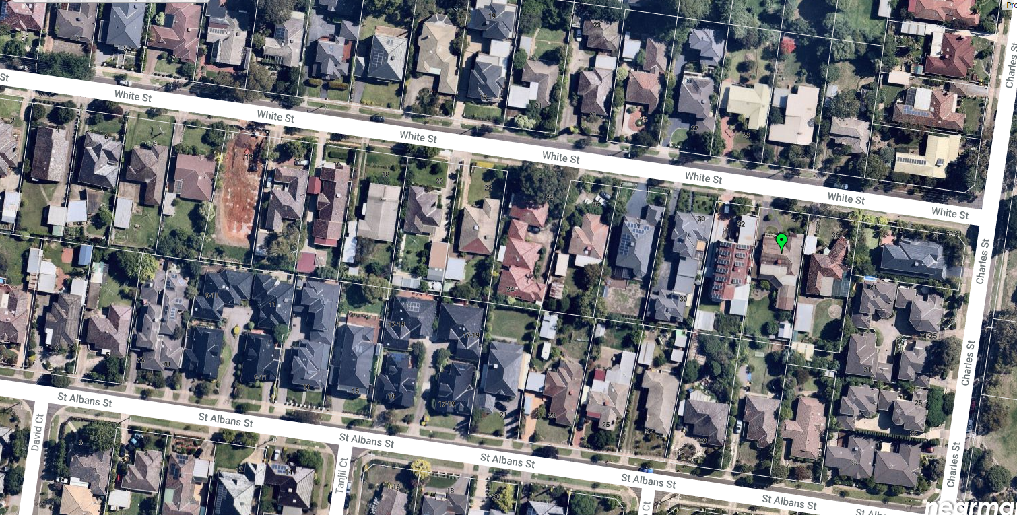
- The above Nearmap image shows that within White Street, almost exclusively single crossovers have been used. However in nearby Charles Street and St Albans Street a number of medium density developments have utilised two crossovers, including a side by side development at 7 St Albans Street.
- That development was approved by the Tribunal in Dore v City of Monash [2000] VCAT 790 (31 March 2000). In that decision the Tribunal found:
7. This dual occupancy proposal had no objectors and the refusal of the Responsible Authority centered around the area character and whether or not there should be two vehicular crossings and two double garages across the frontage of this 17.68m frontage site.
8. The inspection was helpful and noting the crossings and developments in the street, the Tribunal cannot understand how the Responsible Authority has refused this proposal. The project will improve the area and not conflict with or alter the character of the area beyond what has occurred already with other recent developments.
9. The Responsible Authority cannot give blanket refusals based on the frontage width as was the case here. Each proposal must be dealt with on its merits and in this case the Tribunal is satisfied that the proposal will not further alter the area character and should be permitted.
10. The proposal fits the zone requirements, complies with Government policy and the Good Design Guide. The Tribunal understands the basis of the Responsible Authority Local Variations and the reasoning for their consideration in these applications, however they cannot be used as a fixed tool, and an assessment has to be made of each individual application.
- Whilst there has been considerable number of changes to the planning scheme since this decision, I agree with Member Terrill that a blanket prohibition on two crossovers cannot be applied to every site within the Garden City Suburbs Northern Area and GRZ3. Instead each application must be assessed on its merits.
- Standard B14 states that no more than one single crossover should be provided per dwelling facing the street, and as the frontage is less than 20 metres, should not exceed 40% of the site’s frontage, or 6.9 metres for this site. The proposal provides two single crossovers with a combined width of 6 metres, consistent with the standard.
- The landscape plan prepared as part of the amended application indicates that the frontage still has sufficient space to accommodate two, 12 metre Watergums, which will be supplemented with 3 metre bottlebrushes, and 1.2 metre tall coastal rosemary bushes. I am satisfied that this will achieve the garden character desired by the planning scheme, despite the inclusion of an additional crossover, and the proposed footpaths for both dwellings.
- I do recognise that the planning scheme seeks to limit the introduction of crossovers within a streetscape, however some allowance needs to be given to the inclusion of this site within an accessible area where change and more intensive forms are anticipated by the scheme. If this site was not in an accessible area, I may have found that the second crossover was excessive in this streetscape. However in an area that is identified for change it is acceptable.

The side walls of the basement
- The application proposes to provide vehicle parking within a separate semi basement for both dwellings, which will require the provision of retaining walls. For dwelling one the retaining wall will have a maximum height of 1.93 metres, and for dwelling two it will have a maximum height of 1.65 metres.
- I find that the height of the retaining walls is not excessive, and the elevations indicate that the retaining wall for dwelling one is to have a ‘rock like’ finish. I find that this is acceptable but should be used for the retaining walls for both dwellings to soften the impact of the walls in the streetscape. I have required this as a condition of permit.

Narrow planting zone between the driveway and the side fence
- The landscape plan reveals that whilst the space between the driveway and boundary is in some places narrow, it is still sufficient to accommodate a row of 600mm Spiny-headed mat rush at its narrowest point, and a row of the taller 5 metre Lilly Pillys. I am satisfied that these plantings will soften the impact of the retaining walls at this interface and add to the garden city character desired by the scheme.

Front porches including the stairs
- The application proposes the construction of two front porches, setback 5.6 metres from the street frontage, with a height of 4.3 metres. The schedule to the GRZ3 states that buildings should be setback 7.6 metres from the streetscape, however Standard B6 allows porches less than 3.6 metres high to encroach into this setback by 2.5 metres. As the porches are greater than 3.6 metres in height the application is seeking a variation to the standard for these elements.
- The decision guidelines of Clause 55.03-1 of the Monash Planning Scheme require me to consider whether a different setback to the standard is acceptable, having regard to the prevailing setbacks of the area. Nearby setbacks range from 2.3 metres to 12.3 metres with an average 6.7 metres. The adjoining property at 32 white Street has a setback of 5.5 metres, and the dwelling at 36 White Street is 7.8 metres, giving an average of 6.7 metres between the two properties. Whilst I am prepared to accept a reduced setback for dwelling two, I find that the setback to dwelling one needs to be increased to 6.7 metres, to be consistent with the average of the two properties, and the prevailing setbacks of the street. This will provide a transition between the two neighbouring properties and provide a greater level of articulation between the dwellings. I have therefore required the porch of dwelling1 to be setback a minimum of 6.7 metres from the street, and any subsequent internal modifications, which may be achieved by either pushing the entire ground floor back, or by similarly narrowing the entry porch. I will leave it to the designer to determine the most appropriate approach.
- Due to the slope of the land, a series of steps are required to access the porch and then the dwelling itself. Whilst not ideal for those with mobility issues, it does reflect the slope of the land, and is also consistent with other dwellings within the street who have taken a similar approach.

Semi-basement design
- Council criticised the use of a semibasement for the proposal, submitting that it unreasonably increases the height of the built form, which then fails to transition to the adjoining properties.
- The semi basement design elevates the two storey built form to 8.2 metres and due to the height of the basement above natural ground level, the dwellings are considered under the planning scheme to be a three storey dwelling.
- Whilst tall, I note that a similar approach has been taken for the adjoining dwelling at 32 White Street, which reads as a two and a half storey dwelling from the street.
- I find that the increase in height is acceptable, and the dwellings will be a comfortable fit within the streetscape.

Presentation of the garage doors to the street
- Whilst Council submitted that the semi basement design drew attention to the garage doors, I disagree. The doors will be sunken into the site, which limits their visibility and therefore appearance from the streetscape.

Limited recession between ground and upper levels;
- I am satisfied that the second floor of the development has been sufficiently setback from the first floor to appear sufficiently recessed in the streetscape, particularly through the use of the tall porch elements which will sit forward of the upper level of the dwelling.

Box like design
- The design is essentially a series of boxes, with pitched roofs, similar to many other dwellings within the streetscape, including of the adjoining property at 32 White Street. I find that this design response is satisfactory and is an acceptable response to the streetscape, again recognising that this is a street that has been identified within planning policy for change.

The first floor central wing wall
- The application incorporates the use of a narrow brick wall to run between the two properties, probably as a fire wall between the two dwellings. It is most apparent at the second floor, where the brick pillar is in contrast to the proposed rendered walls, and where it will exceed the wall height of the dwelling. I find that this wing wall is not an objectional element to the design, and will assist in ensuring that the dwellings read as two separate dwellings from the streetscape.

Transition to other dwellings in the street
- With the increase in setback to dwelling one, I am satisfied that the proposed development will appropriately transition between the two adjoining properties, and as a consequence the streetscape. The height of the built form, effectively two and half stories is only slightly taller than its neighbour at 32 White Street, and in my view will be a comfortable fit in the streetscape, despite being considerably taller than the existing dwelling at 36 White Street. I therefore find that the proposal is an acceptable response to the neighbourhood character of the area. I have required the endorsement, implementation and ongoing maintenance of the landscape plan as a condition of permit.

Will the proposal provide a reasonable level of internal amenity for the future occupants of the dwellings?
- Council submitted that the proposal was overly reliant on screening devices to prevent overlooking which would compromise the internal amenity of the dwellings, and that the areas of secluded open space for each dwelling, particularly the internal courtyards would not receive sufficient daylight. I will consider each in turn.

Overlooking

Western elevation
- The application currently uses fixed obscure glazing to prevent overlooking from the bedroom 2 and 3 windows of dwelling two, and some additional screening measures may be required for the fourth bedroom to prevent overlooking. Whilst this method complies with the standard, it does have an adverse impact on the amenity of this dwelling. Furthermore, obscure glazing is shown on the stairwell window which is unnecessary. To improve the internal amenity of this dwelling, I have required alternative devices to be used, such as blades, screens or fins, which prevent views into the habitable room windows and secluded private open space of each dwelling whilst ensuring an outlook and daylight for the dwelling. I have required the provision of a sightline which demonstrates that the method used prevents overlooking of the habitable room windows and secluded private open space of the adjoining dwelling within 9 metres of the window.
- The plans also show the retention of the existing two metre brick fence along the boundary. I find that the use of the existing fence is acceptable, and may further negate the need for screening devices for the upper level habitable room windows.

Eastern elevation
- I find that the right balance has been struck between preventing overlooking and the internal amenity of dwelling one. Bedroom 1 and the gallery have been designed to prevent overlooking by using highlight windows and obscure glazing. The bedroom will also contained a southern window which will have a clear outlook, and so I consider that this room will hav a high level of internal amenity. The gallery, whilst a habitable room is a secondary living space for the dwelling and I find that the use of obscure glazing for the gallery will not have an unreasonable impact on the overall amenity of this dwelling. I have therefore not required any changes to the eastern windows. The proposal also seeks to utilise the existing two metre paling fence on this boundary, which I find to be satisfactory.

Solar access to private open space
- Standard B29 requires the boundary of the secluded private open space of the dwellings to be set back a minimum of 7.49 metres from the northern wall of the dwelling. The application proposes a minimum setback of 11 metres, comfortably complying with this standard. One of the key benefits of side by side developments is that they often provide a traditional ‘backyard’ reflecting the existing backyard character of an area and providing a level of internal amenity often lost with ‘one behind the other’ dwelling arrangements. I am satisfied that the secluded private open space for both dwellings will provide a highly useable space for both dwellings, despite being south facing, which is a product of the orientation of this site.
- I am satisfied that the depth of the light court provided between the dwellings is sufficient to ensure that this provides additional light into each dwelling. I note that this does not form part of the secluded private open space for the dwellings, rather it simply allows for additional light into the living spaces of the dwelling, to compensate for the lack of northern light available to the main living areas of these dwellings. Again I am satisfied that this will provide an acceptable level of amenity for these dwellings.

Are there any other matters?
- The adjoining property at 32 White Street Mount Waverley has a series of solar panels on its roof. The shadow diagrams submitted with the application, include that the shadows cast by the development may extend over the panels in the morning period, but by 12 noon there will be no impact. To ensure that the performance of the neighbouring solar system is not unreasonably prejudiced by the development, I have required amended plans demonstrating that there is no shadow cast on the solar panels after 11am, which will give at least 5 hours between 9am and 3pm when no additional shadow is cast by the development over the panels, ensuring that the development does not unreasonably affect the existing system, meeting the objective of Standard B10 of Clause 55.03-5. Given the layout of both dwellings it is likely that no change to the built form will be required to achieve this requirement, but I have worded the condition to allow for consequential changes if required.

What conditions are appropriate?
- Draft conditions were circulated prior to the hearing and any changes to those conditions reflect those discussions plus further consideration by the Tribunal. For completeness, I have amended condition four to reflect the landscape plan prepared by DDT Planning and Design and included the Tribunal’s standard expiry conditions.

Conclusion
- For the reasons given above, the decision of the responsible authority is set aside. A permit is granted subject to conditions.

Katherine Paterson
Member

Appendix A – Permit Conditions

Permit Application No | TPA/49847
Land | 34 White Street Mount Waverley

What the permit allowS
The construction of two dwellings on a lot in accordance with the endorsed plans.

Conditions
- Before the development starts, two copies of amended plans drawn to scale and dimensioned, must be submitted to and approved by the Responsible Authority. When approved the plans will then form part of the permit. The plans must be generally in accordance with the plans prepared by Allan A Armstrong and Associates drawing numbers 1 to 9 inclusive dated 12 December 2019 prepared by Alan Armstrong and Associates but modified to show:
- The retaining walls of both dwellings to have a rock or stone appearance, similar to that shown on the eastern elevation.
- The front porch of dwelling one setback a minimum of 6.7 metres from the streetscape and any subsequent modifications to the dwelling.
- Deletion of the obscure glazing for the stairwell window of dwelling two
- The use of alternative methods to prevent overlooking from bedrooms two, three and four of dwelling two such as blades, fins or screens, which are designed to prevent downward views within nine metres from the window into the secluded private open space and habitable room windows of 32 White Street whilst maintaining an outlook for the dwelling. A sightline diagram must be provided which demonstrates the method used prevents overlooking within nine metres of the window of the adjoining habitable room windows and secluded private open space of the neighbouring dwelling.
- Revised shadow diagrams demonstrating that the proposed development will not overshadow the existing solar panels at 32 White Street after 11am at the September equinox including any consequential design changes needed to achieve this requirement.
- Provide a corner splay or at least 50% clear of visual obstructions (or with a height of less than 1.2 metres) which may include adjacent landscaping areas with a height of less than 0.9m, extending at least 2.0m long x 2.5m deep within the property both sides or from the edge of each vehicle crossing to provide a clear view of pedestrians on the footpath of the road frontage.
- Windows noted as having obscured glazing to include a note confirming the windows will be fixed and obscure (non-film) to a height of at least 1.7m above finished floor level.
- The width of the garage openings.
- A garden area plan.
- The development as shown on the endorsed plans must not be altered without the written consent of the Responsible Authority.
- Prior to the commencement of any building or works, appropriate tree protection fencing must be erected in accordance with Australian Standard AS4970 – 2009 (Protection of trees on development sites) around the Bottlebrush Tree (Callistemon sp.) located in the nature strip of the site. The tree protection fencing must remain in place until the completion of any works hereby approved.
- A landscape plan prepared by a Landscape Architect or a suitably qualified or experienced landscape designer, drawn to scale and dimensioned must be submitted to and approved by the Responsible Authority prior to the commencement of any works. The plan must be generally in accordance with the plan prepared by DDT Planning and Design dated 17 December 2019 but modified to show the changes required by condition 1 of this permit.
When approved the plan will be endorsed and will then form part of the permit.
- Before the occupation of the buildings allowed by this permit, landscaping works as shown on the endorsed plans must be completed to the satisfaction of the Responsible Authority and then maintained to the satisfaction of the Responsible Authority.
- The driveway and parking area is to be constructed to the satisfaction of the responsible authority.
- The new vehicle crossing must be at a minimum 3.0m wide and constructed in accordance with Council standards.
- All vehicle crossings within 1.5m of an adjoining crossing must be converted to a double crossover in accordance with Council standards.
- Any works within the road reserve must ensure the footpath and naturestrip are reinstated to Council standards.
- All new vehicle crossings are to be no closer than 1.0m measured at the kerb to the edge of any pole, drainage or service pit, or other services.
- All on-site stormwater is to be collected from hard surface areas and must not be allowed to flow uncontrolled into adjoining properties or the road reserve.
- The private on-site drainage system must prevent stormwater discharge from each driveway over the footpath and into the road reserve. The internal drainage system may include either:
- A trench gate (minimum internal width of 150mm) located within the property boundary and the back of footpath; and/or
- Shaping the internal driveway so that stormwater is collected in grated pits within the property or;
- Another Council approved equivalent.
- Stormwater discharge is to be detained on site to the predevelopment level of peak stormwater discharge. Approval of any detention system is required from Council prior to works commencing.
- Any new drainage work within road reserve requires the approval of the Council’s Engineering Division prior to the works commencing.
- Once the development has started it must be continued, completed and then be maintained to the satisfaction of the Responsible Authority.
- This permit as it relates to development (buildings and works) will expire if one of the following circumstances applies:
  - The development is not started within two (2) years of the issue date of this permit.
  - The development is not completed within four (4) years of the issue date of this permit.
In accordance with section 69 of the Planning and Environment Act 1987, an application may be submitted to the responsible authority for an extension of the periods referred to in this condition.
– End of conditions –

The submissions and evidence of the parties, any supporting exhibits given at the hearing and the statements of grounds filed have all been considered in the determination of the proceeding. In accordance with the practice of the Tribunal, not all of this material will be cited or referred to in these reasons.
Clause 11.01-1R
Plan Melbourne 2017-2050 page 27

