VICTORIAN CIVIL AND ADMINISTRATIVE TRIBUNAL
planning and environment DIVISION
 | planning and environment LIST | vcat reference No. P1968/2019  PERMIT APPLICATION NO. TPA/50601
CATCHWORDS
Section 79 of the Planning and Environment Act 1987; Monash Planning Scheme; Two and Three Storey Building; Four Dwellings; Residential Growth Zone – Schedule 3; Clayton Major Activity Centre and Monash National Employment and Innovation Cluster.

APPLICANT | Jing Wang
responsible authority | Monash City Council
SUBJECT LAND | 5 Jean Avenue, Clayton
WHERE HELD | Melbourne
BEFORE | Margaret Baird, Senior Member
HEARING TYPE | Hearing
date of hearing | 29 April 2020
DATE OF ORDER | 8 May 2020
CITATION | Wang v Monash CC [2020] VCAT 544

Order

Permit application amended
- Pursuant to clause 64 of Schedule 1 of the Victorian Civil and Administrative Tribunal Act 1998, the permit application is amended by substituting the following plans filed with the Tribunal for the permit application plans:
- Prepared by: Jesse Ant Architects.
- Project no. 19-022.
- Drawing nos. TP05 – TP12 inclusive, 02-03-2020.

No permit granted
- In application P1968/2019, the decision of the responsible authority is affirmed.
- In permit application no. TPA/50601, no permit is granted.

Margaret Baird
Senior Member

APPEARANCES
For Jing Wang [applicant] | Mr Andrew Clarke, Clarke Planning.
For Monash City Council [Council] | Mr Craig Smith, Senior Planner.

Information
Description of proposal | Four townhouse-style dwellings (two double storey and two triple storey). Eight car spaces are proposed in a tandem stacker.
Nature of proceeding | Application under section 79 of the Planning and Environment Act 1987 – to review the failure to grant a permit within the prescribed time.
Planning scheme | Monash Planning Scheme [scheme].
Zone and overlays | Residential Growth Zone, Schedule 3 [RGZ3] (shown below) Clayton Major Activity Centre and Monash National Employment and Innovation Cluster.  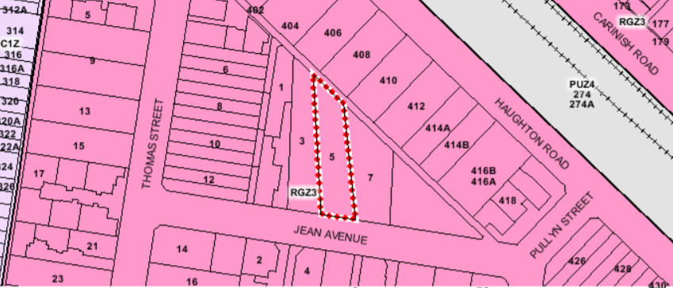
Permit requirements | Clause 32.07-5 - to construct two or more dwellings on a lot. RGZ3 varies clause 55 Standards B6, B13, B17, B28 and B32.
Relevant scheme policies and provisions | Clauses 11, 15, 16, 21, 22.01, 22.05, 32.07, 52.06, 55, 65 and 71.
Subject land description | The subject land is on the north side of Jean Avenue and is 767m² in area. A grassed lane is to the rear (north). A single storey dwelling occupies the land with shedding along the west boundary. The setback from Jean Avenue varies between 15 and 16 metres. The land falls by around 1.0 metre from the rear towards the street.
Tribunal inspection | 4 May 2020 (unaccompanied).

REASONS

INTRODUCTION
- Jing Wang applied to the Monash City Council to construct four dwellings on the subject land. As the Council failed to grant a permit within the prescribed time, the permit applicant has asked the Tribunal to determine the matter and issue a permit.
- The applicant submits the proposal displays many positive elements and these must be weighed against any aspects of the proposal that are borderline or negative. The proposal, it submits, comfortably reaches the threshold of acceptability when the right apportionment of weighting occurs. The applicant says the proposal achieves a clear gain of landscaping and housing while amenity impacts are acceptable in the context of the RGZ3. While arrangements for vehicle access “are not perfect”, all alternatives have been explored and the outcome is acceptable on balance.
- These and related submissions respond to the Council’s position that the permit application should be refused. The Council’s grounds raise concerns about building bulk and massing, landscaping opportunities, streetscape presentation, sense of address and site integration with the street. The Council considers the proposal does not meet multiple policy and character objectives for this growth location. It submits the proposal fails to meet 10 clause 55 objectives (none relating to external amenity impacts), impacts on a street tree, and provides unacceptable access and parking arrangements.
- I must decide whether the proposal will produce an acceptable outcome having regard to the relevant policies and provisions in the scheme. Clause 71.02-3 requires the decision-maker to integrate the range of policies relevant to the issues to be determined and balance conflicting objectives in favour of net community benefit and sustainable development.

Hearing process
- This proceeding was adjourned from its original fixture on 31 March 2020 due to the COVID-19 pandemic wherein face to face Tribunal hearings were adjourned. The hearing is conducted ‘on the papers’, with the agreement of the parties, pursuant to section 100(2) of the Victorian Civil and Administrative Tribunal Act 1998. There are no third parties.
- The submissions leave open some questions about the proposed car stacker arrangements and the adequacy of vehicle access. If I had found that the other aspects of the development are acceptable and together favour the grant of a permit, I would not have determined the application without asking for further submissions in writing or orally about parking and access. Even if parking and access were satisfactory as proposed, I would refuse a permit for the reasons set out in this decision.

Physical and strategic settings
- The physical and strategic contexts that are relevant to the assessment of this permit application are summarised below.
- The subject land:
- Is a modestly-sized lot with few physical constraints other than its relatively narrow width (varying from 12.4 metres at the rear to 15.24 metres along the street frontage).
- Abuts a lane at its rear (north) that appears substantially un-used given its grassed condition.
- Is around 650 metres from the Monash Medical Centre and around 1.5km from Monash University.
- Is within an area that contains a wide diversity of lot sizes and shapes (as evident in the Nearmap extract below).
- Is in an area where many of the original single storey dwellings remain with some garden character although two storey forms and townhouse developments with less planting are evident.
- Adjoins lots with detached single storey dwellings to its east and west that are potential development candidates given the strategic context that applies.
- Is to the south/south-west of detached single dwellings fronting Haughton Road that face the elevated railway line.
- Is in a location with street trees and nature-strips that contribute to the landscape.
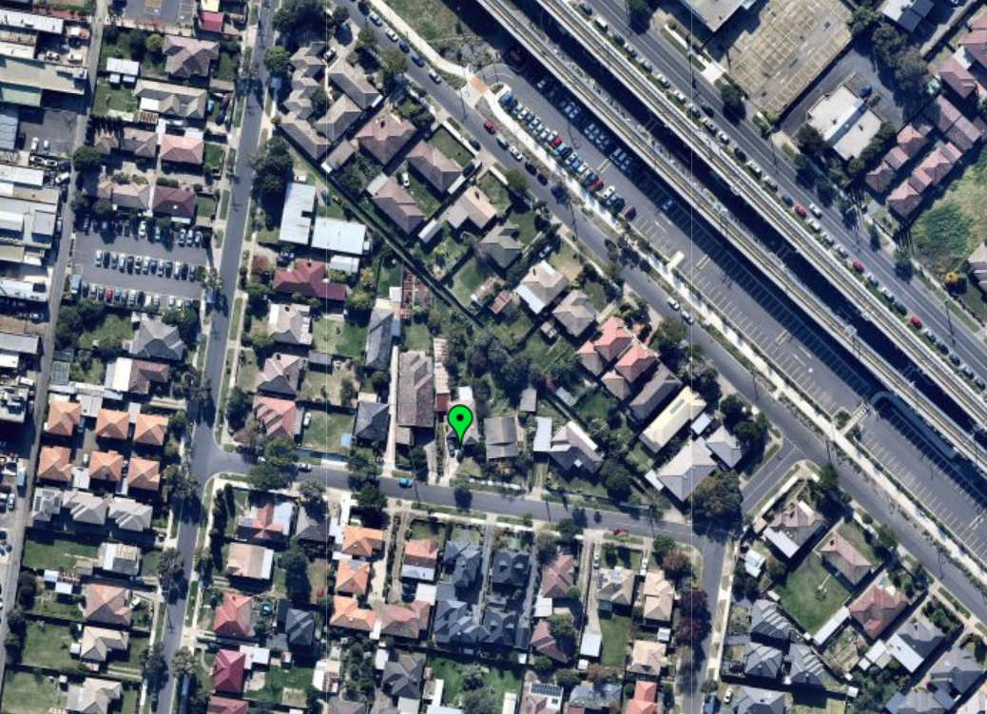
- The subject land and surrounding area is within RGZ3. It is part of the Clayton Major Activity Centre and Monash National Employment and Innovation Cluster where residential growth is directed and expected. The purpose of clause 32.07 includes to provide increased housing densities in buildings up to four storeys and encourage housing diversity. Objectives and provisions relating to transitions to land in other residential areas are not influential or relevant because all abutting land is within RGZ3. The design objectives in the Schedule are to be achieved.
- The objective for RGZ3 is:
- To facilitate housing growth in the form of apartment developments of a high quality design and finish.
- To ensure developments are constructed within an open garden setting through the retention and planting of vegetation, including canopy trees.
- To ensure that the height, scale and form of development respects any sensitive residential interfaces and minimises the appearance of visual bulk.
- The decision guidelines of Schedule 3 include:
- Whether the development contains elements of the ‘garden city’ character. Specifically, whether the proposal:
  - Includes well located open space, primarily unencumbered by easements, to provide for large tree planting and a mixture of indigenous and exotic vegetation in front, side and rear setbacks.
  - Provides vegetation in the front setback that softens the appearance of built form and contributes to the public realm.
  - Sites buildings to minimise the need to remove of significant trees, and protects significant trees on the site and adjoining properties.
  - Maximises planting opportunities adjacent to the street by excluding hard paving such as car parking, turning circles and wide driveways, and minimising basement car parking, within the front setback.
  - Minimises hard paving throughout the site including limiting driveway lengths and widths, providing landscaping on both sides of driveways, and restricting the extent of paving within open space area.
- Include significant breaks and recesses in building massing, is designed to avoid large block like structures dominating the streetscape.
- Whether the development minimises the impact to neighbouring properties, through suitable setbacks from adjacent secluded private open space to enable the provision of screening trees, and scaling down of building form to the adjoining properties in the General Residential Zone, where applicable.
- Clause 32.07 does not include a purpose that ties development to existing character, rather, a new character is encouraged and facilitated. Varied clause 55 standards are part of this. It appears to be common ground between the parties that the proposal essentially meets (or exceeds) the varied standards. I give this significant weight in assessing the proposal’s acceptability including its response to clause 32.07, RGZ3 and preferred character. The area’s preferred future character statement is:
The scale of new residential development will generally comprise larger footprint apartment development of a high-quality design and finish. Some infill town house and unit development will also occur.
Where possible on larger sites, developments will be multi-level, and set in open gardens. Although setbacks from all boundaries will be less than is common in other parts of Monash, the developments will ensure the incorporation of well-maintained landscaping to address the garden city character, albeit in a more urban form.
- I agree with Mr Clarke that this statement aligns with the design objectives in RGZ3. Local policy and RGZ3 make clear the area’s development potential. This is within the broad ‘garden city’ ambition evident in RGZ3’s objectives and decision guidelines. The garden outcome will, obviously, be different to parts of the municipality that are not targeted for growth with a different planning context via zones, overlays and policies.
- My findings apply the scheme as I find it. My application of the scheme is generally consistent with Tribunal decisions referred to in submissions that I have read. To the extent that Mr Clarke refers to different ‘positions’ taken by the Tribunal, on my reading, the cases have been decided on their own facts and circumstances. This point was also made in Yang. All decisions are underpinned by the understanding that the acceptability of a proposal’s built form response to its neighbourhood context must informed by the zone provisions and the applicable policy framework. I viewed several of the locations associated with these cases the applicant relies upon when undertaking my site inspection.
- To the extent that Mr Clarke states that the proposal before me has been shaped by the reasons why the Tribunal refused a permit for the development considered in Yang, it will be evident when reading that decision and my decision that each proposal has been assessed on its merits and in its own context.

UNDERDEVELOPMENT or OVERDEVELOPMENT?

Issues
- The Council says the proposal is both an overdevelopment and underdevelopment. The proposal, Mr Smith says, is an underdevelopment because the scheme seeks a well-designed apartment building through the consolidation of lots. However, the proposed development comprises only four dwellings. In absence of consolidation, Mr Smith submits the narrow width of the lot presents a major constraint and the proposal presents an overdevelopment of the land.
- The applicant states the argument about underdevelopment has been advanced, and lost, in other Tribunal cases. Mr Clarke refers to a proposal for four dwellings (two double storey and two triple storey) in New Bee Pty Ltd. He refers to the land in that case as around Glen Waverley Activity Centre not Clayton but submits the principles and policy expectations are very similar. He relies on the same points he said were made in that case:
Doncaster Road Property Partnership v Manningham CC [2004] VCAT 2445 is often regarded as a leading case on the question of underdevelopment whereby a proposed two storey motor vehicle sales building was proposed on land in a DDO with a 36m height limit seeking residential uses.
In McDonalds Australia Ltd v Stonnington CC [2009] VCAT 749 a proposed single storey convenience restaurant on the corner of Burke and Waverley Rd where a DDO sought 5 storey forms and student housing was not deemed an underdevelopment.
The bar or test to fail on the basis of underdevelopment is significantly higher than our circumstances. Firstly, the actual ‘use’ proposed here is residential, so clearly aligned with the Zone purposes. The proposal is contributing more housing.
3 stories in a 4 storey policy setting is not an underdevelopment, and certainly not one to the extent it conspires against the proposal as a whole as some sort of lost opportunity. We are mid-block infill site and we have produced a proposal to increase housing on this lot by 400% in a manner cognisant of the interfaces yet responsive to the aspirations and purposes of the Zone.
- Mr Clarke also refers to the concept of overdevelopment as a “somewhat nebulous, undefined and unquantifiable item of assessment” and relies on the findings in Associated Town Planning Consultants:
‘Overdevelopment’ is a charge that is thrown around all the time in response to planning applications. Overdevelopment is an outcome in the planning process and is usually sustainable if there are obvious sacrifices in one (or all) of a range of factors including overlooking, overshadowing, lack of open space, tight access, lack of car parking, height, bulk, setbacks and site coverage. Sometimes it will not be the isolated glaring example of failure that is critical but it is the cumulative effect of a number of seemingly lesser examples of non compliance.
Once again I return to ‘context’. I think to properly address overdevelopment you have to go beyond the arithmetic of the planning scheme and of Rescode to consider the site in its geographic context. I think that it is critical to relate the development to where it sits. A design which fails some minimum standards in (say) Port Melbourne may still be acceptable given its context. It may be a site surrounded by tall apartments, or abutted by an industrial site which it has to turn its back on, or it may front open space or even the sea which it is able to borrow from. Its context enables an objective based assessment as well as a more prescriptive analysis. Conversely, a design which may pass all of the arithmetic may still be unacceptable because, in its context, it represents a completely alien intrusion into an area.
- Mr Clarke submits the proposal “does not fail on the single knock-out blow basis and nor does it fail on the cumulative impact basis”. He submits what constitutes an overdevelopment is a consideration that cannot be undertaken absent of understanding the policy context and clearly will differ between various residential zones.

Findings
- I accept the Council’s submission that the scheme provides clear direction about what is sought in the RGZ3 area. More can be achieved by consolidating lots than the proposal for four townhouses. Higher density and greater intensity are part of the broader strategy that directs substantial change to this location and contrasts with locations where the preferred character is different.
- Having said that, it is relevant that the scheme anticipates both townhouses and apartments typologies in this location to achieve the stated strategic ambitions. The likely typology will be affected by factors such as the lot size and configuration. Apartments on larger or consolidated lots will achieve more than a narrow single lot, but development on single lots is not prohibited.
- The long and relatively narrow site is a physical circumstance that creates challenges in designing a residential development. The findings that I set out below lead me to conclude that the proposal displays some of the failings associated with the concept of ‘overdevelopment’ such as the extent of screening, the parking arrangement that seeks to provide two cars per dwelling but creates a substantial parking structure streetscape impacts, and potentially tight vehicle access. Ultimately, my conclusion in this proceeding is that the design response does not achieve an acceptable outcome when assessed against clause 32.07 and Schedule 3 as well as local policy for this location.

CHARACTER

Issues
- The Council’s key concerns are:
- Elements of the building appear as a large block-like structure, particularly in the streetscape.
- The “RGZ3 is unambiguous in its intent in minimising unreasonable bulk and specifically through avoiding large block like structures dominating the streetscape”.
- The proposal is not sympathetic to the existing streetscape. The garage dominates the streetscape and the narrow facade of townhouse no. 1 is not in keeping with the rhythm of the street. The length of the garage west wall is excessive and further contributes to the poor streetscape presentation.
- Services in the front setback, such as electrical meter boxes and mail boxes, pedestrian paths and driveways, together with the narrow frontage result in insufficient space available for landscaping to maintain the garden city character.
- There is an overreliance on highlight windows and external screens which is not sympathetic to the character of the area.
- Mr Smith states trees on adjoining properties would not be impacted subject to the tree protection measures recommended in the arborist report submitted with the application.
- In response, the applicant highlights features of the proposal including the extent of compliance with varied clause 55 standards. Among the points made are the compliant height, the articulated front setback and the rear setback. Mr Clarke refers to the provision of eight trees with a mature height of 6 or more metres at a ratio of one tree per 95m². The applicant comments on the Council’s concerns with respect to RGZ3 objectives including:
- There is variety in wall alignment, roof form, materials, and window positioning. The architectural language is similar to several proposals considered acceptable in this RGZ. The proposal is sufficiently articulated, recessed and includes breaks through the site. The top level is not long and unbroken and there are no cantilevers. It is “far more demure” in built form scale than the developments considered by the Tribunal in Guo, Beattie and Pan.
- The amount of new vegetation is a clear net gain on the existing site conditions. The design allows for suitable space for landscaping.
- Taller and most robust buildings are expected to emerge in this location. The fact the building’s height is 3 metres or one storey less than what clause 32.07 contemplates is relevant. Visual bulk and amenity impacts from building scale to abutting lots are not determinative matters in this case.
- Services do not dominate the front setback. These are conventional elements for any housing proposal.
- It is relevant and notable that Council takes no issue with the landscaping outcome delivered by this proposal. The good landscaping outcome is achieved by not having a long driveway. The double width garage that houses the stackers enables this to occur.
- The proposal is acceptable in terms of the hard paving, driveways, crossovers and garage considerations in the decision guidelines. There is only one crossover and the driveway length has been specifically modified in the amended plans. A consolidated site with a basement would require a passing area and present as double width. There is enough integration and activation across the totality of the façade. This is achieved by habitable room windows, the entry at ground floor, and a primary living zone and balcony at first floor. The streetscape already has a reasonably hard edge to it in terms of a combination of crossovers, driveways, and parking structures. The character will change as new development occurs.
- Arguments about the screening of windows is not a ‘character’ consideration.

Findings
- There is no doubt that the subject land is suitable for redevelopment that will bring substantial change. This is expected by the application of clause 32.07. A more intensive development could be expected than the proposal before me, however, the size and configuration of this lot limits this potential.
- The extent of clause 55 numerical compliance is a favourable outcome of this design. In addition, I consider the following elements positively respond to RGZ3 and the preferred character:
- The extent and presence of built form down the site, having regard to the land’s location within RGZ3 with expectations that adjacent sites will, in time, be redeveloped. The development is separated into two forms, with a narrow break, evident in the elevation reproduced below. Sheer elements are treated architecturally to provide some visual interest. There are two storey townhouses in the locale with sheer walls as well as several others with much more articulated upper floors. In an area where four storey apartment development is facilitated, the massing is acceptable.
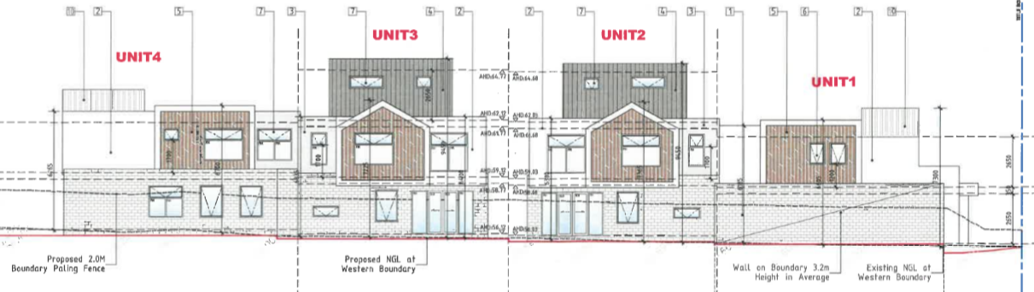
- The above findings are influenced by the ability to provide some landscape to the side and rear of the land as a result of ground level private open space for the rear three dwellings. However, the narrowing of the lot, with a four bedroom rear townhouse (no. 4), reduces these opportunities down the site.
- I am not concerned about window screening from a character perspective, per se, although greater spacing and variation in wall surfaces would create the potential for windows without screening.
- My primary concerns relate to the streetscape impacts of this development. The existing streetscape will change as sites are redeveloped and policy is given effect. However, I am not persuaded that the purpose of clause 32.07, provisions of RGZ3 and local policies for this area are met for the following key reasons:
- The boundary form of the double garage is not well integrated into the design of the building so as to mitigate its significant presence in the streetscape.
- The boundary garage wall is over 12 metres long and approximately 3.2 metres high.
- White rendered side elevations, in part, are relatively plain without visual interest, such as the western upper wall of townhouse no. 1, a design element that is also associated with other parts of the building (eg. townhouse no. 4).
- The single storey form of the garage is wider than the front of townhouse no. 1.
- Landscaping opportunities are limited to other than the small front garden of townhouse no. 1 with the garage as a dominant element.
- A decision guideline in RGZ3 is to (among other things) minimise hard paving throughout the site including limiting driveway lengths and widths, and providing landscaping on both sides of driveways. The design does not provide a driveway extensively down one side of the lot but has excessive hard surfacing proportional to the land’s width given the driveway plus two pedestrian pathways. Services are an added, albeit necessary, element within the landscaped areas.

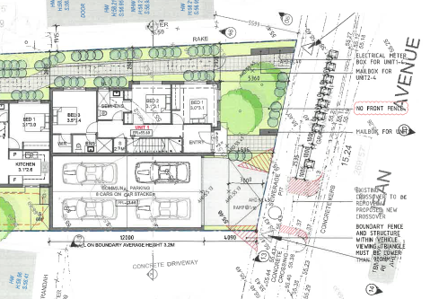

- Mr Smith submits clause 22.05 seeks to promote the retention of mature trees and encourage the planting of new canopy trees to maintain and enhance the garden city character. Clause 22.01 seeks to build upon the important contribution that landscaping makes to the garden city character. The Council submits the proposed vehicle crossing would impact the nature strip tree. Based on its internal advice, there should be no excavation within 2.6 metres of the tree measured from the trunk face. However, 2.53 metres is shown on the plans and the impact would be greater when allowing for concrete formwork. There is no opportunity to relocate the vehicle crossing. This impact on the tree is, therefore, not supported by the Council.
- The applicant states that the amended plans show the vehicle crossover positioned 2.535 metres from the outside edge of the street tree. An increase to 2.6 metres can be accommodated notwithstanding that the applicant’s arborist prefers a setback of 2.85 metres.
- Further, Mr Clarke submits that swept path advice from O’Brien Traffic demonstrates that cars can enter and exit at a 2.85 metres setback from the tree, so it can work more easily at the 2.6 metre setback Council seeks. A permit condition can, and should, be imposed to require the crossover to be setback 2.6 metres from the street tree.
- RGZ3 decision guidelines refer to crossovers and street trees including:
- Where vehicle crossovers are located and whether they are minimised in number to prevent traffic disruption, and preserve nature strips and street trees.
- It is important to protect the tree. I have assumed this matter could be resolved by a permit condition involving an arborist.

INTERNAL AMENITY

Screening devices
- The Council does not contend that there are unreasonable off-site amenity impacts. However, it submits that the extent of screening results in an unacceptable internal amenity outcome for the proposed dwellings. Mr Smith submits that terrace row housing has fundamental design challenges on infill sites, where outlooks are limited and there is a need to protect neighbours from overlooking. The Council submits the design results in a poor amenity outcome for future residents and this is sufficient to warrant the refusal of the application.
- The applicant does not agree. It submits the Council’s submission is mis-guided. Among a number of points, Mr Clarke submits this issue is:
really only determinative when dealing with reverse living style dwellings with upper floor living rooms and open space areas that require screening to meet B22 but in doing so in turn dilute ‘outlook’ and thus internal amenity.
- Ground level living areas for the three rear townhouses do not require extensive screening. Upper level windows to bedrooms and retreats are screened. As indicated above, greater spacing and variation in wall surfaces would create the potential for windows without screening. This would be a better amenity outcome for occupants.
- The east-facing living room windows in townhouse no. 1 are not screened. They are within 2.8 – 3.4 metres of the land to the east. While it is not suggested that they need to be screened, the placement of these windows could be affected by a development on the adjacent land. The outlook to Jean Street would, however, be retained.

Sense of address
- The Council expresses concern about the sense of address for rear dwellings. Mr Clarke states the “side entry path” argument “has also well and truly come tired and run its race”. He relies on the decision in Pan.
- I am satisfied that the front entry treatment sufficiently marks the entry to the rear dwellings which is separated to that for townhouse no. 1. The entry path is also secured, assisting with safety. I find the objectives of clauses 55.03-7 and 55.05-2 are met.

Private open space
- The Council submits 40m² of private open space is not provided for townhouses no. 1 and no. 3. Further, townhouse no. 1 is not provided with 35m² secluded private open space while its balcony has poor solar access. The open spaces for townhouses no. 2 and no. 3 also have poor solar access.
- The applicant says the balcony for the front dwelling is acceptable. Mr Clarke submits that where ground level open space is provided it complies with the varied requirements except townhouse no. 3 that has a shortfall of 2m² that “can easily be tweaked by shifting some internal fence lines by a 500mm or so if one wants to tick this box”.
- Three of the dwellings have ground level living spaces with associated open space. Townhouse no. 1 is a reverse-living format and relies on a balcony facing the street.
- The shadow diagrams do not show shadowing from existing buildings and fencing. It is, however, evident that the ground level spaces for townhouses no. 2 and no. 3 would be considerably shadowed notwithstanding that there is solar access available during the middle of the day. The balcony for townhouse no. 1 would be significantly shadowed, although it benefits from an unencumbered outlook to the street.

Other matters
- A number of other matters are raised in submissions, such as with respect to storage and accessibility for people with mobility limitations. I have not addressed these in detail but agree with the Council that the stacker arrangement has challenges for an occupant with mobility limitations. I have assumed that townhouse no. 1 could be provided with 6m² of external storage.

CAR PARKING ARRANGEMENTS

Issue
- The proposal provides eight car spaces on-site using a car stacker system. A specification for the system has been tendered by the applicant.
- The Council does not oppose car stackers in principle, but submits there are a number of practical issues associated with the stacker configuration in this permit application. These include the following matters:
- The tandem stacker format, which the Council opposes. Mr Smith submits that it is not practical or reasonable to expect independent dwellings to co-ordinate the coming and going of vehicles. Furthermore, vehicles must manoeuvre in the street to co-ordinate tandem movements. This is not a satisfactory outcome in terms of traffic management within the site or the public realm and not consistent with the purpose to ensure the design of car parking is of a high standard and enables easy and efficient use.
- Vehicles cannot exit the site in a forward direction. This is requirement of clause 52.06 for driveways that service four or more car spaces. The driveway services eight car spaces. Vehicles reversing from the site is not consistent with the purpose to ensure that the design and location of car parking is of a high standard, creates a safe environment for users and enables easy and efficient use.
- Council’s traffic engineers advise that the driveway ramp grade is too steep at 10%. Because the driveway services a stacker, the maximum grade should be 3%. Further compounding this issue is the requirement to reverse up the ramp.
- No technical specifications were provided (at the time of the Council’s written submission). There appears to be insufficient head clearance for the lower stacker spaces to elevate to ground level. The Council’s traffic engineers are unable to assess the internal width of the stacker as no technical specifications where submitted with the application.
- In response, among points made, the applicant submits:
- The stackers platform is 5.6 metres wide. The platform is compliant with clause 52.06 and spatially aligns with the width dimension of the garage. Noting a B85 car is no more than 1.9 metres in width, two cars can be accommodated.
- The stacker system operates in a tandem manner whereby each unit is allocated a space in the front row/grid and a space in the back row/grid. This is little different to a single width double length garage. Each dwelling is independent of each other. Tandem arrangements are very conventionally accepted.
- Based on traffic engineering advice, gradients along the driveway leading to the mouth of the garage, which include a flat section 2 metres in length at its doorway, are acceptable and not in conflict with either clause 52.06 or the specification sheets for the stacker. A permit condition could require a sectional drawings demonstrating that no scraping will occur.
- To make the heights of the stacker system work, and to ensure independent access and that 25% of the spaces have a 1.8 metres clearance height, a 3.3 metre internal height is required. The plans show a clearance of 3.12 metres (55.13RL base to 58.25RL ceiling). The 18cm shortfall can be resolved via a permit condition. Much, if not all, of the 18cm can be achieved via a modified and thinner roof form which need not be 400mm in thick. The streetscape implication of what would be required to address this is “at most a few centimetres” and would be “imperceptible and immaterial”.
- To the extent that the Tribunal considers these technical elements are unclear or determinative, the applicant seeks to delay a decision by the Tribunal to allow a traffic engineer to give evidence and explain the intricate details of the combination stacker system. When agreeing to the ‘on the papers’ pathway, the applicant was unaware of the technical matters Council has raised.
- The applicant accepts that vehicles reversing out is “an imperfection and means technical conflict with clause 52.06 which is discretionary”. Forward egress is not possible. The applicant refers to the short driveway length and flat topography. Mr Clarke notes that the driveway is wider than a standard single driveway allowing more leeway for drivers and pedestrians to see cars. He submits there is no front fence to interfere with the line of sight, there is good line of sight across the neighbouring land to the west, and the side boundary paling fence is low. All these factors:
in combination with a few more policy-based considerations such as the net benefit and on balance factor and a submission (absent of empirical evidence but made to an expert Tribunal) that one of the whole points of having more housing in/around activity centres is reduce to car usage so the reality is persons living here will have less (not no) need to get in their car to drive to shops, services and a train station, means the number of ins/outs is going to be much less than if this site was in true suburbia hinterland.

Findings
- As indicated earlier in these reasons, the operation of the stacker system raises multiple questions. The extent of operation required in the public realm and level of inconvenience are among the issues that, on their face, make the proposal problematic.
- As foreshadowed earlier in these reasons, even if parking and access were satisfactory as proposed, I would refuse a permit for the reasons set out earlier in this decision. As I have found the proposal unacceptable for other reasons, I have not sought further written or oral submissions with respect to parking and access.

Conclusion
- Having weighed the positive, neutral and negative impacts and issues associated with this proposal, and examining what the scheme is seeking, I am not persuaded that an acceptable outcome is achieved. Benefits associated with the proposal do not outweigh the issues that I have identified and, on one view, the proposal’s benefits are not as significant in housing terms compared with a higher density and intensity development as is encouraged to occur in this location.
- For the above reasons, the responsible authority’s decision is affirmed. No permit is granted.

Margaret Baird
Senior Member

Section 4(2)(d) of the Victorian Civil and Administrative Tribunal Act 1998 states a failure to make a decision is deemed to be a decision to refuse to make the decision.
Planning report extract.
The subject land is off-set from north. Directional references have been simplified for ease.
The submissions and evidence of the parties, supporting exhibits and statements of grounds filed have all been considered in the determination of the proceeding. In accordance with the Tribunal’s practice, not all of this material will be cited or referred to in these reasons.
As set out in the Council’s email dated 21 April 2020 and the applicant’s emails dated 21 and 22 April 2020.
The applicant’s submission refers to a small non-compliance with Standard B17 and with respect to the amount of private open space for one dwelling.
This is consistent with decisions such as Guo v Monash CC [2019] VCAT 570.
Clause 22.01-4.
Such as clauses 21.01 and 21.04-3. This is part of the broader housing policy that aligns with policies such as clause 15 relating to 20-minute neighbourhoods and clause 16 supporting housing in well-located urban areas. The Housing Strategy is a reference document; Amendment C125 Part 2 is part of its implementation.
Both parties cite multiple Tribunal cases. As Mr Clarke notes, most of the decisions he refers to pre-date Amendment C125 Part 2.
Yang v Monash CC [2019] VCAT 1677. No. 3 Myriong Street, Clayton is similarly sized as the subject land but with a more consistent width. This decision pre-dates gazettal of Amendment C125 Part 2.
Ibid.
Relying on Damaskos v Monash CC [2018] VCAT 1920.
New Bee Pty Ltd v Monash CC [2019] VCAT 1971.
Associated Town Planning Consultants v Yarra Ranges SC [2007] VCAT 321.
The parties do not emphasise the last set of points in RGZ3’s decision guidelines that address (inter alia) irregular shaped lots.
Guo v Monash CC [2019] VCAT 570.
Beattie v Monash CC [2019] VCAT 258.
Pan v Monash CC [2018] VCAT 1309.
This could increase based on the applicant’s submission that the height may need to be adjusted to accommodate the stacker system.
Molloy Report circulated on 7 April 2020 at pages 9 and 10.
Pan v Monash CC [2018] VCAT 1309.

