VICTORIAN CIVIL AND ADMINISTRATIVE TRIBUNAL
planning and environment DIVISION
planning and environment LIST | vcat reference No. P2488/2019  Permit Application no. TPA/50662
CATCHWORDS
Section 80 of the Planning & Environment Act 1987; Monash Planning Scheme; General Residential Zone Schedule 6; Rooming House; Policy; Neighbourhood Character; Internal Amenity; Amenity Impacts; Bicycle spaces;

APPLICANT | Shuangping Guo
responsible authority | Monash City Council
SUBJECT LAND | 36 Koonawarra Street  CLAYTON VIC 3168
WHERE HELD | Melbourne
BEFORE | Katherine Paterson, Member
HEARING TYPE | Hearing
DATE OF HEARING | 28 July 2020
DATE OF ORDER | 31 August 2020
CITATION | Guo v Monash CC [2020] VCAT 930

Order
- The decision of the responsible authority is varied.
- The Tribunal directs that planning permit TPA/50662 must contain the conditions set out in planning permit TPA/50662 issued by the responsible authority on 2 December 2019 with the following modifications:
  - Conditions 1(a), 1(b), 1(c), 1(d), 3 and 5 are deleted.
  - Condition 1(h) is amended to read:
1(h) The provision of two bicycle spaces per rooming house, to be located next to the storage sheds for both buildings.
  - Condition 1(i) is amended to read:
1(i) The bedroom 8 window of rooming house 1 and the bedroom 7 window to rooming house 2 treated to prevent overlooking of the secluded private open space and habitable room windows of the adjoining properties within nine metres of the window through methods such as fins, louvres, screens or blades.. The method used shall be designed to prevent downward views whilst maintaining an outlook for the dwelling. A sightline diagram must be provided which demonstrates that the method used achieves this effect.
  - Condition 6 is amended to read:
6 Not more than 20 persons may reside in the premises at any one time.
  - A new condition 31 is included as follows:
31 Car spaces are only permitted to be used by the occupants of the units and their visitors and must not be subdivided, sold or leased to any other person without the consent of the responsible authority.
  - A new condition 32 is included as follows:
32 Except with the consent of the responsible authority, the premises must be managed as a single entity.
- The responsible authority is directed to issue a modified planning permit in accordance with this order.

Katherine Paterson
Member

Appearances
For applicant | Mr Russell Hocking, Town Planner, Cityshire Planning
For responsible authority | Mr James Turner, Town Planner, Monash City Council

Information
Description of proposal | Construction of two buildings to be used as rooming houses. Building one will contain nine bedrooms and building two will contain seven bedrooms. Each bedroom will have their own ensuite bathroom, with communal living. Dining and kitchen facilities will be provided in each building. A double garage has also been provided for each dwelling with a total of four spaces. Communal areas of open space have also been provided for each building.
Nature of proceeding | Application under section 80 of the Planning and Environment Act 1987 – to review the conditions contained in the permit.
Planning scheme | Monash Planning Scheme
Zone and overlays | General Residential Zone Schedule 6
Permit requirements | Clause 32.08-2 – Use of land for a rooming house
Land description | The subject site has an area of 701.1 square metres and contains a dwelling with associated outbuildings and gardens.

Reasons

What is this proceeding about?
- Shuangping Guo wishes to construct two buildings to be used as rooming houses on land at 36 Koonawarra Street in Clayton. Following Council’s decision to grant a permit for the development they have requested that the Tribunal review a number of the conditions of the permit.
- The applicant seeks to delete conditions 1(a), 1(b), 1(c), 1(d), 1(e), 1(h), 1(i), 3(c), 3(e), 4(g), 5 and 6 from the permit and to reword or renumber conditions 3(a), 3(b), 3(d) and 3(f).
- Council agreed to the deletion of condition 1(d) and suggested a rewording of condition 1(h), but otherwise opposed the changes suggested by the permit applicant. Mr Hocking advised that his client opposed the suggested rewording of condition 1(h) and was seeking for the condition to be deleted in its entirety.
- The conditions opposed by the applicant essentially require the following:
- a reduction in the number of bedrooms;
- reconfiguration of the ground floor to increase the living and communal areas of the rooming house;
- increase to the setback of the south facing bedroom wall;
- the provision of seven bicycle spaces;
- overlooking measures;
- the preparation of a section 173 agreement;
- the preparation of a management plan;
- the ongoing use of the land as a rooming house; and
- a limit on the number of persons who may reside in the premises.
- The question before the Tribunal is whether these conditions are reasonable and appropriate having regard to the provisions of the Monash Planning Scheme. I will consider each in turn.

Number of bedrooms and communal living area
- Conditions 1(a) and 1(b) seek the deletion of one bedroom from each dwelling. Council submits that this condition is necessary as it will enable the enlargement of the communal living areas of each rooming house, as required by condition 1(c).
- Rooming house one will contain nine bedrooms, and will have an open plan living, dining and kitchen room, with an area of approximately 35.16 square metres. Rooming house two is proposed to contain seven bedrooms and will have a communal living, dining and kitchen of 35.84 square metres.
- Council referred me to the Student accommodation policy at clause 22.10 of the scheme, which seeks to “identify acceptable standard of habitation for individual and communal rooms.”. The policy goes on to state that there should be a minimum of 16 square metres of floor area per unit for non-self contained accommodation, which is achieved in the application before me.
- Mr Hocking submitted that the policy at clause 22.10 of the scheme was not directly relevant to this application as although the facility is likely to be used by students, it would not be exclusively so.
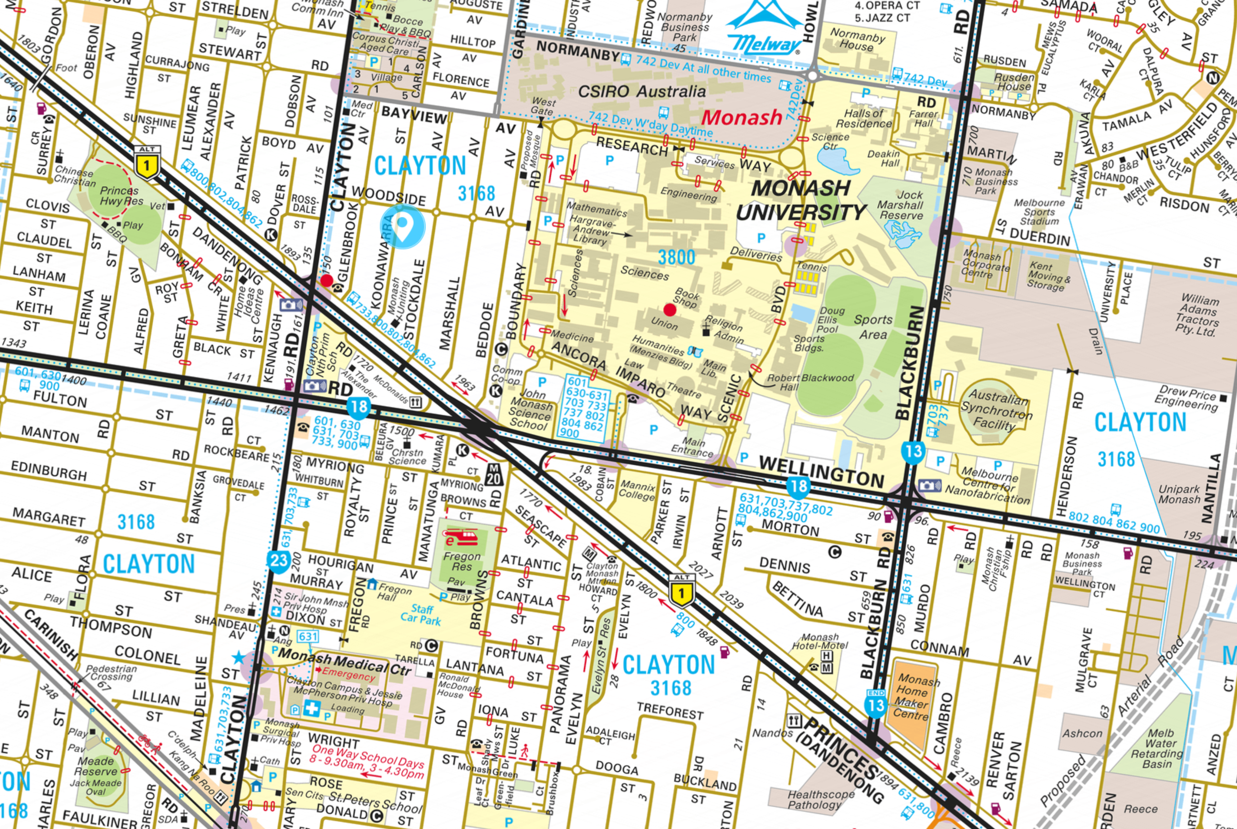
- As can be seen from the above extract from Melway Online, the subject site is in very close proximity to Monash University, CSIRO and Monash Medical Centre. Mr Hocking submitted that the intended users of the facility are university students but could also include visiting doctors and staff for the medical centre as well as providing short term accommodation for the large variety of businesses found in the area. Based on these submissions, I agree that the policy at clause 22.10 doesn’t strictly apply to this application. However, it does provide a useful guide as to what is an appropriate level of amenity for the facility.
- The 16 square metres per dwelling unit is for the bedroom and living accommodation, as detailed by the policy:
An appropriate range of facilities should be incorporated into each self contained and non-self contained unit including separate sleeping area, study area with desk and seating, ensuite facilities, independent heating and cooling, inbuilt cupboards for storage of personal items, internet access, and for self contained units, individual kitchen facilities.
Communal facilities should include individual mailboxes and a dedicated waste storage area. Unless provided to individual units common facilities should also include laundry, kitchen and meals area facilities.
- When combined with the living areas, each bedroom will have a floor area that comfortably exceeds the suggested 16 square metres. The communal areas are sufficient to accommodate the range of facilities suggested by the policy. I therefore find that there is no need for the communal area to be enlarged. I have therefore deleted conditions 1(a), 1(b) and 1(c) from the permit.

Increase to the setback of the south facing bedroom wall
- Council submits that condition 1(e) is required to mitigate the visual bulk impact of the development when viewed from the private open space of No. 1/38 Koonawarra Street to the immediate south.
- The private open space to No. 138 will be located adjacent to the driveway for the proposed development which will provide some separation to proposed built form, however I agree with Council that more needs to be done to mitigate the visual impact of the proposed two storey wall when viewed from this location. The additional setback, whilst relatively minor, will provide a greater level of separation to the built form when viewed from this space which I find is necessary to reduce the appearance of the built form when viewed from this space. I have therefore retained the condition, even though it will lengthen the wall overall.

The provision of seven bicycle spaces
- Council have required the provision of seven bicycle spaces for this development based on clause 22.10-4 which states that one bicycle space should be provided for every two residents. Whilst I discuss the number of persons allowed in the facility later in my decision, I will now consider whether the provision of bicycle spaces is required for this development.
- As stated above, the student accommodation policy at clause 22.10 does not strictly apply to this proposal but can be used as a guide. One of the objectives of the policy is:
To ensure adequate car parking and bicycle storage is provided on site to meet the needs of students and visitors.
- A rooming house is nested under ‘residential building’. Clause 52.34-5 of the scheme does not require the provision of bicycle facilities for residential buildings unless the building is four or more storeys, and even then only one space is required for every ten lodging rooms for residents and one space for every ten lodging rooms for visitors. As such there is no statutory requirement for the provision of spaces for this development.
- Applying the rate of two spaces per every ten rooms provided in clause 52.34-5 would equate to 3.6 spaces for this development. Given that the proposed building will be used (although not exclusively) by students I consider it reasonable that some provision be made for the storage of bicycles. I have therefore required the provision of two spaces per rooming house to be located near to the storage shed for both buildings.

Overlooking measures
- Condition 1(i) requires the provision of fixed obscure glazing for the first floor north and south facing windows to prevent overlooking of the adjoining property.
- Overlooking measures, whilst protecting the amenity of adjoining properties have the potential to significantly affect the internal amenity of dwellings. As such overlooking measures need to be applied with care rather than utilising a blanket approach.
- Upon reviewing the plans, the only windows that have the potential to unreasonably affect the amenity of the adjoining properties through overlooking are the bedroom 8 window of rooming house 1 and the bedroom 7 window to rooming house 2.
- Both windows should be treated to prevent overlooking of the adjoining properties. But this should be done in a way that minimises the impact on the internal amenity of these rooms. Fins, blades and louvre screens are some examples of internal methods that can be used to prevent downward views into an adjoining property whilst maintaining an outlook for the residents. I have therefore reworded the condition to require overlooking treatments to these windows only, and those treatments to be designed to prevent overlooking of the adjoining properties whilst maintaining an outlook for the residents of the rooms. I will require the provision of a sightline diagram to demonstrate that the method used achieves this outcome.

The preparation of a section 173 agreement
- Condition 3 requires the preparation of a section 173 agreement to control the future conduct of the premises. I agree with the permit applicant that the need for a section 173 agreement is unnecessary, and the matters listed under the condition can be dealt with via conditions of permit, where I have considered them necessary. I have therefore deleted the condition in its entirety. But I have retained some elements sought by the agreement as separate conditions of permit.

The preparation of a management plan
- Whilst the applicant stated that a management plan was unnecessary, they have only sought a review of condition 4(g) of the permit, which requires residents to be made aware of public transport and local amenities in the area. I do not consider that this requirement is excessive or unreasonable given the nature of the use, where residents will come and go, and are unlikely to have vehicles. I have therefore retained condition 4, including condition 4(g).

The ongoing use of the land as a rooming house
- Conditions 3(d) and 5 seek to restrict the use of the land for a rooming house unless further permission is granted by the responsible authority. These conditions are unnecessary as the future use of the land is governed by the provisions of the Monash Planning Scheme. I have therefore deleted both conditions.
- Condition 3(e) seeks ensure that the land was not subdivided. The applicant has foreshowed that he wishes to subdivide the land into two lots with common property. Any subdivision of the land will be subject to further planning approval, and the appropriateness of a subdivision will be considered at that time.
- Condition 3(f) states that the rooming house must be managed by a single entity. The permit applicant has requested that this be reworded to allow for not more than two entities, so that each rooming house to be managed separately. Given the nature of the use, I consider it is appropriate that both buildings be managed as a single entity, and as such I have retained this requirement as a new condition. I have included the words “except with the consent of the responsible authority” to allow for more than one entity if that is considered appropriate in the future.

A limit on the number of persons who may reside in the premises
- Conditions 3(a) and 6 seek to restrict the number of residents to 14. The application for review initially sought this to be increased to 16. During the hearing Mr Hocking suggested that there may be some rooms that would be suitable for couples, depending on their size and therefore there may be scope to have even more residents on site. Following the hearing I provided an opportunity for the applicant to circulate a plan showing the size of the proposed bedrooms, and allowed the parties to provide a submission detailing what they considered to be an appropriate number of residents. The permit applicant suggested that 20 would be appropriate, on the basis that two of the rooms in each rooming house would be able to accommodate a couple. Monash City Council suggested 18 on the basis that two of the rooms were sought to be deleted.
- Having found that there is no need to delete the rooms, it follows that a maximum of 20 residents may be accommodated in the building at any one time. I have reworded condition 6 of the permit to allow a maximum of 20 residents at any one time. The condition currently refers to “permanent” residents, however as the rooming house may be used by both short and long term residents, I have reworded the condition 6 so that it now reads:
Not more than 20 persons may reside in the premises at any one time

Conclusion
- For the above reasons, the decision of the responsible authority will be varied, and the planning permit amended.

Katherine Paterson
Member

The submissions and evidence of the parties, any supporting exhibits given at the hearing and the statements of grounds filed have all been considered in the determination of the proceeding. In accordance with the practice of the Tribunal, not all of this material will be cited or referred to in these reasons.
https://online.melway.com.au/melway/ retrieved 24 August 2020
One visitor and one resident

