VICTORIAN CIVIL AND ADMINISTRATIVE TRIBUNAL
planning and environment LIST | vcat reference No. P386/2020  Permit Application no. TPA/51001
CATCHWORDS
Section 77 Planning and Environment Act 1987; Monash Planning Scheme; Neighbourhood Character; Landscaping; Internal Amenity.

APPLICANT | Maria Papaioanou
responsible authority | Monash City Council
SUBJECT LAND | 8 Oberon Avenue OAKLEIGH EAST
WHERE HELD | Melbourne
HEARING TYPE | Hearing
DATE OF HEARING | 10 February 2021
DATE OF ORDER | 18 February 2021
CITATION | Papaioannou v Monash City Council [2021] VCAT 129

Order

Amend permit application
- Pursuant to clause 64 of Schedule 1 of the Victorian Civil & Administrative Tribunal Act 1998, the permit application is amended by substituting for the permit application plans, the following plans filed with the Tribunal:
- Prepared by: | Archimedium Australia
- Drawing numbers: | TP3 Revision C, TP4 and TP5 both Revision B & TP6 Revision A.
- Dated: | 11 December 2020

Permit granted
- In application P386/2020 the decision of the responsible authority is set aside.
- In planning permit application TPA/51001 a permit is granted and directed to be issued for the land at 8 Oberon Avenue OAKLEIGH EAST in accordance with the endorsed plans and the conditions set out in Appendix A. The permit allows:
- Construction of three dwellings on a lot.
Joel Templar
Member

Appearances
For Maria Papaioanou | Mr Simon Skinner, town planner of Planning Sense.  He called evidence from the following witness:  - Mr Robert Thomson, landscape architect of Habitat.
For Monash City Council | Mr James Turner, Planning Appeals Advisor, Monash City Council.

Information
Description of proposal | Construction of three dwellings on a lot. Each dwelling is to be double storey in scale and with individual garages. Two dwellings would be located at the front of the site, in a side-by-side arrangement, with one of those dwellings having individual vehicle access. The third dwelling is to be located towards the rear of the site. A second, separate access is proposed for dwellings two and three along the southern boundary, utilising the existing crossover.
Nature of proceeding | Application under section 77 of the Planning and Environment Act 1987 – to review the refusal to grant a permit.
Planning scheme | Monash Planning Scheme
Zone and overlays | General Residential Zone – Schedule 3 (GRZ3)
Permit requirements | Clause 32.08-6 – to construct two or more dwellings on a lot.
Land description | The subject site is rectangular in shape and is located on the east side of Oberon Avenue Oakleigh East. It has a street frontage and rear boundary of 16.76 metres and a length of approximately 50.29 metres with an overall area of 843 square metres. The site currently has a detached single storey weatherboard dwelling constructed on it, accessed via an existing single width crossing located at the south-west corner of the site. A 2.44 metre wide easement is located along the rear boundary of the land.
Tribunal inspection | 5 February 2021

Reasons

What is this proceeding about?
- This proceeding concerns the review by the applicant of the Council’s decision to refuse to grant a permit for the construction of three double story dwellings on a lot at eight Oberon Avenue in Oakleigh East.
- The Council refused the application broadly on grounds relating to poor fit of the proposed built form with the existing and preferred neighbourhood character, insufficient area for landscaping including canopy trees, Poor internal amenity for future residents an adverse impacts to the amenity of nearby properties. At the hearing, the council relied on all but the last of these grounds.
- There was no dispute between the parties that the site is an appropriate candidate for medium density housing given its size location within an established residential area including access to existing infrastructure and services.
- I inspected the site prior to the hearing albeit only from Oberon Avenue and I also inspected the surrounding area. At the end of the hearing I indicated to the parties that I was generally satisfied that the proposal would result in an acceptable planning outcome and that I would grant a planning permit subject to conditions.
- I advised the parties that the proposal represented an acceptable outcome with respect to its presentation of the built form to the public realm, that there was sufficient area for landscaping and the proposed landscaping as per Mr Thompson’s plan would result in a good outcome, but that the internal amenity for future residents needed to be addressed. I advised the parties that the internal amenity issue could be resolved through conditions relating to adjustments to the proposed screening measures of some of the upper floor windows. I did not detail what changes I would make at the hearing, but advised that written reasons would follow where I would set out more detail with respects to those windows.
- My reasons are set out below.

is the built form and landscaping response acceptable?
- The council submitted that the proposal presentation to the street represents a significant departure from the existing housing stock, which is modest in size and form, with well landscaped front yards that merge into the nature strip and create a sense of space within the street. It also submitted that more recent development that has occurred in the surrounding area has taken on a tandem arrangement and that the proposal represents a different form to the street from other newer development with its side-by-side configuration for dwellings one and two.
- The council relied on the neighbourhood character objectives in clause 55, as well as policy statements and objectives at clause 21.04 and clause 22.01, as well as the preferred character statement which is set out at clause 22.01-4.
- The character description for this area sets out that it is notable for its spacious garden settings, tall canopy trees and consistency of setbacks from at least one side boundary and the rear boundary.
- My observations of the surrounding area differ from the character description provided. Whilst I agree that the surrounding area has spacious garden settings, tall canopy trees and densely planted gardens are not characteristics of the street and the immediate surrounds. There is an emergence of new developments, sitting amongst original modest housing stock.
- New development in the surrounding area generally takes on a double storey form with two or three dwellings per lot in a tandem arrangement, relatively modest front setback areas and modest areas for new planting. I recognise that much of the new development was likely approved prior to much of the current policy in the planning scheme applicable to this proposal. There are also several properties within Oberon Avenue that have two crossovers per frontage.
- Current policy recognises that the subject site is in close proximity to the Monash National Employment Cluster precinct including Monash Medical Centre (MNEC) and Monash University. This provides opportunities for the subject site and surrounding areas to facilitate growth to bolster the functions of the MNEC, consistent with planning scheme policy.
- The zoning of the subject site expects that varied forms of housing will be provided and this gives some rise to an expectation of differing built form. Whilst the preferred character sets out that new housing will continue to evolve to meet the changing needs of the community with new development complementing the scale and sizing of the original housing, this must be read in the context of the zoning of the land and the sites proximity to existing infrastructure and services including education and employment nodes.
- Councils particular concern with the presentation to the street was of the side-by-side configuration of the front to dwellings which would not provide adequate separation between these dwellings creating an overall sense of bulk scale in mass which is contrary to the pattern of development in the street.
- I am not persuaded that the proposed built form presentation to the street will result in an acceptable outcome.
- The proposal is not vastly different from the emerging built form in the street. Although the side-by-side arrangement is would be unique, the overall width of these two dwellings is not something that I find is excessive. There are other newer developments that have a single dwelling presentation to the street but where the front dwelling is wider at both ground and upper floor levels than what both dwellings one and two would be.
- The upper floors of the proposed front two dwellings are setback further from the frontage than the respective ground floors and the built form at the upper level is setback from both side boundaries. The built form at ground level is also setback from one side boundary, which is consistent with what the preferred character seeks.
- There is a level of articulation at the upper levels. Although I find that this articulation is modest, it provides an acceptable outcome in the physical and policy context.

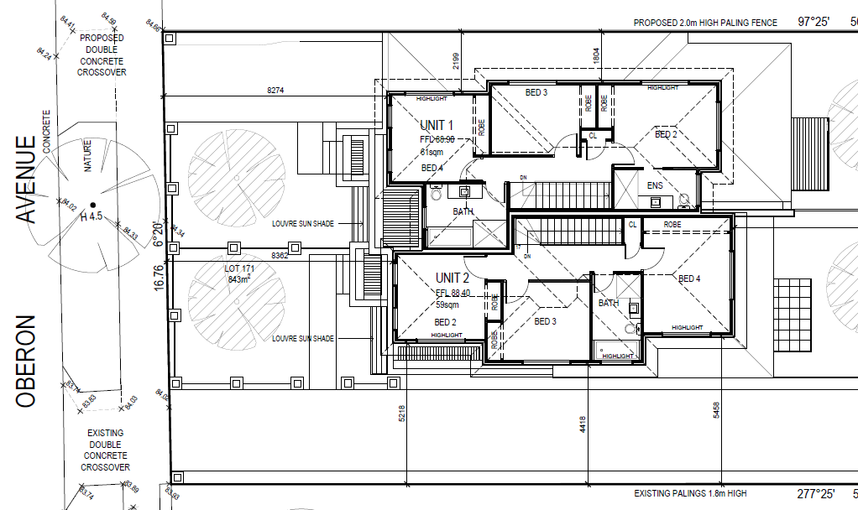

Figure 1: Upper floor plans of dwellings 1 and 2.
- The front facades include a variety of materials, with the upper floor including a recessed section between to the two most prominent elements and given the slope of the land, there is also differences between these two dwellings in terms of floor levels.

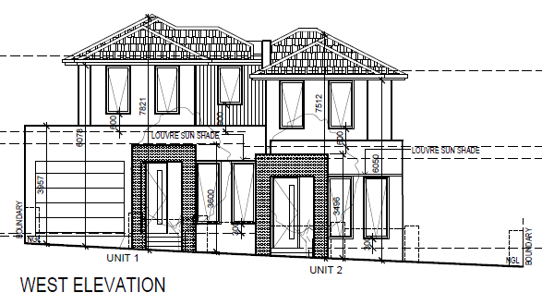

Figure 2: West elevation facing Oberon Avenue.
- There is only one single width garage presenting to the street, which is setback behind the façade line of the associated dwelling. The remaining garages are located to the rear. Whilst there are two crossovers, this would not be the first in the street and I am satisfied that there is adequate space at the front of the property within which to plant vegetation, including canopy trees.
- Whilst the council was critical of the lack of space for planting and lack of side setbacks, I am not persuaded that the overall landscaping outcome will be unacceptable. Mr Thomson’s plan shows a number of canopy trees throughout the site which I find will provide an acceptable complement to the proposed built form.
- The surrounding area does not display an abundance of vegetation and canopy trees in private property, particularly at the rear of sites. That said, there are some properties that have canopy trees towards the rear boundaries but they are infrequent.
- I find that Mr Thomson’s plan will provide a great landscaping contribution to the surrounding area, once mature, than what is presently on the subject site. I accept that the level of built form will also increase but I find the overall design response, including the landscaping is an acceptable outcome with respect to what the planning scheme is seeking on this site and for the surrounding area.
- For these reasons, I find that the proposed built form and landscaping outcome will be acceptable.

does the proposal result in acceptable internal amenity?
- The council raised concerns with respect to the internal amenity of the proposal, in particular the level of screening to upper floor windows and the proximity of the garage of dwelling 2, to that particular dwelling.
- The garage for dwelling two is remote from the dwelling itself but directly accessible from the secluded private open space. Whilst it is not directly accessible from inside the dwelling, I am not persuaded that such an outcome is unacceptable. The garage is securely accessible from the SPOS and directly abuts this area, with a door into the garage. It may not be as convenient as an attached garage with internal access but I find that as proposed, the garage is acceptable.
- In terms of the screening of upper floor windows, all habitable room windows of all three dwellings either have 1.7 metre high sill heights or obscured glazing to 1.7 metres high. The exceptions to this are the west elevation windows. This results in six of the nine bedrooms across the upper floors of the proposal would have all windows screened.
- Whilst I accept that these windows are to bedrooms, the total proportion of these is an unacceptable amount of habitable rooms that would require screening. I find that this would result in a poor internal amenity outcome for future residents.
- However, I find that modifications could be made to avoid screening some of these windows, at least in part. A design solution should normally be found, rather than relying on screening to the extent proposed here. It appears to me that in some cases, screening is not required at all, relying on standard B22 of clause 55.04-6.
- I make the following observations and find that modifications as described should be included as conditions:
  - Unit 1:
    - Bedroom 2 currently indicates obscure glazing to 1.7 metres high. Upon questioning by the Tribunal, Mr Skinner agreed that some different form of screening that addressed overlooking of the adjoining property to the north but which would also provide some outlook from this room could be achieved. I find that this window should have a device on the east elevation window that limits overlooking to the property to the north but retains outward views to the east. Some type of vertical screen, louvres or fin could be attached to limit overlooking in accordance with standard B22.
  - Unit 2:
    - Bedroom 4 east elevation window currently indicates obscure glazing to 1.7 metres high. Upon questioning from the Tribunal, Mr Skinner agreed that this appeared unnecessary in light of the location and aspect of this window given the parameters under standard B22. I agree and accordingly will require this screening to be deleted.
  - Unit 3:
    - Bedroom 3 of this dwelling currently proposes one window which would be screened with obscure glazing to 1.7 metres high. I find that an additional window could be included to the west elevation with any necessary screening in accordance with standard B22 which would provide some greater outlook and improve the amenity of this room. This would necessitate the relocation of the robe. Some form of sun shading may also be required and I have contemplated these consequential changes in a condition.
- Making these changes would halve the amount of bedrooms that would have all windows screened, and result in only one bedroom in each dwelling requiring screening. Whilst not ideal, I find this will be an acceptable outcome. I will include conditions accordingly.
- With these changes, I find that the internal amenity outcome will be acceptable.

Conclusion
- For the reasons given above, the decision of the responsible authority is set aside. A permit is granted subject to conditions.

Joel Templar
Member

Appendix A – Permit Conditions

Permit Application No | TPA/51001
Land | 8 Oberon Avenue Oakleigh East 3166

What the permit allowS
In accordance with the endorsed plans:
- Construction of three (3) double storey dwellings.

Conditions

- Before the commencement of the development, one copy of plans drawn to scale and fully dimensioned, must be submitted to and approved by the Responsible Authority. The plans must be generally in accordance with the VCAT Amended Plans (known as TP3 Revision C, TP4 and TP5 both Revision B & TP6 Revision A by Archimedium Australia dated 11 December 2020) but modified to show:
  - The east elevation window of bedroom 2 of dwelling 1 to delete reference to obscured glazing and amended to show a screening device on the east elevation window that limits overlooking to the property to the north but retains outward views to the east. The device must address overlooking to the property to the north in accordance with standard B22.
  - Deletion of screening to the east elevation window of bedroom 4 of dwelling 2.
  - Addition of a window to the west elevation of bedroom 3 of dwelling 3 and any associated sun shading devices and relocation of the robe.
- The development as shown on the endorsed plans must not be altered without the prior written consent of the Responsible Authority.
- A landscape plan prepared by a Landscape Architect or a suitably qualified or experienced landscape designer, drawn to scale and dimensioned must be submitted to and approved by the Responsible Authority prior to the commencement of any works. The plan must show the proposed landscape treatment of the site including:-
  - the location of all existing trees and other vegetation to be retained on site
  - provision of canopy trees with spreading crowns located throughout the site including the major open space areas of the development
  - planting to soften the appearance of hard surface areas such as driveways and other paved areas
  - a schedule of all proposed trees, shrubs and ground cover, which will include the size of all plants (at planting and at maturity), their location, botanical names and the location of all areas to be covered by grass, lawn, mulch or other surface material
  - the location and details of all fencing
  - the extent of any cut, fill, embankments or retaining walls associated with the landscape treatment of the site
  - details of all proposed hard surface materials including pathways, patio or decked areas.
  - the final location and dimensions of the bin enclosure, mailboxes and services in accordance with the endorsed plans.
When approved the plan will be endorsed and will then form part of the permit.

- Before the occupation of the buildings allowed by this permit, the landscaping works as shown on the endorsed plans must be carried out and completed to the satisfaction of the Responsible Authority. Landscaping must then be maintained to the satisfaction of the Responsible Authority, including that any dead, diseased or damaged plants are to be replaced.
- Concurrent with the endorsement of any plans, a Sustainable Design Assessment (SDA) must be submitted to and approved by the Responsible Authority. Upon approval the SDA will be endorsed as part of the planning permit and the development must incorporate the sustainable design initiatives outlined in the SDA to the satisfaction of the Responsible Authority. The report must include, but is not limited to, the following:
  - Demonstration of how ‘best practice’ sustainability measures have been addressed, having regard to the relevant aspects of Clause 21.13 of the Monash Planning Scheme.
  - Identify relevant statutory obligations, strategic or other documented sustainability targets or performance standards.
  - Document the means by which the appropriate target or performance is to be achieved.
  - Identify responsibilities and a schedule for implementation, and ongoing management, maintenance and monitoring.
  - Demonstrate that the design elements, technologies and operational practices that comprise the SMP can be maintained over time.
All works must be undertaken in accordance with the endorsed Sustainability Design Assessment to the satisfaction of the Responsible Authority. No alterations to the endorsed Sustainable Design Assessment may occur without written consent of the Responsible Authority and (to the extent material and necessary) any relevant flow-on changes to the design response must be also incorporated into the endorsed architectural plans.
- Prior to the occupation of any of the dwellings approved under this permit, a report from the author of the endorsed Sustainable Design Assessment (or similarly qualified person or company) must be submitted to the Responsible Authority. The report must be to the satisfaction of the Responsible Authority and must confirm that (in relation to those relevant completed dwellings ready for occupation) all measures specified in the Sustainable Design Assessment have been implemented in accordance with the approved plan.
- All stormwater collected from the site from all hard surface areas and must not be allowed to flow uncontrolled into adjoining properties or the road reserve.
- The private on-site drainage system must prevent stormwater discharge from the/each driveway over the footpath and into the road reserve. The internal drainage system may include either:
  - a trench grate (minimum internal width of 150 mm) located within the property boundary and not the back of footpath; and/or
  - shaping the internal driveway so that stormwater is collected in grated pits within the property; and or
  - another Council approved equivalent.
- All stormwater collected on the site is to be detained on site to the predevelopment level of peak stormwater discharge. The design of any internal detention system is to be approved by Council’s Engineering Department prior to drainage works commencing.
- The nominated point of stormwater connection for the site is to the south-west corner of the property where the entire site's stormwater must be collected and free drained via a pipe to the kerb and channel via a Council approved kerb adaptor to be constructed to Council standards. Note: If the point of connection cannot be located then notify Council's Engineering Department immediately.
- Provide a corner splay or area at least 50% clear of visual obstructions (or with a height of less than 1.2 metres), which may include adjacent landscaping areas with a height of less than 0.9 metres, extending at least 2.0 metres long x 2.5 metres deep (within the property) both sides or from the edge of the exit lane of each vehicle crossing to provide a clear view of pedestrians on the footpath of the frontage road.
- The second parking space in front of Unit 1’s garage is to have a minimum length of 5.4 metres from the property boundary.
- All garages must be at least 6 metres long and 3.5 metres wide for a single space and 5.5 metres wide for a double space measured inside the garage.
- All new vehicle crossings must be a minimum of 3.0 metres in width and constructed in accordance with Council standards.
- All vehicle crossings within 1.50 metres of an adjoining crossing shall be converted to a double crossing in accordance with Council standards.
- All new vehicle crossings are to be no closer than 1.0 metre, measured at the kerb, to the edge of any power pole, drainage or service pit, or other services. Approval from affected service authorities is required as part of the vehicle crossing application process.
- Any works within the road reserve must ensure the footpath and naturestrip are to be reinstated to Council standards.
- Any existing house drains encountered during the construction of any vehicle crossing is to be modified and reconnected to the satisfaction of Council.
- Engineering permits must be obtained for new or altered vehicle crossings and new connections to Council pits and these works are to be inspected by Council's Engineering Department. A refundable security deposit of $1,000 is to be paid prior to the drainage works commencing.
- All common boundary fences are to be a minimum of 1.8 metres above the finished ground level to the satisfaction of the Responsible Authority. The fence heights must be measured above the highest point on the subject or adjoining site, within 3 metres of the fence line.
- Once the development has started it must be continued and completed to the satisfaction of the Responsible Authority.

Expiry of permit for development
- This permit as it relates to development (buildings and works) will expire if one of the following circumstances applies:
  - The development is not started within two (2) years of the issue date of this permit.
  - The development is not completed within four (4) years of the issue date of this permit.
In accordance with section 69 of the Planning and Environment Act 1987, an application may be submitted to the responsible authority for an extension of the periods referred to in this condition.

– End of conditions –

The submissions and any evidence of the parties, any supporting exhibits given at the hearing and the statements of grounds filed have all been considered in the determination of the proceeding. In accordance with the practice of the Tribunal, not all of this material will be cited or referred to in these reasons.

