VICTORIAN CIVIL AND ADMINISTRATIVE TRIBUNAL
planning and environment LIST | vcat reference No. P1610/2020  Permit Application no. TPA/51238

Applicant | Goosen Holding 165 Pty Ltd

Responsible Authority | Monash City Council
SUBJECT LAND | 165 Atherton Road  OAKLEIGH VIC 3166
HEARING TYPE | Hearing
DATE OF HEARING | 21 June 2021
DATE OF ORDER | 22 June 2021

Order

Amend permit application
- Pursuant to clause 64 of Schedule 1 of the Victorian Civil & Administrative Tribunal Act 1998, the permit application is amended by substituting for the permit application plans, the following plans filed with the Tribunal:
- Prepared by: | ABCAD Design
- Drawing numbers: | Sheets 1 to 8 inclusive Rev 2
- Dated: | 22 April 2021

Permit granted
- In application P1610/2020 the decision of the responsible authority is set aside.
- In planning permit application TPA/51238 a permit is granted and directed to be issued for the land at 165 Atherton Road, Oakleigh in accordance with the endorsed plans and the conditions set out in Appendix A. The permit allows:
- The construction of four dwellings on a lot.

Mary-Anne Taranto
Member

Appearances

For applicant | Mr Simon Skinner, town planner of Planning Sense planning consultants  He called the following witness:  - Mr Robert Thomson, landscape architect of Habitat landscape and environmental design consultants
For responsible authority | Mr David de Giovanni, town planning consultant

Information
Description of proposal | Construction of four double storey dwellings in two separate pairs, each with vehicle access to York Avenue.
Nature of proceeding | Application under section 77 of the Planning and Environment Act 1987 – to review the refusal to grant a permit.
Planning scheme | Monash Planning Scheme
Zone and overlays | General Residential Zone – Schedule 3 (GRZ3)  No overlay controls apply
Permit requirements | Clause 32.08-6 – construct two or more dwellings on a lot
Land description | The site is a generously configured corner lot of 966sqm in a predominantly residential area as depicted in the image below.
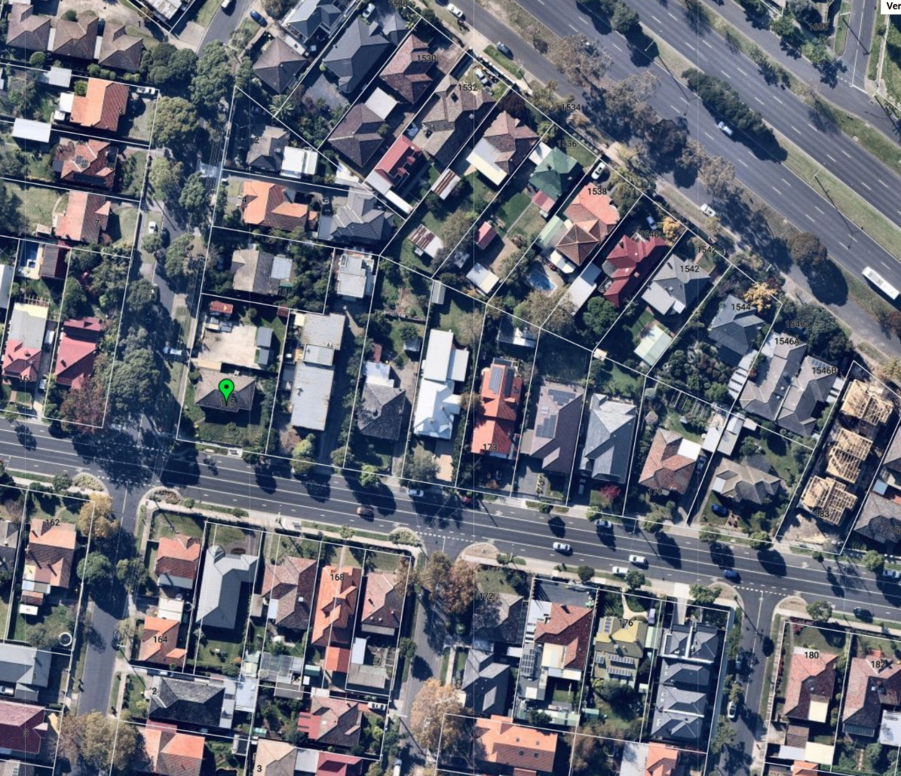  Tribunal inspection | Unaccompanied inspection prior to the hearing.

Remarks

- This matter concerns a review of Monash City Council’s decision to refuse to grant a permit for four 2-storey dwellings configured in two separate pairs at 165 Atherton Road Oakleigh at the north-east corner with York Avenue.
- It was common ground that the site is a suitable candidate for some form of medium density housing. The parties also concur that the proposal would not cause unacceptable residential amenity impacts in relation to neighbours. I agree.
- The key issues in this case are whether the proposal is acceptable in relation to the following considerations:
- Neighbourhood character.
- Landscaping adequacy.
- Car parking and access arrangements.
- Reasons for this decision were given orally at the conclusion of the hearing.

Mary-Anne Taranto
Member

Appendix A – Permit Conditions

Permit Application No: | TPA/51238
Land: | 165 Atherton Road  OAKLEIGH VIC 3166

What the permit allows
The construction of four dwellings on a lot, in accordance with the endorsed plans.

Conditions:

- Before the development starts, two copies of amended plans drawn to scale and dimensioned, must be submitted to and approved by the Responsible Authority. When approved the plans will then form part of the permit. The plans must be generally in accordance with the plans prepared by ABCAD Design, Sheets 1 to 8 inclusive Rev. 2 dated 22.04.21 and marked as ‘Amended Plans for VCAT Review Hearing’ but modified to show:
  - Deletion of the 2-storey parapet walls of Unit 2 (Bedroom 4) and Unit 4 (Bedroom 2) and their redesign to incorporate hipped roof forms and eaves to assist in reducing the vertical presentation of these elements. Such redesigned elements must be integrated and compatible with the overall design of the permitted dwellings, to the satisfaction of the Responsible Authority.
  - The relocation of the existing intersection warning sign.
  - The extent of cut to the rear courtyards and eastern boundary depicted with an overall height and finished floor levels.
  - The height of the retaining wall above ground level, and the depth of the retaining wall below ground.
  - Realignment of the retaining wall along the east boundary so as to provide for a planting area with a width of 0.5m adjacent to this boundary.
  - Plan notations indicating removal of the existing low brick retaining wall to site frontages and its replacement with a suitable masonry structure of a similar height and compatible with the design of the permitted dwellings.
  - Plan notations indicating removal of the Canary Island Date Palm from the site’s south-east corner and its replacement with a suitable tree or shrub to the satisfaction of the Responsible Authority.
  - The internal doors from the garage to the dwellings opening outwards toward the corridor rather than into the garage.
  - The location of the power-pole in the York Street nature strip and suitable setbacks of the crossovers from the power pole.
  - The vehicle accessways and all car spaces including the tandem driveway spaces are to be fully dimensioned on the plans so as to demonstrate compliance with the dimensions described in Clause 52.06-9 of the planning scheme including Diagram 1 – ‘Clearance to car parking spaces’.
  - Any changes recommended in the Sustainable Design Assessment (SDA) report required by Condition 6 of this permit.
- The development as shown on the endorsed plans must not be altered without the written consent of the Responsible Authority.
- The relocation of the intersection warning sign is to be carried out to the satisfaction of the Responsible Authority, and the cost of relocation shall be paid by the land owner.
- Concurrent with the endorsement of any plans pursuant to Condition 1, a landscape plan prepared by a Landscape Architect or a suitably qualified or experienced landscape designer, drawn to scale and dimensioned must be submitted to and approved by the Responsible Authority. The Landscape Plan must be generally in accordance with the Landscape Plan prepared by Habitat Landscape Architects in relation to VCAT application for review P1610/2020 but modified to show:
  - The plan modifications required to be made to the proposal as described in Condition 1 of this permit;
  - The location, depth and height of retaining walls.
  - Correct dimensions of the vehicle accessway / driveway.
When approved the plan will be endorsed and will then form part of the permit.
- Before the occupation of the buildings allowed by this permit, landscaping works as shown on the endorsed plans must be completed to the satisfaction of the Responsible Authority and then maintained to the satisfaction of the Responsible Authority.
- Concurrent with the endorsement of plans requested pursuant to Condition 1, a Sustainable Design Assessment (in accordance with Clause 22.13 of the planning scheme) to the satisfaction of the Responsible Authority must be submitted to and approved by the Responsible Authority. Upon approval the Sustainable Design Assessment will be endorsed as part of the planning permit and the development must incorporate the sustainable design initiatives outlined in the Sustainable Design Assessment to the satisfaction of the Responsible Authority.
- The existing redundant crossing is to be removed and replaced with kerb and channel. The footpath and naturestrip are to be reinstated to the satisfaction of Council.
- All stormwater collected on the site from all hard surface areas must not be allowed to flow uncontrolled into adjoining properties or the road reserve.
- The private on-site drainage system must prevent stormwater discharge from the/each driveway over the footpath and into the road reserve. The internal drainage system may include either:
  - a trench grate (minimum internal width of 150 mm) located within the property boundary and not the back of footpath; and/or
  - shaping the internal driveway so that stormwater is collected in grated pits within the property; and or
  - another Council approved equivalent.
- All stormwater collected on the site is to be detained on site to the predevelopment level of peak stormwater discharge. The design of any internal detention system is to be approved by Council’s Engineering Department prior to drainage works commencing.
- The nominated point of stormwater connection for the site is to the south-west corner of the property where the entire site's stormwater must be collected and free drained via a pipe to the Council pit in the naturestrip to be constructed to Council standards. (A new pit is to be constructed to Council standards if a pit does not exist, is in poor condition or is not a Council standard pit). Note: If the point of connection cannot be located then notify Council's Engineering Department immediately.
- All new vehicle crossings must be a minimum of 3.0 metres in width and constructed in accordance with Council standards.
- All new vehicle crossings are to be no closer than 1.0 metre, measured at the kerb, to the edge of any power pole, drainage or service pit, or other services. Approval from affected service authorities is required as part of the vehicle crossing application process.
- Engineering permits must be obtained for new or altered vehicle crossings and new connections to Council pits and these works are to be inspected by Council's Engineering Department. A refundable security deposit of $1,000 is to be paid prior to the drainage works commencing.
- Once the development has started it must be continued, completed and then be maintained to the satisfaction of the Responsible Authority.
- The permit for development will expire in accordance with section 68 of the Planning and Environment Act 1987, if one of the following circumstances applies:
  - The development is not started before 2 years from the date of issue.
  - The development is not completed before 4 years from the date of issue.
In accordance with section 69 of the Planning and Environment Act 1987, the responsible authority may extend the periods referred to if a request is made in writing before the permit expires, or within six months of the permit expiry date, where the development allowed by the permit has not yet started; or within 12 months of the permit expiry date, where the development has lawfully started before the permit expires.

- End of conditions -

Source: Nearmap – Image captured 29 April 2021

