VICTORIAN CIVIL AND ADMINISTRATIVE TRIBUNAL
planning and environment LIST | vcat reference No. P808/2020  Permit Application no. TPA/50927
CATCHWORDS
Section 77 of the Planning & Environment Act 1987; Monash Planning Scheme; Commercial 1 Zone, Design and Development Overlay Schedule 11, Neighbourhood Character; Design; Traffic; Internal Amenity; External Amenity

APPLICANT | Life Design Architecture Pty Ltd
responsible authority | Monash City Council
SUBJECT LAND | 55-59 Portman Street  OAKLEIGH VIC 3166
HEARING TYPE | Hearing
DATES OF HEARING | 5 November 2020 and 5 February 2021
DATE OF ORDER | 24 March 2021
CITATION | Life Design Architecture v Monash CC [2021] VCAT 226

Order
- Pursuant to clause 64 of Schedule 1 of the Victorian Civil & Administrative Tribunal Act 1998, the permit application is amended by substituting for the permit application plans, the following plans filed with the Tribunal:
Prepared by: | Life Design Architecture
Drawing numbers: | A100S to A901 S inclusive
Dated: | 10 July 2020
- In application P808/2020 the decision of the responsible authority is set aside.
- In planning permit application TPA/50927 a permit is granted and directed to be issued for the land at 55-59 Portman Street OAKLEIGH in accordance with the endorsed plans and the conditions set out in Appendix A. The permit allows:
- The construction of a five-storey mixed use building and associated works; and
- A reduction in parking

Katherine Paterson
Member

Appearances
For applicant | Mr Paul Little, Town Planner, Planning Property Partners. He called the following witness:  - Mr Valentine Gnanakone, Traffic Engineer, One Mile Grid
For responsible authority | Ms Maria Marshall, Solicitor, Maddocks

Information
Description of proposal | Construction of a five-storey building with three level basement to contain two commercial tenancies and 15 apartments. Entry to the basement is via a car park located to the rear of the site.
Nature of proceeding | Application under section 77 of the Planning and Environment Act 1987 – to review the refusal to grant a permit.
Planning scheme | Monash Planning Scheme
Zone and overlays | Commercial 1 Zone and Design and Development Overlay Schedule 11
Permit requirements | Clause 34.01-4 – Construct a building and construct and carry out works  Clause 43.02-2 – Construct a building and construct and carry out works  Clause 52.06-3 – Reduction in parking
Land description | The subject site consists of three allotments, all developed as commercial buildings with access at the rear to the Council owned car park.
Tribunal inspection | 9 March 2021

Reasons

What is this proceeding about?
- Life Design Architecture Pty Ltd wishes to construct a five storey building on land at 55-59 Portman Street, Oakleigh. Following Monash City Council’s (Council) decision to refuse to grant a planning permit for the development, they have requested that the Tribunal review this matter.
- The Council refused the application on a number of grounds but is primarily concerned that at five storeys, the development exceeds the preferred height limit specified in the Design and Development Overlay Schedule 11 (DDO11) of four storeys. Whilst not a mandatory height control, the Council submitted that the particular site conditions do not warrant an increase in height. Council also submitted that the proposed design would create poor internal amenity outcomes for the future occupants of the dwellings, and the design of the car park did not meet the requirements of Clause 52.06. Finally, Council submit that the proposed development would prejudice the future development of the adjoining Council car park.
- At the hearing on 5 November 2020, the Tribunal made some interim findings, as I found that there were some elements of the dispute that were relatively confined and other elements which are less so. An edited version of the transcript is provided below:
In relation to how the building presents to the street including the street wall and the front setback, I found that these elements were generally acceptable and I indicated that if I was of a mind to grant a permit I would not be making changes to either of those elements of the proposal.
Similarly with respect to the orientation of the dwellings with the south facing apartments, I accept the submissions of the permit applicant that it’s a product of the orientation of this site and street and whilst it’s not ideal to have quite so many facing south apartments, it is a product of the fact that we have a site that is orientated towards the street and it’s more desirable here to have more apartments which are orientated towards the street particularly where you are trying to enable equitable development to occur on either side. I find that that orientation to be acceptable.
I will be making some interim orders with respect to the access arrangements. I would like to see some revised plans with respect to the relocation of that driveway to the western side of the site and the subsequent or consequential changes that would have to the car parking layout and other changes that may have as well to the commercial tenancies and to I assume the waste arrangements and perhaps bicycle parking arrangements and the like, just to get a feel to what that impact would be.
Before I could determine whether the increase in height and overall built form is acceptable, I believe I need to see those changes before making an ultimate decision on this application.
I will therefore be making an interim decision seeking further submissions or revised plans showing the relocation and access to the site from the western edge of the site and any consequential changes.
- These findings were reflected in the Tribunal’s orders of the 6 November 2020 which required the permit applicant to circulate amended plans and provided an opportunity to the responsible authority to make a further written submission on the amended plans. I have taken these submissions into account in my decision.
- The order also required the circulation of an agreed wording of draft condition 7. In response, the parties advised that they did not agree to a position on the wording, and it became apparent that the matter may have needed to be referred to a legal member to consider a question of law on the proposed condition. However, following a practice day hearing held on the 5 February 2021, before Deputy President Bisucci, the parties have since reached an agreed position on the wording of the condition. As I have determined to grant a permit for the development, I have included this condition on the permit.

What are the key issues?
- Following on from my interim findings, the remaining questions to be determined by the Tribunal are:
- Is the construction of a five storey building acceptable on this site having regard to the provisions of the DDO11 and the site’s context?
- Are the proposed car parking arrangements acceptable?
- Will the proposal prejudice the future development of the Council car park?

Is the construction of a five storey building acceptable on this site?

Planning Policy
- Clause 11.01-1R seeks to develop a network of activity centres linked by transport, consisting of Metropolitan Activity Centres, Major Activity Centres and Neighbourhood Activity Centres. Oakleigh is identified as a Major Activity Centre within Plan Melbourne 2017-2050.
- Planning policy at clause 11.03-1S seeks to build up activity centres as a focus for high-quality development, activity and living, including providing different and higher forms of housing. The provisions of a five storey mixed use building on this site is generally consistent with these policies.

Local Planning Policy
- Clause 21.01-1 estimates that approximately 10,000 new dwellings will be required for Monash City Council between 2016 and 2031. The policy specifically singles out activity centres to accommodate the growth:
In response to predicted population growth and to satisfy the housing needs of Monash residents it is necessary for Council to plan for different types of housing development in focussed locations around activity and neighbourhood centres. Activity centres provide access to a wide range of goods and services and provide jobs and vibrant local economies. To accommodate growth it is important to direct more intensive, higher scale development to neighbourhood and activity centres that are well serviced by public transport, commercial, recreational, community and educational facilities closer to where people live.
This position is consistent with the objectives and recommendations of Plan Melbourne. In developing this position, consideration has also been given to community opinion, which is generally opposed to more intensive new development which does not respect existing neighbourhood residential character
Locating residential development in activity centres facilitates the creation of safer, more attractive and lively community hubs. The scale of development must be appropriate to the character of the activity centre. Residential development increases the population base utilising the services of the centre, which in turn creates the opportunity for increased employment and installation of a wider range of services and facilities.
- To further guide the location of new housing, the municipality has been divided into various areas with future development potential, with the subject site included within Category 1: Activity and Neighbourhood centres.
- Clause 21.15 provides specific guidance for the development of the Oakleigh Major Activity Centre, with the subject site designated as retail, and in close proximity to a strategic redevelopment site (being the adjoining Council car park). An extract of the Oakleigh Major Activity Centre Framework Plan is provided below. The legend indicates that the retail areas are identified as proposed to be development for retail and commercial purposes with residential constructed above.
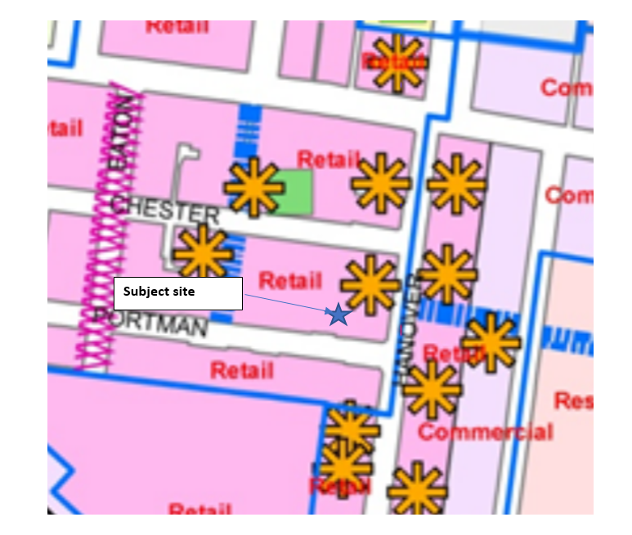
- The activity centre has been further divided into precincts with the subject site included within Precinct 1 – Oakleigh Village. The vision for the precinct is:
To achieve high quality-built form and public realm design that conserves and enhances the valued urban character of the Oakleigh Village and to encourage an appropriate mix of residential and commercial development to support the economic and social sustainability of the Activity Centre.
- Relevant strategies for the precinct include:
- Facilitate use and development within the Oakleigh Major Activity Centre that:-
– supports the existing strong sense of identity and the traditional/cultural character of Precinct 1 – Oakleigh Village
– promotes the Centre as a focal point for the community, fostering its social and cultural development.
– increases diversity and density of dwellings
– meets the form and scale of buildings and the design objectives of the relevant Precinct.
- Consolidate Precinct 1 and 2 as the retail core of the Oakleigh Major Activity Centre.
- Provide a diversity of retail, commercial and community activities to serve the needs of the local community.
- Support the location of major retail developments that may serve a wider catchment area in the retail core of the Oakleigh Major Activity Centre.
- Encourage the maintenance and enhancement of the traditional fine grain streetscape rhythm and building scale of the Oakleigh Village
- Encourage increased diversity and density of housing to meet the needs of the community and increase activity in the Oakleigh Major Activity Centre.
- Encourage new development to be compatible with the future role and preferred design outcomes for the centre.
- Encourage access, movement and car parking within, around and through the Oakleigh Major Activity Centre to be improved.
- Provide adequate new car parking spaces for any new use and/or development replacing the existing public car park spaces so that the total number of public car parking spaces within the Oakleigh Major Activity Centre is not reduced.
- Encourage an appropriate mix of residential and commercial uses to develop within the precinct, in addition to the existing retail development.
- Support the retention and enhancement of the pattern of development in the core centre that is characterised by small lot frontages, two storey federation and inter-war buildings, steeply pitched roofs and architecturally detailed upper storeys.
- Improve and encourage active street frontages to create interest and vitality at the pedestrian level.
- Encourage redevelopment of large sites to include higher density residential dwellings.
- Encourage the establishment of larger retail premises abutting Hanover Street to strengthen the competitiveness of the Activity Centre and to better meet the needs of residents.
- Support the continued improvement of the public realm.
- Whilst some development guidelines have been included within the policy, the DDO11 has been applied specifically to provide guidance on the development expectations for the activity centre.
- The DDO11 provides a four storey preferred height for the subject site, with the land along the eastern side of Hanover Street given a seven storey preferred height limit.
- The DDO11 states:
A building should not exceed the Preferred Building Height (in metres and storeys) specified in the built form precinct provisions of this Schedule unless particular site conditions warrant an alternative design response and that design response demonstrates a respect for, and significantly contributes to, the preferred character of the Oakleigh Major Activity Centre.
- The site adjoins a Council carpark, and whilst it is not a corner site, it does present as the edge of the built form of the activity centre when viewed from the car park to the east in Hanover Street and from the Council car park adjoining the subject site.
- The development will therefore have three interfaces with the public realm, Portman Street and the Council carpark to the east and north, which will then lead to views of the site from Hanover Street and Chester Street. The revised diagrams circulated by the permit applicant on 13 November provided the following illustrations of how the development will appear from these perspectives:

Eastern interface with the carpark
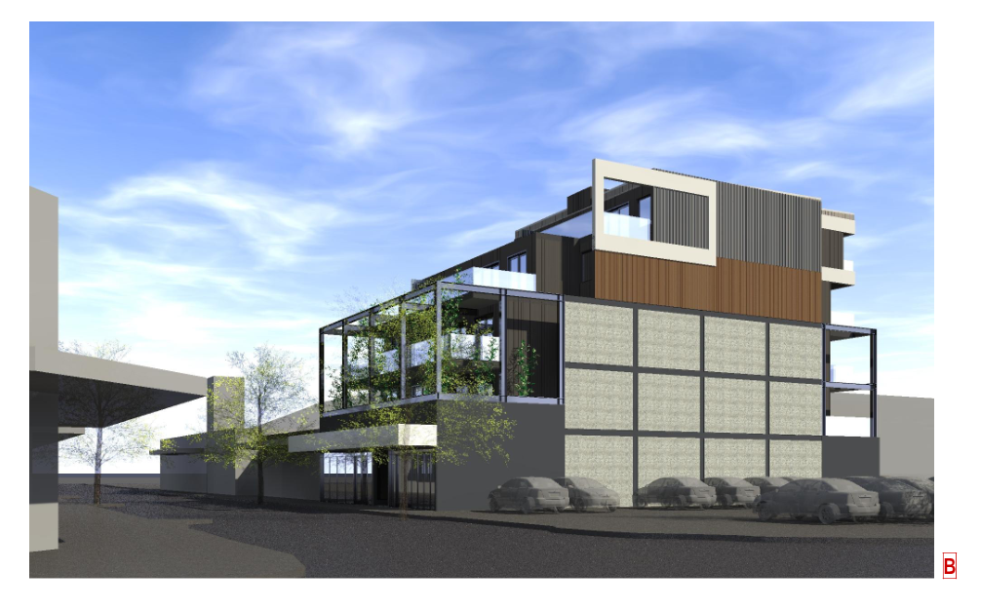

Northern interface with the carpark
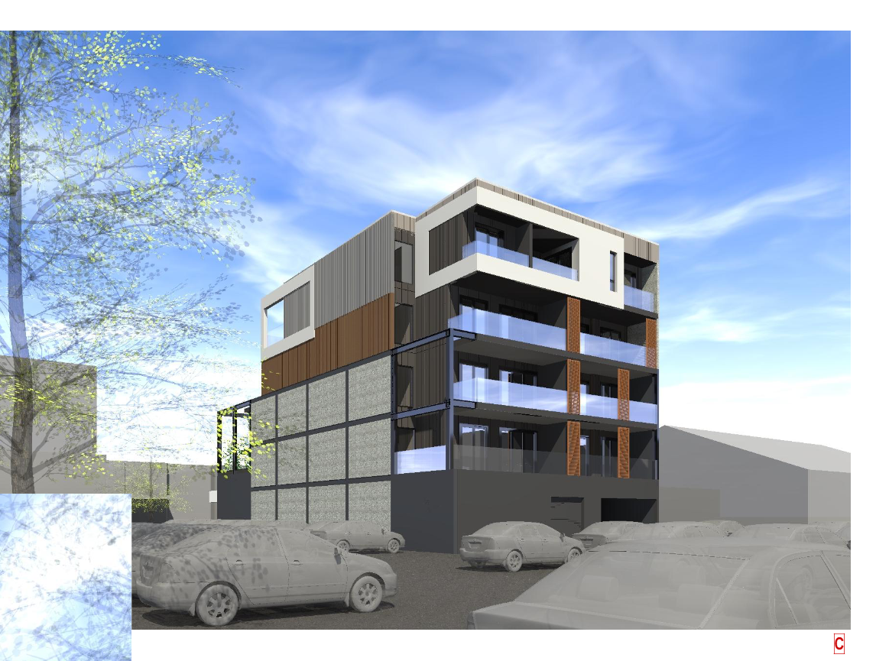

Portman Street
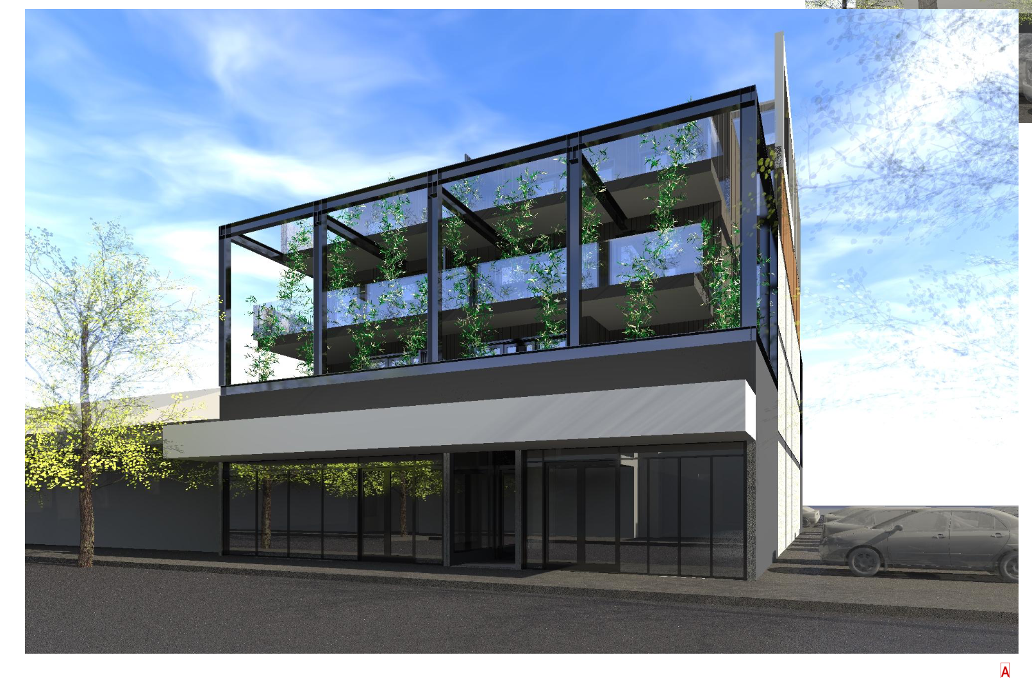
- I note that the eastern interface with the carpark was altered from the previously substituted plans to revert to an earlier façade treatment in this version of the plans. This was in response to discussions at the hearing where the Tribunal noted that the previous treatment of this facade appeared more resolved than the alternative more simple façade treatment proposed by the substituted plans at this interface.
- With this change in place, I find that the design of the proposed built form is highly resolved and will provide an attractive addition to the activity centre. Whilst at five storeys it is higher than the four storey preferred height limit, I accept the submissions of Mr Little that given the site’s location within the activity centre, where seven storey forms are anticipated on the eastern side of Hanover Street, and the designation of the car park as a landmark site, it is likely that the carpark will accommodate a taller form say in the order of six storeys in height. The proposed building would then provide a transition to the lower anticipated four storey forms within the retail core, noting that as this is not a mandatory height limit there are likely to be some sites within the activity centre, such as the approved five storey development at 45-49 Portman Street, which will be developed with taller building forms.
- Even without the strategic designation provided within the scheme, the location of this site at the physical end of the centre lends itself to comfortably absorbing a taller built form. Each elevation has been well resolved including the eastern wall, which has been designed to enable the development of the car park in the future. In the meantime, it will provide an attractive backdrop to the carpark, which is a significant improvement on the existing presentation of built form in this location.
- I therefore find that a five storey built form on this site to be acceptable.

Are the proposed car parking arrangements acceptable?

Parking provision
- The application shows the provision of 19 spaces for the proposed development, 15 for residents, 1 disabled space and 3 for the commercial tenancies, to be contained within a basement accessed via the Council car park.
- Whilst Council supports the provision of parking for the development, they submit that three long term and unencumbered spaces should be made available for the retail uses of the land, to limit the impact of trader parking on local streets as this is an ongoing issue of concern within the locality. They also have concerns with the design of the proposed basement, particularly the basement ramp width and gradient. They also considered that to facilitate the future development of the Council car park, the most appropriate location for the entry to the basement was the western side of the building, rather than the east.
- The Tribunal had the benefit of evidence by Mr Valentine Gnanakone of One Mile Grid. It was his evidence that a passing area was not required at the entry as the site does not connect to a road zone and the accessway is not longer than 50 metres. He did acknowledge that due to the size of the site there are limitations to providing passing areas within the basement levels. To reduce the potential for conflict between vehicles, he recommended the installation of a traffic warning system to alert any motorists leaving the basement that a vehicle has entered the basement, and to wait until the vehicle has reached their parking space before proceeding to leave the basement.
- It was also his evidence that whilst the entry to the basement could be moved to the eastern end that this would likely result in the loss of a space in the Council car park. Ms Marshall for Council indicated that it was Council’s preference that the entry be relocated, notwithstanding that this would likely result in the loss of a car space within the Council car park.
- The revised plans which where prepared in response to my order of the 6 November 2020 also included a swept path analysis which confirmed that the change will result in the loss of public car parking space, as follows:

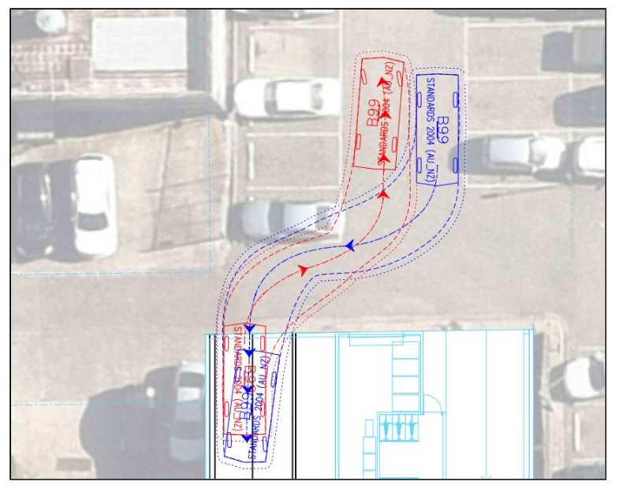
- The statement also advised that car park design, including the basement gradients as shown on the revised plans, have achieved the outcomes desired by Council’s draft condition 4.
- In response to the revised material, Council advised that they maintain their opposition to the proposed traffic light system, and submit that the basement width should be widened to an internal width of 5.5 metres, and a visibility splay be provided at the western wall, particularly as the amount of traffic using the rear laneway is likely to increase overtime.
- I agree that increased visibility to the west is desirable, particularly given the existing use of the laneway by commercial and other vehicles. I consider that this could be achieved through various methods and not necessarily via the traditional visibility splay. I will leave it to the permit applicant to determine the most appropriate method of increasing the visibility for oncoming traffic to the west. I have required this as a condition of permit.
- I am satisfied based on the evidence that a wider entry ramp is not required for this development to provide a passing bay. The proposed basement will accommodate 19 vehicles and Mr Gnanakone’s evidence was that proposal would generate a peak hour demand of 10 vehicles, or one vehicle every six minutes. The likelihood of a vehicle exiting and entering at the same time is low. However, on the rare occasions that this does occur, I am satisfied that the traffic light system as proposed by Mr Gnanakone should be sufficient to avoid conflict between vehicles. I have therefore reworded condition 4 to delete the details already shown on the revised plans, and to include the recommendations of Mr Gnanakone.
- Council submitted that a wider entry would also avoid the loss of the Council car parking space, however I am not convinced that this is the case. If the basement ramp was widened, a vehicle exiting the site would need to travel onto the right side of the ramp to exit in a manner which avoids the car space. Without any traffic evidence, I am not satisfied that this outcome is preferrable to the outcome currently before he Tribunal. Whilst the proposal will result in the loss of a public car parking space, something which is not desired by policy, this is a car park which has been designated for redevelopment, and the loss of this space is likely to be recovered overtime. In any case, based on Mr Gnanakone’s evidence, the existing retail uses on the site result in a parking credit of eight spaces. With the loss of the space in the Council carpark, the proposal seeking a reduction of four spaces, resulting in a net gain of four spaces for users within the activity centre. As such this proposal will generate less demand for parking than the existing use of the site.
- Council submitted that the three retail spaces should be unencumbered to provide for general parking associated with the retail uses. Given that the spaces are proposed to be located within a basement, with a traffic light system, they would be difficult to access by for short term users, such as customers of the retail premises unless guided by a person with knowledge of the basement. Whilst I have not specified that the retail spaces are to be allocated for staff only (as suggested by Council’s condition), to provide a greater flexibility in the use of the spaces, I recognise that the retail spaces are likely to be used by drivers with knowledge of the basement, such as owners, mangers or staff of the retail premises. I have not required the accessible space to be allocated to enable this space to be utilised by a maximum number of users.
- With these changes in place, I am satisfied that the proposed access arrangements are satisfactory.

Will the proposal prejudice the future development of the Council car park?
- During the hearing Council submitted that it intends to develop the car park at some point in the future, although it is unknown at this stage what the outcome for the site will be. It is possible that the site could be developed as a standalone car park facility such as the multistorey carparks that have been recently constructed by the Council within Atkinson Street Oakleigh and Bogong Avenue Glen Waverley or a mixed use development. I have considered both in my consideration of this application.
- With the relocation of the access way to the west, I am satisfied that the proposed development will not prejudice the ability of the car park to be redeveloped n the future either as a multistorey carpark or mixed use development. Whilst the future redevelopment will need to respond to the balconies of the proposed dwellings, I am satisfied that the layout of the proposed built form and in particular the design of the eastern façade will enable the equitable development of the Council carpark, noting that the Council site is significantly larger than the site before me.
- The parties have agreed to a revised wording of condition 7 which will allow for the access arrangements to the site to be altered in the event that the car park is redeveloped. To further ensure that access is required to the site, I have I have placed a condition on the permit requiring vehicle access to be provided to the site to the satisfaction of the responsible authority prior to the occupation of the development.

What conditions are appropriate?
- Draft conditions were discussed at the hearing, and any changes to those conditions reflect those discussions as well as further consideration by the Tribunal. I have decided to delete condition 11, as the hours of construction are addressed in the construction management plan.
- For completeness I have included the Tribunal’s standard expiry condition, with works to commence within three years and to be completed within five years.

Conclusion
- For the reasons given above, the decision of the responsible authority is set aside. A permit is granted subject to conditions.

Katherine Paterson
Member

Appendix A – Permit Conditions

Permit Application No | TPA/50927
Land | 55-59 Portman Street  OAKLEIGH VIC 3166

What the permit allowS
In accordance with the endorsed plans:
- The construction of a five-storey mixed use building and associated works; and
- A reduction in parking

Conditions

Before the development starts, three copies of amended plans drawn to scale and dimensioned, must be submitted to and approved by the Responsible Authority. The submitted plans must clearly delineate and highlight any changes. When approved the plans will be endorsed and will then form part of the permit.
The plans must be generally in accordance with the plans marked ‘VCAT Hearing Issue’ –dated 11 November 2020 prepared by Life Design Architecture but modified to show:
- The provision of a visibility splay or alternative method to enable a vehicle leaving the basement to observe oncoming traffic travelling from the laneway from the west.
- The provision of a traffic light system as endorsed under condition 4 of this permit.
- An external colours and materials schedule and pallet for the building.
 | The development as shown on the endorsed plans must not be altered without the written consent of the Responsible Authority.
No less than 19 car spaces must be provided on the land for the development including one car space marked and allocated to each apartment, two car spaces to Commercial tenancy 1 and one car space to Commercial tenancy 2 and 1 ‘accessible’ car space.
4.f

 | Prior to the commencement of buildings and works a traffic management plan must be prepared by a suitably qualified traffic engineer and submitted for approval to the responsible authority. When approved, the traffic management plan will be endorsed and form part of this permit. The traffic management plan must outline the operation of a traffic management system as detailed in the evidence of Mr Valentine Gnanakone of One Mile Grid dated 23 October 2020, including the installation of a traffic light system.
5 | Bicycle parking facilities shall generally follow the design and signage requirements set out in Clause 52.34 of the Monash Planning Scheme.
Prior to the commencement of works on the site, the owner shall prepare a Waste Management Plan for the collection and disposal of garbage and recyclables for all uses on the site. The Waste Management Plan shall provide for:
- The method of collection of garbage and recyclables for uses;
- Designation of methods of collection including the need to provide for private services or utilisation of council services;
- Appropriate areas of bin storage on site and areas for bin storage on collection days;
- Measures to minimise the impact upon local amenity and on the operation, management and maintenance of car parking areas;
- Litter management.
A copy of this plan must be submitted to Council.
Prior to the commencement of the permitted development, the owner of the Subject Land to which this permit relates must enter into an agreement with the Responsible Authority under section 173 of the Planning and Environment Act 1987. The agreement must provide for the following matters:
- Council grants the owner (including its servants, agents, contractors and invitees) a licence to use, enter and pass over (with or without vehicles) such part of the existing Council car park at the rear of the Subject Land (Council Land) as is shown on the endorsed plans (Licensed Land) for the purposes of access to and egress from the Subject Land, for nominal consideration:
- the owner and Council acknowledge and agree that:
a. the owner (including its servants, agents, contractors and invitees) is not entitled to an exclusive right to use, enter and pass over (with or without vehicles) the Licensed Land for the purposes of access to and egress from the Subject Land, and must not obstruct or restrict the use of the Licensed Land by other persons authorised to use the Council Land;
b. Council may use, or permit other parties to use the Council Land, and may close the Council Land to vehicles and pedestrians at any time reasonably required by Council; and
c. the licence that Council grants the owner under paragraph a) does not:
i. create any estate or interest in the Licensed Land other than a contractual right;
ii. constitute an easement, a lease, a right in the nature of a right of way, a road or a public highway; and
- nothing in the agreement prevents or restricts Council (or any successor in title to the Council Land) from using and developing the Council Land, provided that if the proposed use and development adversely affects the owner’s right under paragraph a), then Council (or any successor in title) will use reasonable endeavours to provide alternative access to the Subject Land from such other part of the Council Land determined by Council (or any successor in title).
The costs of the City of Monash in relation to the drafting, reviewing, executing and registering the agreement must be borne by the owner.
 | No bin or receptacle or any form of rubbish or refuse shall be allowed to remain in view of the public and no odour shall be emitted from any receptacle so as to cause offence to persons outside the land.
 | Adequate provision shall be made for the storage and collection of garbage and other solid wastes and these facilities are to be located on the site to the satisfaction of the Responsible Authority.
Before the development starts, a construction management plan must be prepared and submitted to the Responsible Authority for approval. The plan must be to the satisfaction of the Responsible Authority. Once approved, the plan must be implemented to the satisfaction of the Responsible Authority. The plan must address the following issues:
- measures to control noise, dust and water runoff;
- prevention of silt or other pollutants from entering into the Council’s underground drainage system or road network;
- the location of where building materials are to be kept during construction;
- site security;
- maintenance of safe movements of vehicles to and from the site during the construction phase;
- on-site parking of vehicles associated with construction of the development;
- wash down areas for trucks and vehicles associated with construction activities;
- cleaning and maintaining surrounding road surfaces;
- a requirement that construction works must only be carried out during the following hours:
- Monday to Friday (inclusive) – 7.00am to 6.00pm;
- Saturday – 9.00am to 1.00pm;
- Saturday – 1.00pm to 5.00pm (Only activities associated with the erection of buildings. This does not include excavation or the use of heavy machinery.)
The amenity of the area must not be detrimentally affected by the use or development, through the:
- transport of materials, goods or commodities to or from the land;
- appearance of any building, works or materials;
- emission of noise, artificial light, vibration, smell, fumes, smoke, vapour, steam, soot, ash, dust, waste water, waste products, grit or oil;
- presence of vermin.
 | No equipment, services, architectural features or structures of any kind, including telecommunication facilities, other than those shown on the endorsed plans shall be permitted above the roof level of the building unless otherwise agreed to in writing by the Responsible Authority.
 | All stormwater collected on the site from all hard surface areas must not be allowed to flow uncontrolled into adjoining properties or the road reserve.
 | One copy of the plans for the drainage and civil works must be submitted to and approved by the Engineering Department prior to the commencement of works. The plans are to show sufficient information to determine that the drainage works will meet all drainage conditions of the permit.
 | Once the development has started it must be continued and completed to the satisfaction of the Responsible Authority.
 | Prior to the occupation of the development vehicle access to the site must be provided to the satisfaction of the responsible authority.
- This permit as it relates to development (buildings and works) will expire if one of the following circumstances applies:
  - The development is not started within three (3) years of the issue date of this permit.
  - The development is not completed within five (5) years of the issue date of this permit.
In accordance with section 69 of the Planning and Environment Act 1987, an application may be submitted to the responsible authority for an extension of the periods referred to in this condition.
– End of conditions –

The submissions and evidence of the parties, any supporting exhibits given at the hearing and the statements of grounds filed have all been considered in the determination of the proceeding. In accordance with the practice of the Tribunal, not all this material will be cited or referred to in these reasons.
Taken from drawing TPA901T prepared by Life Design Architecture dated 11 November 2020.

