VICTORIAN CIVIL AND ADMINISTRATIVE TRIBUNAL
planning and environment LIST | vcat reference No. P1007/2021  Permit Application no.TPA/51362
CATCHWORDS
Section 77 of the Planning and Environment Act 1987, Monash Planning Scheme, General Residential Zone Schedule 6, Neighbourhood Character, Front Setback

Applicant | Lucarelli Superannuation Pty Ltd

Responsible Authority | Monash City Council
Respondents | John Iorlano, Arlene Edwards & Others
Referral Authorities | Head, Transport for Victoria
 | Melbourne Water

SUBJECT LAND | 1365 Centre Road  CLAYTON VIC 3168

HEARING TYPE | Hearing

DATE OF HEARING | 21 & 22 February 2022

DATE OF ORDER | 10 March 2022

CITATION | Lucarelli Superannuation Pty Ltd v Monash CC [2022] VCAT 234

Order
- Pursuant to clause 64 of Schedule 1 of the Victorian Civil and Administrative Tribunal Act 1998, the permit application is amended by substituting for the permit application plans, the following plans filed with the Tribunal:
- Prepared by: | Jesse Ant Architects
- Drawing numbers: | TP08 – TP20
- Dated: | 20.12.2021
- Landscape Plan | Revision D
- In application P1007/2021 the decision of the responsible authority is affirmed.
- In planning permit application TPA/51362 no permit is granted.

Tracey Bilston-McGillen
Member

Appearances
For Lucarelli Superannuation Pty Ltd | Mr Andrew Clarke, town planning consultant.
For Monash City Council | Mr David De Giovanni, town planning consultant.
For John Iorlano, Arlene Edwards & Others | Mr Iorlano in person.
For Head, Transport for Victoria | No appearance.
For Melbourne Water | No appearance.

Information
Description of proposal | It is proposed to develop the land with a three storey apartment building comprising eleven (11) dwellings on land affected by a Special Building Overlay and to alter access to a Transport Zone 2.
Nature of proceeding | Application under section 77 of the Planning and Environment Act 1987 – to review the refusal to grant a permit.
Referral responses | Melbourne Water – no objection subject to conditions.  Department of Transport – no objection subject to conditions.
Planning scheme | Monash Planning Scheme
Zone and overlays | General Residential Zone – Schedule 6 (GRZ6).  Special Building Overlay (SBO).  Abuts a Transport Zone-Category 2.
Permit requirements | Clause 32.08-6 - construction of two or more dwellings on a lot in GRZ6.  Clause 44.05 -2-buildings and works in an SBO.  Clause 52.29-2 – a permit is required to create or alter access to a road in a Transport Zone 2.
Planning scheme policies and provisions | Clauses 11, 15, 16, 18, 21, 22.01, 22.04, 22.05, 22.13, 32.08, 44.05, 52.02, 52.06, 52.29, 55, 65 and 71.02
Tribunal inspection | I inspected the review site and its environs following the hearing.
Land description | The review site is a mid-block allotment located on the northern side of Centre Road and four properties east of the intersection with Burton Avenue.  The site is a rectangular shaped allotment with front/rear boundary widths of 19.51 metres, side boundary lengths of 48.77 metres and a combined land area of 951.50 square metres.  The land is generally flat. The north-western corner is the highest corner with an RL of 52.24 metres and the south-eastern corner is the lowest corner with an RL of 52.19 metres.  The site currently accommodates a double fronted weatherboard dwelling with pitched tiled roof and expansive paved area within the site frontage. A side driveway along the western side boundary leads to a rear garage, rear outbuilding and large open backyard. The site does not contain any vegetation of significance.  Abutting the site to the west is a single dwelling at 1363 Centre Road, Clayton. The land at 1363 Centre Road was the subject of a recent VCAT proceeding with a permit issued for the construction of four three-storey dwellings in two attached pairs.

Reasons

What is this proceeding about?
- This is an application for review against the decision of the Monash City Council [Council] to refuse to grant a planning permit for the redevelopment of 1365 Centre Road Clayton for a three storey apartment building comprising eleven (11) dwellings.
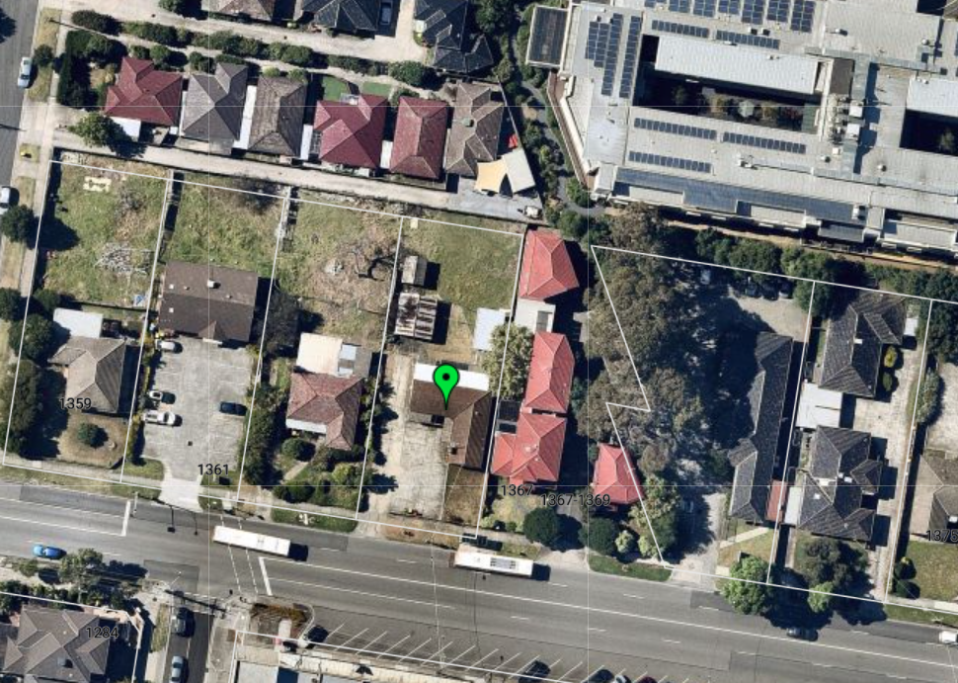
Figure 1: Review site and surrounds. Source Nearmap.
- Council refused the development on a number of grounds relating to inconsistencies with planning policy, zone provisions, the use of the laneway, adverse impact on the landscape character of the area, an overdevelopment of the site and garden area non-compliance.
- A number of concerns were raised by objectors including the impact on the amenity of the adjoining property, including loss of privacy and overshadowing, the massing and scale of the development and the three storey height of the building.
- The applicant submitted that the proposed development is supported by the planning policy framework that calls for a diverse range of housing and the development generally meets the relevant ResCode standards with the exception of overshadowing. It was further put that the Special Building Overlay (SBO) has in part, determined the front setback and the need for rear at grade car parking.
- There was no dispute that this site can be redeveloped, and I discuss this issue below. But this is a constrained site because of the SBO, mandatory garden area requirement and varied setback provisions. Melbourne Water requires that a combined five metre setback from the eastern and/or western property boundary is provided. In this proposal, there is a two metre setback from the eastern boundary and three metres from the western boundary. As a result of the setback requirement, this limits the development width of the site. The site is also subject to a garden area requirement of 35%, with the proposed development complying, providing 35.05%. The applicant submitted that both the garden area requirement and the SBO inform the layout of the proposed development and in particular the setbacks from the site boundaries and the at grade car parking at the rear of the site.
- I find this is a proposal which to me, is compromised in order to meet both the garden area requirement, the SBO and the varied zone provisions resulting in a built form that I find is inappropriate. I further find that the proposed development fails to provide a built form that promotes the preferred garden city character by ‘minimising hard paving throughout the site by limiting the length and width of accessways and limiting paving within open space areas’ and a built form that seeks to ensure ‘developments are constructed within an open garden setting through the retention and planting of vegetation, including canopy trees’. My reasons for this decision follow.

Basis of Decision

Planning policy and zone
- As noted in the Information Table, the adjoining site at 1363 was subject to a Tribunal hearing and a permit was issued for the construction of four dwellings in Lucarelli v Monash CC. This permit was issued recently in December 2021. The decision noted that it was common ground between the parties that the site was a suitable candidate for redevelopment. I agree that the same finding applies here. The review site is a suitable candidate for redevelopment for the following reasons.
- The zoning and planning policy framework support increased housing densities. Clause 21.04-1 includes the review site within the Monash National Employment Cluster (Category 3) area. Further, areas within the Monash National Employment Cluster are areas identified as having future development potential and as being in a housing diversity area. Council put that the emphasis in these areas is placed on new development satisfying the intent of the preferred future character statement, and that the ‘garden city character within all residential areas should be maintained and enhanced’.
- The GRZ6 supports diverse housing with the objective stating:
To facilitate housing diversity in the form of units, townhouses and apartment developments of high quality design and finish.
- As I observed above, the proposed development does not fail because of broad policy support for a diverse range of housing. Clearly, there is support for the redevelopment of this site. It is the intensity and form that is of concern.

Neighbourhood character
- I am persuaded by Council’s submission that whilst there is a clear motivation to facilitate housing diversity, it is not a case of anything goes. There are clear neighbourhood character policies that set out the preferred character for the review site and area. The neighbourhood character policy is at clause 22.01 with the review site being located within the Monash National Employment Cluster and Clayton Activity Centre – Housing Diversity Area. The preferred future character for the review site is as follows:
The Clayton Activity Centre and the cluster more broadly are expected to experience major redevelopment, as one of the key areas for employment growth within Melbourne. As such, the core of the activity centre and the cluster are anticipated to accommodate growth and more diverse housing needs. This area also forms an interface to the surrounding garden city suburbs. New development should provide a transition between these areas.
New housing will generally comprise multi dwelling developments such as units and, where appropriate, low rise apartments. Front and rear setbacks will be less than those preferred in the garden city areas, however, will still provide the opportunity for landscaping. Landscaping and open space within developments will remain an important feature for this character area. Canopy trees within developments and separation between buildings will provide visual and environmental amenity for occupants and the residents of existing dwellings. New developments will be designed and constructed to a high standard, ensuring they provide a positive architectural impact.
- The review site is also zoned General Residential Zone Schedule 6 – Monash National Employment and Innovation Cluster and Clayton Activity Centre [GRZ6]. This schedule establishes a number of neighbourhood character objectives including:
To facilitate housing diversity in the form of units, townhouses and apartment developments of high quality design and finish.
To provide an interface between the Clayton Activity Centre, the Monash Employment and Innovation Cluster, the housing growth area and the lower scale surrounding garden city suburban areas.
To encourage development that respects sensitive residential interfaces and minimises building mass and visual bulk in the streetscape through landscaping in the front setback and breaks and recesses in the built form.
To promote the preferred garden city character by minimising hard paving throughout the site by limiting the length and width of accessways and limiting paving within open space areas.
To ensure developments are constructed within an open garden setting through the retention and planting of vegetation, including canopy trees.
- The proposed ground floor layout is detailed in Figure 2 below. Notably the rear third of the site is completely paved (the first and second floors of the building extend over the majority of the paved area).
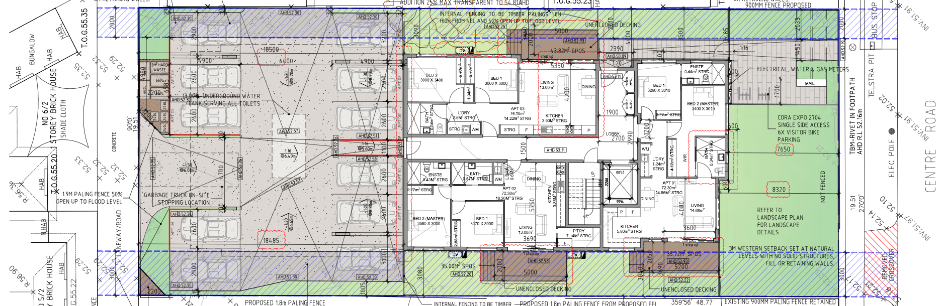
Figure 2: Proposed ground floor layout.
- Having regard to the various character policy statements and objectives, it informs us that future development within this area is to:
- Provide housing diversity.
- Front and rear setbacks will be less than other areas but will still provide an opportunity for landscaping.
- Landscaping and open space remains an important feature for this character area.
- Provide for canopy trees within developments.
- Separation between buildings provide visual and environmental amenity for residents.
- High standard development.
- Minimising hard paving throughout the site by limiting the length and width of accessways and limiting paving within open space areas.
- Provide landscaping in the front setback and breaks and recesses in the built form.
- I have a key concern with the front setback, the level of pavement in the rear third of the site and the flow on consequence of limited landscaping in the rear of the site.

Front setback
- Standard B6 is varied in the schedule to the zone to provide for a minimum 4 metre front setback. The development proposes a front setback of between 7.67 metres and 8.32 metres to the wall of apartment 1. Council submitted that it would prefer to see a lesser front setback and one that is more consistent with the 4 metre variation.
- Council submitted that the intent of requiring and implementing the 4 metre front setback is to achieve the new preferred character. Council highlighted that clause 71.02-2 states that ‘the consistent application of planning policy over time should achieve a desired outcome’. Council noted that the adjoining approval and development of the site at 1363 Centre Road has a front setback of 4.03 metres to the wall of townhouse 1 with a porch encroachment. The decision makes the observation that the front setback is consistent with the varied provision.
- The applicant submitted that the proposed development complies with the front setback variation seeking a minimum of 4 metres. It was put that the 4 metre setback requirement is a minimum, it is not a mandatory control and it is not expressed as a maximum. It was contended that variation in the front setback is to be expected from a starting point of 4 metres. It was further put that the intended urban design outcome is not a uniform row at 4 metres for all lots. It was suggested that because of the emphasis on garden city character, a deeper front setback would be welcomed.
- The applicant further submitted that there is ‘no denying’ that the need for the greater front setback is to comply with the garden area, given it is a mandatory requirement.
- I agree with the applicant that the wording of the variation is not to be read as a mandatory 4 metre setback. However, I am persuaded by Council, that when the variation is read in conjunction with policy statements such as ‘Front and rear setbacks will be less than those preferred in the garden city areas, however, will still provide the opportunity for landscaping’, the intent or opportunity is for a lesser front setback to achieve the preferred neighbourhood character. The intent is to have a setback that is generally consistent with the vision for the area.
- Whilst I acknowledge the challenges this site has due to the application of the SBO, I find that the varied front setback requirement of 4 metres should be generally complied with. The varied setback is not mandatory and is not a maximum, but it establishes the setback to achieve the future preferred character. Perhaps the wording of the varied provision could be clearer. Nevertheless, I am persuaded by Council that there is a need to apply planning policy consistently over time to achieve the desired outcome. The proposed setback ranging from 7.67 metres and 8.32 metres undermines Council’s neighbourhood character policy and is at odds with preferred neighbourhood character policy. This site has an opportunity to provide a lesser front setback, which would, with the right design, still allow for planting to occur to promote the further greening of the municipality as well as providing for a more intense form of development.
- I find that it is the large, paved area at the rear that is the concern because it has dictated the form of development on the site, rather than the proposed development taking its cues from the zoning and policy provisions.

Landscaping
- GRZ6 varies Standard B13 requiring one canopy tree plus one canopy tree per 5 metres of site width and a canopy tree should reach mature height of at least equal to the building height of the development and vegetation in the front site and rear setbacks.
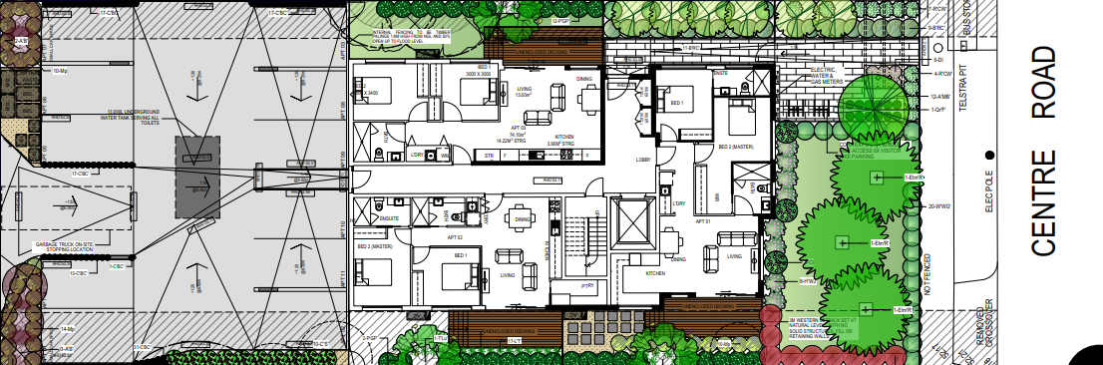
Figure 3: Proposed landscaping plan.
- Council refused the proposed development on the ground that the development failed to comply with the landscaping provisions. Council submitted that the need for car parking to extend to the side boundaries means there is no capacity for canopy tree planting for the rear third of the site. The following objective was highlighted:
To promote the preferred garden city character by minimising hard paving throughout the site by limiting the length and width of accessways and limiting paving within open space areas.
- Council further underpinned their concern by highlighting the policy at clause 22.01 which states:
Provide side and rear setbacks capable of supporting canopy trees.
- The applicant submitted that the proposed development provides adequate landscaping with a number of trees proposed in the front setback, along the side boundaries and rear boundary.
- It is well established that Monash seeks to continue the greening of its municipality. The policy framework establishes a number of policies seeking further landscaping and canopy trees, even in areas that are zoned for more intense development such as the General Residential Zone not Neighbourhood Residential Zone. I agree with the applicant that the front setback, due to its size is able to accommodate a number of canopy trees. I have made my comments regarding the front setback above. The landscaping is very limited in the rear of the site due to the large car park area that extends across the entire site width. The landscaping plan details a very small landscape strip along the car parking side boundaries, but it is questionable if anything meaningful could be planted along the eastern boundary.
- In summary, whilst the front setback can be landscaped, it is not enough. The proposed development fails to address or satisfy the objective to minimise paving by limiting the width and length of accessways and in this case the at grade car parking area. Again, this is a fatal flaw of this development.

Built form layout
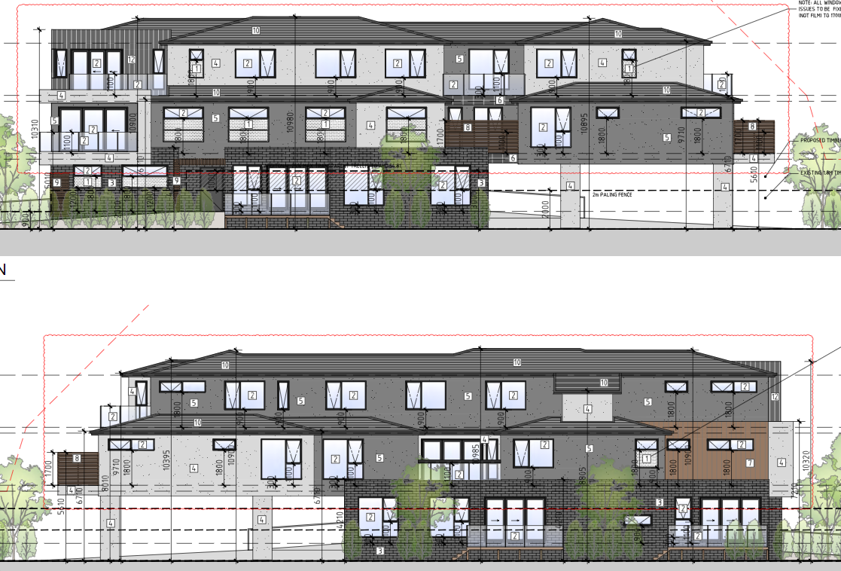
Figure 4: Proposed east and west elevations. Source Plans.
- Policy seeks separation between buildings to provide visual and environmental amenity. The proposed built form is a continuous one, noting there is a slight modulation in the form along the elevations.
- Council raised concern with the continuous form of the proposed building noting the recent approval of 1363 Clayton Road to the west is an approval for four townhouses in two modules with spacing between the modules in the centre of the site.
- The applicant referred me to 4 Burton Avenue, Clayton which is a decision of Council granting a permit for an apartment building. It was highlighted that the building is a continuous length with no separation. This approval notably provides a basement car park, a landscaped garden area in the rear of the site and landscaping along the side boundaries. In regard to the approvals at 1363 Clayton Road and 4 Burton Avenue, they provide context and character to the area but as it is well established, each site is assessed on its own merits.
- As I identified above, I have a concern with the proposed layout largely due to the paved area for parking taking up the rear third of the site, boundary to boundary. The proposal also fails to achieve policies that call for separation in buildings.

Amenity impacts
- Amenity concerns were raised in the form of overshadowing, visual bulk and loss of privacy. Council noted that due to the raised floor level, the ground level is 0.8 metres above natural ground level potentially requiring screening at the ground level. If a permit was to be granted, the loss of privacy could be addressed with conditions ensuring overlooking is minimised and complies with Standard B22.

Overshadowing
- In terms of overshadowing, Council submitted that an accurate assessment of the overshadowing impacts has not been undertaken because the plans do not detail the existing shadow cast from existing buildings.
- The applicant submitted that the development fails to comply with Standard B21 (Overshadowing) but despite this, considers the development acceptable and compliant with the objective:
To ensure buildings do not significantly overshadow existing secluded private open space.
- I accept the submission of the applicant that in considering the overshadowing issue, it is noted that there are two large trees in the adjoining courtyard of the property to the east that would cast shadow over the adjoining courtyard. However, for the fullness of information and assessment, the existing shadows cast should have been included in the drawings. I say this particularly, as I consider the proposed 9am and 3pm shadows cast are significant and as the applicant has submitted, the proposal fails against Standard B21.
- Townhouses 1 and 2 of the adjoining development to the east at 1367-1369 Centre Road have their courtyards and balconies orientated to the site. The applicant submitted that the size and orientation of these townhouses makes it difficult to fully comply with Standard B21. Whilst this maybe the case, it is an existing circumstance that needs to be considered. As it is proposed, I find that the proposed development fails to satisfy the objective ‘To ensure buildings do not significantly overshadow existing secluded private open space’.

Visual bulk
- Concern was raised that the three storey building would be visually imposing to the adjoining properties. Visual bulk is a concept that combines a range of factors (but not limited to) including the building’s height, setbacks, articulation, landscaping and materials. The adjoining property to the east is a number of townhouses with two in particular having their courtyards orientated to the site.
- Policy for the area cannot be ignored and whilst it seeks housing diversity, it also seeks development that minimises building mass and visual bulk with breaks and recesses in the built form. The proposed development is a continuous built form that fails to provide any recesses at the first and second levels and fails to achieve policies seeking to minimise building mass and bulk. Due to the location of the car park in the rear third of the site, as identified above, there is an inability for meaningful landscaping to be provided along the length of the east and western boundaries. Landscaping is often a technique used to soften the visual impact of a building. I also share Council’s and the objector’s concerns that an overall fence height of 2.57 metres (fence plus trellis) on the eastern boundary would further result in a sense of enclosure and visual bulk to the adjoining townhouses 1 and 2 to the east.
- As proposed, I am persuaded by Council that the development would have an unreasonable visual impact on the adjoining properties, particularly to the east and the small courtyards.

Car parking, access and waste
- Car parking for the units is provided in the rear of the site in an at grade car park. The number of car spaces provided on site complies with the provisions of clause 52.06. It is proposed to use the rear laneway for access to the car parking spaces as well as for the waste management. A draft permit condition requires the sealing of the laneway, and the applicant agreed that the laneway would need to be sealed due to the increase in use and the waste management truck.
- Council submitted that Council’s traffic engineers raised concern with the fact the waste collection truck is required to reverse from the driveway and onto the laneway (a public road and pedestrian path) in order to exit onto the road in a forward direction. I make the observation that it is noted that Council’s waste management team had no objection to private collection from the rear of the car parking area. Council also raised concern with the number of vehicles using the laneway for access.
- The applicant’s traffic engineer submitted that the proposed level of cars using the laneway is within an acceptable range and he sees no issue, including no safety concerns. Mr Hardingham also had no concerns with a garbage truck using the laneway as it can park within the site and then use the laneway to reverse in order to exit to Burton Avenue in a forward manner. Swept paths were provided to demonstrate turning circles.
- I am persuaded by Council that there are concerns with the use of the laneway and the manoeuvrability of the waste/garbage trucks, bearing in mind that due to the different types of waste it is likely to be more than one trip per week. The truck relies on the laneway to reverse in into the laneway in order to exit the laneway in a forward direction. It was Mr Hardingham’s view that the traffic and waste arrangements are satisfactory but he did state when questioned, that it would be preferable for a truck to be able to turn within the site and not have to reverse in to the laneway, but that would result in the loss of a car space and a reduction in car parking does not form part of this review.
- With the boundary abutting a laneway, it is inevitable that the site would use it for access. However, I am persuaded by Council that any correcting/reversing movement by the garbage truck should be performed within the boundaries of the site, and not rely on reversing into the right of way. I am concerned that the proposed arrangement is again the consequence of the proposed car park layout extending across the width of the site. I find there is a difference between the use of the laneway by cars accessing car parking and waste/garbage trucks. In order for the use of the laneway by trucks to be considered acceptable, I would think it is preferable to understand how many trucks would be accessing the site (noting the varying types of waste pick up), the sealing of the laneway and the trucks being able to turn within the boundaries of the site.
- As it is proposed, I share Council’s concerns.

Other matters
- Council raised a number of other concerns including internal amenity for future occupants. I have not addressed this issue as I am refusing the proposed development for other reasons. Internal amenity is an issue that needs to be considered and addressed in any future proposal.

Conclusion
- The key failure with the proposed development is the layout of the at grade car parking in the rear of the site. It appears that the boundary to boundary layout dictated the form of development (noting the SBO and garden area mandatory requirement). I find that the approach is not site responsive as it led to concerns with landscaping, front setback, compliance with garden areas, visual bulk and amenity concerns from neighbours. Any future design needs to start from a comprehensive site context and analysis to determine how best the site could accommodate more than one dwelling.

- For the reasons given above, the decision of the responsible authority is affirmed. No permit is granted.

Tracey Bilston-McGillen
Member

The submissions and evidence of the parties, any supporting exhibits given at the hearing and the statements of grounds filed have all been considered in the determination of the proceeding. In accordance with the practice of the Tribunal, not all of this material will be cited or referred to in these reasons.
[2021] VCAT 1459.

