VICTORIAN CIVIL AND ADMINISTRATIVE TRIBUNAL
planning and environment LIST | vcat reference No. P1980/2020  Permit Application no.TPA/51148

Applicant | Pai Property Consultants Pty Ltd

Responsible Authority | Monash City Council

SUBJECT LAND | 31 Stockdale Street  CLAYTON VIC 3168

HEARING TYPE | Hearing

DATE OF HEARING | 27 July 2021

DATE OF ORDER | 25 August 2021
Pai
CITATION | Pai Property Consultants Pty Ltd v Monash CC [2021] VCAT 967

Order
- Pursuant to clause 64 of Schedule 1 of the Victorian Civil and Administrative Tribunal Act 1998, the permit application is amended by substituting for the permit application plans, the following plans filed with the Tribunal:
- Prepared by: | Pai Property Group
- Drawing numbers: | Project 201968014 – TP1- TP8, Rev C
- Dated: | May 2021
- In application P1980/2020 the decision of the responsible authority is affirmed.
- In planning permit application TPA/51148 no permit is granted.

Jane Tait
Member

Appearances
For Pai Property Consultants Pty Ltd | Mr Phillip Rygl, town planner,  Connect Town Planning
For Monash City Council | Ms Sally Moser, Principal Planner/Appeals Advisor

Information
Description of proposal | To construct two double storey residential buildings to be used for student accommodation and a reduction in the car parking requirements.  The site layout includes the two residential buildings in a mirror image with a central party wall. Each building will be accessed via a separate crossover and entry door.  The ground floor of each building includes four student accommodation units (the ‘units’) and the first floor includes five units and a retreat. The units include a bed, en-suite, kitchen, laundry robe and desk, except for Unit 1 that does not include a kitchen and laundry.  The two buildings include a separate double garage and bin store, bicycle storage and lockers at ground floor level.  The buildings are set back 5 metres from the frontage and the garages abut the north and south boundaries. The buildings propose a maximum height of 7.7 metres. The buildings include skillion roofing and rendered and face brickwork walls.  The site coverage is 58% and garden area is 36%,
Nature of proceeding | Application under section 77 of the Planning and Environment Act 1987 – to review the refusal to grant a permit.
Planning scheme | Monash Planning Scheme
Zone and overlays | General Residential Zone – Schedule 6 (GRZ6)
Permit requirements | Clause 32.08-2 – to use the land for accommodation  Clause 32.08-9 – To construct a building or carry out works associated with the use in a Section 2 of Clause 32.08-2  Clause 52.06-3 – To reduce the number of car parking spaces required under Clause 52.06-5
Land description | The site is located on the west side of Stockdale Avenue, north of Princes Highway, Clayton. It has a 17.68 metre frontage, depth of 41.45 metres and overall area of 732.84 square metres. It is occupied by a single storey brick detached house that has a brick garage in the rear yard. There is no significant vegetation and the site is generally flat. There is a 1.83 metre wide drainage and sewerage easement along the west (rear) boundary.  Abutting land uses include two double storey units to the north at 29 Stockdale Avenue and 22 Woodside Avenue. The secluded open space for both dwellings abuts the common boundary. The site also abuts the rear yard of a double storey dwelling at 34 Koonawarra Street.  To the south there is a single storey weatherboard dwelling at 33 Stockdale Avenue. Planning Permit TPA/49989 was issued at the direction of the Tribunal (consent orders) in September 2019 for a two storey residential development for student accommodation on this land. Further south at 35 Stockdale Avenue is vacant land. Permit TPA/48071 was issued at the direction of the Tribunal for two storey student accommodation on this site. The east side of Stockdale Avenue contains detached dwellings that are setback 6-9 metres from the frontage.
Tribunal inspection | An unaccompanied site inspection of the site and surrounding area was conducted after the hearing.

Reasons

What is this proceeding about?
- Pai Property Consultants Pty Ltd (the ‘applicant’) is proposing to construct two double storey attached residential buildings to be used for student accommodation at 31 Stockdale Avenue, Clayton. Monash City Council (the ‘Council’) refused to grant a planning permit and the applicant has requested the Tribunal review this decision.
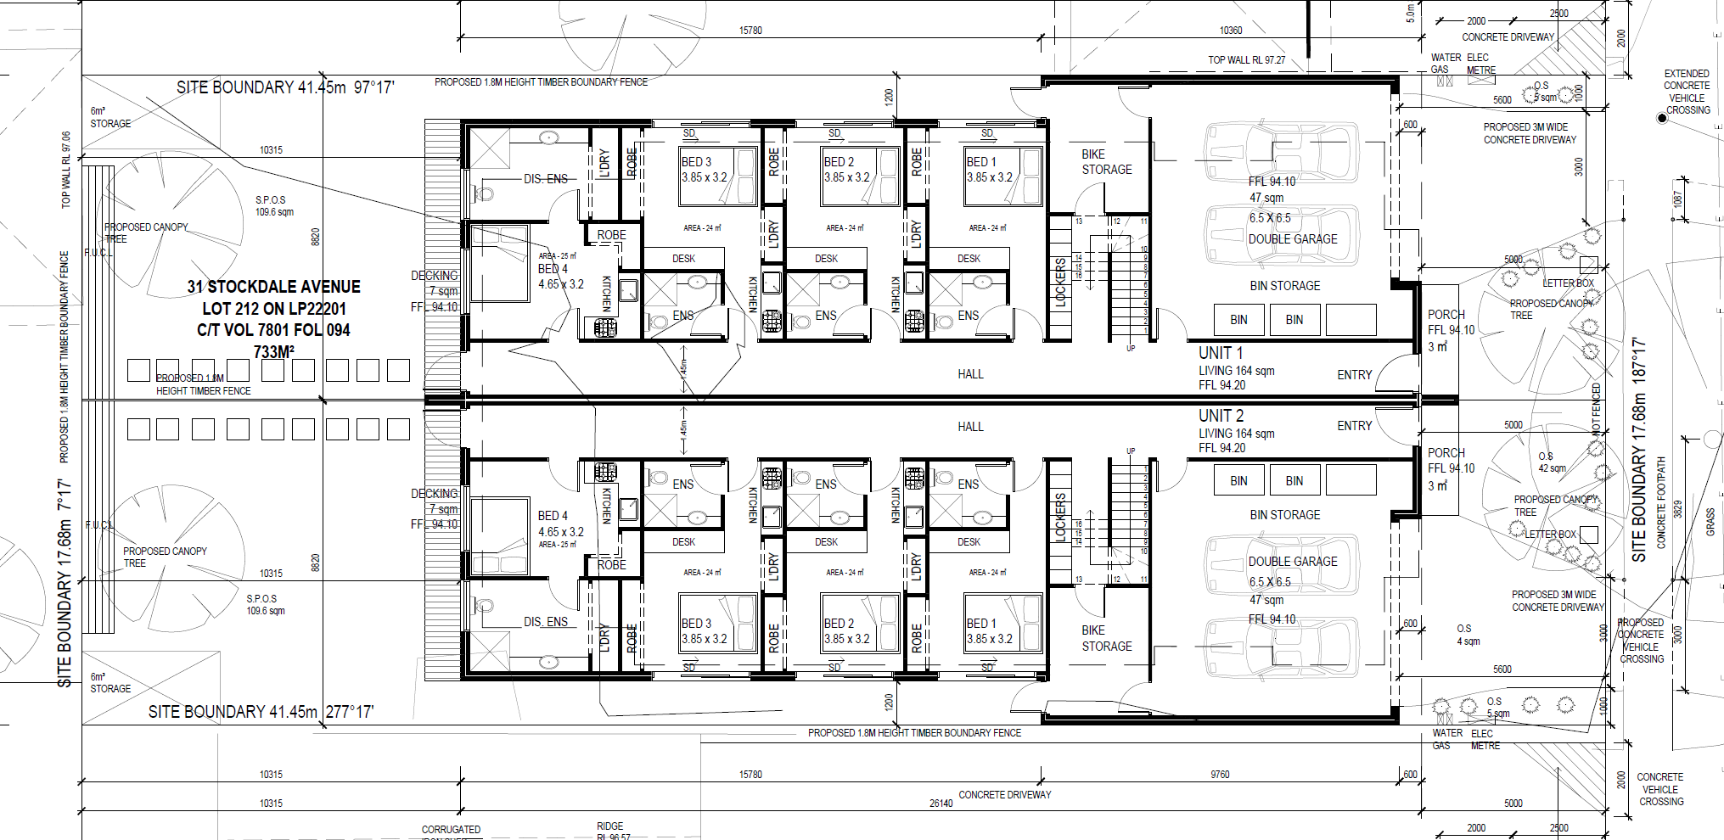
Source: Pai Property Consultant - Ground Floor Plan (Rev C)
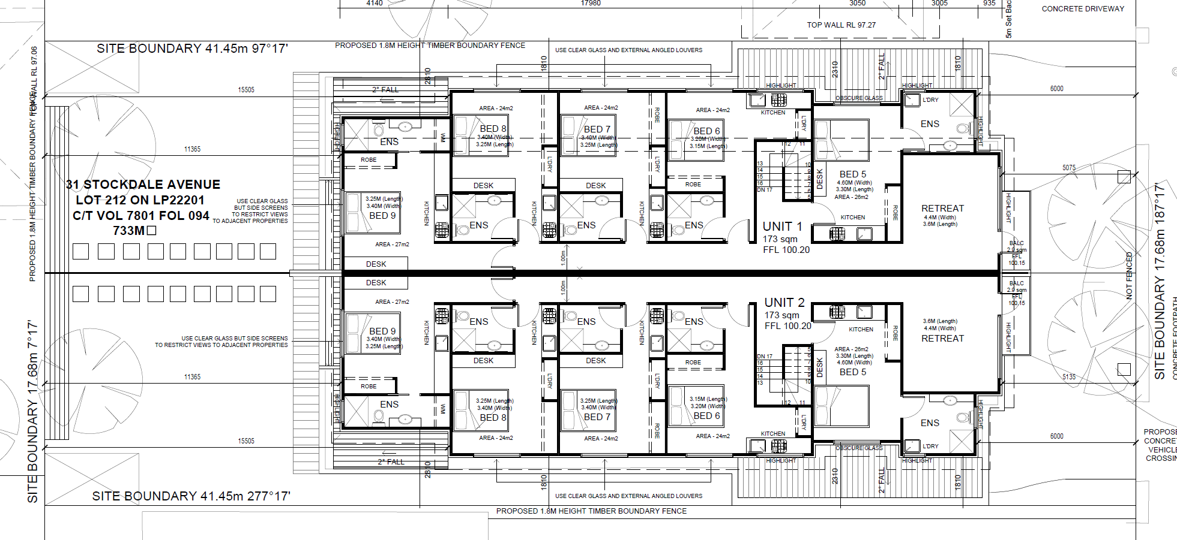
Source: Pai Property Consultant - First Floor Plan (Rev C)
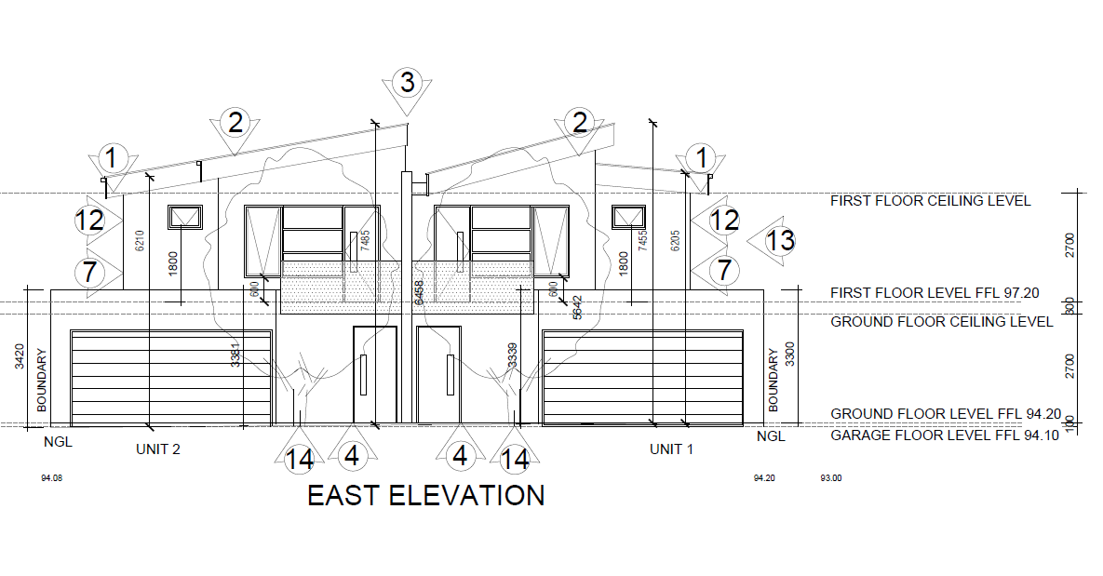
Source: Pai Property Development – East (front) elevation
- Council’s grounds of refusal are that the proposal is inconsistent with the Student Accommodation Policy at Clause 22.10 as there will be poor internal amenity for students. Other grounds are that the development is contrary to the existing and preferred neighbourhood character described in Clause 22.02 due to the scale, mass, bulk and impacts on the landscape character of the area. It also says the proposal is contrary to the Monash Housing Strategy, does not adequately satisfy the objectives and design standards of Clause 55, provides inadequate car parking and fails to demonstrate compliance with the Sustainable Development Policy at Clause 22.13.
- The applicant argues the proposal is an appropriate design response in the policy and physical context and warrants approval. A Statement of Grounds was lodged from a nearby owner on grounds relating to parking, traffic, waste management and environmental sustainability.
- Prior to the commencement of the hearing, the applicant circulated amended plans in accordance with the Tribunal Practice Note PNPE9. These amendments include changes to the ground floor bin storage, garage, bicycle store and internal rearrangement of Unit 4 to create door access to the rear yard. Other changes include larger store and clothes drying facilities in the rear yard, change from hipped to skillion roofing and relocation of the retreat at first floor level so the communal area is facing the street. Having reviewed the amended plans, Council advised that it had no objection but continues to maintain its opposition to the proposal. I subsequently substituted the amended plans to form the plans subject to review in this proceeding.

What are the key issues?
- Having considered the submissions and inspected the subject land and locality, I find the following key issues in this matter are:
- Does the development respond to its zoning and policy context?
- Is the development an acceptable response to the preferred neighbourhood character?
- Has an adequate level of amenity been provided for students?
- Is the provision and car parking layout acceptable?
- Is there an acceptable level of amenity for neighbouring properties?
- The Tribunal must decide whether the proposal achieves an acceptable planning outcome. Clause 71.02-3 requires the decision maker to integrate a range of policies relevant to issues to be determined and balance conflicting objectives in favour of net community benefit and sustainable development.
- I have decided to affirm Council’s decision and direct that no permit be granted. I find the provision of two identical residential buildings containing student accommodation fails to respond to the preferred neighbourhood character and the buildings fail to provide an adequate level of amenity for students. My reasons follow.

Does the development respond to its zoning and policy context?

Zoning and Overlays
- The subject site is located within a General Residential Zone 6 (GRZ6) that relates to the Monash Employment and Innovation Cluster and Clayton Activity Centre. The Neighbourhood Character objectives for this schedule at Clause 1.0 state:
- To facilitate housing diversity in the form of units, townhouses and apartment developments of high quality design and finish. To provide an interface between the Clayton Activity Centre, the Monash Employment and Innovation Cluster, the housing growth area and the lower scale surrounding garden city suburban areas.
- To encourage development that respects sensitive residential interfaces and minimises building mass and visual bulk in the streetscape through landscaping in the front setback and breaks and recesses in the built form.
- To promote the preferred garden city character by minimising hard paving throughout the site by limiting the length and width of accessways and limiting paving within open space areas.
- To ensure developments are constructed within an open garden setting through the retention and planting of vegetation, including canopy trees.
- The zone contains varied requirements for Clause 55 that relate to minimum frontage and rear setbacks, landscaping, private open space and fencing. The development satisfies the varied standards. The building height (7.7 metres) and garden area (36%) meets the requirements of the zone.
- The strategic intent of the Planning Policy Framework (PPF) is to encourage in-fill development that responds appropriately to the context and character of the neighbourhood. Clause 11.01-1S of the scheme directs infill development to areas that are well serviced, close to activity centres and along existing transport routes.
- Clause 16.01-2R encourages a diversity of housing choice and a sustainable city by locating development in and around major activity centres and areas with good access to public transport. Clause 16.01-3S also reinforces the need for housing diversity to meet changing household needs whilst also encouraging well-designed medium density development that respects neighbourhood character, makes better use of existing infrastructure and improves energy efficiency of housing. Clause 15.01-5S (Neighbourhood Character) is also relevant as it contains an objective to recognise, support and protect neighbourhood character, cultural identity and sense of place.
- The Local Planning Policy Framework (LPPF) reinforces the above policies in the PPF. This includes Clause 21.01 that identifies the importance of the garden city character of Monash. This clause states that new development must be carefully designed to satisfy the intent of each character type, including the enhancement and maintenance of the garden areas. Relevant objectives are to meet the accommodation needs of students in proximity to tertiary institutions with convenient access to public transport and a range of commercial, retail, entertainment and social facilities.
- Clause 21.04-1 nominates the site is within Category 3- Residential Land in the Monash National Employment Cluster which is based on the Monash Housing Strategy which is a Background document in Clause 21.04-4. Category 3 of the Housing Strategy has objectives for housing change and diversification. This category is an area where residential development is encouraged and outcomes include lower density unit and townhouse style development at the interface with surrounding residential areas and potential for apartments, subject to careful design. The future character statement notes the precinct can accommodate affordable accommodation and a diversity of housing, particularly in the vicinity of the university.
- Clause 22.01 – Residential Neighbourhood Character Policy notes the site is in Precinct 3, the Monash National Employment Cluster and Clayton Activity Centre – Housing Diversity Area. Findings on how the development responds to the preferred character of Precinct 3 will be discussed below.
- Clause 22.10 – Student Accommodation Policy is also applicable. This policy contains objectives, performance criteria and measures for development. In accordance with performance measures in Clause 22.10-4, the site is within a preferred location as it is within 400 metres of a bus route (i.e. 300 metres from bus services along Clayton Road) and within 1.5 kilometres of Monash University (i.e. 350 metres walking distance). Other performance measures include neighbourhood character and internal amenity, urban design, open space, amenities, landscaping and car parking/bicycle storage. Findings on these matters will be discussed below.

What do the parties say?
- Council acknowledges there is broad policy support for student accommodation, but this is not at any cost. It says the policies require high standards of building design, landscaping and sustainable design. It also says that provision of student housing is supported but not at the expense of neighbourhood character and amenity impacts on the occupants and adjoining properties.
- The applicant argues that a significant level of change is anticipated in the zoning and state and local policies. It says this proposal is consistent with this direction and the level of change is already been experienced within the surrounding area as there are many examples of townhouses and apartment developments nearby.

Tribunal Findings
- I agree the site is an ideal location for student accommodation as it is within a preferred location in Clause 22.10. It is also within the Monash National Employment Cluster which encourages a diversity of housing, including student accommodation. However, I agree with Council that the state and local policies say this change is not unfettered as it must respond to the preferred neighbourhood character whilst also providing a reasonable level of internal amenity for students and neighbouring properties.
- This is where this development fails. It has not responded to the existing or preferred neighbourhood character and fails to provide a reasonable level of amenity to future occupants. This is largely due to the applicant’s desire to construct two residential buildings on the land instead of one integrated building that provides suitable amenities for students whilst also responding to the existing neighbourhood character. My reasons follow.

Is the development an acceptable response to the preferred neighbourhood character?

What is the preferred future character?
- Clause 22.01-4 describes the preferred character for the Monash National Employment Cluster and Clayton Activity Centre – Housing Diversity Area as follows:
New housing will generally comprise multi dwelling developments such as units and, where appropriate, low rise apartments. Front and rear setbacks will be less than those preferred in the garden city areas, however will still provide the opportunity for landscaping. Landscaping and open space within developments will remain an important feature for this character area. Canopy trees within developments and separation between buildings will provide visual and environmental amenity for occupants and the residents of existing dwellings. New developments will be designed and constructed to a high standard, ensuring they provide a positive architectural impact.
- GRZ6 also contains the following neighbourhood character objectives:
- To facilitate housing diversity in the form of units, townhouses and apartment developments of high quality design and finish.
- To provide an interface between the Clayton Activity Centre, the Monash Employment and Innovation Cluster, the housing growth area and the lower scale surrounding garden city suburban areas.
- To encourage development that respects sensitive residential interfaces and minimises building mass and visual bulk in the streetscape through landscaping in the front setback and breaks and recesses in the built form.
- To promote the preferred garden city character by minimising hard paving throughout the site by limiting the length and width of accessways and limiting paving within open space areas. To ensure developments are constructed within an open garden setting through the retention and planting of vegetation, including canopy trees.

What is the physical context?
- Both parties agree the site is in an area undergoing change from the original 1950’s-60’s housing stock to double storey multi-dwelling developments, which is becoming the dominant form of housing. This has been occurring over the past 20 years and includes some student housing and reflects the strategic context of the Planning Scheme.
- Council aptly described the character of Stockdale Avenue as containing a mix of single storey detached brick and weatherboard dwellings and two storey brick and rendered multi-unit developments. Most units are in a tandem arrangement but there are also some newer duplex dwellings that include two crossovers. There is a regular spacing of dwellings in the street due to the grid subdivision pattern that generally includes a driveway along one side boundary. There is consistency of front setbacks and the dwellings contain visible front gardens that contain medium exotic trees and shrubs. Secluded open space is located to the rear of the site.
- There are existing student accommodation premises nearby at 44 and 46 Koonawarra Street. These two double storey buildings are inappropriate incursions in this neighbourhood as they contain extensive hard paving for car parking in the frontage and dominate the streetscape.
- Student housing has also been approved in the street but not yet built at 33 and 35 Stockdale Avenue. A permit was issued at the direction of the Tribunal by consent orders between the parties for 33 Stockdale Avenue. The layout of this development is shown below:
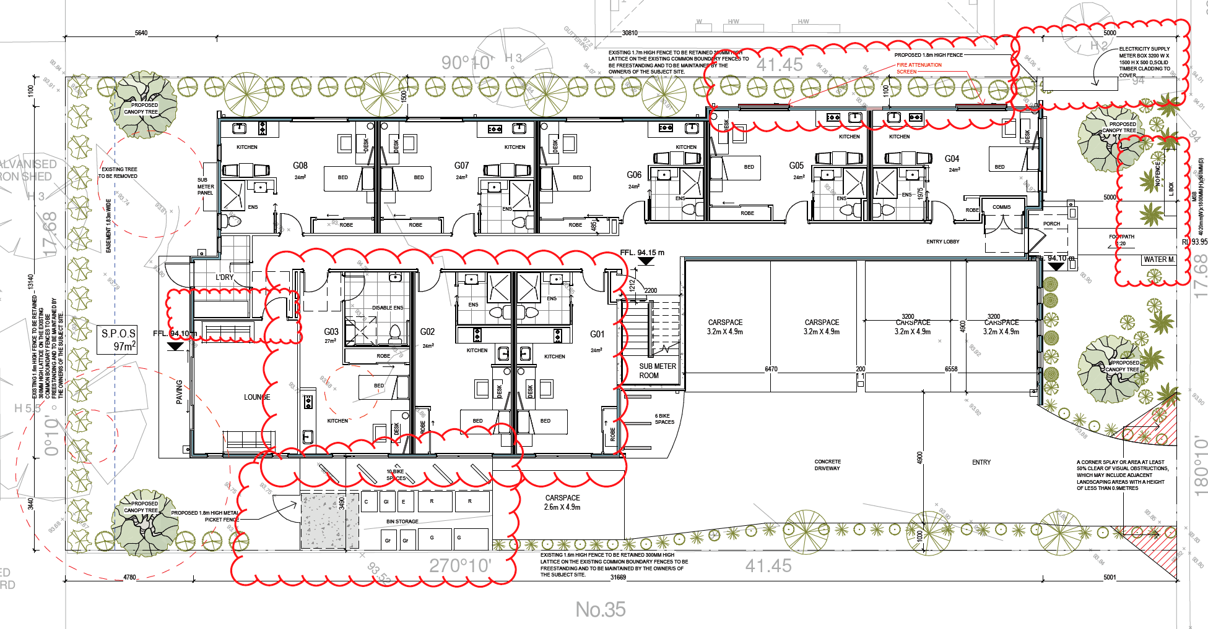
Source: Endorsed plans for TPA/49989/A- Sheet 1 of 3 – TP03 – Ground Floor plan
- A permit was granted for student accommodation at 35 Stockdale Avenue at the direction of the Tribunal in Kong v Monash CC. The layout of this development is shown below:

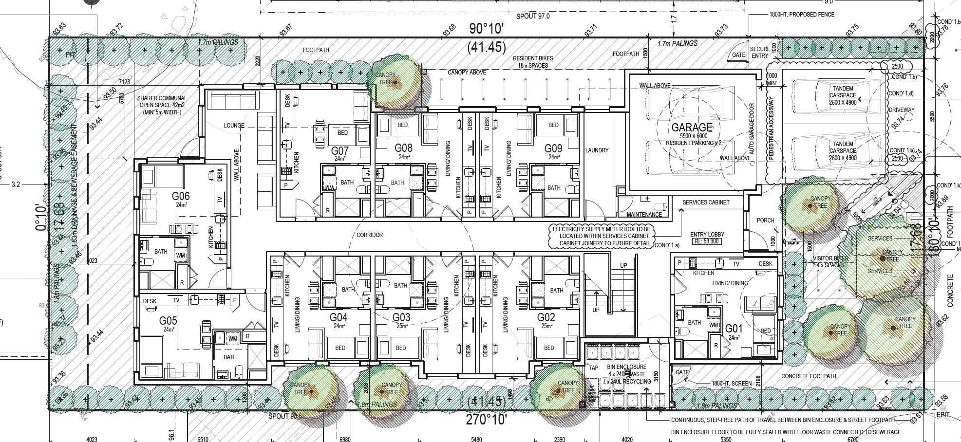
Source: Endorsed plans for TPA/48071 Sheet 1 of 3 – Ground floor plan
- These are examples of student housing that are integrated in one building, include one crossover, generous front gardens and accessible communal facilities within the building for students. These developments generally address the performance measures in Clause 22.10 as there is space in the frontage and around the buildings for landscaping to complement the garden character of this neighbourhood.

Landscaping/Layout
- Clause 22.01-3 contains a general policy to minimise the scale and massing of development and to respect the character of surrounding development. The GRZ6 contains a neighbourhood character objective to address visual bulk through landscaping in frontages and to provide breaks and recesses in the built form. Clause 22.10-4 also contains a performance measure for built form to respond its context.
- Council argues the proposal is not responsive. It says the combination of the bulky design, boundary to boundary form, short side setbacks and high percentage of hard paving in the frontage setback reduces the ability for landscaping and to filter views of the built form. It submits the building is uncharacteristically elongated and has minimal side setbacks that is not found in this neighbourhood. It says the sheer bulk and mass of the proposed building when viewed from the street and adjoining properties is incongruous with the existing and preferred neighbourhood character.
- The applicant submits the development is consistent with the newer town house and apartment developments nearby as it provides well-proportioned garden areas that can accommodate at least four canopy trees in the frontage setback. It considers the layout minimises hard paving as it avoids using a gun-barrel driveway and the rear setback of over 10 metres exceeds the GRZ6 requirement. The applicant says the building provides suitable setbacks and articulated built form at the upper levels to avoid unreasonable visual bulk.

Tribunal Findings
- I acknowledge the five metre frontage setback and ten metre rear setback exceed the varied requirement in the GRZ6. However, I find many aspects of this development contrary to the preferred and existing neighbourhood character for the following reasons:
- The boundary-to-boundary development across the site is contrary to the existing dwelling spacing in the street. My site inspection of this area and aerial photographs indicate that most dwellings are set back from one side boundary for the driveway;
- The two double garages are prominent features in the façade and they accentuate the extensive built form across the site. This is not evident in other dwellings nearby;
- The site layout limits the ability for landscaping in the frontage due to the two wide driveways in the frontage. This results in approximately only 40 square metres of landscaping space in the frontage. Whilst there is a landscape strip adjacent to the side boundaries, this will not adequately soften the appearance of the two driveways in the frontage;
- There are no ground floor habitable room windows in the façade of each building. Whilst the design includes a small balcony and larger first floor windows in the façade, this does not compensate for the lack of connectivity with the street at ground floor level;
- There is limited space for screen landscaping along the side (north and south) boundaries. A 1.2 metre setback from the boundary is inadequate for landscape filtering as a path from the garage will also be provided in this setback;
- There is no articulation of the side elevations at ground floor level and only minimal articulation at first floor level. The provision of a 1.81-2.3 metre first floor setback does not provide suitable breaks and recesses in the built form. This will result in a bulky, elongated built form facing adjoining properties which is inconsistent with other multi dwelling developments nearby and contrary to the neighbourhood character objectives of the GRZ6;
- I acknowledge the design has attempted to incorporate design features to create visual interest such as the use of a variety of materials and skillion roofing. I also note that sufficient space is provided in the rear yard for landscaping, including canopy trees. However, the desire to accommodate two residential buildings results in many issues that are not found in the single student accommodation buildings. I consider the approved student accommodation buildings nearby at 33 and 35 Stockdale Avenue will not have the same impacts on the neighbourhood character as this proposal.

Has an adequate level of amenity been provided for students?
- Clause 22.10- Student Accommodation Policy is designed to encourage provision of high quality student accommodation. It contains include several performance measures relating to the internal amenity for students.

Open Space
- The performance measure at Clause 22.01-4 recommends that a communal open space should be provided at ground level that is located to the side or rear of the building with convenient access from the student amenities area. The plans show each building is provided with a total of 109.6 square metres which exceeds the minimum requirement of 75 square metres per building. This includes the rear yard, first floor retreat and balcony.
- Council argues the communal open space is not convenient from the student amenities area. It notes:
While the quantum of space meets the requirement there in no student amenities area in either dwelling next to the outdoor spaces. Students are therefore in their rooms or outside. The applicant will argue there is an upstairs area with a balcony however the balcony at 2.5 square metres will do little to provide outdoor relief for the occupants. It is however acknowledged it will provide the upper level accommodation units with a nearby space. Notwithstanding that, the balcony is only a metre in width falling well short of the 8 square minimum area of Standard B28 failing the minimums under Clause 55.
- Council says the upper-level retreat is not conveniently accessible for the ground floor occupants. It says the design provides students with the option to access the retreat or the outdoor space but not both. The applicant considers the arrangement is satisfactory as occupants can access the rear yard by walking along the hallway through the new rear door or through the bike storage area and then walking along the side setbacks. It says the longest distance is just over 27 metres, which is not unreasonable or significantly detached. The applicant submits that if this issue was a significant concern, bedroom 4 could be converted to a communal lounge that would provide direct access to rear yard.

Tribunal Findings
- I am not persuaded by the applicant’s arguments and find the communal open space layout is poorly designed and will result in a reduced level of amenity for occupants. I have come to this conclusion for the following reasons:
- There is no ground floor communal area with direct access to the rear yard;
- The rear yard is only accessible from the central passageway or via the side setbacks. Both these routes are past the doors and windows of the other units which would reduce the privacy for occupants; and
- The first floor retreat is not convenient for ground floor units, particularly those at the western end of the building.
- I note the approved plans at 33 and 35 Stockdale Avenue show the provision of a communal lounge at the rear of the building with access to the secluded open space. This layout is possible as it is integrated development within one building.
- In response to Council’s concerns, the applicant suggested that bedroom 4 could be converted into a communal lounge to improve the level of connectivity to the rear yard. Whilst this would address this concern, I am not prepared to entertain amendments to the plans to address this internal amenity issue given my findings about the overall built form, layout and setbacks of the two buildings.

Self Contained Rooms
- The plans show Unit 1 is not self-contained as it does not include kitchen and laundry facilities. Initially the applicant advised that communal kitchen facilities can be provided in the first-floor retreat for these students. It then suggested the floor plan could be modified to provide the facilities for this unit. I acknowledge that basic food preparation facilities could be provided as a condition on the permit.

Waste Management
- Clause 22.10 contains a performance measure to provide a dedicated waste storage area. The plans indicate waste storage is within the double garage.
- Council is concerned there is no dedicated waste area and this will create conflicts with vehicles, particularly for waste disposal and bin removal on collection days. It says this area cannot be sealed, does not contain a wash down area and is not provided with proper ventilation. The applicant says that dedicated waste management/bin storage is provided at ground floor level with access from the corridor. It says the bin storage area is clear of the parking area in the garage and bins can easily be collected by private contractor that will have access through the garage door.
- I consider it is preferable that a separate waste storage area be provided for this type of accommodation to enable it to be properly managed and cleaned. I note the other approved student accommodation facilities have external bin storage that is easily accessible for collection.

Bicycle Storage
- A bicycle storage area is provided to the rear of the garage within the building. Clause 22.10 requires the provision of nine spaces for both buildings. Council says this is a shortfall of one space per building and the area fails to meet the minimum dimensions of Clause 52.34-6. It also submits the storage area is only accessible from the garage which is not deemed as convenient. The applicant says bicycle storage will be provided using a ‘Ned Kelly’ system that allows for five spaces. It submits that additional bicycle parking can be provided in the rear shed.
- I agree with Council that bicycle parking is not convenient as access is through the garage or two doors. An externally accessible bicycle store would be a better arrangement for students to improve its accessibility. I therefore consider this is another example of how the internal amenity of the buildings has not been successfully managed.

Is the provision and car parking layout acceptable?
- Clause 22.10-4 requires car parking to be provided at a rate of 0.3 spaces per bed within preferred locations. This equates to five spaces per building. Council submits the provision of four spaces for the two buildings is insufficient for 18 students which will lead to impacts on the on-street supply. It says the Clause 22.10 rate was already a concessional rate to encourage student accommodation close to Monash University.
- The applicant submitted a traffic report with the application that supports a reduction in car parking rate. It says that surveys of existing student accommodation nearby have a parking demand of 0.09 spaces per student. It also says the findings in Kong v Monash for 35 Stockdale Avenue determined that 0.22 spaces per bed was acceptable. This decision also considered tandem car parking was acceptable.
- I am prepared to accept that the provision of four spaces for 18 beds is adequate given the site is located within easy walking distance of Monash University and the development also provides bicycle storage, albeit in a compromised location.

Is there an acceptable level of amenity for neighbouring properties?
- Council argues the setback and lack of articulation of the side elevations is not responsive to adjoining properties. It says the minimum setback of 1.2 metres at ground floor level fails to provide opportunity for landscape to buffer the development from adjoining properties. Council submits the setback of the first floor 1.81-2.61 metres from the north boundary is inadequate adjacent to the adjoining open space and greater setbacks are required to accommodate tree planting and improved articulation. It also says continuous built form of the first floor south elevation is not responsive to the sensitive interfaces of the adjoining dwelling.
- The applicant submits there is adequate articulation of the buildings as there is only one wall on the boundary and the first floor setbacks meet Clause 55.04-1 (Standard B17 – Side and Rear Setbacks). It says the upper level is suitably recessed and articulated to avoid unreasonable visual bulk impacts to adjoining properties.
- I find that the first floor north elevation will not result in unacceptable visual bulk impacts on the secluded open space of 29 Stockdale Avenue as it steps back 2.81 metres opposite this space. Additionally, the first floor south elevation is facing the driveway and garage of 33 Stockdale Avenue. If the student accommodation is constructed on this site in accordance with the endorsed plans, the south elevation will be facing the driveway, store and bicycle parking area of this building only. Therefore there will be limited amenity impacts to the south.

Other matters
- Council has refused this application on grounds that the proposal fails to demonstrate compliance with the Environmentally Sustainable Development Policy at Clause 22.13. It argues the supporting documentation fails to adequately address the assessment criteria and does not demonstrate how compliance can be achieved.
- Whilst understanding Council’s intention to achieve environmentally sensitive design outcomes, I find this matter could be addressed by permit condition.

Conclusion
- For the reasons given above, the decision of the responsible authority is affirmed. No permit is granted.

Jane Tait
Member

Kong v Monash CC (corrected) [2018] VCAT 1462.
The submissions and any supporting exhibits given at the hearing and the statements of grounds filed have all been considered in the determination of the proceeding. In accordance with the practice of the Tribunal, not all of this material will be cited or referred to in these reasons.
Council submission – para 65.

