VICTORIAN CIVIL AND ADMINISTRATIVE TRIBUNAL
planning and environment LIST | vcat reference No. P61/2021  Permit Application no.TPA/51525
CATCHWORDS
Application under Section 77 of the Planning & Environment Act 1987 to review refusal to grant a permit; Monash Planning Scheme; General Residential Zone 3 – Garden City Suburbs; five triple storey dwellings; neighbourhood character; Garden City Character; landscaping; amenity and safety

Applicant | Mingcheng Bayside Development Pty Ltd

Responsible Authority | Monash City Council
Respondent | Leon James Chymko
Referral Authority | Head, Transport for Victoria

SUBJECT LAND | 42 High Street Road  ASHWOOD VIC 3147

HEARING TYPE | Hearing

DATE OF HEARING | 3 September 2021

DATE OF ORDER | 1 October 2021

CITATION | Mingcheng Bayside Development Pty Ltd v Monash CC [2021] VCAT 1135

Order
- Pursuant to clause 64 of Schedule 1 of the Victorian Civil & Administrative Tribunal Act 1998, the permit application is amended by substituting for the permit application plans, the following plans filed with the Tribunal:
Prepared by: | Archimedium Australia Pty Ltd
Drawing numbers: | TP2, TP3, TP4, TP5, TP6, TP7 and LP1
Revision: | B
Dated: | July 2021

- In application P61/2021 the decision of the responsible authority is set aside.
- In planning permit application TPA/51525 a permit is granted and directed to be issued for the land at 42 High Street Road Ashwood in accordance with the endorsed plans and the conditions set out in Appendix A. The permit allows:

- Construction of five (5) triple storey dwellings and alteration of access to a road in a Road Zone Category 1

Christopher Harty
Member

Appearances
For Mingcheng Bayside Development Pty Ltd | Mr Simon Skinner, Town Planner from Planning Sense Town Planning Consultants. He called the following witness:  - Mr Robert Thomson, Landscape Architect from Habitat Landscape Environmental Design Consultants
For Monash City Council | Mr David De Giovanni, Town Planner from David De Giovanni Town Planning
For Head, Transport for Victoria | No appearance
For Leon James Chymko | In person

Information
Description of proposal | The construction of five (5) triple storey dwellings and alteration of access to a road in a Road Zone Category 1.
Nature of proceeding | Application under section 77 of the Planning and Environment Act 1987 – to review the refusal to grant a permit.
Planning scheme | Monash Planning Scheme
Zone and overlays | General Residential Zone Schedule 3 – Garden City Suburbs (GRZ3)  Vegetation Protection Overlay Schedule 1 – Tree Protection Area (VPO1)
Permit requirements | Clause 32.08-6 to construct two or more dwellings on a lot.  Clause 52.29 to alter access to a road in a Road Zone Category 1.
Relevant scheme policies and provisions | Clauses 11, 15, 16, 18, 21.04, 22.01, 32.08, 52.06, 52.29, 55, 65 and 71.02.
Land description | The subject land is located on the south side of High Street Road, Ashwood (site) and has an immediate abuttal to a Woolworths supermarket and associated laneway to the west. The site is a rectangular shaped lot with a frontage width of 18.29 metres and depth of 48.77 metres and with an overall area of 892 square metres. It has a fall of approximately 2 metres from the south-west corner to the north-east corner. The site is vacant and cleared.  The surrounding area comprises a mix of commercial development associated with the supermarket and the neighbourhood activity centre along Warrigal Road to the west and residential development of single storey units to the east and south and opposite the road to the north. The single storey units to the east and south have their respective private open space areas facing the site.
Tribunal inspection | 29 September 2021 unaccompanied

Reasons

What is this proceeding about?
- Mingcheng Bayside Development Pty Ltd (applicant) seeks to construct five (5) triple storey dwellings at 42 High Street Road, Ashwood (site). Monash City Council (Council) determined on 23 October 2020 to refuse to grant a permit. The applicant has lodged a review of Council's decision.
- The applicant wishes to develop the site with five (5) dwellings each containing three bedrooms to be contained within one building module (refer to Figure 1 for perspective images). It is proposed to have a three-storey reverse living arrangement comprising:
- Ground floor level driveway access and double garages for each dwelling. Dwelling 1 has a bedroom and Dwelling 5 has a sitting room
- First floor level containing kitchen, living, and dining areas. Dwellings 2, 3, 4 and 5 also each have a bedroom.
- Second floor level with each dwelling containing two additional bedrooms.
- Areas of private open space comprise:
- Dwelling 1 with a private open space area at ground floor level within the front setback that is accessed from a bedroom. The private open space is created by a 2 metres high brick and metal insert front fence recessed 3 metres from the front boundary. In addition, at first floor level, a balcony is provided accessed from the living/dining area with an area of 22.5 square metres.
- Dwellings 2, 3 and 4 each with west facing balconies on the first-floor level with areas of 12, 11 and 11 square metres respectively.
- Dwelling 5 with a ground floor level rear yard private open space area of 79 square metres accessed from a sitting room. In addition, at first floor level, a balcony is provided accessed from the living/dining area that faces both south and west with an area of 15.5 square metres.
- Other features of the proposal include:
- An overall height of 9.4 metres.
- Site coverage of 35.6%, site permeability of 40.4% and garden area of 36.19%.
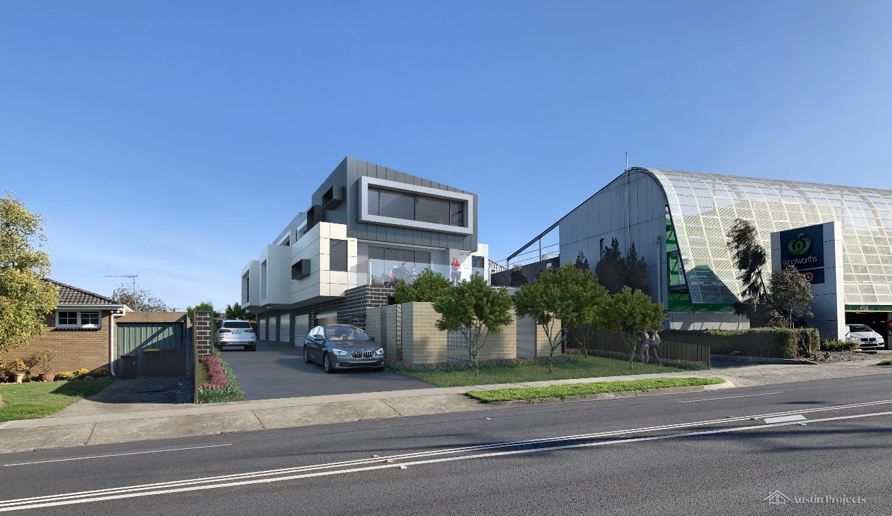
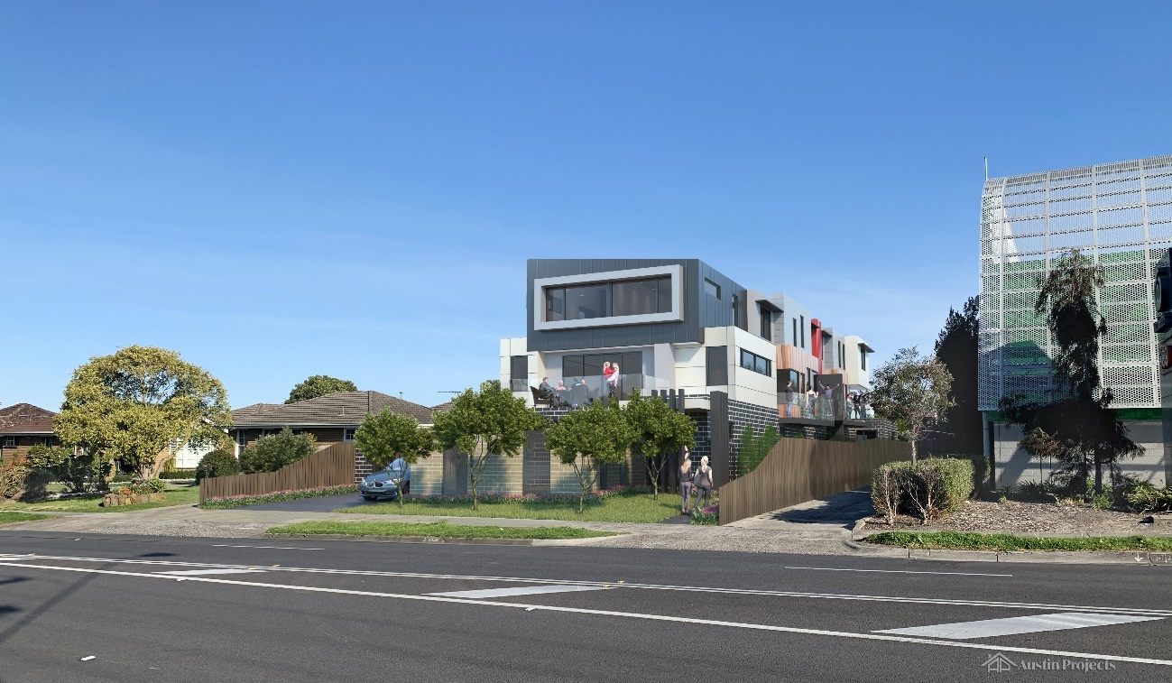

Figure 1: Perspective images of the proposal
- Visitor car parking is not required as the site is located within the Principle Public Transport Network (PPTN).
- Access from High Street Road is proposed via a crossover and driveway with a recessed entry gate that is 5 metres in width with the driveway extending along the eastern boundary of the site. Pedestrian access is separately provided along the western boundary with an entry gate and path with landscaping that accesses each dwelling’s entry.
- The building is contemporary in design with angled roof forms at second floor level, rectangular proportions, and materials comprising face brickwork at ground level, weathertex and render at first floor level, and a combination of alucobond sheeting, render and similar clad materials at second floor level.
- Council's grounds for refusing the permit were primarily that the proposal failed to provide an acceptable design response to the site and policy contexts for the area. Council considered:
- The building site layout, bulk and mass will not contribute positively to the neighbourhood character (both existing and desired future character) of the area.
- The layout and design fail to satisfy objectives relating to internal amenity, amenity impacts, private open space, building entries and detailed design.
- The proposal impacts on and does not contribute sufficiently with regards to landscaping with respect to the Garden City Character of the area.
- The proposal does not provide for active or passive surveillance to the street, the common driveway, or the pedestrian walkway.
- The respondent (objector) supports Council’s position and contends the proposal just does not fit in with the prevailing character of the neighbourhood.
- The applicant submits the proposal represents an acceptable planning outcome, complies with the relevant elements of the Monash Planning Scheme, and should be supported.

What are the key issues?
- The issues raised within the context of this review relate generally to the proposal's design responsiveness to the site and policy context of the area and particularly the design response to the Garden City Character and associated neighbourhood character of the area. There are also issues around amenity and safety. Having heard the submissions, evidence and inspected the site and locality, the key issues arising from this proposal are:
- Does the proposal appropriately respond to the site and policy context of the area?
- Are impacts on amenity unreasonable?
- Is safety reasonably addressed?
- I must decide whether the proposal will produce an acceptable outcome having regard to the relevant policies and provisions in the Monash Planning Scheme. Net community benefit is central in reaching a conclusion. Clause 71.02 - Integrated Decision Making of the planning scheme requires the decision-maker to integrate the range of policies relevant to the issues to be determined and balance conflicting objectives in favour of net community benefit and sustainable development.
- With this proposed development I must decide whether a permit should be granted and, if so, what conditions should be applied.
- Having considered all submissions and evidence presented with regards to the applicable policies and provisions of the Monash Planning Scheme, I find the proposal represents an acceptable outcome.
- The proposal is a reasonable response to the policy outcomes sought under the planning scheme with respect to its setting adjacent to the Warrigal Road commercial precinct and a commercial supermarket building. The landscape evidence demonstrates that the Garden City Character can be respected.
- I have decided to set aside the decision of Council and that a permit is granted subject to conditions outlined in Appendix A. My reasons follow.

Does the proposal appropriately respond to the site and policy context of the area?
- The physical context of the site and surrounds, and the policy context affecting the site interplay to outline what acceptable outcomes are sought for it with regards to residential development.

The site context
- The site is a residential lot fronting High Street Road in Ashwood. It can be described as a site that sits on the south-eastern edge of the commercial centre that straddles Warrigal Road (Ashwood Neighbourhood Activity Centre). It is located adjacent to the Commercial 1 Zone (C1Z) with site abuttal to an existing Woolworths supermarket and adjoining laneway to the west. The area to the east of the site is developed with single storey units around 1980s vintage. Bordering the site to the south is a laneway and further single storey units. It is an area that has experienced medium density housing development associated with a 1970 to 1990s era (refer to Figure 2).
- The site is referred to by the applicant as having a transitional role between the commercial development to the west and residential neighbourhoods to the east.
- Council generally contends that the proposal seeks an over-reliance on the abutting supermarket-built form to justify the intensity of the three-storey typology and pays insufficient regard to the abutting and surrounding neighbourhood residential character with its predominantly single storey-built form. Council considers that further contributing to this poor design response is the insufficient space provided within the development for landscaping and planting of canopy trees that contributes towards the Garden City Character set out in the Monash Planning Scheme.
- The applicant contends Council has not placed appropriate weight on the immediate contextual abuttal of the site to the business centre or the main road frontage of the site and has approached its assessment as though the site was in a quieter, more sensitive residential streetscape or a more isolated neighbourhood setting.
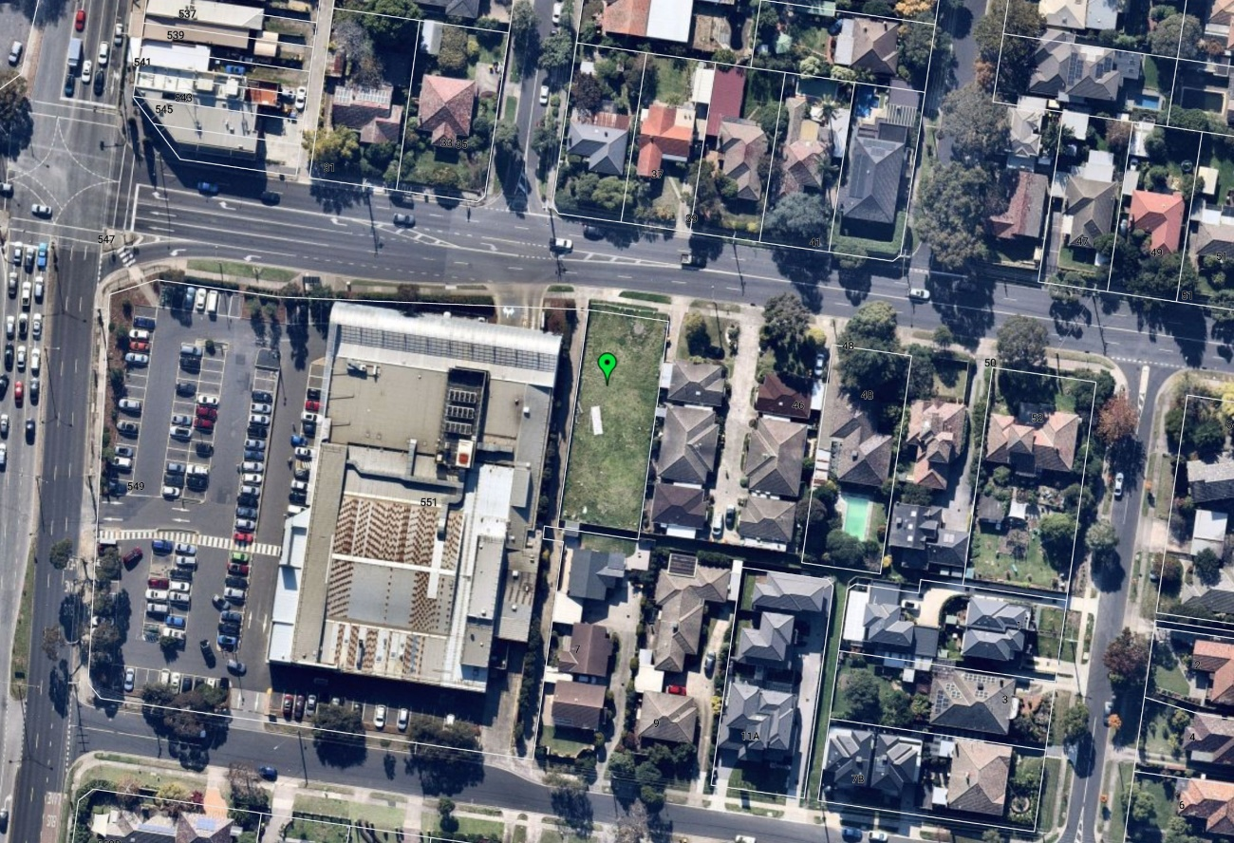

Figure 2: Aerial image of site location

The policy context
- Monash City Council has undertaken significant strategic work through Amendment C125 Parts 1 and 2, which implements the Monash Housing Strategy, 2014. The site was rezoned under Amendment C125 Part 2 on 14 November 2019 from the previous General Residential Zone Schedule 2 – Monash Residential Areas (GRZ2) to the General Residential Zone Schedule 3 - Garden City Suburbs (GRZ3). The GRZ3 affects the residential area that is located to the east of the Ashwood Neighbourhood Activity Centre. Further east, the Neighbourhood Residential Zone (NRZ) takes effect as one gets closer to Gardiners Creek.
- I note that previous permits have been issued for various forms of residential development on the site, none of which have progressed and all of which were granted under the previous zoning.
- The GRZ encourages a diversity of housing types and housing growth particularly in locations offering good access to services and transport. It also encourages development that respects the neighbourhood character of the area.
- Council stressed that it is the reference to neighbourhood character and Garden City Character under the GRZ3 that establishes the strategic context within which the assessment of character needs to take place, and which should be at the forefront of an assessment. While I acknowledge Council’s position in this regard, I also do acknowledge that the site is located within good access to services, facilities, and transport and fronts a dual lane arterial road within the PPTN.
- Neighbourhood character and Garden City Character go hand in hand under the Monash Planning Scheme with a strong theme resonating with how new residential development is considered. Erosion of the Garden City Character through loss of significant vegetation and tree canopy and inappropriate redevelopment of residential areas is a key concern identified in the planning scheme.
- The planning scheme recognises that new development should provide suitable setbacks, appropriate site coverage and site permeability and sufficient open space areas to allow for tree retention and new planting to support Garden City Character.
- Schedule 3 of the GRZ reinforces the Garden City Character theme through the inclusion of the following neighbourhood character objectives:
- To support new development that contributes to the preferred garden city character through well landscaped and spacious gardens that include canopy trees.
- To promote the preferred garden city character by minimising hard paving throughout the site by limiting the length and width of accessways and limiting paving within open space areas.
- To support new development that minimises building mass and visual bulk in the streetscape through generous front and side setbacks, landscaping in the front setback and breaks and recesses in the built form.
- To support new development that locates garages and carports behind the front walls of buildings.
- The GRZ3 also includes decision guidelines addressing:
- Whether the development provides an appropriate transition to built form on adjoining sites.
- The robustness of proposed materials and finishes.
- The impact of the shape and dimensions of the lot on the ability of the development to meet any requirements of this schedule.
- The location and number of vehicle crossovers.
- The impact of the development on nature strips and street trees.
- The location, quantity and species of vegetation provided.
- Clause 21.04 – Residential Development identifies how residential development will be provided and recognises the need to manage residential growth to ensure it is directed to neighbourhood activity centres that are well serviced by public transport, retailing, community facilities and employment opportunities. It identifies the importance of reducing pressure on the less accessible areas to allow their garden city character to be preserved. The policy reinforces the Monash Housing Strategy, 2014 and identifies various residential character types of which the site falls within an area of incremental change in Category 8 – Garden City Suburbs.
- The policy seeks to encourage the provision of a variety of housing types and sizes that will accommodate a diversity of future housing needs and preferences that complement and enhance the garden city character of the municipality. It includes a strategy to ensure that development enhances the garden city and landscaped streetscape character of the neighbourhood and promotes good streetscape design. The policy also includes strategies that seek to maintain the single detached dwelling character in suburban areas while also directing more intensive higher scale development to neighbourhood activity centres that are well served by public transport, commercial and community facilities.
- Regarding the Garden City Suburbs, the Monash Housing Strategy includes a prevailing objective for providing opportunities for modest housing growth and diversification with emphasis on preserving and enhancing Garden City Character.
- The Garden City Character theme is reinforced in policy under Clause 22.01 – Residential Development and Character Policy, which references larger setbacks for canopy tree planting, including side boundaries being capable of supporting canopy trees. The policy includes residential character statements for various residential areas in the municipality and seeks development to respond to the preferred future character statements.
- The site is identified within residential character type Garden City Suburbs Northern Areas, which has the following preferred future character statement:
Although there will be changes to some of the houses within this area, including the development of well-designed and sensitive unit development and, on suitable sites, some apartment development, these will take place within a pleasant leafy framework of well-vegetated front and rear gardens and large canopy trees.
Setbacks will be generous and consistent within individual streets. Building heights will vary between neighbourhoods. Neighbourhoods with diverse topography and a well-developed mature tree canopy will have a larger proportion of two storey buildings. In the lower, less wooded areas, buildings will be mainly low rise unless existing vegetation or a gradation in height softens the scale contrast between buildings. New development will complement the established buildings through consistent siting, articulated facades and use of materials. New development will consider energy efficiency and sustainability principles. Long expanses of blank wall will be avoided, particularly when adjacent to public parks, reserves and other open space areas, where the building should address the public area.
Architecture, including new buildings and extensions, will usually be secondary in visual significance to the landscape of the area when viewed from the street. New development will be screened from the street and neighbouring properties by well planted gardens that will ensure the soft leafy nature of the street is retained.
Gardens will consist of open lawns, planted with a mix of native and exotic vegetation and trees.
Existing mature trees and shrubs will be retained and additional tree planting within streets and private gardens will add to the tree canopy of the area.
Buildings will be clearly visible through these low garden settings, and non-existent or transparent front fences. Additional vehicle crossovers will be discouraged.
The built-form will be visually unified by well-planted front gardens that contain large trees and shrubs and street tree planting. Trees within lots to be redeveloped will be retained wherever possible to maintain the established leafy character.
Landscape elements such as remnant indigenous vegetation and the large old coniferous wind-rows will be retained until trees are no longer healthy or safe.

The Tribunal’s findings
- I acknowledge that whilst the planning scheme places strong emphasis on protecting and enhancing Garden City Character, the descriptions of the site and surrounds and what I have viewed from my inspection is that:
- The site is cleared and vacant with a large tree that was located near the front of the site having been lawfully removed and which now holds no impediments to accommodating medium density residential development.
- Both the site and the immediate surrounding residential area has minimal contribution to the leafy Garden City Character sought by the planning scheme. The surrounding residential area comprises multi-unit developments with few canopy trees and modest landscaped gardens. The most significant canopy tree contribution to Garden City Character in this area is predominantly from street trees and more dense trees and vegetation located within the Gardiners Creek reserve that is approximately 430 metres to the east of the site.
- The site is located on the edge of commercial development associated with a neighbourhood activity centre that straddles Warrigal Road, which although not recognised as such in the Monash Planning Scheme, is recognised under the adjoining Boroondara Planning Scheme. The site is next to an existing supermarket which has a built form that is commercial in nature and typology. The supermarket has a core building with a height of around 6 metres and an architectural feature skin of around 10.5 metres in height. This offers a robust edge to which the site acts as a transition with the single storey residential built form on the other side of the site.
- The location of the site, lack of impediments to development means it can provide for a modest form of residential development that is more intense that what is to the east and to which it can act as a zone of transition and gateway between existing low scale residential development and commercial development along this section of High Street Road.
- I find the proposal is not at odds with the intent and aspirations of the planning scheme given these physical and policy contexts.
- The evidence of Mr Thomson on behalf of the applicant demonstrates that the proposal can enhance the Garden City Character of this location through landscaping that includes canopy tree planting in addition to planting of shrubs and groundcovers. Part of Mr Thomson’s evidence included a landscape plan (refer to Figure 3) showing that seven (7) canopy trees greater than 9 metres in height (including 5 trees at 10 metres in height) could be planted together with 11 canopy trees at around seven metres or more in height. The landscape plan also included 10 palm trees that can reach 7 metres in height. This level of tree planting was also shown on the landscape plan to be supplemented by around 23 other shrubs.
- I find the landscape plan that formed part of Mr Thomson’s evidence satisfies the GRZ3 varied requirements of Standard B13 for landscaping and it would go a long way towards introducing more vegetation on the site than what existed and what is absent now. His evidence demonstrated that his suggested landscaping would contribute to a combination of screening and filtering of the new built form, albeit at three storeys or 9.4 metres in height.
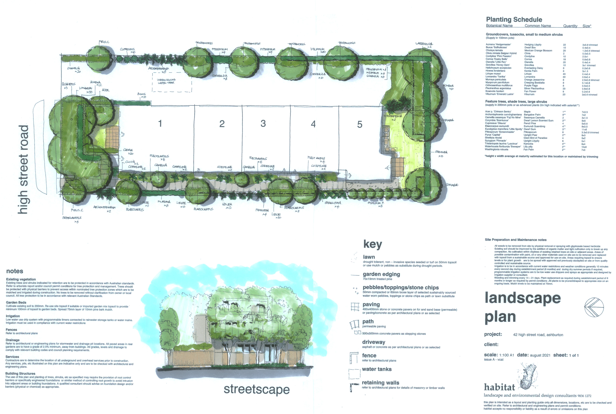

Figure 3: Landscape plan evidence
- I particularly note that occupants of the single storey units around the site would have a filtered view of the proposed built form looking up through the vegetation once it has matured. This will help break up the overall bulk and mass of the proposal.
- Council was concerned with the height of the proposal forming too much of a ‘jarring’ contrast to the single storey building heights of surrounding residential development. Council was also concerned that the extent of continuous built form extending down the length of the site with its lack of breaks in built form creates one large building mass. This mass and bulk would be contributed by the cantilevered first floor level over the garages and driveway to the east and facing the adjoining residential housing and their respective private open space areas at ground level. Council considered the extent of building mass would be most pronounced from oblique views into the site from the street.
- I note that the proposed built form is located along the central spine of the site occupying proportionally 50% of the overall site width and resulting in no walls on boundaries and the built form setback from all boundaries. These setbacks include:
- From the front street boundary (north) 3 metres to a front fence, 7.6 metres to the front wall at ground floor level, 7.6 metres to the balcony and 10.6 to 11.2 metres to the front wall at first floor level and 10.6 metres at second floor level.
- From the eastern side boundary, 5 to 6.5 metres associated with the driveway at ground floor level, 4.4 to 5.5 metres at first floor level and 6.5 to 7.5 metres at second floor level.
- From the rear southern boundary, 5 to 6.4 metres, 6.4 to 7.2 metres at first floor level (with slightly lessor setbacks from balconies) and 6.9 to 7.2 metres at second floor level.
- From the western side boundary, 2 to 3 metres at ground floor level, 3 to 5.3 metres at first floor level (with lessor setbacks from balconies) and 2.6 to 4.2 metres at second floor level.
- The layout of the proposal offers a restrained and centralised built form response relative to its context.
- The variety of the setbacks combined with the articulation and variety of colours and materials and finishes provide for an outcome, that, although is associated with a three storey and continuous built form, is one that creates interest through the variety of the typology. My views, in this regard, would be different if the setbacks to the east and south were in the order of a couple of metres.
- The proposal is appropriately setback from the more sensitive northern, eastern, or southern boundaries to minimise significant detrimental impacts.
- The proposal is an acceptable response to the physical and policy contexts. It is a modest residential development that responds to the adjacent commercial development, separates itself from all boundaries and provides landscaping opportunities that respects neighbourhood character, contributes to Garden City Character, and maximises location adjacent to a commercial centre in Ashwood.

Are impacts on amenity unreasonable?
- The impacts on amenity from the proposal primarily relate to the proposed reverse living arrangements and orientation of private open space for future occupants of the proposed dwellings and overlooking issues from the second floor to the east.

Reverse living and private open space orientation
- The proposal generally includes living areas on the first- floor level and bedrooms on the second-floor level. Balconies are provided for all dwellings with Dwellings 1 and 5 having additional private open space at ground level to the north and south respectively. Balconies for Dwellings 2, 3, 4 and 5 at the first-floor levels face to the west towards the supermarket building (the balcony for Dwelling 5 also has a part southern orientation).
- Council contends that the reverse living design and balcony orientation results in private open space areas for the dwellings facing west and experiencing a poor amenity outlook through facing the hot western sun and facing a commercial building that does not offer an attractive outlook.
- I noted that the supermarket has landscaping along its eastern façade including trees, which helps to break up its built form. Often, reverse living arrangements can pose problems with overlooking into adjoining private open space areas or habitable room windows of adjoining dwellings. This is not the case here. No external amenity impacts arise. The presence of separation from the supermarket building by the existing intermediate laneway and existing landscaping on the supermarket building and the proposed landscaping along the pedestrian access path along the western side boundary offers an appropriately softened design response for the proposed dwellings.
- I note the sizing of the balconies for Dwellings 2, 3 and 4 do not fully comply with the GRZ3 variation to Standard B28 under Clause 55.05-4 which requires an area of 10 square metres with a minimum width of 2 metres. The proposed balconies in this instance provide an area of 8.6 square metres with a minimum width of 2 metres. The applicant proposed that this could be overcome by internally adjusting the stairs to increase the balcony areas to 12.7 square metres and provide an area of 10.6 square metres with a minimum of 2 metres width. I consider this is an acceptable improvement and will include a condition.
- The southern orientation of the private open space areas of Dwelling 5 at both ground and first floor levels to the south was a concern of Council with respect to lack of solar access. The applicant accepted that the private open space of Dwelling 5 does not comply with the requirements for solar access under Standard B29 (Clause 55.05-5). It appears a small section in the south-east corner of the ground floor level secluded private open space of Dwelling 5 will not be overshadowed. The applicant submitted, that despite this limitation, the private open space areas provided at both ground floor level and at first floor level with the balcony which also enjoys an orientation to the west provides space for private recreation in excess of what is required under the GRZ3.
- I note the applicant suggests that an improved outcome for solar access to the south of Dwelling 5 could be achieved through deletion of Bedroom 3 from the second-floor level. This would ensure that approximately 35 square metres of the ground floor level secluded private open space would receive solar access. I consider this an appropriate response and would improve solar access and have included a condition.

Overlooking
- Council contends the east facing windows of the dwellings along the second-floor level create potential overlooking into the private open space areas of the adjoining dwellings to the east. The applicant considered the height of these bedroom windows and the necessity for any person standing and looking down towards the adjoining properties to the east would either be beyond the view arc of 9 metres or be screened by the cantilevered section of the first-floor level. The applicant suggested a condition could be included requiring this to be demonstrated and if required the use of fixed external screens to control the downward angle of any view would be appropriate. I consider it appropriate to include a condition requiring the use of fixed external screens with louvres that avoid any downward view would be sufficient to achieve a satisfactory response and acceptable outcome.
- Generally, subject to the conditions I have considered, I find that the impacts on amenity are not unreasonable.

Is safety reasonably addressed?
- Council considered that entry arrangements of the dwellings associated with the proposed pedestrian path down the western side of the proposed development would be narrow and well setback behind the front wall of the building to create a poor level of safety for future occupants of and visitors to the dwellings.
- Council believes the poor response to safety is heightened by an absence of any ground floor level habitable room windows facing the pedestrian path limiting surveillance and enhancing opportunities for concealment of this space.
- The applicant refutes Council’s concerns. The pedestrian access down the western side of the proposed development comprises a space 3 metres in width that includes a curvilinear concrete path amid landscaping and provided in part with weather protection from the first-floor level balconies. It will be clearly discernible from the street guided by the letterboxes and visible entry to Dwelling 1. A gate that can provide security is provided for access to the other dwellings. Each dwelling entry is located in a foyer area with a sidelight window which allows any visitors to be seen.
- I accept the position of the applicant on the basis that access to Dwellings 2, 3 4 and 5 can be controlled and managed. A similar situation also exists with regards to vehicular access to the site with a security gate system to be installed on the east side of the proposal. Generally, I find the level of safety is not compromised and has been reasonably addressed.

What conditions are appropriate?
- I have had the benefit of a 'without prejudice' discussion of draft permit conditions circulated by Council.
- There is some discussion between parties as to what conditions should be imposed. I have discussed some of them within my reasons.
- I have included conditions as I consider appropriate for the proposal and the issues regarding the proposed development.

Conclusion
- For the reasons given above, the decision of the responsible authority is set aside. A permit is granted subject to conditions.

Christopher Harty
Member

Appendix A – Permit Conditions

Permit Application No | TPA/51525
Land | 42 High Street Road  ASHWOOD VIC 3147

What the permit allowS
In accordance with the endorsed plans:
- Construction of five (5) triple storey dwellings and alteration of access to a road in a Road Zone Category 1

Conditions
- Before the development starts, two copies of amended plans drawn to scale and dimensioned, must be submitted to and approved by the responsible authority. When approved the plans will then form part of the permit. The plans must be generally in accordance with the plans prepared by Archimedium Australia Pty Ltd, dated July 2021 and marked as 'Revision B' but modified to show:
  - Ramp grades (except within 5 metres of the frontage) to be designed as follows:
    - Maximum grade of 1 in 4.
    - Provision of minimum 2.0 metre grade transitions between different section of ramp or floor for changes in grade in excess of 12.5% (summit grade change) or 15% (sag grade change). The measured ramp grade of the proposed ramp transition between Unit 2 and 3 garages does not match with the annotation.
    - Grade changes greater than 18% or less than 3 metres apart are to be assessed for clearances in accordance with Appendix C of the Australian Standard for Off - Street Car Parking, AS/NZS 2890.1.
  - Any changes recommended in the Sustainable Design Assessment (SDA) report required by Condition 4 of this permit;
  - Corner splay or area at least 50% clear of visual obstructions (or with a height of less than 1.2 metres), which may include adjacent landscaping areas with a height of less than 0.9 metres, extending at least 2.0 metres long x 2.5 metres deep (within the property) both sides of vehicle crossing to provide a clear view of pedestrians on the footpath of the frontage road.
  - The second level east facing bedroom windows of dwellings 2, 3, 4 and 5 to be screened with permanently fixed external screens with panels that are 25% transparent and control the direction of view to avoid downward looking views into the private open space or habitable room windows of adjacent properties in accordance with Standard B22.
  - The first floor east facing windows noted as being screened to include details of the extent of screening, and that these windows be fixed to 1.7m height.
  - The balcony of dwelling 5 on the south elevation to be noted as having obscured glazing.
  - The location of water tanks, solar hot water systems, solar panels, and condensers.
  - The area of balconies associated with Dwellings 2, 3 and 4 increased by internally adjusting the stairs to achieve compliance with providing a minimum 10 square metres of balcony area with a minimum of 2 metres width.
  - The deletion of Bedroom 3 from the second-floor level of Dwelling 5 to increase the extent of solar access to the secluded private open space at ground floor level to an area of approximately 35 square metres.
  - Provision of the pedestrian path to the west in permeable paving.
  - A landscape master plan showing planting, species selections, quantities and sizes generally in accordance with the Landscape Plan, dated August 2021 Issue A-VCAT prepared by Habitat Landscape and Environmental Design Consultants and attached to the evidence of Robert Thomson. Tree species to be planted in the front and rear setbacks and along the eastern side boundary are to be planted in advanced sizes (Refer also to Conditions 5 and 6).
- The development as shown on the endorsed plans must not be altered without the written consent of the responsible authority.
- Before the occupation of the buildings allowed by this permit, landscaping works as shown on the endorsed plans must be completed to the satisfaction of the responsible authority and then maintained to the satisfaction of the responsible authority.
- Concurrent with the endorsement of plans requested pursuant to Condition 1, a Sustainable Design Assessment (in accordance with Clause 22.13) to the satisfaction of the responsible authority must be submitted to and approved by the responsible authority. Upon approval the Sustainable Design Assessment will be endorsed as part of the planning permit and the development must incorporate the sustainable design initiatives outlined in the Sustainable Design Assessment to the satisfaction of the responsible authority.
- Unless otherwise approved in writing by the responsible authority, prior to commencement of the development the landscape master plan must be submitted to and endorsed by the responsible authority. When approved, the plan will be endorsed and will then form part of the permit. Plans must be generally in accordance with the landscape master plan and show:
  - Scale and dimensions
  - The layout of proposed new planting
  - A detailed planting schedule of all proposed trees and plants including botanical names, common names, pot sizes, sizes at maturity and quantities for each species
  - Tree species to be planted in the front and rear setbacks and along the eastern side boundary are to be planted in advanced sizes.
  - All proposed groundcover & shrub planting with a minimum container size of 150mm and must not exceed 400 mm in height at maturity
  - The maintenance schedule for all proposed planting
  - The estimated canopy of the mature trees (at 20 years) must be shown to scale
- Prior to completion of the development, landscaping works shown on the endorsed Landscape Master Plan must be completed to the satisfaction of responsible authority.

Department of Transport Conditions (5 to 9)
- Prior to the commencement of use or occupation, a sealed access crossover as at least 5 metres wide at the property boundary with the edges of the crossover angled at 60 degrees to the edge of the road, at least for the first 3.0 metres with 3.0 metres radial turnouts must be constructed to the satisfaction the responsible authority and at no cost to Head, Transport for Victoria.
- Prior to the commencement of use or occupation, all disused or redundant vehicle crossings must be removed, and the area reinstated to the satisfaction of the responsible authority and at no cost to the Head, Transport for Victoria.
- Prior to the commencement of the use or the occupation of the buildings or works hereby approved, the access crossover and associated works must be provided and available for use.
- Vehicles must enter and exit the land in a forward direction at all times.
- The level of the footpaths must not be lowered or altered in any way to facilitate access to the site.
- A detailed plan of the crossover access design to High Street Road must be submitted to the responsible authority for approval. A Road Opening Permit, with associated refundable security bond, will be required from Council's Engineering Department prior to the roadworks commencing.
- All stormwater collected on the site from all hard surface areas must not be allowed to flow uncontrolled into adjoining properties or the road reserve.
- The private on-site drainage system must prevent stormwater discharge from the/each driveway over the footpath and into the road reserve. The internal drainage system may include either:
  - a trench grate (minimum internal width of 150 mm) located within the property boundary and not the back of footpath; and/or
  - shaping the internal driveway so that stormwater is collected in grated pits within the property; and or
  - another Council approved equivalent.
- All stormwater collected on the site is to be detained on site to the predevelopment level of peak stormwater discharge. The design of any internal detention system is to be approved by Council's Engineering Department prior to drainage works commencing.
- The nominated point of stormwater connection for the site is to the north-east corner of the property where the entire site's stormwater must be collected and free drained via a pipe to the 225mm Council drain in the naturestrip via a 900mm x 600mm junction pit to be constructed to Council standards. Note: If the point of connection cannot be located then notify Council's Engineering Department immediately.
- All new vehicle crossings are to be no closer than 1.0 metre, measured to the edge of any power pole, drainage or service pit, or other services. Approval from affected service authorities is required as part of the vehicle crossing application process.
- All new crossings must be a minimum of 3.0 metres in width.
- The existing redundant crossing is to be removed and replaced with kerb and channel. The footpath and naturestrip are to be reinstated to the satisfaction of Council.
- All vehicle crossings within 1.50 metres of an adjoining crossing shall be converted to a double crossing in accordance with Council standards.
- Any works within the road reserve must ensure the footpath and naturestrip are to be reinstated to Council standards.
- Once the development has started it must be continued, completed and then be maintained to the satisfaction of the responsible authority.
- This permit as it relates to development (buildings and works) will expire if one of the following circumstances applies:
  - The development is not started within three (3) years of the issue date of this permit.
  - The development is not completed within five (5) years of the issue date of this permit.
In accordance with section 69 of the Planning and Environment Act 1987, an application may be submitted to the responsible authority for an extension of the periods referred to in this condition.

– End of conditions –

No permit requirement was triggered under VPO1 as no vegetation removal was proposed.
The submissions and evidence of the parties, any supporting exhibits given at the hearing and the statements of grounds filed have all been considered in the determination of the proceeding. In accordance with the practice of the Tribunal, not all of this material will be cited or referred to in these reasons.
All compliant with the requirements of the planning scheme.
This commercial centre is referred to under the Boroondara Planning Scheme as the Ashwood Neighbourhood Activity Centre due to Warrigal Road forming the municipal boundary between Boroondara and Monash City Councils.
The Monash Housing Strategy, 2014 is a background document under Clause 21.04-4 and a Policy Reference document under Clause 22.01-6.
Refer to Maintaining the Garden City Character under Clause 21.01-2.
Schedule 3 to the GRZ includes stricter variations to Clause 55 requirements relating to Site coverage of 50% compared to 60%, site permeability of 30% compared to 20%, rear setbacks of at least 5 metres and one canopy tree plus at least one canopy tree per 5 metres of site width.
Compared to areas such as the activity centres, boulevards, and the Monash National Employment Cluster.
Under Clause 55.03-8.

