VICTORIAN CIVIL AND ADMINISTRATIVE TRIBUNAL

|  |  |
| --- | --- |
| planning and environment LIST | vcat reference No. P453/2021  Permit Application no.TPA/51791 |
| CATCHWORDS | |
| Section 79 of the *Planning and Environment Act 1987*; General Residential Zone GRZ3; Two Lots; Six Dwellings; National Employment Cluster; Garden City Suburbs; Landscape Response; Off-Site Amenity Impacts; Internal Amenity and Site Layout. | |

|  |  |
| --- | --- |
| **Applicant** | LH Group Enterprises Pty Ltd |

|  |  |
| --- | --- |
| **Responsible Authority** | Monash City Council |

|  |  |
| --- | --- |
| SUBJECT LAND | 7 - 9 Thompson Street  CLAYTON VIC 3168 |

|  |  |
| --- | --- |
| HEARING TYPE | Hearing |

|  |  |
| --- | --- |
| DATE OF HEARING | 31 August 2021 |

|  |  |
| --- | --- |
| DATE OF ORDER | 10 September 2021 |

|  |  |
| --- | --- |
| CITATION | LH Group Enterprises Pty Ltd v Monash CC [2021] VCAT 1046 |

# Order

### Permit granted

1. In application P453/2021 the decision of the responsible authority is set aside.
2. In planning permit application TPA/51791 a permit is granted and directed to be issued for the land at 7 - 9 Thompson Street, Clayton, in accordance with the endorsed plans and the conditions set out in Appendix A. The permit allows:

* Construction of six (6) double storey dwellings.

|  |  |  |
| --- | --- | --- |
| **Margaret Baird**  **Senior Member** |  |  |

# Appearances

|  |  |
| --- | --- |
| For applicant | Mr D Bowden, SongBowden Planning. |
| For responsible authority | Mr P English, Peter English and Associates. |

# Information

|  |  |
| --- | --- |
| Description of proposal | Six, two storey, dwellings. Four front units are designed to present as two detached dwellings. Dwellings 5 and 6 are at the rear of the land. Dwellings 1 and 4 each have a single crossover to a single garage with tandem car space. The balance of the dwellings are accessed via a central driveway. A landscape plan has been prepared. |
| Nature of proceeding | Application under section 79 of the *Planning and Environment Act 1987* – to review the failure to grant a permit within the prescribed time.[1] |
| Planning scheme | Monash Planning Scheme [**scheme**]. |
| Zone and overlays | General Residential Zone [**GRZ**] Schedule 3 Garden City Suburbs [**GRZ3**].  Design and Development Overlay Schedule 15 [**DDO15**]. |
| Permit requirements[2] | Clause 32.08 to construct two or more dwellings on a lot. Mandatory requirements are met. |
| Relevant scheme policies and provisions | Clauses 11, 15, 16, 21, 22.01, 22.04, 22.05, 22.13, 32.08, 43.02, 52.06, 55, 65 and 71. |
| Land description[3] | The subject land comprises two lots with an overall site area of 1,393m2. The land is close to the junction of Thompson Street and Carinish Road. One lot is currently vacant while the other contains a dwelling. |
| Tribunal inspection | The Tribunal advised parties at the start of the hearing that it is familiar with the area. |

# Reasons[4]

## INTRODUCTION

1. LH Group Enterprises Pty Ltd applied to the Monash City Council [**Council**] to construct six dwellings on the subject land. As the Council failed to grant a permit within the prescribed time, the applicant applied to the Tribunal asking for that permit to be granted.
2. The Council has subsequently indicated that it opposes a permit being granted. The Council’s grounds focus on the proposal’s response to neighbourhood character and its inadequate landscape outcome. The Council’s submission states that the site comprises a comparatively large, flat and unencumbered parcel of land that is suitable for a medium density development. However, in Council’s view, six dwellings of the size proposed will produce an outcome that attempts to squeeze too much built form on the site, with consequential impacts in relation to neighbourhood character, visual bulk to neighbouring properties, and a lack of landscaping. Although medium density development is an emerging feature in the area, the Council says the proposal fails due to a combination of the extensive ground-level footprint, insufficient first-floor recession, limited building articulation, lack of building separation, and inadequate landscaping opportunities.
3. The applicant challenges all grounds relied upon by the Council. It submits the proposed development will sit comfortably within the emerging character of the surrounding area. By virtue of its inclusion in the Monash National Employment Cluster and adjacent to the Clayton Activity Centre, the land is designated for change, diversification and intensification. The applicant argues that there are no unreasonable off-site amenity impacts and the development provides for a high level of internal amenity.

## PLANNING CONTEXT

1. The parties have addressed the relevant scheme policies and provisions, which I do not recite. They agree that the proposal contributes to the range of housing options available and to urban consolidation. The GRZ3 and scheme policy support medium density development in this location.
2. In applying the scheme, a dilemma arises from:

* The land’s notation as being included in the Monash National Employment and Innovation Cluster through *Plan Melbourne* and the framework plan at clause 21.04 (shown below as Category 3[5]); and
* The land’s rezoning to GRZ3 through Amendment C125 Part 2 and concurrent designation the Garden City Suburbs – Southern Areas character area through clause 22.01.

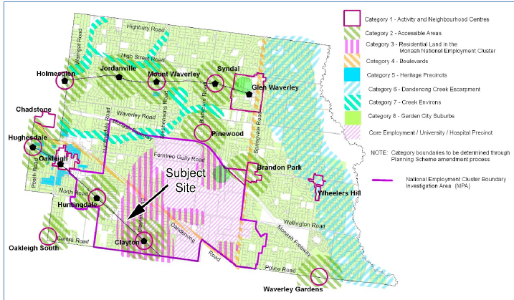

Extract from Residential Development Framework Map 3 at clause 21.04-1

(from Mr English’s submission with the subject land identified)

(Tribunal highlighting of Category 3 and Note)

1. The Categories are explained in clause 21.04-1. The clause states that the residential development framework translates the overall aims of the housing strategy into a location plan (Map 3) that broadly identifies the preferred location for different types of housing. Map 3 includes a Note – “*Category boundaries to be determine through Planning Scheme amendment process*”. Clause 21.04-3 states zones are applied as follows:

Applying the Residential Growth, General Residential, Neighbourhood Residential and Mixed Use Zones including specific schedules to achieve preferred development outcomes.

1. The rezoning to GRZ3 – Garden City Suburbs occurred at the same time as other land was rezoned GRZ6 – Monash National Employment and Innovation Cluster and Clayton Activity Centre. Some land within the hatched Category 3 Area was rezoned GRZ3 (subject land and surrounds), while other land (such as in Thompson Street, east of Flora Road) was rezoned GRZ6. The schedules have some commonalities but also evident differences.
2. The applicant emphasises, and asks the Tribunal to give weight to, the subject land’s inclusion within “*Category 3: Monash national employment cluster*”, which is a housing growth area. Conversely, the Council refers to the evolution of policy and emphasises the current zoning and applicable residential character area set out in clause 22.01-4 (shown on map 1 from that policy below). The subject land is within the Garden City Suburbs Southern Areas, aligned with the GRZ3.

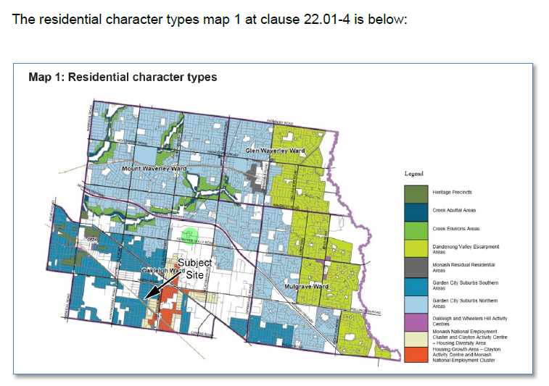

1. Clause 22.01 directs residential growth to the National Employment Cluster[6], but clause 22.01 includes the subject land in an area for modest growth[7] or incremental change. Strategically, the residential outcome for Category 8 areas is less intense than directed to the Category 3 areas.[8]
2. I was referred to several recent Tribunal decisions that describe a “*tension*” between the policy and the application of zones.[9] Broader objectives with respect to growth near to major facilities in the National Employment Cluster are a relevant strategic consideration, however, my decision must be based on the zone and related character policies that clearly apply.
3. There is an evident inconsistency that requires resolution by the planning authority. In applying the scheme in the current case, the zone and preferred character carry weight rather than the hatching in the framework plan that, as the plan itself states, is subject to determination. Having said that, the subject land is in an area that is well placed relative to the Clayton Activity Centre, the Monash Medical Centre and Monash University, although it is not adjacent to these facilities. Change is expected, but not the degree of change that is directed to locations closer to these facilities that are within, for example, Residential Growth Zones or in GRZ6.
4. Contextually, there is a presence of multi-unit development in the immediate environs of the subject land including double storey townhouses. There remains a strong representation of the traditional single storey dwelling stock, with some two storey dwellings east along Thompson Street.
5. Clauses 22.01-3 and 22.01-5 set out character policies and decision guidelines, which I have considered but do not recite. The policy is specific to matters such as street setback, landscaping, side and rear setbacks, private open space, and built form and scale. The Council’s submission summarises key policies as:

* Respect the style of surrounding development, and maintain consistent setbacks and building spacing.
* Minimise the impacts of bulk and scale.
* Provide consistent front setbacks.
* Minimise the dominance of car storage facilities and vehicle crossings.
* Respect the height, building materials, roof forms, scale and rhythm of surrounding development.
* Provide a high degree of articulation, particularly in areas where the prevailing built form is single-storey.
* Boundary construction should be in the context and character of the site and adjoining properties.
* Minimise hard paving by limiting driveway widths and lengths and providing landscaping on both sides of driveways.
* Ensure site coverage respects the character of the area.

1. Clause 22.01-4 describes the preferred character for the Garden City Suburbs – Southern Areas:

Modest dwellings with simple pitched rooflines and articulated facades will continue the prevailing development themes. On larger sites, low rise apartment development may be appropriate, provided the development is sited within generous open space, is well landscaped, retains the ‘open landscape character’ of the garden suburban setting and tapers down in scale closer to the boundaries of the site.

While the housing mix within this area will continue to evolve to meet the changing needs of the community, new development will complement the scale and siting of the original housing within the area. In doing so, it will enhance the generous spacious, open, landscaped character of the area.

This character area will be notable for its spacious garden settings, tall canopy trees, consistency in front setbacks and the maintenance of setbacks from at least one boundary and from the rear of the site. New dwellings will address the street and upper levels will be recessed and/or articulated to minimise the impression of building scale.

Front fences will be low to enable vegetation to be visible from the street, allow clear views of buildings and give the street an open quality. Fencing will complement the architecture of the building in design, colour and materials.

Existing mature trees and shrubs within properties should be retained and additional tree planting proposed to gradually create a tree canopy in the private domain, including at the rear of properties.

This will create a visually permeable buffer between the house and street. The soft quality of the street that is derived from the wide nature strips and street tree planting will be maintained by ensuring that there is only one crossover per lot frontage.

Expanses of blank, or continuous, walls will be avoided, particularly when adjacent to public parks or creating the appearance of a continuous building mass. The character of existing public open space within the area will be protected by ensuring that buildings directly adjacent are set back and buffered with planting that complements that within the public open space.

Sympathetically designed architecture is encouraged in preference to imitations of historic styles.

1. This preferred future character statement contrasts with character policy for the Monash National Employment Cluster and Clayton Activity Centre – Housing Diversity Area and the Housing Growth Area – Clayton Activity Centre and Monash National Employment Cluster in clause 22.01-4.
2. It is evident through the policy documents that the varied built form outcomes are complemented by landscaping, consistent with the Garden City character that underpins the strategic directions for Monash.
3. GRZ3 is part of the implementation of strategic directions. The neighbourhood character objectives in GRZ3 are:

* To support new development that contributes to the preferred garden city character through well landscaped and spacious gardens that include canopy trees.
* To promote the preferred garden city character by minimising hard paving throughout the site by limiting the length and width of accessways and limiting paving within open space areas.
* To support new development that minimises building mass and visual bulk in the streetscape through generous front and side setbacks, landscaping in the front setback and breaks and recesses in the built form.
* To support new development that locates garages and carports behind the front walls of buildings.

1. Varied clause Standards B6, B8, B9, B13, B17, B28 and B32 apply.
2. Decision guidelines in clause 7.0 of GRZ3 must be considered, in addition to others in clause 32.08 and the scheme including:

* Whether the development provides an appropriate transition to built form on adjoining sites.
* The robustness of proposed materials and finishes.
* The impact of the shape and dimensions of the lot on the ability of the development to meet any requirements of this schedule.
* The location and number of vehicle crossovers.
* The impact of the development on nature strips and street trees.
* The location, quantity and species of vegetation provided.

1. Other relevant scheme policies and provisions have been listed in the ‘Information’ section, above.

## neighbourhood character

1. The Council submits the proposal does not adequately meet relevant planning policies because the land is not capable of suitably accommodating six dwellings in the manner proposed. Its submission, and the delegate’s report, describe the proposal as being contrary to the existing and preferred future neighbourhood character.
2. Mr English’s submission explains the basis of the Council’s conclusion including the following matters:

* The combined building forms of Dwellings 1, 2, 3 and 4 present to the street as two large buildings, occupying most of the site frontage, only separated by the central driveway. The dominance of the buildings is accentuated due to a lack of articulation on the façades and a large upper level footprint in relation to the ground floor. The majority of the ground-level façade is on a flat plane, and Council’s preference would be for additional setback variations to be provided in order to alleviate the mass and better articulate the façade.
* At the upper level, the extent of the first floor area is relatively large. First floor components exhibit little or no setback in relation to the ground floor. The upper levels generally feature minimal recession from the ground level in order to appropriately mitigate the impact of visual bulk. Adjacent to the central driveway, the buildings will also present a vertical form with minimal recession.
* The dominance of the development in the streetscape is exacerbated by the boundary to boundary design across the site frontage, with the only gap provided being in the location of the central driveway. Setbacks from the eastern and western boundaries would mitigate the impacts of bulk by providing generally smaller forms and increasing landscaping opportunities.
* Although the attached form is disguised reasonably well under combined rooflines, the two buildings facing the street are mirror images of each other which produces a repetitive outcome on the site. In Council’s view, a preferable outcome would be to provide variation in the architectural form, colours, materials and setbacks in order to introduce a degree of diversity and minimise repetition in the streetscape.
* Landscaping opportunities around the buildings, particularly along the eastern and western boundaries, are extremely limited given that the proposal is constructed to the eastern and western boundaries in the form of several garages, with the remaining portions of the buildings proposed reasonably close to boundaries. Internally within the site, the concrete driveway and location of buildings also provide little landscape capacity.
* When viewed from the street, only small landscaping strips are provided between the dwellings ranging between 500 millimetres and one metre in width. Landscaping opportunities across the frontage of the site are further constrained as a result of the proposed three vehicle crossings although the Council does not oppose three crossings *per* se.

1. The applicant submits the proposal responds to the strategic directions for the National Employment Cluster and also GRZ3. The development meets all varied clause 55 standards and responds to the physical context which includes many units and two storey forms. The design contributes to the landscape objectives and presents in a similar manner as other multi-unit sites.
2. Mr Bowden presented photographs and other material challenging the Council’s submission. He submits the bulk and mass of the proposed development is not atypical of new multi-unit development that has emerged, and is emerging, in the GRZ3 area. The proposal, Mr Bowden says, is appropriate to the residential character of the area only part of which is single storey. I note some examples to which he refers include sites now in GRZ6 but were approved before that rezoning.
3. I have referred to the physical and planning contents earlier in these reasons. I am persuaded to accept the submissions by the applicant with respect to the design’s response to the evident neighbourhood features and preferred character for GRZ3.
4. The proposal adopts the presentation of two houses to the street which responds to the large two storey houses, often with sheer walls, found in the immediate environs of the subject land. The presentation is evident in the elevation below.

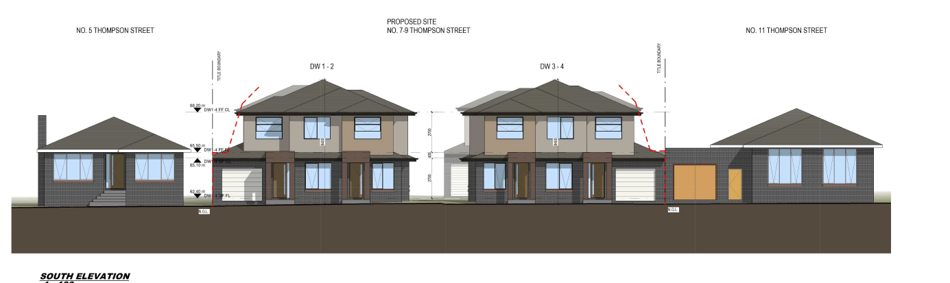

1. While boundary garages are proposed, spacing is achieved with the central driveway and the garages are recessed. With a site width of some 30 metres, the access and garaging arrangements are not unduly dominant, while the landscape plan shows the canopy trees and associated planting potential in the front setback. No front fence is proposed, and that will assist the ability of landscaping to be appreciated in the streetscape.
2. The architecture responds to the preferred character and evident character elements. While the Council prefers the front dwellings to be better distinguished, I am not persuaded the outcome is an unacceptable streetscape response in this setting, including existing townhouses in the immediate viewing cone around the intersection of Thompson Street and Carinish Road. Sheer and limited articulation of some wall planes are not unusual in the contemporary dwellings in this neighbourhood and the larger GRZ3 precinct. Here, there is limited change in wall planes, but the eaves assist with some articulation akin to existing double storey dwellings.
3. The separation of upper floor building mass is evident in the first floor plan, an extract of which is below:

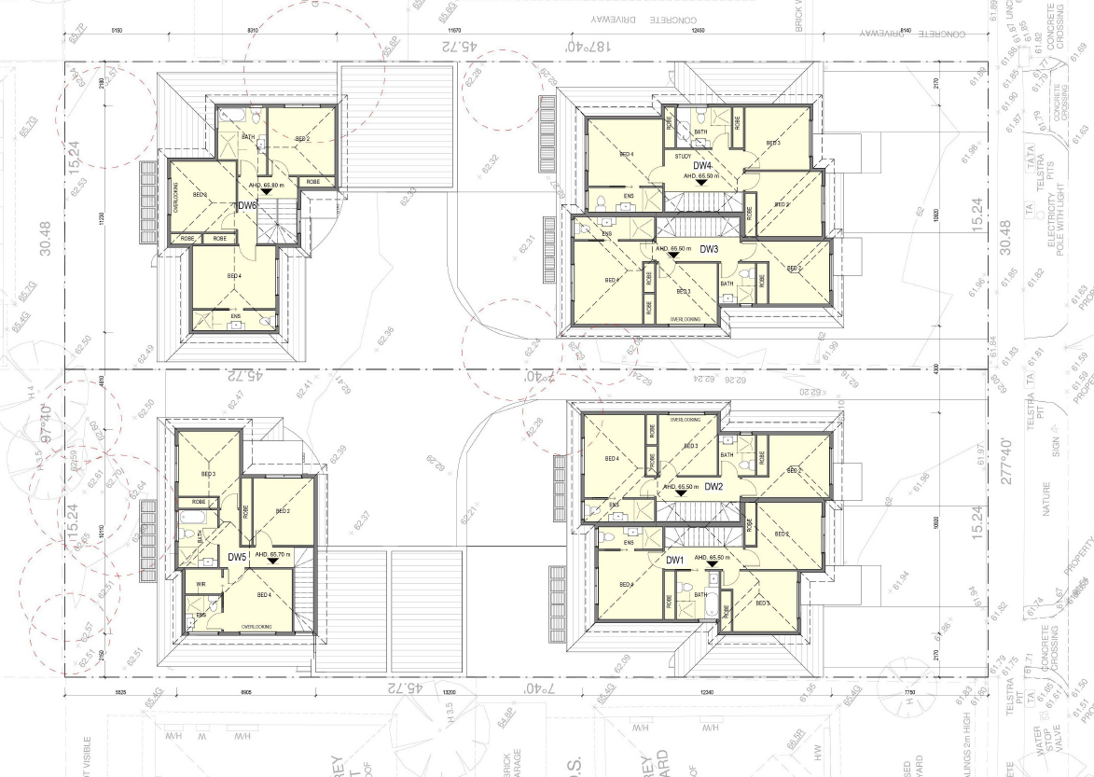

1. This is part of the approach to provide an acceptable graduation to existing dwellings. The extent of development is less than seen on some double storey multi-unit developments in the area.
2. I understand concerns about limited landscape opportunities however, the varied Standard B13 is met. The landscape plan shows 12 canopy trees are proposed across the site, including trees in the rear setback and north of the visitor car space to provide a visible landscape element within the site.
3. I am persuaded that the purpose of clause 32.08 is met and an acceptable balance is achieved. I find the proposal meets the objectives of clause 55.02 – Neighbourhood Character and Infrastructure, including clause 55.02-1. The proposal is an acceptable response to the existing and preferred future character.

## off-site amenity impacts

### Visual bulk

1. The Council submits the proposal has unacceptable visual bulk and mass when viewed from the surrounding properties that would adversely affect the amenity of these neighbouring properties. It is most concerned about secluded private open spaces to the north and north-east of the subject land. Relying on clause 22.01-3 policies with respect to “*Built form and scale of development*” to minimise visual bulk impacts to neighbouring properties and preserve backyard character, the Council submits the extent of development proposed to the rear would result in an unreasonable impact.
2. While accepting varied Standard B17, and Standard B18, are met, the Council argues that the limited boundary setbacks combined with the reasonably extensive length of upper-level form, will present a significant level of bulk to the adjoining properties, substantially impacting the outlook from the neighbouring open space areas.
3. The applicant disagrees emphasising the proposal’s numerical compliance with clause 55 (including as varied by GRZ3) and noting the lack of objections from abutting properties to the north, east and west. Among the submissions by the applicant are:

* All side and rear setbacks comply with Standard B17.
* Walls on boundary are limited.
* The orientation of the lot and the generous side setbacks ensure that existing windows on neighbouring properties are provided with adequate daylight access to satisfy Standard B19 and Standard B20.
* Whilst there will be some additional shadow cast into the properties to the east and west, the shadow impacts will comply with Standard B21.

1. It appears common ground between the parties that the numerical standards in clause 55-04 - Amenity Impacts are met. These include a 5 metre rear setback for both proposed rear dwellings. The relevant objectives are, in my view, also met.
2. The upper floor of Dwelling 5 steps back past the garage of the adjacent dwelling, so that the upper level is set back from the private open space (some 4.7 metres from the common boundary for Bedroom 3). The northern interface to No. 2/20 Alice Street is a service yard with its main open space unaffected.
3. The upper levels of Dwellings 5 and 6 are not substantially articulated. However, the size of the upper levels is not uncommon for multi-unit developments approved in this locale that have two storey forms to the rear of sites. The upper levels of Dwellings 5 and 6 are separated by approximately 4.6 metres between walls and 2.6 metres between eaves. The rear (northern) corridor of open space is able to be landscaped, as indicated in the landscape plan:

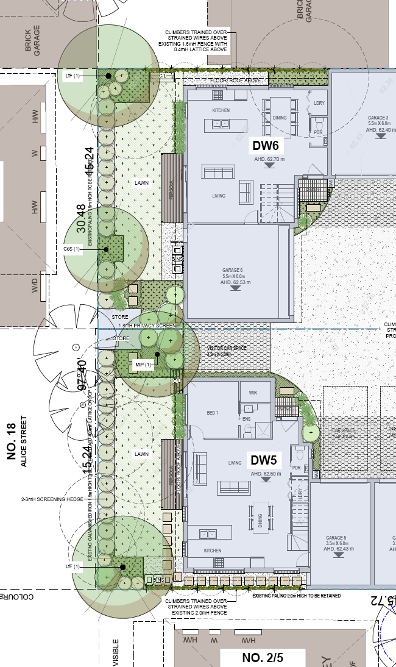

1. I find an acceptable outcome is achieved having regard to the strategic context that applies.

### Overlooking

1. The Council submits overlooking has not adequately been addressed with respect to the two rear dwellings. Several bedrooms would have direct views into neighbouring secluded private open space areas. Further, it submits internal views do not appear to be addressed in relation to bedroom 4 in each of Dwellings 1-4. The windows would appear to have downward views into the neighbouring secluded private open space areas.
2. The applicant accepts some screening is required and also suggests additional window revisions to facilitate improve passive surveillance within the site.
3. These matters can be addressed by permit conditions, so as to limit overlooking as sought by Standard B22 - Overlooking and Standard B23 Internal views. Specifically, conditions will require:

* Bedroom 3 windows of Dwelling 5 and Bedroom 2 windows of Dwelling 6 to be screened to limit overlooking.
* The addition of a window in the southern elevation of Bedroom 3 of Dwelling 5.
* The addition of a window in the western elevation of Bedroom 2 of Dwelling 6, with internal rearrangement of the robe as required.
* Bedroom 4 windows of Dwellings 1 to 4 to be screened to limit internal views.

## internal amenity and site layout

1. The Council’s grounds address parts of clause 55.05 – On-Site Amenity and Facilities. It raises the following matters with respect to internal amenity:

* The parking locations for Dwellings 2 and 3 are inconvenient in relation to each dwelling. The garages are situated to the rear of the dwelling without direct access to the dwelling or open space is provided. Occupiers would have to walk around to the front entrance.
* Dwellings 5 and 6 have a poor sense of address with narrow façades, stairwells/powder rooms located at the front facades and facades dominated by garages. Dwelling entrances are small, have insufficient shelter, are constrained by vehicle turning areas and lack transition space. There is a lack of full height windows to address the driveway and passive surveillance is limited.
* Dwellings 5 and 6 kitchen and dining room windows are not provided with 1 metre clear to the sky given the eaves and common boundary fencing.
* Secluded private open space for Dwellings 2 and 3 do not have a minimum width of 5 metres for its whole 35m2.

1. Mr English submits that, individually, none of these concerns are reasons to refuse a permit but, cumulatively, they are indicators of a development that is too intense.
2. The applicant disagrees. It submits:

* The dwelling entrances for Dwellings 5 and 6 are well orientated towards the street despite being located at the rear of the site. They have windows at ground and first floor level providing surveillance of the common accessway with low level landscaping commensurate with the nature of this common area space.
* The issue of daylight to windows to the kitchen windows facing east and west is acknowledged. Given these are secondary windows to an open plan living area, the 1m clear to the sky component is not considered unreasonable to vary, noting that could be addressed via a permit condition if required.
* The concern about the lack of the 5 metres width for Dwellings 2 and 3 is unreasonable. These open spaces exceed the standard with over 75m2 of open space with the primary area being north-facing. The usability of these spaces is considered entirely acceptable.

1. The applicant accepts a permit condition in relation to kitchen and dining room (east and west) windows in Dwellings 5 and 6 to be provided with 1 metre clear to sky.
2. Notwithstanding its submissions, the applicant also offers some potential changes to address several of the Council’s concerns:

* The addition of a window in the southern wall of the front porch associated with Dwelling 5.
* The addition of a gate in the northern fence associated with Dwelling 2 to facilitate access from garage 2 (as shown on the landscape plan).
* The addition of a gate in the northern fence associated with Dwelling 3 to facilitate access from garage 3 (as shown on the landscape plan).

1. While the proposal meets many of the relevant standards and objectives in clause 55.05, I consider the changes are warranted and will overcome the layout concerns with respect to garage access. Revised window treatments, referred to above, will also assist to provide some casual and passive surveillance within the site.
2. I note uncontested permit conditions address the Council’s requested modifications to the car parking design and driveway ramp grades.

## Conclusion

1. For the reasons given above, the decision of the responsible authority is set aside. A permit is granted subject to the conditions in Appendix A.

|  |  |  |
| --- | --- | --- |
| **Margaret Baird**  **Senior Member** |  |  |



# Appendix A – Permit Conditions

|  |  |
| --- | --- |
| Permit Application No | TPA/51791 |
| Land | 7 - 9 Thompson Street  CLAYTON VIC 3168 |

|  |
| --- |
| What the permit allowS |
| In accordance with the endorsed plans:   * Construction of six (6) double storey dwellings. |

## Conditions

### Amended Plans

1. Before the development starts, plans drawn to scale and dimensioned must be submitted to and approved by the Responsible Authority. When approved, the plans will be endorsed and will then form part of the permit. The plans must be generally in accordance with the Section 57A plans submitted with the application dated December 2020, prepared by Bello Design Group, but modified to show:
   1. The Bedroom 3 windows of Dwelling 5 and Bedroom 2 windows of Dwelling 6 to be screened to limit overlooking.
   2. Addition of a window in the southern elevation of Bedroom 3 of Dwelling 5.
   3. Addition of a window in the western elevation of Bedroom 2 of Dwelling 6, with internal rearrangement of the robe as required.
   4. The Bedroom 4 windows of Dwellings 1 - 4 inclusive to be screened to limit internal views.
   5. Dwellings 5 and 6 kitchen and dining room (east and west) windows to be provided with 1 metre clear to sky.
   6. Addition of a window in the southern wall of the front porch associated with Dwelling 5.
   7. Addition of a gate in the northern fence associated with Dwelling 2 to facilitate access from garage 2.
   8. Addition of a gate in the northern fence associated with Dwelling 3 to facilitate access from garage 3.
   9. The on-site visitor parking space clearly marked.
   10. The development to comply with condition 14.
   11. A horizontal timber fence (or similar) provided adjacent to the driveway to the open space areas of dwellings two and three.
   12. The maximum grade within a parking module measured parallel to the angle of parking is to be 1 in 20. Measured in any other direction is to be 1 in 16.
   13. A Sustainable Design Assessment in accordance with condition 4 of this Permit.

All to the satisfaction of the Responsibility Authority.

### No Alterations

1. The development as shown on the endorsed plans must not be altered without the prior written consent of the Responsible Authority.

### Common Boundary Fences

1. All common boundary fences are to be a minimum of 1.8 metres above the finished ground level to the satisfaction of the Responsible Authority. The fence heights must be measured above the highest point on the subject or adjoining site, within 3 metres of the fence line.

### Sustainable Design Assessment

1. Concurrent with the endorsement of plans requested pursuant to Condition 1, a Sustainable Design Assessment (in accordance with Clause 22.13) to the satisfaction of the Responsible Authority must be submitted to and approved by the Responsible Authority. Upon approval the Sustainable Design Assessment will be endorsed as part of the planning permit and the development must incorporate the sustainable design initiatives outlined in the Sustainable Design Assessment to the satisfaction of the Responsible Authority.

### Landscaping

1. Concurrent with the endorsement of any plans pursuant to Condition 1, a landscape plan prepared by a Landscape Architect or a suitably qualified or experienced landscape designer, drawn to scale and dimensioned must be submitted to and approved by the Responsible Authority prior to the commencement of any works. The plan must be generally in accordance with the plan prepared by John Patrick Landscape Architecture, Dwg No. VCAT01, Job No. 21-481-L, dated August 2021. The plan must show the proposed landscape treatment of the site including:-
   1. the location of all existing trees and other vegetation to be retained on site
   2. provision of canopy trees with spreading crowns located throughout the site including the major open space areas of the development
   3. planting to soften the appearance of hard surface areas such as driveways and other paved areas
   4. a schedule of all proposed trees, shrubs and ground cover, which will include the size of all plants (at planting and at maturity), their location, botanical names and the location of all areas to be covered by grass, lawn, mulch or other surface material
   5. the location and details of all fencing
   6. the extent of any cut, fill, embankments or retaining walls associated with the landscape treatment of the site
   7. details of all proposed hard surface materials including pathways, patio or decked areas
   8. changes required by Condition 1.

When approved the plan will be endorsed and will then form part of the permit.

### Tree Protection

1. No building material, demolition material or earthworks shall be stored or stockpiled under the canopy line of any tree to be retained on or on adjoining sites during the construction period of the development hereby permitted.

### Landscaping Prior to Occupation

1. Before the occupation of the buildings allowed by this permit, landscaping works as shown on the endorsed plans must be completed to the satisfaction of the Responsible Authority and then maintained to the satisfaction of the Responsible Authority.

### Drainage

1. All on-site stormwater is to be collected from hard surface areas and must not be allowed to flow uncontrolled into adjoining properties or the road reserve.
2. The private on-site drainage system must prevent stormwater discharge from the/each driveway over the footpath and into the road reserve. The internal drainage system may include either:
   1. a trench grate (minimum internal width of 150 mm) located within the property boundary and not the back of footpath; and/or
   2. shaping the internal driveway so that stormwater is collected in a grated pit on the property; and/or
   3. another Council approved equivalent.
3. All stormwater collected on the site is to be detained on site to the predevelopment level of peak stormwater discharge. The design of any internal detention system is to be approved by Council’s Engineering department prior to drainage works commencing.

### Vehicle Crossovers/Driveways

1. All new vehicle crossing must be a minimum of 3.0 metres in width and constructed in accordance with Council standards.
2. All new crossings are to be no closer than 1.0 metre measured at the kerb to the edge of any power pole, drainage or service pit, or other services. Approval from affected service authorities is required as part of the vehicle crossing application process.
3. The development must be provided with a corner splay or area at least 50% clear of visual obstruction (or with a height of less than 1.2m) extending at least 2.0 metres long x 2.5 metres deep ( within the property) on both sides of each vehicle crossing to provide a clear view of pedestrian on the footpath of the frontage road.
4. Approval of each proposed crossing, and a permit for installation or modification of any vehicle crossing is required from Council’s Engineering Department.
   1. The layout of the development shall follow the Design Standards for car parking set out in Clause 52.06-9 of the Monash Planning Scheme as detailed below:
   2. Driveway to be at least 3 metres wide.
   3. Driveway gradient to be no steeper than 1 in 10 (10%) within 5 metres of the frontage to ensure safety for pedestrians and vehicles.
   4. Ramp grades (except within 5 metres of the frontage) to be designed as follows:
      1. Maximum grade of 1 in 5.
      2. Provision of minimum 2.0 metre grade transitions between different section of ramp or floor for changes in grade in excess of 12.5% (summit grade change) or 15% (sag grade change).
      3. Grade changes greater than 18% or less than 3 metres apart are to be assessed for clearances in accordance with Appendix C of the Australian Standard for Off - Street Car Parking, AS/NZS 2890.1.

### Urban Design

1. The walls on the boundary of adjoining properties shall be cleaned and finished in a manner to the satisfaction of the Responsible Authority.

### Completion of Buildings and Works

1. Once the development has started it must be continued and completed to the satisfaction of the Responsible Authority.

### Permit Expiry

1. This permit will expire in accordance with section 68 of the *Planning and Environment Act 1987*, if one of the following circumstances applies:

* The development has not started before two (2) years from the date of issue.
* The development is not completed before four (4) years from the date of issue.

In accordance with section 69 of the *Planning and Environment Act 1987*, the responsible authority may extend the periods referred to if a request is made in writing before the permit expires, or within six months of the permit expiry date, where the development allowed by the permit has not yet started; or within 12 months of the permit expiry date, where the development has lawfully started before the permit expires.

**– End of conditions –**

1. Section 4(2)(d) of the *Victorian Civil and Administrative Tribunal Act 1998* states a failure to make a decision is deemed to be a decision to refuse to make the decision.
2. A permit is not triggered under DDO15.
3. Nearmap extract, contained in the delegate’s report.
4. Submissions, supporting exhibits and the statements of grounds have all been considered in the determination of the proceeding. In accordance with the Tribunal’s practice, not all of this material will be cited or referred to in these reasons.
5. Which is identical to the plan in the *Housing Strategy 2014*.
6. Category 3 in the Monash Housing Strategy.
7. Category 8 in the Monash Housing Strategy.
8. Evident in clause 21.04 and clause 22.01.
9. *Vassilakis v Monash CC* [2021] VCAT 572; *Zhou v Monash CC* [2021] VCAT 452; *Jarmien Development Pty Ltd v Monash CC* [2018] VCAT 1076 (the last decision predates Am C125 Part 2).