VICTORIAN CIVIL AND ADMINISTRATIVE TRIBUNAL
planning and environment DIVISION
 | planning and environment LIST | vcat reference No. P2307/2019  PERMIT APPLICATION NO. TPA/50167
CATCHWORDS
Section 77 of the Planning and Environment Act 1987; Monash Planning Scheme; Two Storey Townhouses; Four Dwellings; Residential Growth Zone – Schedule 3; Clayton Major Activity Centre and Monash National Employment and Innovation Cluster.

APPLICANT | Aldo Di Nicolantonio
responsible authority | Monash City Council
SUBJECT LAND | 113 Kanooka Grove  CLAYTON VIC 3168
WHERE HELD | Melbourne
BEFORE | Margaret Baird, Senior Member
HEARING TYPE | Hearing
date of hearing | 19 June 2020
DATE OF ORDER | 29 June 2020
CITATION | Di Nicolantonio v Monash CC [2020] VCAT 700

Order

No permit granted
- In application P2307/2019, the decision of the responsible authority is affirmed.
- In permit application no. TPA/50167, no permit is granted.

Margaret Baird
Senior Member

APPEARANCES
For applicant | Mr R Hocking, City Shire Planning Pty Ltd.
For responsible authority | Mr J Turner, Principal Planner – Appeals Advisor.

Information
Description of proposal | Four double storey dwellings.
Nature of proceeding | Application under section 77 of the Planning and Environment Act 1987 – to review the refusal to grant a permit.
Planning scheme | Monash Planning Scheme [scheme].
Zone and overlays | Residential Growth Zone, Schedule 3 [RGZ3] (shown below), Clayton Major Activity Centre and Monash National Employment and Innovation Cluster.  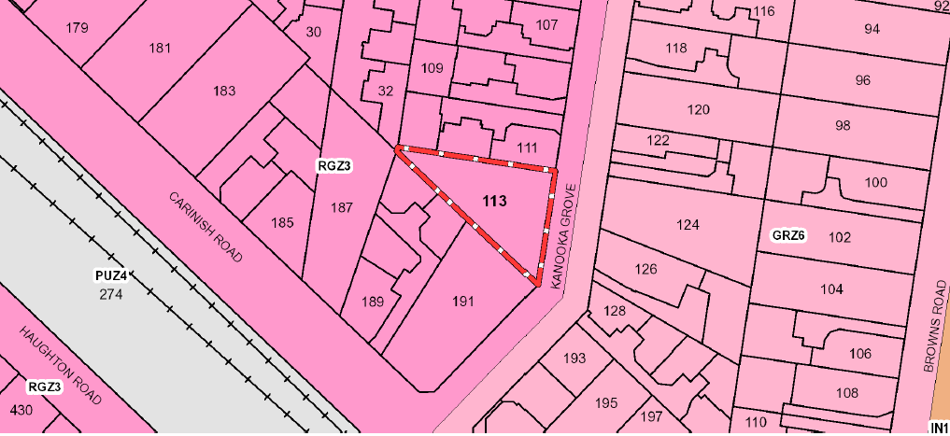
Permit requirements | Clause 32.07-5 - to construct two or more dwellings on a lot.
Relevant scheme policies and provisions | Clauses 11, 15, 16, 21, 22.01, 22.05, 32.07, 52.06, 55, 65 and 71.
Subject land description | The subject land is on the west side of Kanooka Grove, close to its southern end with Carinish Road and the elevated Skyrail. The land is triangular in shape and has an area of 839m². It contains a dwelling.  The subject land abuts properties that are developed with single storey or double storey townhouses to the north, south and west. Land on the east side of Kanooka Grove is within a General Residential Zone Schedule 6 [GRZ6]. Opposite the subject land are single storey dwellings at Nos. 124 and 126 Kanooka Grove, the latter of which contains two dwellings.  The area is characterised by one and two storey dwellings, including multi-units. The existing units include older single storey dwellings and recent double storey forms.
Tribunal inspection | 24 June 2020 (unaccompanied).

REASONS

ABOUT THIS APPLICATION
- Mr Aldo Di Nicolantonio [applicant] applied to the Monash City Council [Council] to construct four dwellings on the subject land. The Council refused to grant a permit. The permit applicant has asked the Tribunal to review that decision and grant a permit for the proposed development.
- The applicant submits the proposal to construct four double storey townhouses is appropriate given the irregular shape of the subject land and the prevailing character of medium density housing. Mr Hocking submits that the triangular lot requires a specific design and site-specific response. The design meets the preferred character statement and objectives for this location including achieving dwelling diversity. The design meets all varied clause 55 standards in RGZ3 and positively contributes to the landscaping and design outcomes sought by RGZ3 having regard to the strategic context and specific site considerations that apply.
- These and related submissions respond to the Council’s position that the permit application should be refused. The Council submits that the critical issue is that the proposal is an under-development of the site and is contrary to the clear direction given by the scheme for the Clayton Activity Centre. The Council also has concerns regarding the inadequate provision of landscaping, building bulk and mass, as well as vehicle access.
- I must decide whether the proposal will produce an acceptable outcome having regard to the relevant policies and provisions in the scheme. Clause 71.02-3 requires the decision-maker to integrate the range of policies relevant to the issues to be determined and balance conflicting objectives in favour of net community benefit and sustainable development.

strategic CONTEXT

Current scheme
- It is common ground that the subject land is located within the boundaries of the Clayton Activity Centre where change is directed and expected by State and local policy and through the application of the RGZ3.
- The subject land and surrounds in the RGZ3 are expressly earmarked for housing growth.
- The purpose of clause 32.07 includes to provide increased housing densities in buildings up to four storeys and encourage housing diversity.
- The design objectives in the schedule are to be achieved. The objectives for RGZ3 are:
- To facilitate housing growth in the form of apartment developments of a high quality design and finish.
- To ensure developments are constructed within an open garden setting through the retention and planting of vegetation, including canopy trees.
- To ensure that the height, scale and form of development respects any sensitive residential interfaces and minimises the appearance of visual bulk.
- The decision guidelines in RGZ3 include (among others):
- Whether the development contains elements of the ‘garden city’ character. Specifically, whether the proposal:
  - Provides vegetation in the front setback that softens the appearance of built form and contributes to the public realm.
  - Maximises planting opportunities adjacent to the street by excluding hard paving such as car parking, turning circles and wide driveways, and minimising basement car parking, within the front setback.
  - Minimises hard paving throughout the site including limiting driveway lengths and widths, providing landscaping on both sides of driveways, and restricting the extent of paving within open space area.
- Where vehicle crossovers are located and whether they are minimised in number to prevent traffic disruption, and preserve nature strips and street trees.
- Include significant breaks and recesses in building massing, is designed to avoid large block like structures dominating the streetscape.
- Whether the development minimises the impact to neighbouring properties, through suitable setbacks from adjacent secluded private open space to enable the provision of screening trees, and scaling down of building form to the adjoining properties in the General Residential Zone, where applicable.
- Where the dimensions of an irregular shaped or corner lot make it difficult to meet side and rear setback standards, variation to these standards will be considered where the development proposal demonstrates that it contributes to ‘garden city’ character. Specifically, whether the variation or reduction in setback allows the development to:
  - Provide sufficient and well located open space elsewhere on the site, primarily unencumbered by easements, to provide for large trees to be retained or planted within front, side and rear setbacks, and secluded open space areas.
  - Retain or plant vegetation in the front setback that softens the appearance of built form and contributes to the public realm.
  - Minimise the impact to neighbouring properties, through suitable setbacks from adjacent secluded private open space to enable the provision of screening trees, and scaling down of building form to the adjoining properties.
  - Establish setbacks that are appropriate taking into account the shape of the lot and the setbacks of adjoining properties.
- Clause 32.07 does not include a purpose that ties development to existing character, rather, a new character is encouraged and facilitated. Varied clause 55 standards are part of this. It appears to be common ground between the parties that the proposal meets the varied standards. I give this significant weight in assessing the proposal’s acceptability including its response to clause 32.07, RGZ3 and preferred character.
- The area’s preferred future character statement is:
The scale of new residential development will generally comprise larger footprint apartment development of a high-quality design and finish. Some infill town house and unit development will also occur.
Where possible on larger sites, developments will be multi-level, and set in open gardens. Although setbacks from all boundaries will be less than is common in other parts of Monash, the developments will ensure the incorporation of well-maintained landscaping to address the garden city character.

Clayton Activity Centre Structure Plan
- Mr Turner refers to the adopted Clayton Activity Centre Structure Plan (January 2020) [Plan]. The subject land is in a residential intensification area with a preferred building height of 3-5 storeys/10-16 metres. Surrounding land, including the GRZ6 area on the east side of Kanooka Grove, is part of that area too, with preferred heights below (in storeys):
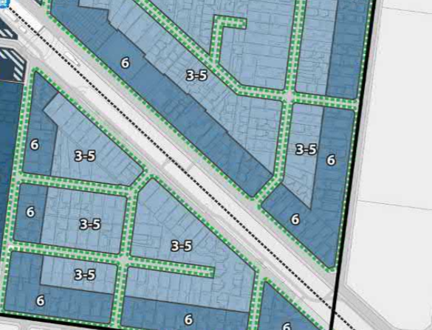
Subject land
- The Plan says the application of the RGZ will be expanded. I note the precinct overview refers to a variety of housing types including “low scale apartments and townhouses with landscaped front gardens sit comfortably next to detached dwellings and define a high quality and contemporary character for the precinct”. The overview, and built form and development requirements including building heights, need to be read together. Statutory implementation of the Plan must proceed through Ministerial authorisation and any independent Panel process and hence the Plan cannot be determinative. It is, however, relevant to appreciate and understand the strategic directions being pursued. I note that an exclusively apartment outcome is not part of the vision as currently cited.
- Mr Hocking submits the Plan is relevant and carries weight.

TRIBUNAL DECISIONS ADDRESSING THE STRATEGIC CONTEXT
- Mr Hocking refers to a number of Tribunal decisions in relation to the strategic context that applies in this case. I have considered these decisions and make the following observations and findings with respect to the principles to which they refer and their utility in relation to the decision I must make in this proceeding.
- Tribunal decisions in Beattie and HLP International Pty Ltd:
- Make the point that I have already made that a new character is being facilitated in the RGZ rather than maintenance of an existing character. The existing character is factually-based. For example, the character area described in Beattie was strongly represented by the original dwelling stock while the subject land in the current proceeding is in an area where single storey and two storey multi-unit development has occurred historically and more recently.
- Are directed to circumstances where there has not been substantial change to date and the older built form cannot be taken as the benchmark. In other places, the existing character may represent what the scheme is seeking as a consequence of redevelopment that aligns with the scheme’s directions through policy and zone objectives.
- Needed to reconcile the purpose of the RGZ and objectives in RGZ3 with local policy, pre-dating Amendment C125 Part 2. This matter has since been resolved with the gazettal of that Amendment.
- Refer to the question of building typology and the fact that infill townhouse development is part of the preferred character.
- More recent decisions in Yang and Papermite reach the same conclusion that apartments are not the only form of development sought for these locations. The decision in Papermite, post-dates the gazettal of Amendment C125 Part 2. Member Glynn found:
The policy at clause 22.01 also encourages the consolidation of sites to achieve residential intensification where this is ‘specifically encouraged by the relevant zoning schedule’. This site is in RGZ3 where no such specific encouragement is specified.
- My recent decision in Wang makes a similar/related finding:
I accept the Council’s submission that the scheme provides clear direction about what is sought in the RGZ3 area. More can be achieved by consolidating lots than the proposal for four townhouses. Higher density and greater intensity are part of the broader strategy that directs substantial change to this location and contrasts with locations where the preferred character is different.
Having said that, it is relevant that the scheme anticipates both townhouses and apartments typologies in this location to achieve the stated strategic ambitions. The likely typology will be affected by factors such as the lot size and configuration. Apartments on larger or consolidated lots will achieve more than a narrow single lot, but development on single lots is not prohibited.
The long and relatively narrow site is a physical circumstance that creates challenges in designing a residential development…
- These decisions about development in Monash RGZ3 areas involve proposed development (in all or part) of three storeys. Some were approved and others not. Those that were refused were found to have specific design issues taking into account objectives and decision guidelines in RGZ3. Given the planning outcome being pursued, references to sensitive interfaces are particularly at the transitional locations, such as with the GRZ cited in the decision guidelines at clause 5.0 of RGZ3. In the current case, GRZ6 is opposite the subject land but no party contends that there is a transitional consideration that carries weight.
- The decision guidelines in RGZ3 are directed to achieving development and landscape (Garden City) outcomes in line with the stated design objectives. In Yang, Member Whitney said:
I also acknowledge that the purposes of the RGZ3 refer to buildings up to and including four storeys being constructed for housing provision and that the proposal before me might be said to be a more tempered response at only three storeys. However, for the reasons set out above, I hold concerns as to the design response that is before me and how that addresses the RGZ3, notwithstanding that it is three and not four storeys.
Notwithstanding that the site is located in a zone that supports increased density and housing diversity, that same zone also directs me to specific decision guidelines that speak to various aspects of the design and presentation of the development. The overall impression is of a large, block like structure with a significant and evident amount of hard paving and with little available space in the side setbacks to soften that impression. Overall, I find that the design of this development does not contain elements of the Garden City character and will not minimise the appearance of visual bulk, as sought by RGZ3.
- None of these Monash decisions were made having regard to the now-adopted Clayton Activity Centre Precinct Structure Plan. A draft of the Plan was referred to in Papermite, where Member Glynn said in part:
The proposed three storey building is less than the preferred six storey sought in the draft strategy, but I must address the proposal in context of the existing scheme that has a purpose of up to four storeys and no specific direction to consolidate sites or provide for taller form. If the structure plan is adopted and changes are made to the planning scheme to create a different design regime, then the applicant may seek to revisit the proposal to establish a higher order development.
- In other municipalities, and under different scheme provisions, submissions about the under-development of a site have been assessed where structure planning had proceeded to development controls and associated policy in a scheme. In Nice Star, Member Fong said:
The fundamental issue of this review is that the design of the development has not made use of the incentives for development in this area, an area where Maroondah has high expectation to achieve its Ringwood Activity Centre and housing provision of housing.
In other words, I am not satisfied that the proposal is consistent with the zoning of the land, the DDO that affects it and Clause 22.06.
- In Yearone, Member Birtwistle concluded:
As the Council rightly stated, it is more common for the Tribunal and Council’s to consider the vexed issue of overdevelopment of land. Less common is the issue of underdevelopment. In this instance, the hierarchy of planning policies and controls, from PPF, LPPF, zoning and overlays all ascribe a significant value to land within this important Activity Centre. There is no lack of clarity about the intent of this area to do the ‘heavy lifting’ in providing increased housing density at a scale not seen in other residential settings within Maroondah. Development should optimise the full potential of sites and in this instance, reflect its location within a Central Activities Area. The proposal does not achieve this.
- The factual circumstances are very different to those applying in the current proceeding. Relevantly, there is no DDO for the subject land and surrounding properties in the Clayton Activity Centre that would implement a structure plan. This could emerge through the structure planning process. The adopted Plan is a relevant matter, although the outcome of that process is not at any stage that can be given weight. It is, however, clear that the RGZ3 and current planning work envisages more than two storey townhouses – a design response that would be acceptable (in principle) in other locations within the municipality.

UNDER-DEVELOPMENT

Issues
- The applicant submits the proposal to construct four double storey townhouses is appropriate given the unusual shape of the subject land and because the immediate neighbourhood is dominated by double storey townhouses.
- Mr Hocking submits that the unusually-shaped lot is almost the last undeveloped property at the southern end of Kanooka Grove. The proposed building typology accords with the preferred character statement and objectives for this location. Buildings of less than four storeys are not precluded nor are townhouses. Recognising that the land is designated for substantial change, the applicant submits that the design responds to this, including by adopting the efficiencies associated with a reverse-living format. The proposal, in the applicant’s submission, carries forward the broader strategic framework for Clayton. Policies should not be slavishly applied, rather they must be considered as relevant to the specific facts and circumstances.
- Mr Hocking states that more could potentially be done on this site, such as providing three storey dwellings at the front of the land. But he says this would unlikely be approved by the Council.
- These and related submissions presented by the applicant respond to the Council’s position that approval of the current application will undermine and preclude the long-term achievement of the policy objectives for the Clayton Activity Centre. Mr Turner submits the locational attributes of the land cannot be under-stated. The land is in one of the higher order activity centres within the Monash municipality. The change expected within the Clayton Activity Centre is very clearly expressed by the inclusion of the site in the RGZ which indicates that this is an area where more intense housing and change in built form is sought. The Plan is seeking to accommodate some 8,000 people. In addition to RGZ3 calling for housing growth in the form of apartments, the preferred future character for the Clayton Activity Centre states that the scale of new residential development will generally comprise larger footprint apartment development of a high-quality design and finish.

Findings
- I have already indicated that the existing (and new) policy does not limit development to apartments. RGZ3 seeks to facilitate apartment developments while the preferred character statement seeks new development that is generally larger footprint apartments with some infill townhouses and units.
- There is a clear expression of achieving more than would be the norm or envisaged in character areas without the same emphasis on a new character and housing growth. Double storey townhouses could be expected in GRZ areas, including using balconies for private open space in some locations. I say this having regard to the varied schedules to clause 32.08 in this scheme.
- This is relevant because the applicant’s case discusses how the proposal fits with the existing character and characterises the area as being dominated by double storey townhouses. Put another way, the applicant says the proposed four townhouses would represent an acceptable degree of fit in character and streetscape terms having regard to the prevailing pattern of contemporary development.
- But to what extent should the existing multi-unit developments and townhouses provide the benchmark and are they representative of the preferred character based on clause 22.01-4?
- I have difficulty with the applicant’s justification for two reasons.
- One, I do not consider the area is dominated by double storey townhouses. There is an evident presence of units that can be appreciated in the Nearmap extract below. These include two storey townhouses. However, there are also many older single storey units and detached houses. Giving effect to the scheme’s policies envisages more than this.
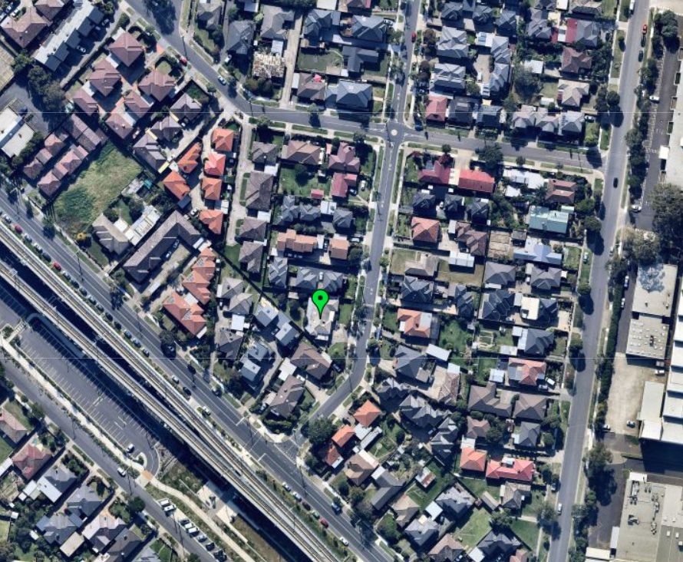
- Two, and related to the previous point, the strategic outcome here is not to fit in with the existing character because that character does not represent the much more intensive residential area described in local policy and being pursued through RGZ3. I am not persuaded to accept that the proposal’s good fit with the existing character is reason to support the application when I am also not persuaded that the prevailing character has evolved already in a way that aligns with the strategic directions and purpose of clause 32.07. The fact that the adjacent sites are developed with multiple dwellings might make consolidation and higher intensity development more difficult and a longer term proposition given multiple ownerships, however this does not prevent intensification as can be seen in many locations throughout Melbourne. The subject land is not an ‘infill’ site surrounded by development at the higher scale being encouraged and facilitated by the application of clause 32.07, the objectives stated in RGZ3 and the preferred character statement. Proposed developments of three storeys in this strategic setting have been found to not represent an under-development in other Tribunal proceedings but, in this case, the proposal for four double storey dwellings.
- The applicant’s submission refers to the extent to which the proposal for a three storey form would not be a good streetscape fit. Mr Hocking comments that it would look “odd” and “clumsy” and would unlikely be approved by the Council. These submissions do not persuade me to accept the design response presented in this permit application as an acceptable outcome – a new character is being sought for this area and that means new residential development will depart from the existing character. As the Council puts its case for refusing permits in locations such as these because of under-development, it will be incumbent on the Council to facilitate applications that give effect to the RGZ3 and associated policies.
- The applicant’s case places significant weight on the triangular shape of the subject land and limitations that configuration presents to an apartment building or more intensive development. This is a relevant matter in the decision guidelines in RGZ3. The fact that the subject land is irregularly shaped limits its potential compared with other sites taken individually. However, Mr Hocking’s submission itself acknowledges that more could be achieved.
- Having considered all of the material before me, I find the design response does not achieve an acceptable outcome when assessed against clause 32.07 and RGZ3 as well as local policy for this location.

BUILDING BULK AND LANDSCAPING

Issues
- The Council submits the development would be visually dominating and obtrusive to its neighbours. It submits the RGZ3 seeks to manage visual bulk to respect sensitive residential interfaces and minimise the appearance of visual bulk. Mr Turner states that the size of the ground floor footprints and the extent of hard surface area are significant without sufficient separation between buildings and first floor walls. In addition, there are limited landscaping opportunities including for canopy tree planting. There is insufficient space to achieve landscaping that would be consistent with the Garden City character sought within the Activity Centre.
- In response, the applicant highlights features of the proposal including compliance with all varied clause 55 standards. The applicant submits that the extent to which there is visual bulk must be understood in the strategic context that applies and landscaping opportunities can be achieved consistent with the strategic context.

Findings
- I agree with the Council that RGZ3 encourages residential intensification but with landscaping remaining a unifying feature of the streetscape. However, I am not persuaded that the proposal represents unacceptable visual bulk nor is unduly limited in landscape opportunities in the planning context that applies.
- It is relevant that all varied clause 55 standards are met and that adjacent sites involve development on and close to the common boundaries with the subject land. The Council’s submission does not articulate specific locations where visual bulk would represent an excessive impost or unacceptable outcome.
- The upper levels of the proposed dwellings are all spaced and some articulation is provided in wall planes and materials.
- The reverse-living format is acceptable. Further, there are opportunities for four canopy trees to be planted in the front setback and some more limited opportunities for the rear yards of both Dwelling 3 and Dwelling 4 to also each have a canopy tree. That potential has not been challenged in the Council’s submission.

VEHICLE ACCESS
- The Council submits vehicle access to Dwellings 1 and 2 do not comply with the requirements in clause 52.06-9. I have not explored this matter in detail, given my earlier findings. This could have been addressed through permit conditions.

Conclusion
- For the above reasons, the responsible authority’s decision is affirmed.

Margaret Baird
Senior Member

Planning report extract.
The submissions and evidence of the parties, supporting exhibits and statements of grounds filed have all been considered in the determination of the proceeding. In accordance with the Tribunal’s practice, not all of this material will be cited or referred to in these reasons.
The Council’s submission withdraws a number of grounds relating to several clause 55 non-compliances and relating to internal amenity.
Such as clauses 21.04, 21.06 and 22.01.
Clause 22.01-4.
Beattie v Monash CC [2019] VCAT 258.
HLP International Pty Ltd v Monash CC [2018] VCAT 942.
Yang v Monash CC [2019] VCAT 1677.
Papermite Pty Ltd v Monash CC [2019] VCAT 1954.
Ibid, [21].
Wang v Monash CC [2020] VCAT 544, [20] – [22], footnote excluded from the quote.
Yang v Monash CC [2019] VCAT 1677, [28] and 30].
Papermite Pty Ltd v Monash CC [2019] VCAT 1954, [54].
For example, Doncaster Road Property Partnership v Manningham CC [2004] VCAT 2445.
Nice Star Pty Ltd v Maroondah CC [2017] VCAT 365, [34] – [35].
Yearone Pty Ltd v Maroondah CC [2019] VCAT 1036, [46].
At both a metropolitan and local level
Sections 60(1A)(g) and 84B of the Planning and Environment Act 1987.
I note that I was referred to a site nearby in Carinish Road that is approved with a three storey apartment building.

