VICTORIAN CIVIL AND ADMINISTRATIVE TRIBUNAL
planning and environment DIVISION
planning and environment LIST | vcat reference No. P304/2019  Permit Application no. TPA/49441
CATCHWORDS

Section 80 Planning and Environment Act 1987, upper level setbacks, neighbourhood character, internal amenity, size of living rooms for nine bedroom dwellings.

APPLICANT | Clayton Road Oakleigh Pty Ltd
responsible authority | Monash City Council
Referral Authority | VicRoads
SUBJECT LAND | 121 Clayton Road, Oakleigh East
WHERE HELD | Melbourne
BEFORE | Alison Glynn, Member
HEARING TYPE | Hearing
DATE OF HEARING | 12 August 2019
DATE OF ORDER | 16 August 2019
CITATION | Clayton Road Oakleigh Pty Ltd v Monash CC [2019] VCAT 1239

Order

Conditions changed
- The decision of the responsible authority is varied.
- The Tribunal directs that planning permit TPA/49441 must contain the conditions set out in planning permit TPA/49441 issued by the responsible authority on 18 January 2019 with the following modifications:
  - Conditions 1a), 1b) 1c) and 1f) are deleted.
  - Condition 1d) is amended to read:
1d) One of bedrooms 1, 2 or 3 of Dwelling 1 deleted and replaced with additional dining / living area to allow for a more functional space for the kitchen and dining area to the satisfaction of the responsible authority.
  - Conditions in the planning permit are renumbered accordingly.
- The responsible authority is directed to issue a modified planning permit in accordance with this order.

Alison Glynn
Member

Appearances
For Clayton Road Oakleigh Pty Ltd | Mr Kyle O’Brien, town planner of David Lock Associates Pty Ltd.
For Monash City Council | Ms Adrianne Kellock, town planner of Kellock Town Planning Pty Ltd.

Information
Description of proposal | Construction of two dwellings on a lot. Each dwelling contains nine bedrooms and amenities that depict a capacity to be used for shared living.
Nature of proceeding | Application under section 80 of the Planning and Environment Act 1987 – to review the conditions contained in the permit. Specifically conditions 1a) to 1c) that require increased upper level setbacks and conditions 1d) to 1f) that require internal alteration to the ground floor living and laundry areas.
Planning scheme | Monash Planning Scheme
Zone and overlays | General Residential Zone – Schedule 2 (GRZ2)  No overlays. The land abuts a road in a road zone category 1 (RDZ1)
Permit requirements | Clause 32.08 – construction of two or more dwellings on a lot in GRZ2.  Clause 52.29 – alteration of access to a Road Zone Category 1.

Relevant scheme policies and provisions | Clauses 11, 15.01, 16, 21.04, 21.08, 22.01, 22.05, 22.10, 32.08, 52.29, 55 and 65.
Land description | The site has a 17.68 metre frontage to the east side of Clayton Road and a depth of 41 metres to create a 725 sqm site. There is a single storey dwelling currently on the site. To the direct south are a set of five, double storey dwellings across a double lot. To the north is a current application for two and three storey townhouses.

Reasons

What is this proceeding about?
- Monash City Council has granted a planning permit to construct two dwellings on a lot at 121 Clayton Road, Oakleigh East. The dwellings are large, each containing nine bedrooms. The council has imposed a number of conditions that require alterations to the application plans. These changes are to reduce the upper level footprint of the dwellings, particularly the front dwelling, and enacted through conditions 1a) to 1c). The council also seeks changes to the internal layout of both dwellings to increase their living spaces, proportionally to the number of bedrooms provided through conditions 1d) to 1f).
- The applicant opposes these conditions 1a) through to 1f) saying the character of the area does not require the upper level setbacks and that the internal room configuration is acceptable.
- My reasons below discuss these issues in context of the Monash Planning Scheme through which I must make my assessment.

Are additional upper level building setacks needed?
- The three conditions contested require:
- Dwellings 1 and 2 to be set back at least 7 metres from each other at first floor. (condition 1a)
- The eastern wall of bedroom 7 in dwelling 1 set back at least 10.5 metres from the eastern (front) boundary. (condition 1b)
- The western wall of bedroom 8 in dwelling 1 set back at least 11 metres from the eastern (front) boundary. (condition 1c)
- Figure 1 below depicts the changes sought.
- The council maintains that these conditions are needed to moderate the upper level form from the street and the adjoining neighbour to the south, mostly as an issue of neighbourhood character and visual bulk.
- The character of this area is changing and dominated by large dwellings and modern townhouses. The existing character guidelines for this area are of little assistance given this change. It is also relevant that the site sits close to Monash University and within the Monash Innovation and Employment Cluster, a factor that is also recognised in the adopted Monash Housing Strategy, 2014. I therefore find a first principles approach that considers the immediate physical context is needed to assessing the site context and impact on neighbourhood character.
- This existing physical context includes a number of robust buildings along Clayton Road. There are also many double storey townhouses both on Clayton Road and behind, to the west of the review site. The development directly to the south includes a multi-dwelling, double storey townhouse development. Given this context I find nothing in that warrants the additional setbacks to the street or between the two dwellings. As a question of character I find conditions 1a), 1b) and 1c) unnecessary and not justifiable.
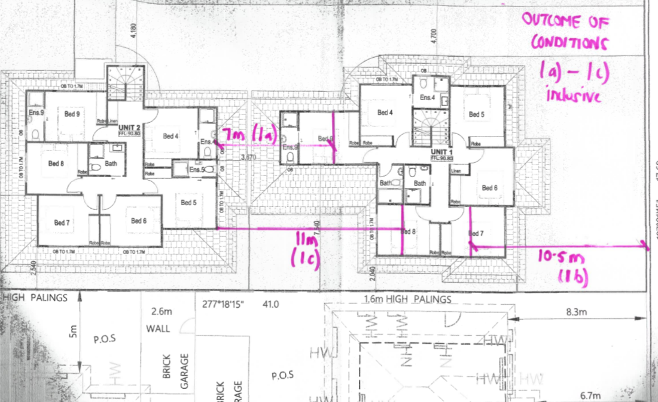
Figure 1 - upper level footprint of plans with hand notation of changes sought.
- The council also submits that conditions 1a) and 1c) link to maintaining reasonable amenity to the adjoining dwelling directly south. The council submits the break between buildings imposed through condition 1a) will reduce visual bulk to the secluded private open space area to the south and condition 1c) will avoid additional shadow to the same secluded open space area.
- I am satisfied there is no need to amend the development to address visual bulk or shadow. The rear section of the front dwelling (Dwelling 1) is sufficiently north of the existing dwelling to the south that it will not be excessively imposing. In concluding this I note that dwelling 2 was considered acceptable to the council even though it is generally closer to the secluded open space of an adjoining dwelling to its south.
- Condition 1c) will remove any additional shadow to the secluded open space of the dwelling to the south, but the additional shadow that the front dwelling casts is so very minor I find it is does not warrant alteration of bedroom 8.
- The secluded open space of the dwelling directly south of dwelling 1 has a relatively small secluded open space area that is ‘hemmed in’ by its own garage to its west and its dwelling footprint to its east. Currently it does not receive the standard requirement of direct sunlight directed by clause 55.04-5 so the consideration is whether any additional shadow should be considered acceptable. In this instance I am satisfied it is, as the additional shadow is for less than one square metre between 9 and 10am in the morning. This will have a negligible impact on the usability of the adjoining secluded private open space so I am satisfied that the new building does not significantly overshadow the existing secluded private open space next door.
- It therefore follows that I find no amenity or character reason to retain conditions 1a), 1b) or 1c) and will direct they be deleted.

Is additional ground level living space needed?
- The contested conditions require:
- Bedroom 3 in dwelling 1 changed to a dining/living area to allow for a more functional space for the kitchen and dining area. (condition 1d)
- The laundry of dwelling 2 to be reconfigured to be located where bedroom 3 is shown to allow for a more functional space for the kitchen and dining area. (condition 1e)
- The effect of conditions 1d) and 1e) is to increase the size of the living, kitchen and dining areas as shown in figure 2 below. Condition 1e) also seeks the laundry to be a separate room to provide functional space as a laundry. I discuss the specific need for a separate laundry below at paragraph 29.

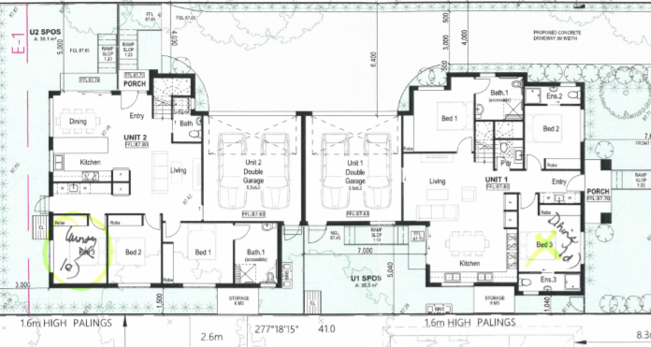
Figure 2 - ground floor of application plans with permit condition notations
- The applicant submits that the council has reached outside its discretion in applying what it considers are arbitrary numerical standards for the size of living spaces that do not exist in the planning scheme. It says the communal spaces are acceptable for the number of potential residents. The applicant submits:
- Kitchen and living areas are provided. The kitchen to dwelling 1 will comprise two stoves, two sinks and two fridges to cater for meal preparation of residents. The kitchen to dwelling 2 also has two fridges, but only one sink and one stove.
- The communal space of dwelling 1 (excluding the kitchen bench) totals 32.5 sqm and the communal space of dwelling 2 is 33.9 sqm.
- It is likely that not all residents will require use of the communal facilities at the same time and may choose to eat meals or undertake activities in individual bedrooms or external to the site.
- The planning scheme does not prescribe minimum room sizes for dwellings, other than for apartment dwellings and addressed through clause 58. The council relies on a decision of the tribunal in Dang v Monash CC where the tribunal found a need to increase living room sizes for two, seven bedroom dwellings. The council also provided me with a copy of plans to that decision and acknowledged that in that decision the living areas were smaller than in the proposal before me.
- In Dang, the tribunal acknowledged that ‘the scheme is largely silent on the provision of living spaces within dwellings’ with clause 15.01 offering ‘indirect guidance in that it encourages the development of places that are safe and that support the social well-being of the community’. I share these comments of the tribunal. Since the Dang decision, clause 15.01 has been amended but has strategy under clause 15.01-1S to ‘ensure development contributes to community and cultural life by improving the quality of living and working environments, facilitating accessibility and providing for inclusiveness’.
- In Dang the tribunal commented that the directions of clause 15.01 ‘suggest that dwellings should also enhance safety and personal well-being’ and that some ‘opportunity to socialise with the people one is living with contributes to well-being’ I consider this remains valid even with the changes to clause 15.01 that have occurred. As also noted in Dang, clause 21.04 of the Monash Planning Scheme acknowledges the need for dwelling diversity in terms of providing for a range of household types and sizes and that many students live in sub-standard accommodation.
- In discussing the conditions at the hearing I questioned if the intent of the proposal is to accommodate students in a shared accommodation or rooming house arrangement, given the layout of the dwellings. Mr O’Brien acknowledged on behalf of the applicant that the intent is to use the dwellings as rooming houses and that this will need a separate permit for use and development in accordance with changes to the planning scheme introduced while the application was being processed by the council.
- At the time the permit application was made to the council in August 2018 a dwelling could be used as ‘shared accommodation’ to accommodate students without the need for a planning permit if the dwelling accommodated less than 10 persons. A response to further information provided by the applicant in September 2018 to the council confirms that the intent of the dwellings is for them to be established as class 1b) buildings under the Building Act 1993, being a boarding house.
- In late October 2018 the planning scheme was changed to establish ‘rooming house’ as a separate definition to that of a dwelling. A rooming house is defined as ‘land’ used for a rooming house as defined in the Residential Tenancies Act 1997. As set out in Port Phillip CC v Chen Group (Aust) Pty Ltd
[60] The Residential Tenancies Act 1997 defines “Rooming house” to mean a building in which there is one or more rooms available for occupancy on payment of rent, in which the total number of people who may occupy those rooms is not less than 4 or in respect of which a declaration under a section of that legislation is in force. “Rent” is a defined term in that legislation, with a specific meaning in the context of a Rooming house:
in relation to the residency of a rooming house, the amount paid to a rooming house owner by a resident to occupy a room and use facilities and services.
[61] “Resident” is also defined in that legislation with specific reference to a rooming house:
in relation to a rooming house, a person who, with the agreement of the rooming house owner, occupies a room as his or her only or main residence.
- Whether the dwellings are converted to a rooming house within which students may rent rooms, or whether students co-own or co-lease the dwellings is unknown, but it is common ground that the intent of the dwellings is that they are occupied by students in a shared living arrangement. This is also evident in the provision of en-suites to most bedrooms and the extensive kitchen facilities. The location of Monash University some 500 metres to the east is a key attractor for the dwellings to be used for student accommodation.
- The council has a student accommodation policy at clause 22.10. Ms Kellock submits that she is not clear whether the policy applies as her enquires with council officers is that it only applies where the use is to accommodate students and she was advised that the dwellings are yet to be sought to converted to a rooming house. I am satisfied that even if the dwellings are not converted to a rooming house, it is evident from submissions made and the information before me that the dwellings are designed to accommodate students and the student accommodation policy at clause 22.10 therefore applies. This is because the policy states it applies where a permit is required for a dwelling, including ‘two or more Dwellings that are purposely designed and to be built specifically for student accommodation’.
- The policy refers to a student accommodation policy of the council, dated 2009 that directs that common kitchen and dining/meals area should cater for the total number of students. There is no prescribed size, and nor are the council conditions seeking a prescribed size. The conditions simply seek to provide communal space that can accommodate at least eight adults living in at least eight bedrooms.
- While the applicant estimates the shared living and dining areas are over 30 sqm in area my assessment differs. The dining area of dwelling 2, between the window and kitchen bench, west of the entry door is approximately 3.5 x 2.5 metres. While not all residents may eat together, providing a dining space that precludes this opportunity, or the opportunity for students to have friends share a meal, is not an amenable or liveable outcome. The usable living space of dwelling 2, not encumbered by hallway space, is approximately 3 x 3.5 metres. For an eight-bedroom dwelling, designed to accommodate students I find this space inadequate. I therefore find that condition 1e) that requires bedroom 3 of this dwelling to be converted to a laundry with a larger communal kitchen and living space has a nexus to its developed form and is reasonable. It therefore should be retained.
- The more open plan arrangement of dwelling 1 is marginally better than in dwelling 2 but I remain concerned that it is a small space for the shared living arrangement. I am not specifically concerned that bedroom 3 should be deleted and converted to a living space, but the kitchen and living space should be larger. This could be achieved through deleting one of bedroom 1, 2 or 3 at ground level. I note that deleting bedroom 1 would improve northern orientation to the living space and potentially provide a more functional layout to the living area.
- I therefore will amend condition 1d) to require that one of bedrooms 1, 2 or 3 at ground level be deleted to allow for a larger dining and living area.

Is a separate laundary needed to each dwelling?
- The council maintains that each dwelling should be provided with a separate room for a laundry. Each dwelling is currently provided with laundry facilities but both are what both parties referred to as ‘European style’ cupboard laundries in hallway spaces.
- Both dwellings include two washing machines in large hallway cupboards. I see no need for these to be in separate rooms and nothing was put to me that explained this specific need. I therefore will delete condition 1f). I have retained condition 1e) to ensure that the living and dining space is increased as is described as the intent of condition 1e) not because I find a specific need for a separate room for a laundry.

Conclusion
- For the reasons given above, the decision of the responsible authority is varied. The permit is varied to delete conditions that reduce the upper level footprint and the need for separate laundry rooms.

Alison Glynn
Member

The submissions of the parties, any supporting exhibits given at the hearing, and the statements of grounds filed; have all been considered in the determination of the proceeding. In accordance with the practice of the Tribunal, not all of this material will be cited or referred to in these reasons.
[2018] VCAT 107
[2019] VCAT 918.
Section 3(1) of the Residential Tenancies Act 1997.
Ibid.
The application plans provide nine bedrooms. The effect of conditions 1d) 1e) and 1f) is to reduce the dwellings to 8 bedrooms each.
between the front door, garage and rear door.

