VICTORIAN CIVIL AND ADMINISTRATIVE TRIBUNAL
planning and environment DIVISION
 | planning and environment LIST | vcat reference No. P76/2020  PERMIT APPLICATION NO. TPA/44843/A
CATCHWORDS
Section 77 of the Planning and Environment Act 1987; Monash Planning Scheme; Three Storey Apartment Building; Amendments to Permit.

APPLICANT | Macrina Pty Ltd
responsible authority | Monash City Council
REFERRAL AUTHORITY | The Head, Transport for Victoria (VicRoads – Metropolitan South East Region)
respondent | A McNamara
SUBJECT LAND | 1801 Dandenong Road and 85 Macrina Street, Oakleigh East
WHERE HELD | Melbourne
BEFORE | Margaret Baird, Senior Member
HEARING TYPE | Hearing
dates of hearing | 23 June and 25 September 2020
date of PRACTICE DAY HEARING | 17 July 2020
DATEs OF INTERIM ORDERS | 23 June and 17 July 2020
DATE OF final ORDER | 30 September 2020
CITATION | Macrina Pty Ltd v Monash CC [2020] VCAT 1089

Order

Amended permit granted
- In application P76/2020, the decision of the responsible authority is set aside.
- In permit application no. TPA/44843/A, an amended permit is granted and directed to be issued for the land at 1801 Dandenong Road and 85 Macrina Street, Oakleigh East, in accordance with the endorsed plans and on the conditions set out in Appendix A.

- The permit allows the following:
- Construction of a three (3) storey building containing 20 dwellings (apartments) above a basement carpark and alteration/creation of access to a road in a Road Zone Category 1.

Margaret Baird
Senior Member

APPEARANCES
For Macrina Pty Ltd | Ms N Taylor, Devcon Planning Services Pty Ltd.
For Monash City Council | Mr J Turner, Principal Planner – Appeals Advisor.
For A McNamara | Mr A McNamara.

Information
Description of proposal | Amendment to Permit TPA/44843 that allows a part two and part three storey building with 18 apartments and a basement car park. Based on Issue E plans, it is proposed to add floor area to create 20 dwellings. Other changes are proposed to several units and the basement (comprising several stackers to accommodate a total of 27 car spaces including one more visitor space).
Nature of proceeding | Application under section 77 of the Planning and Environment Act 1987 – to review the refusal to grant an amended permit.
Planning scheme | Monash Planning Scheme [scheme].
Zone and overlays | General Residential Zone, Schedule 2 [GRZ2]. Dandenong Road is a Road Zone Category 1.
Permit requirements | Clause 32.08-6 a permit is required to construct two or more dwellings on a lot. GRZ2 varies clause 55 Standards B6, B13, B17, B28 and B32.
Relevant scheme policies and provisions | Clauses 11, 15, 16, 21, 22.01, 22.05, 32.08, 52.06, 55, 65 and 71.
Subject land description | The vacant subject land is on the north-west corner of Dandenong Road and Macrina Street, Oakleigh East. The land comprises two separate titles with a combined area of 1,202.7m². A service lane is on Dandenong Road/Princes Highway. The land abuts single storey units to its west and side-by-side double storey units to its north. A mix of dwellings is opposite in Macrina Street. The land is in an established residential area characterised by detached brick and weatherboard dwellings with hipped tiled roofs (c.1950’s/60’s) and some multi-unit housing.
Tribunal inspection | 22 June 2020 (unaccompanied) as parties were advised at the start of the hearing on 23 June and 25 September 2020.

REASONS

INTRODUCTION
- Macrina Pty Ltd [applicant] applied to the Monash City Council [Council] to amend Permit TPA/44843 to modify the approved apartment building. Among multiple changes are two additional dwellings, five extra basement car spaces and several larger dwellings (to three bedrooms). The amendments seek to reduce the ground level western setback for two dwellings and modify the two storey component of the approved apartment development so as to comprise three storeys (adding Apartment 2.06).
- As the Council refused to grant the amendments to the permit, the permit applicant has asked the Tribunal to review that decision.
- The Council’s position is the proposed amendments result in a development that is too intensive for this site, in this context. The enlarged building will have a detrimental impact on the character of the area and amenity of neighbouring properties. Mr McNamara agrees with the Council that the amended development does not respect the character of the area, is too visually dominant and lacks visual breaks. He has broader concerns about the extent of development and nature of change occurring in the area that is affecting amenity, impacting on existing residents and straining infrastructure (such as on-street parking and road capacity). The use of car stackers is questioned. Mr McNamara submits property values would be affected. A statement of grounds by another original objector raises similar concerns about the proposal’s high density, failure to respect the neighbourhood and garden character, and negative impacts that will arise.
- In response, the applicant submits the proposal complies with the scheme and is not substantially different to what has already been approved. The proposed amendments do not significantly alter the character of the approved development. Among the submissions made on behalf of the applicant are that a three storey building was originally approved in an apartment building format. The proposal retains breaks and does not contribute to unreasonable visual bulk. The garden areas are not significantly changing as a result of the amendment application. Car stackers are a valid way to provide car parking.
- I must decide whether the amendments requested to the permit will produce an acceptable outcome having regard to the relevant policies and provisions in the scheme. Clause 71.02-3 requires the decision-maker to integrate the range of policies relevant to the issues to be determined and balance conflicting objectives in favour of net community benefit and sustainable development.

strategic CONTEXT
- The strategic context that is relevant to the assessment of this permit application is summarised below. This is not, per se, contentious, other than one matter that I refer to below.
- The subject land and surrounding area is within GRZ2 (Monash Residential Areas) with GRZ3 further to the north. It is within an area identified as part of the Garden City Suburbs. There is a strong policy emphasis on retention of neighbourhood character and the enhancement of the Garden City character. GRZ2 is applied to achieve preferred development outcomes. There are no neighbourhood character objectives or decision guidelines in GRZ2 to supplement the provisions of clause 32.08.
- It is, however, also relevant that the subject land is on Dandenong Road which is given a strategic role by the scheme. Boulevards are identified as a specific category in clause 21.04. Objectives in clause 21.04-3 include:
- To locate residential growth within neighbourhood and activity centres, the Monash National Employment Cluster and the boulevards (Springvale Road and Princes Highway) to increase proximity to employment, public transport, shops and services. This will assist to preserve and enhance garden city character and special character in the balance of the municipality.
- To encourage the provision of a variety of housing types and sizes that will accommodate a diversity of future housing needs and preferences that complement and enhance the garden city character of the city.
- To recognise the need to conserve treed environments and revegetate new residential developments to maintain and enhance the garden city character of the municipality.
- To encourage a high standard of architectural design in buildings and landscaping associated with residential development that takes into account environmentally sustainable development.
[Tribunal underlining]
- Strategies include:
- Ensure that new residential development enhances the character of the neighbourhood, having regard to the preferred future character statements contained within Clause 22.01.
- Ensure that development enhances the garden city and landscaped streetscape character of the neighbourhood, responds to the features of the site and surrounding area and promotes good streetscape design.
- Ensure that new residential development provides a high level of amenity including internal amenity, privacy for occupants and neighbours, access to sunlight, high quality private and public open space, canopy tree cover, and effective traffic management and parking.
- Allow some residential growth along those parts of the boulevards(Springvale Road and Princes Highway) that can support higher scale development in terms of neighbourhood character and accessibility.
- Provide an appropriate built form transition between activity centres and residential areas through innovative and high quality architectural design, appropriate setbacks and landscaping.
- The parties do not agree as to whether the subject land is within the National Employment Cluster. It is within an investigation area shown in clause 21.04 (Map 3) but, on my review of the material presented, does not appear to be within any specific identified or nominated precinct or cluster.
- Clause 22.01 addresses neighbourhood character. Its objectives include:
- To build upon the important contribution that landscaping makes to the garden city character of Monash.
- To encourage new development to achieve architectural and urban design outcomes that positively contribute to neighbourhood character having particular regard to the applicable preferred future character statement for the area.
- To encourage the provision of a variety of housing types to accommodate future housing needs and preferences.
- To direct residential growth to neighbourhood and activity centres, the Monash National Employment Cluster and the boulevards (Springvale Road and Princes Highway).
- Among relevant policies at clause 22.01-3 are general and topic-specific policies that I have considered but do not recite. The relevant preferred future character statement for Garden City Suburbs Southern Areas includes:
Modest dwellings with simple pitched rooflines and articulated facades will continue the prevailing development themes. On larger sites, low rise apartment development may be appropriate, provided the development is sited within generous open space, is well landscaped, retains the ‘open landscape character’ of the garden suburban setting and tapers down in scale closer to the boundaries of the site.
While the housing mix within this area will continue to evolve to meet the changing needs of the community, new development will complement the scale and siting of the original housing within the area. In doing so, it will enhance the generous spacious, open, landscaped character of the area.
This character area will be notable for its spacious garden settings, tall canopy trees, consistency in front setbacks and the maintenance of setbacks from at least one boundary and from the rear of the site. New dwellings will address the street and upper levels will be recessed and/or articulated to minimise the impression of building scale.
…
Existing mature trees and shrubs within properties should be retained and additional tree planting proposed to gradually create a tree canopy in the private domain, including at the rear of properties. This will create a visually permeable buffer between the house and street. The soft quality of the street that is derived from the wide nature strips and street tree planting will be maintained by ensuring that there is only one crossover per lot frontage.
Expanses of blank, or continuous, walls will be avoided, particularly when adjacent to public parks or creating the appearance of a continuous building mass. …
- The fact that residential growth is directed to the Princes Highway/ Dandenong Road is relevant in assessing the proposal’s character response.
- I have considered the decision guidelines at clause 22.01-5.
- I have also considered other relevant clauses of the scheme, as listed in the ‘Information’ section of these reasons.

Flooding
- I address this matter first even though the Council and applicant agree that design changes to address drainage considerations can be resolved through permit conditions. Ms Taylor refers to revised floor levels shown in a set of Issue F plans that, she submits, address this issue. Those plans also include changes to reduce shadowing impacts on properties to the west that would otherwise arise from an increase in the building height.
- The Issue F plans were prepared for a compulsory conference scheduled in April 2020 which did not proceed due to the pandemic. The compulsory conference was not re-scheduled. The proceeding was listed for the hearing that I am now conducting. Ms Taylor waived any prejudice relating to those ‘without prejudice’ plans. It is apparent that the building would increase in height up to around 400mm in the Issue F plans. This would, in the Council’s submission, require the plans to be further advertised.
- These plans show the maximum height of the building being increased to 9.548 metres (Ms Taylor refers to this as an approximate increase of 400mm). The elevations vary, as Ms Taylor described at the hearing. For example, the north elevation is increased to 9.183 metres, the west elevation is 9.240 metres and the east elevation is 9.398 metres. Ms Taylor states that increased setbacks for Apartment 2.06 accommodate the extra height to avoid impacting the existing approved shadows (apart from where the existing approved shadow already falls over a building). Below is an extract of the top floor, toward the north/rear. It shows revised and increased setbacks to proposed Apartment 2.06. This would become a two bedroom dwelling, rather than contain three bedrooms.
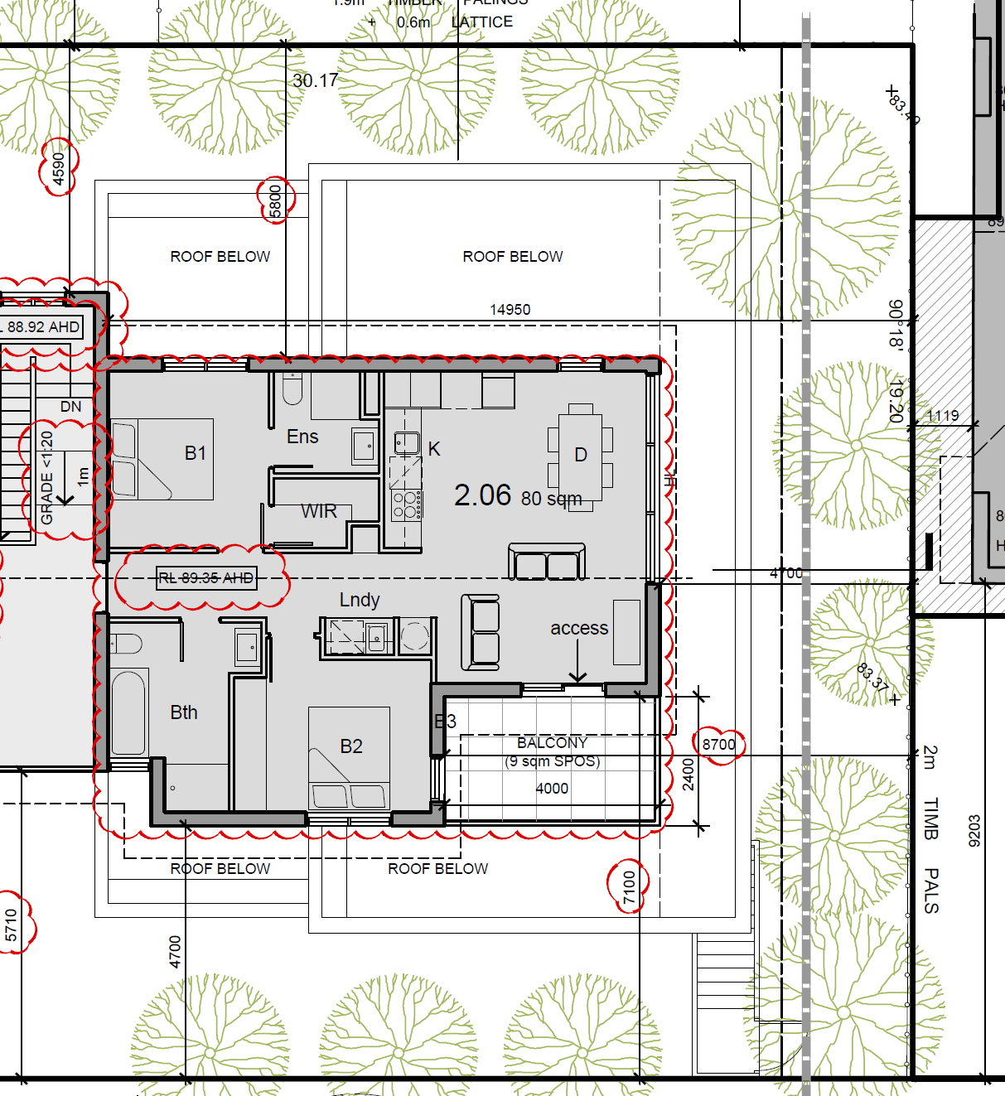
- I agree with Ms Taylor that the flooding/drainage issue should be able to be resolved through design changes which will not impact neighbouring properties. However, added height to address flooding and drainage may give rise to potential impacts that warrant advertising. None of the abutting property owners are parties in this proceeding.
- There was some discussion at the hearing about a potential permit condition that might limit any increase in the maximum building height (beyond the Issue E plans). It became clear via Ms Taylor’s instruction from the architect that lowering the height in the Issue F plans by 150mm could be achieved. Lowering by 200mm may, in Ms Taylors’s words, “be tight”.
- Later in these reasons I conclude that the size and position of Apartment 2.06 in the Issue E plans does not achieve an acceptable outcome. However, the reduced size of Apartment 2.06 shown on the Issue F plans, with deeper setbacks from boundaries, would achieve an acceptable character, streetscape and amenity outcome.
- I have decided that the question of any increased building height can be resolved through the endorsement of plans, in line with the Council’s position at the start of the hearing. If raised floor levels cause the building height to rise beyond what would not be generally in accordance with the Issue E plans, a further amendment may be required including advertising.

CHARACTER

Issues
- The Council regards the amended design as an uncomfortable fit for this site. Mr Turner states that the Council’s position is that the design response is poor and will have a detrimental impact on Macrina Street and adjoining properties due to the building’s increased bulk and mass and reduced setbacks. Mr Turner submits there is a clear expectation that any development on this site will preserve the Garden City character and provide meaningful areas of landscaping in order to respond to the preferred future character statement. Upper levels are to be recessed and/or articulated to minimise the impression of building scale.
- Mr Turner submits the amendments mean the development will be too visually dominant and will no longer provide the ‘townhouse rhythm’ that the original design would have delivered. The Council submits that the lengthy third level together with the reduced setbacks create unreasonable bulk and mass that extends deep into Macrina Street. Objectors agree. They refer to the way in which the development, as amended, departs from the existing character, is too dominant, and sets an undesirable precedent.
- Of particular concern to the Council are proposed modifications to Apartments G.02 and G.04 that reduce the setback to the western boundary at ground floor level. This will reduce landscaping and result in an unacceptable response to the garden character sought by local policy.
- The applicant does not agree. Ms Taylor submits the Issue E plans have a maximum height of 9.2 metres to the amended section of the building, excluding the 9.71 metres at the Dandenong Road end of the development which was approved and is not proposed to change. She states the Issue F plans have a maximum height of 9.548 metres to this rear section. The approved development has a maximum height of 9.4 metres to the rear of the third storey section of the building. The second storey section of the building has a maximum height of 7.4 metres as nominated on the east elevation. Ms Taylor submits the difference in height from the approved plans is 1.8 metres for the Issue E plans and 2.148 metres for the Issue F set.
- Ms Taylor submits GRZ2 allows a maximum building height of 11 metres and three storeys. A level of change is sought to the existing character and the level of change sought by the amendment is reasonable in the context of both the existing and the evolving character around the subject land. Ms Taylor submits the proposal retains breaks and does not contribute to unreasonable visual bulk. The modifications are not substantial so as to conclude the outcome is unacceptable. The garden areas are not significantly changing as a result of the amendment application. Ms Taylor submits the amendment will result in the loss of two trees along the western boundary. No changes are proposed within both the Dandenong Road and Macrina Street frontages nor are any changes proposed to landscaping along the north boundary of the site.

Findings
- I have referred to the strategic context that applies to an assessment of the amendments being sought to the approved development. I understand the concerns raised by objectors that additional dwellings are felt to undermine the character of the area and set a precedent for more development that, they consider, will change the character of the area. While policy seeks to respect the height, scale and massing of existing dwellings in the neighbourhood, a related policy seeks residential growth along Dandenong Road. The preferred character statements seeks to balance these considerations by stating (among other things) that on “larger sites, low rise apartment development may be appropriate, provided the development is sited within generous open space, is well landscaped, retains the ‘open landscape character’ of the garden suburban setting and tapers down in scale closer to the boundaries of the site”. The subject land is a larger site comprising two lots. An apartment building has already been approved by the Council. As a matter of principle, two more dwellings, and increasing the size of several dwellings, do not provide grounds to refuse the application mindful that this boulevard is targeted for growth. That is the case even though extra houses and residents will add to activity in the neighbourhood.
- In my view, the determinative issues are the reduced ground level setbacks to the west, some reduction in upper level setbacks to Macrina Street, and the additional third level where there is currently a two storey form transitioning to the north. These are all opposed by the Council, although in response to my questions, a scaled-back Apartment 2.06 could be acceptable from the Council’s perspective.
- The approved development has a very deep transition to the north. An image provided by the applicant (an extract of which is below) assists to show where the two storey element is proposed to become three levels. Apartment 2.06 is to be set back 4.7 metres from Macrina Street, 4.7 metres from the north boundary and 5.3 metres from the west boundary. Its balcony is closer to the street and northern boundary. Apartment 2.05 is set back a minimum of 3 metres from Macrina Street. A 5.9 metre deep recess separates that dwelling from the new Apartment 2.06. There is also some modification to materials and finishes from the approved development. No change is proposed to the landscape opportunities around the eastern and northern parts of the site.
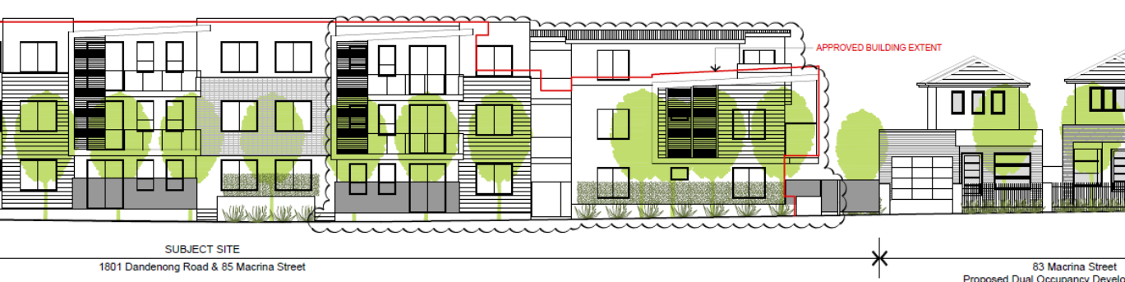
- I am satisfied that there is scope to provide additional built form above the two storey section of the approved development while tapering down in scale closer to the boundaries of the site.
- In its proposed form, I am not persuaded that Apartment 2.06 adequately achieves this preferred character outcome because of the combination of the reduced front setback for the northern section of the east elevation of Apartment 2.05 and then Apartment 2.06 with its forward balcony (evident in the plan extract below with Council markings):
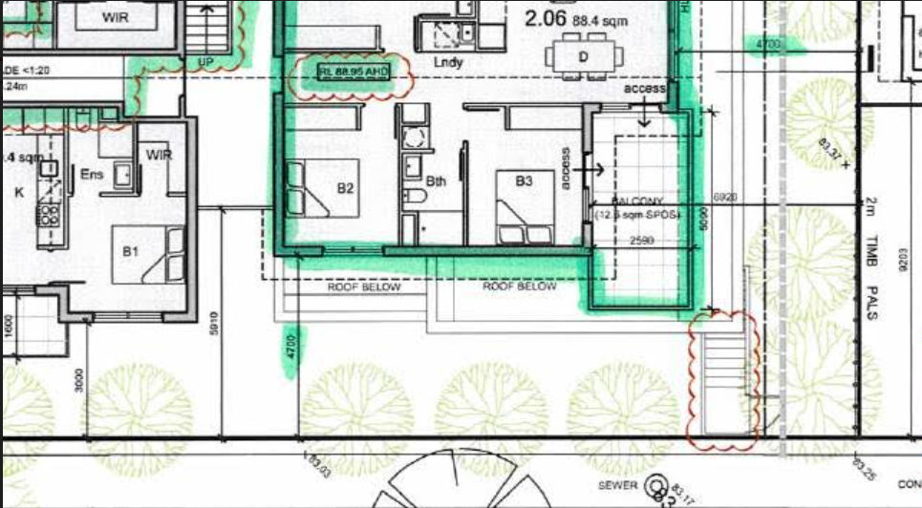
- There is the related impact on the secluded private open spaces to the west by the extended continuous three level built form, notwithstanding standard B17 of clause 55.04-1 is met.
- Reducing the size of Apartment 2.06 as shown in the Issue F plan (TP08) demonstrates that an acceptable transition can be achieved with modulation and articulation to break the mass. The two bedroom dwelling would have a deeper setback from the western boundary with the balcony contained within the envelope. It would have a better layout and improved amenity. I note the Issue F plan changes the depth of the recess (referred to above) to 5.71 metres. This seems acceptable taking into account that the break is widened by the revised unit layout and assists to modulate the building.
- The changes to the ground level western elevation do not have a significant streetscape impact, as evident in the applicant’s image below:
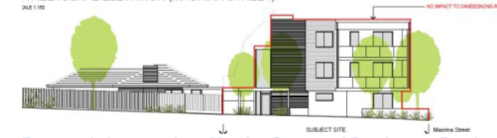
- The changes to Apartment G.02 occur behind a bin enclosure and adjacent to a carport associated with the front unit to the west. While the deeper setback may be preferable, I am not persuaded the changes to Apartments G.02 and G.04 cause an unacceptable character outcome. The land to the west also fronts the Dandenong Road boulevard where more intensive is expected in line with local policy.
- For the above reasons, I find the amendments to the approved development are acceptable when assessed under the character provisions of the scheme including clauses 32.08 and 55 as well as local policies, subject to modifications to reduce the size of Apartment 2.06 and to increase setbacks from boundaries as shown on TP08 Issue F.

off-site impacts

Issues
- The Council submits the proposal fails to appropriately manage visual bulk and will present as a large and very bulky building to the neighbouring properties abutting the subject land to the west. Mr Turner submits the addition to the upper level removes the transition from the three storey form down to two levels, as is evident in the approved design. He submits the lengthy three storey built form will result in unreasonable visual bulk and mass which will impact the amenity of the rear courtyards of Nos. 2 and 3/1799 Dandenong Road.
- Ms Taylor submits No. 1/1799 Dandenong Road would not be impacted by the additional built form as it sits behind the wall of Apartment 2.04. The third storey additions would be visible from the rear yards of Nos. 2 and 3/1799 Dandenong Road but, in her submission, the setbacks are generous. The western elevation is heavily articulated to reduce any perception of visual bulk and landscaping along this boundary will grow to further soften the appearance of the built form. The proposal has been designed such that the additional storey does not increase the overall height equivalent to a storey but a maximum of two metres approximately of increased height.

Findings
- I accept Ms Taylor’s submission that the additional floor area (based on increased setbacks to a scaled-down Apartment 2.06) achieves an acceptable interface with the adjacent dwellings. A setback of 5.8 metres from the western boundary adds articulation and provides stepping in the wall plane in addition to varied materials. The western setback also assists to manage shadowing of adjacent private open spaces.
- My assessment of the sightlines from the secluded private open spaces abutting the western boundary of the subject land is that the additional floor would have limited visual impact. I have referred to the proposal’s compliance with standard B17. There are no submissions that the amendments do not comply with other clause 55 numerical standards.

traffic and parking
- Mr McNamara explains his concerns about the proposal’s impacts on traffic and on-street parking. These include additional traffic and congestion, increased on-street parking, the tight street setting with more parked cars, and the prospect that people will not use car stackers. Ms Hanlon’s statement of grounds aligns with these concerns.
- The Council does not oppose the amendment application on traffic and parking grounds, including the use of car stackers. Its internal referral raises several detailed design matters that are proposed to be addressed by permit conditions.
- I accept Ms Taylor’s submission that parking for the additional units, and enlarged dwellings, is provided in the basement. An additional at-grade visitor car space is also provided. No reduction in the parking requirements of clause 52.06 is sought. The provision is, therefore, satisfactory notwithstanding concerns about existing pressures on on-street parking and that, on occasions, residents or their visitors will use public on-street parking.

Private open space
- The Council submits the application fails to meet the varied requirements of standard B28 and will therefore affect the amenity of future occupants. Mr Turner refers to the reduced western setback for Apartments G.02 and G.04 that in turn reduce private open space from 51 and 52m² to approximately 30m² with a minimum width of 3.5 metres. He submits this is not characteristic of the area, where dwellings are typically provided with relatively large areas of ground level open space and does not meet the private space objective at clause 55.05-4. Mr Turner also questions balconies for Apartments 2.02, 2.03, 2.04 and 2.05 that he submits fail to meet standard B43.
- I agree with Ms Taylor that standard B43 does not apply given transitional provisions apply. The proposed balconies satisfy standard B28.
- Ms Taylor submits the private open spaces for Apartments G.02 and G.04 are 37m² and 38m² respectively. This may include a narrower one metre wide section. Despite this, I accept the applicant’s submission that the outcome is acceptable for this apartment development and will provide a suitable area for residents of these dwellings. The spaces are satisfactorily configured. I find the objective of clause 55.05-4 is met.

OTHER MATTERS

Property values
- Reference has been made to potential impacts on property values should an amended permit be granted. As with the case with many other instances when this ground is identified by objectors to a planning permit application, potential loss in property values is not a matter upon which there is any evidence. Moreover, if values are affected by adverse amenity impacts, then it is the amenity questions that must be considered, not their ramifications in terms of property values. This is the approach usually adopted by the Tribunal in these types of proceedings.

Impact on services
- Mr McNamara expresses concern about the increased strain on services that result from more dwellings being permitted. I have referred to the strategic framework that provides the basis for a decision in this proceeding. The Council has a policy position to direct residential growth to locations including boulevards (Springvale Road and Princes Highway). This will bring increased development. In establishing this policy, the Council would have been aware of the infrastructure capacity, including opportunities and constraints. These broader considerations do not provide reasons to refuse the proposed amendments to the approved Permit.

Conclusion
- Subject to modifications by conditions, I am persuaded that the proposed amendments to the approved development are acceptable. I will therefore set aside the Council’s decision and direct an amended permit be issued in accordance with the conditions in Appendix A.

Margaret Baird
Senior Member

APPENDIX A
PERMIT APPLICATION NO: | TPA/44843/A
LAND: | 1801 Dandenong Road and 85 Macrina Street, Oakleigh East
WHAT THE PERMIT ALLOWS:
In accordance with the endorsed plans:
- Construction of a three (3) storey building containing 20 dwellings (apartments) above a basement carpark and alteration/creation of access to a road in a Road Zone Category 1.

conditions:

Amended Plans
- Before the development starts, three copies of amended plans drawn to scale and dimensioned, must be submitted to and approved by the Responsible Authority. The plans must be generally in accordance with the in accordance with the plans prepared by RPC Architects Plan Reference: Job No. 1889, TP01 Issue E to TP15 Issue E (total of 15 plans) , but further modified to show:
  - Deleted.
  - Deleted.
  - Amended- The bottom 400mm of all fences (except common boundary fences) to be ‘pool-type’ fence to allow for overland flows.
  - A full schedule of materials, external finishes and colours (including samples of colour palette).
  - Deleted.
  - Deleted.
  - Deleted.
  - Amended- A minimum of four visitor spaces within the basement to be clearly marked as ‘visitor spaces’.
  - The finished floor levels of all units located in 85 Macrina Street should maintain a minimum clearance of 400mm above the finished landscape levels of the ground around the building. FFLs and spot levels are to be provided on plans detailing this.
  - Deleted.
  - New- details of car stackers on Section 02 to the satisfaction of the Responsible Authority.
  - New- An amended landscape plan in accordance with Condition 8.
  - New- Setbacks for Apartment 2.06 in accordance with the plan TP08 Issue F (dated 17/02/20).
- The development as shown on the endorsed plans must not be altered without the written consent of the Responsible Authority.
- Once the development has started it must be continued and completed to the satisfaction of the Responsible Authority.
- The removal of 2 street trees and their replacement (location to be determined by Council) from the Dandenong Road frontage nature strip will be carried out by Council at full cost to the permit holder. The permit holder will also be responsible for the full cost of additional street tree planting along the Macrina Street nature strip frontage to the site (the number of trees and location to be determined by Council).
- No equipment, services, architectural features or structures of any kind, including telecommunication facilities, other than those shown on the endorsed plans shall be permitted above the roof level of the building unless otherwise agreed to in writing by the Responsible Authority.

Waste Management Plan
- Prior to the commencement of buildings and works, the owner shall prepare a Waste Management Plan for the collection and disposal of garbage and recyclables for all uses on the site by private contractor. The Waste Management Plan shall provide for:
  - The method of collection of garbage and recyclables for uses;
  - Designation of methods of collection by private services;
  - Appropriate areas of bin storage on site and areas for bin storage on collection days;
  - Dimensions of waste areas;
  - The number of bins to be provided and capacity;
  - Details on method and frequency of cleaning and maintenance of waste areas;
  - Details of ventilation;
  - A bin washing facility;
  - Hours of waste and recyclables collection;
  - Measures to minimise the impact upon local amenity and on the operation, management and maintenance of car parking areas;
  - Litter management.
A copy of this plan must be submitted to and approved by the Responsible Authority. Once approved the Waste Management Plan will be endorsed to form part of the permit.

Construction Management Plan
- Prior to the commencement of buildings and works, a Construction Management Plan must be prepared and submitted to the Responsible Authority for approval. The plan must be to the satisfaction of the Responsible Authority. Once approved, the plan must be implemented to the satisfaction of the Responsible Authority. The plan must address the following issues:
  - measures to control noise, dust and water runoff;
  - prevention of silt or other pollutants from entering into the Council’s underground drainage system or road network;
  - the location of where building materials are to be kept during construction;
  - site security;
  - maintenance of safe movements of vehicles to and from the site during the construction phase;
  - on-site parking of vehicles associated with construction of the development;
  - wash down areas for trucks and vehicles associated with construction activities;
  - cleaning and maintaining surrounding road surfaces;
  - a requirement that construction works must only be carried out during the following hours:
- Monday to Friday (inclusive) – 7.00am to 6.00pm;
- Saturday – 9.00am to 1.00pm;
- Saturday – 1.00pm to 5.00pm (Only activities associated with the erection of buildings. This does not include excavation or the use of heavy machinery.)

Landscaping
- A landscape plan prepared by a Landscape Architect or a suitably qualified or experienced landscape designer, drawn to scale and dimensioned must be submitted to and approved by the Responsible Authority prior to the commencement of any works. The plan must show the proposed landscape treatment of the site including:-
  - the location of all existing trees and other vegetation to be retained on site;
  - planting to soften the appearance of hard surface areas such as driveways and other paved areas;
  - a schedule of all proposed trees, shrubs and ground cover, which will include the size of all plants (at planting and at maturity), their location, botanical names and the location of all areas to be covered by grass, lawn, mulch or other surface material;
  - the location and details of all fencing;
  - the extent of any cut, fill, embankments or retaining walls associated with the landscape treatment of the site;
  - details of all proposed hard surface materials including pathways, patio or decked areas.
The landscape plan must include;
- A minimum of three additional canopy trees in the front setback to Dandenong Road.
- Screen planting along the western and northern boundaries of the site.
- Provision of canopy tree planting in the front setback to Macrina Street.
When approved the plan will be endorsed and will then form part of the permit.
- Before the occupation of the buildings allowed by this permit, landscaping works as shown on the endorsed plans must be completed to the satisfaction of the Responsible Authority and then maintained to the satisfaction of the Responsible Authority.

Vehicle access and car parking
- Before the development permitted is completed, areas set aside for parked vehicles and access lanes as shown on the endorsed plans must be:
  - constructed to the satisfaction of the Responsible Authority;
  - properly formed to such levels that they can be used in accordance with the plans;
  - surfaced with an all-weather sealcoat to the satisfaction of the Responsible Authority;
  - drained, maintained and not used for any other purpose to the satisfaction of the Responsible Authority;
  - line-marked to indicate each car space and all access lanes to the satisfaction of the Responsible Authority.
  - Parking areas and access lanes must be kept available for these purposes at all times.
  - All on site visitor car spaces are to be clearly marked as ‘visitor spaces’
- The proposed crossing is to be constructed in accordance with the City of Monash standards to the satisfaction of the Responsible Authority.
- The existing redundant crossings in Macrina Street are to be removed and replaced with kerb and channel. The footpath and nature strip are to be reinstated to the satisfaction of the Responsible Authority.
- All new crossings are to be no closer than 1.0 metre measured at the kerb to the edge of any power pole, drainage or service pit, or other services. The proposed vehicle crossing will affect an existing Telstra pit and will be within 1 m of an existing water stop. Approval from Telstra and the water authority are required as part of the vehicle crossing application process.
- No less than 1 car space must be provided on the land for each one and two bedroom dwelling. No less than 2 car spaces must be provided on the land for each three bedroom dwelling. Visitor car parking must be provided at a rate of no less than 1 car space to each 5 dwellings. Any future subdivision of the development must provide allocation of car parking on Title in accordance with this requirement including all visitor car parking located within common property.

Engineering
- Stormwater discharge is to be detained on-site to the predevelopment level of peak stormwater discharge. Approval of any detention system is required from Council prior to works commencing. Please refer to the notes section of this permit for additional details
- All on-site stormwater is to be collected from hard surface areas and must not be allowed to flow uncontrolled into adjoining properties.
Development Engineering Advice
- Before the development starts, a site layout plan drawn to scale and dimensioned must be approved by the Responsible Authority.
- The plans must show a drainage scheme providing for the collection of stormwater within the site and for the conveying of the stormwater to the nominated point of discharge.
- The nominated point of stormwater connection for the site is to the east of the property where the entire site’s stormwater drainage must be collected and free drained via a pipe to the Council pit in the nature strip of Macrina Street to Council Standards. (A new pit is to be constructed if a pit does not exist or is not a standard Council pit). If the point of discharge cannot be located then notify Council’s Engineering Division immediately.
  - Amended- The property has been referred to Monash Council as an overland flow path. The requirements to protect the property are as follows:
  - The Finished Floor Levels of all units located in 85 Macrina Street should maintain a minimum clearance of 400mm above the finished landscape levels of the ground around the building.
  - The natural ground level along the northern easement is to remain the same. The finished surface level adjacent to the building is to slope towards this easement and to the road.
  - The fences across the northern boundary can be paling fences as long as there is adequate spacing at the bottom to allow for overland flow.
  - All other fences are to be a 'pool-type' fence at the bottom to allow for overland flows.
  - The 2.44 m wide gap along the northern boundary is to be kept clear of all structures.

Time Limit
- This permit will expire in accordance with section 68 of the Planning and Environment Act 1987, if one of the following circumstances applies:
- The development is not started before 4 July 2021.
- The development is not completed before 4 July 2023.
In accordance with section 69 of the Planning and Environment Act 1987, the responsible authority may extend the periods referred to if a request is made in writing before the permit expires, or within six months of the permit expiry date, where the development allowed by the permit has not yet started; or within 12 months of the permit expiry date, where the development has lawfully started before the permit expires.

--End Conditions--

The submissions of the parties, supporting exhibits and statements of grounds filed have all been considered in the determination of the proceeding. In accordance with the Tribunal’s practice, not all of this material will be cited or referred to in these reasons. Interim orders addressed the permit expiry and the need to address the requirements of the Aboriginal Heritage Act 2006 and Aboriginal Heritage Regulations 2018. These matters were resolved by the approval of a cultural heritage management plan and Council’s approval of an extension of time to commence the development (to 4 July 2021).
At the start of the hearing, Mr Turner stated that the Council is not pursuing its ground of refusal relating to flooding. This matter, he said, could be addressed by permit conditions.
Map 3 at clause 21.04-1.
Clause 22.01-4.
An impression of this can be gained from section 04 (noting the floor levels require refinement).

