VICTORIAN CIVIL AND ADMINISTRATIVE TRIBUNAL
PLANNING AND ENVIRONMENT DIVISION
planning and environment LIST | vcat reference No. P202/2019  Permit Application no. TPA/48814
CATCHWORDS
Five double storey dwellings; Policy imperative for additional housing in this location; Neighbourhood character – existing, policy for preferred character; and schedule 3 to the General Residential Zone.

APPLICANT | RYJ Development Pty Ltd
responsible authority | Monash City Council
RESPONDENTs | Mr W Derbyshire  Mr G Lowe
SUBJECT LAND | 24 – 26 Darbyshire Road, Mount Waverley
WHERE HELD | Melbourne
BEFORE | Rachel Naylor, Senior Member
HEARING TYPE | Hearing
DATE OF HEARING | 9 August 2019
date of interim orders | 12 August 2019 and 15 November 2019
DATE OF final ORDER | 24 January 2020
CITATION | RYJ Development Pty Ltd v Monash CC [2020] VCAT 87

Order

Amend name
- Pursuant to section 127 of the Victorian Civil and Administrative Tribunal Act 1998 the application is amended by changing the name of the applicant to:
RYJ Development Pty Ltd
- Pursuant to clause 64 of Schedule 1 of the Victorian Civil & Administrative Tribunal Act 1998 the permit application is amended by changing the name of the permit applicant to:
RYJ Development Pty Ltd

Amend permit application
- Pursuant to clause 64 of Schedule 1 of the Victorian Civil & Administrative Tribunal Act 1998, the permit application is amended by substituting for the permit application plans, the following plans filed with the Tribunal:
Prepared by: | Jesse Ant Architects
Drawing numbers: | TP01, TP02, TP03, TP05 Demolition Plan & Streetscapes, TP05 Basement Plan, TP06, TP07, TP08, TP09, TP10, TP11, TP12 and TP13
Dated: | 21-06-2019
- Pursuant to clause 64 of Schedule 1 of the Victorian Civil & Administrative Tribunal Act 1998, the permit application is amended by the description of the proposal to include the waiving of the one residential visitor car space required under clause 52.06.

No permit granted
- In application P202/2019 the decision of the responsible authority is affirmed.
- In planning permit application TPA/48814 no permit is granted.

Rachel Naylor
Senior Member

Appearances
For applicant | Mr A Clarke, town planner of Clarke Planning  Mr Clarke called Mr T Aravidis, landscape architect of Species Landscape Architecture to provide expert evidence.
For responsible authority | Mr D De Giovanni, town planner
For Mr Derbyshire | Mr W Derbyshire
For Mr Lowe | Mr G Lowe

Information
Land description | The site comprises two lots – Nos. 24 & 26. It has a combined street frontage of 34.14m, a depth of 42.67m and a total site area of 1,456sqm.  The site has a slope of about 4 metres diagonally across it, with the general visual impression of a fall to the rear. There is a 1.83m wide easement along the rear (south) boundary.  Each lot currently contains a modest single storey house. There is vegetation scattered across the two lots including a Liquidambar tree of about 7m in height in the front garden of No. 26.
Description of proposal | Construction of five double storey dwellings.  The dwellings contain four bedrooms with the exception of Dwelling 3 that provides three bedrooms. Each dwelling has a double garage. The Dwelling 5 garage is in a basement form with the others located at ground level. The design features contemporary architecture with materials including brick and render and pitched roof forms. The overall maximum building height is Dwelling 5’s east elevation at 8.2m.
Nature of proceeding | Application under section 77 of the Planning and Environment Act 1987 – to review the refusal to grant a permit.
Planning scheme | Monash Planning Scheme
Zone and overlays | General Residential Zone Schedule 3 – Garden City Suburbs (GRZ3)  Vegetation Protection Overlay Schedule 1 – Tree Protection Area
Permit requirements | Clause 32.08-6 Construction of two or more dwellings on a lot in GRZ3  Clause 52.06-3 Reducing the standard residential visitor car parking requirement from one space to zero spaces.

Reasons

What is this proceeding about?
- RYJ Development Pty Ltd (the Applicant) seeks a review of the Council’s decision to refuse to grant planning permission for the construction of five double storey dwellings on the site known as Nos. 24 and 26 Darbyshire Road, Mount Waverley.
- The Council refused the planning application because it considers the proposal is contrary to the existing neighbourhood character and policy expectations for this area. Key issues of concern include the site constraints of topography and interfaces with back gardens; the on-street impacts of reducing car parking; the large size of the proposed dwellings; the compromised internal amenity of three of the dwellings; and the excessive bulk and massing presented both internally and to adjacent properties. The Council more recently has submitted that the changes made to the planning scheme since the hearing, including the applicable zone schedule and the new neighbourhood character policy that now applies to this site, continue to support its concerns.
- Two of the three objectors to the permit application lodged statements of grounds with the Tribunal raising similar issues to those raised in the Council’s grounds of refusal. Both Mr Derbyshire and Mr Lowe explained their concerns in the hearing and made submissions in response to the changes that have been made to the planning scheme since the hearing.
- The Applicant submits this proposal complies with a number of the varied clause 55 standards in the new zone schedule; and that proposal is an appropriate response to the callings of the new neighbourhood character policy. The Applicant considers the proposal respects the existing character within which change is to be expected and its emphasis on gardens, landscaping, driveways and then built form require a contextual response and, in general terms, this character policy is not dissimilar to the policies that existed at the time of the hearing.
- The Council and the Applicant each referred to two other Tribunal decisions in Darbyshire Road and sought to rely upon or distinguish the findings in these decisions dependent upon their particular viewpoint. During my inspection of the neighbourhood, I had the benefit of seeing both of these properties. I have also had the benefit of viewing the plans and landscape plans associated with each of these decisions. Each case must be decided on its own merits. I agree with the submissions made by both the Council and the Applicant during the hearing that the physical conditions of this site include differences to the other two decisions/sites. Similarly, the proposed design before me is different to the designs in the other decisions. In general terms, these two decisions had regard to the particular facts and circumstances/context of the respective site and its surrounding neighbourhood in deciding whether or not to grant a permit for the particular design proposed. I must do the same in this case. That is consider the particular facts and circumstances/context of this site and its surrounds in deciding whether the proposed design is an acceptable response to the neighbourhood.
- The Applicant has emphasised in all of its submissions that the proposal is spread over the consolidated two lots which means the proposal equates to about 2.5 dwellings per lot, a density not dissimilar to that already found in this neighbourhood. It is not the number of dwellings but the layout of the development including the driveways, dwellings/buildings and landscaping that determine the acceptability of a proposed design response to its surrounding neighbourhood. The Council’s submission highlights that this proposal has chosen to include four out of five dwellings that each contain four bedrooms. This has an impact on the layout of a development given the size of the floor areas to be accommodated.
- For reasons that I will now explain, I share Mr Derbyshire’s concern about the interface between the proposed design and his property along the west side of the site. The proposal creates an unacceptable visual bulk impact.

Policy imperative for new development in this neighbourhood
- I agree with the findings in the two VCAT decisions referred to that this site is not particularly proximate to public transport or services. Nevertheless, I also agree with the findings of Senior Member Hewet that that does not mean the site cannot be developed with medium density housing. Indeed, this neighbourhood already contains quite a number of examples of medium density housing, including along Darbyshire Road. The layout of these developments typically contain two or three dwellings with a common driveway along one side boundary. Mr Derbyshire already has such examples along his west side boundary and his rear boundary.
- The Applicant points out there is a general policy including at the State level that supports urban consolidation, and that is what this proposal does. However, the Applicant also acknowledges that urban consolidation in this case still means that a design must be acceptably respectful of its surrounds, including the character of the neighbourhood and the amenity of the adjoining properties.
- I agree with the Council’s submission that a typical suburban location such as this that is removed from nearby activity centres, public transport and a range of services means there is no policy imperative for new development at the expense of neighbourhood character. In other words an acceptable design outcome must provide a balance between development and neighbourhood character. As per the General Residential Zone purpose, the development of this site must be respectful of the neighbourhood character.

Neighbourhood character
- The Applicant and the Council acknowledge that the preferred neighbourhood character contained in the new policy in the planning scheme gives recognition to the existing character and seeks new development to respect that character.
- Both of the other VCAT decisions related to properties on the north side of Darbyshire Road. There is general agreement amongst the parties that the south of the road has some different characteristics to the north side. The south side of Darbyshire Road slopes. The Council identifies a slope to the west (toward Mr Derbyshire’s property) and a greater slope of about 4 metres diagonally across the site towards the south (to the rear of the property). This means dwellings/buildings often sit below the footpath level and do not have the same elevated prominence that exists on the north side of the street.
- There are two dwellings located on the east side of this site. They share a driveway along the common boundary. The front dwelling is two storey and is separated from this site by the driveway. The rear dwelling is single storey and is built on or close to the common boundary with this site. There is also a new three dwelling development located adjacent to the southwest half of the rear boundary of this site. They are all two storeys and there is a common driveway on its north side, which includes being adjacent to this site and Mr Derbyshire’s property.
- The proposed layout includes a central communal driveway with a dwelling located on either side of it, fronting Darbyshire Road. The proposed dwelling on the west side has its own separate driveway and its garage as part of the streetscape presentation. No issues were raised by any party about the proposed streetscape presentation. Effectively the design continues the existing conditions of having two detached dwellings facing the street, separated by a central driveway. The front setbacks and the landscaping with new trees all contribute to the maintenance and enhancement of the existing neighbourhood character.
- The Applicant points out the use of a communal central driveway limits the amount of hard stand paving and driveway areas in comparison to if the two properties had each been individually developed. Whilst this may be a benefit, it also has a design impact of locating the dwellings around the driveway, which means the buildings can be located close to side and rear boundaries.
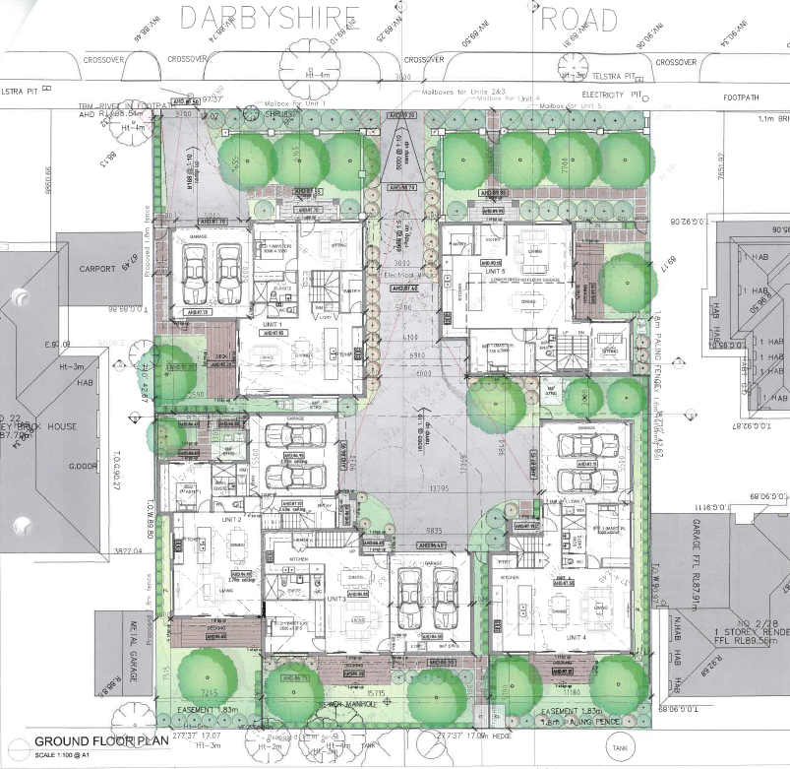

- The ground floor plan extract above illustrates that there are generous rear setbacks. The proposed rear dwelling in the southeast corner of the site is located close to the driveway and rear unit of the two dwellings on the eastern adjoining land. It also illustrates that the two dwellings on the west side of the site have sections that are built close to Mr Derbyshire’s property. He explained during the hearing that his eastern open space area is a bluestone outdoor entertaining area. Mr Derbyshire questioned why the development appears to be built closer to his property than to the eastern side boundary. In his view, the eastern side has no sensitivity because there is a driveway and garage effectively running the length of that boundary.
- The Applicant acknowledges there is sensitivity to the west of the site including ‘arguably’ Mr Derbyshire’s eastern entertaining area, but submits the design has side setbacks, well separated first floors and landscaping. The Applicant further submits that the eastern habitable room windows in Mr Derbyshire’s house do not experience a ‘generic visual bulk’ impact because there is a building break in that location with a tree proposed.
- I am not persuaded that the design response in proximity to the western side boundary of this site is acceptable. The two dwellings along this western side of the site are built close to the boundary. As Mr Derbyshire points out, some of the ground floor walls may be set back one metre, but the eaves extend into this setback so the benefits to be derived from a one metre setback are limited. Further, Mr Aravidis’ landscape concept plan is different to the architectural plans, including the extract of the ground floor plan shown on the previous page.
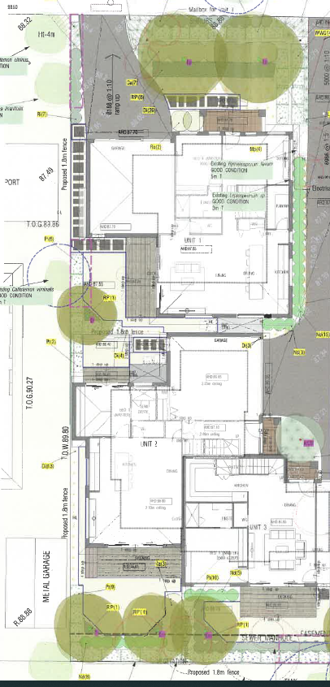
- Mr Aravidis’ landscape concept plan (of which an extract of the western half is shown on the previous page) contains little opportunity for landscaping of any significance other than for one tree in the rear courtyard of the front unit (unit 1) and one tree in the rear southwest corner of the site. Mr Aravidis explained during the Council’s cross-examination that a hedge of about 3.5 metre mature height can be planted along the western side boundary between units 1 and 2 (the rear dwelling in the southwest corner of the site). He also explained there is not enough room for a hedge to the south of the room of unit 2 that is proposed to be built to the boundary. Mr Aravidis explained during Mr Derbyshire’s cross-examination that he is not designing a garden, but rather designing a landscape and so his aim is for low maintenance.
- I acknowledged with the Applicant in the hearing that Mr Aravidis’ evidence was remarkably frank. He was frank about the design being deliberately maintenance free or requiring only simple maintenance. He was also frank about there being uncertainty as to whether the plants he has chosen will be planted by the developer and whether they will be maintained by future owners. Hence, his approach has been to a design a landscape of simplicity.
- If a development wishes to rely upon landscaping to soften the impact of building form, then there needs to be sufficient room to create beneficial areas for landscaping. I am not persuaded this is achieved along the western side of the site. Whilst there is separation between units 1 and 2 and further separation at the first floor levels, I agree with Mr Derbyshire that there still remains an unacceptable visual bulk impact upon his amenity.
- The Applicant identified the focus within the policy framework on garden character with specific focus given to trees, including by the fact that there is a tree conservation local planning policy. Mr Aravidis’ landscape concept does provide trees and, throughout the site, the plan proposes trees in suitable locations. The rest of the landscaping concept is reasonably minimal and simple, which is in part to encourage the maintenance and retention of the trees. However, overall there are minimal tree opportunities created along either of this site’s side boundaries.
- The new GRZ Schedule 3 that now applies to this site has a new formula for calculating the number of canopy trees – ‘at least one canopy tree plus at least one canopy tree per 5 metres of site width’. The Applicant’s submission responding to this suggests it means ‘the proposal needs either 6 or 7 trees along its frontage depending on how one “rounds”’. The formula talks about the ‘site width’ rather than the site frontage and the whole of the modified standard B13 is for new development to provide or retain a certain number of canopy trees, a mix of species and:
- Vegetation in the front, side and rear setbacks; and
- Vegetation on both sides of accessways.
- The modified standard appears to seek vegetation throughout a development and, again, this proposed layout does not provide for this outcome.
- I have previously explained in other decisions that I have made that the term visual bulk is used to describe a negative impression that a new building may have upon its surrounds. The impact of the visual bulk may be acceptable if the planning scheme encourages a more intensive form of development to take place in a particular neighbourhood, but that is not the case here. So, the proposed design needs to address the visual bulk impact through various means such as setbacks and articulation, including the materials and finishes. Landscaping can assist to limit or soften the appearance of the buildings, but it is not a substitute. The building form (and its visual bulk impact) must be acceptable on its own merits.
- Mr Derbyshire’s house has habitable windows facing this site, a sideage that he submits is used on occasion for outdoor entertaining and a rear garden, separated from the site by an existing garage. The Applicant acknowledged during the hearing that the two dwellings on the west side of the site will have a high degree of visibility. I find the setbacks and articulation are minimal and do not sufficiently address the visual bulk impact.
- There is a generous setback from the rear boundary, which is divided into three private open space areas. The Council points out the majority of this rear area will be in shadow throughout the day due to its southern location/orientation. The Council also points out some aspects of the design of the three rear dwellings have not met the solar access to open space standard B29. The Applicant disputes some of the Council’s calculations. It is not necessary to determine compliance with standard B29 as there is no doubt this southern area is affected by extensive overshadowing. The shadows are cast not only by the three rear dwellings, but also from Mr Derbyshire’s garage on the west side and the garage of the rear dwelling on the east side of the site.
- The Council is also concerned about the energy efficiency of the rear dwellings given their limited or non-existent northern orientation, and the limited windows facing east and west. The Applicant submits the Council’s focus was upon daylight and the design allows for appropriate levels of daylight given the dwellings at either end of the rear row have additional windows facing east, west or north.
- It is not necessary for every dwelling to have northerly oriented open space or habitable rooms. Other orientations can and are also acceptable. Energy efficiency in design is about more than just sunlight access. Nevertheless, these issues combined with the visual bulk impact to the west and the limited landscaping opportunities to the side boundaries are all characteristics of this design that I find have not acceptably responded to the site and its surrounding neighbourhood.

Other matters
- The Council questioned the ease of access into the semi basement garage of unit 5 in the northeast section of the site. This unit is on a slope and the turning movement occurs over two different proposed gradients. I was advised that the Council sought views from its traffic engineers on the amended design but, at the time of the hearing, none had been forthcoming, so I do not know if the Council’s engineers share this concern. The Applicant submits its traffic engineer is happy with the turning movements and that turning circles were done, however they are not contained in the traffic engineering comments submitted by the Applicant. This is not a reason to refuse this proposal, but it is a matter that should be clarified and resolved as part of any new permit application.
- Mr Lowe is concerned about the increased vehicles parking on the street including if no visitor car space is provided; and is also concerned about the increase in traffic. He pointed out the roundabouts along Darbyshire Road were installed about 2 to 3 years ago in response to the rat-run routes vehicles take between Huntingdale and Highbury Roads. Mr Derbyshire also points out the child care centre at the west end of the street generates on-street parking, particularly for staff.
- I am not persuaded these are reasons to refuse to allow additional dwellings to be built on this site. This proposal provides the number of resident car spaces required by the planning scheme. This level of resident parking will have a consequential impact of generating traffic, particularly in the immediate vicinity of local streets. The Council has not raised any concerns with the level of additional traffic proposed on these local roads. Whether a visitor car space is required will need to be considered afresh if a new permit application still proposes five dwellings (as four or less does not require visitor car parking).

Conclusion
- For the reasons given above, the decision of the responsible authority is affirmed. No permit is granted.

Rachel Naylor
Senior Member

The submissions and evidence of the parties, the supporting exhibits given at the hearing and the material and submissions filed during and after the hearing have all been considered in the determination of the proceeding. In accordance with the practice of the Tribunal, not all of this material will be cited or referred to in these reasons.
Aussiehome (South Yarra) Pty Ltd v Monash CC [2018] VCAT 430 determined by Member Rundell for the site at 19 Darbyshire Road, Mount Waverley; and Najeem v Monash CC [2019] VCAT 813 determined by Senior Member Hewet for the site at 3 Darbyshire Road, Mount Waverley.
Provided by the Council in response to a request during the hearing that was confirmed in an Interim Order issued after the hearing.

