VICTORIAN CIVIL AND ADMINISTRATIVE TRIBUNAL
planning and environment DIVISION
planning and environment LIST | vcat reference No. P1243/2019  Permit Application no. TPA/50000
CATCHWORDS
Demolition; Considerations given no specific local policy guidance; Historical significance; Architectural significance; Farmhouse; Reconstruction and restoration.

APPLICANT | Mr B Carroll
responsible authority | Monash City Council
SUBJECT LAND | 241-243 Lawrence Road  MOUNT WAVERLEY VIC 3149
WHERE HELD | Melbourne
BEFORE | Rachel Naylor, Senior Member  Rebecca Cameron, Member
HEARING TYPE | Hearing
DATEs OF HEARING | 13-14 January 2020
date of interim order | 17 January 2020
DATE OF final ORDER | 27 April 2020
CITATION | Carroll v Monash CC [2020] VCAT 528

Order

No permit granted
- In application P1243/2019 the decision of the responsible authority is affirmed.
- In planning permit application TPA/50000 no permit is granted.

Rachel Naylor  Senior Member | Rebecca Cameron  Member

Appearances
For applicant | Ms M Livingstone, town planner of SongBowden Planning Pty Ltd  She called the following witnesses:  - Mr B Raworth, heritage consultant of Bryce Raworth Pty Ltd; and  - Mr G Cross, structural design engineer and building surveyor of Bayside Building Services
For responsible authority | Ms S Moser, town planner of Moser Planning Services Pty Ltd  She called the following witness:  - Mr D Wixted, heritage consultant of Heritage Alliance

Information
Land description | The site has a 33.53m frontage, a 40.2m depth and an area of 1,483sqm. There is a sewerage easement along the rear of the site and the land is relatively flat. There is a steep ramp at the south end of the frontage providing vehicular and pedestrian access to the site as it is alongside a bridge over the railway line. This means Lawrence Road is about 2 metres above the natural ground level of the site.  The site contains a single storey three bedroom building with weatherboard cladding, known as the ‘Dillion residence’. It is an individually significant heritage place in the planning scheme, where it is described as an ‘Edwardian farmhouse’.
Description of proposal | Demolition of the existing building and associated outbuildings and construction of five double storey dwellings
Nature of proceeding | Application under section 77 of the Planning and Environment Act 1987 – to review the refusal to grant a permit.
Planning scheme | Monash Planning Scheme
Zone and overlays | General Residential Zone Schedule 2 – Monash Residential Areas (GRZ2)  Heritage Overlay HO46 – 241-243 Lawrence Road, Mount Waverley (HO46)
Permit requirements | Clause 32.08-6 Construction of two or more dwellings on a lot in GRZ2  Clause 43.01-1 Demolition of a building, construction of a building including pergolas and verandahs, and fencing and decks if visible from the street, and construction and carrying out of works in HO46

Reasons

Overview
- Mr Carroll (the applicant) initially sought planning permission to demolish the existing buildings on the land at 241-243 Lawrence Road, Mount Waverley and to construct six double storey dwellings. There were no objections to this planning permit application. The Council refused to grant a permit because of concerns about:
- The demolition of the heritage building;
- Non-compliance with the Monash Housing Strategy 2014 and adopted Amendment C125;
- Non-compliance with clause 55, particularly relating to matters of neighbourhood character and design detail; and
- The landscape outcome proposed.
- Amended plans reducing the number of dwellings to five and thereby modifying the proposed layout and design were circulated by the applicant before this hearing. We substituted these amended plans in our Interim Order and they now form the basis of our consideration of the merits of this proposal. The Council’s concerns and grounds of refusal have not changed as a result of these amended plans.
- The key issue is the acceptability of the demolition of the heritage significant building. If we find the demolition is acceptable, we then need to consider the Council’s other concerns about the proposed design detail and how the new design respects the neighbourhood character. For reasons that we will now explain, the demolition is not acceptable. This means we have not made findings on the Council’s other concerns.

Demolition of an individually heritage significant Edwardian farmhouse
- Demolition is often considered a poor and/or negative outcome in a heritage setting. The Burra Charter (the Australia ICOMOS Charter for Places of Cultural Significance 2013) acknowledges change, including demolition, may be necessary, but that change is undesirable where it reduces cultural significance. The Burra Charter goes on to state ‘demolition of significant fabric of a place is generally not acceptable’. A similar sentiment is often found in many of the Heritage local planning policies in planning schemes across Victoria. Despite this, the Heritage Overlay provides the discretion to grant planning permission for demolition. So, each planning application for demolition must be considered on its own merits.

Considerations for demolition
- The purpose of the Heritage Overlay includes:
To conserve and enhance heritage places of natural or cultural significance.
To conserve and enhance those elements which contribute to the significance of heritage places.
- The most relevant decision guideline in the Heritage Overlay to the issue of demolition is:
Whether the demolition, removal or external alteration will adversely affect the significance of the heritage place.
- To assist in the exercising of the discretion to allow demolition under the Heritage Overlay, heritage local policies in planning schemes often provide specific guidance about the consideration of demolition proposals. However, that is not the situation here. The Heritage local policy at clause 22.07 of the Monash planning scheme contains general objectives that have relevance to the issue of demolition:
- To recognise, conserve and enhance places and streetscapes in Monash identified as having architectural, cultural or heritage significance as described in the Monash Heritage Study (1999).
- To conserve those buildings and places designated as being contributory to the cultural heritage significance of Monash.
- The policy also contains some decision guidelines that have relevance to the issue of demolition, including:
- The available physical and documentary evidence showing how an altered exterior, especially the facade of a building, once looked in the past.
- The recovery of the cultural heritage significance of buildings by reconstructing removed elements. Contemporary requirements might render the re-construction of removed elements impractical.
- The potential impact of a proposal on the heritage values of the site or its setting and area. Heritage values extend beyond particular buildings, to include places, landscapes and features.
- The cultural heritage significance of the site and all nearby places identified in the Heritage Study.
- In addition to Heritage policy considerations, it is also necessary to consider whether discretion should be exercised having regard to the balancing of all relevant policies in favour of sustainable development and net community benefit.
- All of these considerations are addressed below.
- Mr Raworth gave evidence that, given the lack of specific demolition guidance in the Heritage local planning policy, the ‘typical matters’ to consider include:
- Revisiting the significance of the heritage place in its current setting;
- How the circumstances described in the citation have changed as it is 20 years old;
- The condition of the building in terms of its integrity and significance;
- The structural integrity of the building and whether its significance remains after remedial works are undertaken; and
- General planning issues such as the balancing of all relevant policies in favour of sustainable development and net community benefit.
- There is a fine line about how to consider the first two matters identified by Mr Raworth. It is not the role of the Tribunal to ‘revisit’, review or reconsider the identification of this site as being of individual heritage significance. That decision is already made, and the site is individually listed as a heritage place (heritage overlay HO46) in the planning scheme. If the circumstances of this site are considered by the Applicant and its consultants to be no longer worthy of that recognised heritage significance, the appropriate course of action is to seek Council support for a planning scheme amendment to change or remove the individual heritage overlay. The focus of our consideration is whether the demolition is acceptable of a building on a site that is identified in the planning scheme as being of individual heritage significance.

The significance of heritage place HO46
- The significance of the heritage place needs to be understood in order to consider the discretion available and decide whether to allow demolition of the existing buildings on the site. This site contains an Edwardian building/house and also some outbuildings. Neither party, nor the expert heritage witnesses raised any concern about the demolition of the outbuildings. They are not recognised as having any heritage significance, so their demolition is acceptable. Hence, the focus of our consideration is upon the Edwardian building/house on the site.
- The site is identified in the Monash Heritage Study (1998/1999) as containing a house built for Joseph Dillion in 1912/1913 on a land holding of 10.5 acres (including this site). The history of the site explains Mr Dillion grew vegetables on his land, which he subsequently augmented with another eight acres. The house is described in the Study as follows:
A small asymmetrical post Edwardian timber villa highly representative of an artisan’s cottage of the period with a projecting gable ended wing with fretted barges and a verandah now built in as an additional space within the house. The projecting wing is further distinguished by the use of ashlar boarding whilst the remainder of the cladding is square edged weatherboards. The roof is corrugated iron clad and the chimney stack is of red brick with simple corbelling.

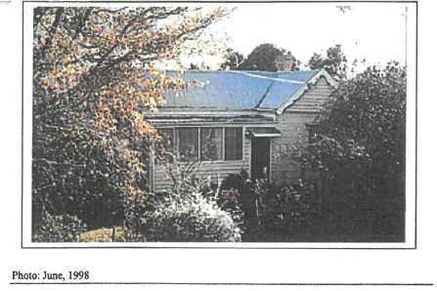

Extract from Mr Raworth’s evidence statement of the photograph of house contained in the citation from the Monash Heritage Study

- The Monash Heritage Study contains the following Statement of Significance for this site:
The Dillion residence is historically significant (criterion A) in that it recalls the era of market gardening which was crucial to the economy of the region from settlement until the period of post second World War suburbanisation. The house exhibits the principal characteristics of a farmhouse of the Edwardian period in Mount Waverley, being unpretentious both in dimension and architectural style (Criterion D). It is now a rare survivor in the Municipality, (Criterion B) comparing with nearby houses at 236 and 276 in Lawrence Road.
- Mr Raworth considers there is confusion in the citation about whether this building is a farmhouse or a workers cottage and hence the application of criterion D. Mr Wixted acknowledges the house is modest compared to the other farmhouses recognised in other individual Heritage Overlay controls. Nevertheless, Mr Wixted considers this house is still understandable as a small farmhouse. Certainly, the history identified in the citation and the historic aerial images contained in the expert witness statements concur with the views of both witnesses that this house has been used in association with market gardening. Hence, the ‘cottage’ description in the citation does not detract from its recognition of use in the manner of a farmhouse. Also, the experts agree the cottage description in the citation and the recognition of the building in architectural terms in the statement of significance (criterion D) is secondary to its historical significance (criterion A). The historical significance of this house on this site is not in dispute between the heritage experts.

The farmhouses along Lawrence Road
- In the previous paragraph, we mentioned Mr Wixted’s reference to other farmhouses recognised in the planning scheme. Mr Wixted points out there are only a small number of designated heritage significant farmhouses in the whole of Monash. The Heritage policy decision guidelines include considering the cultural heritage significance of the site and all nearby places identified in the Heritage Study. In this case, the Heritage Overlay schedule in the Monash planning scheme identifies four farmhouses of individual heritage significance along Lawrence Road:
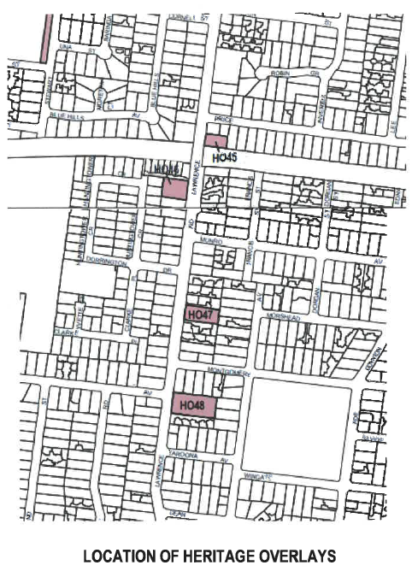

Extract from Council submission showing the four individually listed farmhouse locations along Lawrence Road

- Mr Wixted and Mr Raworth agree that there are limited farmhouses remaining in metropolitan Melbourne, and they also agree that farmhouses of the Edwardian period in this municipality are rare. Mr Raworth’s agreement on this point is in regard to farmhouses generally. His agreement is not specifically with reference to the house on this site as he considers it is a workers cottage rather than a farmhouse.
- The citations for each of the four heritage places in Lawrence Road were provided during the hearing. They are helpful in gaining an understanding of what is significant about them, including the significance of this site in HO46. For example:
- No. 236 Lawrence Road (HO45) contained six Monterey Pine trees surviving from the property’s agricultural period as well as a representative Federation period single front timber cottage. Both the trees and the house are listed in HO45. Its statement of significance identifies the property as historically important as a rare surviving farmhouse in the municipality recalling the era before suburbanisation when the Mulgrave Shire was engaged in the production of food for Melbourne markets. The statement also includes the following:
… It also directly recalls the 1899 subdivision of the Lawrence Road area into 10.5 acre farming lots when the descendants of the preceding generations of farmers purchased allotments thereby remaining in rural production. In this respect it appears to have been representative of many properties occupied by farmers of limited means. …
- No. 262 Lawrence Road (HO47) contains a Federation period double fronted cottage built by a market gardener. The house is listed in HO47. Its statement of significance identifies the property as historically important for the same reasons as HO45, including that it is a rare surviving farmhouse in the municipality.
- No. 276 Lawrence Road (HO48) contains a ‘substantial’ Federation period house set in a ‘spacious garden’. The house is listed in HO48. Its statement of significance identifies the property as historically significant as ‘a rare surviving substantial farmhouse in the municipality’. The statement also includes the following:
… It is of interest for its links with the Cotter family, amongst the district’s earliest settlers, and as a farmhouse more substantial than those more commonly associated with the area.
- All of these heritage places were assessed and implemented into the planning scheme via the same Monash Heritage Study in the late 1990s. All of them are recognised for their historical significance associated with the era of market gardening that predated post World War Two suburbanisation. This review site has a distinction from the others as its house is of the Edwardian era rather than the Federation era, and this site is recognised as having architectural significance.
- Despite the inclusion of HO45 in the planning scheme, the Council allowed the demolition of the farmhouse on that property (No. 236 Lawrence Road) in 2015. After the hearing, we asked the Council to circulate the Council officer report that assessed the proposed demolition of that house. It appears Council’s heritage advisor recommended its retention, but the officer report gave greater weight to the content and views expressed by the permit applicant’s heritage assessment and structural inspection reports, including that the extent of repairs necessary would result in ‘significant replacement of the stumps, sub-flooring frame, wall, roof and ceiling frame’. The officer report concludes little if any of the original building materials would be retained, so the retention of the dwelling ‘is not considered to be practical nor is it considered to be a financially viable option for current or any future owners’.
- The applicant submits these circumstances are comparable to this proposal and emphasised the words in the officer’s report:
the substantial rebuild of the dwelling resulting in little if any retention of the original building materials.
- We have not seen the detail of the reports submitted with that permit application, so it is not possible to undertake a direct comparison of the necessity for and extent of new works. Having regard to the material and evidence before us in this case, we are not persuaded the quoted statement above is comparable. We explain why later in these reasons.

Historical and architectural significance
- The heritage assessment criteria referred to in the statement of significance for this site are:
- Criterion A – Importance to the course, or pattern, of Victoria’s cultural history;
- Criterion B – Possession of uncommon, rare or endangered aspects of Victoria’s cultural history; and
- Criterion D – Importance in demonstrating the principal characteristics of a class of cultural places and objects.
- All four heritage places in Lawrence Road include criterion A in their statements of significance. Criterion B is only included for this review site despite the fact that the other statements of significance also describe their respective sites as a rare example. The only heritage place including criterion D is this review site. These criteria are described with the relevant assessment guidelines in Heritage Council Victoria guidelines and we have included an extract of relevant aspects in Appendix A to these reasons.

Historical significance
- Historical significance, as identified in criterion A and criterion B, is different to architectural significance, which is often captured through the application of criterion D. For example, many heritage precincts identified for having buildings built in a similar era will include the application of criterion D.
- The historical significance of this site is its market gardening land use including the farmhouse. Mr Wixted and Mr Raworth agree farmhouses are rare in this municipality. The statements of significance for the farmhouses along Lawrence Road all identify criterion A, and for this site also criterion B. The citations and statements of significance describe the majority of the farmhouses using the terms of ‘cottage’ and ‘farmhouse’ interchangeably, hence we are not persuaded the use of the term ‘cottage’ in the citation for this site is suggestive of it being anything other than a house associated with the market gardening history. Given this, the use of the term of farmhouse also remains apt to this site.
- As explained earlier, there is no dispute between the experts that the area surrounding Lawrence Road was used for market gardening and that the house on this site was in existence at that time. Mr Raworth’s evidence contains the 1945 aerial image (refer to extract) of the house on this site with agricultural land around it. The house in the top right corner of the extract is the farmhouse on HO45 that has been demolished.
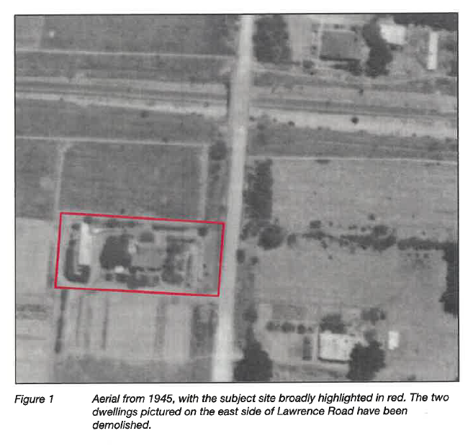
- The expert witnesses agree that part of the historical significance is the fact that the house is situated on a large allotment of 1,483 square metres. This situation also exists for HO47 and HO48. Each of these three heritage lots are obviously larger than the residential development/lots that surround them.
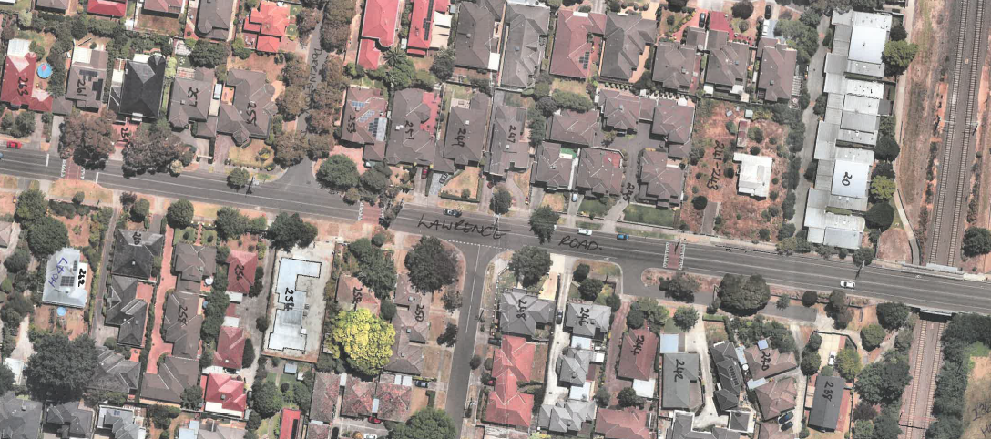

The site is at right hand side and HO47 is at the left hand side. The site is obviously a larger allotment. (Extract of aerial photo tabled at hearing)

- This enables a retention of a setting that is representative of its historical use as part of market gardening. This site, HO47 and HO48 all had established gardens surrounding the houses. The garden and established trees on this site were removed prior to the current land owner purchasing it. The experts agree the removal of these features is a loss. Mr Raworth considers the loss of the garden has contributed to a loss of its heritage significance. We are not persuaded of this given the garden has never been protected by the Heritage Overlay. The location of the house on this site remains unchanged, albeit the setting is now different because of the loss of the garden (refer to the photograph on the next page). However, a garden within the setting including new trees can be created. As there are no heritage restrictions on this aspect of the setting, the nature and design of such a garden has flexibility.
- The Heritage policy decision guidelines state the heritage values extend beyond the particular building. This is of particular relevance in this case as the historical significance of the site is the setting of the building, well set back from its boundaries and on a large allotment capable of accommodating a garden.
- Given all of these findings, we are not persuaded the heritage significance of this site as identified through criterion A and criterion B has been significantly diminished or lost.
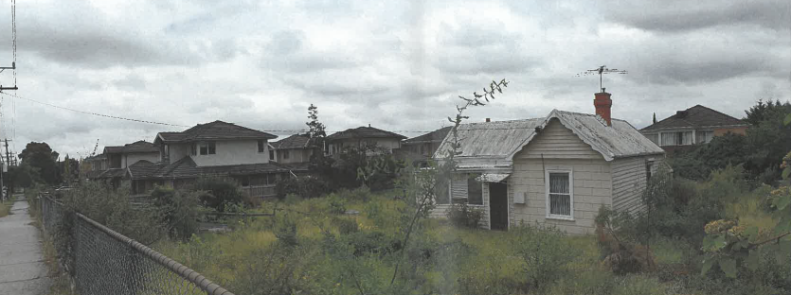

Extract from SongBowden photographs
- Both experts were asked whether the house could be moved closer to the site’s boundaries to make room for new development on the site. Mr Wixted considers the house could be relocated if it is not moved very far. Under re-examination, he elaborated that the front and north side setbacks need to be respected so it should not be moved too far, e.g. no more than a couple of metres. As Mr Raworth considers the site has lost its significance, his view is it does not matter where the house is located on the site. Obviously, the experts have differing views on this as they hold different views on the heritage significance. Space around the house is part of its historical significance. Any movement of the house on the site would need to be considered afresh having regard to this significance.

Architectural significance
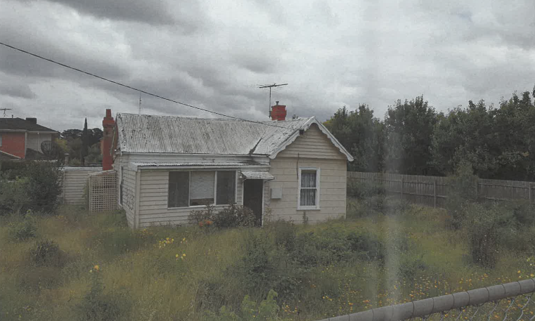
- As explained earlier, both experts consider the identified architectural significance (criterion D) to be secondary to its historical significance. Mr Wixted described the building as a signifier of the land settlement and use in the municipality and the architectural significance is of ‘low weight’. Mr Raworth considers the historical significance should be seen to be associated with the fabric (i.e. the house). He is of the view the extent of works required to the building is ‘essentially similar to demolition’ so the building has lost its significance. Mr Raworth also considers that, whilst the building is a rare Edwardian workers cottage associated with market gardening in Mount Waverley, there are more and better architectural examples of Edwardian cottages in Oakleigh. He describes the existing building as an isolated and altered example of a representative building type and period, and is of modest local significance.
- We accept the experts’ opinions that the architectural significance is of lesser weight than the historical significance. Often in cases involving Criterion D alone, the position put in regard to demolition is that the works required to address the existing condition of the building is significant and the original fabric will no longer remain. That is part of the Applicant’s justification for demolition in this case.

The existing condition of the building
- Mr Wixted and Mr Raworth agree that the integrity of the site is lower now than at the time of its listing because of the loss of the garden and because of the decline in the condition of the building. Mr Raworth and Mr Wixted agree that the building is in need of remedial work. Mr Wixted considers this work does not diminish the integrity and significance of the building. Mr Raworth disagrees.
- The Council is concerned about how the building has fallen into disrepair, pointing out the property is vacant, it is not secure and it has been subject to vandalism in the past. We accept that the current state of the building is not attributable to the Applicant. There remains risks of vandalism as a result of the open nature of the site, and this will require ongoing management by the Applicant until such time as the site is occupied again.

Structural integrity and works required
- Mr Wixted points out that the structural integrity of the building and the extent of works required is not a matter that needs to be considered under the Heritage policy. Nevertheless, it is a matter that can be considered for reasons that include:
- There are Heritage local planning policies in other planning schemes that do have this as a consideration, so in a general sense it can be a relevant consideration regardless of whether it is specifically mentioned or not;
- Mr Raworth considers it is a relevant consideration in this case; and
- The structural integrity of the building and the works required to address this are relevant to considering whether the significance of the heritage place will be adversely affected by the remedial works.
- Mr Wixted acknowledges timber buildings are susceptible to rot but they are also ‘very easy to repair’ or add to. In his opinion, it is never difficult to structurally repair a timber house. He considers most timber buildings are ‘much more forgiving’ in regard to structural work and reconstruction.

Mr Cross’ evidence
- Mr Cross’ view is the current condition of the building is definitely due to neglect. He estimates there has been at least 40 years of dilapidation because of the conditions of the stumps, such that the building is falling into the ground.
- Mr Cross’ evidence identifies the fall of the floor levels across the building, which vary between 20 and 184mm (as per the following illustration).
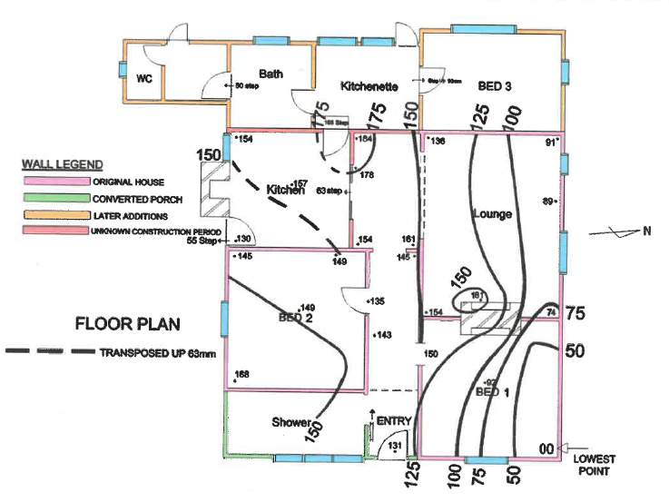
- This means the walls start to lean and he describes the northeast corner of the building as ‘really bad’. This corner is in the ground. The entire roof is bent and Mr Cross’ opinion is that it is simpler in terms of time and cost to replace the rafters and the whole of the roof. However, he also points out the building is not about to fall over. He says bits of the building will fall off or subside but never the whole building.
- In his opinion the gable end on the front façade is not original. Some of the window frames are aluminium and others are rotten or out of square because of the dropping of the floor, etc. The ceiling frame is structurally unsound but Mr Cross describes that as simple to replace. Mr Cross’ evidence provides illustrations of the defective weatherboards, such as the example on the following page.
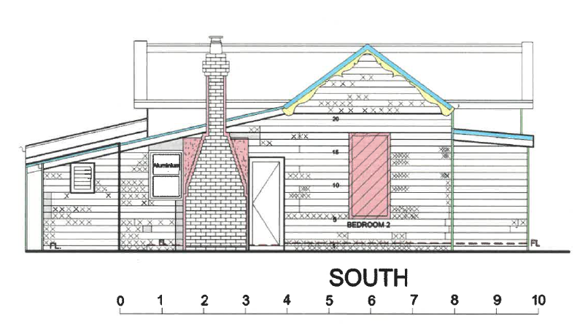

Extract from Mr Cross’ evidence. Crosses are defective weatherboards.

- Page 2 of Mr Cross’ evidence lists the fabric of the building that can be retained including the south chimney, 11 square metres of solid blocking on the front façade, a maximum of about 10% of the weatherboards, the studs and 50 square metres of the pine floor boards (about 80% of the original flooring). The northern chimney could remain but Mr Cross points out the building needs to be lifted 600mm. As this chimney is largely internal, we accept it is possible for its exterior portion to be retained, particularly if the roof and ceiling is replaced (enabling sufficient building construction for its retention).
- Mr Cross’ evidence is that anything can be done at a cost. The costs he estimates in this case are ‘not alarming’. He agrees with Mr Wixted that this timber building is easy to repair. It involves primarily new material and some work to retrieve some of the material that will be retained/reused.

Restoration and Reconstruction
- The applicant submits the rectification works will remove the heritage significance of the building, and a replica of a heritage building is not justified. Mr Raworth describes Mr Cross’ evidence as requiring wholesale change and that it will be ‘almost an entire new building’. He describes the extent of works as essentially similar to demolition. Mr Raworth considers the necessary rebuilding would remove the last vestiges of its heritage significance. This is because the loss of the original fabric effectively breaks that link.
- The Heritage policy decision guidelines include consideration of ‘recovery of cultural heritage significance of buildings by reconstructing removed elements’ and the available physical and documentary evidence showing how an altered façade of a building looked in the past. Mduch of the existing building is original and has fallen into disrepair by neglect. An aspect of the original building that is not known based on the material presented during the hearing is the original façade of the front verandah. Mr Raworth states:
37 While it is known that the façade/former verandah area has been altered, the reconstruction and interpretation of it to its original specifications would be largely speculative as it is unknown how the dwelling originally presented. As highlighted above, speculation on the original design features of a place is outside Burra Charter practice.
- The Burra Charter provides the following definitions of restoration and reconstruction:
Restoration means returning a place to a known earlier state by removing accretions or by reassembling existing elements without the introduction of new material.
Reconstruction means returning a place to a known earlier state and is distinguished from restoration by the introduction of new material.
- The explanatory note for reconstruction includes that new material may include recycled material salvaged from other places that should not be to the detriment of any place of cultural significance.
- Articles 18 to 20 of the Charter explains restoration and reconstruction as follows:
Article 18. Restoration and reconstruction
Restoration and reconstruction should reveal culturally significant aspects of the place.
Article 19. Restoration
Restoration is appropriate only if there is sufficient evidence of an earlier state of the fabric.
Article 20. Reconstruction
20.1 Reconstruction is appropriate only where a place is incomplete through damage or alteration, and only where there is sufficient evidence to reproduce an earlier state of the fabric. In some cases, reconstruction may also be appropriate as part of a use or practice that retains the cultural significance of the place.
20.2 Reconstruction should be identifiable on close inspection or through additional interpretation.
- We accept that speculation about the former front verandah is outside Burra Charter practice. However, the same cannot be said for the balance of the front façade or the side elevations of the original portions of the building. Given the primary aspect of the heritage significance is its historical significance and the experts agree its architectural significance is of lesser weight, the need to speculate about the front verandah does not negate or remove all of the site’s recognised heritage significance of land use and the setting of the building on a large allotment. Introducing an aspect of non-original or interpretive fabric will not compromise the integrity of the heritage place’s historical significance. Our finding on this point is influenced by the fact that this farmhouse, like the others along Lawrence Road, are primarily of historical significance. This site is the only one to be recognised for architectural significance, and both experts agree this significance is of lesser weight than the site’s historical significance. As Mr Raworth points out, there are better examples of Edwardian dwellings elsewhere in the municipality.
- Mr Cross’ evidence illustrates that the balance of the front and side facades of the original house can be restored or reconstructed as necessary. We acknowledge there is a cost implication for this, but we are not persuaded such costs outweigh the benefits derived from the rectification works to the building that will conserve and enhance the site’s historical significance.
- Mr Raworth considers the outcome would not be a heritage building in any true sense, but rather ‘a facsimile or replica’ of little or no intrinsic interest. This view is related to the fact that some of the building will need to be reconstructed as opposed to restored. This is an unfortunate but necessary outcome in this case because the existing condition of the building has fallen into disrepair by long-term neglect. This building is over 100 years old. Any timber building of that age cannot remain without ongoing maintenance, including repairs such as replacing weatherboards with new weatherboards. The circumstances this timber building now faces is that a greater portion of repairs are necessary, which will involve areas of reconstruction rather than merely small repairs. Demolition being allowed because of neglect and the need for significant repairs and reconstruction could mean a far greater loss of heritage places over time. The Burra Charter states reconstruction is appropriate where a place is incomplete through damage and where there is sufficient evidence to ‘reproduce’ an earlier state of the fabric. The term ‘reproduce’ can be defined as a copy, a facsimile, a duplication or a replication. Hence, replacing an original weatherboard with a replica weatherboard to the earlier known state is achieving an acceptable outcome. So long as reconstruction is undertaken in accordance with Burra Charter practices, the significance of the heritage place is not lost.
- The Council relied on previous decisions that have found the physical condition of a heritage significant building should be in a ruinous condition that is beyond repair, both physically and economically before demolition is allowed. The applicant points out some of the cases relied upon by the Council, including the CBA Building Designers case, did not present any structural evidence. Each case must be decided on its own merits. Mr Cross’ evidence identifies the breadth of rectification works required but also acknowledges that this work can be done in this case and the costs are of such heritage rectification works are always likely to be expensive. Mr Cross’ evidence is that the costs in this case are not alarming and ‘anything can be repaired at a cost’.

Mould tests
- Mr Cross and Mr Raworth have both referred to and relied upon laboratory tests by Biological Health Services of the fungal, spore trap and tape lift mould tests undertaken within the existing building. A copy of the report by Biological Health Services has been provided. Mr Cross’ evidence relies on the tests that found mould in all parts of the lining of the building, and explained this means there is a need for a schedule of works. He explains the mould results are compared to international standards of tolerance in terms of people with respiratory problems/asthma. Mr Cross’ evidence contains a schedule of works necessary to rectify this situation, including protecting the remaining timber (structural and lining boards), treating each remaining timber and then undertaking reassembly of the construction. Mr Raworth considers ‘a substantial degree of work would be required to remediate’ the mould impact. His expert witness statement then moves on to address the matters of reconstruction and restoration in the Burra Charter.
- We have given limited weight to the assessment undertaken by Biological Health Services. The assessment was not the subject of expert evidence and hence has not been tested through cross-examination. The assessment focuses upon the interior of the building including plasterboard, cabinetry, ceiling and insulation. The interior of the building has no recognised heritage significance and can be modified and replaced without planning permission. Hence, whilst new works are necessary to address the mould within the building, the lack of any internal heritage controls means such works are legitimate and have limited relevance to the merits of the demolition.

Balancing all relevant policies in favour of sustainable development and net community benefit
- The overall proposal before us is to demolish the existing buildings and to construct five new double storey dwellings with an altered point of access to Lawrence Road. This is illustrated below in the extract of the proposed site plan. One of the matters to consider in deciding whether to allow the demolition of a heritage place is to determine if the overall proposal achieves sustainable development and net community benefit that outweighs the loss of the heritage place.

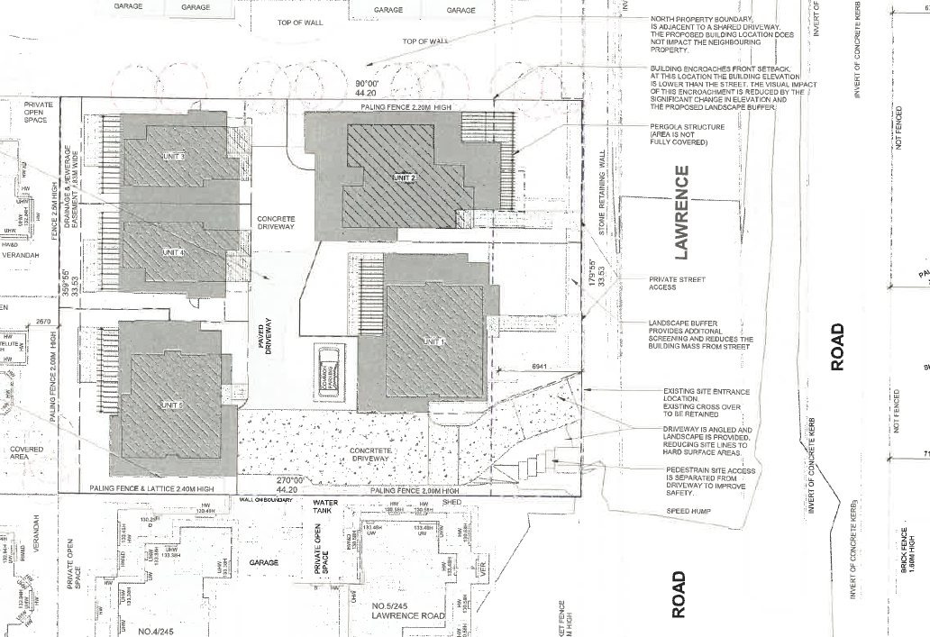

- Neither the applicant, nor the Council sought to rely on this consideration in the reasons why they say demolition should or should not be allowed. In particular, the applicant submits the merits of this proposal do not rise or fall on the balancing of policy in favour of sustainable development and net community benefit. This is because the applicant considers the heritage significance is lost whether it is via reconstruction or demolition. Nevertheless, we raised this consideration during the hearing and the parties had the opportunity to address us about this.
- Demolishing the existing buildings provides for the opportunity to construct the proposed five dwellings, so this would result in a contribution of four new dwellings into this part of the municipality. The applicant submits this site is identified as being in an area just below Category 1 where the most substantial growth is anticipated to occur. Having regard to the current policies in the planning scheme, this overstates the anticipated housing growth on this site.
- The Council explains the Syndal neighbourhood centre is the closest activity centre to this site, which is about 700 metres away. Bus routes along Blackburn Road and Syndal train station are a similar distance away. This means the site is located some distance from public transport and other services, and would not be considered to be within easy walking distance. The Council describes the site as being ‘at the outer edge of a Category 2 accessible area’ under clause 21.04 of the planning scheme. The Council provided a map of this accessible area that is not in the planning scheme. It shows that the ‘edge’ appears to the properties on the west side of Lawrence Road, including this site. The Council explained it was a deliberate decision to include individually significant heritage places within accessible areas as the merits of a permit application could be considered on a case by case basis. Such consideration would include the fact that the objectives and strategies in clause 21.04-3 (which includes accessible areas) give particular recognition to ensuring heritage places are ‘identified and conserved’ (objective) and their heritage significance is conserved and enhanced (strategy).
- Clause 21.04-1 is generally silent as to what level of development is anticipated for the accessible areas, including this area. The objectives at clause 21.04-3 are largely general in nature. In addition to the heritage objective mentioned in the previous paragraph, the objectives also encourage the provision of a variety of housing types and sizes that will accommodate a diversity of future housing needs and complement and enhance the garden city character. This site is in Garden City Suburbs (Northern) in the Residential Development and Character local planning policy. Its description of the future character begins with the following:
Although there will be changes to some of the houses within this area, including the development of well-designed and sensitive unit development and, on suitable sites, some apartment development, these will take place within a pleasant leafy framework of well-vegetated front and rear gardens and large canopy trees.
- These relevant policies are not emphatic about the extent of change (and new development) that is envisaged. Whilst this site has heritage significance, the objectives and strategies make it clear that this site’s development potential will be tempered despite being in an accessible area. The preferred future character seeks well designed and sensitive unit development within well vegetated front and rear gardens. The Council is not persuaded this proposed design achieves an acceptable design response to this policy direction. Whilst units or townhouses are clearly contemplated, we are not persuaded there is any specific policy direction that envisages the extent of development contemplated, particularly when the objectives and strategies also provide specific recognition of heritage places and their significance. Hence, we are not persuaded the balance of the relevant planning policies outweigh the demolition and loss of this individually significant heritage place.

Conclusion
- For the above reasons, the decision of the Responsible Authority is affirmed. No permit shall issue.

Rachel Naylor  Senior Member | Rebecca Cameron  Member

Appendix A – extract of heritage council victoria guidelines

Criterion |  | A basic test for satisfying the criterion extracted from Guidelines
Criterion A | Importance to the course, or pattern, of Victoria’s cultural history | The place/object has a CLEAR association with an event, phase, period, process, function, movement, custom or way of life in Victoria’s cultural history.  +  The association of the place/object to the event, phase, etc IS EVIDENT in the physical fabric of the place/object and/or in documentary resources or oral history.  +  The EVENT, PHASE, etc is of HISTORICAL IMPORTANCE, having made a strong or influential contribution to Victoria.
Criterion B | Possession of uncommon, rare or endangered aspects of Victoria’s cultural history | The place/object has a CLEAR association with an event, phase, period, process, function, movement, custom or way of life in Victoria’s cultural history.  +  The association of the place/object to the event, phase, etc IS EVIDENT in the physical fabric of the place/object and/or in documentary resources or oral history.  +  The place/object is RARE OR UNCOMMON, being one of a small number of places/objects remaining that demonstrates the important event, phase, etc.
Criterion D | Importance in demonstrating the principal characteristics of a class of cultural places and objects | The place/object is one of a CLASS of places/objects that has a CLEAR association with an event, phase, period, process, function, movement, important person(s), custom or way of life in Victoria’s cultural history.  +  The EVENT, PHASE etc is of HISTORICAL IMPORTANCE, having made a strong or influential contribution to Victoria.  +  The principal characteristics of the class are EVIDENT in the physical fabric of the place/object.

The submissions and evidence of the parties, the supporting exhibits given at the hearing, and the material/submissions filed after the hearing have all been considered in the determination of the proceeding. In accordance with the practice of the Tribunal, not all of this material will be cited or referred to in these reasons.
Article 15 of the Burra Charter, specifically articles 15.1 and 15.3.
Other than the remaining three farmhouses in Lawrence Road, there is one in Burwood and one in Syndal.
Assessing the cultural heritage significance of places and objects for possible state heritage listing: The Victorian Heritage Register Criteria and Threshold Guidelines. Updated 4 April 2019
Looking at the property sale information on these two properties on the internet suggests No. 262 has an area of about 1,579sqm and No. 276 has an area of about 2,910sqm.
Harding v Port Phillip CC [2004] VCAT 1471 and CBA Building Designers v Greater Bendigo CC [2010] VCAT 2088
This last test has three options, so we have included the one that appears to relate to this site.
The definition of CLASS in the Heritage Council Victoria Guidelines includes – A class is generally defined by a specific purpose of use, era, design characteristic, construction technique, materials used or some other recognisable quality. A class should be readily discernible as a sub-category of a broad place type and should not be narrowed by multiple qualifiers (for example, timber constructed, Edwardian era, rural theatres).

