VICTORIAN CIVIL AND ADMINISTRATIVE TRIBUNAL
planning and environment DIVISION
planning and environment LIST | vcat reference No. P2045/2019  Permit Application no. TPA/50198
CATCHWORDS
Monash Planning Scheme; Application under section 77 of the Planning and Environment Act 1987; GRZ2; Proposal for six 2-storey dwellings; Neighbourhood character; On-site amenity.

APPLICANT | Malcolm Mount Waverley P/L
responsible authority | Monash City Council
SUBJECT LAND | 3 Malcolm Court  MOUNT WAVERLEY VIC 3149
WHERE HELD | Melbourne
BEFORE | Mary-Anne Taranto, Member
HEARING TYPE | Hearing
DATE OF HEARING | 26 June 2020
DATE OF ORDER | 28 July 2020
CITATION | Malcolm Mount Waverley P/L v Monash CC [2020] VCAT 684

Order

Amend permit application
- Pursuant to clause 64 of Schedule 1 of the Victorian Civil & Administrative Tribunal Act 1998, the permit application is amended by substituting for the permit application plans, the following plans filed with the Tribunal:
- Prepared by: | Archimedium Australia Pty Ltd
- Drawing numbers: | Project No. 2018/26 Sheets TP3 to TP8 inclusive, Revision B
- Dated: | January 2019

No permit granted
- In application P2045/2019 the decision of the responsible authority is affirmed.
- In planning permit application TPA/50198 no permit is granted.

Mary-Anne Taranto
Member

Information
Description of proposal | Construction of six 2-storey dwellings in two attached groups of three. These comprise 2 x 2-bedroom, 1 x 3-bedrooms, 2 x 4 bedrooms and 1 x 5-bedrooms. Main living areas are at ground level together with secluded private open space that ranges in area from 44sqm to 53sqm. Each are to have separate driveways with single car garages and a second uncovered tandem space.  The design of the dwellings include pitched tiled roofs, flat colorbond roofs to garages, rectilinear portico elements and parapet walls. External materials include face brick, render and timber feature elements.  A landscape plan has been prepared which makes provision for canopy trees along both frontages and part of the north boundary.
Nature of proceeding | Application under section 77 of the Planning and Environment Act 1987 – to review the refusal to grant a permit.
Zone and overlays | General Residential Zone – Schedule 2 (GRZ2)  No overlay controls apply
Permit requirements | Clause 32.08-6 – Construction of two or more dwellings on a lot in GRZ2
Relevant scheme policies and provisions | Clauses 11, 15, 16, 21.04, 22.01, 55, 65 and 71.02
Land description | Located on the north-west corner of Malcolm Court and Greenfell Road, this 1,362.7sqm irregular shaped site has frontages of 24.79m and 37.9m to each frontage with an arc of 19.62m between the two. A 1.83m wide drainage and sewerage easement runs along the west side boundary. The land falls by about 1.8m from north-east to south-west. The site is developed with a single storey brick dwelling and swimming pool. Vehicle access is from Greenfell Road. Vegetation comprises small shrubs and plants.
Tribunal inspection | Unaccompanied inspection of site and surrounds.

Reasons

introduction
- Malcolm Mount Waverley Pty Ltd (the applicant) is seeking a review of Monash City Council’s decision to refuse a planning permit for six 2-storey dwellings on a corner lot in Malcolm Court, Mount Waverley.
- In bringing this review, the applicant relies on amended plans which I have substituted for the permit application plans. While the number of dwellings and their general layout remains unchanged, notable changes include a reduction in the upper level footprints of Units 1 and 3 and increased separation between the upper level of the Malcolm Court dwellings and between Units 2 and 3 in Greenfell Road.
- The council maintains its opposition to the proposal in its now amended form although it no longer relies on its fourth ground of refusal in relation to vehicle access and movements.
- The council submits that the proposed siting and design of the dwellings do not achieve an acceptable fit in neighbourhood character terms and would not allow for an acceptable landscaping response. Concerns are also raised about the acceptability of SPOS in terms of both on-site amenity and character.
- The applicant submits that this site is highly suited to a more intense form of development given its proximity to the Jordanville train station and activity centre. In this context, it says that the council’s policy framework is poorly resolved and places too much emphasis on neighbourhood objectives and insufficient weight on the achievement of housing objectives in this highly accessible area. All of the council’s grounds are refuted. In so doing, the applicant submits that this proposal responds acceptably to the physical context where canopy trees are not a key feature and that higher and more robust 2-storey buildings, both existing and emerging, is influential.
- The key issues that I need to determine in this case is:
- The weight to be given to planning scheme policies and the Monash Housing Strategy 2014.
- Whether the proposal responds in an acceptable way to its planning and physical contexts in terms of its intensity, siting and design.
- The acceptability of the proposal in terms of on-site amenity.
- Having considered the material filed and assisted by my inspection of the site and surrounding area, I have found that while the site is highly suited to a more intense form of development than one dwelling, the particular design response would not achieve an acceptable outcome in terms of neighbourhood character and levels of on-site amenity for several of the units. My reasons follow.

HEARING PROCESS
- This proceeding was adjourned from its original fixture on 27 April 2020 due to the COVID-19 pandemic wherein face to face Tribunal hearings were adjourned. The hearing is conducted ‘on the papers’, with the agreement of the parties, pursuant to section 100(2) of the Victorian Civil and Administrative Tribunal Act 1998.
- While the applicant’s submission acknowledges the existence of neighbouring hedge screen planting along the north boundary (within the side setback of No. 1 Malcolm Court), the submissions leave open some questions about the proposal’s impacts on this planting. The landscape plan also omits any reference to this vegetation. The impacts of the garage and kitchen wall of Unit 6 upon this vegetation are unknown. It is also unclear from the plans whether the retaining wall shown within the review site along this boundary is existing or proposed. If proposed, the impacts of this wall on neighbouring vegetation is similarly unknown.
- A further issue arising from my perusal of aerial photography shows that a number of canopy trees were removed from the land near the Greenfell Road frontage in the 12 months preceding the lodgement of the permit application.
- Another issue concerns the acceptability of siting parts of Unit 1 over the 1.83m wide drainage and sewerage easement which encumbers the land along the west boundary.
- If I had found that the other aspects of the development capable of determination are acceptable which together favour the grant of a permit, I would not have determined this proceeding without asking for further submissions in writing or orally about these matters. I also make it very clear that I have put these unresolved matters aside in reaching my findings about other aspects of this proposal which I have been able to determine.
- In so doing, even if these matters were found to be satisfactory, I would refuse a permit for the reasons set out in this decision.

the physical and strategic contexts
- The following images show the site’s location relative to its broader and more immediate physical contexts.
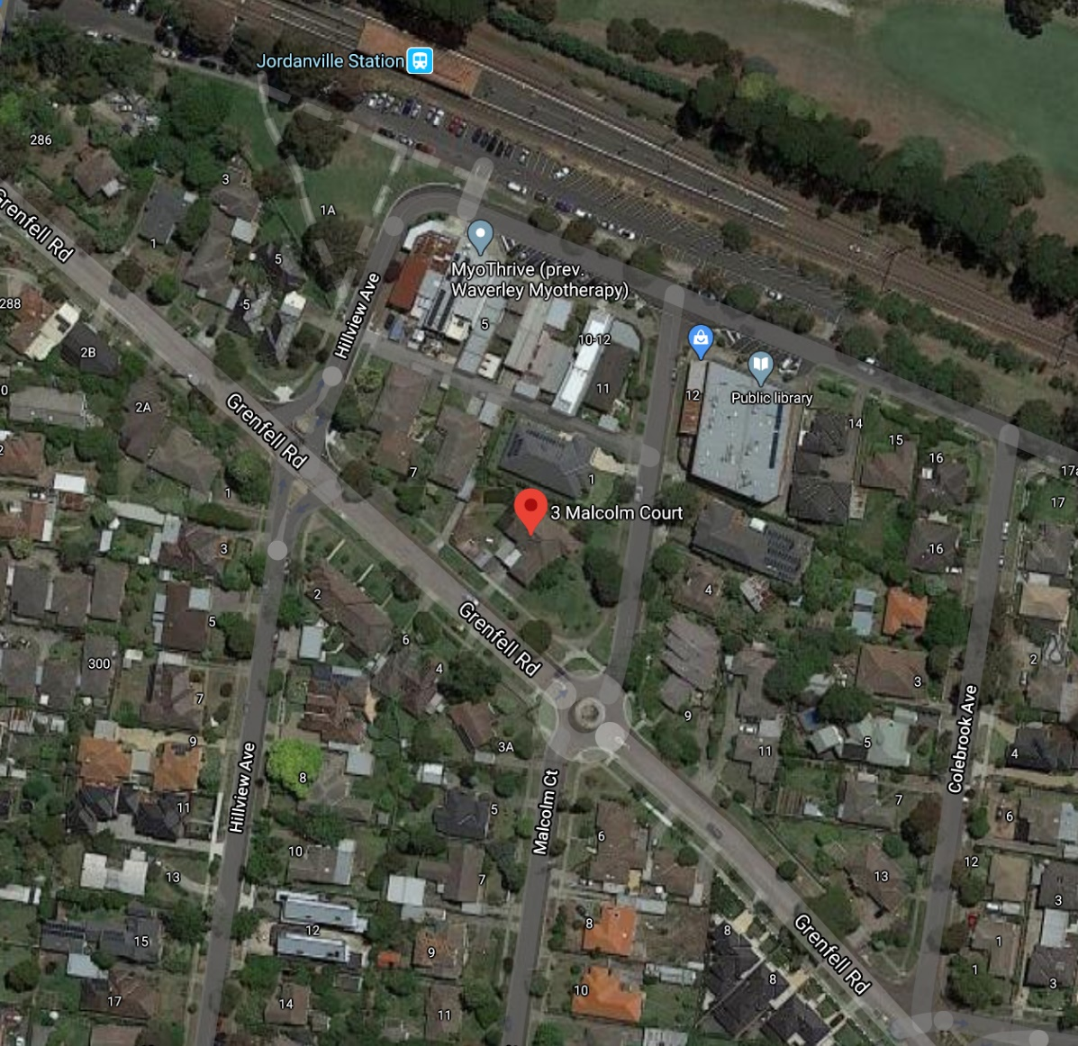
Source: Google maps
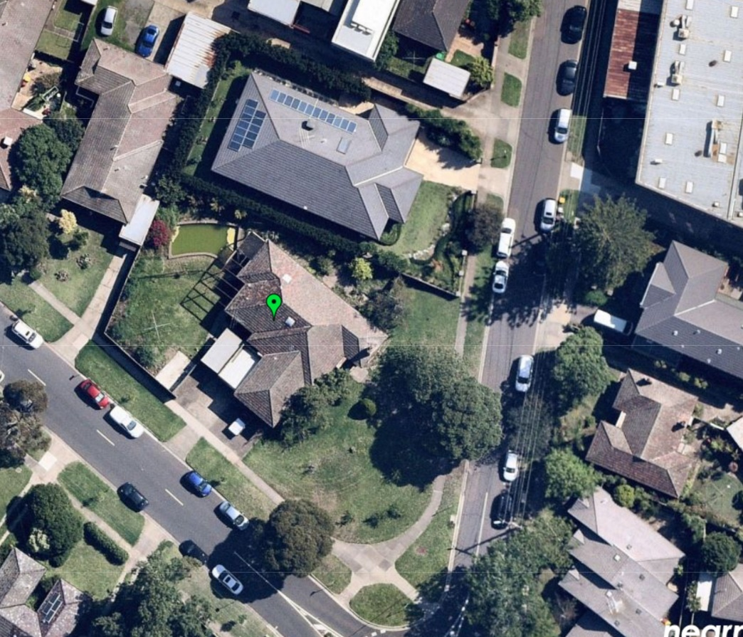
Source: Nearmap
- The following features are notable:
- In its more immediate context, the review site has abuttals to other properties. To the north is No. 1 Malcolm Court and to the west is No. 7 Greenfell Road.
- No. 1 Malcolm Court is developed with a contemporary single storey brick dwelling with a front setback of approximately 10m. A notable feature is extensive perimeter planting around its side and rear boundaries.
- The abutting dwelling to the west (Unit 5/7 Greenfell Road) is developed with an older style single storey unit – one of five units in this complex.
- Use and development in the more immediate surrounds is residential. It comprises both older style single and multi-dwellings, many which are single storey. These are interspersed with newer and larger 2-storey dwellings and multi-dwellings, including the single dwelling opposite at No. 2 Malcolm Court and No. 8 and 12 Greenfell Road (three dwellings).
- The subdivision pattern is irregular, contributing to the varied siting of development and informal but clearly urban character.
- The landscape character is informed by established vegetation including canopy trees in both the public and private realms. Older single storey forms are frequently set within larger garden settings and generally subservient to this vegetation. The emerging form of newer and larger 2-storey scaled development has a more obvious presence with higher levels of site coverage relative to garden space and vegetation.
- A small activity centre with a predominance of service type premises is located in Windsor Avenue about 200m to the north-west. These have 2-storey forms clearly evident from the environs of the review site. North again is Jordanville train station and the Riversdale Golf Club.
- A wide range of established services and facilities exist in the area.

the Planning context

Zoning
- The zoning of the site and surrounds is shown in the following image.
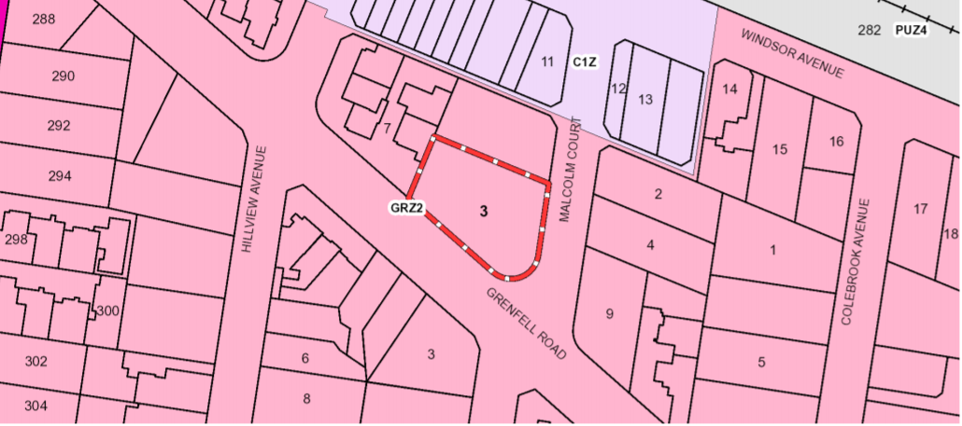
- The site and its immediate surrounds are within the GRZ2. Zone purposes include:
To encourage development that respects the neighbourhood character of the area.
To encourage a diversity of housing types and housing growth particularly in locations offering good access to services and transport
- The minimum garden area requirement is 35% and at 44.7%, this is met by the proposal.
- Schedule 2 is titled Monash Residential areas. No neighbourhood character objectives, application guidelines or decision guidelines are specified. The maximum building height is the default of 11m and 3 storeys under clause 32.08-10. These mandatory requirements are both met by this proposal.
- Three clause 55 standards are varied. These are:
- Standard B6 – Front setback – 7.6m while for side streets the default setbacks of this standard continue to apply.
- Standard B28 – Private Open Space (POS) – Total area of POS is to be 75sqm with a minimum secluded area (SPOS) at the side or rear of 35sqm and minimum dimension of 5m.
- Standard B32 – Front fence should not exceed 1.2m.

Policy framework
- State and regional policies in the Planning Policy Framework (PPF) variously support the provision of medium density housing in established urban areas which contribute to housing diversity, affordability and urban consolidation objectives.
- A relevant strategy is to create a city of 20 minute neighbourhoods, that give people the ability to meet most of their everyday needs within a 20 minute walk, cycle or local public transport trip from their home.
- Urban design related policies seek to create a distinctive and liveable city with quality design and amenity and which responds positively to the local context, enhances the public realm and which contributes to existing or preferred neighbourhood character.
- Policies also seek to maximise the use of existing infrastructure and increase the diversity and density of development along the Principal Public Transport Network (PPTN), particularly at interchanges, activity centres and where principal public transport routes intersect.
- In terms of local policies, key policies for housing are to be found at clauses 21.04 (Residential Development) and clause 22.01 (Residential Development and Character Policy). Both were most recently amended with the gazettal of Amendment VC125 Part 2 on 14 November 2019.
- In relation to clause 21.04:
- the Residential Framework Map from the Monash Housing Strategy shows the site within Category 8 – Garden City Suburb with a Category 2 – Accessible area overlaid – see extract of Framework Plan below.
- Category 8 – Garden City Suburbs is described as an area suitable for incremental change.
- Category 2 – ‘Accessible areas’ are described as areas with future development potential.
- In relation to ‘accessible areas’, further strategic work includes the Stage 3 implementation of the Monash Housing Strategy 2014 which amongst other things includes:
- Preparing urban design principles and built form guidelines for the boulevards (Springvale Road and Princes Highway) and the accessible areas around activity centres.

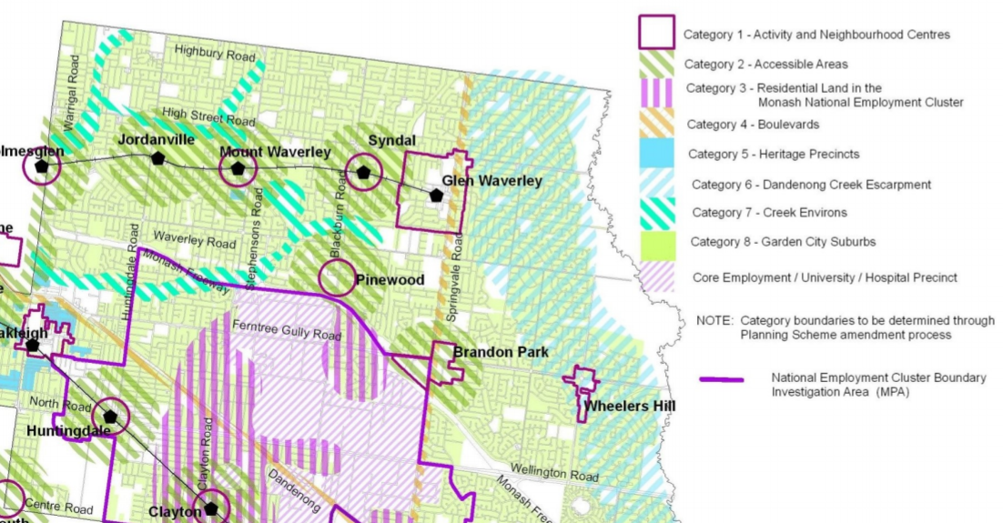
Review site

- Policy objectives and strategies reinforce aspirations for new development that complements and enhances the garden city character concept.
- Other strategies of particular relevance include the following:
- Ensure that new residential development enhances the character of the neighbourhood, having regard to the preferred future character statements contained within Clause 22.01.
- Ensure that development enhances the garden city and landscaped streetscape character of the neighbourhood, responds to the features of the site and surrounding area and promotes good streetscape design.
- Encourage vegetation retention and provision on development sites.
- Ensure that new residential development provides a high level of amenity including internal amenity, privacy for occupants and neighbours, access to sunlight, high quality private and public open space, canopy tree cover, and effective traffic management and parking.
- Maintain the predominantly single detached dwelling character in suburban areas by promoting low rise development as the preferred character for the majority of the residential areas within the city.
- Direct more intensive, higher scale development to neighbourhood and activity centres that are well serviced by public transport, commercial, recreational, community and educational facilities.
- Background documents include recent strategic reports, notably, the Neighbourhood Character Review (February 2015) and Monash Housing Strategy (October 2014).
- In relation to the Residential Development and Character policy at clause 22.01, policies that have universal applicability across all character areas ask for development that:
- is consistent with preferred character statements;
- respects the character of surrounding development including the maintenance of consistent setbacks and which allows vegetation and large trees to be planted in front side and rear setbacks;
- provides side setbacks that maintain an open, spacious streetscape character and separation of dwellings.
- includes buildings designed to reflect the spacing and rhythm of existing streetscapes.
- provides side and rear setbacks capable of supporting canopy trees and green corridors in backyards.
- provides a separation between dwellings constructed on the same site to break up built form and support additional landscaping.
- ensures private open space areas are sufficient for the recreation needs of the likely future residents, including useable dimensions, direct access to living spaces and good access to sunlight whilst contributing to the preferred garden city character.
- locates and minimises vehicle crossovers to prevent traffic disruption, and preserve nature strips and street trees.
- maximises landscaping in front setback areas by minimising the number of crossovers.
- ensure buildings respect the built form, rhythm and proportions of existing dwellings in the neighbourhood.
- Preferred future character statements have been expressed for each character type.
- In this case, ‘Garden City Suburbs (Northern)’ is applicable. While I have considered this statement, I do not recite it in full here. I relevantly note however that this statement anticipates that there will be changes to some of the houses within this area, including the development of well-designed and sensitive unit development within a pleasant leafy framework of well-vegetated front and rear gardens and large canopy trees. New development is also expected to complement the established buildings through consistent siting, articulated facades and use of materials and long expanses of blank wall will be avoided. Additional vehicle crossovers will be discouraged.
- Other local policies of relevance to this proceeding include those at clause 21.06 and 22.05.
- Clause 21.06 relates to Major and Neighbourhood centres and these types of centres are identified as being the likely focus of change over the next 30 years. Under this policy, various objectives and strategies are identified for these centres reflective of their place in the hierarchy of activity centres and their identified primary focus.
- The nearby Jordanville activity centre is not identified as either a Major or Neighbourhood activity centre in either Map 5 or Table 1 to this policy.
- The Tree Conservation Policy at clause 22.05 supports the council’s key policy direction of maintaining and enhancing the concept of its garden city character.
- A policy is that semi-mature canopy trees with spreading crowns be planted as part of any new development, in open space areas, along boundaries adjacent to neighbouring open space and in front setback areas.

Weight of planning scheme policies versus Housing Strategy

Outline of submissions
- The applicant contends that the inclusion of the site within a Category 2 - Accessible area in the housing framework plan under clause 21.04 lends support for a ‘moderate’ degree of housing change. While not adjacent to Category 1 activity centre it is said submitted that ‘this local hub functions as a node of community interaction, business activity and public transport’.
- It is further submitted that ministerial approval of Amendment C125 Part 2 occurred on the proviso that further strategic work needs to be undertaken by the council for accessible areas, comprising the formulation of urban design principles and built form guidelines.
- It is further contended that the need for this further strategic work ‘clearly indicates that a more intensive and robust form of housing changes [sic.] is strategically envisaged for residential land surrounding Activity Centres and railway stations’.
- In the context of the site’s location at the edge of the Jordanville local centre less emphasis on neighbourhood character is thus said to apply. Further, while medium density housing will result in some form of neighbourhood character change, it is also contended that the relevant test is not change per se but whether the change has been respectfully managed having regard to context.
- The council acknowledges that State and local policy envisages medium density housing close to employment and activity centres. However, ‘the critical issue for the Council with this application is what is proposed does not adequately responds [sic.] to its site and context’. Although advancing urban consolidation policies, it is contended that the design response does not do this in a way that implements neighbourhood character policy and adopted neighbourhood character guidelines.

Tribunal’s findings
- There is no question in my mind that this site is highly suited to a more intense form of residential development given the very favourable physical and locational attributes it enjoys. This large site is a short stroll from the Jordanville train station and a small activity centre and has good access to a range of established services and facilities. Its proximity to the rail network places the site within the PPTN area.
- The applicant’s submissions are based in large part on the Housing Strategy. This background document provides ‘objectives’, statements of ‘future character’ and ‘residential outcomes’. These variously refer to ‘moderate housing change and diversification serving as a transition between commercial and residential areas’. Apartments at the interface with activity centres and lower density unit and townhouse style development at the interface with residential areas are also outcomes that are envisaged. At the same time, objectives also seek development that is ‘respectful of neighbourhood character and amenity, with greater emphasis placed on these objectives in proportion to the distance from commercial zones and transport nodes’.
- The future character indicates that these areas will provide for a diverse range of housing types while retaining key aspects of the existing built form and landscape character of the area. Improved building design and quality will also be encouraged to maximise the comfort for future residents (and neighbours) as well as minimising running and maintenance costs.
- All of these directions have a sound strategic planning basis and are common enough in contexts such as this. I am mindful however that as the Housing Strategy has the status of a background document it does not form part of and cannot override policies contained in the planning scheme.
- That much is clear from clause 72.08 which explains the role of background documents as follows:
A background document may:
- Have informed the preparation of, or an amendment to, this planning scheme.
- Provide information to explain the context within which a provision has been framed.
- Assist the understanding of this planning scheme.
- Thus, while I have considered these directions for Category 2 - Accessible areas in the Housing Strategy, they do not provide the more detailed ‘meat on the bones’ that the weight of planning scheme policies have to assist decision makers in the exercise of their discretion, particularly in relation to preferred built form and character outcomes.
- It is therefore fair to observe that at present, there is somewhat of a planning scheme policy vacuum in terms of clear built form and character expectations for these accessible areas. Unfortunately, that is likely to remain so until the additional strategic work is completed.
- Nonetheless, it remains that I must apply the planning scheme as it stands at the time of making my decision. Therefore, my assessment of this proposal’s acceptability commences with the provisions of the GRZ2 and the existing planning scheme policy framework. The site’s favourable physical attributes, reflected by its inclusion within a Category 2 - Accessible area in the residential framework plan at clause 21.04, remain as relevant and influential considerations that inform the exercise of my discretion.
- In the circumstances, I am inclined to allow a greater degree flexibility in my application of planning scheme policies that relate to residential development outcomes including preferred character than I might otherwise. At the same time, I am cognisant that the site is within the GRZ2, whose purposes encourage development that respects the neighbourhood character of an area. This contrasts for example with the Residential Growth Zone, where such a purpose is absent. It would also be wrong to ignore other important policy objectives that apply to this residential setting within the GRZ2 and which have broad applicability, including high quality urban design and amenity for existing and future residents.
- It is against this backdrop that I have assessed this proposal.

Proposal’s response to its planning and physical contexts

Outline of submissions
- In support of its position that the proposal would not achieve a comfortable fit for this location and would not respond in an acceptable way to the surrounding context and statement of preferred character. In so doing, it is said that the proposal fails the first objective and standards for neighbourhood character, which I take to mean a reference to clause 55.02. More particularly, the council’s submission identifies the following concerns:
- The double storey attached form with minimal separation extending across two street frontages represents a significant departure from the generally low scale housing stock in the area.
- Insufficient first floor recession, separation and articulation.
- The proposal focuses far greater attention on achieving six generous family homes that are:
  - too dominant, bulky and lack articulation;
  - are provided in an attached form that requires garaging and crossovers/driveways that are too dominating and negatively impact the streetscape in a way that is not in keeping with the existing or desired future character of the area;
  - the number and siting of crossovers and garages are inconsistent with the open gardens that characterise the surrounding area where policy asks to maximise landscaping in front setbacks by minimising the number of crossovers.
- A sense of spaciousness around dwellings and maintenance and creation of a garden city character is not achieved by the proposed layout.
- The applicant’s submission draw attention to the following features of the design and layout which it says are contextually responsive and acceptable:
- Front and side setbacks substantially comply with Standard B6 and to the extent that a minor ground floor non-compliance exists for Bedroom 1 of Unit 4 on the corner, an acceptable transition in setbacks to neighbouring dwellings remain.
- First floor street setbacks to Malcolm Court exceed the 7.6m front setback under Standard B6 as varied in GRZ2.
- Like Units 4 to 6, the first floor setbacks of Units 1 to 3 have good articulation with stepped façades, ‘view corridors’ and staggered setbacks that provide an acceptable transition to neighbours.
- While the appearance of Units 4 to 6 in Malcolm Court will bring about a noticeable degree of change, this is acceptable for this context which is not a pristine environment given the large range of dwelling types, street boundary brick walls and dominant commercial forms diagonally opposite.
- Attached ground floor construction is an observable design element and this response is any event acceptable for this robust context.
- The 2-storey building scale and heights are ‘low rise’ in the context of clause 22.01.
- All units have single width crossovers and driveways, recessed single garages allowing habitable room windows and front porches that project forward.
- Crossovers are spaced to allow for front garden space and planting between crossovers.
- High timber fence will be removed from front boundary along Greenfell Road.
- It is further submitted that the proposal responds positively to clause 22.01 policy directives to:
- ensure respect the built form, rhythm and proportions of existing dwellings in the neighbourhood; and
- incorporate higher degrees of articulation for double storey development in streetscapes where the prevailing built form is single storey.

Tribunal’s findings
- In-principle, I consider that the concept of developing this site with six dwellings that are 2-storeys in scale is acceptable for this context.
- The proposed building height is also acceptable and would meet the objective at clause 55.03-2.
- I acknowledge that housing is traditionally single storey with a very open low scale appearance. However, I agree with the applicant that the more robust commercial buildings in the activity centre that are visible from the site and its more immediate environs together with the newly evolving 2-storey residential buildings inform at least in part, the surrounding built form context.
- I also agree in-principle with the concept of providing two modules of three dwellings each in an attached form. I find that the spacing between the upper levels of individual dwellings and between the two modules offers an acceptable degree of relief to avoid the impression of a solid and continuous building mass that policy seeks to avoid.
- I find that ground level setbacks are largely acceptable. They adopt staggered footprints to create visual interest while providing an acceptable transition to abutting dwellings in both streets.
- In terms of upper level setbacks, building bulk and articulation, the development is largely acceptable except for the following.
- The upper level footprint of Unit 4 provides an insufficient degree of stepping back from the lower level on its west and south sides, noting also that that the parapet wall at ground level reaches a height of 4m in this location. On approach from the west in Greenfell Road this aspect of the development would be visually dominant and bulky.
- I also find that the design and appearance of Unit 3 on its east side is not acceptable. This aspect of the development has a 15m blank wall at ground level above which sits a 10.5m long 2-storey wall with negligible articulation. I consider that the east elevation would have a poor visual presentation when viewed obliquely from Greenfell Road but more so from indoor areas and the SPOS of both Units 4 and 5 which have a direct outlook and abuttal to this side of the dwelling. The SPOS of Unit 5 is also abutted on its north side in part by 2-storey elements of Unit 3, contributing to a sense of enclosure of the SPOS and high levels of overshadowing due to 2-storey forms on three of its sides.
- I consider that the overall arrangement of these four dwellings particularly, the siting of Unit 3 on what is effectively the rear boundary of Units 4 and 5 is poorly conceived. The proposed siting of these dwellings and location of SPOS would give rise to poor levels of visual amenity for Units 4 and 5, particularly the latter, noting also that these are substantially sized dwellings with four and five bedrooms respectively.
- In terms of the number of vehicle crossovers, while there is policy discouragement for additional crossovers, I find that the substantial length of both street frontages is in-principle capable of absorbing three crossovers and driveways. In Malcolm Court, I find that this arrangement is acceptable taking into account their spacing and width, in both the public and private realms respectively.
- I consider however that the spacing and location of the three driveways and crossovers, in Greenfell Road, as distinct from the number of them, would not produce an acceptable streetscape outcome.
- Units 1, 2 and 3 are narrowly configured and their crossovers are all placed close together over a distance of approximately 18m. While I acknowledge that space is available in garden areas for landscaping between them, I consider that the resultant amount of paving and the space between driveways and crossovers is not respectful of the pattern and rhythm of these elements in the area. Contributing to my concerns with this arrangement is the breadth of paving that arises from the joinder of Unit 1’s crossover with its western neighbour.
- In combination, I find that the design and siting of these elements would have a discordant appearance in this part of the Greenfell Road streetscape and represents too great a departure from the existing and preferred character aspirations for this area.
- In combination with the building bulk and siting issues I have described, I consider that the neighbourhood character objective at clause 55.02-1 is not met.

on-site amenity

Outline of submissions
- The council submits that the development fails to substantially meet the varied requirements of Standard B28 for open space provision, having regard to both the amenity outcome for future residents and in neighbourhood character terms. Particular concerns were raised about the amenity of SPOS for Units 1 and 3.
- The applicant submits that the proposal achieves a high level of compliance with the varied open space standard with spaces that will support both good levels of on-site amenity and landscaping including canopy trees as depicted on the landscape plan and consistent with the garden city character concept.

Tribunal’s findings
- I acknowledge that in relation to the provision of SPOS, the proposal meets the varied numeric standards that apply in GRZ2. While the overall provision of POS is not provided for Unit 1, the shortfall of approximately 4.5sqm is in my view not fatal to this proposal, taking into account the good amenity on offer to this dwelling’s north facing SPOS and its size with just two bedrooms.
- I similarly find that the amenity of Unit 2’s SPOS is acceptable.
- I also consider that Unit 6’s SPOS will meet the reasonable service and recreation needs of its residents while offering acceptable levels of amenity.
- At the northern interface with No. 1 Malcolm Court, overall, I find that there is appropriate space for an acceptable landscape response along this boundary consistent with policy directions to do so.
- Returning to Unit 6, the finished site level of this unit’s SPOS and its associated deck are elevated above Unit 3’s SPOS. In the case of the deck, this will sit 1.1m higher than the proposed finished site level of Unit 3’s SPOS. The boundary fence between the two is to be raised above Unit 3’s SPOS on a retaining wall. As a result, I calculate that this fence will extend to an overall height of approximately 2.6m measured above the finished ground level of Unit 3’s SPOS.
- I find that the design of the SPOS for Unit 3 with its angled, narrower configuration at the interface with Unit 6’s deck and high boundary fencing together with the siting of the meals area which provides the sole means of access to the SPOS are poorly arranged.
- I concur with the council that the SPOS for Unit 3 will offer poor levels of on-site amenity. I find that this arrangement would not contribute to a high quality of on-site amenity and private open space sought by policy under clause 21.04. I make similar findings in relation to the amenity of the SPOS for Units 4 and 5 for reasons that I have expressed above in relation to their relationship with Units 3 and 6.

other issues
- I consider that the proposal would not have unreasonable off-site impacts in relation to the abutting dwelling to the west, taking into account the limited interface and siting of existing habitable room windows and SPOS relative to the proposed siting of the units.
- At the interface with No. 1 Malcolm Court, I consider that the siting of Units 1 to 3 relative to this neighbouring dwelling’s side aspect is acceptable.
- In-principle, I also consider that the siting of Unit 6 on the common boundary is acceptable if the neighbouring planting is able to be retained to provide some softening of this unit’s 2-storey form on its north side, noting the presence of existing habitable room windows on this side.
- I also find that the number of parking spaces and access generally are acceptable elements of this proposal. While reversing movements onto both streets will be required, this is a relatively low speed, low traffic environment.
- In saying this I note that a slight reconfiguration of Unit 4 and Unit 5’s crossovers and driveways can be achieved as shown on the conceptual layout plan (Revision C TP3) appended to the applicant’s submission to minimise potential impacts on the street tree in Malcolm Court.

conclusion
- I have given careful consideration as to whether the shortcomings that I have identified with this proposal could be remedied through further plan modifications via conditions in a permit.
- I have come to the conclusion however that discrete modifications cannot be made without creating unknown consequential effects to other parts of the proposal. The overall layout of the two modules and the relationship between them at the interface between Unit 3 and Units 4, 5 and 6 is too flawed and warrants a significant and integrated detailed design review to achieve an acceptable outcome in terms of neighbourhood character and internal amenity.
- For these reasons I conclude that no permit is to be granted.

Mary-Anne Taranto Member

The submissions of the parties, supporting exhibits and the statements of grounds filed; have all been considered in the determination of the proceeding. In accordance with the practice of the Tribunal, not all of this material will be cited or referred to in these reasons.
Substitution of the plans was not opposed in the submissions filed by the council.
Vegetation was removed some time between 23 August and 7 October 2018. See Nearmap images captured on 23 August 2018 and 7 October 2018. For the purposes of Standard B13 (landscaping) at clause 55.03-8, the permit application form is dated 7 March 2019, less than 12 months after the removal of this vegetation.
Clause 15.01-4R
For example Clauses 15.01-1R, 15.01-2S and 15.01-5S
Clause 18.02-2R.
Clause 21.04-4.
Planisphere.
Planisphere.
Page 4 of applicant’s primary written submission.
Page 5.
Page 12 of council’s written submission.

