VICTORIAN CIVIL AND ADMINISTRATIVE TRIBUNAL
planning and environment DIVISION
 | planning and environment LIST | vcat reference No. P44/2020  PERMIT APPLICATION NO. TPA/50280
CATCHWORDS
Section 77 of the Planning and Environment Act 1987; Monash Planning Scheme; Side by Side Two Storey Dwellings; General Residential Zone – Schedule 3; Garden City Suburbs (Northern); Two Driveways; Impact on Street Tree; Boundary Development.

APPLICANTs | Asim Ahmed, Faiza Ahmed, Mario Highmoor & Preeti Highmoor
responsible authority | Monash City Council
SUBJECT LAND | 4 Moorong Street, Chadstone
WHERE HELD | Melbourne
BEFORE | Margaret Baird, Senior Member
HEARING TYPE | Hearing
date of hearing | 18 June 2020
DATE OF ORDER | 29 June 2020
CITATION | Ahmed v Monash CC [2020] VCAT 699

Order

No permit granted
- In application P44/2020, the decision of the responsible authority is affirmed.
- In permit application no. TPA/50280, no permit is granted.

Margaret Baird
Senior Member

APPEARANCES
For Asim Ahmed, Faiza Ahmed, Mario Highmoor & Preeti Highmoor [applicants] | Mr C Mackenzie, Planning Appeals. He called the following person to present expert evidence:  - Mr M Nees, horticultural consultant.
For Monash City Council [Council] | Mr J Turner, Principal Planning – Appeals Advisor.

Information
Description of proposal | Construction of two double storey side-by-side dwellings. Each dwelling is provided with a separate driveway and crossover. Two street trees are proposed to be retained and one is proposed to be removed.
Nature of proceeding | Application under section 77 of the Planning and Environment Act 1987 – to review the refusal to grant a permit.
Planning scheme | Monash Planning Scheme [scheme].
Zone and overlays | General Residential Zone, Schedule 3 [GRZ3] (shown below) Garden City Suburbs.  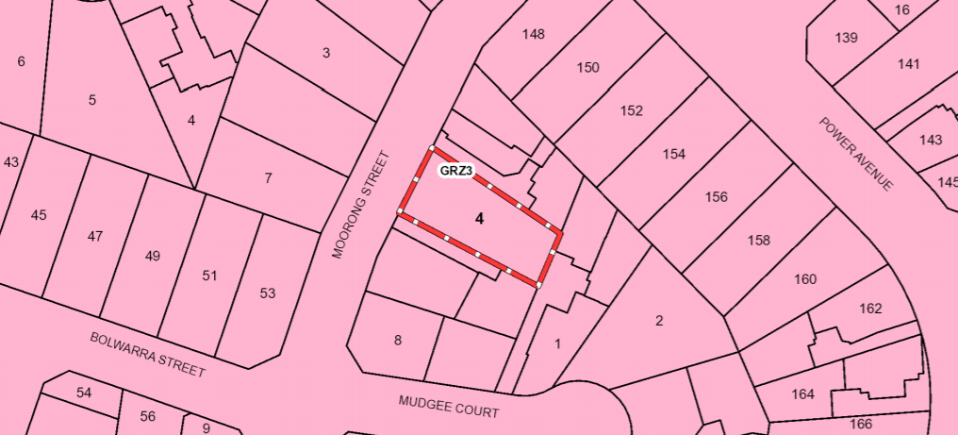
Permit requirements | Clause 32.08-6 - to construct two or more dwellings on a lot. GRZ3 varies clause 55 Standards B6, B13, B17, B28 and B32.
Relevant scheme policies and provisions | Clauses 11, 15, 16, 21, 22.01, 22.05, 32.08, 52.06, 55, 65 and 71.
Subject land description | The subject land is on the south-east side of Moorong Street and is 636m² in area. It is 18.29 metres wide along the street frontage and narrows toward the rear. Moorong Street falls toward Power Avenue.  Adjacent sites to the north-east and south-west are developed with units. Both have driveways abutting the subject land.  There is an evident pattern of the original dwelling stock in the area being replaced with multi-unit developments. Multi-unit developments abut all three boundaries of the subject land. All adopt a tandem layout.
Tribunal inspection | 17 June 2020 (unaccompanied) as parties were advised at the start of the hearing.

REASONS

INTRODUCTION
- Asim Ahmed, Faiza Ahmed, Mario Highmoor & Preeti Highmoor [applicants] applied to the Monash City Council [Council] to construct two dwellings on the subject land.
- As the Council refused to grant a permit, the permit applicants have asked the Tribunal to review that decision.
- The Council’s position is that the permit application should be refused because:
- the layout of the development in a side-by-side configuration is not sympathetic to the character of the area; and
- the side-by-side layout requires a second crossover that will result in the loss of a street tree which has a significant presence in the streetscape.
- The applicants submit the proposal warrants approval having regard to all of the relevant considerations. They say that there is ample support in policy and the nearby context for the development typology adopted in this design response. Mr Mackenzie submits that removal of the street tree is sought to facilitate a second driveway. Two other street trees will be retained. In addition, new front yard trees and a replacement street tree will be planted. In the applicants’ submission this is supportable when all relevant factors are considered and balanced. The outcome presented in this permit application is acceptable, in the applicants’ submission, even though it departs from aspects of policy preferring retention of the street tree and a single crossing and driveway on the site.
- I must decide whether the proposal will produce an acceptable outcome having regard to the relevant policies and provisions in the scheme. Clause 71.02-3 requires the decision-maker to integrate the range of policies relevant to the issues to be determined and balance conflicting objectives in favour of net community benefit and sustainable development.

strategic CONTEXT
- The strategic context that is relevant to the assessment of this permit application is summarised below. This is not, per se, contentious.
- The principle of developing the land with two dwellings is not in issue.
- The key issues are the adoption of a side-by-side design response with removal of a street tree and proposed boundary development.
- The subject land and surrounding area is within GRZ3. It is within an area identified as part of the Garden City Suburbs and incremental change. There is a strong policy emphasis on retention of neighbourhood character enhancement of Garden City character. GRZ3 is applied to achieve the preferred development outcomes. The neighbourhood character objectives in GRZ3 are:
- To support new development that contributes to the preferred garden city character through well landscaped and spacious gardens that include canopy trees.
- To promote the preferred garden city character by minimising hard paving throughout the site by limiting the length and width of accessways and limiting paving within open space areas.
- To support new development that minimises building mass and visual bulk in the streetscape through generous front and side setbacks, landscaping in the front setback and breaks and recesses in the built form.
- To support new development that locates garages and carports behind the front walls of buildings.
- The decision guidelines at clause 7.0 of GRZ3 include:
- Whether the development provides an appropriate transition to built form on adjoining sites.
- The robustness of proposed materials and finishes.
- The impact of the shape and dimensions of the lot on the ability of the development to meet any requirements of this schedule. The location and number of vehicle crossovers.
- The impact of the development on nature strips and street trees.
- The location, quantity and species of vegetation provided.
- Clause 32.08 includes a purpose that ties development to respecting neighbourhood character. Varied clause 55 standards are part of this. It appears to be common ground between the parties that the proposal essentially meets (or exceeds) the varied standards. I give this significant weight in assessing the proposal’s acceptability including its response to clause 32.08, GRZ3 and preferred character.
- Clause 22.01-2 has an overall neighbourhood character objectives including:
- To build upon the important contribution that landscaping makes to the garden city character of Monash.
- To encourage new development to achieve architectural and urban design outcomes that positively contribute to neighbourhood character having particular regard to the applicable preferred future character statement for the area.
- To encourage the provision of a variety of housing types to accommodate future housing needs and preferences.
- Among relevant policies at clause 22.01-3 are general policies that include to “Preserve and enhance treed character of Monash”. In addition, policies relating to landscaping and vehicle crossings include the following (as relevant to this case):
Landscaping
Site buildings to minimise the need to remove significant trees, and protect significant trees on the site and adjoining properties.
Ensure development is adequately set back from existing and proposed trees to ensure their protection and longevity.
Retain or plant canopy trees, particularly within front setbacks to soften the appearance of the built form and contribute to the landscape character of the area.
Ensure street trees are retained and protected.
Vehicle crossings
- Locate and minimise vehicle crossovers to prevent traffic disruption, and preserve nature strips and street trees.
- Maximise landscaping in front setback areas by minimising the number of crossovers.
[Tribunal emphasis added]
- The relevant preferred future character statement is as follows:
Although there will be changes to some of the houses within this area, including the development of well-designed and sensitive unit development and, on suitable sites, some apartment development, these will take place within a pleasant leafy framework of well-vegetated front and rear gardens and large canopy trees.
Setbacks will be generous and consistent within individual streets. Building heights will vary between neighbourhoods. Neighbourhoods with diverse topography and a well-developed mature tree canopy will have a larger proportion of two storey buildings. In the lower, less wooded areas, buildings will be mainly low rise unless existing vegetation or a gradation in height softens the scale contrast between buildings. New development will complement the established buildings through consistent siting, articulated facades and use of materials. New development will consider energy efficiency and sustainability principles. Long expanses of blank wall will be avoided, particularly when adjacent to public parks, reserves and other open space areas, where the building should address the public area.
Architecture, including new buildings and extensions, will usually be secondary in visual significance to the landscape of the area when viewed from the street. New development will be screened from the street and neighbouring properties by well planted gardens that will ensure the soft leafy nature of the street is retained.
Gardens will consist of open lawns, planted with a mix of native and exotic vegetation and trees. Existing mature trees and shrubs will be retained and additional tree planting within streets and private gardens will add to the tree canopy of the area.
Buildings will be clearly visible through these low garden settings, and nonexistent or transparent front fences. Additional vehicle crossovers will be discouraged.
The built-form will be visually unified by well-planted front gardens that contain large trees and shrubs and street tree planting. Trees within lots to be redeveloped will be retained wherever possible to maintain the established leafy character.
Landscape elements such as remnant indigenous vegetation and the large old coniferous wind-rows will be retained until trees are no longer healthy or safe.
- I have considered the decision guidelines at clause 22.01-5.
- Rezoning of the land in November 2019 to GRZ3, other changes to both local policy at clause 21.04, and the policies and new preferred character statements at clause 22.01 result in a different planning context than applied at the time of other Tribunal decisions to which I have been referred. While I agree with Mr Mackenzie that the policy seeking one crossover per lot has existed in the scheme for a lengthy period, I must apply the scheme as I find it based on the current provisions and policies. The scheme has changed since November 2019, notwithstanding some policy themes remain the same. To the extent that the applicants cite decisions in other cases (eg. support for the removal of a street tree in Thye Hern Lim) it will be evident when reading that decision and my decision that each proposal has been assessed on its merits and in its own planning context.

REMOVAL OF A Street Tree

Issues
- The street tree in issue is a Snow Gum (Eucalyptus Pauciflora) based on the expert evidence. The tree was identified in an earlier arborist report on behalf of the applicants as a Yellow Gum while the Council’s Arborist referred to it as a Wallangarra White Gum. The parties have proceeded on the basis of the expert evidence and neither contend that anything turns on the various descriptions as part of the permit application process.
- The Council submits the development will destroy the Snow Gum which is in fair to good health. The tree should be and could be retained while the site is redeveloped in a tandem format. The Council submits retention of the tree is consistent with GRZ3, and policies in clauses 21.04, 22.01 and 22.05, and its loss is too great a sacrifice to be considered an acceptable planning outcome for the street. The tree is regarded by the Council as being healthy, important to neighbourhood character, and with a long useful life expectancy. Mr Turner submits that loss of the tree will see the development dominated by hard surfaces rather than trees and landscaping thereby fragmenting the streetscape.
- The applicants submit that the Council’s concerns about two driveways and a side-by-side typology are heightened or reinforced by the need to remove the existing street tree. Only one of three street trees is to be removed. The applicants rely on Mr Nees’ evidence with respect to observations about the street tree in issue, the other two street trees that are to be retained, and street trees in the wider area.
- Among Mr Nees’ observations are that there is no uniform or consistent street tree pattern in terms of species, size, maturity, spacing, and a number of trees adjacent to individual lots. Mr Nees suggests that there is an opportunity to plant a new street tree on a neighbouring frontage; potentially a flowering gum as it is used successfully elsewhere as a street tree. This species has a consistent form, more impressive canopy, and better suited to a street tree compared with a Snow Gum. A flowering gum could reach a similar height as the existing Snow Gum in approximately five years.
- The applicants submit that removal of the street tree will not disrupt a consistent pattern of mature trees. Its removal is an acceptable outcome when balancing all relevant considerations, including new planting proposed in the front setback of the development. A strong front garden character will be achieved.
- Mr Mackenzie refers to the Tribunal’s findings in Thye Hern Lim where the Tribunal records expert evidence that street trees in Glenora Street comprise an eclectic mix of species, with little consistency in planting, age, theme or arrangement. The evidence was that there is not an integrated avenue of trees or a coherent streetscape. In time, there would be no loss in a number of trees and little change in the streetscape having regard to the potential to plant a new tree.
- The permit application does not propose removal of the northern most street tree, a Hakea. Notwithstanding, Mr Mackenzie suggests that the Tribunal could consider its removal as part of the current consideration, mindful that its removal was said to be acceptable by the Council’s internal referral in April 2019.

Findings
- The applicants do not contest that the removal of the Snow Gum is required as a consequence of the design response adopted. That is, there are no submissions that the design response can proceed with the street tree being able to be retained and protected.
- The Snow Gum is the largest of the three street trees. This can be seen in my photographs below.
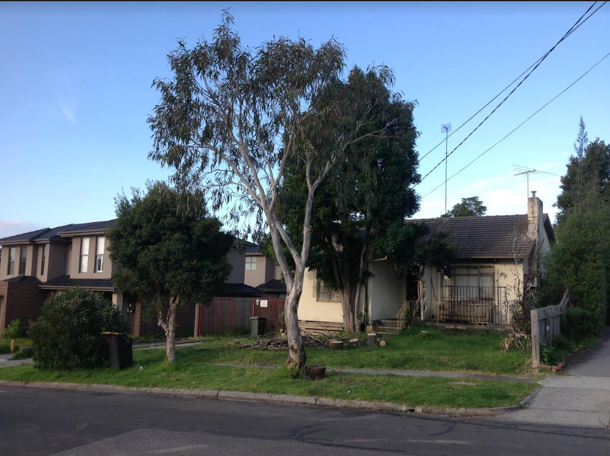

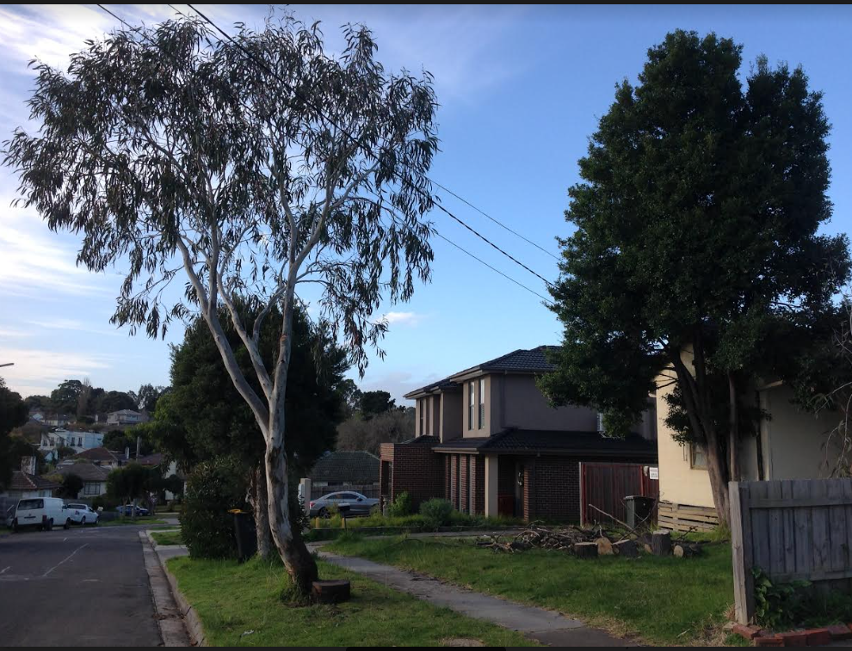
- My inspection confirms the varied street tree pattern cited in evidence. That is, a presence of street trees but with variety in elements such as species, age, size, spacing, canopy density and extent, and overall form. This is also consistent with the findings in Thye Hern Lim.
- On my reading of the Tribunal’s decision, the tree in issue (a Weeping Bottlebrush) was said to have fair to poor structure with a short useful life expectancy and a low retention value. It was said in evidence to likely need to be removed and was described by the Tribunal as having little intrinsic value and little contribution to the streetscape. Based on the evidence before me, the Snow Gum is not similarly fragile. It is clear to me that the Snow Gum makes a positive streetscape contribution and there is no reason to determine that it will not continue to do so - and increasingly so as it continues to grow.
- The description and arboricultural assessments of the Snow Gum between the Council’s internal referral and in Mr Nees’ evidence are consistent and there are no challenges to descriptions given in expert evidence. Mr Nees’ assessment includes the following:
The recent site assessment indicated that the Acute bifurcated stem union or formation appears to be developing in a satisfactory way and the likelihood of failure as the tree develops in my opinion, is not great.
The stem and structure of the Snow Gum can be described as stout and structurally sound with a moderate level of foliage density. It appears to be in good/fair health with a moderate level of vigour and a useful life expectancy greater than 20 years.
- In response to my questions, Mr Nees’ evidence is that the tree is currently approximately 7 to 8 metres high and 5 metres wide today. It is approximately 15 years old. Mr Nees’ opinion is that the Snow Gum has the potential to grow to approximately 12 metres in height and 10 metres in width.
- Mr Nees described the shape and form of the tree as typical of the species. Its irregular form does not reflect a structural fault. Having regard to my inspection which included streets in the near and wider area, at the hearing I observed that the Snow Gum in question is not distinguished from many other Eucalypt species planted in nearby streets that also have irregular form. Mr Nees agreed with my observation. His evidence also notes that the species is not a commonly used street tree.
- Mr Nees evidence does not assess street tree planting from the perspective of the planning scheme provisions and policies. His evidence does not assess a landscape or streetscape contribution, in amenity terms.
- I agree with Mr Turner that the scheme does not distinguish between street trees that are part of a more consistent planting pattern and species theme compared with the more eclectic situation here. In my view there is a strong policy position to retain and protect street trees, particularly where they are healthy and make an evident contribution. For example, clause 22.05 states that it is important to ensure that (among others) trees that have been planted and have now matured are retained, where possible, when development proceeds and that new canopy trees with spreading crowns can be planted as part of all new developments.
- I accept that a new street tree is potentially possible further to the north of the subject land. However, that does not justify removal of a street tree of this size, condition, health, and with its expected growth and longevity, mindful that there are other ways in which the subject land can be developed with two dwellings thereby contributing to housing goals.
- In Thye Hern Lim the Tribunal formed the view that removal and replacement of a street tree was a minor change that was outweighed by the contribution to contemporary dwellings could make to broad planning objectives. It also found that the street tree could readily be replaced. Having regard to the current planning scheme context, and the condition and contribution to Snow Gum makes, I do not reach the same conclusion in the circumstances of the proceeding before me.
- I make no findings with respect to the Hakea which is not proposed to be removed in this permit application.

SIDE-BY-SIDE FORMAT AND BOUNDARY DEVELOPMENT

Issues
- The Council submits that the 18.29 metre wide frontage of the site cannot comfortably accommodate two driveways without adversely impacting on the landscaping capacity of the site, the landscape character of the surrounding area and the retention of street trees.
- The Council submits that boundary to boundary development is out of character for the area, as most of the redeveloped sites are in tandem formation and do not extend across the whole site. Mr Turner submits that the rhythm and massing of the development is inconsistent with policy, and is an intense response to the built form. He submits the proposal represents a significant departure from the pattern of development which generally comprises dwellings set in well landscaped gardens. The issue is not about two storey form, he says, but the configuration of the layout selected in this design response.
- In response, the applicants submit that the side-by-side layout is acceptable having regard to multiple contextual factors:
- The neighbours are setback 6.0m and 6.8m. B6 would normally call for a 6.4m front setback. GRZ-3 calls for 7.6m.
- The proposal exceeds a 7.6 m requirement…. The front garden will therefore be notably deeper than both neighbours.
- The 18.29 m frontage allows the layout to provide 11 m+ between the driveways, with more than 7.6 m depth, providing a generous central front garden area suitable for two front yard trees.
- The layout also provides for small gardens along each driveway edge and the 8m deep rear yards provide generous garden areas with for new trees proposed.
- … The various assessment factors considered, balanced and found to be acceptable in 2 Glenora and 166 Power are also provided in this proposal.
- The applicants submit the Council does not support both garages on boundaries and would prefer one garage set off a site boundary. There is no preference as to which side, rather it is a generalised preference. The applicants submit that there are many side-by-side layouts with one garage offset from a boundary with the intent to maintain a streetscape rhythm of dwelling separation. Mr Mackenzie relies on the fact that both abutting sites have been redeveloped with driveways along the boundary with the subject land. Consequently, 3 to 4 metres built form separation is achieved. Having said that, Mr Mackenzie submits that a permit could require a one metre setback of Dwelling 1 from its boundary without adversely altering the cohesion of the design or internal functionality.

Findings
- Design responses involving side-by-side dwellings for sites in Monash have been the subject of many decisions by the Tribunal. They have often been contentious because policy has sought to limit vehicle crossovers to one. The two decisions to which Mr Mackenzie refers (and other examples he has photographed) involve wider lots, in the order of 19 and 20 metres, contrasting with many lots found in the municipality that are around 15-16 metres wide.
- The Council’s position is based on objectives about enhancing the Garden City character, maximising opportunities for landscaping and maintaining the provision of on-street parking.
- Despite the lot pattern in the Moorong Street, and nearby streets, involving lots that appear to be of a similar width as the subject land, the predominant character of multi-unit development is a tandem format. This does not mean that that is the only format that can be approved, however, it is a factor in understanding existing pattern of development.
- Submissions outlining some of the benefits of a side-by-side format, also cited in the Glenora Street decision, must be considered in the context of the specific circumstances of a site. For example, a common criticism of tandem layouts is that they might place two storey built form close to the rear boundary. In the current case, the subject land is surrounded by dwellings in a tandem format. This means that there is already development in what previously would have a rear yard context but also that there are less-sensitive interfaces associated with driveways on all adjacent sites.
- I have earlier observed that the pattern of development associated with original dwelling stock and new multi-unit developments is predominantly, albeit not exclusively, involves a side setback. This might be achieved by a driveway or by setting back a building. There is an evident pattern of spacing in this location. In addition, the preferred character statement includes new development complementing established buildings through consistent siting.
- Even if one accepts that the wide site enables a potentially acceptable outcome with two single crossovers, the issue in this case is the loss of a street tree in the public realm. I have set out my reasons earlier as to why I have concluded that removal of the street tree is not acceptable.
- Having regard to the width of the subject land, there is scope to provide a setback from one side boundary. If I had been minded to grant a permit, this could have been addressed by permit conditions. I agree with the applicants’ submission that the setback to Dwelling 1 would not have adverse impacts with respect to functionality and layout.

Conclusion
- There are only a limited number of matters in dispute in this proceeding. The principle of developing the subject land with two dwellings is agreed between the parties.
- For the above reasons, the responsible authority’s decision is affirmed. No permit is granted.

Margaret Baird
Senior Member

Planning report extract. The land has been rezoned since the Council’s decision following the Gazette all of Amendment C125 Part 2 In November 2019.
The submissions and evidence of the parties, supporting exhibits and statements of grounds filed have all been considered in the determination of the proceeding. In accordance with the Tribunal’s practice, not all of this material will be cited or referred to in these reasons.
Map 3 at clause 21.04-1.
The applicants’ submission refers to a small non-compliance with Standard B17.
Clause 22.01-4.
Thye Hern Lim v Monash CC (Corrected) [2017] VCAT 985; Archsign Pty Ltd v Monash CC [2017] VCAT 1176.
Thye Hern Lim v Monash CC (Corrected) [2017] VCAT 985.
Ibid.
Ibid, [54], [56] and [57].
Paragraphs 3.1.4 – 3.1.5 of the statement of evidence dated 2 June 2020.
Thye Hern Lim v Monash CC (Corrected) [2017] VCAT 985, [60].
Thye Hern Lim v Monash CC (Corrected) [2017] VCAT 985, [34], the Tribunal said: I think that on sites that are relatively wide, the side by side arrangement can be a preferable design response compared to a tandem arrangement. This is a site responsive design that takes advantage of the wide frontage, and recognises that it has only a modest depth. Two dwellings in a tandem arrangement would probably result in the front dwelling extending across the front, and it would place two storey built form close to the rear boundary. This proposal allows the two dwellings to enjoy north solar access to their front rooms, rather than the rear dwellings possible being overshadowed by the front dwelling. It also enables the built form to be set backs from the rear boundary.
Clause 22.01-4.

