VICTORIAN CIVIL AND ADMINISTRATIVE TRIBUNAL
planning and environment DIVISION
planning and environment LIST | vcat reference No. P746/2019  Permit APPLICATION no. TPA/49582

CATCHWORDS
Section 77 of the Planning and Environment Act 1987; Monash Planning Scheme; Neighbourhood Residential Zone NRZ4; Character Type E; Dandenong Valley Escarpment; Preferred Character; Landscape Outcome.

APPLICANT | Nemish Kumar Vrujlal Dalsaniya
responsible authority | Monash City Council
SUBJECT LAND | No. 9 Roycroft Close, Glen Waverley
WHERE HELD | Melbourne
BEFORE | Margaret Baird, Senior Member
HEARING TYPE | Hearing
DATE OF HEARING | 22 October 2019
DATE OF ORDER | 31 October 2019
CITATION | Dalsaniya v Monash CC [2019] VCAT 1675

Order

Application amended
- Pursuant to section 127 of the Victorian Civil and Administrative Tribunal Act 1998 the application is amended by changing the name of the applicant for review to:
Nemish Kumar Vrujlal Dalsaniya

Permit application amended
- Pursuant to clause 64 of Schedule 1 of the Victorian Civil and Administrative Tribunal Act 1998 the permit application is amended by changing the name of the permit applicant to:
Nemish Kumar Vrujlal Dalsaniya
- Pursuant to clause 64 of Schedule 1 of the Victorian Civil and Administrative Tribunal Act 1998 the permit application is amended by substituting the following plans filed with the Tribunal for the permit application plans:
- Prepared by: | Ario Arch;
- Drawing numbers: | TP02 – TP05 inclusive, all marked as Rev C.

No permit granted
- In application P746/2019 the decision of the responsible authority is affirmed.
- In permit application no. TPA/49582, no permit is granted.

Margaret Baird
Senior Member

APPEARANCES
For Nemish Kumar Vrujlal Dalsaniya | Mr J Livingston, JLP Melbourne.  He called the following person to present expert evidence:  - Mr R Thomson, landscape architect.
For Monash City Council | Mr J Turner, Principal Planner – Appeals Advisor.

INFORMATION
Description of proposal | Side-by-side, two storey dwellings.  Each unit contains five bedrooms. Dwelling 1, to the north, has a double car garage. Dwelling 2 has two car spaces in a tandem layout. Both driveways are served by a shared crossover, widening the existing crossover by one metre.  Vegetation is to be removed, with one fruit tree retained. A landscape plan proposes new canopy trees and other planting.
Nature of application | Application under section 77 of the Planning and Environment Act 1987 – to review the refusal to grant a permit.
Planning scheme | Monash Planning Scheme [scheme].
Zone and overlays | Neighbourhood Residential Zone Schedule 4 [NRZ4]. NRZ4 varies multiple clause 55 standards.  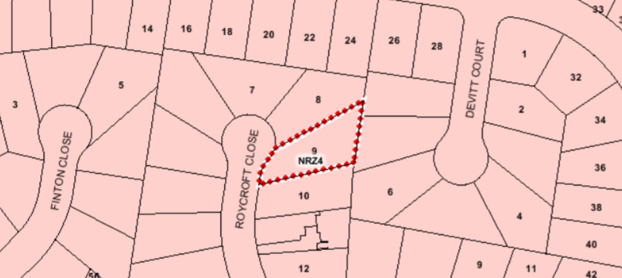  Vegetation Protection Overlay Schedule 1 [VPO1].
Permit requirements | Clause 32.09 to construct two dwellings on the lot.
Relevant scheme policies and provisions | Clauses 11, 15, 16, 21, 22.01 (Character Type E), 22.05, 32.09, 42.02, 52.06, 55, 65 and 71.
Land description | The subject land is on the east side of Roycroft Close. The land has an area of 843m² with a narrow frontage compared to the wider rear (eastern) boundary. A 2.44 metre wide easement extends along the rear boundary.  The property contains a single storey detached dwelling and some trees, including fruit trees.
Tribunal inspection | 25 October 2019 (unaccompanied).

Reasons

What is this proceeding about?
- Nemish Kumar Vrujlal Dalsaniya proposes to develop two, side-by-side double storey dwellings on the subject land. The aerial image below identifies the location of the subject land within Roycroft Close.
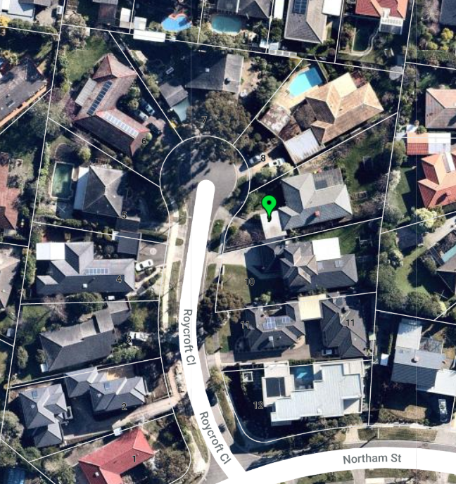
- The Monash City Council refused a permit for this proposal on grounds that contend the proposal is out of character particularly in regard to the development’s mass, bulk and scale and its inadequate response to the landscaping outcomes sought by the scheme. The Council argues the proposal will have an adverse impact on the streetscape. In addition, it considers the proposed development produces an inappropriate planning outcome in relation to the existing and preferred character and will have an adverse impact on the amenity of adjoining properties. The Council maintains its grounds despite substituted plans.
- The permit applicant has brought this proceeding to the Tribunal asking to set aside the Council’s decision. It challenges all grounds argued against the permit application.
- Relying on expert landscape evidence, the applicant submits the proposed development achieves the outcomes sought by the scheme as assessed through clause 32.09 and NRZ4, the desired future character statement for Character Type E, and all clause 55 objectives. It is relevant, in the applicant’s submission, that varied numerical clause 55 standards are met. Further, the applicant submits the design achieves the landscape outcomes sought by the scheme, relying on Mr Thomson’s evidence.
- A statement of grounds by a neighbouring property owner opposes the extent of development, loss of green space and raises additional concerns particularly with respect to overlooking and loss of daylight to habitable rooms.
- I must decide whether the proposal achieves an acceptable planning outcome having regard to the relevant policies and provisions of the scheme. Clause 71 requires the decision-maker to integrate the range of policies relevant to the issues to be determined and balance conflicting objectives in favour of net community benefit and sustainable development.
- The key matters for my determination are:
- Whether the proposal respects the neighbourhood character and contributes to the preferred character.
- Whether off-site amenity impacts are acceptable.
- In setting out my findings in relation to these matters, I only briefly refer to the relevant physical and planning contexts next. These matters are substantially agreed between the parties, and well discussed in Mr Turner’s and Mr Livingston’s submissions.

WHAT ARE THE RELEVANT PHYSICAL AND PLANNING CONTEXTS?

Physical setting
- The subject land is in an established residential area. It is located toward the northern end of Roycroft Close, a court that is characterised by single and double storey dwellings mostly with prominent vehicle garaging. There are two examples of multi-unit developments, one with single storey dwellings (at No. 11) and one with double storey dwellings (at No. 2). The latter is relatively recently constructed, having been approved in February 2018. Generally, a range of building styles and forms is represented.
- While there are some large canopy trees associated with several properties, the landscape is relatively open. Although the subject land is part of the Valley Escarpment, it is not steeply sloping. There is a gentle fall to the east.
- More broadly, the current character description in clause 22.01 for Character Type E aptly refers to the 1970s and 1980s era of development, curvilinear subdivision pattern, topography, open front gardens and limited front fencing.

Planning context
- The subject land is in the NRZ where a purpose in clause 32.09 is to “manage and ensure that development respects the identified neighbourhood character, heritage, environmental or landscape characteristics”.
- The objectives of clause 55 must be met. A preferred character statement is contained within local policy, to which I refer below.
- NRZ4 seeks to advance the specific neighbourhood character outcomes for this location. The neighbourhood character objectives are:
- To ensure new development maintains the important view lines to the Dandenong Ranges, along the streets and between buildings.
- To ensure development is defined by its spacious and generous garden settings, tall canopy trees and consistent built form and setbacks.
- To encourage open gardens to the street, and the planting and retention of significant trees.
[Emphasis not in original]
- Varied clause 55 standards are B6, B8, B9, B13, B17, B28 and B32.
- At clause 7.0 of NRZ4, a long list of decision guidelines includes the following that are most relevant to the application:
- Whether the proposed development incorporates [sic] landscape scheme that contributes to the ‘Dandenong Creek Escarpment’. Specifically, whether the proposal:
  - Provides sufficient and well located open space, primarily unencumbered easements, to provide for a large trees to be retained or planted within the front, side and rear setbacks, and secluded open space areas. Environmental weeds and artificial grass should not be used. [sic]
  - Minimises hard paving throughout the site including limiting driveway lengths and providing landscaping on both sides of driveways, and restricting the extent of paving within open space areas.
  - Maximises planting opportunities adjacent to the street by excluding hard paving such as car parking, turning circles and driveways.
  - Includes the potential to break up the appearance of building mass through the provision of space for trees and vegetation between dwellings on the same site.
- Whether the development complements the landscape setting by including the following features:
  - Built form that is sufficiently recessed and articulated, as viewed from the open space adjoining the creek and neighbouring properties, to reduce visual bulk and ensure vegetation is the dominant element as viewed from the open space and adjoining properties.
  - Buildings that visually recede into a continuous backdrop of canopy trees by avoiding visually intrusive upper storeys and large expanses of blank walls.
- How vehicle crossovers are located and minimised in number to prevent traffic disruption, and preserve nature strips, front gardens and street trees.
[Emphasis not in original]
- Clause 21.04 emphasises the Garden City Character that is a pivotal theme for Monash.
- Policy is that new development should be carefully designed and sited to complement the current character and to satisfy the intent of the desired future character statements. Development should respond to and enhance the quality and style of surrounding development. This is important when it is appreciated that the desired future character, or preferred character, is about building on the contribution that landscaping already makes. Policy seeks to further that contribution in the Character Type E area. This is evident in the desired future character statement that refers to the way in which the area will evolve:
The urban character of this area will evolve within a landscape that has a large number of native trees spread throughout both the public and private domain providing an overhead canopy visually unifying the diverse built-form of some neighbourhoods and providing a strong relationship with the semi-natural landscape of Dandenong Creek.
Dwellings will be designed to sympathetically integrate with any existing native trees and shrubs on, or adjacent to, the development site and relate in form and siting to the topography of the Character Type. Architecture of contemporary excellence that is energy efficient and sustainable will be encouraged. Building scale, height and bulk will be generally similar within neighbourhoods. Large scale contrasts between buildings will be discouraged except where existing trees and shrubs soften the junction between buildings or where there is a gradated change in scale.
Setbacks will be varied in many neighbourhoods but will be consistent within individual streets and will be sufficiently generous to enable the development of significant native tree canopy and vegetation. The main unifying element will be the canopy of native trees in both the public and private domain. Most gardens will be open to the street with no walls or fences, allowing the soft naturalistic qualities of most neighbourhoods to be retained. Large walls and fences will be discouraged except where they are already a visually dominant streetscape element.
The soft quality of the street that is derived in part from the nature strips will be maintained by ensuring that there is only one single crossover per lot frontage.
Planting will generally enable filtered views of the architecture and engender a sense of visual continuity with the street and adjacent properties.
[Emphasis not in original]
- Although Roycroft Close sees limited canopy trees on multiple lots, landscaping is to be enhanced, with overhead canopy as a unifying element.
- General and Character Area policies are relevant in addition to the desired future character statement. Decision guidelines at clause 22.01-4 have also been considered in my assessment.
- Other relevant provisions and policies are listed in the ‘Information’ section of these reasons and include:
- Clause 22.05 relating to tree conservation. This sets out objectives, policy and decision guidelines that I have considered. While Mr Livingston submits that this policy has less significance because a permit is not triggered for vegetation removal under VPO1, on my reading the policy applies to all land and addresses retention of mature and semi-mature canopy trees and street trees, as well as maintaining, enhancing and extending the Garden City character. In this regard a policy is that:
Semi-mature canopy trees with spreading crowns be planted as part of any new development, in open space areas, along boundaries adjacent to neighbouring open space and in front setback areas to reinforce the Garden City Character of the area.
- Clause 52.06 relating to parking supply and design.
- General decision guidelines at clause 65.

DOES THE PROPOSAL RESPECT NEIGHBOURHOOD CHARACTER AND CONTRIBUTE TO THE PREFERRED CHARACTER?
- The development of two dwellings on the land is acceptable. Scheme policy encourages a variety in housing types but, in this location, residential development is to generally be low rise. This is not in dispute between the parties in this proceeding.
- The applicant submits that the Council opposes a side-by-side development in principle. My task is to assess the proposal before me rather than to form a view about whether any side-by-side development can occur on the subject land.
- The applicant’s case emphasises the proposal’s compliance with the numerical standards in clause 55, including varied standards such as B8, B9, B17 and B28 that seek to give effect to the policy aims for this Character Type. Mr Livingston submits the proposal is a positive response to the desired future character and NRZ4 for reasons that include:
- The proposed side-by-side configuration allows comfortable setbacks to the front street and rear boundary, including the retention and protection of trees to the east of the subject land. Trees to the south have not been assessed by an arborist but can also be protected.
- Only one crossover is provided (by widening the existing crossover) and garages are set back behind the front porches.
- Double storey development is well articulated with first floor setbacks providing an appropriate transition and gradation to abutting houses.
- No front fencing is proposed.
- The only boundary development is the north-west point of Dwelling 1’s garage that will not be prominent and is a design response that accords with other garages on boundaries in Roycroft Close.
- The side-by-side format is the most suitable for this lot and achieves more opportunities for landscaping. There is not a pattern of canopy trees on many lots and specifically not associated with side boundaries. Some tree planting is achieved along side boundaries as demonstrated in the landscape plan. This will soften the interface from neighbouring properties. Mr Thomson has explained the basis for tree selection, notably the better prospect for narrower trees to be retained in the longer term compared with higher canopied trees that can fit in the available spaces. His evidence is that this is preferred and pragmatic because dwelling occupants and adjacent residents become concerned about high canopies including for maintenance.
- The triangular-shaped landscape bed to the south-west of the land ensures that there is a landscaped streetscape presentation. This space is evident in the ground floor plan extract below.
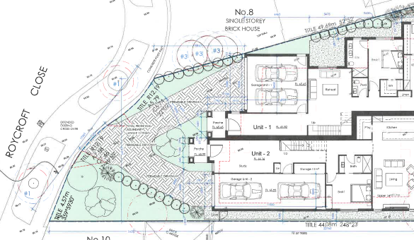
- The images below are included in the substituted plans and give an indication of the dwellings’ form and presentation.
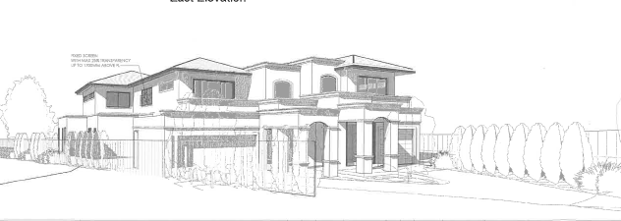
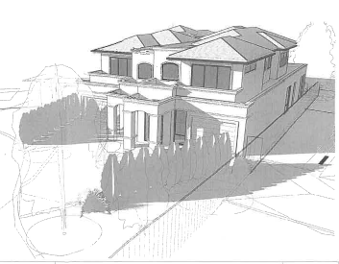
- The Council does not agree with the applicant’s submissions. Mr Turner submits the proposed development is inconsistent with the desired future character in terms of its integration with the streetscape, built form and design details. He submits:
- The proposal will not contribute to the leafy framework of well planted front gardens and canopy trees due to the limited amount of garden space available. Small side and rear setbacks cannot accommodate large canopy trees without compromising the usability of the space.
- The dominant form of the dwellings, with insufficient first floor recession, and lack of building separation and articulation, do not contribute positively to the streetscape or neighbourhood character.
- The extent of hard surface at the front of the site affects landscaping opportunities and there is insufficient landscaping to soften the built form from key view lines in the street.
- There is no opportunity to provide landscaping to soften the appearance of the dwellings from adjoining properties, particularly along the southern boundary; new landscaping opportunities are limited to the front and rear.
- As the Tribunal frequently states, meeting clause 55’s numerical standards is a relevant consideration in assessing the merits of the permit application. However, it does not guarantee a design that responds to specific local character features. I have referred to some of the key character features above as well as the preferred character sought by scheme policy.
- Elements of the proposed design are acceptable in principle. These include:
- The design concept that offers an impression of one house as seen from the street, rather than the oft-seen mirror image.
- The two storey presentation to the street, which responds to multiple two storey dwellings nearby.
- A contemporary design response including the materials and finishes.
- The lack of a front fence to maximise the opportunity for landscaping in the front garden so as to contribute to the neighbourhood character.
- The recessed garage positions, even though the garages occupy a significant portion of the building’s street façade.
- The protection of trees and vegetation on abutting lots.
- Despite this, I am persuaded by the Council’s submission that the proposal does not satisfy the purpose of clause 32.09 and neighbourhood character objectives in NRZ4, or Standard B1 and its objective at clause 55.02-1. This is for the reasons that I explain next.
- The subject land has a relatively narrow frontage to the court. The design provides one vehicle crossing. This responds to policy that seeks to minimise the loss of kerbside parking and green space, as well as avoid the hardening of the streetscape. Policy also seeks to ensure garages and associated elements do not dominate or visually disrupt the streetscape.
- Although the development includes a significant presentation of garaging, that is not the key issue given prominent and forward garages are a strong feature associated with many lots. Rather, the issue is the extent of paving associated with the two driveways. This is notwithstanding I accept the proposed landscape plan provides for several upper canopy trees in the front setback that should be able to grow to a significant height and that I also accept some wide driveways exist in the Close. The triangular area at the south-west offers a positive landscape contribution. But the balance of the front setback is essentially paved to accommodate the split driveways.
- The extent of hard surfacing on this modest frontage is compounded by the breadth of the development that, together, result in a development across the narrowest part of the site that is close to being from boundary-to-boundary and where it is doubtful that the development will have the soft quality preferred for this location. The building scale, mass and bulk substantially contrasts with other dwellings including the multi-unit sites. Trees and shrubs will not, in my view, adequately soften the junction between buildings as also desired for this area.
- While many houses in the street do not have planting along both side boundaries, there is an evident sense of space and separation. I am not persuaded that the proposal responds to the sense of building spacing and rhythm which is an apparent character feature in this location.
- The planting of canopy trees around the site, including side and rear boundaries, and along boundaries adjacent to neighbouring open space and in front setback areas, is a policy in clause 22.01-3, a consideration in NRZ4 and a component of policy in clause 22.05-3. The side setbacks are limited so as to facilitate this outcome. It is relevant that the landscape evidence is that canopy trees could be planted in the spaces available, however, Mr Thomson’s experience is that they are less likely to be retained in the long term because of concerns by neighbours and occupants with respect to overhanging canopies. Instead, the proposed planting is of modestly sized trees, that although potentially able to achieve 5 to 7 metres in height, do not facilitate an outcome that aligns with the desired future character statement.
- Overall, the substantial scale of these five bedroom homes is not sufficiently offset by opportunities for planting to provide the sufficiently generous garden character outcome sought by the scheme for this location.

ARE POTENTIAL OFF-SITE AMENITY IMPACTS ACCEPTABLE?

Visual bulk to neighbours
- The Council submits the proposal would present unreasonable visual bulk to adjacent properties, particularly to the south. The visual impact of the bulk and mass when viewed from surrounding properties adversely affects their amenity and does not accord with policy that planting of canopy trees should occur along boundaries with neighbouring open spaces.
- Mr Livingston disagrees. He submits the proposal achieves an acceptable interface given the conditions on abutting properties. He relies on the landscape evidence with respect to the vegetated interface that can be achieved. Mr Livingston also contends that the primary outlook for the dwelling to the south is eastwards, across the Valley, rather than north toward the subject land although no material was presented to verify the verandah layout or whether views can be obtained from the adjacent house.
- I have substantially addressed the matter of building bulk through the site, above. Having regard to the policy and scheme provisions referred to, I am unable to conclude that the scale and bulk of the double storey dwellings extending into the rear of the site, adjacent to single storey dwellings and the secluded private open space of No. 10 Roycroft Close, is appropriate and acceptable.
- It is relevant that the envelope contained in Standard B17 of clause 55 is met or exceeded. However, the envelope is a cross-section at a particular point along a boundary and takes no account of the length of the wall being measured. I agree with the Council’s concerns about the proximity of the two storey form adjacent to the secluded private open space to the south. The development extends well beyond the verandah and north-facing secluded private open space of the property to the south. There is less of an issue with respect to the interface with No. 8 Roycroft Close to the north, given the position of the garage, the side setback of the dwelling on this property, and the location of secluded private open space which is substantially unaffected by the proposed development.
- I note Mr Livingston’s submission about the potential for properties to gain views to the Dandenong Ranges from this location. This was in the context of a primary outlook for the property to the south being to the east, rather than toward the subject land. However, as I noted at the hearing, aside from the fact that the specific circumstances of this dwelling to the south and its verandah were unknown, the proposal includes screening to upper-level windows that could otherwise enjoy any long distance views (should they be possible). Mr Livingston submits that this could be addressed by a different form of screening device. I accept that may be possible, however, it also appears to me that the design response has not particularly had regard to such an opportunity should it exist.

Loss of daylight to adjacent habitable room windows
- This concern is raised in the statement of grounds by the owner of No. 8 Roycroft Close. I accept the assessment made by both the Council and applicant that Standard B19 in clause 55 is met.

Shadowing of solar panels at No. 10 Roycroft Close
- Mr Livingston addressed this matter in his submission, although it is not raised in either the Council’s grounds or in the grounds filed by the non-party in this proceeding. I am not certain that the property at No. 10 Roycroft Close has solar panels, as the aerial photograph is unclear. The roof top elements could be skylights. Even if they are solar panels, I agree with Mr Livingston that there is not a significant impact as a consequence of the proposed development. Given the roof height, and shadowing information before me, it is unlikely that the proposal will have an unreasonable impact on the panels’ performance.

Overlooking to neighbours
- The Council suggests screening is required to several windows in the development, to limit overlooking to abutting lots. This is addressed on the plans.

Tree protection
- The parties agree that the protection of trees on abutting properties can be addressed through permit conditions.

What is the Tribunal’s conclusion?
- For the above reasons, I will affirm the responsible authority’s decision.
- I am not persuaded that the design response sufficiently respects the neighbourhood character and it will not positively contribute to the desired future character. It fails when assessed under clauses 32.09 and 55, with compounding adverse visual bulk impacts. This is not a location where the proposal’s contribution to housing diversity and consolidation outweigh its failure to achieve acceptable character and amenity outcomes.

Margaret Baird
Senior Member

The zoning is shown in the property report extract.
No permit is triggered under clause 42.02.
I have considered the submissions of all parties, all written and oral evidence, all exhibits tendered by the parties, and all statements of grounds filed. I do not recite or refer to all of the contents of those documents in these reasons. Orders to substitute plans were made at a Practice Day Hearing.
Nearmaps image.
This predates the current planning controls that apply to the land, post Amendment C125.
This is not a full list. It excludes, among other things, the last set of decision guidelines because, even though it is an irregular lot, the proposal meets the varied Standard B17.
Clause 22.01.
Clause 22.13 is a relevant policy relating to environmental sustainability. The proposal is not of the type listed in Table 1.
Clause 22.01-2.
The Council takes no issue with swept path diagrams showing how vehicles can access and egress the two driveways. It may be arguable that the layout meets the purpose of clause 52.06 to “ensure that the design and location of car parking is of a high standard, creates a safe environment for users and enables easy and efficient use”. I have not explored this further.
I make this finding even if I accept that the varied Standard B13 is met.
Global Alpha Group Pty Ltd v Boroondara CC [2013] VCAT 1929 at [39].

