VICTORIAN CIVIL AND ADMINISTRATIVE TRIBUNAL
planning and environment LIST | vcat reference No. P717/2020  Permit Application no. TPA/50512
CATCHWORDS
Monash Planning Scheme; General Residential Zone, Schedule 2; Two double-story dwellings plus basement; Neighbourhood character; Car parking.

APPLICANT | Likos Investments Pty Ltd
responsible authority | Monash City Council
SUBJECT LAND | 37 Woonah Street  CHADSTONE VIC 3148
HEARING TYPE | Hearing
DATE OF HEARING | 4 March 2021
DATE OF ORDER | 20 April 2021
CITATION | Likos Investments Pty Ltd v Monash CC [2021] VCAT 370

Order

Amend permit application
- Pursuant to clause 64 of Schedule 1 of the Victorian Civil & Administrative Tribunal Act 1998, the permit application is amended by substituting for the permit application plans, the following plans filed with the Tribunal:
- Prepared by: | Roke Design Studios
- Drawing numbers: | TP01-TP11, Issue No. TP-22
- Dated: | 16/10/2020

Permit granted
- In application P717/2020 the decision of the responsible authority is set aside.
- In planning permit application TPA/50512 a permit is granted and directed to be issued for the land at 37 Woonah Street, Chadstone in accordance with the endorsed plans and the conditions set out in Appendix A. The permit allows:
- Construction of two dwellings on a lot in the General Residential Zone, Schedule 2.

Judith Perlstein
Member

Appearances
For applicant | Robert Williams, planner of Human Habitats Pty Ltd  Dimitri Likopoulos of Likos Investments Pty Ltd.
For responsible authority | James Turner, planner of Monash City Council.

Information
Description of proposal | Construction of two double-storey dwellings with basement.
Nature of proceeding | Application under section 77 of the Planning and Environment Act 1987 – to review the refusal to grant a permit.
Planning scheme | Monash Planning Scheme
Zone and overlays | General Residential Zone, Schedule 2 (GRZ2).
Permit requirements | Clause 32.08-6 - construction of two dwellings on a lot in the GRZ2.
Relevant scheme policies and provisions | Clauses 11, 15, 16, 21.02, 21.04, 22.01, 32.08, 52.06, 55, 65 and 71.
Land description | The subject site is located on the north side of Woonah Street, opposite Margot Street, with the rail reserve to its north.  It is rectangular in shape, with a frontage of 15.24 metres, a depth of 38.75 metres and a total area of 590.6 square metres.  A 1.83 metre wide easement runs along the rear boundary of the site.  The site is currently vacant with an existing vehicle crossing at the western end of the frontage. To its east are two double-storey dwellings recently constructed in a tandem arrangement and to its west is an original single dwelling.  An aerial image of the subject site is included below.
Tribunal inspection | Following the hearing, I undertook an unaccompanied inspection of the subject site and surrounding area.
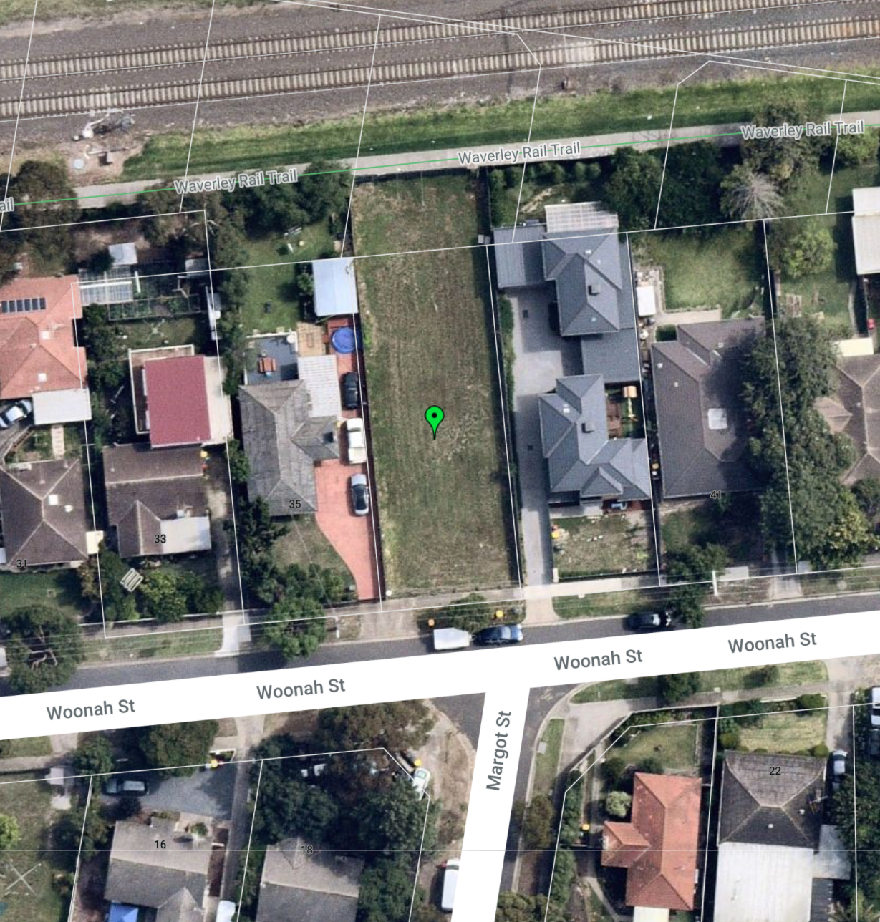

Reasons

What is this proceeding about?
- The applicant proposes to develop two double-storey dwellings in a side by side arrangement on the subject site, with a basement garage provided via a single crossover to provide parking for both dwellings.
- The council determined to refuse to grant a permit for the following reasons:
1. The proposal is inconsistent with neighbourhood character objectives of Clause 55.02-1 of the Monash Planning Scheme.
2. The proposal is inconsistent with design detail objectives of Clause 55.06-1 of the Monash Planning Scheme.
3. The proposal is inconsistent with Clause 22.01 (Residential Development and Character Policy) of the Monash Planning Scheme.
4. The proposal is an inappropriate design response having regard to neighbourhood character and residential policy.
5. The proposed design would not allow for the overall development to comply with the landscaping objectives of Clause 55.03-8 of the Monash Planning Scheme.
6. The proposal does not comply with the design standards contained in Clause 52.06-9 of the Monash Planning Scheme as there is a reliance on reversing into garages and corrective manoeuvres, and the basement ramp is not provided with transition grades at either ends of the ramp.
7. There is over-reliance on screening of windows which reduces internal amenity for future residents.
8. The proposal does not provide sufficient daylight to all new ground floor habitable room windows in accordance with the objectives of Clause 55.05-3 of the Monash Planning Scheme.
9. The dwelling entries do not comply with the objective of Clause 55.05-2 of the Monash Planning Scheme.
- Prior to the Tribunal hearing, amended plans were circulated which have now been substituted for the application plans. These plans sought to address some of the council’s concerns and have successfully done so. The council confirmed at the commencement of the hearing that it no longer relies on grounds 2 and 8 and is satisfied that the basement ramp is now provided with transition grades and therefore relies only on the first part of ground 6. The council, in its submissions, also did not pursue ground 5.
- The applicant contests the grounds of refusal and considers that the proposed development is site responsive and represents an appropriate form of development in the well-serviced Chadstone area.
- I must determine whether the development provides an acceptable response to its built form and policy contexts, whether it imposes unacceptable amenity impacts on its neighbours and whether it provides acceptable amenity for its future residents.
- I must decide whether a permit should be granted and, if so, what conditions should be applied. Having considered the site context and the submissions presented with regard to the applicable policies and provisions of the Monash Planning Scheme (Scheme), I have decided to set aside the decision of the responsible authority and direct that a permit be granted. My reasons follow.

Does the development provide an acceptable responce to its built form and policy contexts?

The proposal and site context
- The proposal is to construct two double-storey dwellings in a side by side configuration with a basement car park. The basement is to be accessed by a ramp on the western side of the frontage in the location of the existing crossover and the building has been designed to be set back from both side boundaries with an appearance similar to that of a single dwelling. The street view of the proposal is included below.
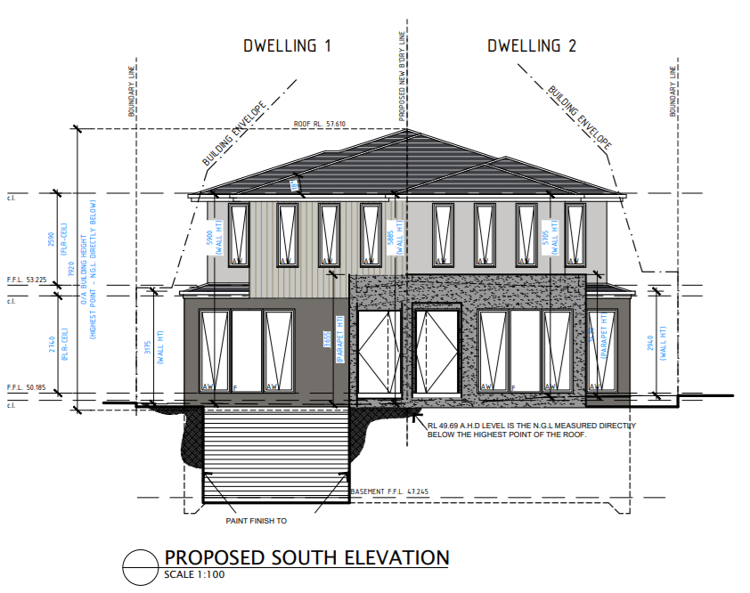
- The maximum height of the dwellings is 7.935 metres and the site coverage is 49.32% with a garden area of 44%. Two car spaces and storage for each dwelling are provided in the basement, with stairs leading up to the ground floor. A guest bedroom and living, kitchen dining areas are located at the ground floor of each dwelling with the living area opening to a north facing deck and secluded private open space. Three bedrooms and two bathrooms are provided for each dwelling at first floor.
- The site is well located in terms of access to facilities, services and transport.
- The surrounding residential area comprises a mix of original single-storey dwellings and newer dwellings, including predominantly double-storey dwellings and multi-dwelling developments with many double-storey dwellings in a tandem configuration. However, there are also examples of side by side double-storey dwelling developments in the neighbouring streets, often with two crossovers to the street.

The planning scheme context
- The site is located in the General Residential Zone, Schedule 2 (GRZ2). A permit is required to construct two or more dwellings on a lot and the schedule includes variations to the clause 55 requirements of street setback, private open space and front fence height. All of these varied requirements are met by the proposal and there are no overlays affecting the site.
- The purpose of the GRZ2 includes encouraging development that respects the neighbourhood character and encouraging a diversity of housing types and housing growth in locations offering good access to services and transport.
- Clause 21.04 and 22.01 of the Scheme provide guidance as to the development objectives of the council with respect to different areas of the municipality. Within clause 21.04, the site is included in Category 2 – Accessible Areas, and within clause 22.01, in Garden City Suburbs (Northern).
- Accessible areas are nominated as areas with future development potential, subject to a consideration of the character of the neighbourhood, as expressed in clause 22.01.
- The preferred future character statement applicable to the subject site is reproduced below. A significant proportion of land within the municipality is included within the Garden City Suburbs Northern area.
Although there will be changes to some of the houses within this area, including the development of well-designed and sensitive unit development and, on suitable sites, some apartment development, these will take place within a pleasant leafy framework of well-vegetated front and rear gardens and large canopy trees.
Setbacks will be generous and consistent within individual streets. Building heights will vary between neighbourhoods. Neighbourhoods with diverse topography and a well-developed mature tree canopy will have a larger proportion of two storey buildings. In the lower, less wooded areas, buildings will be mainly low rise unless existing vegetation or a gradation in height softens the scale contrast between buildings. New development will complement the established buildings through consistent siting, articulated facades and use of materials.
New development will consider energy efficiency and sustainability principles. Long expanses of blank wall will be avoided, particularly when adjacent to public parks, reserves and other open space areas, where the building should address the public area.
Architecture, including new buildings and extensions, will usually be secondary in visual significance to the landscape of the area when viewed from the street. New development will be screened from the street and neighbouring properties by well planted gardens that will ensure the soft leafy nature of the street is retained.
Gardens will consist of open lawns, planted with a mix of native and exotic vegetation and trees. Existing mature trees and shrubs will be retained and additional tree planting within streets and private gardens will add to the tree canopy of the area.
Buildings will be clearly visible through these low garden settings, and nonexistent or transparent front fences. Additional vehicle crossovers will be discouraged.
The built-form will be visually unified by well-planted front gardens that contain large trees and shrubs and street tree planting. Trees within lots to be redeveloped will be retained wherever possible to maintain the established leafy character.
Landscape elements such as remnant indigenous vegetation and the large old coniferous wind-rows will be retained until trees are no longer healthy or safe.
- The following relevant context was also raised by the applicant:
Based on the Residential Framework Map in Clause 21.04 the Holmesglen Neighbourhood Activity Centre area extends east approximately to Collins Street. The subject site is within approximately 300 metres of the Activity Centre area and forms part of this transition to the Garden City Suburbs area further east on the other side of Power Avenue.
Greater density, change and diversity of housing is encouraged in this location, balanced by need to respond to character of the area.

Tribunal consideration
- This council has, over many years, clearly established the priorities for the municipality and championed the concept of the garden city character. It is well understood that Monash City Council highly values the vegetation found in both public and private space and considers that space for provision of landscaping should be maximised in a development site, particularly in front and rear setbacks.

- Where two or more dwellings are proposed on a site, the council has consistently expressed a clear preference for dwellings to be sited one behind the other in order to use only one crossover for vehicular access, thereby minimising space within the frontage for hard surface and maximising opportunities for landscaping.
- Consistent with the council policy, this proposal includes only one crossover. However, the design proposes a side by side dwelling arrangement with a shared basement and single ramp access to that basement. The consequence of this is that the rear private open space and living areas of both dwellings face north and will benefit from maximum sunlight. The rear of the site also faces a railway reserve rather than built form, providing unobstructed light to the private open space.
- This design has taken the council’s preference for a single crossover but has provided it within a form that allows two dwellings directly facing the street. While the council submitted that this is unusual and inconsistent with the neighbourhood character of the area, the applicant brought several examples of similar development within the neighbouring streets.
- Where this proposal is distinguishable from the other examples brought is the introduction of the single basement ramp which allows space for planting within the front setback and does not require a second crossover or two garages within the dwelling frontage. While I agree with the council that a basement ramp is not a design feature of the area, respect for neighbourhood character does not mean that new design elements cannot be introduced into the neighbourhood.
- Aside from the basement ramp, this proposal, with its pitched roof form, maximum height below 8 metres, lack of front fencing, setbacks from both side boundaries and minimum front setback of 7.6 metres is generally consistent with the zone requirements and local policy and with other newer dwellings in the locality. The introduction of the basement allows for greater landscaping and less hard paving throughout the site than is generally required for multi-dwelling developments.
- The design of the dwellings, through the combined roof form, shared porch area and single driveway access, respects the detached character of dwellings found within the streetscape. The built form and bulk of the proposal is also similar to that of other double-storey dwellings in the vicinity of the site, including those on the adjoining site to the east.
- I note that the council referred to the following policy in clause 22.01-3 under the heading ‘site coverage and permeability’:
Exclude hard paving such as car parking, turning circles, driveways and basement car parking within street setback areas.

- There is a difficulty that arises if this policy statement is read on its own. It appears to say that any form of car parking ought to be avoided on a site. Rather than focussing on this statement on its own to find that basement car parking is not appropriate, I prefer to read it in the context of the policy statements directly above and below that statement, being:
Ensure the extent of site coverage and hard paving respects the neighbourhood character.
Minimise hard paving throughout the site by limiting driveway widths and lengths, providing landscaping on both sides of driveways, and restricting the extent of paving within open space areas
- I find that, when considering the entirety of the policy, the provision of a basement car park within this development is consistent with the intent of council policies concerning site coverage and permeability.
- In terms of the landscaping and open space areas provided by the proposal, as shown below, I find that they will contribute to the landscaped character of the area and that the rear, north-facing, private open spaces provided for each dwelling will provide a good amenity outcome for future residents.
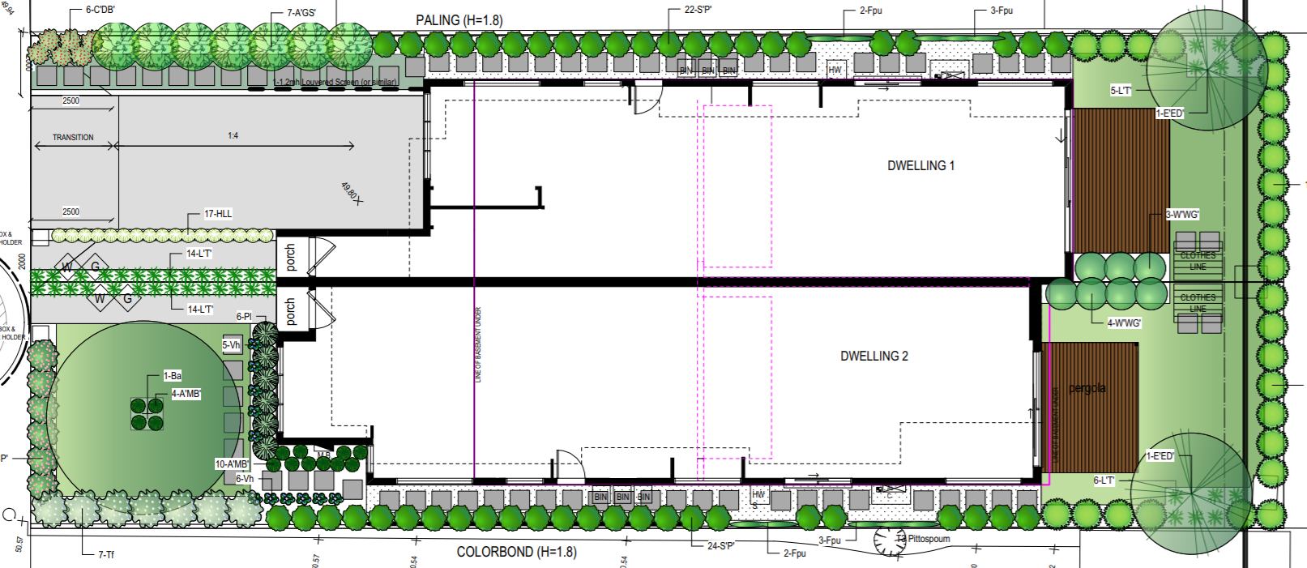
- There was discussion during the hearing about whether some of the upper level windows shown as screened could be unscreened. I have not amended the screening as shown on the plans because neighbouring properties who were not party to the hearing may have relied on that screening to inform their decision not to object to the application.
- I have, however, included a condition requiring consideration of alternative methods of screening that could retain views and openness for future residents while limiting overlooking of neighbouring properties. This could be achieved, for example, by fixed external panels or louvres rather than opaque glazing.
- I do not share the council’s concern that the dwelling entry objective and standard of clause 55.05-2 is not met. Although the doorways to the two dwellings are located next to each other, they are each proposed to have their own pedestrian pathway and porch area and separate spaces for letter boxes. I am satisfied that each dwelling will have its own sense of identity.
- I find that the proposal provides an acceptable response to the Scheme and site context, would not impose unacceptable amenity impacts on neighbouring residents and would provide acceptable amenity for future residents.

Would car parking and access be acceptable?
- The council submitted that the car parking provided is ‘inadequate and unreasonably awkward’. The swept path diagrams initially submitted with the application were not revised with the amended application plans and, therefore, the changed access to the basement had not been considered in the form of swept path diagrams. Following the hearing, new swept path diagrams were prepared to reflect the basement access as shown in the substituted plans. These confirmed that access was maintained to each garage and vehicles could adequately enter and exit the basement.
- Although vehicles will require corrective manoeuvres, including reversing, to enter and exit the spaces, these manoeuvres are acceptable in a residential basement garage with four car spaces serving only two properties. Vehicles can comfortably enter and exit the basement in a forward direction and there is sufficient room within the basement garage to perform the vehicle movements required.
- I find that the car parking and access is acceptable.

What conditions are appropriate?
- In determining the conditions of permit, I have had regard to the draft conditions discussed at the hearing and the submissions of the parties as well as the matters arising from my reasons above.

Conclusion
- For the reasons given above, the decision of the responsible authority is set aside. A permit is granted subject to conditions.

Judith Perlstein
Member

Appendix A – Permit Conditions

Permit Application No: | TPA/50512
Land: | 37 Woonah Street  CHADSTONE VIC 3148

What the permit allows
In accordance with the endorsed plans:
- Construction of two dwellings on a lot in the General Residential Zone, Schedule 2.

Conditions:
- Before the development starts, amended plans to the satisfaction of the Responsible Authority must be submitted to and approved by the Responsible Authority. The plans must be drawn to scale and dimensioned. When the plans are endorsed they will then form part of the Permit. The plans must be generally in accordance with the amended plans submitted to Council prepared by Roke Design Studio, Sheets 1-11, Revision TP-22 and dated 16.10.2020 but modified to show:
  - Corner splay notation updated to state: “Provision of a corner splay or area at least 50% clear of visual obstructions (or with a height of less than 1.2 metres), which may include adjacent landscaping areas with a height of less than 0.9 metres, extending at least 2.0 metres long x 2.5 metres deep (within the property) both sides or from the edge of the exit lane of each vehicle crossing to provide a clear view of pedestrians on the footpath of the frontage road.”
  - Street tree protection fence in accordance with Condition 5.
  - The correct private open space area in accordance with the plan titled sheet 12 of 12, proposed dwelling one POS, dated 3 March 2021.
  - If possible, revised screening treatment to upper level windows, in particular those facing north, to provide for views for future residents while still meeting the requirements of Standard B22 in clause 55.04-6 of the Monash Planning Scheme.
- The development as shown on the endorsed plans must not be altered without the written consent of the Responsible Authority.

- Concurrent with the endorsement of any plans pursuant to Condition 1, a landscape plan prepared by a Landscape Architect or a suitably qualified or experienced landscape designer, drawn to scale and dimensioned must be submitted to and approved by the Responsible Authority. When endorsed, the plan will form part of the Permit. The Landscape Plan must be generally in accordance with the Landscape Plan dated October 2020, Prepared by Zenith Concepts Landscape Design, except that the plan must show:
  - Street tree protection fence in accordance with Condition 5.
- Before the occupation of the buildings allowed by this permit, landscaping works as shown on the endorsed plans must be completed to the satisfaction of the Responsible Authority and then maintained to the satisfaction of the Responsible Authority.
- Before any development (including demolition) starts on the land, a four-sided tree protection fence must be erected around the street tree to define a "Tree Protection Zone" at a distance of at least 2.5m measured from the trunk face. The tree protection fence must remain in place until all construction is completed on the land, except with the prior written consent of the Responsible Authority.
- A plan detailing the drainage works must be submitted to the Engineering Division prior to the commencement of works. The plans are to show sufficient information to determine that the drainage works will meet all drainage requirements of this permit.
- All stormwater collected on the site from all hard surface areas must not be allowed to flow uncontrolled into adjoining properties or the road reserve.
- The nominated point of stormwater connection for the site is to the north-west corner of the property where the entire site's stormwater must be collected and free drained to the Council 225mm pipe located within the rear easement of via a 900x600mm junction pit to be constructed to Council standards. Note: If the point of connection cannot be located then notify Council's Engineering Department immediately.
- Once the development has started it must be continued and completed to the satisfaction of the Responsible Authority.

- In accordance with section 68 of the Planning and Environment Act 1987, this permit will expire if one of the following circumstances applies:
  - The development is not started before 2 years from the date of issue.
  - The development is not completed before 4 years from the date of issue.
In accordance with section 69 of the Planning and Environment Act 1987, the responsible authority may extend the periods referred to if a request is made in writing before the permit expires, or.
  - within six (6) months afterwards if the development has not commenced; or
  - within twelve (12) months afterwards if the development has not been completed.
Council and the Victorian Civil and Administrative Tribunal are unable to approve requests outside of the relevant time frame.

- End of conditions -

From www.nearmap.com.au, taken on 22 January 2021.
The submissions of the parties, any supporting exhibits given at the hearing, and the statements of grounds filed; have all been considered in the determination of the proceeding. In accordance with the practice of the Tribunal, not all of this material will be cited or referred to in these reasons.
In the written submissions of the applicant, at [21-22].

