VICTORIAN CIVIL AND ADMINISTRATIVE TRIBUNAL
planning and environment LIST | vcat reference No. P449/2021  Permit Application no. TPA/51675
CATCHWORDS
Application under section 77 of the Planning and Environment Act 1987; Review the refusal to grant a permit; Monash Planning Scheme; General Residential Zone – Schedule 3; Two additional dwellings; Neighbourhood character; Internal amenity; Car parking location.

APPLICANT | George Ikosidekas
responsible authority | Monash City Council
RESPONDENT | Raymond Short
SUBJECT LAND | 14-16 Legon Road Oakleigh South
HEARING TYPE | Hearing
DATE OF HEARING | 4 August 2021
DATE OF ORDER | 19 October 2021
CITATION | Ikosidekas v Monash CC [2021] VCAT 1234

Order

Amend name
- Pursuant to section 127 of the Victorian Civil and Administrative Tribunal Act 1998 the application is amended by changing the name of the applicant to:
George Ikosidekas

Amend permit application
- Pursuant to clause 64 of Schedule 1 of the Victorian Civil & Administrative Tribunal Act 1998, the permit application is amended by substituting for the permit application plans, the following plans filed with the Tribunal:
- Prepared by: | Ikonomidis Design Studio
- Job number: | 00241
- Drawing numbers: | TP04-TP07
- Revision reference: | Revision J Traffic Engineer Design
- Dated: | June 21

No permit granted
- In application P449/2021 the decision of the responsible authority is affirmed.
- In planning permit application TPA/51675 no permit is granted.

Sarah McDonald
Member

Appearances
For applicant | Dominic Scally, Best Hooper Lawyers.  He called the following witnesses:  - Russell Fairlie, traffic engineer,  Ratio Consultants Pty Ltd.  - Rob Thomson, landscape architect,  Habitat landscape and environmental design consultants.
For responsible authority | Peter English, town planner, Peter English & Associates Pty Ltd.
For respondent | Raymond Short, in person.

Information
Description of proposal | Construction of two additional dwellings on land currently occupied by five dwellings, and associated car parking and fencing.
Nature of proceeding | Application under section 77 of the Planning and Environment Act 1987 – to review the refusal to grant a permit.
Planning scheme | Monash Planning Scheme.
Zone and overlays | General Residential Zone–Schedule 3 (GRZ3).
Permit requirements | Clause 32.08-6: To construct two or more dwellings on a lot in the GRZ3.
Relevant scheme policies and provisions | Clauses 11, 15, 16, 21.01, 21.04, 22.01, 22.05, 32.08, 52.06, 55, 65, and 71.
Land description | The review site is located on the western side of Legon Road. The rear of the site has a secondary frontage to Olinda Grove to the east. The site is rectangular, with a frontage to Legon Road of 30.48 metres, a depth of 40.69 metres, and an overall area of 1240 square metres. The extent of the eastern boundary that has frontage to Olinda Grove is approximately 11 metres. Five, single-storey ‘villa unit’ type dwellings occupy the site.  Figure 1: Review site and surrounding context  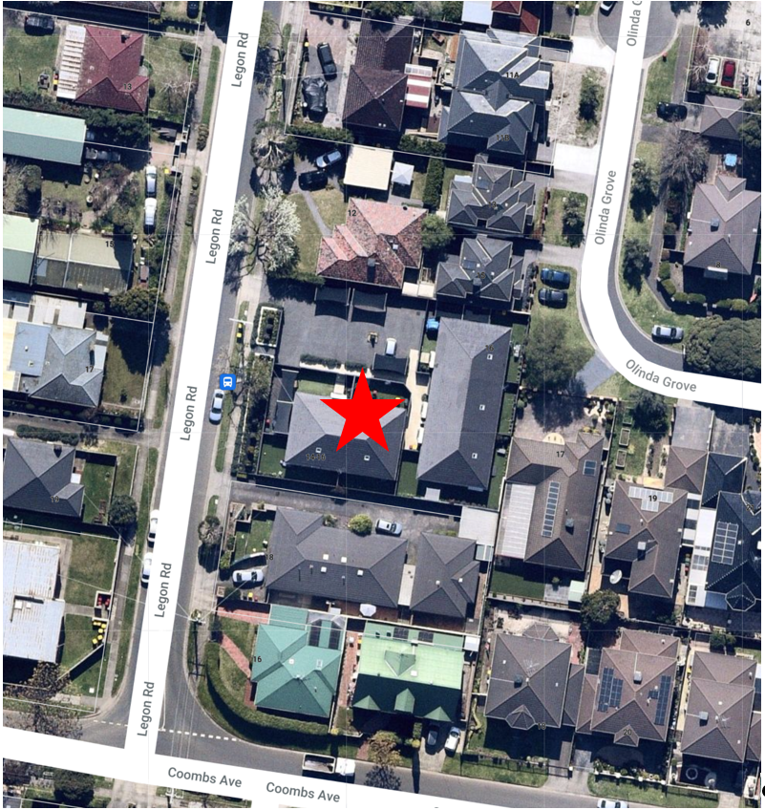

Reasons

What is this proceeding about?
- George Ikosidekas (the applicant) is seeking a planning permit to develop two additional dwellings on the land at 14-16 Legon Road, Oakleigh South (the review site). There are currently five, single-storey dwellings on the site.
- The proposal is to retain the five existing dwellings and to construct two additional dwellings over the area currently occupied by an open-air communal car park. The proposed dwellings are to be on a single level at first floor level above the communal car park.
- The Monash City Council (the Council), as the responsible authority, has refused to grant a planning permit for the proposal.
- Its grounds of refusal relate to matters of neighbourhood character, internal amenity, off-site amenity impacts, and failure to comply with objectives and standards of clause 55 of the Monash Planning Scheme (the Scheme).
- Mr Ikosidekas has sought this review of the Council’s decision.
- Raymond Short (the respondent) is a resident of a dwelling on the adjoining property to the north of the review site (12 Legon Road). Mr Short objected to the permit application and is a respondent in this application for review. Mr Short objections to the proposal relate to traffic and car parking, overdevelopment, privacy, noise, and structural impacts on his dwelling.
- At the hearing the applicant sought to substitute amended plans for the permit application plans. The amended proposal includes alterations to the car parking layout, including a new vehicle access to Olinda Grove, and changes to the car parking arrangements. There being no objection from the other parties, I substituted the amended plans for the permit application plans. It is on these plans that this decision is based.
- Despite the amended plans the Council and Mr Short maintain their opposition to the proposal but consider some of their concerns have been addressed. The Council no longer has concerns about the vehicle movements in the under-croft car park, and Mr Short’s concerns about overlooking have been addressed.
- However, as a result of the amended plans the Council relies on an additional ground of refusal relating to the proposed vehicle access from Olinda Grove to the new car parking space to be created for the existing unit 5. The additional ground relates to the angle of the proposed vehicle access in Olinda Grove and the impact of this vehicle access on the existing street tree.
- The Council’s submissions include, in summary:
- The proposal simply seeks to fit too much onto the vacant area of site, with a more appropriate outcome potentially being a single dwelling within this vacant area.
- The proposal is contrary to the neighbourhood character and associated policies. The Council’s concerns relate to the transition to the single storey scale of neighbouring dwellings, the setback and articulation of front facade of the proposed new building, the garages not being recessed from the building facade, the building on the side boundary, and the extent of hard paving and car parking visible from the street.
- The proposal reduces the visibility and sense of address to all of the dwellings apart from unit 5.
- The extent of screening to proposed unit 7 results in internal amenity issues.
- The extent of the proposed building footprint limits the opportunity to provide a landscape outcome consistent with Council policy.
- The proposed driveway to the new car spaces for unit 5 is an awkward alignment and too close to the existing street tree.
- The submissions for Mr Ikosidekas in support of the application include, in summary:
- Council’s grounds do not raise issue regarding strategic planning considerations indicate the proposal is not controversial and reflects the proposal’s response to boarder planning policy objectives which concern the use and development of urban sites such as this.
- Council’s criticisms have failed to acknowledge the existing site conditions and improvements the proposal will result by way of landscaping and built form.
- The car parking will be concealed from the street, which will be an improvement on the current conditions which are characterised by expanses of hardstand parking areas.
- The proposal meets standard B6 (at clause 55.03-1) regarding the setback from the front street.
- The landscaping in the plan prepared by Mr Thomson will meet the location variation to standard B13 (at clause 55.03-8 (Landscaping objectives)),
- The proposal represents an acceptable planning outcome regarding neighbourhood character considerations.
- The proposed building setbacks from the northern side boundary is consistent with the location variation to standard B17 (at clause 55.04-1).
- The application is fully compliant regarding carparking for both residents and visitors.
- The layout and design of the car parking meets the Australian Standard.
- In support of the application, the submissions for Mr Ikosidekas rely on the evidence of:
- Mr Robert Thomson in relation to landscaping; and
- Mr Russell Fairlie in relation to traffic and parking.

What are the key issues?
- Based on the submissions and statements of grounds, and the relevant policies and provisions of the planning scheme, I consider the key issues to be resolved are:
- Is the front facade of the proposed building acceptable in the streetscape and policy context?
- Does the proposal provide acceptable landscaping opportunities?
- Are the car parking spaces within the front setbacks of Legon Road and Olinda Grove acceptable?
- Will the internal amenity of unit 7 be acceptable?
- Does the proposal provide acceptable dwelling entries to the existing and proposed dwellings?
- The Tribunal must decide whether a permit should be granted and, if so, what conditions should be applied. In doing so, I must consider whether the proposal will produce ‘acceptable outcomes’, rather than optimal or preferable outcomes, in relation to the relevant policies and provisions of the planning scheme.

What are the details of the existing conditions and proposed development?
- The five existing dwellings currently occupying the review site comprise single-storey, ‘villa unit’ type dwelling. The dwellings are arranged in two blocks forming an L shape. Units 1 and 2 extend along the southern side of the site, and units 3–5 extend along the western side. Carparking is currently provided in an open area in the north-western portion of the site, in the setback area of unit 1 from Legon Road (two spaces), and in the northern side setback of unit 5 (one space). Vehicle access is currently only from Legon Road.
- The application proposes to retain the existing dwellings and construct two additional dwellings in a new building built over the existing communal car park. The proposed dwellings are on a single level at first floor level above the communal car park. The car parking will be rearranged to accommodate five car parking spaces in this area. A garage door in the front wall of the new building will enclose the car park along its street frontage.
- The proposed new unit 6 forms the western half of the first floor level of the new building. Unit 6 faces and has its dwelling entry to Legon Road. Proposed new unit 7 forms the eastern half of the first floor level of the new building. Its pedestrian entry is via a door in the southern side of the building. It is accessed from the pedestrian pathway that provides access to the existing units 1–5. Each of the proposed dwellings comprise two bedrooms. Units 6 and 7 each have a balcony for their outdoor private open space. The balcony to unit 6 faces Legon Road, while the balcony to unit 7 is on the northern side of that dwelling.
- Unit 5 is to be altered to reorient its ‘front’ entry to the Olinda Grove frontage.
- The amended proposal includes alterations to the existing car parking layout. The existing car parking for unit 1 is to be removed and one new car space provided in the south-western corner with a new vehicle access to Legon Road. The car parking space for unit 5 is to be relocated to the Olinda Grove frontage, with a new vehicle access to Olinda Grove. One visitor car parking space is to be created between the front of the new building and Legon Road.

Figure 2: Site/Ground floor layout
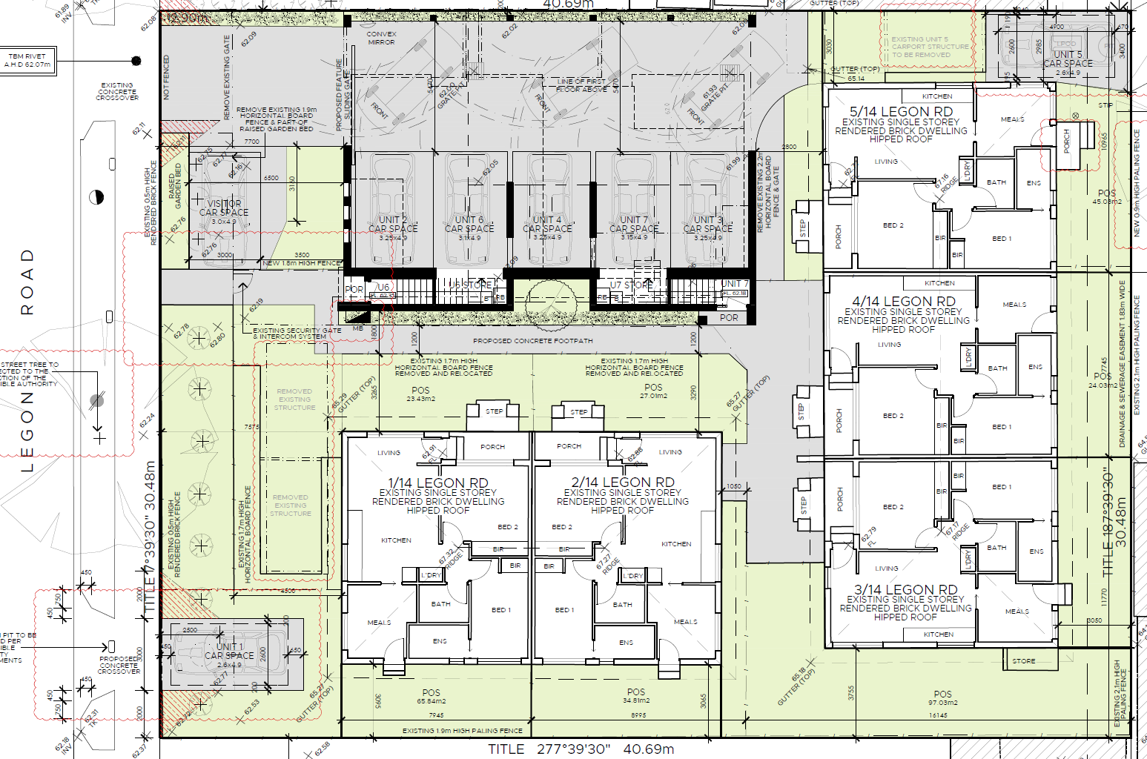

Figure 3: First floor plan
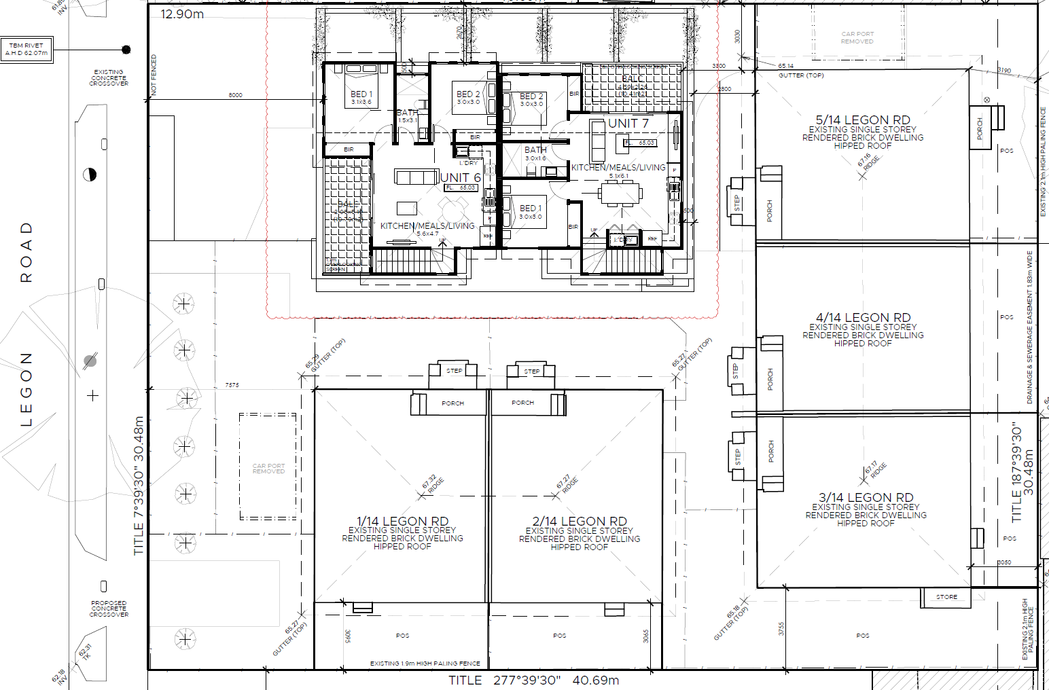

Figure 4: West elevation / Legon Road frontage
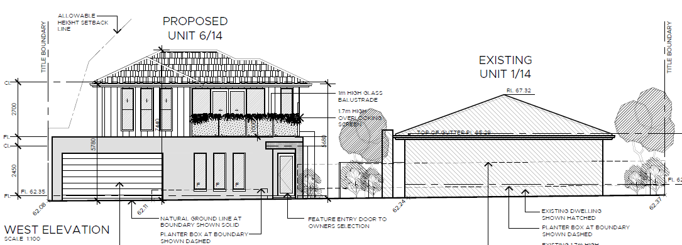

What is the relevant Planning context and key facts of the case?
- I have been provided with a detailed description of the review site and its environs, the proposal, and the relevant policies and provisions of the Scheme. It is not necessary for me to repeat that material other than to record the following policies and provisions of particular relevance to the key issues.
- The review site is within the ‘Category 8 – Garden City Suburbs’ area under the local Residential Development Framework at clause 21.04. The Category 8 – Garden City Suburbs areas are identified as areas suitable for ‘incremental change’.
- The review site is zoned General Residential Zone – Schedule 3, Garden City Suburbs (the GRZ3). A planning permit is required for the proposal under clause 32.08-6 to construct two dwellings. The purpose of the GRZ3 seeks, as relevant:
To implement the Municipal Planning Strategy and the Planning Policy Framework.
To encourage development that respects the neighbourhood character of the area.
To encourage a diversity of housing types and housing growth particularly in locations offering good access to services and transport.
- The neighbourhood character objectives of the GRZ3 are:
To support new development that contributes to the preferred garden city character through well landscaped and spacious gardens that include canopy trees.
To promote the preferred garden city character by minimising hard paving throughout the site by limiting the length and width of accessways and limiting paving within open space areas.
To support new development that minimises building mass and visual bulk in the streetscape through generous front and side setbacks, landscaping in the front setback and breaks and recesses in the built form.
To support new development that locates garages and carports behind the front walls of buildings.
- The maximum building height for dwellings in the GRZ3 is 11 metres and three storeys. The GRZ3 schedule includes local variations to the siting and design standards of clause 55. As relevant to the key issues in dispute, these include the minimum street setback standard B6, the landscaping standard B13, and side and rear setbacks standard B17.
- The GRZ3 schedule also includes decision guidelines which must be considered as appropriate. These are:
- Whether the development provides an appropriate transition to built form on adjoining sites.
- The robustness of proposed materials and finishes.
- The impact of the shape and dimensions of the lot on the ability of the development to meet any requirements of this schedule.
- The location and number of vehicle crossovers.
- The impact of the development on nature strips and street trees.
- The location, quantity and species of vegetation provided.
- Under the local ‘Residential Development and Character Policy’ at clause 22.01, the review site is in the ‘Garden City Suburbs (Southern)’ character area. The preferred future character statement for the Garden City Suburbs (Southern) area includes:
Modest dwellings with simple pitched rooflines and articulated facades will continue the prevailing development themes. On larger sites, low rise apartment development may be appropriate, provided the development is sited within generous open space, is well landscaped, retains the ‘open landscape character’ of the garden suburban setting and tapers down in scale closer to the boundaries of the site.
While the housing mix within this area will continue to evolve to meet the changing needs of the community, new development will complement the scale and siting of the original housing within the area. In doing so, it will enhance the generous spacious, open, landscaped character of the area.
This character area will be notable for its spacious garden settings, tall canopy trees, consistency in front setbacks and the maintenance of setbacks from at least one boundary and from the rear of the site. New dwellings will address the street and upper levels will be recessed and/or articulated to minimise the impression of building scale.
Front fences will be low to enable vegetation to be visible from the street, allow clear views of buildings and give the street an open quality. Fencing will complement the architecture of the building in design, colour and materials.
Existing mature trees and shrubs within properties should be retained and additional tree planting proposed to gradually create a tree canopy in the private domain, including at the rear of properties. This will create a visually permeable buffer between the house and street. The soft quality of the street that is derived from the wide nature strips and street tree planting will be maintained by ensuring that there is only one crossover per lot frontage.
Expanses of blank, or continuous, walls will be avoided, particularly when adjacent to public parks or creating the appearance of a continuous building mass ……
- The policy at clause 22.01-3 includes general policies as well as policies specific to street setback, landscaping, side and rear setbacks, fences, vehicle crossings, built form and scale of development, and car parking, among other things. I have had regard to these in reaching my findings.
- The local ‘Tree Conservation Policy’ at clause 22.05, seeks:
- To maintain, enhance and extend the Garden City Character throughout Monash by ensuring that new development and redevelopment is consistent with and contributes to the Garden City Character as set out in the Municipal Strategic Statement.
- To promote the retention of mature trees and encourage the planting of new canopy trees with spreading crowns throughout Monash.
- The policy includes, as relevant to the circumstances of this proposal:
- Existing street trees be retained and protected.
- Semi-mature canopy trees with spreading crowns be planted as part of any new development, in open space areas, along boundaries adjacent to neighbouring open space and in front setback areas to reinforce the Garden City Character of the area.
- The car parking provisions at clause 52.06 require provision of one car parking space for each two bedroom dwelling, and one car parking space for visitors to every five dwellings for developments of five or more dwellings. The proposal provides the required car parking.
- I have not undertaken a view of the review site and surrounding area. However, I have been provided with a range of photographs, aerial photographs, and plans that enable me to arrive at a decision about the matters in dispute.

What are my findings?
- The review site’s physical and strategic context support its potential to accommodate additional housing. It is in an existing urban area designated for incremental change, in proximity to existing services, facilities and employment opportunities.
- Rather the key issues with this proposal relate to its layout and design response to the physical and strategic context.
- I am satisfied this proposal does provide an acceptable outcome in several respects. These include matters relating to the building design and neighbourhood character, landscaping and car parking location. However, there are several aspects of the detailed design response that I find do not provide acceptable outcomes. These relate to internal amenity of dwelling 7, the dwelling entries, and the private open space for unit 5. My detailed findings are set out below.

Building design and neighbourhood character
- I am satisfied the double-storey form of the proposed building responds to the site context and policies and provisions of the Scheme. The scale of development within Legon Street is a mix of one and two storey buildings. The proposed double-storey form limits the transition in the building scale to one storey to the single-storey form of the buildings on either side.. The first floor level of the new building is set back from the interface with the single-storey dwelling on the adjoining property to the north (see Figure 4). The proposed building setbacks from the Legon Street frontage of 7.7 metres at ground floor level and 8.0 metres at first floor level are slightly more than the 7.6 metre minimum setback required by the local variation to standard B6. The first floor level setback steps further back to 10 metres for over half its the width. The front facade is articulated through the variation in the first floor level setback, variations in building materials, window fenestration, and the hipped roof form. Even though part of the front facade will appear as an almost sheer two storey element, this is an existing characteristic of double storey dwellings within the Legon Street streetscape.
- Even though the proposed garage door is not recessed back from the front wall of the proposed building, as sought by the policy at clause 22.01-3, I am satisfied it provides an acceptable outcome. The building and garage door will screen the car parking area that is currently an open area car park within the streetscape. This provides a significant visual amenity improvement from the existing conditions. It also supports the neighbourhood character objective of the GRZ3 that seeks to minimise hard paving throughout the site by limiting the length and width of accessways and limiting paving within open space areas.

Landscaping
- I am satisfied the proposal provides generous areas for landscaping, particularly along the street frontage and the southern side and eastern boundaries. Even though the opportunities for landscaping along the northern boundary are limited, this is an existing condition. The proposal does improve upon this existing condition by removing car parking spaces from along the northern boundary and providing landscaping in its place.
- I am satisfied that Mr Thomson’s landscape plan provides for a landscape outcome consistent with the policy at clause 22.01-3, and the neighbourhood character objectives and local variation to the landscaping standard B13 under the GRZ3 schedule. Mr Thomson’s landscape plan includes the planting of 14 canopy trees across the site, in addition to other landscaping. This exceeds minimum requirement for seven canopy trees required by the local variation to standard B13.
- I am also satisfied the landscaping along the northern boundary proposed in Mr Thomson’s landscape plan maximises the potential for landscaping in this location. The plan includes trees near each street frontage, and climbing plants trained over support structures along the interface with Mr Short’s dwelling. I satisfied the trees will contribute to the overall sense of a garden setting in both the Legon Road and Olinda Grove streetscapes, and the visual amenity as viewed from Mr Short’s property.
- Overall Mr Thomson’s landscape plan supports the ‘garden city character’ being sought by the policy at clause 22.01.

Car parking location
- The proposal includes three car parking spaces within the front setback areas along Legon Road and Olinda Grove. These are: the visitor car parking space in front of the proposed new building, the new car parking space for unit 1 in the Legon Street setback, and the new car space for unit 5 in the Olinda Grove setback. The location of car parking spaces in street setbacks is inconsistent with policies for street setbacks at clause 22.01-3, which seeks to ‘exclude garages, carports and car spaces from street setbacks’. Despite this, I am satisfied the proposed locations of these new car parking spaces are acceptable in the context of the existing conditions of the site and its surrounds.
- The visitor car parking space is located partly in the area of the existing open car park. Although this space is located a little closer to the street frontage than the existing car park, a new landscaped garden bed is to be provided between this car space and the new building in an area that is currently paved. Mr Thomson’s landscape plan shows that a tree and other planting can be planted in the garden beds either side of this car space.
- The new car parking space to unit 1 will replace the two existing car spaces that are currently located between unit 1 and the Legon Road frontage, both of which are covered by carport type structures. The proposal will reduce the number of car spaces and the extent of paved surface within this setback area. It will also increase landscaping within this location. The location of the new car space adjacent the southern side boundary, although partially sitting in front of unit 1, will reflect the siting of driveways within the Legon Road streetscape.
- Being set to the side of the unit, the proposed car parking spaces for unit 5 reflects the siting of driveways within Olinda Grove streetscape and will not be out of place.

Impact on street tree
- The Council takes issue with the alignment of the new vehicle access from Olinda Grove to the proposed car parking space for unit 5. The Council’s traffic engineers take issue with what they say is the awkward alignment of the proposed vehicle crossover. The Council’s arborist takes issue with the proximity of the vehicle access to the existing street tree. The Council submits that no excavation should occur within 3.8 metres of the tree base, and that the amended plans indicate the edge of the vehicle access would be approximately 3.6 metres from the centre of the tree. The Council says that moving the access further away from the tree will create greater access issues, while moving it closer to the tree will further impact the trees root system.
- The applicant relies on Mr Fairlie’s evidence in relation to the acceptability of the alignment of the vehicle crossover. At the hearing Mr Scally also relied on a written memorandum prepared by Kylie May, a consultant arborist. Ms May undertook a root investigation along the alignment of the new vehicle access. In summary, Ms May recommended relocating the crossover slightly to the north to reduce the encroachment of the access into the Tree Protection Zone (TPZ) of the street tree, from 13.1% to 10%, to conform with the Australian Standard AS4970-2009 Protection of trees on development sites. Ms May’s recommendation was based on the plans prepared prior to the root investigation.
- As Ms May’s memorandum was not filed as a witness statement and she was not called to give evidence at the hearing, I cannot attribute the memorandum the same weight as that of the statements and evidence of a witness. The same applies to the comments of the Council’s traffic engineer and arborist, neither of whom filed a witness statement or were called to give evidence at the hearing.
- I find the information in Ms May’s memorandum to be more instructive than the comments of the Council’s arborist as Ms May’s information is based on the root investigation she undertook, and includes calculations and a diagram of the encroachment into the TPZ of the different access alignments.
- I am persuaded by Mr Fairlie’s evidence that the proposed alignment of the vehicle crossover as repositioned in the amended plans provides the required clearance to the street tree as indicated by Ms May’s memorandum. I am also persuaded by Mr Fairlie’s evidence that there are no issues in vehicles gaining satisfactory access to and from the car space to unit 5. I am satisfied the swept path analysis demonstrates the proposed vehicle access provides for acceptable and safe access.
- Based on Mr Fairlie’s evidence, I am persuaded it would also be possible to construct the vehicle access above the natural surface level of the ground within the TPZ of the street tree, if necessary.

Internal amenity of unit 7
- I find that the proposal will not provide an acceptable internal amenity for proposed unit 7. This is due to the excessive use of screening to windows and the balcony to limit overlooking to adjacent dwellings. Other than glazed doors to the living room and one window to the stairwell, all of the other windows to unit 7 are screened with opaque/obscure glazing to a height of 1.8 metres.
- Although the living room glazed doors are not screened they have an outlook to the screened balcony, the perimeter of which is also to be screened to a height of 1.8 metres. While the proposed screening addresses Mr Short’s concerns relating to the potential overlooking of his property, it will not provide an acceptable internal amenity for the future residents of unit 7.
- Had the outlook from the living room glazed doors been to a generously proportioned balcony this may have been acceptable. A balcony of dimensions that provided opportunities for a broader outlook and sightlines above the 1.8 metre screen, and the opportunity for landscaping on, or around, the balcony, may have provided an acceptable outlook and internal amenity for the dwelling. However, the proposed balcony is only 2.26 metres wide opposite the glazed doors.
- I am not persuaded by the suggestions by Mr Scally on behalf of the applicant that the screening around the balcony could be reduced to a balustrade height with a horizontal shelf to restrict overlooking in a downwards direction. While this may be possible, and perhaps preferable, I could not require this though a permit condition. This is because such a change may impact the adjoining properties to the north, and the owner/occupier of one of those properties (15 Olinda Gove) is not a party to this proceeding.

Dwelling entries
- I am satisfied that the reorientation of unit 5 to have its frontage and entry to Olinda Grove provides an improved aspect and dwelling entry to this dwelling. Currently unit 5 has its frontage to the open air car parking area. The existing entry will be directly opposite the rear wall of the new building, and obscured from view from Legon Road and internal pedestrian path.
- However, I am not satisfied that the proposal provides an acceptable response to the dwelling entry objective and standard B26 (at clause 55.05-2) in relation to other units. That objective seeks ‘To provide each dwelling or residential building with its own sense of identity’. Standard B26 requires that:
Entries to dwellings and residential buildings should:
- Be visible and easily identifiable from streets and other public areas.
- Provide shelter, a sense of personal address and a transitional space around the entry.
- The dwelling entries to unit 1-4 and 6-7 are to be concealed behind a high fence across the frontage. The proposed entry point to the dwellings comprises a gate in the fence, adjacent to the visitor car space. While the proposal for an intercom security entry gate will provide a degree of safety, the proposal does not provide a sense of entry or personal address as sought by the dwelling entry objective and standard B26. While the fence and gate are an existing condition, due to the open nature of the communal car park the entry porches for the existing dwellings are visible from the street above the fence. The proposed new building will alter the existing view lines from the street.
- Even if the fence and entry gate were to be removed or relocated the proposed dwellings entries to units 6 and 7 are nothing more than ‘doors in a wall’ which lead directly onto the internal stairs. There are no rooms or windows at ground floor level of these dwellings providing an outlook to the entries. The internal pedestrian access to units 1–4 and unit 7 is simply a pathway running between the southern side of the proposed new building and the 1.7 metre high fences that extend across the fronts of units 1 and 2.
- I am satisfied that some of these concerns could be addressed through amendments to the plans. These include:
- The front fence could be removed from its alignment forward of the buildings and realigned to not be further forward than the front wall of the proposed building.
- The fences along the northern side of the private open spaces of units 1 and 2 could be set back from the pedestrian path (by approximately 300-400millimetres) to allow planting along the side of the path. This is reflected in Mr Thomson’s landscape plan. Those fences could also be lowered in height to provide a more open landscape setting along the pedestrian path, and opportunities for passive surveillance of this area from units 1 and 2.
- I also note that the design detail of the front façade of the new building has the appearance of a typical double storey dwelling, which will give unit 7 a presence and sense of identity.
- However, the issue with the dwelling entry to unit 6 cannot be readily remedied. There is no space at ground floor level of the proposed building to provide anything more than the front door.

Private open space for unit 5
- I am also concerned about the provision of private open space for unit 5. Currently the private open space for this unit is within its eastern (rear) setback area. With the proposal to reorient the entry to unit 5 to Olinda Grove, this area of private open space will now form its front yard, rather than secluded private open space.
- While an open space area to the north of unit 5 will be created by the relocation of the existing car parking space (and carport) that currently occupies this space, its intended use is not clear. While this area could be the private open space for unit 5 this is not articulated on the plans. Nor is this area directly accessible from inside unit 5, or even conveniently accessible with the only apparent access being from the proposed car space at the new frontage of unit 5. If this area is intended to be the secluded private open space for unit 5 the current arrangements are inconsistent with standard B28 of the private open spaces objective at clause 55.05-4. That standard requires private open space to have convenient access from a living room. While alterations to unit 5 to install glazed doors within its northern wall could address this issue, this does not form part of this proposal. I also note that based on the plans and the photographs it appears the floor level of unit 5 is somewhat elevated above the ground level. As such it may be necessary for steps or a deck to provide access from the dwelling into the space.

Summary
- In summary, this proposal would result in some improvements to the streetscape presentation of this site and the contribution it makes to the neighbourhood character, including to the ‘garden city’ landscape character sought. However, the design details of this proposal do not provide an acceptable response to the site context and policies or provisions of the Scheme.
- Ultimately I am not satisfied that the benefits of this proposal outweigh the poor amenity outcome for proposed unit 7 and the poorly resolved secluded private open space for unit 5.
- Given the constraints of retaining the existing dwellings on the land it may be this proposal is simply seeking too much of this site. This is not to say the existing dwellings should not be retained. Rather, noting the significant amenity issues for proposed unit 7, it may be this proposal is simply seeking one too many dwellings in the proposed new building.

Are there any other issues?
- Mr Short raises concerns that some of the existing dwellings have three bedrooms and therefore require two car parking spaces under the provision of clause 52.06. Mr Short relies on previous real estate advertisements for the existing dwellings that advertised them as three bedroom dwellings. While I note Mr Short’s concerns, I must assess the application on the proposal before me. The amended application plans show each of the existing and proposed dwellings to have only two bedrooms. As such they each only require one car parking space. The proposal complies with this requirement. I would not have refused to grant a permit for this proposal on the basis of the number of car parking spaces provided.
- Mr Short’s concerns regarding the impacts of the proposal on the structure of his dwelling is not a relevant planning consideration.
- While various other issues with the proposal have been raised, I am satisfied that these are not determinative as to whether a planning permit should be issued. As such I will not elaborate my findings on these.

Conclusion
- For the reasons I have given, the decision of the responsible authority is affirmed. No permit is granted.

Sarah McDonald
Member

Source: Nearmap (Photo dated 1 September 2021). The subject land is identified by a red star.
The submissions and evidence of the parties, any supporting exhibits given at the hearing and the statements of grounds filed have all been considered in the determination of the proceeding. In accordance with the practice of the Tribunal, not all of this material will be cited or referred to in these reasons.
Having regard to the decision guidelines at clause 65 of the planning scheme.
Source: Plan TP04 Revision J.
Source: Plan TP05 Revision J.
Source: Plan TP06 Revision J.
Clause 21.04-1
Clause 32.08.
GRZ3 schedule, at clause 1.0.
Clause 32.08-10.
GRZ3 schedule, at clause 4.0.
GRZ3 schedule, at clause 7.0.
Clause 22.01-4.
Clause 22.05-2.
Clause 22.05-3.
For example, shops and train stations at Huntingdale (approximately 1 kilometre to the north-west) and Clayton activity centre (approximately 1.2 kilometres to the south-east).
Unit 1 to the south and the dwelling at 12 Legon Road to the north.
For example, the dwellings at 6 and 10 Legon Road.
Dated 20 July 2021.
Of John Patrick Landscape Architects Pty Ltd.
The root investigation was undertaken on 18 June 2021.
The swept path analysis provided at appendix A of Mr Fairlie’s evidence statement is based on plans supplied on 28 June 2021, which is the date of the statement of service of the amended plans.
With the exception of unit 3 which is obscured by unit 2.

