VICTORIAN CIVIL AND ADMINISTRATIVE TRIBUNAL
planning and environment LIST | vcat reference No. P424/2020  Permit Application no. TPA/51200
CATCHWORDS
Monash Planning Scheme; Section 77 of Planning and Environment Act 1987; Industrial 1 Zone; Clause 22.08; Replacement of existing floodlit sign with an electronic major promotion sign; Existing permit; Visual impact; Traffic safety and whether particular concentration is required.

APPLICANT | Maple Media Pty Ltd
responsible authority | Monash City Council
referral authority | Head, Transport for Victoria (Department of Transport)
SUBJECT LAND | 178-180 Haughton Road, Oakleigh
HEARING TYPE | Hearing
DATE OF HEARING | 12 March 2021
DATE OF interim ORDER | 15 March 2021
date of order | 20 August 2021
CITATION | Maple Media Pty Ltd v Monash CC [2021] VCAT 951

Order

Amend application
- Pursuant to clause 64 of Schedule 1 of the Victorian Civil and Administrative Tribunal Act 1998, the permit application is amended by changing the description of the land from 178 Haughton Road, Oakleigh to:
178-180 Haughton Road, Oakleigh.

No permit granted
- In application P424/2020 the decision of the responsible authority is affirmed.
- In planning permit application TPA/51200 no permit is granted.

Mary-Anne Taranto
Member

Appearances
For applicant | Mr Adam Whitford  He called the following witness:  - Mr Brent Hodges, traffic engineer of Quantum Traffic
For responsible authority | Mr James Turner, principal planner – appeals advisor for Monash Council
For referral authority | Mr James Coutts, statutory planner of Department of Transport

Information
Description of proposal | Replacement of an existing floodlit promotion sky sign with an electronic major promotion sky sign which is to have a total display area of 54.95sqm with dimensions of 4.3m x 12.72m and overall height of 9.32m above ground level. The new sign is to be fixed to, and partially above, the south-east face of the wall of an existing building on the land at No. 178 Haughton Road, but also within the curtilage of No. 180 Haughton Road. The sign would have a dwell time of 30 seconds with messages changing by remote means.
Nature of proceeding | Application under section 77 of the Planning and Environment Act 1987 – to review the refusal to grant a permit.
Zone and overlays | Industrial 1 Zone (IN1Z)  Design and Development Overlay – Schedule 1 (DDO1)  Haughton Road and North Road are both within a Road Zone Category 1 (RDZ1)
Permit requirements | Clauses 52.05-2 and 52.05-2 – Construction and display of an electronic major promotion sky sign.
Relevant scheme policies and provisions | Clauses 15.01-1S, 18.02-3S, 22.03, 22.08, 52.05, 65 and 71.02
Land description | The review site comprises two lots near the junction of Haughton Road and the service road of North Road in Oakleigh. The land is used and developed with a factory and outdoor storage yard for steel manufacturing and sales of construction related accessories. The existing floodlit sign is attached to the east wall of the factory building.
Tribunal inspection | Undertaken subsequent to the hearing on two occasions.

Reasons

What is this proceeding about?
- Maple Media (the applicant) is seeking a review of Monash City Council’s decision to refuse a permit for the construction and display of an electronic major promotion sky sign which would replace an existing floodlit sign in a similar position on the land.
- The council’s reasons for refusal are as follows:
1 The proposal is not consistent with Clause 52.06-9 of the Monash Planning Scheme in that it will create (exacerbate) a road safety hazard – the proposed sign is in a location where particular concentration is required, and has the potential to dazzle and/or distract road users.
2 The proposal has the potential to negatively impact on the safety and efficiency of the arterial road network.
3 The sign fails to meet the objectives of Clause 22.03 and Clause 22.08 which discourages promotional signage in low scale business and industrial areas.
4 The sign fails to satisfy the objectives of Clause 22.08 which discourages electronic signs to be located outside of entertainment precincts.
- The first two grounds of refusal reflect the objection to the sign by the Department of Transport on behalf of the Head, Transport for Victoria who is a relevant determining referral authority. Referral of the application was required to this authority as the sign is within 60m of an arterial road (North Road).
- The applicant, through its submissions, contends that the proposal is of a high quality and would fit in with and enhance the surrounding commercial and industrial context. Considerable reliance was placed on the presence of the existing sign which was permitted in 1987 and that its replacement with the proposed sign would be an improvement. Relying on the traffic evidence given by Mr Hodges, it was also asserted that the sign would not cause traffic safety concerns.
- There are essentially two key issues for consideration:
- The acceptability of the proposed sign type, location and scale in terms of its visual impacts upon the public realm.
- The proposal’s impact on road safety.
- I note that the proposal’s impacts on residential amenity was not a matter raised in the submissions or grounds of the council. To the extent that such impacts are a relevant consideration and this is a hearing de novo, I have not made findings about this matter given that the determinative issues in this case largely hinge on the issues I have identified above.
- In making my findings, I record that I have also been assisted by my inspections of the site which I undertook on two occasions – once on a weekend and once during the week during daylight hours and non-peak traffic conditions.
- These inspections were undertaken during the COVID-19 pandemic. It was common ground that the prevailing traffic conditions have altered during 2020 and 2021 compared to pre-pandemic conditions, with lower vehicle volumes and different travel patterns now apparent, reflecting a shift towards lower rates of CBD-bound commuter trips.
- I have approached my assessment with these considerations in mind. It is impossible to know whether pre-pandemic conditions will return at some stage at the future. However, in the absence of any other available information about likely long term future trends, I have proceeded on the basis of the material made available to me at the hearing variously relied upon by the parties and in the traffic evidence of Mr Hodges.
- My overall conclusion is that the proposal would not be unacceptable in terms of its visual impacts for this particular setting. However, I have found that particular concentration is required by drivers along parts of the surrounding road network that is primarily exposed to the sign and that this sign would distract road users to the detriment of road safety.
- I have therefore decided that a planning permit must not be granted.
- My reasons follow.

What is proposed?
- Removal of an existing sign in its entirety is proposed and a new replacement sign in the same location is intended on the east side of the main factory building on the land.
- However, the display area is to be increased by approximately 1m along its bottom edge that is presently occupied by a walkway structure and floodlights. A plan of the proposed sign is extracted below.
- Thus, the existing display area will be increased by approximately 12.35sqm to a total of 54.95sqm. This means that the proposed sign will, in essence, be 1m lower to the ground than the existing display area for advertisements. The sign will also extend by about 1.85m above the top of the side wall to which it is to be mounted and this reflects the current situation.
- The sign will be fitted with a modem allowing static advertisements and images to be changed remotely and every 30 seconds (dwell time). The transition between advertisements is proposed to occur instantaneously. I understand from the applicant’s submissions that a small company name plate is also proposed on colorbond cladding of the structure but details of this element are not shown.

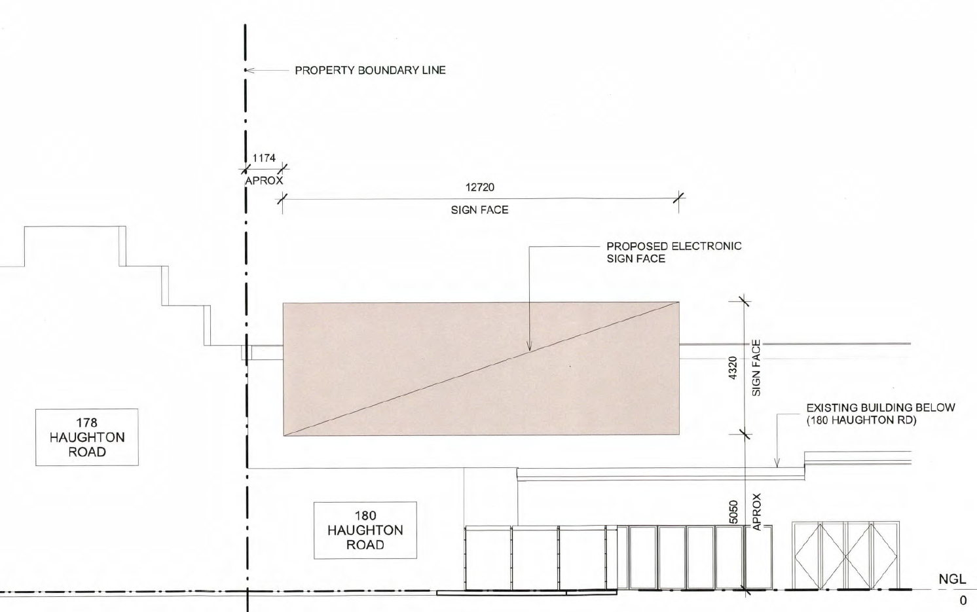

- The sign is oriented so that it is primarily directed at west bound traffic along North Road. The sign would also be visible from other vantage points including from Haughton Road, Huntingdale train station, vehicles exiting the Clarendon Avenue/North Road intersection and other surrounding roads. A montage extracted from the permit applicant’s material shows the proposed sign as viewed from North Road in a westerly direction, despite the caption’s reference to ‘looking north’.
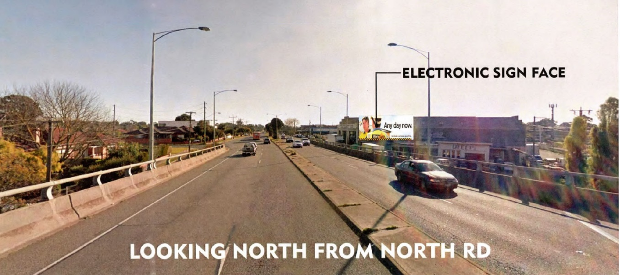

What is the physical context?
- The location of the review site is shown in the image below extracted from Mr Hodges’s statement of evidence.
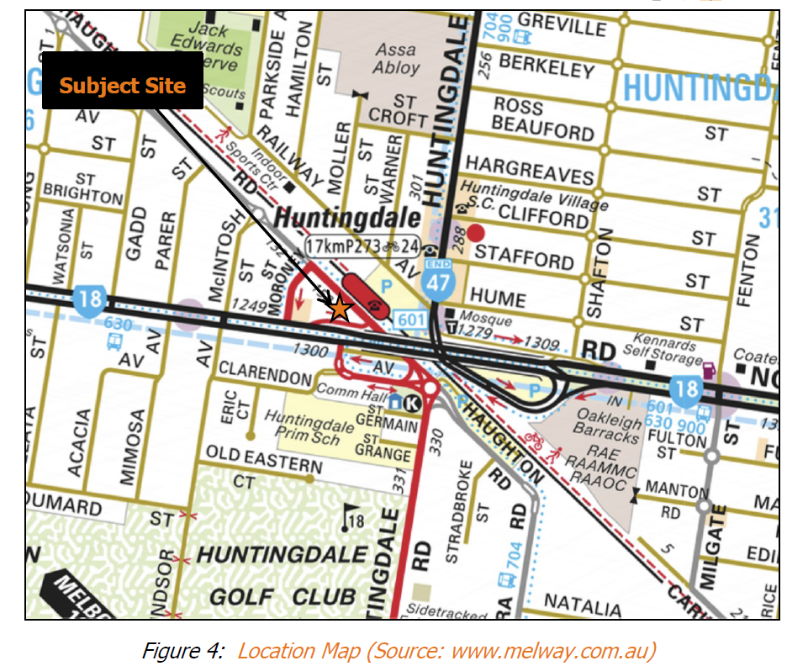
- The site forms part of a small group of industrially zoned sites hosting a variety of commercial and light industrial uses. The review site is located at a lower level than the North Road overpass.
- Other key features of the surrounding context include Huntingdale railway station on the opposite side of Haughton Road, which is serviced by a large at-grade car park, while residential uses predominate to the south and north-west. Huntingdale primary school is accessed via Huntingdale Road (south) and Clarendon Avenue.
- As might be appreciated from the above image, the road network is somewhat convoluted. Huntingdale Road and North Road are arterial roads carrying high traffic volumes. Notably:
- The portion of North Road to which the sign is primarily directed, is an overpass elevated above the review site, Haughton Road and the railway line. It carries approximately 42,000 vehicles per day, split approximately 50/50 in each direction. A speed limit of 70km/hr applies.
- North Road comprises two traffic lanes and a bicycle lane in each direction, separated by a central median. It has a crest roughly 150m to the east of the sign. A guard rail defines the edge of the overpass.
- Huntingdale Road is discontinuous. For west-bound vehicles along North Road seeking to travel south on Huntingdale Road, access is gained via Clarendon Avenue. This movement is also required to reach Haughton Road.
- Clarendon Avenue carries approximately 6,700 vehicles per day and it was common ground that much of this traffic is south-bound. It operates with left-in and left-out movements at its intersection with North Road almost directly opposite the sign. Mr Coutts described it as having the characteristics of an off-ramp – a description with which I agree.
- A one-way (west-bound) service road for North Road (the service road) is also present beside the overpass. It runs parallel to the overpass but at a lower level than it. It operates with stop signs and connects with Clarendon Avenue near its intersection with the main carriageway of North Road.
- The intersection of Clarendon Avenue, Haughton Road and Huntingdale Road is controlled by a roundabout and it is also near a pedestrian crossing.
- For east-bound vehicles along North Road, Haughton Road is accessed via a one-way service road section of North Road which also runs parallel to, but at the same lower grade as the review site.
- The aerial image below shows surrounding development. The green marker shows the sign’s location.
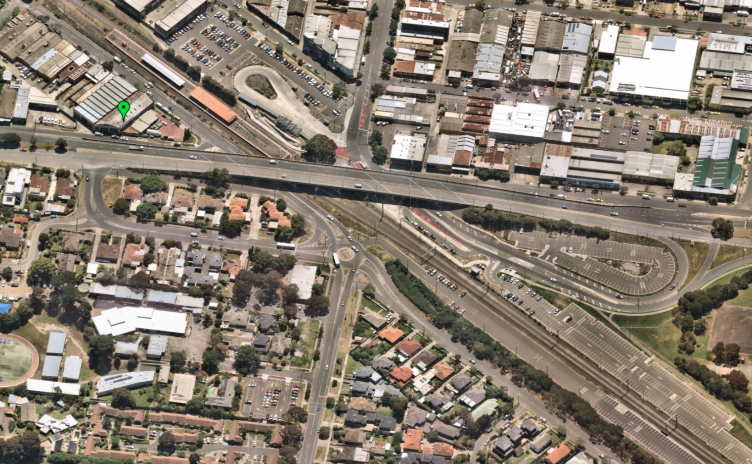
Service road
Clarendon Ave
North Road overpass
Source: Nearmap – Image captured 8 November 2020.
- The host building has a 2-storey scale and the height of the wall to which the sign is to be fixed is approximately 7.5m. The existing presentation of the site from North Road on approach to the Clarendon Avenue intersection is shown below.

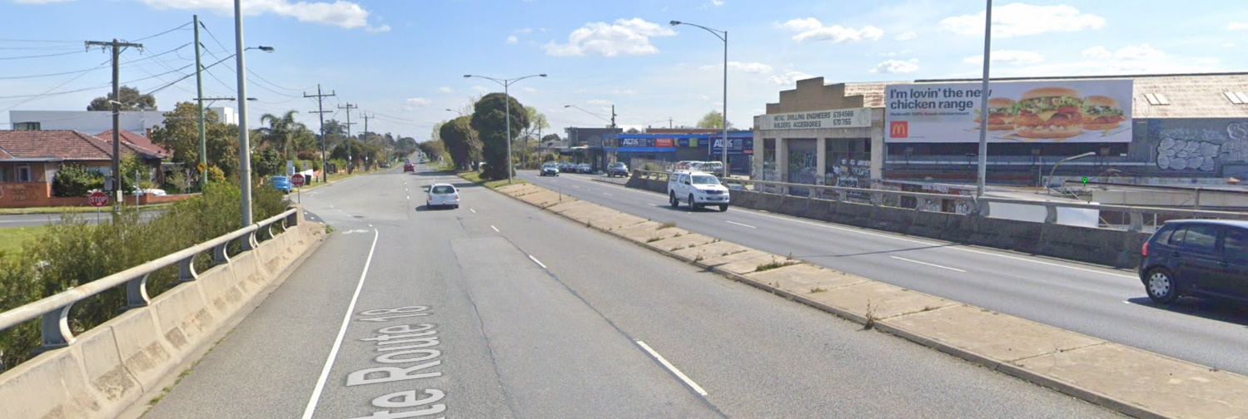
Existing sign
Clarendon Avenue
Source: Google maps – Image captured September 2019.

How should the proposed sign be categorised?
- There was some debate at the hearing as to the categorisation of the proposed sign. In addition to being an electronic sign, the council submitted that the sign might also have the features of an animated sign – a position not supported by the applicant.
- The term ‘promotion’ sign rather than major promotion sign was also used interchangeably by the applicant. A third issue concerns the form of illumination and whether the existing permit includes an ‘electronic sign’, which I return to shortly by reference to my assessment of the relationship of this proposal to the existing sign permit and planning permissions that are now required.
- Relevant definitions are set out at clause 73.02 (with my underlining):
Animated sign
A sign that can move, contains moving or scrolling parts, changes its message, flashes, or has a moving or flashing border.
Electronic sign
A sign that can be updated electronically. It includes screens broadcasting still or moving images.
Major promotion sign
A sign which is 18 square metres or greater that promotes goods, services, an event or any other matter, whether or not provided, undertaken or sold or for hire on the land or in the building on which the sign is sited.
Promotion sign
A sign of less than 18 square metres that promotes goods, services, an event or any other matter, whether or not provided, undertaken or sold or for hire on the land or in the building on which the sign is sited.
Sky sign
A sign:
a) on or above the roof of a building, but not a verandah;
b) fixed to the wall of a building and which projects above the wall; or
c) fixed to a structure (not a building) so that part of it is more than 7 metres above the ground.
Display area
The area of that part of a sign used to display its content, including borders, surrounds and logo boxes.
It does not include safety devices, platforms and lighting structures.
If the sign does not move or rotate, the area is one side only.
Sign
Includes a structure specifically built to support or illuminate a sign.
- Having considered the particular features of the proposed sign, I find that it is an electronic, major promotion, sky sign.
- It is a ‘major promotion’ sign given that the sign’s size is greater than 18sqm that would otherwise allow it to qualify as a ‘promotion sign’. To the extent that the existing permission for a promotion sign encapsulates what is now categorised as a ‘major promotion’ sign, I also rely on my assessment below in relation to planning permissions now required.
- For completeness, as the proposed sign protrudes by about 1.8m above the height of the wall to which it is to be mounted, it is also a sky sign.
- In relation to the term ‘animated sign’, I acknowledge that advertisements to be displayed will change every 30 seconds in this case and could be said to be a sign that ‘changes its message’. However, my reading of this definition connotes signs of the type that are more akin to those which involve continuous or near continuous movement of its lighting or other sign elements frequently involving single words, phrases and lighting arranged in a more simplistic fashion than digital LED illumination. Examples might include car park entry signs with messaging that changes constantly from ‘Casual parking’ to ‘$17 per hour’ or signage in the window of a shop selling hot take-away food with lights arranged to create illuminated images depicting the movement of steam from hot chips or a cup of coffee.
- Adopting this interpretation, if the proposed sign were to be programmed, for example, so that its message changed every 5 seconds I might form the view that it has the features of an animated sign.
- Ultimately, the appropriate categorisation will turn on the relevant facts and circumstances.
- Even if I am wrong, for the purposes of this proceeding, my substantive findings would not be any different. In saying this I note that all of these sign types are within section 2 of the table to Office and Industrial (Low limitation) category of sign controls under clause 52.05-11 and the requirements for a permit under clause 52.05-5 are activated for each sign type as I explain below.

What planning permissions are required?
- Clause 52.05 relates to advertising signs and is the primary assessment tool for this proposal in addition to various policies including the council’s Industry and Business Development Policy at clause 22.03 and Outdoor advertising policy at clause 22.08. Before turning to permissions required, it is necessary to consider the effect of the existing planning permit which allowed the sign presently on display. Both the existing permit and the sign which is proposed for replacement are relevant considerations in the assessment of the proposal now before me.

Relevance of the existing permit
- Permit 4340 which was issued on 23 November 1987 by the then City of Oakleigh gives the following permission:
To construct and exhibit a Floodlit/Promotion/Panel/Sky sign on Lot 32 on Lodged Plan No. 8316, being No. 178 Haughton Road, Huntingdale, City of Oakleigh in accordance with the endorsed plan.
- The permit is subject to seven conditions, as set out below:
- The buildings and works hereby authorised shall be carried out strictly in accordance with the conditions of this permit and with the plan which, when endorsed is/or will be annexed hereto and which is thus hereby incorporated in this permit.
- The sign(s) shall be maintained in good condition to the approval of the Responsible Authority.
- The sign(s) shall not include any flashing or scintillating lights.
- Once started, the project shall be continued and completed to Council approval.
- No further advertising shall be exhibited on the site without the prior written permission of the Responsible Authority.
- The lights shall be suitably baffled so as not to emit any direct lighting outside the site.
- Prior to the construction of the sign hereby permitted a Building Approval shall be obtained from the Building Surveyor of the City of Oakleigh.
- I have not been provided with a copy of the plans for endorsement referred to in condition 1. I also note that the existing permit does not have an expiry condition.
- I understand that the applicant originally made application to amend the existing permit to give effect to the current proposal. However, upon advice from the council to do so, the applicant made a fresh permit application which the council assessed, refused and which is now the subject of this review.
- While the applicant expressed some misgivings about this permission pathway that it ultimately agreed to embark upon, it remains that the refusal of permit application TPA/51200 is the subject of this proceeding.
- I also observe that to the extent that permission may have been validly sought in the alternative by way of an application under s.72 of the Planning and Environment Act 1987 to amend the existing permit, the discretion to be exercised would not be materially different under either permission pathway.

Operation of clause 52 and permissions required
- I say that being mindful of the requirements described in clause 52.05-2. These include that if a sign that can be interpreted in more than one way, the planning requirements for each type of sign, or the most restrictive requirement, must be met.
- Further, and importantly, under clause 52.05-5 the following provisions are relevant:
Existing signs
A sign that was lawfully displayed on the approval date or that was being constructed or put up for display on that date may be displayed or continue to be displayed and may be repaired and maintained.
The content of a lawfully displayed sign may be renewed or replaced. However, a permit is required if:
- The display area is to be increased.
- The renewal or replacement would result in a different type of sign.
A sign that is reconstructed must meet the relevant sign requirements.
- New permissions are now required because:
- the display area of the sign for advertising content is to be increased by more than 12sqm, as the proposal effectively seeks to occupy that part of the existing sign presently occupied by the walkway structure which is to be removed;
- the proposed sign has the features of a different type of sign including at least its features of an ‘electronic’ sign instead of a floodlit sign; and
- in renewing or replacing the existing sign, a development permission is invoked because the proposal involves the construction and putting up for display a different type of sign.

Exercise of discretion
- The presence of the existing sign as distinct from the construction and display of a new sign for the first time is relevant to the exercise of discretion for a proposal. As Deputy President Dwyer explained in Drive By Developments Pty Ltd v Melbourne CC [2020] VCAT 1270, ‘the planning impacts will necessarily differ’. However, the replacement sign involves removal of the existing sign and its reconstruction including attachment to the host building anew. This implicitly constitutes development which clause 52.05 is intended to regulate.
- Further, although nothing really turns on this given that new permissions are required for the reasons that I have outlined above and that the requirements of clause 52.05 must be met, I should also add that I do not agree with the applicant’s submissions that reference to the term ‘floodlit’ encapsulates the sign type ‘electronic’. This submission seemed to be made on the basis that my discretion should be further narrowed. In support of these submissions, the applicant referred to the decision of Senior Member Daicic in Ilex Holdings Pty Ltd v Port Phillip CC (Corrected) [2019] VCAT 2047 (Ilex).
- There are at least two fundamental differences between the proceeding before me and the circumstances that the Tribunal faced in Ilex.
- First, the display area of the sign in Ilex was to remain the same rather than increasing as is proposed here.
- Second, a central dispute in Ilex was the form of illumination that was permitted under the permit proposed to be amended in that case and the form proposed in an electronic sign. The existing permit in Ilex was granted for ‘… an illuminated panel promotion sign…’.
- The term ‘illuminated sign’ is not discretely defined in clause 73.02 and in the ensuing detailed analysis of case law, relevant material and submissions, the Tribunal formed the view that the sign:
… when changed to digital, remains an ‘illuminated sign’ as permitted by the Permit. This is because the nature of illumination is proposed to change from illumination by external lighting, to internal illumination by way of energised electronic pixels but it nevertheless remains an illuminated sign.
- By way of contrast, in the proceeding before me the description of the permission in the existing permit is for the more narrowly defined ‘floodlit sign’. This limits the scope of illumination in the present circumstances to that of a floodlit sign. Indeed, as the Tribunal found in Ilex:
Had the Permit sought to limit the scope of ‘illumination’ to that of a ‘floodlit’ sign (in accordance with the sign currently located on the review site) the preamble could have made this restriction clear. Particularly given ‘floodlit sign’ was a defined term within the South Melbourne Planning Scheme at the time the Permit was granted. The same would apply with reference to ‘internally illuminated’ which was defined also and yet it chose not to do so. [My underlining]
- Third, whereas the term ‘illuminated’ is not defined in clause 73.02, both ‘floodlit sign’ and ‘electronic sign’ are separately defined sign types under this clause as follows:
Floodlit sign - A sign illuminated by external lighting provided for that purpose.
Electronic sign – A sign that can be updated electronically. It includes screens broadcasting still or moving images.
- While there are a number of sign terms that have overlapping elements in their definitions, the form of illumination to describe ‘floodlit’ and ‘electronic’ signs have intrinsic characteristics that are mutually exclusive. Fundamentally, the replacement of the floodlit sign with an electronic sign introduces a new sign type and one which has a larger display area for which a new permission is necessary having regard to the operation of clause 52.05-5.
- Further, a sign that is reconstructed must also meet the relevant sign requirements that are specified under clause 52.05.
- This includes referral of applications to the relevant referral authority (in this case the Head, Transport for Victoria represented by the Department of Transport), application requirements, decision guidelines for all signs and major promotion signs, the inclusion of certain mandatory conditions on any permit granted including the imposition of an expiry condition and compliance with specified conditions in the tables at clauses 52.05-11 to 52.05-14.

will the sign’s visual appearance in the public realm be acceptable?
- The council submits that while the proposed form of signage has a role to play in mixed use locations such as this one with commercial and industrial activity, it is submitted that the sign’s elevated position will dominate the skyline and is not in proportion with the low scale form of the host building or the role and function of this location which is not part of an activity centre.
- The applicant relies on the historic presence of the existing sign and a smaller sign before it as a relevant consideration. It also asserts that the proposed sign, like that which already exists, promotes goods and services not sold on the land, is an improvement on the current design, and will otherwise enhance the image of this industrial area when viewed from North Road. If approved, it also submits that a benefit would derive from the introduction of an expiry condition on any permit granted.

What does the planning scheme say?
- There is a clear policy theme throughout the Monash planning scheme that promotes good urban design and the consideration of the impacts of signage on the visual amenity, appearance and character of an area.
- Council’s Outdoor advertising policy at clause 22.08 builds on these policies and has purposes and general objectives, that amongst others, seeks to ensure that:
- the style of advertising that responds to the role of activity centres;
- provides guidance for advertising in industrial and business developments;
- avoids the erosion of the aspiration for a ‘garden city’ character in Monash; and
- controls the proliferation of advertising signs along major transport routes.
- In the exercise of discretion, decision guidelines refer to the objectives of this policy, whether the signage is required for the identification of the business or other use on the site; whether the specific objectives at Clause 22.08-5 have been complied with and the design guidelines at Clause 22.03-3 for applications in certain zones including land in the IN1Z.
- Performance criteria for certain sign types is also provided in the decision guidelines under this policy. Major promotion signs have the performance criteria ‘Generally inconsistent with the Garden City image’.
- For sky signs, the performance criteria are:
May be considered for centre identification at the major entry points of a large retail centre. The design should be integrated with the architectural features of the centre including its scale and construction detail.
Centre identification signs may be internally illuminated or floodlit but animated signs, flashing signs, reflective signs and associated bunting signs are discouraged.
Promotional advertising on sky signs is discouraged.
- Guidance for electronic signs is not provided.
- Under clause 22.08, the site is within Business Character Type 2. A statement of preferred character is provided which I have considered, but which offers little direct assistance for this proposal.
- Decision guidelines at clause 52.05-8 are manifold and relevantly refer to the sensitivity of the area, compatibility with the desired future character, the impact of any illumination, impact on views and vistas including the potential to dominate the skyline, the relationship to the streetscape, setting, site and building including:
- The proportion, scale and form of the proposed sign relative to the streetscape, setting or landscape.
- The position of the sign, including the extent to which it protrudes above existing buildings or landscape and natural elements.
- The ability to screen unsightly built form or other elements.
- The scale and form of the sign relative to the scale, proportion and any other significant characteristics of the host site and host building.
- Specific guidance is also provided for major promotion signs including the following locational principles:
- Major promotion signs are encouraged in commercial and industrial locations in a manner that complements or enhances the character of the area.
- Major promotion signs are discouraged along forest and tourist roads, scenic routes or landscaped sections of freeways.
- Major promotion signs are discouraged within open space reserves or corridors and around waterways.
- Major promotion signs are discouraged where they will form a dominant visual element from residential areas, within a heritage place or where they will obstruct significant viewlines.
- In areas with a strong built form character, major promotion signs are encouraged only where they are not a dominant element in the streetscape and except for transparent feature signs (such as neon signs), are discouraged from being erected on the roof of a building.

Will the proposal achieve an acceptable visual outcome?
- I agree with the applicant that in-principle, the long-standing presence of the existing floodlit promotion sign is a very relevant matter. In this case, it weighs in favour of this location’s suitability. The ability to impose a restriction on the sign’s display in circumstances where none presently exists is also a matter that I find weighs in favour of this proposal.
- While the replacement sign is to be larger and more visually obvious and likely to attract greater attention due to that fact and its electronic format with messages that change every 30 seconds, I find that its visual presentation and scale relative to the host building, the site and its surrounds would be acceptable.
- More particularly, while not a location identified as an activity centre, the location is one that is very robust with buildings and other structures that are set within a highly urbanised and hard-edge setting.
- Although the sign will extend by about 1.8m above the parapet height of the existing wall in an identical fashion to the existing sign, it will largely be read against the unsightly wall and roof profile of the host building rather than as a high skyline element.
- I consider that its more modern presentation and overall design will add some vitality and visual interest to this otherwise visually robust industrial environment – an outcome that I regard as consistent with the decision guidelines for major promotion signs at clause 52.05-8.
- I therefore find that the sign would not be unacceptable on visual amenity grounds when viewed from the public realm.

Will the sign be a safety hazard?
- The Department of Transport asserts that the sign poses an unacceptable safety risk and would not meet two decision guidelines under clause 52.05-8.
- First, it says that the section of North Road from which the sign is to be primarily viewed on approach to the Clarendon Avenue intersection requires particular concentration. In support of this contention, the Department of Transport referred to:
- the role of Clarendon Avenue as a connector road with the features of an off-ramp from North Road between two main arterials catering for more than 6000 vehicles per day;
- limited visibility of the Clarendon Avenue intersection on approach from the east in North Road; and
- the crash history on the western approach to the intersection, comprising six recorded casualty accidents in the period 2015 to 2020, three of which occurred in the left lane involving rear end collisions and which are said to be of particular relevance.
- Second, it is submitted that the sign, due to its size, low height relative to the main carriageway and type – being an electronic sign whose advertisements and luminance change – is more able to capture the driver’s attention involuntarily and cause a distraction. It is therefore contended that the ability for drivers to perform their regular driving task may be reduced. Further, it is asserted that the onus is on the applicant to demonstrate that the sign will not be a safety hazard, that the Tribunal should prefer the opinion of the Department of Transport and otherwise adopt the precautionary principle.
- In making these submissions, Mr Coutts drew heavily on the document ‘Impact of Roadside Advertising on Road Safety (2013) – Austroads Publication No. AP-R420-13’ (the Austroads report). This report summarises the extant literature on distraction risk associated with roadside advertising, documents a review of existing guidelines across road agencies throughout Australia to identify inconsistencies and gaps and provides ‘best practice’ guiding principles and recommendations to assist in the creation of guidelines for consistency across road agencies.
- The council supports the position put by the Department of Transport.
- For the applicant’s part, the traffic evidence of Mr Hodges is relied upon. He does not dispute the Department of Transport’s overview of recorded casualty accidents and the description, role and general functioning of the surrounding road network. It was also common ground that absent any mention of the existing sign in the police reports detailing recorded casualty accidents, its role as a causal factor cannot be relied upon. Suffice to say, it was Mr Hodges’s opinion that given traffic volumes, the number of reported casualty crashes is not unexpected, low, trending down in recent years and of generally low severity while conceding that changing travel behaviour due to the COVID pandemic is likely to have positively influenced recent downward trends. He too accepts the summary of research described in the Austroads report and referred to this document in support of his evidence.
- It was Mr Hodges’s opinion that the primary section of North Road from where the sign will be viewed is not a zone where particular concentration is required and that it represents typical driving conditions on the road network. In this case, he relies on the relatively straight horizontal road alignment, the moderate and consistent grades on the overpass, absence of any significant driver decisions to be made and that ‘no intersections are located in the length of road where the sign is visible and likely to be read by passing drivers’. Suffice to say, he accepts that the determination of whether ‘particular concentration is required’ involves subjective judgement and is not just limited to the one example cited in clause 52.05-8 of a ‘high pedestrian volume intersection’.
- Of the intersection with Clarendon Avenue, Mr Hodges describes its left-in and left-out only role as one that is simple to negotiate. In terms of rear-end crashes on approach to the intersection that have occurred, he regards those as low severity while accepting that queues negotiating the Haughton Road roundabout and pedestrian crossing and the need for some level of deceleration by left turning vehicles on North Road may be relevant causal factors. The need to slow to give way to a bicycle in a bike lane may be another factor. He accepts that the crest on the overpass has a role in limiting sight distances and visibility of queued vehicles on approach to the intersection. However, he also opines that while not definitive, the road has likely been designed to the required engineering standards so that the end of queued vehicles will be visible to an approaching vehicle at any given point from the overpass. That being the case, he opines that the presence of queues is likely to a ‘null point’ as a factor contributing to rear end collisions. The absence of any detailed design plans and feature surveys, and inability to experience queuing events due to the current road conditions affected by the COVID pandemic were cited as reasons for this qualified response.
- The viewing zone where sign is said to be most visible is said to be between 165m to 200m from the sign and this falls within the 10 degree vision cone. Between 80m to 165m from the sign, the sign is said to be within the 10 to 20 degree vision cone. Beyond this, it is Mr Hodges’s evidence that the sign rapidly disappears from view.
- In relation to distraction, Mr Hodges also relied upon the guiding principles and recommendations in the Austroads report but also drew heavily from two more recent studies whose Australian context is said to make them more relevant than other overseas studies referred to in the Austroads report. He did however acknowledge a number of their limitations, expressing the view that more research would be desirable.
- Both studies were undertaken in 2015 after the release of the Austroads report and are:
- a research paper titled ‘Digital billboards ‘down under’. Are they distracting to drivers and can industry and regulators work together for a successful road safety outcome?’ by Samsa Consulting (the Samsa study);
- a study titled ‘An On-Road Study of the Effect of Roadside Advertising on Driving Performance and Situational Awareness (2015)’, Monash University Accident Research Centre (the MUARC study).
- In the Samsa study, 29 participants ranging in age from 25 to 54 years of age with a minimum of five years driving experience were fitted with eye tracking glasses and drove an instrumented vehicle along a 14.6km route through Brisbane for approximately 90 minutes. A total of 21 ‘static’ billboards and four digital billboards were included in the driving route.
- The Samsa study sought to determine two questions, one of which relevantly for the issues in this proceeding is whether fixations and driving performance differ significantly in the presence of digital billboards compared to static billboards.
- In the MUARC study, 19 drivers aged between 22 and 47 years with a minimum driving experience of 2 years drove an instrumented vehicle through a 38km route in metropolitan Melbourne. Eleven billboards (10 ‘static’ and one electronic) were present in the selected route. Amongst other tasks, drivers were asked to vocalise (‘think aloud’) while driving by describing features in the environment (such as road signs, billboards and other road users) and how those features relate to them.
- Mr Hodges summarised the findings of these studies as follows:
- there is no significant differences in driver behaviour and situational awareness between static and electronic billboards;
- drivers are not overly distracted by either sign type;
- drivers tend to pay attention to billboards when driving demands are low. Conversely when driving demands are high, drivers can ‘self-regulate’ their attention to billboards and focus on the immediate driving task; and
- when drivers do fixate on billboards, average fixations are well below 0.75s which is the considered to be the minimum perception / reaction time to an unexpected event.
- Drawing upon the findings of these studies Mr Hodges expressed the view that the conversion of the existing sign from a floodlit billboard to an electronic sign is not likely to result in any change in driver behaviour compared to existing conditions.
- Further, to the extent that the different physical characteristics of electronic signs may cause a distraction, Mr Hodges agrees with application of the best practice guidelines described in the Austroads report.
- These parameters include a dwell time of 30 seconds, instantaneous message changing and the inclusion of permit conditions controlling maximum sign luminance levels that do not exceed those of static signs in ambient light conditions. He also supports a condition requiring the sign’s default to a blank screen in failure mode – a measure not included in the Austroads report.

What does the planning scheme say?
- Overarching policies at the state level require that planning is to recognise the need for, and as far as practicable contribute towards various matters that include health, wellbeing and safety, a high standard of urban design and amenity and accessibility.
- Urban design policies build on these themes with strategies that include:
Ensure that development, including signs, minimises detrimental impacts on amenity, on the natural and built environment and on the safety and efficiency of roads.
Promote good urban design along and abutting transport corridors.
- Policies in relation to transport and the road system refer to the creation of an efficient and safe network with a relevant strategy that includes the following:
Plan and regulate the design of transport routes and nearby areas to achieve visual standards appropriate to the importance of the route with particular reference to landscaping, the control of outdoor advertising and, where appropriate, the provision of buffer zones and resting places.
- In addition to regulating the development of land for signs and consideration of their impacts on the visual amenity, appearance and character of an area, the last purpose of clause 52.05 is:
To ensure that signs do not cause loss of amenity or adversely affect the natural or built environment or the safety, appearance or efficiency of a road.
- Decision guidelines that apply to all sign types make reference to a number of matters. There are 10 matters specified under the decision guideline of road safety. The two most relevant are as follows:
- The impact on road safety. A sign is a safety hazard if the sign:
…
Could dazzle or distract drivers due to its size, design or colouring, or it being illuminated, reflective, animated or flashing
Is at a location where particular concentration is required, such as a high pedestrian volume intersection.

Does this location require particular concentration?

Defining ‘particular concentration’
- The planning scheme does not define the term ‘a location where particular concentration is required’. It is common ground however that while a relevant matter includes ‘a high pedestrian volume intersection’ an assessment is not limited to such a feature.
- The Tribunal has observed on other occasions that whether a location is one where particular concentration is required will turn on the particular facts and circumstances of each case. Like many situations involving the exercise of discretion in town planning disputes, context is key. As highlighted by the Tribunal in Maple Media Pty Ltd v Greater Dandenong CC [2019] VCAT 269:
I am not persuaded that considering the issue of ‘particular concentration’ can be generalised to simply accepting that all drivers need to concentrate; or that a controlled intersection means the level of concentration required is less than the ‘particular concentration’ contemplated in the decision guidelines about whether a sign is a safety hazard. Rather, whether ‘particular concentration’ is required at a location requires a consideration of the context of the particular location in question.
This issue of ‘particular concentration’ has been considered in other Tribunal decisions, including in Kushinda Pty Ltd v Whitehorse CC (Kushinda) and Drive By Developments Pty Ltd v Monash CC (Drive By Developments). These decisions demonstrate the relevance of the context of a particular location. Kushinda involved the intersection of Whitehorse and Springvale Roads in Nunawading, where the right hand turning traffic is fully controlled with green/red arrows. The Tribunal found this was not a complex decision-making environment that required ‘particular’ attention. Drive By Developments was an uncontrolled, high-speed merging context on the Monash Freeway near the Jacksons Road outbound loop on-ramp and the lane merge area on the inbound carriageway of the Monash Freeway near the Jacksons Road bridge. The Tribunal erred on the side of caution, and refused the proposed sign due to its potential for hazard creation and distraction to motorists in this location.
In this case, I find particular concentration is required for the part of the Junction intersection involving the Centre Road and Police Road traffic. This part of the Junction intersection is not fully controlled, involves vehicles travelling down an incline into the intersection (Police Road) and potentially two lanes of vehicles seeking gaps to turn right from Centre Road. This part of the Junction intersection has experienced a high number of recorded crashes.
- Merge conditions, traffic speeds, the presence of intersections, number and type of traffic control devices and the presence of an incline and thus the road geometry are identified in these examples.
- I can envisage many other circumstances where particular concentration may arise. These may include the interplay of surrounding topographical considerations; the design standard of the road environment and its surrounds; sight distances and the presence of any obstructions; the position, configuration and type of intersections; lighting conditions; the number, type and function of traffic lanes; the type and number of road users including pedestrians, cyclists or heavy vehicles and their familiarity with particular environmental conditions; queuing characteristics; the number and sources of driver information required to be processed by road users and so on.
- Such considerations may not be limited to the road environment only but may involve the interaction between the road environment and what is occurring in the surrounding context. I consider that these factors will in many cases reflect the complexity of the driving task but this may not always be the case. The interaction of seemingly simple environmental conditions may in combination create a high probability of unexpected driving conditions warranting heightened driver demands and in turn, particular concentration. Such is the case here for reasons to which I return.
- To this I would add that recorded casualty crash statistics are certainly relevant, instructive and useful but not necessarily determinative of whether particular concentration is required in any given location. They are one input of many. As the Tribunal highlighted in Tewlen Pty Ltd v Melbourne CC (includes Summary) (Red Dot) [2010] VCAT 535:
… the degree of weight which they are afforded should be tempered for a number of reasons. Specifically, the statistics do not include property damage or minor incidents which are not reported and there is also the potential that drivers will not admit to being distracted due to the liability implications.

Tribunal’s findings
- I am not persuaded by the evidence that the section of North Road and the intersection with Clarendon Avenue is one that can be characterised as so simple that particular concentration is not required. On the other hand, I do not regard this location as one which is so overtly demanding that a highly focussed attentional state is elicited, of the kind that allows the driver to readily suppress extraneous external distractions unrelated to the driving task. Rather, I think that while there are many straight-forward elements of the driving task for west-bound drivers on the overpass approaching the Clarendon Avenue intersection, in this particular context, road conditions also have a propensity to change unexpectedly with a consequential increase in attentional demands. Thus, I consider that this is an environment where a distraction away from the driving task is likely to increase the likelihood of, or create, a traffic hazard.
- In this case, I find that particular concentration is required here due to a number of contextual features. These apply in addition to those identified by Mr Hodges as factors that may contribute to the likelihood of rear-end collisions in this location in the nature of three of the six recorded casualty accidents in the left lane on the overpass on approach to Clarendon Avenue intersection – vehicles queuing or decelerating and the possible presence of a cyclist in the bicycle lane.
- First, while the Clarendon Avenue/North Road intersection operates with left-in and left-out movements only, the west-bound North Road service road runs parallel to the overpass and terminates in front of this intersection, adding complexity to the intersection. This arrangement is shown in the images below.

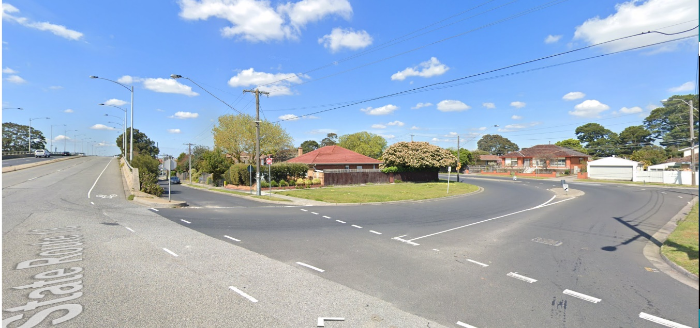
Service road
North Road overpass
Clarendon Avenue
Source (both images): Google maps – Image captured October 2019.
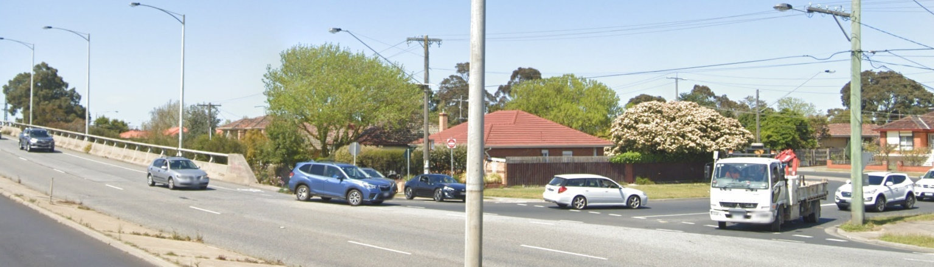

- West-bound vehicles exiting the service road and seeking to enter the North Road carriageway need to conduct a merge movement. This is shown in the two images above and below.
- While possible, I consider it highly unlikely that such west-bound drivers will turn left into Clarendon Avenue and perform a U-turn to return to the north-bound leg of Clarendon Avenue. Some may however continue onto Windsor Avenue to access North Road further west.
- For such drivers in the latter group, and for south-bound drivers more generally exiting the service road, the left-turning movement into Clarendon Avenue involves entry into the central part of the intersection parallel to both the bicycle lane and left west-bound lane of the North Road overpass.
- The images below show west-bound approach from the service road to the Clarendon Avenue intersection.

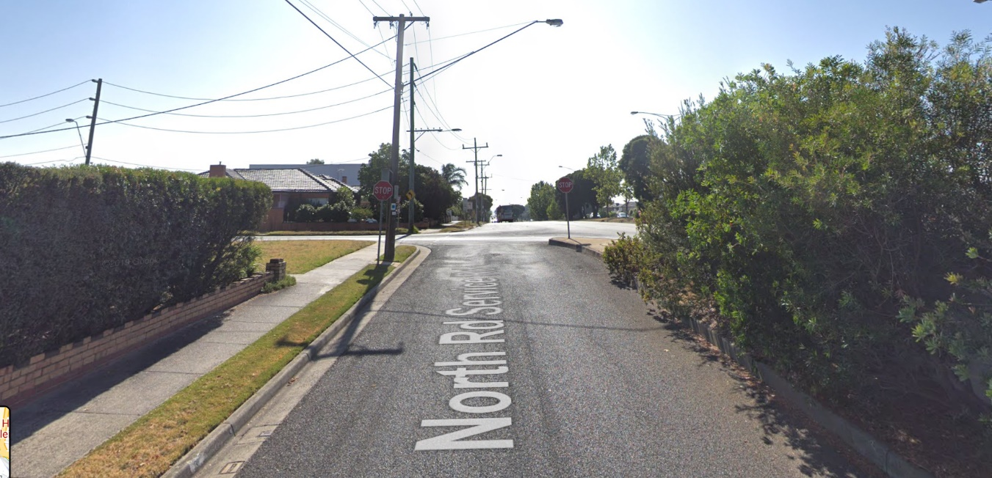
Source (both images): Google maps – Image captured January 2019.

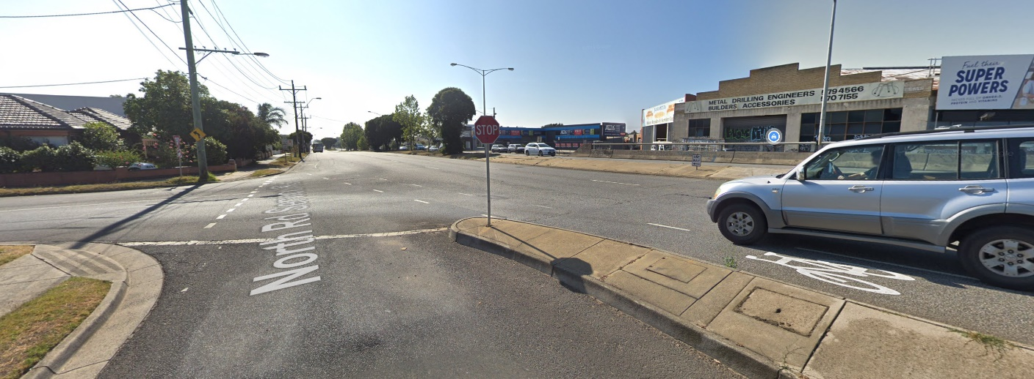
Existing sign

- For completeness, my site inspection indicated that the sign will be visible from the north-bound lane on approach to the Clarendon Avenue intersection and in peripheral views from the west-bound service lane of North Road on approach to this intersection. In relation to the latter, drivers seeking to merge onto North Road will be required to turn their head to the right to look for on-coming vehicles travelling west-bound on the overpass. The sign, at about 35m away, will be exposed in such views as the images above and below show.

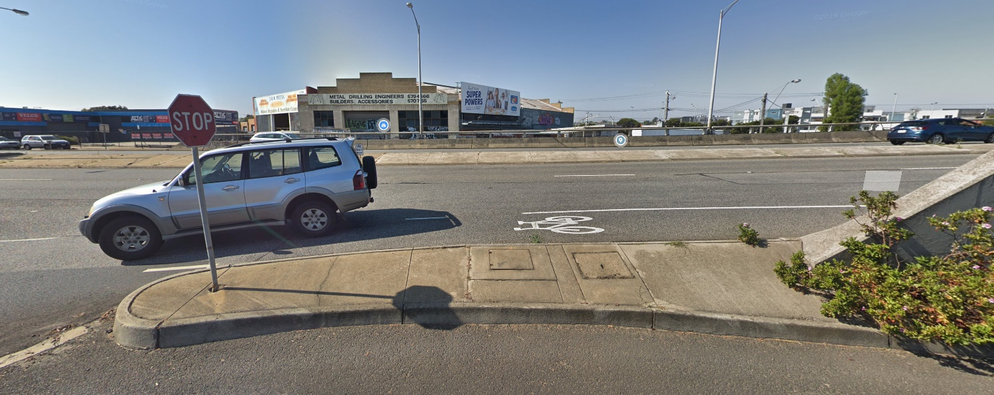
Existing sign
Source: Google maps – Image captured January 2019

- Second, the guard rail to the edge of the North Road overpass and planting on approach to Clarendon Avenue limit visibility of the intersection and the service road. The following image shows the approach to the Clarendon Avenue intersection from the North Road overpass.
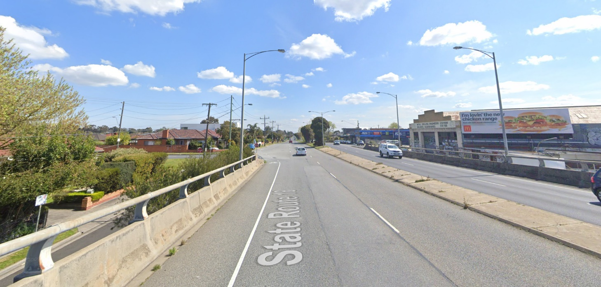
Existing sign
Clarendon Avenue
Source: Google maps – Image captured September 2019
- Further, Clarendon Avenue is offset behind the alignment of the guardrail to accommodate the parallel service road which also contributes to its limited visibility for west-bound drivers on the overpass, as seen in the images above.
- Despite the presence of two road signs on the overpass – particularly for drivers unfamiliar with this connector road including those seeking to turn left, sudden deceleration may be required.
- Third, this section of North Road on approach the Clarendon Avenue has an incline.
- Fourth, the accident history in this 200m section of North Road on approach to Clarendon Avenue from where the sign will be visible involves a cluster of rear end collisions on what is seemingly an undemanding and straight stretch of road.
- Having formed the view that the sign is at a location where particular concentration is required, in such circumstances, the decision guidelines state that this sign is a safety hazard.
- I now turn to a consideration of the sign’s impact on road safety and whether it will distract drivers.

Will the sign cause distraction to the detriment of road safety?
- Both the Samsa and MUARC study usefully add to the body of research conducted since the 2013 Austroads report on the effects of roadside advertising signs on driving performance and situational awareness.
- They do however have their limitations as acknowledged in the studies themselves and by Mr Hodges.
- Importantly, the limited age cohort of participants in both 2015 studies is not representative of the broader driver population. Inexperienced younger drivers are not represented in either study. The driving performance of this group is most likely to be detrimentally affected by external distractions including roadside advertising and especially when movement and changes in luminance occurs. Nor are drivers in the older age cohorts included in these studies.
- In relation to the younger inexperienced drivers, the Austroads report, which preceded both the Samsa and MUARC studies and is referenced in the latter, makes the following observation:
Concerns about irrelevant processing consuming resources required for optimal driving performance are even more salient for inexperienced drivers. Inexperienced drivers demonstrate significantly greater impairment from secondary tasks while driving (Shinar, Meir & Ben-Shoham 1998). The most likely explanation for this is that many of the tasks involved in driving are not yet as automatised as they are for experienced drivers and therefore compete for limited processing resources to a greater extent. [My underlining]
- Further, the Outdoor Media Association funded the Samsa study and the MUARC study was partly funded by the outdoor advertising company iOM. Only one electronic sign was included in the MUARC study. While different methodologies were used, both necessitated the use of external interventions and relatively short trip durations during daylight hours that to some extent may have artificially and positively influenced drivers’ behaviour and their situational awareness.
- Samsa measured fixation length and determined that single fixation lengths were similar for static and digital signs. However, this does not take into account multiple fixations. Thus, in relative terms it is not possible to determine the difference between digital signs and static signs in contributing to total fixation lengths of more than 2 seconds across a 6 second period – a benchmark derived from the research of others which is broadly accepted by researchers to double the risk of near-crashes and crashes.
- There are also many variables at play that are not systematically captured in either study that may well influence study outcomes. As the MUARC study concludes, ‘a number of further research steps are indicated by the current study’ which aptly includes the following:
A wider range of roadside advertising aspects could also be included in future studies, including systematically examining billboard content, size, height and location to determine if, and how, these aspects influence the impact of billboards on driver behaviour. For example, it is possible that a billboard may have a greater impact on driving behaviour and safety if placed at a high workload section of the road network (e.g., lane merges or around rail level crossings) and less of an impact at another, less demanding section of roadway. Determining which aspects of billboards can be changed to decrease any potential negative impact they may have on driver behaviour could provide key insights to inform the safer design and placement of roadside advertising.
While this research could be conducted on-road with systematic manipulation of billboards, this research could also be conducted in a simulated environment so that billboard features and placement can be more easily modified. [My underlining]
- The Samsa study similarly observes that:
… other than operational characteristics of digital billboards, other signage characteristics such as size, advertising content, luminance, exposure and roadside position were not explored as they differ greatly and would have likely confounded the results. [My underlining]
- It remains, as it did at the time of the Austroads report’s publication in 2013, that more research needs to be done.
- For these reasons, and for the purposes of this proceeding, I can give no weight to both 2015 studies relied upon in the evidence of Mr Hodges. In summary:
- the limited age cohort of participants in both 2015 studies is not representative of the broader driver population with research indicating that when distracted, inexperienced drivers are particularly susceptible to the detrimental effects of distractions on driving performance;
- outdoor advertising organisations were involved in funding and sponsorship arrangements for both studies;
- a sample size of one major promotion sign was included in the MUARC study, which diminishes the statistical significance of this study’s results;
- while different methodologies are adopted in both studies, each involved trips of short duration during daylight hours and un-natural external interventions that may have artificially and positively influenced drivers’ behaviour and their situational awareness;
- the methodology in Samsa does not allow an analysis to be made of total fixations away from the forward roadway within a 6 second period, including any multiple fixations associated with electronic signs and their relative difference to static signs; and
- there are many siting, design and environmental variables at play in real world situations that are not systematically captured in either study.
- For the purposes of the assessment that I need to undertake in this proceeding, I find that the Austroads report – authored by a not-for profit, non-partisan organisation funded by a collective of Australian and New Zealand government transport agencies – offers the most salient information and guidance on the factors for consideration in understanding the possible safety implications of roadside advertising on road safety. I also make this finding in the absence of any other specific guidance in the planning scheme and the acceptance of the Austroads report by both the Department of Transport and Mr Hodges as a document that is relevant and of assistance to the issues that I need to determine in this proceeding. I agree and have therefore considered it and applied it in making my findings.

Austroads Research Report AP-R420-13
- In terms of human factors that are relevant to understanding the possible safety implications of roadside advertising, the Austroads report acknowledges that in most driving situations, most of the time, drivers probably possess substantial spare cognitive capacity for the processing of driving-irrelevant information.
- But even if cognitive capacity is not being consumed to such a degree as to impair driving performance in itself, the fact that a driver is not looking in the correct direction to safely negotiate the road and other traffic – that is their eyes are off the forward roadway – may result in an incident, especially if conditions change suddenly.
- The Austroads report goes on to affirm that the key question is whether there are situations or individuals where processing is recruited or interfered with by driving-irrelevant material to the detriment of driving performance. In response to this question, the Austroads report says this:
The considerations reviewed above suggest that the answer to this is in the affirmative. While attention may be less likely to be captured by irrelevant material in a demanding driving situation, it is clear that in some driving situations it is likely that movement or changes in luminance will involuntarily capture attention and that particularly salient emotional and engaging material will recruit attention to the detriment of driving performance, particularly in inexperienced drivers. Where this happens in a driving situation that is also cognitively demanding, the consequences for driving performance are likely to be significant. Furthermore, if this attentional capture also results in a situation where a driver’s eyes are off the forward roadway for a significant amount of time this will further reduce safety. Additionally, road environments cluttered with driving-irrelevant material may make it difficult to extract the information that is necessary for safe driving, particularly for older drivers.
- On the effects of different forms of advertising, the review of literature identified in the Austroads report found that:
- Video advertising can be significantly more distracting than static advertising.
- Digital billboards can be more distracting than conventional billboards.
- Suppression of involuntary attention capture by environmental events is more likely if the driving task is very demanding and requires a focussed attentional state. For example, only when a driver is on an unfamiliar road, driving at high speed, in heavy traffic, while trying to navigate to an unfamiliar destination is the driving task likely to become demanding.
- The typical driving task and driving environment is quite undemanding.
- Fundamental research also suggests that motion and luminance changes in digital billboards are likely to be highly effective in capturing attention involuntarily in everyday driving environments.
- Street level advertisements attracted more attention than raised advertisements when drivers were instructed to look for hazards. This is because street level advertisements fall within the normal window within which drivers habitually scan for hazards and that advertisements within this window are inappropriately capturing attention.
- In summary, the Austroads’ report conclusions on road safety state that there is compelling evidence that distraction is a major contributor to crashes while acknowledging that studies providing direct evidence that roadside advertising plays a significant role in these distraction based crashes are currently not available.
- It continues by stating that:
The studies that have been conducted show convincingly that roadside advertising is distracting and that it may lead to poorer vehicle control. However, the evidence is presently only suggestive of, although clearly consistent with, the notion that this in turn results in crashes.
- While looking at an external object increased the crash risk by nearly four times, less than 1% of all crashes and near crashes involved distraction from roadside advertising. This suggests that the contribution of roadside advertising to crashes is likely to be relatively minor.
- Conversely, it is said in the Austroads report that:
… from a Safe System perspective it would be difficult to justify adding any infrastructure to the road environment that could result in increased distraction for drivers. The exception to this may be in the case of very monotonous roads where drivers are likely to suffer the effects of passive fatigue.
- In addition to a summary of current jurisdiction and industry guidance across Australia, best practice guidelines are described in Section 9 of the Austroads report. These are shown in two tables – Table 9.1 – Sign Design Guidance and Table 9.2 – Sign Placement Guidance.
- While I accept that the guidance for sign design described in Table 9.1 can be met by this proposal through the imposition of suitable permit conditions relating to movement, flashing lights, dwell time, transition time, luminance, and the like, I consider that the proposal responds poorly to the guidance for Sign Placement in Table 9.2. This is particularly so in relation to longitudinal profile, vertical placement, risk profile of the road environment and likely driver demands.
- Having regard to these considerations and applying them to the present circumstances before me, I make the following findings.

Tribunal’s findings
- First, it is relevant that the replacement sign being electronic rather than a static type is likely to draw a greater level of attention than the current sign and is able to do so involuntarily.
- I say this acknowledging the proposed 30 second dwell time where a changing message is likely to be experienced by 34% of drivers when travelling at 70km/hr and other luminance control measures. Such signs are attractive and my own experience of them is that they more engaging with their richness of colour, content and levels of luminance relative to ambient background conditions than traditional non-digital static sign types. They are highly effective at involuntarily capturing attention as the research suggests and this is precisely what they are designed to do.
- Second, the sign is to be located to the right hand side of the east-bound carriageway. While this is not necessarily unusual, it needs to be understood in the context of the configuration of the Clarendon Avenue intersection and the service road, which as I have described above, is aligned further left of the main North Road carriageway in an atypical manner and in the opposite direction to the sign.
- The location on approach to the intersection is one where I consider that sudden deceleration can and most likely occurs as a consequence of the characteristics of the road network. This includes the road geometry, the obscuring effects of the guard rail and vegetation on the western edge of the overpass, traffic conditions where queuing is also likely and merge movements required across the Clarendon Avenue intersection from west-bound vehicles exiting the service road onto North Road. The need to maintain eyes on the forward roadway to respond to sudden changes in conditions assumes a particularly high level of importance in such situations.
- Aside from the complexity of the movement at this intersection for drivers exiting the service road, particularly for vehicles continuing west-bound and merging onto North Road, visibility of the sign by may also be a source of distraction for this group of drivers. Primarily in the case of merging west-bound vehicles, this may contribute to the likelihood of poor driver decision making and in turn, lead to sudden changes in traffic conditions on North Road.
- Third, the evidence was predicated on a different form of illumination, but no explicit analysis was undertaken of the effects on driver distraction and traffic safety arising from an increased display area of the proposed sign. This enlargement effectively results in a lowering of the sign’s bottom edge by 1m so that its height aligns more closely to the driver’s eye level in the vertical field when viewed from the main carriageway along North Road and just above the height of the guard rail on the east side of the overpass. The enlargement of the sign not only has the potential to draw a greater level of the driver’s attention away from the forward roadway, but it is also more likely to do so than a sign positioned in a more elevated position in the landscape.
- I consider that the likelihood of the sign attracting attention in peripheral views and on closer approaches to the Clarendon Avenue intersection on the overpass is therefore greater than what was described in the view cone analysis relied upon in the evidence of Mr Hodges.
- Fourth, notwithstanding my contrary findings that the driving experience described by Mr Hodges is one that he regards as relatively standard and undemanding in this location, there was no suggestion that it is monotonous. Thus, I do not consider that the replacement sign would beneficially provide enhanced driver alertness.
- Nor is there any suggestion that the driving task for west-bound motorists on the overpass is of the kind that is so demanding, that it elicits such a focused attentional state whereby the driver suppresses involuntary attention capture by environmental factors unrelated to the driving task.
- I am therefore not persuaded on the basis of the material and evidence before me, that the proposed change in the type of sign from that which is a floodlit static sign to an electronic sign, whose display area is also larger, will not increase distraction. In fact, I conclude that it is likely to increase distraction in a location where particular concentration is required and will diminish the safety of the local road network.
- I have also formed the view that despite the favourable attributes of the proposed sign in terms of its visual and urban design impacts, on balance, these do not outweigh its likely road safety disbenefits.

Conclusion
- For these reasons, and in light of the decision guidelines and purposes of clause 52.05 together with the policy framework whose objectives promote the safe and efficient operation of the road network, I conclude that a permit must not be granted.
- The council’s decision to refuse a permit is affirmed.

Mary-Anne Taranto
Member

On the basis of information shown on the plans and my further detailed review of the application material subsequent to the hearing, I have seen fit to amend the permit application by amending the description of the land from 178 Haughton Road, Oakleigh so as to also include 180 Haughton Road, Oakleigh pursuant to clause 64(2) of Schedule 1 of the Victorian Civil and Administrative Tribunal Act 1998.
The submissions and evidence of the parties, supporting exhibits given at the hearing, and the statements of grounds filed; have all been considered in the determination of the proceeding. In accordance with the practice of the Tribunal, not all of this material will be cited or referred to in these reasons.
I also understand that the existing permit followed an earlier permit for a smaller sign.
I note this description of the land is the adjoining land to the north-west of the review site. This is possibly an administrative error but there is no dispute that the proposal before me seeks to replace the existing sign which is attached to the east face of the building of No. 178 Haughton Road but within the curtilage of No. 180 Haughton Road.
I say ‘at least’ because I note that the existing permit gives permission for a ‘promotion’ sign. It is not necessary for me to undertake an analysis of whether that permission as it was defined in the planning scheme at the time the permit was granted would also include permission for a ‘major promotion sign’. I rely on the fact that planning permissions are required because the proposal would result in a larger and different type of sign than the existing sign (including its ‘promotion’ function) in addition to its reconstruction and the proposal in all of its facets must still meet the relevant sign requirements.
Adopting the reasoning of Deputy President Dwyer in Drive By Developments Pty Ltd v Melbourne CC [2020] VCAT 1270.
[43]
See Drive By Developments Pty Ltd v Melbourne CC [2020] VCAT 1270 [36], [38], [41] – [42]
[2019] VCAT 2047 [114]
Ibid. [115]
Clauses 15.01-1S, 18, 18.02-3S, 21.12-3, 21.13 and 22.03.
Page v – Statement of evidence.
Prepared for the 2015 Australasian Road Safety Conference (Gold Coast, Queensland).
Which I understand to mean billboards that are not electronic or digital in nature.
Clause 11.
Clause 15.01-1S.
Clauses 18 and 18.02-3S
[44] – [46]
(Corrected) [2018] VCAT 958
[2017] VCAT 1889
Impact of Roadside Advertising on Road Safety (2013) – Austroads Publication No. AP-R420-13 Page 13.
Ibid. Page 12.
Klauer, S., Guo, F., Sudweeks, J., & Dingus, T. (2010). An analysis of driver inattention using a case-crossover approach on 100-car data: Final report. (DOT HS 811 334). Washington, D.C.: U.S. Department of Transportation.
Page 30.
Page 9.
I acknowledge that the MUARC is regarded as Australia’s largest and most respected accident and injury prevention research organisation.
See https://austroads.com.au/about-austroads
Page 12.
Page 13.
Pages 11, 14 and 15.
Page 41
Page 42
Longitudinal placement includes that ‘Advertising devices should not be located so that they are visible at the approach to, or from, an intersection, pedestrian crossing, tram stop or in any location that is likely to be highly demanding of attention.’
Vertical placement is that ‘Advertising devices should not be placed at a height that coincides with the normal ‘hazard viewing window’ that drivers scan. That is, they should be elevated above the height of vehicles, pedestrians and traffic control devices, but not so high that they draw the gaze away from the forward roadway.
Similar findings were made by the Tribunal in Tewlen Pty Ltd v Melbourne CC (includes Summary) (Red Dot) [2010] VCAT 535 [36] in which the decision of Octopus Media Pty Ltd v Canada Bay City Council [2006] NSWLEC 580 was cited with approval.

