VICTORIAN CIVIL AND ADMINISTRATIVE TRIBUNAL
planning and environment LIST | vcat reference No. P212/2021  Permit Application no. TPA/51493
CATCHWORDS
Section 77 of the Planning and Environment Act 1987; General Residential Zone GRZ6; Two Dwellings and Rooming House; National Employment Cluster; Garden City Suburbs; Character Response; Off-Site Amenity Impacts; Internal Amenity; Parking Provision.

Applicant | Sherry Chen

Responsible Authority | Monash City Council
SUBJECT LAND | 20 Koonawarra Street  CLAYTON VIC 3168
HEARING TYPE | Hearing
DATE OF HEARING | 29 September 2021
DATE OF ORDER | 20 October 2021
CITATION | Chen v Monash CC [2021] VCAT 1207

Order

Permit granted
- In application P212/2021 the decision of the responsible authority is set aside.
- In planning permit application TPA/51493 a permit is granted and directed to be issued for the land at 20 Koonawarra Street, Clayton, in accordance with the endorsed plans and the conditions set out in Appendix A. The permit allows:
- Use of the land for one rooming house, and construction of two double storey dwellings and one double storey building to be used for the purposes of a rooming house.

Margaret Baird
Senior Member

Appearances
For applicant | Mr R Hocking, City Shire Planning.
For responsible authority | Mr B McGeehan, Senior Statutory Planner.

Information
Description of proposal | Construction of two double storey dwellings and one double storey building to be used for the purposes of a rooming house.
Nature of proceeding | Application under section 77 of the Planning and Environment Act 1987 – to review the refusal to grant a permit.
Planning scheme | Monash Planning Scheme [scheme].
Zone and overlays | General Residential Zone [GRZ] - Schedule 6 Monash National Employment Cluster and Clayton Activity Centre [GRZ6].
Permit requirements | Clause 32.08 to construct two or more dwellings on a lot.  Clause 32.08 to use land for a section 2 use ‘rooming house’ as it does not meet the exemption requirements at clause 52.23-2, and to construct a building or construct and carry out works associated with a use in section 2.
Relevant scheme policies and provisions | Clauses 11, 15, 16, 21, 22.01, 22.04, 22.05, 22.13, 32.08, 52.06, 52.23, 52.34, 55, 65 and 71.
Land description | The subject land is on the east side of Koonawarra Street. The land is rectangular in shape with a frontage of 17.07 metres, a depth of 41.05 metres, and an overall area of 700.7m². The land contains a dwelling. There is no significant vegetation, nor slope. A 3.05 metre wide easement extends across the rear boundary.  The subject land is within a residential area where built form includes original stock c.1950’s and 1960’s and more recently constructed townhouses.

Reasons

INTRODUCTION
- Sherry Chen [applicant] applied to the Monash City Council [Council] to construct two double storey dwellings and one double storey building to be used as a rooming house on the subject land.
- The Council determined to refuse a permit. It accepts the location is well-suited to the style of the proposed development and use. However, it also submits the development outcome presents a multitude of issues and is non-compliant with the scheme in many respects. They include neighbourhood character as well as inadequacies in the layout of the development, particularly associated with the proposed rooming house.
- The Council argues the proposal has “pushed the envelope” to a point where levels of internal usability and amenity will be compromised, unreasonable bulk will be presented to the street, waste will not be adequately managed, inadequate storage is provided to occupiers of the rooming house, vehicle movements are compromised, areas of secluded private open space are cluttered with services, and formal bicycle parking lacking. In the Council’s submission, these and other issues are caused by attempting to accommodate too much on the site.
- The applicant challenges all grounds relied upon by the Council. It submits the proposal is consistent with the purpose of clause 32.08 and the objectives of GRZ6 “when they are read through the prism of the prevailing policy framework having regard to higher-order policies which must inform the full assessment process”. The applicant contends the proposal contributes to the evolving character of this neighbourhood rather than the entrenched “now redundant neighbourhood character”. It submits the proposal is the type of outcome sought for this part of Clayton.
- Based on the submissions, the key issues for determination are:
- Is the proposed rooming house use acceptable?
- Is the neighbourhood character response acceptable, including with respect to vegetation and landscaping?
- Are potential off-site amenity impacts acceptable?
- Is an acceptable level of internal amenity achieved?
- I have considered material filed and presented by the parties focussing on these key issues. Clause 71.02-3 requires the decision-maker to endeavour to integrate the range of planning policies relevant to the issues to be determined and balance conflicting objectives in favour of net community benefit and sustainable development for the benefit of present and future generations.

PLANNING CONTEXT
- The parties have addressed the relevant policies and provisions in the scheme. I do not recite all of this material but refer to key matters, as relevant to this proceeding, next.

Strategic directions
- The GRZ6 and the suite of applicable policies support intensification in this location given the subject land’s designation as part of the Monash National Employment and Cluster through Plan Melbourne and in the framework plan at clause 21.04 (shown below as Category 3).
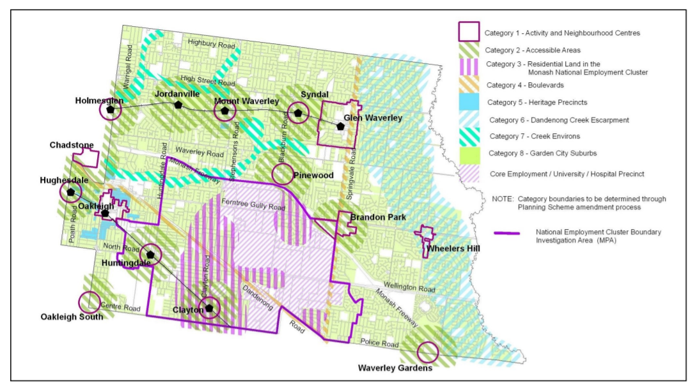Extract from Residential Development Framework Map 3 at clause 21.04-1
Subject land (approx.)

- The clause states that the residential development framework translates the overall aims of the housing strategy into a location plan (Map 3). The Map broadly identifies the preferred location for different types of housing. The Monash National Employment and Cluster is an area of future development potential and, as a character type, is a housing growth area. Objectives in clause 21.04-3 include:
- To locate residential growth within neighbourhood and activity centres, the Monash National Employment Cluster and the boulevards (Springvale Road and Princes Highway) to increase proximity to employment, public transport, shops and services. This will assist to preserve and enhance garden city character and special character in the balance of the municipality.
- To encourage a high standard of architectural design in buildings and landscaping associated with residential development that takes into account environmentally sustainable development.
- I do not recite the strategies in the scheme but have had regard to them.
- The suite of residential zones, including specific schedules, are applied to achieve preferred development outcomes. GRZ6 is part of this implementation. The neighbourhood character objectives in GRZ6 are:
- To facilitate housing diversity in the form of units, townhouses and apartment developments of high quality design and finish.
- To provide an interface between the Clayton Activity Centre, the Monash Employment and Innovation Cluster, the housing growth area and the lower scale surrounding garden city suburban areas.
- To encourage development that respects sensitive residential interfaces and minimises building mass and visual bulk in the streetscape through landscaping in the front setback and breaks and recesses in the built form.
- To promote the preferred garden city character by minimising hard paving throughout the site by limiting the length and width of accessways and limiting paving within open space areas.
- To ensure developments are constructed within an open garden setting through the retention and planting of vegetation, including canopy trees.
- Varied clause 55 Standards B6, B13, B17, B28 and B32 apply.
- Decision guidelines in clause 7.0 of GRZ6 must be considered, in addition to others in clause 32.08 and the scheme including:
- Whether the development provides an appropriate transition to built form on adjoining sites.
- The robustness of proposed materials and finishes.
- The impact of the shape and dimensions of the lot on the ability of the development to meet any requirements of this schedule.
- The location and number of vehicle crossovers.
- The impact of the development on nature strips and street trees.
- The location, quantity and species of vegetation provided.
- Clause 22.01 addresses future residential character. Among its objectives are to encourage new development to achieve architectural and urban design outcomes that positively contribute to neighbourhood character having particular regard to the applicable preferred future character statement for the area. Clause 22.01-3 sets out policy under a range of headings that I have considered, but do not recite. Among them are “general”, “ built form and scale of development”, “vehicle crossings” and “landscaping”.
- Clause 22.01-4 describes the preferred character for the Monash National Employment Cluster and Clayton Activity Centre – Housing Diversity Area and the Housing Growth Area – Clayton Activity Centre and Monash National Employment Cluster in clause 22.01-4:
The Clayton Activity Centre and the cluster more broadly are expected to experience major redevelopment, as one of the key areas for employment growth within Melbourne. As such, the core of the activity centre and the cluster are anticipated to accommodate growth and more diverse housing needs. This area also forms an interface to the surrounding garden city suburbs. New development should provide a transition between these areas.
New housing will generally comprise multi dwelling developments such as units and, where appropriate, low rise apartments. Front and rear setbacks will be less than those preferred in the garden city areas, however will still provide the opportunity for landscaping. Landscaping and open space within developments will remain an important feature for this character area. Canopy trees within developments and separation between buildings will provide visual and environmental amenity for occupants and the residents of existing dwellings. New developments will be designed and constructed to a high standard, ensuring they provide a positive architectural impact.
- Decision guidelines in clause 22.01-5 include:
- The applicable preferred future character statement.
- Whether the development will have an adverse impact on neighbourhood character.
- Whether the development will have an adverse impact on the amenity of adjoining properties.
- Whether the development will have an adverse impact on the environment.
- It is clear that change is expected in this location, including units, within a framework where the preferred future character involves opportunity for landscaping (as underpins the important Garden City policy theme) and ensures a positive architectural impact.
- The Monash National Employment Cluster and Clayton Activity Centre – Housing Diversity Area differs from the Housing Growth Area – Clayton Activity Centre and Monash National Employment Cluster which is within the Residential Growth Zone.
- Other relevant scheme policies and provisions have been listed in the ‘Information’ section, above.

Proposed rooming house Use
- The proposed rooming house land use is not opposed by the Council.
- It is relevant that the specific provision for rooming houses, at clause 52.23, has a purpose to “facilitate the establishment of domestic-scale rooming houses” [emphasis added].
- Clause 52.23 sets out permit exemptions. It does not provide application requirements, decision guidelines, or design or amenity assessment criteria.
- A key issue in the current proceeding is the basis upon which the amenity and layout of the rooming house is assessed. In the absence of specific policy which provides guidance in deciding whether a rooming house presents an acceptable outcome to future occupants, the Council has used parts of clause 22.10 to guide (or as a tool) in assessing acceptability.
- Mr Hocking submits clause 22.10 is not applicable to this proposal. He says the Council’s assessment of the permit application and its submission to the Tribunal operates off the erroneous basis that one policy can be interchanged over a different land use. He submits this is incorrect “both in a statutory sense and in terms of fairness”.
- The clause 22.10 policy states in part:
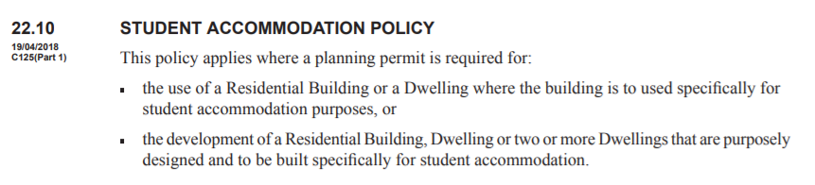
- Clause 21.04 states that clause 22.10 is used:
… to facilitate the provision of high quality student accommodation in preferred locations, which is appropriate in terms of neighbourhood character, the provision of car parking, open space, student amenities and landscaping, and is suitably operated and used in an ongoing manner.
- The policy does not apply, and is not intended to apply, to the current permit application because the permit application is for a purpose-built rooming house and not for a building to be specifically used for student accommodation.
- In discussing this issue with the parties at the hearing, it appears a similar issue arose in another Tribunal proceeding involving a nearby property. In Guo, the Tribunal was considering the review of several conditions on a permit for two rooming houses at No. 36 Koonawarra Street (close to the subject land in the current case). In Guo, the Tribunal said:
As can be seen from the above extract from Melway Online, the subject site is in very close proximity to Monash University, CSIRO and Monash Medical Centre. Mr Hocking submitted that the intended users of the facility are university students but could also include visiting doctors and staff for the medical centre as well as providing short term accommodation for the large variety of businesses found in the area. Based on these submissions, I agree that the policy at clause 22.10 doesn’t strictly apply to this application. However, it does provide a useful guide as to what is an appropriate level of amenity for the facility.
- I have not assessed the proposal against locational criteria that apply to a permit application for student accommodation.
- The applicant states students could seek to rent accommodation in the proposed rooming house in the current proceeding. Even so, the permit application is for a purpose-built rooming house and I find one must be cautious about applying a policy intended for one purpose to a different land use. This is the case, even if it is felt that there is a level of applicability and there are no other available prescriptive guidelines or standards. The same is the case in applying clause 58 to the current case, which was another reference in the Council’s submission. It is open to the Council, as the planning authority, to develop policy relating to rooming houses for inclusion in the scheme if it believes that there are gaps warranting attention.
- Mr Hocking states that the proposed rooming house is to be licensed. Licenses are granted under other legislation that is not before me in this proceeding. At the hearing it was noted that the Consumer Affairs minimum standards are not prescriptive with respect to design details such as bedroom/room sizes. It is not for me to comment upon their adequacy or with respect to other regulations/legislation, but I can appreciate why the Council considers the internal amenity of the proposed facility to be a relevant matter. I address its submissions later in these reasons.

neighbourhood character
- The Council submits the proposal fails to provide an acceptable outcome in terms of the expectations of clause 22.01-4:
New development should be designed to respond to the context of the site within its surrounds and to respect the predominant characteristics of the built form of the surrounding area including the preferred neighbourhood character of the area.
- The Council submits the siting, massing and detailed design do not integrate well with the surrounding residential streetscape and would set an undesirable precedent for the future neighbourhood character of the area. It submits the design is in stark contrast to the urban design and pattern of residential development on neighbouring and near-by lots. It raises concerns with multiple clause 55 standards relating to character including Standards B1, B5 integration with the street, B13 landscaping, B14 access, B18 walls on boundary, and B31 design detail.
- The Council refers to a range of issues including unsympathetic bulk that is exemplified in the use of numerous cantilevered elements, sheer wall elements, unbroken building form mid-rear of the lot, walls on boundary exceeding the standard (in terms of both maximum and average height) and lack of landscaping capacity (particularly given cantilevered first floor elements). Further, as a result of narrow setbacks, and secluded open space areas which are minimum to meet the standard, the ability to sustain substantial vegetation is limited. The Council submits that this is reflected in the landscaping plan which includes two canopy trees that are not commensurate to the almost 8 metres overall building height and are constrained by the limited spacing between Dwellings 1 and 2.
- The applicant challenges these submissions. It contends the scale, size and form of the proposal represent an acceptable outcome. The development is of “high quality design and finish”. It submits the only sensitive residential interface might be argued to be in the “backyard-scape” (bearing in mind all the surrounding land is in an area identified for substantial change) and, among other things, the proposal has significant setbacks from the rear boundary. The applicant refers to the streetscape presentation that minimises building mass and visual bulk, and promotes landscaping. The “preferred garden city character” and “open garden setting” are met.
- The subject land abuts three dwellings to its north and double storey dwellings to its east (part), evident in the Council’s image below.
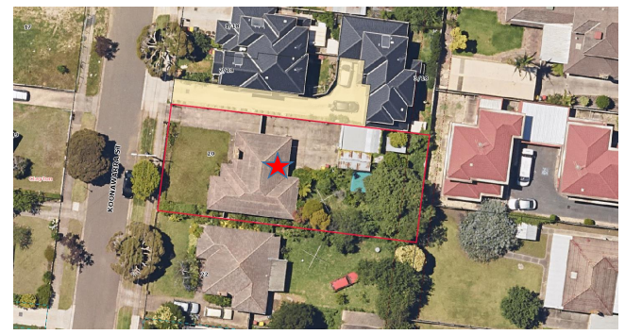
- There is a presence of recent multi-unit developments in the environs of the subject land, although much of the original building stock remains.
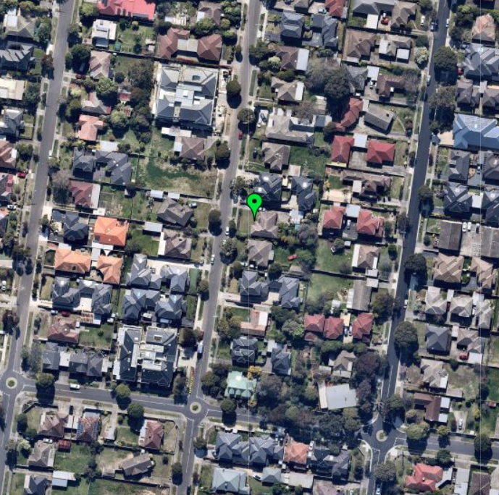
- Recent dwellings include two storeys, sometimes attached forms, and sometimes with two crossovers. There is also the apartment complex at Nos. 27-29 Koonawarra Street, on the north-west corner with Woodside Avenue. Most recent dwellings have pitched roofs and upper level recession but the wider area includes contemporary alternatives to pitched roofs as well as quite sheer wall planes over two floors.
- In considering all submissions and the proposal’s character response, it is relevant to have regard to the land’s physical context and consider how implementation of the strategic directions for the National Employment Cluster and GRZ6 will cause built form to evolve and change. That is to occur in a way that still responds to the Garden City character, as set out in the preferred character statement.
- It is relevant that the proposed development meets all varied clause 55 standards; standards that are part of the implementation of the strategic directions for this location.
- The extent of development proposed on the land is not dissimilar to other lots with three dwellings. The Council relies on the proposal’s failure to include a lower form within the site to respond to the following pattern:
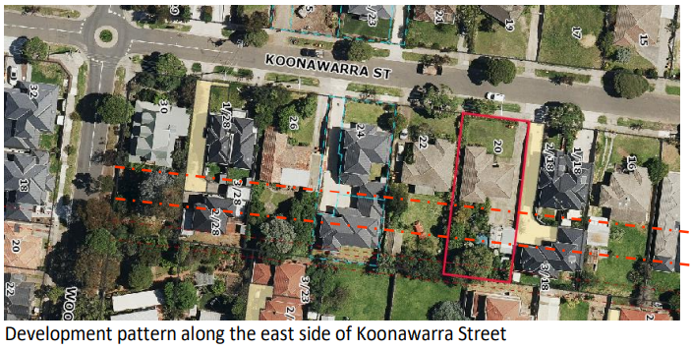
- The pattern referred to involves some built elements in a corridor. It is not a ‘classic’ backyard character, in my view, given the siting of townhouses as part of this corridor.
- Each site has its own context and interfaces to consider. In the current case, two storey development associated with Dwelling 2 and the rooming house is opposite a driveway to the north and secluded private open space to the south, evident in the first floor plan extract, below. The proposal achieves separation between buildings on the subject land. As I refer to below, there are not unacceptable direct amenity impacts arising from the proposed layout. Nor can it be presumed in this location where this current corridor, to the extent that it exits, is a broader character feature or one that will be retained with the redevelopment of sites in this area. Several examples of side-by-side development, and the apartment complex at the Woodside Avenue corner, are indicators of other approved developments nearby that take a different approach.
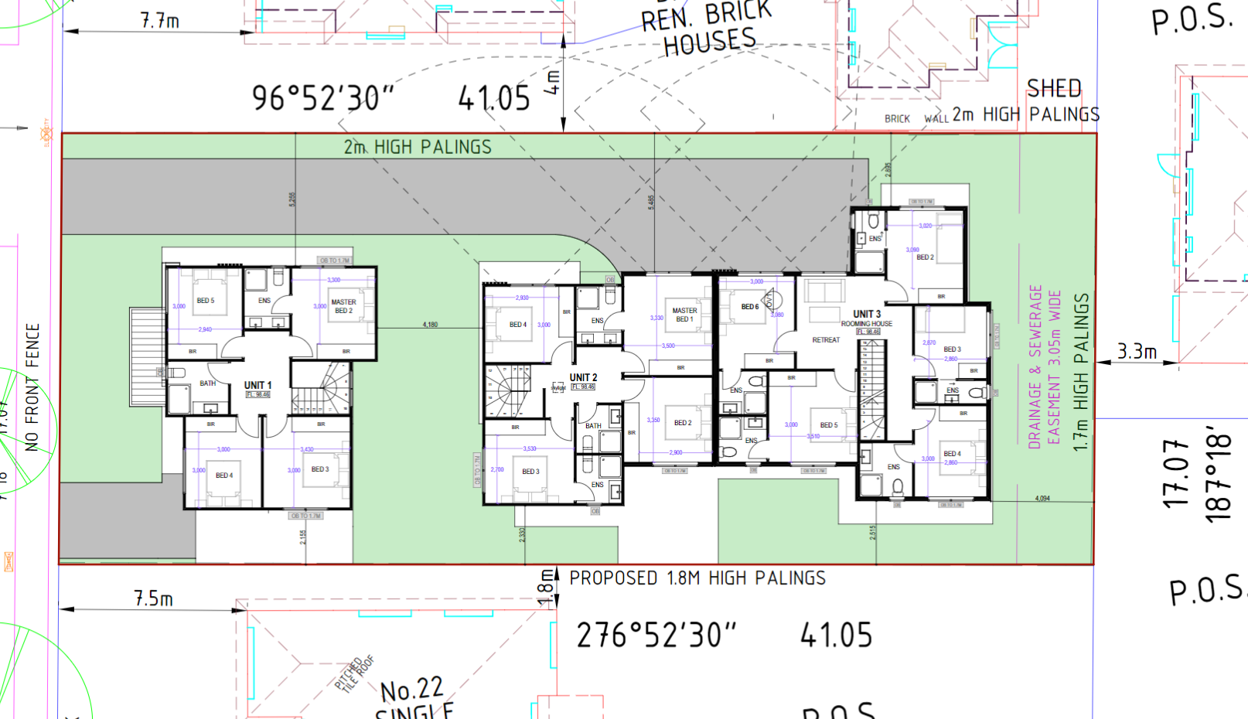
- The proposal’s two crossovers satisfy Standard B14 of clause 55. The use of two crossovers is discouraged in the general policy at clause 22.01. It is not, however, expressly part of the preferred character for this location. Other recent developments have two crossovers including in Koonawarra Street, and the lot widths assist enable the crossovers to be accommodated as well as landscaping to facilitate a garden setting.
- I agree with the Council that the design adopts some sheer two storey elements, with limited upper floor recession. I appreciate that there are architectural differences in this proposal that depart from many, but not all, developments in this location including the proposed angled skillion roof. Having said that, areas of first floor overhang are greater to the north side of Dwelling 2 and the rooming house rather than part of the streetscape presentation. The streetscape presentation is of one dwelling appropriately set back in accordance with Standard B6, with articulation and with some recessive elements as seen below. I am not persuaded the outcome is unacceptable given the policy and the strategic directions for this area.
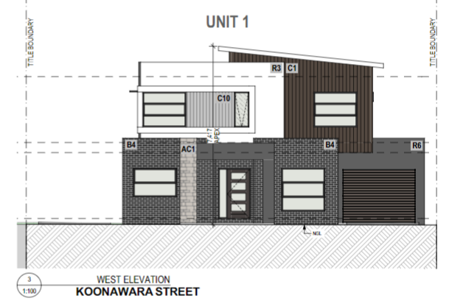
- A further specific matter is that the proposed walls on the southern boundary (garages 1 and 2) exceed the maximum average (3.6 metres rather than 3.2 metres).
- Standard B18 is not met. The objective of clause 55.04-2 is:
To ensure that the location, length and height of a wall on a boundary respects the existing or preferred neighbourhood character and limits the impact on the amenity of existing dwellings.
- The decision guidelines require consideration of matters including:
- The extent to which walls on boundaries are part of the neighbourhood character.
- The impact on the amenity of existing dwellings.
- The opportunity to minimise the length of walls on boundaries by aligning a new wall on a boundary with an existing wall on a lot of an adjoining property.
- The orientation of the boundary that the wall is being built on. The width of the lot.
- The extent to which the slope and retaining walls or fences reduce the effective height of the wall.
- The need to increase the wall height to screen a box gutter.
- The two sections of wall do not align with north-facing windows in the adjacent dwelling to the south. The walls are associated with garages, rather than any other part of the proposed buildings. The walls assist to mitigate, to some extent, the visibility of the upper floor levels from the adjacent land to the south. I have not been persuaded of an amenity impact associated with the varied Standard B18, such as unacceptable overshadowing or daylight loss. In addition, the presence of one garage on a side boundary is not unique in this locality and the garage for Dwelling 1 will not be an unduly prominent streetscape element. I find the objective of clause 55.04-2 is met.
- Overall, I am persuaded that the purpose of clause 32.08 is met and an acceptable balance is achieved. I find the proposal meets the objectives of clause 55 relating to neighbourhood character including clause 55.02-1. The proposal is an acceptable response to the preferred future character.

Vegetation and landscaping

Street tree
- The use of two crossovers causes the new, southern, crossover to be positioned close to a street tree. The Council submits the design will likely adversely affect that tree, further increasing the development’s impact on the streetscape. Its position is based on the advice of the Council’s Senior Arborist. The preferred setback to the street tree is 2.8 metres, whereas 2.1 metres is proposed and preparation works will be closer. The Council says the tree will grow larger and its roots may affect the crossover.
- Based on the arborist report accompanying the permit application, the applicant submits the tree can be retained. A tree management plan formed part of that arborist report.
- The arborist report refers to this tree as a Water Gum, of mature age, with a height of approximately 5 metres. The structural root zone is 1.75 metres and the tree protection zone is 3 metres. The proposed crossover would cause an encroachment into the tree protection zone. On the Council’s calculations this would (with excavations to around 1.8 metres) be an encroachment of 11.32%; above 8.2% cited in the report (and shown in an extract below).
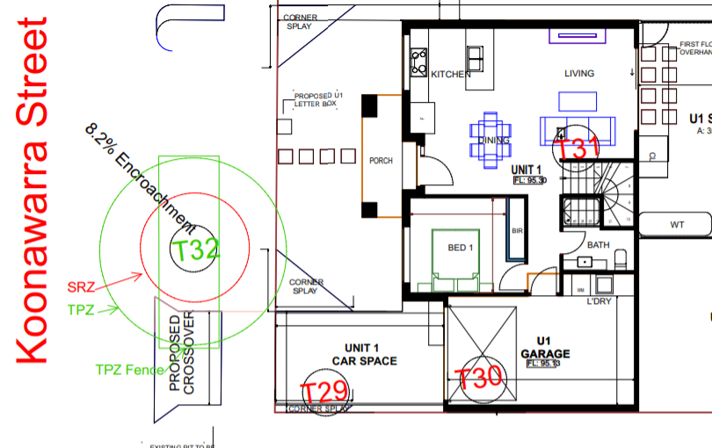
- This encroachment is greater than the 10% guideline in Australian Standard AS 4970-2009 Protection of Trees on Development Sites. The Standard allows for encroachment into the TPZ of 10%, without investigation of the root zone, provided that the size of the TPZ may be extended in another area, contiguous with the original TPZ, to compensate for the encroachment.
- I have not been persuaded that the encroachment will adversely impact on the tree or that a tree management plan cannot properly ensure its retention (with investigation of the root zone being required).
- The Council will need to be satisfied through a tree management plan, and this can be addressed by a permit condition.

Tree removal
- The permit application involves removal of all existing vegetation on the subject land. The Council refers to loss of a tree at the south-east of the site, tree #22. It says the retention of this significant, healthy, established tree should have been incorporated into the design, allowing the development to be instantly supported by this vegetation.
- The arborist report accompanying the permit application refers to this tree as a Native Frangipani with a medium retention value. The report says the tree’s structural condition is “OK” and states it is healthy and vigorous. Some canopy is dead.
- I accept the benefits of its immediate effect, but I have not been persuaded that the tree’s removal is unacceptable and that it must be retained.

Landscaping
- It is relevant to the above findings that the proposed landscaping treatment, in the landscape plan, provides canopy tree planting and associated new landscaping.
- The Council’s submission refers to the lack of vegetation to soften the built form outcome. It says that as a consequence of narrow setbacks, and secluded open space areas which are minimum to meet the standard, there is limited ability to sustain substantial vegetation. As already noted, it submits this is reflected in the landscaping plan which includes two canopy trees that are not commensurate to the almost 8 metres overall building height and are constrained by the limited spacing between Dwellings 1 and 2. It also refers to the lack of landscaping associated with the gun barrel driveway and side setbacks.
- The applicant disagrees. It relies on the landscape plan and the proposal’s compliance with, among others, Standard B13. It also notes that this is a location where three storey development is allowed by clause 32.08.
- Varied Standard B13 includes:
New development should provide or retain:
- At least one canopy tree, plus one canopy tree per 5 metres of site width;
- A mixture of vegetation including indigenous species;
- Vegetation in the front, side and rear setbacks; and
- Vegetation on both sides of accessways.
A canopy tree should reach a mature height at least equal to the maximum building height of the new development.
- I accept the proposed canopy trees do not meet the height referred to in the varied Standard. I am satisfied that species selection can be reviewed to achieve taller (and if needed) narrower canopy trees. There is also scope for two additional trees – including in the front setback and in the rear. These matters can be addressed through a landscape plan endorsed by the Council. The applicant has not opposed a permit condition requiring the provision of at least 1 (one) canopy tree with a minimum mature height of 8 metres within the front and rear yards of each building. In this way, I find the proposal can contribute appropriately to the relevant landscape objectives.

off-site amenity impacts
- The parties agree that the proposal complies with side and rear setback provisions (Standard B17), as it also does in respect of other clause 55.04 requirements for north-facing windows, overlooking, overshadowing and internal views. The proposal is acceptable with respect to these matters.
- There are no details on the plans with respect to external plant and equipment. This can be addressed by permit conditions.

Other clause 55 matters – siting and layout
- The Council refers to multiple additional non-compliances with clause 55 Standards B10 energy efficiency, B12 safety, B14 access, B26 dwelling entry, B28 private open space, B30 storage and B34 site services.
- Having considered the submissions, I am not persuaded there are grounds to refuse a permit, as the relevant objectives are met. I address the key issues next.

Dwelling 1
- The Council considers the proposal is really for two rooming houses. It submits that it is unusual for a freestanding dwelling to be laid out as is the case with Dwelling 1. The Council also refers to a lack of northern light to this dwelling, under-sized spaces, a lack of storage such as a linen cupboard and pantry, and functional issues with the layout. The Council submits the dwelling does not achieve an acceptable level of amenity and would be unlikely to support the needs of a family, which is purportedly its purpose.
- No permission has been sought to use Dwelling 1 as a rooming house.
- The five bedroom dwelling has a constrained living/dining/kitchen area when considering the five bedrooms provided but it not fatally flawed. I note the plans show furniture which does not appear accurately sized, as Council has pointed out. Further detail about the internal fit-out would be helpful and would be expected as part of the further design process. There is scope to modify the internal layout to provide improved communal/shared spaces for a family, through secondary consent or a permit amendment process. I will not, however, direct that modification.

Dwelling 2
- Standard B15 is not met with respect to the proximity of the north-facing living room window to the common driveway. This can be addressed by a permit condition raising the lower sill height to 1.4 metres so as to comply with the Standard.
- The entry to Dwelling 2 is regarded as inadequate and unsafe (Standards B5 and B12). The entry is not directly or indirectly visible from the street and the porch does not project to present an ‘cues’. This is again something that could be improved by a condition requiring a design detail to better mark the entry.

Rooming house
- The Council provides detailed submissions about the layout of the rooming house, including in terms of:
- Bedroom sizes;
- The size and layout of communal facilities;
- The lack of amenities such as mail boxes, details of heating/cooling, telephony/internet, meters for utilities, the design of the storage facilities and the size of the clothes line;
- Outlook, natural light and cross-ventilation;
- Insufficient storage size and for use by separate people.
- In so doing, the Council refers to the ‘requirements’ under clause 22.10 and also notes the provisions of clause 58.
- The issues reflect concerns about the standard of accommodation for the applied-for rooming house use. As discussed above, the proposal is said to fail multiple clause 55 standards, some of which I have addressed earlier.
- The Council’s concern about bedroom sizes does not take account of the entire space available to an occupant. I calculate five of the six rooms as approximately 14.4 – 17.2m², with bedroom 3 being only approximately 10.7m² as a single room. These measurements include robes and private ensuites. Two are more than 16m² and bedrooms 2 and 4 are respectively approximately 15.2m² and 15.3m². The student accommodation policy that the Council relies upon refers to 16m². The smallest room is more concerning but has not been shown to fail to comply with any scheme or other legislative requirement. There is scope to merge rooms should this be proven to fail specific standards/regulations for a rooming house.
- Through the hearing, Mr Hocking has referred to several modifications to respond to the concerns raised by the Council, which can be added as permit conditions. They include some additional storage, operable skylights for upper level and changing obscure glazing to another screening treatment to offer a better outlook from some upper level rooms.
- Access to the rear garage is workable, noting a correcting movement is allowable under the relevant Australian Standard.
- Waste collection can be addressed through the waste management plan, that is required to be to the Council’s satisfaction.
- There is not a basis within the scheme that properly allows me to conclude that the issues raised warrant refusal of a permit.
- As indicated, the rooming house would be the subject of other approvals that will ensure all relevant standards/regulations for the use are met.

Environmental sustainability and energy efficiency
- The Council raises concern about insufficient northern light, particularly for living rooms as well as the adequacy of documentation demonstrating how required environmental performance improvements can be achieved.
- I agree that the ESD material requires revision, including to take account of design changes that will be directed through Condition 1.
- There seems scope to add a window in the ground floor northern elevation of the rooming house (such as a highlight or slot window). I will require this change by a permit condition.

PARKING

Cars
- Car parking for the two dwellings meets the requirements of clause 52.06-2.
- Pursuant to clause 52.06-5, the rooming house must provide one car space to each four bedrooms. The rooming house has six bedrooms, requiring one space (rounded down). The plans show two spaces.
- The Council states accessible parking has not been provided for the rooming house. It notes this is not a requirement of the scheme but is a relevant matter under the Building Code of Australia for a rooming house. If one accessible space is required, then only one car space could be accommodated in the garage servicing the rooming house. The Council submits this would create additional on-street parking and potentially conflict between users of the rooming house.
- The applicant disagrees there would be a requirement for an accessible space for the rooming house, based on the Disability (Access to Premises – Buildings) Standards 2010.
- I do not need to resolve this disagreement. The proposal meets the scheme’s provisions and no permit is required under clause 52.06 with respect to the number of on-site car spaces. If an accessible space is required for the rooming house by other legislation, the proposal would still comply with clause 52.06-2 and would not trigger a new permission.
- A traffic assessment accompanied the permit application and I have not been persuaded that the design fails clause 52.06-9.

Bicycles
- The Council accepts that no bicycle storage is required for the proposed rooming house (residential building) pursuant to clause 52.34. It relies on clause 22.10 in questioning the lack of on-site bicycle spaces and referring to the lack of excess area to provide any spaces in the already-constrained garage.
- The applicant agrees that bicycle parking is not required by clause 52.34. Nonetheless, the applicant suggests two spaces can be provided on the north side of northern wall of the rooming house (living room). This can be accommodated through permit conditions.

Conditions
- I have considered submissions about permit conditions, mindful of some modifications to the rooming house offered by the applicant to which I have referred.
- The applicant opposes a section 173 agreement but accepts the matters in proposed Condition 6 as permit conditions. I agree that a section 173 agreement is not required but key matters can form part of conditions relating to the rooming house use and management. I will not include Condition 6e but the Council may add this as a note.
- I further accept the applicant’s submissions with respect to the allowable number of occupants of the rooming house.
- I will require a tree management plan to form part of the Condition 1 requirements.

Conclusion
- Redevelopment of the subject land is not in contention in this proceeding. While I understand the basis of the Council’s extensive criticisms of the proposed rooming house, I have set out the reasons why I consider the proposal is acceptable based on the applicable provisions of the scheme. I also find the proposal represents a suitable character outcome given the way in which development has occurred, and is guided for the future, in this location. Off-site amenity impacts are acceptable and the street tree can be protected through a tree management plan.
- For the above reasons, the responsible authority’s decision is set aside. A permit is granted subject to the conditions in Appendix A.

Margaret Baird
Senior Member

Appendix A – Permit Conditions

Permit Application No: | TPA/51493
Land: | 20 Koonawarra Street  CLAYTON VIC 3168

What the permit allows
In accordance with the endorsed plans:
- Use of the land for one rooming house, and construction of two double storey dwellings and one double storey building to be used for the purposes of a rooming house.

Conditions:

Amended Plans Required
- Before the development commences, amended plans to the satisfaction of the Responsible Authority must be submitted to and approved by the Responsible Authority. The plans must be drawn to scale and dimensioned. When the plans are endorsed they will then form part of the Permit. The plans must be generally in accordance with the plans submitted with the application but modified to show:
  - Rooming house:
    - The provision of bicycle storage for at least two bicycles;
    - Additional external storage shed;
    - Operable skylights for upper level bedrooms;
    - Modifications to the obscure glazing for upper level bedrooms to allow a different form of screening that limits overlooking but achieves some outlook in accordance with clause 55.04-6;
    - A window in the ground floor northern elevation of the rooming house (eg. a highlight or slot window).
  - Dwelling 2:
    - Design details to better mark the entry to Dwelling 2;
    - The north-facing ground floor living room window modified to comply with Standard B15 of clause 55.03.
  - Plans updated to reflect all assumptions relied upon within the Sustainable Design Assessment to be endorsed under Condition 4 of this permit.
  - Location of external plant and equipment such as air conditioning units.
  - Plans updated to reflect all assumptions relied upon within the Waste Management Plan to be endorsed under Condition 5 of this permit.
  - The street tree identified to be shown to be retained and provided with tree protection fencing in accordance with Australian Standard AS4970:2009 - Protection of Trees on Development Sites.
  - A Tree Management Plan and accompanying arborist report to ensure protection of the street tree as a consequence of the proposed new crossover to Dwelling 1.
  - A Landscape Plan prepared in accordance with Condition 3 of this permit.
  - A Sustainable Design Assessment in accordance with Condition 4 of this permit.
  - A Waste Management Plan prepared in accordance with Condition 5 of this Permit.

No Alteration or Changes
- The development as shown on the endorsed plans must not be altered without the prior written consent of the Responsible Authority.

Landscape Plan
- Concurrent with the endorsement of any plans pursuant to Condition 1, a landscape plan prepared by a Landscape Architect or a suitably qualified or experienced landscape designer, drawn to scale and dimensioned must be submitted to and approved by the Responsible Authority. When endorsed, the plan will form part of the Permit. The Landscape Plan must show:
  - Any changes required by Condition 1;
  - The provision of tree protection fencing as specified within Condition 1;
  - Provision of canopy trees with spreading crowns located throughout the site including the major open space areas of the development generally as depicted within the drawings submitted with the application;
  - Planting to soften the appearance of hard surface areas such as driveways and other paved areas;
  - A schedule of all proposed trees, shrubs and ground cover, which will include the size of all plants (at planting and at maturity), their location, botanical names and the location of all areas to be covered by grass, lawn, mulch or other surface material;
  - The location and details of all fencing;
  - The extent of any cut, fill, embankments or retaining walls associated with the landscape treatment of the site;
  - The provision of at least 1 (one) canopy tree with a minimum mature height of 8m within the front and rear yards of each building;
  - Details of all proposed hard surface materials including pathways, patio or decked areas; raingarden(s) referred to with the STORM report detailed on the landscaping plan; and areas of driveway / grades indicated.
When approved the plan will be endorsed and will then form part of the permit.

Sustainable Design Assessment
- Concurrent with the endorsement of plans in accordance with Condition 1, an amended Sustainable Design Assessment (SDA) to the satisfaction of the Responsible Authority must be submitted to and approved by the Responsible Authority. When approved, the amended SDA will be endorsed and will form part of this permit. The amended SDA must be generally in accordance with the SDA submitted with the application, but modified to show:
  - Any changes required by Condition 1;
  - STORM report corrected / modified to ensure consistency with development plans; and
  - STORM treatment result must remain at least 100%.

Ongoing Sustainable Management Plan (SMP) Requirement
- The provisions, recommendations and requirements of the endorsed Sustainable Management Plan must be implemented and complied with to the satisfaction of the Responsible Authority.

Waste Management
- Concurrent with the endorsement of any plans pursuant to Condition 1, a Waste Management Plan must be submitted and approved by the Responsible Authority. The amended Waste Management Plan must be generally in accordance with the Waste Management Plan submitted with the application but modified to show, to the satisfaction of the Responsible Authority:
  - The purpose as stated in the City of Monash Waste Management Guide for Applicants to be included;
  - A plan of the waste storage area proposed;
  - The waste storage area to be separate from the garage and provided within a sealed, vermin-proof room;
  - A detailed description of the development including TPA number, proposed uses, number of levels and existing land use;
  - Revision of food waste calculation for proposed use given higher generation rate anticipated for proposed use (10L/week/user);
  - The provision of a food waste recycling system;
  - A 240L dedicated glass bin to be provided;
  - In-dwelling and recreational receptacles described;
  - Location of hard waste to be confirmed;
  - Swept path diagram of waste vehicle including collection location; and
  - Details of sewer drain and bin washing facilities within waste storage area.
The provisions, recommendations and requirements of the endorsed Waste Management Plan must be implemented and complied with to the satisfaction of the Responsible Authority.

Rooming House Use
- Each of the rooming house rooms designed for a single occupant must only be used by a single occupant and rooming house rooms designed for two persons must not be used for any more than two persons.
- No more than nine (9) occupants can reside in the rooming house at any given time.
- Car parking spaces are only permitted to be used by the occupants of the units and their visitors and must not be subdivided, on-sold or leased to any other person.
- All common areas on the endorsed plans must be made available and accessible to a resident on a shared basis at all times.

Rooming House Management Plan
- Prior to the commencement of the use, a Management Plan for the Rooming House is to be prepared, submitted to and approved by the Responsible Authority. The Management Plan must include the following:
  - The contact details of the responsible contact person displayed in a manner and location so that it is visible to any person entering the site. This information is to be updated as required immediately following any change to the nominated responsible contact person.
  - Details of the terms of accommodation and the maximum number of persons to be accommodated onsite.
  - Car parking spaces are only permitted to be used by the occupants of the units and their visitors and must not be subdivided, on-sold or leased to any other person.
  - A register that documents the allocation of car spaces.
  - Maintenance of buildings and grounds, including all landscaped areas.
  - Provision of information to students on local public transport and amenities in the area.
  - Permanent display of the Management Plan in a common area accessible to all residents of the rooming house facility.

Landscaping and Street Tree Protection
- Before the occupation of the buildings allowed by this permit, landscaping works as shown on the endorsed plans must be completed to the satisfaction of the Responsible Authority and then maintained to the satisfaction of the Responsible Authority.
- All landscaping works shown on the endorsed landscape plan(s) must be maintained and any dead, diseased or damaged plants replaced, all to the satisfaction of the Responsible Authority.
- Before any development (including demolition) starts on the land, a tree protection fence must be erected around trees identified within the endorsed Tree Management Plan to define a “Tree Protection Zone” as detailed in the endorsed arborist report. The fence must be constructed as specified in the endorsed arborist report. The tree protection fence must remain in place until all construction is completed on the land, except with the prior written consent of the Responsible Authority.

Car Parking and Accessways
- Before the use starts or any building is occupied, areas set aside for parked vehicles and access lanes as shown on the endorsed plans must be:
  - Constructed to the satisfaction of the Responsible Authority;
  - Properly formed to such levels that they can be used in accordance with the plans;
  - Surfaced with an all-weather sealcoat to the satisfaction of the Responsible Authority;
  - Drained, maintained and not used for any other purpose to the satisfaction of the Responsible Authority;
  - Line-marked to indicate each car space and all access lanes to the satisfaction of the Responsible Authority.
Parking areas and access lanes must be kept available for these purposes at all times.
- Low intensity / baffled lighting must be provided to ensure that car park areas and pedestrian accessways are adequately illuminated without any unreasonable loss of amenity to the surrounding area, to the satisfaction of the Responsible Authority.
- Any new vehicle crossover or modification to an existing vehicle crossover must be constructed to the satisfaction of the Responsible Authority.

Privacy screens
- Prior to the occupancy of the development, all screening and other measures to prevent overlooking as shown on the endorsed plans must be installed to the satisfaction of the Responsible Authority. Once installed the screening and other measures must be maintained to the satisfaction of the Responsible Authority. The use of obscure film fixed to transparent windows is not considered to be 'obscure glazing' or an appropriate response to screen overlooking.

Services and Plant Equipment
- All pipes (except down-pipes), fixtures, fittings and vents servicing any building on the site must be concealed in service ducts or otherwise hidden from external view, to the satisfaction of the Responsible Authority.
- No equipment, services, architectural features or structures of any kind, including telecommunication facilities, other than those shown on the endorsed plans shall be permitted above the roof level of the building unless otherwise agreed to in writing by the Responsible Authority.
- Any required fire services, electricity supply, gas and water meter boxes must be discreetly located and/or screened to compliment the development to the satisfaction of the Responsible Authority. Any required services must be clearly detailed on endorsed plans forming part of this permit.
- No bin or receptacle or any form of rubbish or refuse shall be allowed to remain in view of the public and no odour shall be emitted from any receptacle so as to cause offence to persons outside the land.

Drainage & Stormwater
- The site must be drained to the satisfaction of the Responsible Authority.
- No polluted and/or sediment laden runoff is to be discharged directly or indirectly into Council's drains or watercourses during and after development, to the satisfaction of the Responsible Authority.
- Stormwater discharge is to be detained on site to the predevelopment level of peak stormwater discharge. Approval of any detention system is required by the City of Monash prior to works commencing.

Time for Starting and Completion
- In accordance with section 68 of the Planning and Environment Act 1987, this permit will expire if one of the following circumstances applies:
  - The development has not started before 2 (two) years from the date of issue.
  - The development is not completed before 4 (four) years from the date of issue.
  - The use has not commenced within 2 (two) years from completion of the development.
In accordance with section 69 of the Planning and Environment Act 1987, the responsible authority may extend the periods referred to if a request is made in writing before the permit expires, or:
  - within six (6) months afterwards if the use or the development has not commenced; or
  - within twelve (12) months afterwards if the development has not been completed.
Council and the Victorian Civil and Administrative Tribunal are unable to approve requests outside of the relevant time frame.

- End of conditions -

There is no dispute that the mandatory requirements are met.
The submissions and evidence of the parties, supporting exhibits, and the statements of grounds filed have all been considered in the determination of the proceeding. In accordance with the Tribunal’s practice, not all of this material will be cited or referred to in these reasons.
This is the amended permit application lodged with the Council.
Which is identical to the plan in the Housing Strategy 2014.
Clause 21.04-1.
Guo v Monash CC [2020] VCAT 930. This proceeding was a review of conditions under section 80 of the Planning and Environment Act 1987.
Ibid, [10], footnotes excluded.
I understand that other legislation regulates rooming houses, such as under the Residential Tenancies Act 1997 and the Public Health and Wellbeing Regulations 2009.
Contrasting with some other preferred character statements in clause 22.01. I note the objectives in GRZ6 refer to the length and width of accessways but not expressly to the number.

