VICTORIAN CIVIL AND ADMINISTRATIVE TRIBUNAL

|  |  |
| --- | --- |
| planning and environment LIST | vcat reference No. P11510/2021  Permit Application no.TPA/52663 |
| CATCHWORDS | |
| Section 77 *Planning and Environment Act 1987*; Monash Planning Scheme; Commercial 1 Zone; local activity centre; Internal amenity; Car parking | |

|  |  |
| --- | --- |
| **Applicant** | Tender Prey Pty Ltd |

|  |  |
| --- | --- |
| **Responsible Authority** | Monash City Council |
| **Referral Authorities** | Head, Transport for Victoria |
|  | Melbourne Water |

|  |  |
| --- | --- |
| SUBJECT LAND | 207 High Street Road  ASHWOOD VIC 3147 |

|  |  |
| --- | --- |
| HEARING TYPE | Hearing |

|  |  |
| --- | --- |
| DATE OF HEARING | 28 February 2022 |

|  |  |
| --- | --- |
| DATE OF ORDER | 23 March 2022 |

|  |  |
| --- | --- |
| CITATION | Tender Prey Pty Ltd v Monash CC [2022] VCAT 319 |

# Order

1. Pursuant to section 127 of the *Victorian Civil and Administrative Tribunal Act* *1998* the application is amended by changing the name of the applicant to:

Tender Prey Pty Ltd

1. Pursuant to clause 64 of Schedule 1 of the *Victorian Civil and Administrative Tribunal Act 1998* the permit application is amended by changing the name of the permit applicant to:

Tender Prey Pty Ltd

1. Pursuant to clause 64 of Schedule 1 of the *Victorian Civil and Administrative Tribunal Act 1998*, the permit application is amended by substituting for the permit application plans, the following plans filed with the Tribunal:

|  |  |
| --- | --- |
| * Prepared by: | DCA Design |
| * Drawing numbers: | Revision E TP00-TP12 |
| * Dated: | November 2021 |

1. In application P11510/2021 the decision of the responsible authority is set aside.
2. In planning permit application TPA/52663 a permit is granted and directed to be issued for the land at 207 High Street Road ASHWOOD VIC 3147 in accordance with the endorsed plans and the conditions set out in Appendix A. The permit allows:

* Buildings and works within a Commercial 1 Zone (CZ1) and Special Building Overlay (SBO1) to construct a shop with an associated caretaker’s house and four (4) triple storey dwellings and a reduction in the car parking requirements of Clause 52.06 of the Monash Planning Scheme.

|  |  |  |
| --- | --- | --- |
| Megan Carew  **Member** |  |  |

# Appearances

|  |  |
| --- | --- |
| For Tender Prey Pty Ltd | H Gerrard, Town Planning Consultant, Glossop Planning. He called T Hardingham, Traffic Engineer to give evidence. |
| For Monash City Council | G Gilfedder, Town Planning Consultant, Currie and Brown |
| For Head, Transport for Victoria | No appearance[1] |
| For Melbourne Water | No appearance |

# Information

|  |  |
| --- | --- |
| Description of proposal | To construct a mixed-use development for four dwellings and one retail premises with an associated caretaker’s house. |
| Nature of proceeding | Application under section 77 of the *Planning and Environment Act 1987* – to review the refusal to grant a permit. |
| Planning scheme | Monash Planning Scheme |
| Zone and overlays | Commercial 1 Zone (C1Z)  Special Building Overlay (SBO) as to part  High Street Road is within the Transport Zone 2- Principal Road Network |
| Permit requirements | Clause 34.01-4- Buildings and works in the C1Z  Clause 44.05-2-Buildings and works in the SBO.  Clause 52.06- Reduction in car parking requirements. |
| Relevant scheme policies and provisions | Clauses 11, 15, 16, 17, 18, 19, 21, 22.02, 22.04, 22.05, 22.13, 34.01, 44.05, 52.06, 52.29, 53.18, 55, 65, 72.01 |
| Land description | The site is located on the north side of High Street Road and is part of a small group of commercial premises/ shops. The site is developed with a double storey building containing a vacant shop at ground level and a dwelling above. The site has frontage of approximately 6.09 m and a total site area of 272.5m2.  It abuts a laneway to the west and north sides of the property and there is an existing garage to the north. There is a significant slope from the rear to the front of the site. There is a large gum tree in the north west corner of the site. To the west is a newly constructed child care centre.To the north west is a landscape gardening supplies business. To the rear is an education centr3e. |
| Tribunal inspection | I inspected the review site and its surrounds following the hearing. |

Figure 1: Review site

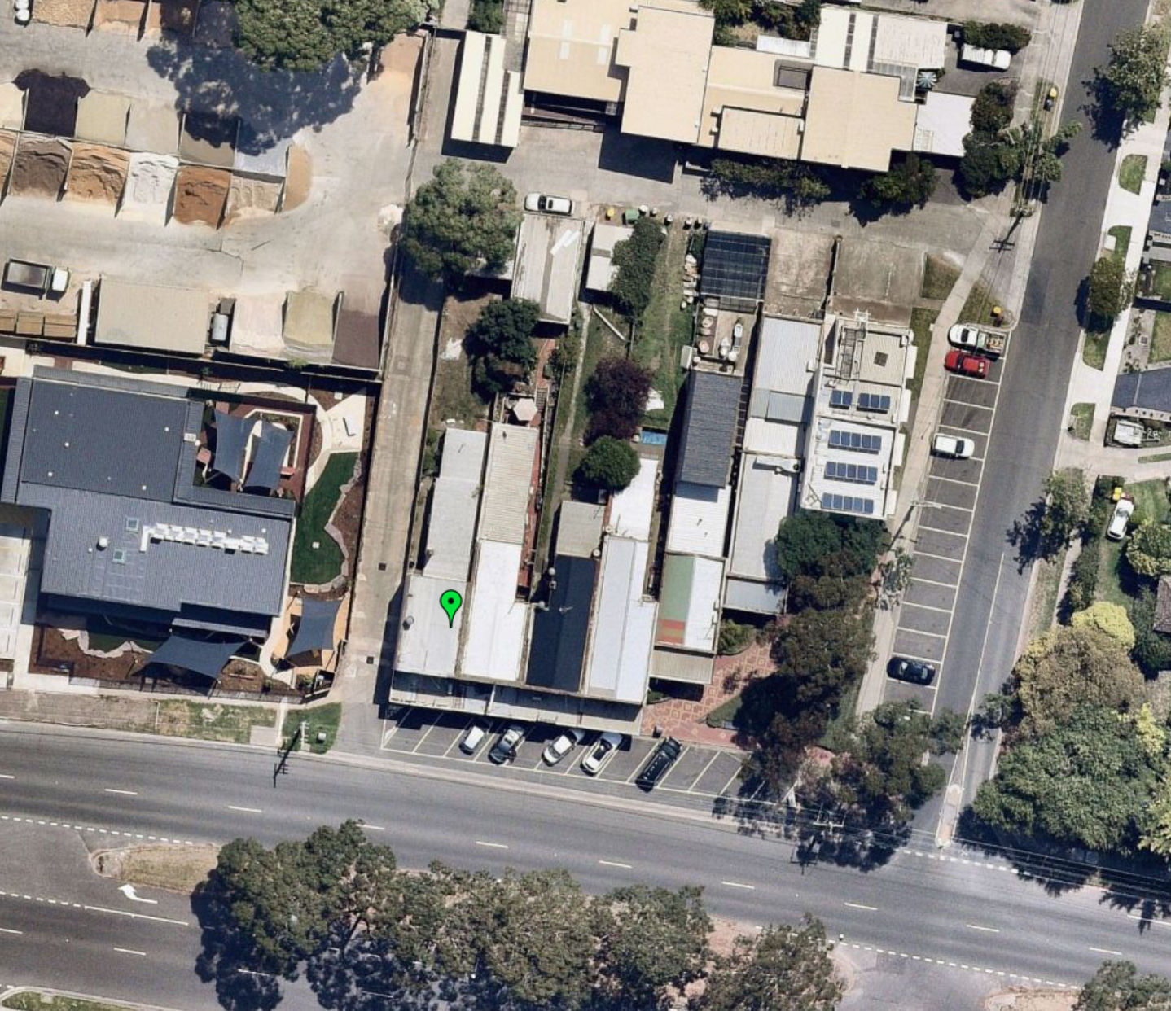

# Reasons[2]

## What is this proceeding about?

1. The applicant seeks to introduce a mixed-use development to this small strip activity centre with a retail premises at ground floor with caretakers dwelling above and four new dwellings behind.
2. Council did not support the proposal. Council says the proposal creates significant bulk and massing, results in poor internal amenity for future occupants and provides inadequate car parking.
3. Having inspected the site and surrounds and considered the policy framework, the purpose of the zone, the decision guidelines of the relevant clauses of the Monash Planning Scheme, the submissions of the parties and the evidence before me, I have determined to set aside the decision of the Responsible Authority. I have found that, subject to conditions, the proposal is well-conceived and is consistent with the Commercial 1 zoning and location within this small activity centre. My reasons are set out below.

## What are my findings?

1. Various submissions were put to me regarding the site’s context and the expectation for more intensive use under the policy framework. The parties accepted that at a broad level, there is support in the planning scheme for more intensive use and development of this site given its zoning and location and proximity to services.
2. I find that the mixed-use proposal is fully supported by the Commercial 1 Zone that has the objectives *to create vibrant mixed use commercial centres for retail, office, business, entertainment, and community uses* and *to provide for residential uses at densities complementary to the role and scale of the commercial centre*. No planning approval is required for the uses proposed (noting that the frontage at ground level is to High Street Road and access to the residential components is taken from the side lane).
3. The Council’s key concerns were the built form proposed, the suitability of the internal amenity and car parking. I address these matters below

## IS THE BUILT FORM ACCEPTABLE?

1. The applicant submits that the amended plans provide a comfortable built form response. In contrast, Council submits that:

This is a robust context but a location with limited constraints and a canvas that provides for innovative design excellence in a new development. The proposal however does not achieve design excellence with limited articulation or breaks to provide interest to this bookend site.

1. The proposal is three storey in scale in the context of adjoining commercial development which is double storey. I find that the overall height is acceptable in its context within the Commercial 1 Zone and the scale of the childcare centre to the west.
2. The shop front will face the street at ground floor and will provide for an active frontage to High Street Road. I have required the return of the glazing to the western elevation to address traffic considerations (see discussion below) and to assist activation. Council was concerned about the massing of the upper levels to the street, submitting that the ‘presentation and scale is at odds with the other commercial buildings and would be improved by the third floor being recessed’.
3. In contrast, the applicant submitted that:

To maintain architectural interest in the front façade, rather than providing a standard ‘2 + 1’ built form, the first floor has also been recessed from the ground floor (though not to the extent of the second floor) with the balcony of the second floor partly cantilevering over the first floor. As depicted on the 3D images provided it is submitted that this adds depth to the façade and provides for greater architectural and visual enhancement of the development when viewed from High Street Road.

1. I find that the presentation and scale to the frontage is acceptable in the context of the robust location on a main road and within a commercial grouping. However, I have required the first floor balcony be extended to the street to provide for a street edge that more closely matches the traditional shop form. This extension could be used for a planter if desired. In addition, I have required a detail treatment of the boundary wall to the adjoining property to the east where it is exposed.
2. The interface of the dwellings is to the laneway. At ground floor the frontage will be dominated by the garaging and entries. However, each also provides a small home office area at ground floor which will in my view provide for sufficient activation and passive surveillance of the laneway.
3. Council was critical of the western and northern elevations including the choice of materials, colours and finishes and the level of articulation provided. Council considered that the Juliet balconies should be deleted, and the bathrooms set back to provide for greater articulation. In addition, Council considered that the balcony to the north should be squared.
4. The permit applicant considered that the proposal provided a good level of articulation and did not support the squaring of the end of the triangular balcony. The applicant submitted that this space could be used for a planter or similar.
5. I find that the level of articulation is acceptable in this robust location. However, I agree with Council that the materials, colours and finishes require refinement. Specifically, I find that the profile and detail of the timber look weatherboard should be specified, and that materiality should be simplified with the balustrade to the ‘Juliet’ elements to match the balconies. In respect to the rear balcony, I find that from an urban design perspective this corner should be squared to provide a consistent design approach to each elevation. I have required these matters to be considered in the permit conditions.
6. There was no dispute that the proposal responded to external amenity concerns given that the site has a limited interface with residential properties.

## LAND USE CONFLICT WITH Childcare centre and LANDSCAPING SUPPLIES BUSINESS

1. The depth of the block and narrow width makes it difficult to avoid orientation of the dwellings to the side elevation and each dwelling has its balcony and windows orientated to either the north or west.
2. The adjoining childcare centre has play spaces at both ground and first floor to its eastern side. Noise associated with this use has the potential to impact on future residents of the proposed dwellings. However, I am satisfied that this is acceptable because of the location of the review site within the Commercial 1 Zone where amenity expectations differ from a residential area, the separation provided by the laneway and the proximity to the main road which would generate significant traffic noise.
3. Of greater concern is the impact of the landscape supplies business. As discussed at the hearing, this adjoining business could have significant amenity implications for future residents in terms of machinery noise, truck use of the laneway and dust. On my inspection I observed trucks entering the site from the laneway and the operation of machinery for loading (see Figure 2). The landscaping supplies business is located within the General Residential Zone and I understand that it has been present for many years. While I accept that, in time, the site may be redeveloped, the proposal also needs to provide for acceptable internal amenity in the interim.
4. I find that if dwellings are to be introduced in this location, that there should be some consideration to the protection of the amenity of future occupants from this longstanding use. I have required double glazing to be provided to all windows and doors on these elevations (the Sustainable Design Assessment only requires this to habitable rooms) or an alternative treatment to these elevations to address noise from the adjoining landscape supplies business and I have included this as a conditions.
5. While I have not required it, I consider that the incorporation of openable/ moveable screens to balcony areas would be beneficial to enable additional amenity to these areas and that such measures could be considered by the applicant in the design of any final plans (such screens could also potentially provide some western sun protection).

Figure 2 Photos Tribunal’s own

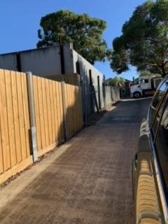 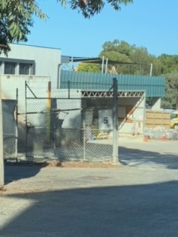

## INTERNAL AMENITY

1. Council submitted that the dwellings would have poor internal amenity due to their orientation, lack of shading to windows, lack of storage and access from the laneway.
2. I find that, subject to addressing the land use conflict discussed above, that the proposed dwellings will have an acceptable level of internal amenity. As set out above, I am satisfied that access from the laneway is acceptable and that passive surveillance has been provided for. While small, the dwellings have bedrooms and living areas of reasonable size. Windows and balconies are not required to be screened. The dwellings are located close to facilities and larger areas of public open space.
3. I note that the areas of the balconies for dwellings 2-4 are shown on the plans as having less than 8m2 in area. The applicant submits that this is an error. Permit conditions can address this matter.

## CAR PARKING and Traffic

1. The proposal provides for the car parking requirement for the proposed shop use within a car stacker, together with the car space for the associated caretaker’s house. The car stacker is a pit type. Access to the pit space requires the car parked on the lid to vacate before the pit space can rise to ground level. The parties agreed that as the car stacker spaces are not individually accessible, the two car spaces should be allocated to the shop and its associated dwelling (which would be a caretaker’s house).
2. All car parking associated with the residents of the four dwellings is provided on the review site in accordance with the requirements of Clause 52.06 of the planning Scheme.
3. The proposal requires a residential visitor car space which is not provided for. Council’s traffic engineers had no objection to the reduction in car parking numbers in this area. I find that the reduction of one visitor car space is acceptable given that this is an area with reasonable access to bus services on the main road.
4. The evidence of Mr Hardingham found that the use of the laneways to access the garages was appropriate and that the swept paths would be acceptable. However, the evidence did not correctly identify the width of the existing laneway as per the land title as identified by Mr Gilfedder. Mr Hardingham provided the following advice:

Harris from DCA confirms that the base survey plan shows the width of the laneway to the west of the subject site as 4.75m.

This is the width used in the swept path diagrams.

The reference is my evidence to 5.3m is incorrect and it should read 4.75m based on the survey plan.

The Council old subdivision plan showing “15 feet” would equate to a width of 4.6m.

I am not sure why there would be a difference (4.6m vs 4.75m) but the survey plan should be the most accurate.

A “re-establishment survey” may be required to confirm exact boundaries, but the small difference should not be an issue in regards to the swept paths.

1. I find that it is acceptable to use the laneways for access, noting that the northern car space for dwelling 5 is located similarly to the existing garage on the land. Pedestrian safety is addressed due to the width of the laneways and the provision of refuges at the dwelling entry points. The slightly narrower width of the laneway (if realised) would constrain access to the proposed garages. The permit applicant identified that it would be possible to further widen the entry doors if required for each garage to provide for improved access. I find that access is acceptable, including the need for a corrective manoeuvre as shown in the evidence. I have required amended swept paths to reflect the title dimensions and for the plans to address any changes required in the permit conditions.
2. The suitability of the car stacker is a little more problematic. Council identified that there was a need for an access shaft to be provided that would normally be located at the end resulting in the need for a longer garage. The permit applicant advised that this can be provided to the side of the stacker and the evidence of Mr Hardingham identified how this could be accommodated. The conditions would require this to be shown on the plans.
3. Council was also concerned about the availability of space around the stacker. Mr Hardingham explained that there are no stacker columns above the pit. I am satisfied that the space around the stacker at ground level is acceptable.
4. Mr Hardingham noted that there is no corner splay proposed at the south-west corner of the site as this matches the existing situation. He considered that if Council desired, they could install a convex mirror on the western side of the laneway adjacent to the footpath and angled to allow exiting drivers and any pedestrians on the footpath approaching from the east to have a view of each other. As discussed at the hearing the provision of a glazed return to the shop front on the corner would also potentially provide for improved visibility at this location and I have required this by condition.
5. I am satisfied that the traffic generated by the proposal can be accommodated within the surrounding road network based on the evidence of Mr Hardingham. The trips generated by the proposed development (one trip every 20 minutes on average in each peak) would be expected to be readily accommodated by the laneway and the surrounding street network and would be expected to have no significant impact on the safety and operation of the surrounding road network.

## What conditions are appropriate?

1. In determining the conditions of permit I have had regard to the draft conditions provided by the Council, the submissions of the parties, the evidence before me and the matters set out in my reasons above.
2. I have amended the tree protection conditions to address the possible removal of this tree by the neighbour.
3. I have simplified the Construction Management Plan condition and included specific reference to traffic management within the laneways.
4. The parties agreed that a longer permit expiry was acceptable.

## Conclusion

1. For the reasons given above, the decision of the responsible authority is set aside. A permit is granted subject to conditions.

|  |  |  |
| --- | --- | --- |
| Megan Carew  **Member** |  |  |

# Appendix A – Permit Conditions

|  |  |
| --- | --- |
| Permit Application No | TPA/52663 |
| Land | 207 High Street Road  ASHWOOD VIC 3147 |

|  |
| --- |
| What the permit allowS |
| In accordance with the endorsed plans:   * Buildings and works within a Commercial 1 Zone (CZ1) and Special Building Overlay (SBO1) to construct a shop with an associated caretaker’s house and four (4) triple storey dwellings and a reduction in the car parking requirements of Clause 52.06 of the Monash Planning Scheme. |

## Conditions

1. Before the development starts, amended plans drawn to scale and correctly dimensioned must be submitted to the satisfaction of and approved by the Responsible Authority. When approved, the plans will be endorsed and then form part of the Permit. The plans must be generally in accordance with the development plans prepared by DCA Design (Revision E) dated November 2021 but modified to show:
   1. Dwelling 1 to be delineated as a caretaker’s house.
   2. Corrected area schedule including the correct size of the balconies.
   3. A detailed design of the carparking stacker system allocated to the shop and associated caretaker’s house showing the location of the maintenance pit.
   4. Correction to the internal ground floor wall below the stair to allow bins to move to the garage of shop/caretaker’s house.
   5. Swept paths diagrams that are based on the correct width of laneway as per the Certificate of Title or alternatively as determined by a title reestablishment survey.
   6. Any changes to the width of the garages required to accommodate the correct laneway width.
   7. Details of how the grade of the laneway will be managed to allow transition of grade into the garages.
   8. Return of the shop window to the western elevation in the southwest corner of the building.
   9. An amended materials, colours and finishes schedule that includes:
      1. Detail of the type, profile and colour of the timber look weatherboards.
      2. The balustrade of the ‘Juliet” balcony to the bedrooms on the first floor to the bedrooms of Dwellings 2 – 4 to be matched to the balconies.
      3. Details of the finish of the exposed wing boundary wall at second floor level on the eastern side to provide visual interest.
   10. Extension of the first floor balcony of the caretaker’s dwelling to the front boundary.
   11. Redesign of the shape of the balcony associated with Dwelling 5 to provide a minimum area of 8 square metres, minimum depth of 1.6 metres and removal of sharp internal corners including any consequential changes to the layout of the dwelling.
   12. A revised Waste Management Plan in accordance with Condition 3 to accommodate:
       1. Projected waste generation rates for a mixed used development; and
       2. On site storage for the bins associated with the commercial tenancy.
   13. Provision for sun screening measures or alternative treatments to the west facing habitable room windows of Dwellings 1 – 4 if required by the Sustainable Design Assessment in Condition 5.
   14. Double glazing noted to all windows and doors on the western and northern elevations or an alternative treatment to reduce noise from the adjoining landscape supplies business.
   15. The location and design of any proposed electricity supply meter boxes.
   16. A revised Sustainable Design Assessment in accordance with Condition 5 to incorporate all the above required changes.
   17. Unless the tree is removed, details of construction techniques to protect and minimise any impact to the tree on the adjoining property at No 209 High Street Road.
2. The development as shown on the endorsed plans must not be altered without the prior written consent of the Responsible Authority.
3. Concurrent with the endorsement of plans required pursuant to Condition 1, a Waste Management Plan must be submitted and approved by the Responsible Authority. The plan must incorporate all the changes required under Condition 1.

The provisions, recommendations and requirements of the endorsed Waste Management Plan must be implemented and complied with to the satisfaction of the Responsible Authority.

1. Prior to the commencement of works on the site (including demolition and excavation), a Construction Management Plan (CMP) must be submitted and approved by the Responsible Authority. No works are permitted to occur until the CMP has been endorsed by the Responsible Authority. Once endorsed, the CMP will form part of the permit and must be implemented to the satisfaction of the Responsible Authority. The CMP must address the following issues:
   1. hours for construction activity;
   2. measures to control noise, dust and water and sediment laden runoff;
   3. prevention of silt or other pollutants from entering into the Council’s underground drainage system or road network;
   4. measures relating to removal of hazardous or dangerous material from the site, where applicable;
   5. cleaning and maintaining surrounding road surfaces;
   6. public safety and site security;
   7. a plan showing the location of parking areas for construction and subcontractors' vehicles on and surrounding the site, to ensure that vehicles associated with construction activity cause minimum disruption to surrounding premises;
   8. a Traffic Management Plan including how access to the laneways will be managed;
   9. measures to ensure that sub-contractors/tradespersons operating on the site are aware of the contents of the CMP;
   10. contact details of key construction site staff;
   11. any other relevant matters, including the requirements of Head, Transport for Victoria or Public Transport Victoria.

The provisions, recommendations and requirements of the endorsed Construction Management Plan must be implemented and complied with by all contractors to the satisfaction of the Responsible Authority.

1. Concurrent with the endorsement of any plans, a Sustainable Design Assessment **(SDA)** must be submitted to and approved by the Responsible Authority. Upon approval the SDA will be endorsed as part of the planning permit and the development must incorporate the sustainable design initiatives outlined in the SDA to the satisfaction of the Responsible Authority. The report must include, but is not limited to, the following:
   1. Demonstration of how ‘best practice’ sustainability measures have been addressed, having regard to the relevant aspects of Clause 22.13 of the Monash Planning Scheme.
   2. Identify relevant statutory obligations, strategic or other documented sustainability targets or performance standards.
   3. Document the means by which the appropriate target or performance is to be achieved.
   4. Identify responsibilities and a schedule for implementation, and ongoing management, maintenance and monitoring.
   5. Demonstrate that the design elements, technologies and operational practices that comprise the SMP can be maintained over time.

All works must be undertaken in accordance with the endorsed Sustainability Design Assessment to the satisfaction of the Responsible Authority. No alterations to the endorsed Sustainable Design Assessment may occur without written consent of the Responsible Authority and (to the extent material and necessary) any relevant flow-on changes to the design response must be also incorporated into the endorsed architectural plans.

1. Prior to the occupation of any of the dwellings approved under this permit, a report from the author of the endorsed Sustainable Design Assessment (or similarly qualified person or company) must be submitted to the Responsible Authority. The report must be to the satisfaction of the Responsible Authority and must confirm that (in relation to those relevant completed dwellings ready for occupation) all measures specified in the Sustainable Design Assessment have been implemented in accordance with the approved plan.
2. The site must be drained to the satisfaction of the Responsible Authority.
3. A plan detailing the drainage works must be submitted to the Engineering Division prior to the commencement of works for approval. The plans are to show sufficient information to determine that the drainage works will meet all drainage requirements of this permit.
4. Stormwater discharge is to be detained on site to the predevelopment level of peak stormwater discharge. Approval of any detention system is required by the City of Monash prior to works commencing; or any alternate system.
5. No polluted and/or sediment laden runoff is to be discharged directly or indirectly into Council's drains or watercourses during and after development, to the satisfaction of the Responsible Authority.
6. Any works within the road reserve must ensure the footpath and naturestrip are to be reinstated to Council standards.
7. Any new vehicle crossover or modification to an existing vehicle crossover must be constructed to the satisfaction of the Responsible Authority.
8. Once the development has started it must be continued and completed to the satisfaction of the Responsible Authority.
9. Walls on boundaries must be finished to the satisfaction of the responsible authority.

### Melbourne Water Conditions:

1. Prior to the development plans being endorsed, amended plans must be submitted to Council and Melbourne Water addressing Melbourne Water's conditions. Plans must be submitted with ground and floor levels to Australian Height Datum (AHD) and must be amended as follows:
   1. All habitable areas on ground floor (inc shop area and associated WC) must be set no lower than 53.7 metres to Australian Height Datum (AHD) which is 300mm above the applicable flood level for the property of 53.4 metres to AHD.
   2. Finished floor level of all carports/ garages which allow entry to lower basement level car stackers must be constructed no lower than 53.7 metres to AHD which is 300mm above the applicable flood level for the property of 53.4 metres to AHD.
   3. Any openings (eg. entries, windows, vents etc) to lower basement level car stackers must be constructed no lower than 53.7 metres to AHD which is 300mm above the applicable flood level for the property of 53.4 metres to AHD.

### Expiry of permit for development

1. This permit as it relates to development (buildings and works) will expire if one of the following circumstances applies:
   1. The development is not started within three (3) years of the issue date of this permit.
   2. The development is not completed within five (5) years of the issue date of this permit.

In accordance with section 69 of the *Planning and Environment Act 1987,* an application may be submitted to the responsible authority for an extension of the periods referred to in this condition.

**– End of conditions –**

1. The two authorities supported the proposal subject to conditions.
2. The submissions and evidence of the parties, any supporting exhibits given at the hearing and the statements of grounds filed have all been considered in the determination of the proceeding. In accordance with the practice of the Tribunal, not all of this material will be cited or referred to in these reasons.