VICTORIAN CIVIL AND ADMINISTRATIVE TRIBUNAL
planning and environment LIST | vcat reference No. P363/2021  Permit Application no.TPA/51849
CATCHWORDS
Application under section 77 of the Planning and Environment Act 1987. Monash Planning Scheme. Neighbourhood Residential Zone, Schedule 4 (Dandenong Creek Escarpment). No Overlays apply. Construct two or more dwellings on a lot - 33 dwellings in single and double storey form. Proposal’s response to housing and neighbourhood character policies. Proposed vehicular and pedestrian access and traffic arrangements. Amenity impacts
Applicant | 501 Mulgrave Pty Ltd (ACN 628 940 607)

Responsible Authority | Monash City Council
Referral Authority | The Head, Transport for Victoria

SUBJECT LAND | 501-521 Police Road  MULGRAVE VIC 3170

HEARING TYPE | Hearing

DATE OF HEARING | 24 August 2021

DATE OF ORDER | 29 October 2021

CITATION | 501 Mulgrave Pty Ltd v Monash CC [2021] VCAT 1245

Order
- Pursuant to section 127 of the Victorian Civil and Administrative Tribunal Act 1998, the permit application is amended by substituting for the permit application plans, the following plans filed with the Tribunal:

- Prepared by: | Moya Design
- Drawing numbers: | TP1-TP10 VCAT Issue 1
- Dated: | 05/07/2021
- In application P363/2021 the decision of the responsible authority is affirmed.
- In planning permit application TPA/51849 no permit is granted.

Michael Nelthorpe  Presiding Member |  | Peter Gaschk  Member

Appearances
For applicant | Mr John Cicero, lawyer of Best Hooper Lawyers. He called the following witnesses:  - Mr David Crowder, town planner of Ratio Consultants;  - Ms Hilary Marshall, traffic engineer of Ratio Consultants; and  - Mr John Patrick, landscape architect of John Patrick Landscape Architects.
For responsible authority | Mr David Vorchheimer, lawyer of HWL Ebsworth Lawyers. He called the following witnesses:  - Mr Brodie Blades, urban designer of Blades Studio; and  - Mr Leigh Furness, traffic engineer of the Traffix Group.

Information
Description of proposal | Construction of 33 dwellings served by an internal ‘loop’ accessway from Police Road East.
Nature of proceeding | Application under section 77 of the Planning and Environment Act 1987 – to review the refusal to grant a permit.
Planning scheme | Monash Planning Scheme (the Planning Scheme)
Zone and overlays | Neighbourhood Residential Zone Schedule 4 (Dandenong Valley Escarpment Area) (NRZ4)
Permit requirements | Clause 32.09-6: To construct two or more dwellings on a lot.
Relevant scheme policies and provisions | Clauses 11, 15, 16, 18, 19, 21.01, 21.02, 21.03, 21.04, 21.08, 21.13, 22.01, 22.04, 22.05, 22.13, 32.09, 52.06, 53.18, 55, 65 & 71.02
Land description | A consolidated site at the north-east corner of Eastlink and Police Road with a 173m frontage to Police Road, a variable depth of 77 - 82m and an area of 13,200sqm. It is located near the top of the Dandenong Creek escarpment and falls 17.0m from west to east.  A single-storey dwelling, tennis court and a mix of large and small trees and shrubs occupies the larger of the amalgamated lots while three dwellings and associated outbuildings occupy the smaller of the amalgamated lots.  Vehicle access to the review site is currently provided via a single crossover leading to a partially concealed driveway from Police Road, close to the western boundary, and a crossover within the south-east corner of the review site, just east of the intersection of Police Road and Gladstone Road. The review site also abuts Katoomba Drive to the north. However, there is no vehicle or pedestrian access to this road.
Tribunal inspection | Undertaken unaccompanied 15 October 2021.

Reasons

What is this proceeding about?
- 501 Mulgrave Pty Ltd (‘the Applicant’) proposes to construct 33 dwellings at 501-521 Police Road, Mulgrave. Monash City Council (‘the Council’) refused to grant a permit for an iteration of the plans showing 41 dwellings. The Council’s grounds of refusal related to:
- The proposal’s response to housing and neighbourhood character policies; and
- The proposed vehicular and pedestrian access arrangements.
- The Applicant seeks a review of this decision.
- The Applicant relies on amended plans that respond to the Council’s grounds and are informed by the advice of the witnesses called in this proceeding.
- After reviewing these plans, the Council maintains its grounds of refusal, except for those relating to clause 55 objectives on daylight to existing windows and overlooking. It relies on expert urban design and traffic engineering evidence that support its position.
- At the hearing, the Council advised that it accepts the advice of its traffic engineering expert that visitors can park safely and efficiently on the internal accessway, and that private waste collection vehicles can satisfactorily access the site. Consequently, it does not pursue the grounds of refusal relating to these matters.

What are the key issues?
- Having considered the submissions, supporting material and evidence from the parties we consider the key issues are:
- Is the proposal an acceptable response to the Planning Scheme’s policies and provisions?
- Is access from the site safe and convenient?

Summary of our findings
- We find that the proposal is not an acceptable response to the Planning Scheme’s policies and provisions. In particular, the proposal fails to respond acceptably to the purposes and objectives of NRZ4 and clause 55 on neighbourhood character in the policy context of ‘limited development potential’.
- We also find that the proposed vehicle access from Police Road East is not safe enough to be acceptable, particularly given the scale of development proposed on the site and that alternative vehicle access is available from Katoomba Drive. We find this is a threshold issue that requires a redesign of the proposal.
- We provide our reasons for these findings after describing the relevant features of the site and surrounds and the proposal.

The relevant features of the site and surrounds
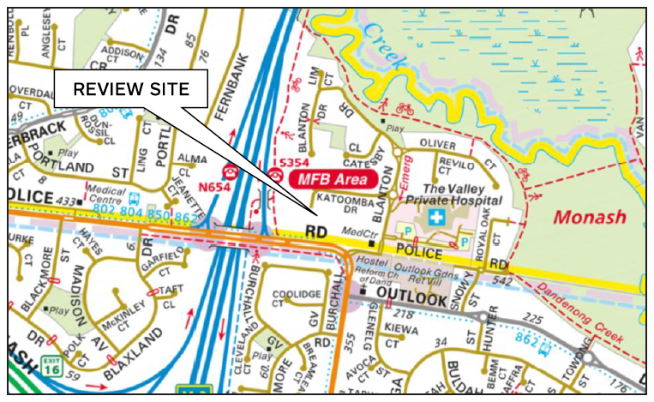
- This large, underdeveloped site is in a small pocket of residential and institutional uses between Eastlink and the Dandenong Creek. Its 1.3ha size is uncommon. Relevant features for the design response are:
- the 77-82m width and 1:10 fall from west to east;
- the two trees with high retention value and three trees of moderate retention value;
- the two elevated abuttals to main roads; and
- the existing access point to a local road (Police Road East).
- The site is deep in the residential hinterland of Mulgrave. It does not have convenient access to shops or schools and is not in range of the Principal Public Transport Network. Some bus routes exist along Police Road, Gladstone Road and Outlook Drive but we consider the lack of access to rail will result in a heavier reliance on private vehicle transport to and from the site. The adjacent residential area is a conventional late 20th century subdivision, with single dwellings on lots of 700-800 square metres. The Valley Private Hospital and Outlook Gardens Retirement Village add significant institutional built form to the neighbourhood’s character and add to traffic movements on the road network.

the proposal

Site layout
- It is proposed to remove all existing structures on the site and construct 33 dwellings served by a 5-metre wide accessway. 32 dwellings are two-storeys in height, with upper levels mainly recessed from the ground floor footprint. All have four bedrooms, including a ground floor bedroom. All have a contemporary suburban appearance.
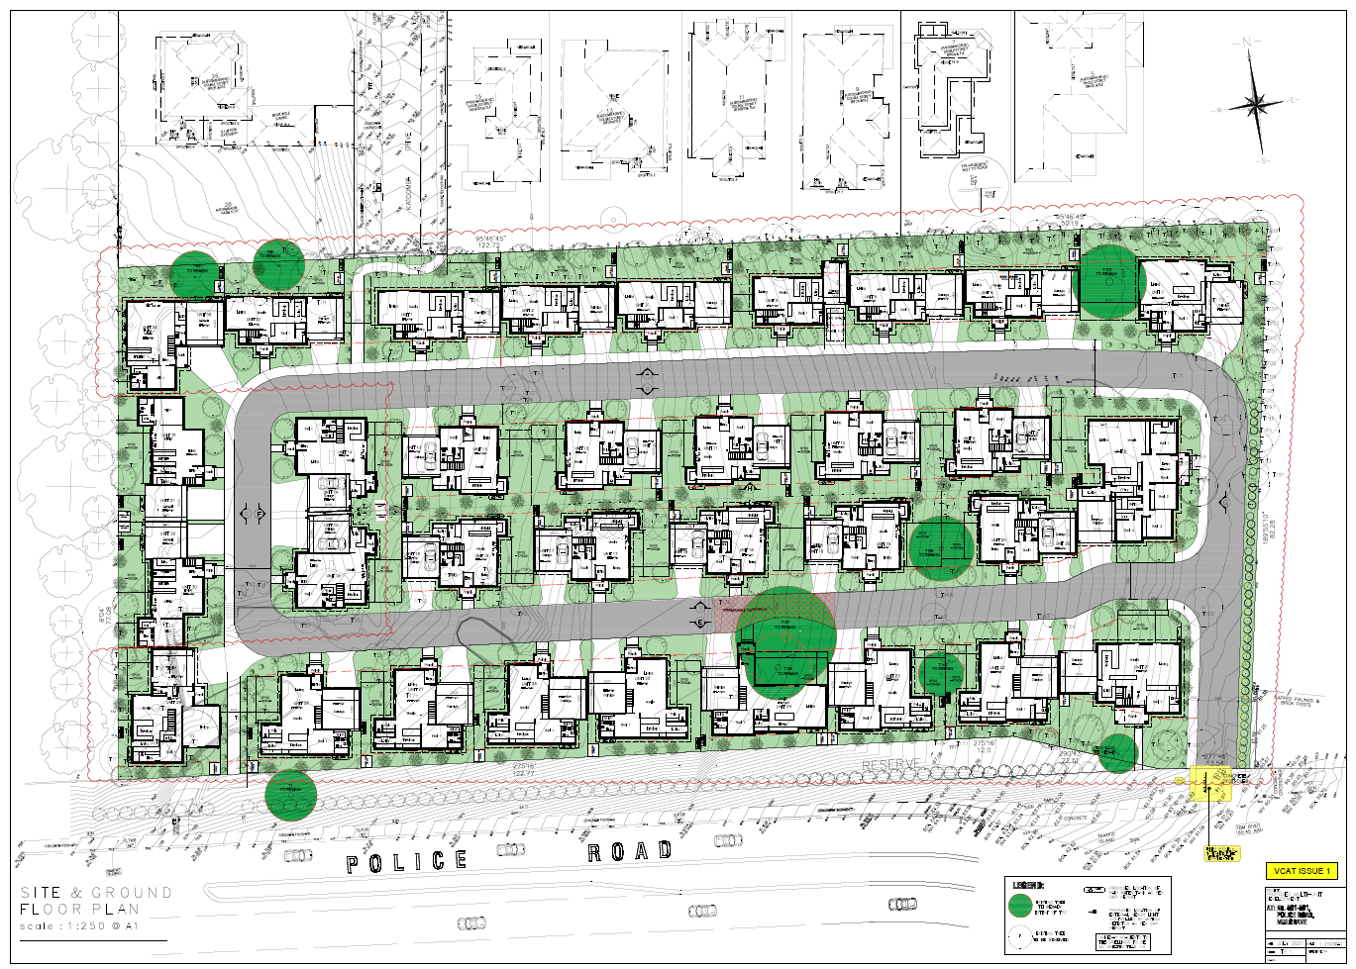
Site Plan with ground floor layout
- Dwelling 21, in the south-east corner, faces Police Road East and has the required 7.6m front setback. It is elevated approximately 2.5m above the footpath. Otherwise, all dwellings are set back 3m from the edge of the internal accessway.
- Areas of secluded private open space with the required dimensions are located to the rear of 16 dwellings and to the side of a further 16. One area of secluded private open space is in front of Dwelling 24 to accommodate the tallest retained tree on the site.
- The dwellings next to the north and west boundaries have narrow footprints and the dwellings abutting existing dwellings have the required 5m rear setback. Rear setbacks are reduced on the west and south boundaries where the site abuts the main road network.
- The proposed vehicle access is via an existing crossover to Police Road East. This is proposed to be widened to 5.5m and have a 1:10 gradient. No details of the gradient of the internal accessway are shown on the plans, but Ms Marshall advises that she has reviewed longitudinal sections and found them to be satisfactory.
- Segments of internal footpath are provided next to the internal accessway, and pedestrian paths join Police Road East and Katoomba Drive.
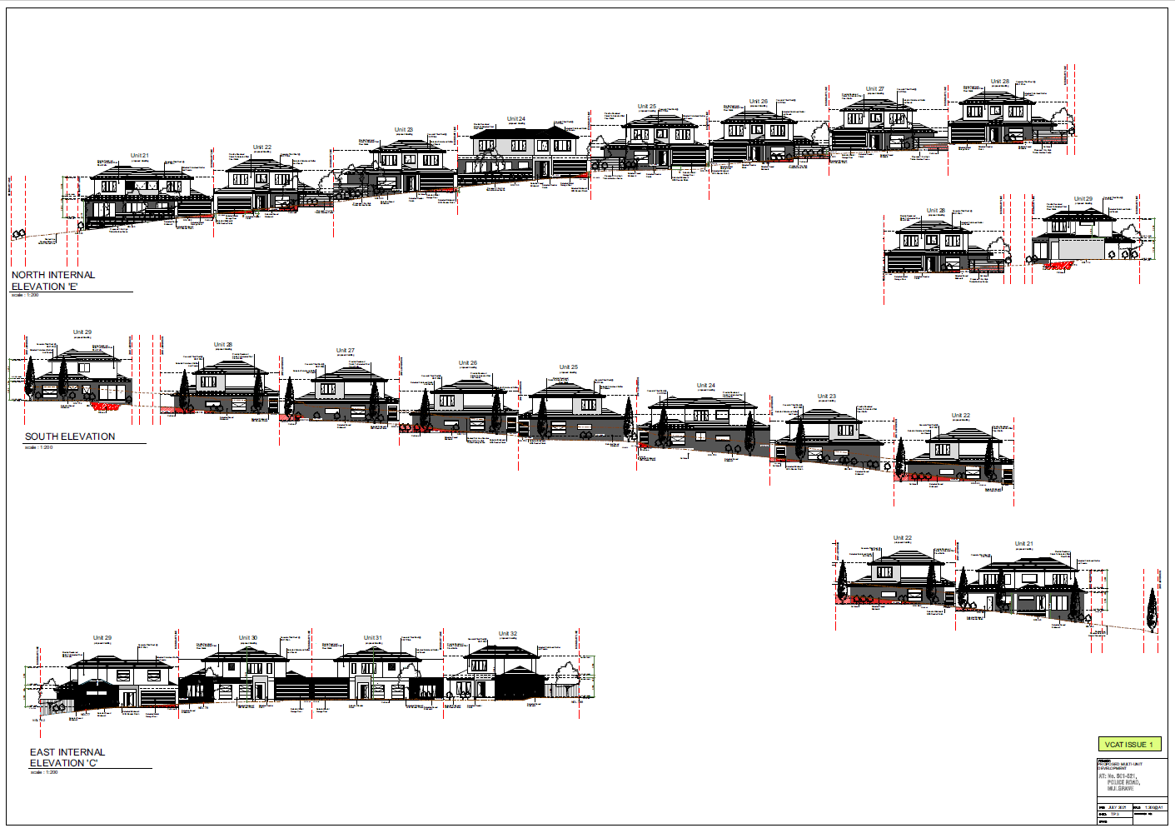
A sample of the proposed elevations

Slope
- 29 dwellings step down the site’s 1:10 slope and are accessed from the east-west sections of the internal accessway. The dwellings sit at natural ground level at some point across their frontage. The side-facing areas of secluded private open space provide separation between dwellings ensure that garages can be accessed at, or close to, the level of the accessway..

Existing trees and Landscaping
- Nine trees are shown as retained on the architectural plans. Mr Patrick’s evidence is that only six are worth retaining. The highest value trees are a 17m tall Spotted Gum visible from outside the site, a semi-mature Golden Elm in the north-east section of the site, a reasonably large Argyle Apple and a reasonably large Southern Blue Gum near the Spotted Gum, a Paperbark in the north-west corner, and a modest Bottlebrush near the south-east corner.
- Separately, the Council advises that two River Red Gums, a Prickly Leaf Paperbark and three Manna gums were removed from the site since July 2019. We understand that the Prickly Leaf Paperbark and the River Red Gums were of moderate to high retention value and would have been visible from outside the site.
- Comprehensive landscaping is proposed. Each dwelling will have a deck or terrace accessed from their living areas and areas of lawn in their rear or side gardens. Black Sheoaks, with mature height of 6m, are the predominant tree used in these areas and in the front setbacks. These are complemented by Dwarf Lemon Scented Gums with a mature height of 6m-8m.
- Crepe Myrtles (18 in total) with mature heights of 4m or 7m are also used in front setbacks, along with low level shrubs and ground covers. 3 Capital Pears with a 6m-10m mature height occupy narrow spaces in the centre of the site.
- The tallest trees, being Red Box with heights of 7m-15m and Blackwoods with heights of 12m-20m are mainly on the perimeter of the site.
- We expect that the proposed landscaping is comparable to the Waverley Park estate, albeit with significantly reduced setbacks from the accessways.

Future subdivision
- We understand that each dwelling and the surrounding open space complies with the mandatory 300sqm site area for new lots.
- The future lots would have frontages of 15m-18m and depths of 15m-20m along their side and rear boundaries. These lots would include the 3m front setbacks, which would be managed by the Owners’ Corporation.

Is the proposal an acceptable response to the Planning Scheme’s policies and provisions?

The planning framework
- The relevant Planning Scheme policies see the area containing the site as having limited development potential and encourage built form that contributes to the preferred neighbourhood character.
- These are relative terms. To a large degree, they are codified in NRZ4. The objectives and standards of clause 55 as varied by the Schedule 4 sets the baseline for multi-dwelling development, as follows:
Neighbourhood character objectives:
To ensure new development transitions down in scale towards the creeks, respecting and reinforcing the natural topography.
To ensure development is defined by its spacious and generous garden settings, tall canopy trees and consistent built form and setbacks.
Subdivision requirement and varied clause 55 standards:
  - Mandatory minimum lot size of 300sqm;
  - 50% site coverage;
  - 7.6m front setbacks for new dwellings facing streets;
  - 5m rear setbacks;
  - 75sqm of private open space; and
  - One canopy tree plus one canopy tree per 5m of site width, with a minimum mature height equal to the height of the roof.
- We agree with the parties that an acceptable response must integrate these objectives, standards and requirements as far as possible, and balance conflicting objectives in favour of net community benefit.
- We have included the mandatory minimum lot size in our considerations, notwithstanding the proposal is only for the development of the land. The mandatory nature of the minimum lot size influences the layout and character setting of the proposal and is a relevant consideration under clause 65 of the Planning Scheme.

The evidence
- We heard contrasting evidence on whether the proposal is an ‘acceptable response’. Mr Blades takes a strategic approach that emphasises Planning Scheme objectives, while Mr Crowder takes a statutory approach that emphasises clause 55.
- Mr Blades’ evidence is that the proposal is the ‘wrong design response’ for the site. He says that it does not meet the Planning Scheme’s objectives on character and urban design because it’s density, lot size, lot shape, and streetscapes are too inconsistent with the character of the surrounding residential area. As well as this, he believes that its poor connection to Katoomba Drive and poor internal pedestrian network are unacceptable urban design outcomes.
- At risk of stripping the nuance from his opinion, we summarise Mr Crowder’s approach as follows:
- where the site interfaces with existing properties, clause 55 must be fully engaged;
- within the site, the proposal is satisfactory if it meets the standards of clause 55 for on-site amenity and facilities, energy efficiency, safety and parking location (the ‘internal’ standards); and
- the site-related objectives, such as site coverage, permeability, and landscaping, should be measured holistically.
- We are influenced by aspects of both approaches.
- Mr Blades’ objectives-based approach leads us to conclude that a first principles approach should apply to the site. Nevertheless, we do not agree that only a conventional subdivision would meet the Planning Scheme’s neighbourhood character objectives.
- A first principles approach emphasises clause 55.01, which requires a description of the features and constraints of a site and its surrounds, and a design response that ‘derives from and responds to’ this description (as well as meeting clause 55’s objectives and responding to neighbourhood character policy).
- This is appropriate because much of clause 55 has little work to do in a proposal of this size where there are no public streets. Neighbouring residents are unlikely to walk or drive through the development, given its ‘private’ nature. This is not the typical situation where clause 55 applies. Typically, clause 55 applies to infill developments where two or more dwellings replace a single dwelling on a street.
- There are several examples of where clause 55 does not work in the typical way. The front setback objective is almost irrelevant because only three of the proposed dwellings face an existing street. This differs from the typical clause 55 assessment, where front setbacks are highly relevant to the assessment of neighbourhood character. The side and rear setback objectives only apply to 11 of the proposed dwellings because the remaining 22 do not abut existing properties. This differs from the typical clause 55 assessment where these setbacks define neighbouring amenity. The design detail objective is of little relevance as views of this proposal from the public realm will be filtered by existing topography, mature vegetation and distance.
- To this degree, we agree with Mr Crowder that the interface with existing development is where front, rear and side setbacks and design detail apply. But we do not agree that meeting the quantitative ‘internal’ standards within the site guarantees an acceptable outcome. While we accept that built form that cannot be seen from outside the site does not need to mimic the existing built form character, we find that the broader site-related objectives must deliver an acceptable neighbourhood character outcome.
- For example, the landscaping objectives include:
To encourage development that respects the landscape character of the neighbourhood.
- We consider that there is no guarantee that compliance with the quantitative ‘internal’ standards will meet this objective. Rather, the whole development must respect the neighbourhood’s landscape character.
- We assess the design response in the following section. We conclude that it does not respond adequately to the spacious landscape character of the surrounding residential area. Our findings are that:
- the combination of the site’s width and the mandatory minimum 300sqm lot size constrains the design response;
- the built form is an unacceptable response to the slope of the land;
- specific aspects of the design response are unacceptable on grounds of urban design, tree retention and internal amenity for future occupants;
- the design response is too heavily influenced by the 300sqm minimum lot size and consequently lacks spaciousness and does not create a sense of built form in a landscaped setting; and
- the street trees of Katoomba Drive are a significant and visually compelling part of the neighbourhood’s character. The contribution of these trees to the neighbourhood’s character cannot be ignored because the proposal does not have a ‘street’.

On the design response
- The notable features and setting of the site are its size, shape, elevation from main roads, slope and views. The notable features of the surrounding residential neighbourhood are prominent built form on sloping sites, large lots, tall street trees and wide roads.

The future lot layout
- We find that the 77m-82m width of the site, combined with the mandatory 300sqm minimum lot size, constrains the future lot layout. The following analysis demonstrates this finding.
- Mr Blade’s evidence includes a conventional subdivision layout as an alternative design option for the site.
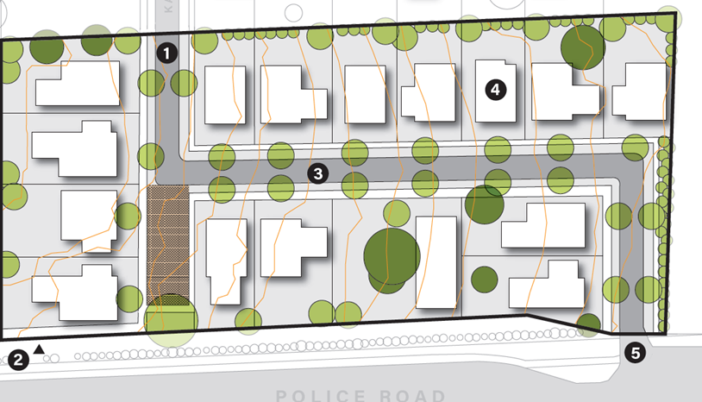
The conventional subdivision in Mr Blades’ evidence.
- The plans considered by the Council is another alternative. It shows two access arms with three dwellings across the site. We consider this has shortcomings because rear fences face an accessway, yet it has the benefit of being able to vary the depth of lots across the site.
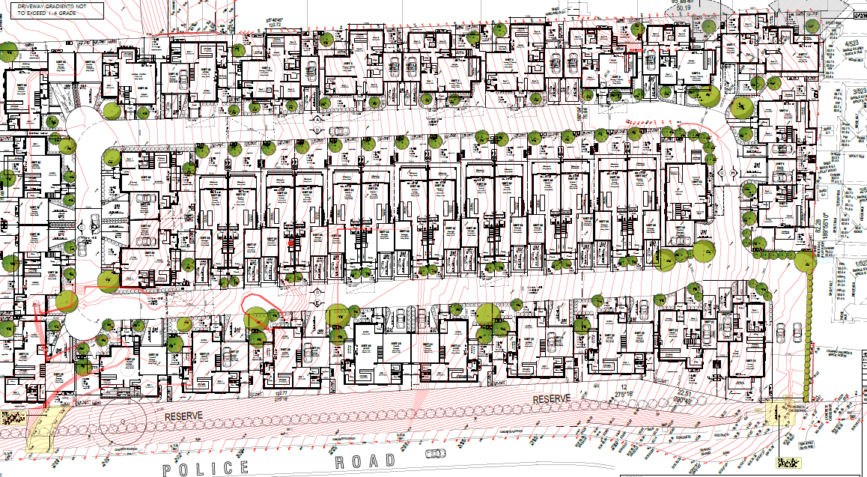
The plans considered by the Council
- The proposal before us (i.e., the substituted plans) is another alternative. It has two access arms and four dwellings across the site.
The proposal before us (i.e., the substituted plans)
- This layout is constrained because only minor changes can be made to depth of lots across the site’s width. The combination of the site’s width of 77m-82m and the 23m width of the two accessways and front setbacks (each being 11.5m wide) leaves an average width of 57m for the four dwellings across the site. This results in an average lot depth of less than 15m. It cannot be increased without ‘flipping’ to the one of the alternatives described above.
- A final alternative is to provide access across the contours, as shown below. Mr Blades sketched this layout during cross-examination, yet it has not been tested.
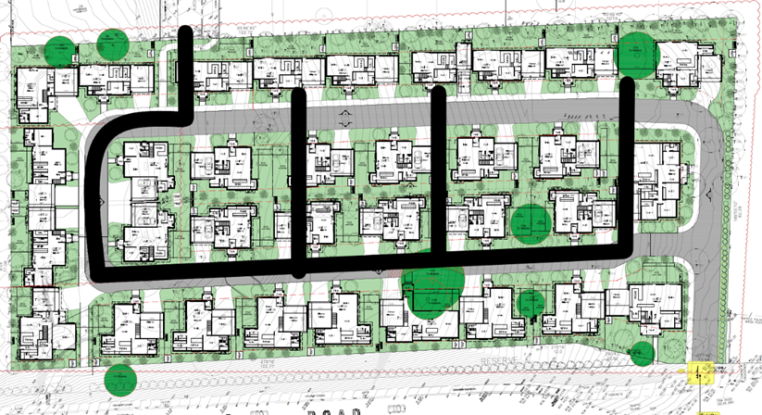
A high-level concept of access across the contours
- This analysis demonstrates that the Applicant has few viable options to develop the site. It provides a context for the Council’s concern about the shallow front setbacks and our concerns over spaciousness, tree retention and internal amenity. Reducing the number of lots would not address the shallow depth of the lots, unless one of the alternative designs was used.

The siting of units and secluded private open space on the future lots
- Most of the Units use a flat floorplate despite the 1:10 slope of the land. We recognise the benefits of this design for internal mobility. We acknowledge that all units are suitable for multi-generational households as they have ground floor bedrooms with ensuites. We agree with Mr Crowder that this is a positive outcome, and it meets the Planning Scheme’s objectives for dwelling diversity.
- However, this approach has disadvantages because the floorplate often protrudes above natural ground level on the low side of the unit. This is accentuated on sloping sites where units are closer together. The proposal seeks to respond to this issue in two ways that we discuss below:

Units 1 to 7
- Units 1 to 7 step down the site in two groups of three, followed by an 8.7m space to Unit 7. Some garages are at a lower floor level than the living areas to ensure vehicle access and to lessen the depth of the ‘step’ to the adjoining dwelling.
- We find that this ‘stepping’ has not been managed well. For example, at the frontages of Units 2 and 3, the driveway and garage of Unit 2 is 1.9 metres higher than Unit 3. A barrier of some kind would be required to protect cars accessing the garage and it would need to be up to 3m high when viewed from Unit 3. A similar, yet less severe pattern of level differences of more than a metre exists between Units 1 and 2, Units 4 and 5, and Units 5 and 6. We find these are poor design outcomes and cast doubt on the success of Mr Patrick’s landscape concept for the accessway.
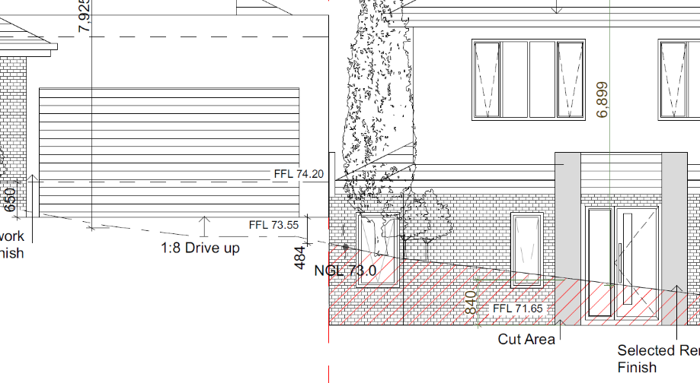
Level differences between the frontages of Units 2 and 3
- At the rear, the Unit 3 living area is cut 1.5m below natural ground level. This creates a 3.3-metre-high boundary wall when combined with a 1.8m fence between Units 2 and 3. We consider this is a poor design outcome.
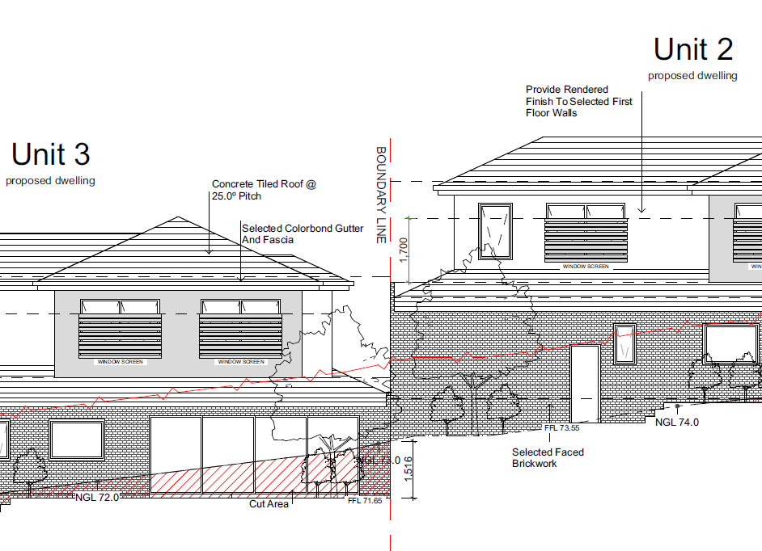
Level differences at the rear of Units 2 and 3
- Further to this, the 8.7m space between Units 6 and 7 that is set aside for the existing Golden Elm is proposed to be filled to a maximum depth of 1.1m. This is not an acceptable response to this established tree as it is well understood that excessive fill denies oxygen to the tree’s roots and will result in its decline.
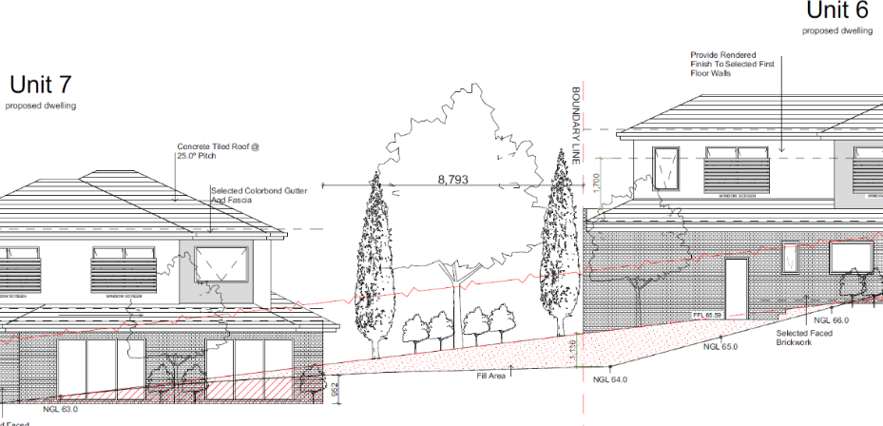
Up to 1.1m of fill is shown under the canopy of the retained Golden Elm (centre of the image)
- The plans also show sliding exterior doors on the side of Unit 7 that faces the Elm, yet the wall containing these doors is in 952mm of cut. Any paved area served by these doors would encroach into the Elm’s Tree Protection Zone. We find this is not an acceptable design response.

Dwellings 8 to 20 and 22 to 28
- These units have their secluded private open space to the side rather than the rear. This reduces the impact of the slope, responds to the shallow lot depth, and makes vehicle access more manageable. However, these units have their own problems with slope.
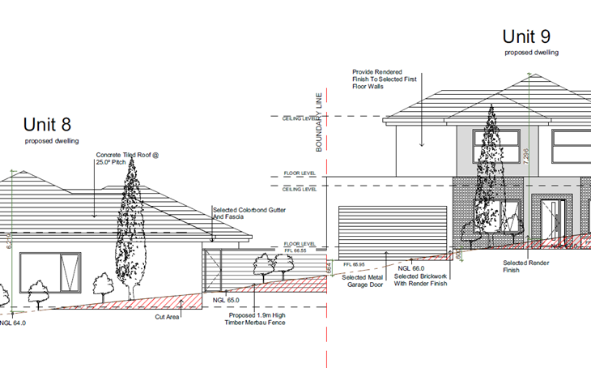
The height difference between the secluded private open space of Unit 8 and the garage wall of Unit 9
- The secluded private open space of Unit 8 faces the side wall of Unit 9’s garage across a 5.5m distance. A paved area extends 2m into Unit 8’s secluded private open space. The finished floor level of Unit 9’s garage is 1.65m above that of Unit 8. When combined with the 3m height of Unit 9’s garage wall, it creates a 4.6m height difference. Thus, a future resident standing in the secluded private open space of Unit 9 would look up at this 4.6m wall (comprised of a retaining wall on the boundary and a garage wall above) from less than 3m away. This is not an acceptable design outcome in an area where policy promotes limited development.
- This pattern continues up the site. A 5.2m wall would exist between Units 9 and 10, a 5.1m wall would exist between Units 10 and 11, and a 4.8m wall would exist between Units 11 and 12. Similar arrangements would occur between Units 19 and 20, and Units 22 and 23. We find these outcomes do not deliver an acceptable amenity outcome for future residents.
- The pattern varies for Units 12 to 14. The secluded private open space areas of Units 12 and 13 abut each other at different levels (as marked up below). 2.4m high boundary fencing would be required to avoid internal overlooking between Unit 13’s deck and Unit 12’s living areas, and this fence would be at a considerably higher level than Unit 12’s living areas and open space terrace. Thus, a future resident standing on the secluded private open space of Unit 12 would look up at a barrier of at least 3.7m from less than 3m away. We find this is a poor design outcome.
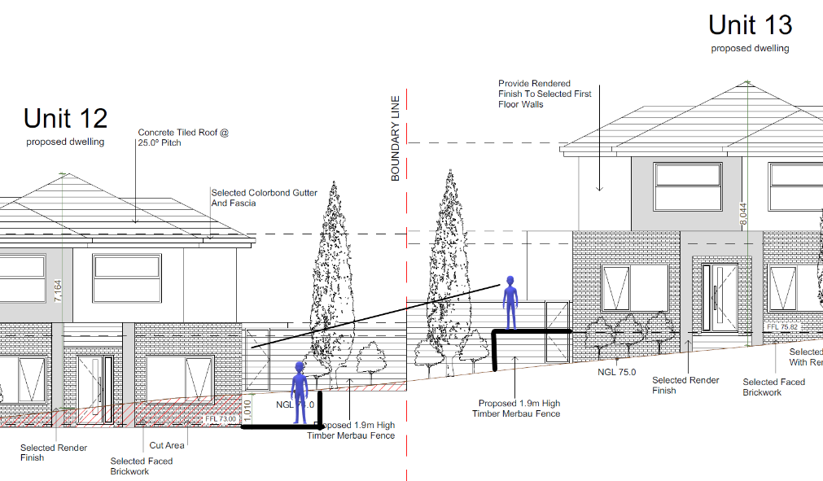
Plans marked up by the Tribunal
- With Units 13 and 14, the secluded private open space of Unit 14 is on the high side of the garage of Unit 13.
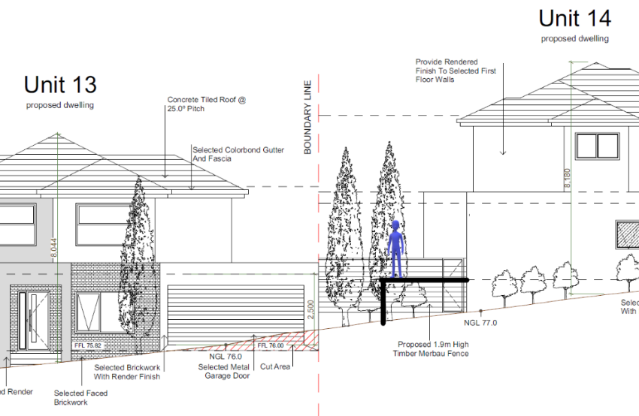
Plans marked up by the Tribunal
- This results in the deck of Unit 14 being slightly lower to the garage roof of Unit 13. This is an awkward visual relationship given that the deck is less than 3m from the garage, and the ground level space below the deck would be difficult to use. It may be acceptable if it occurred only once on the site, but it is repeated between Units 15 and 16, Units 16 and 17, Units 17 and 18, Units 18 and 19, and Units 20 and 8. This is unacceptable.
- The image of Units 12 and 13 also shows a change of level that casts doubt on Mr Patrick’s landscape concept for the front setbacks. Much of Unit 13 is up to 1.1m below natural ground level. We are not clear how this cut works with the level of the access way. It suggests a relatively severe change in level across the 3m front setback. This occurs with most units along this accessway. In addition, the barrier between adjoining garages that we described earlier, is likely to be required between Units 20 and 8, Units 21 and 22 and Units 25 and 26.
- A different issue arises between Units 19 and 20, and Units 22 and 23. The reasonably large Argyle Apple is on the boundary between Units 19 and 20, while the reasonably large Southern Blue Gum is slightly within the boundary of Unit 23. The design response seeks to retain these trees by including them in abutting side-facing areas of secluded private open space.
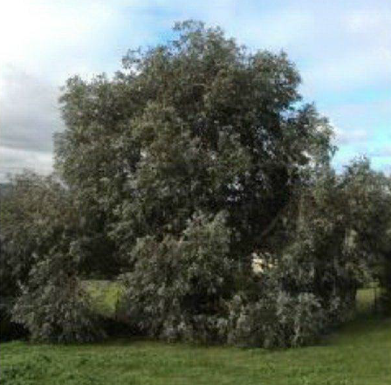
The Argyle Apple
- Mr Patrick describes the Argyle Apple as an attractive tree requiring some pruning to shape. We concur with Mr Patrick’s assessment. The project arborist describes it as being 11.5m tall and 9m wide, with a 9.36m Tree Protection Zone and a 3m Structural Root Zone.
- The design response locates this tree on a fence line, with 600mm of cut in the Structural Root Zone, and with Unit 20’s secluded private open space in cut below it. These works are contrary to the Australian Standard AS4970: 2009 - Protection of Trees on Development Sites and we are not persuaded that the tree will not survive these works. Apart from this, we find it is not an appropriate setting for a tree of this size and value to the site.
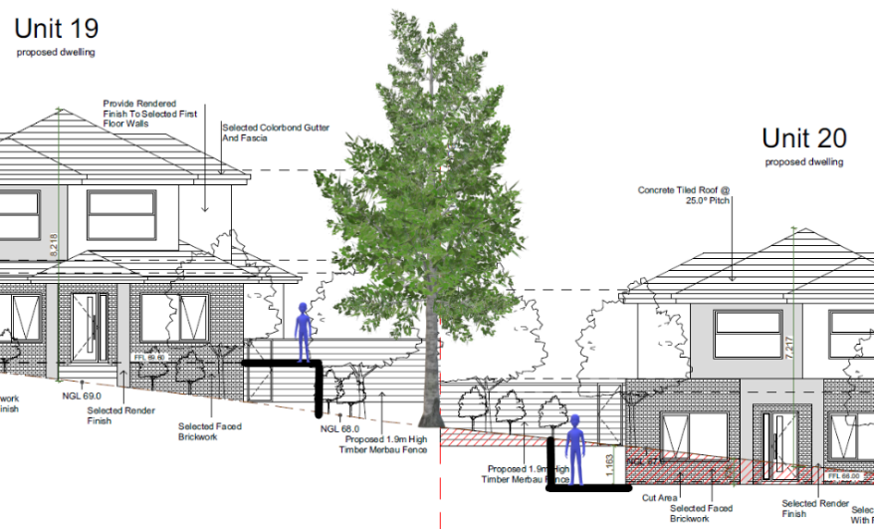
Plans marked up by the Tribunal
- With Mr Patrick, we discussed the potential impact on the Southern Blue Gum between Units 22 and 23 (Tree 25). The project arborist describes it as being 10.5m tall and 8m wide, with an 8.4m Tree Protection Zone and a 2.9m Structural Root Zone.
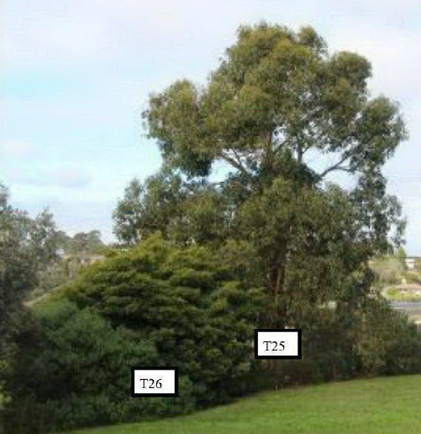
The Southern Blue Gum
- Mr Patrick agreed that this tree’s Tree Protection Zone would need to be maintained within Unit 22’s boundary, thus there could be no change to natural ground level in this area. This is not shown on the plans and could not reasonably occur without infringing on the amenity of Unit 22’s secluded private open space, as shown below.
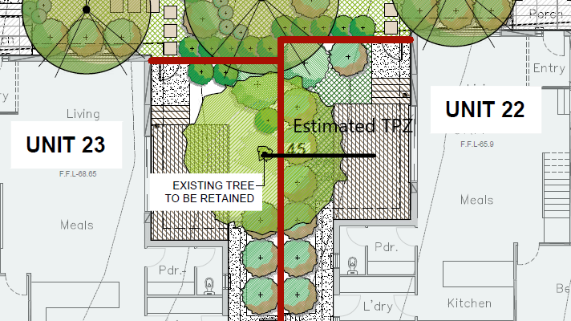
Tree Protection Zone (TPZ) estimated by the Tribunal (in black)
- We are concerned this tree will not survive these works. It is also questionable whether it should be retained in a unit’s secluded private open space. The Tribunal understands that Southern Blue Gums are very large trees that are only appropriate for large open space settings.
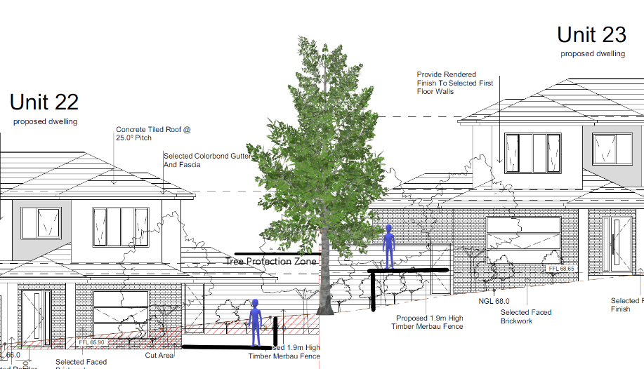
Plans marked up by the Tribunal
- Finally, we are troubled by the height of sub-floors, retaining walls and fencing required because of the slope. The images show that these features lead to disjointed frontages, and we expect that this occurs on side and rear boundaries as well. In many cases, narrow areas of open space sit below retaining walls with built form or high fences above. This will deliver poor amenity for future residents and derives from an unacceptable design response.
- We find these are fatal design issues for the proposal and raise significant amenity concerns for future occupants.

On the mandatory subdivision control
- All lots aim to achieve the minimum lot size (300sqm) under the NRZ4. When combined with the proposed built form, we consider that this standardised design approach has not been successful. It also results in an unacceptable design outcome at the public interface and end of Katoomba Drive.
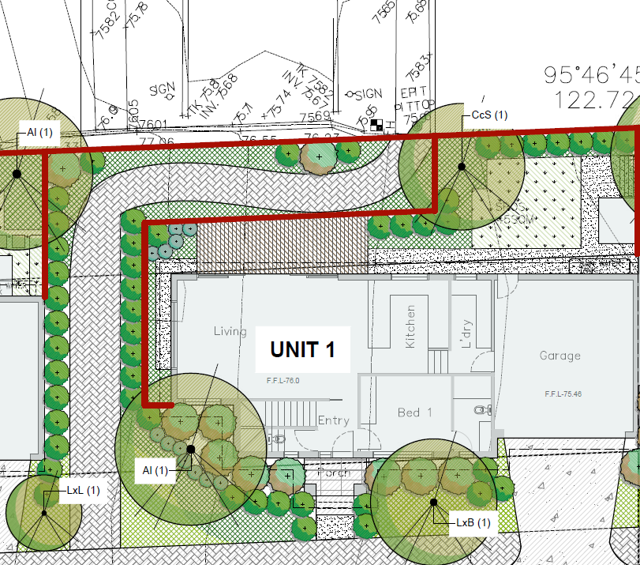
The pedestrian path relative to the deck of Unit 1
- Unit 1 and a pedestrian path to Katoomba Drive is located across the unfinished end of that street. Rather than leading directly into the estate, the path winds uphill from the low-side footpath to avoid Unit 1. It results in a high fence less than 2m from the glazed sliding doors of Unit 1’s living area and would require a barrier on the north side of the pedestrian path due to the 1.4m fall to the road pavement. This is an unacceptable design outcome on a site of this size.
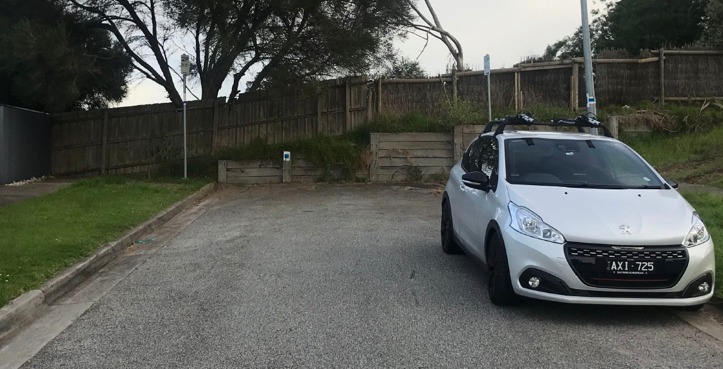
The existing retaining wall and fence at the end of Katoomba Drive
- Apart from this, we are not persuaded that a development at the mandatory minimum lot size reflects the intent of this control. It applies to an established area where lot sizes are generally 700-800sqm, where its effect would be to prohibit three dwellings on a typical lot. This creates an expectation of multi-dwelling lots that average 350-400sqm, rather than the 300sqm proposed for this site.

The neighbourhood character objectives and landscaping
- The neighbourhood character objectives of Schedule 4 to the Zone are:
To ensure new development transitions down in scale towards the creeks, respecting and reinforcing the natural topography.
To ensure development is defined by its spacious and generous garden settings, tall canopy trees and consistent built form and setbacks.
- The first objective allows a multi-dwelling development on this site because it is some distance from the Dandenong Creek.
- The second objective, in part, calls for spaciousness. Based on our analysis, we find that the proposal is not a spacious layout as sought by this objective. We find the design response has sought to meet the quantitative standards of clause 55 but has not achieved acceptable character and amenity outcomes. The small front setbacks are constrained and much of the secluded private open space is in narrow areas between built form and high fences.
- The second objective also calls for tall canopy trees. When questioned by the Council, Mr Patrick acknowledged that almost all the proposed canopy trees were 6-7m high. As such, they would reach, rather than exceed the height of the units. We acknowledge Mr Patrick’s expertise and believe that he has generally chosen appropriate species for the areas of secluded private open space and the front setbacks. However, trees that are the height of the units do not deliver necessarily deliver the landscape character sought by the objectives where built form is to ultimately sit within a mature landscape setting.
- We have plotted the genuinely ‘tall canopy trees’ below:
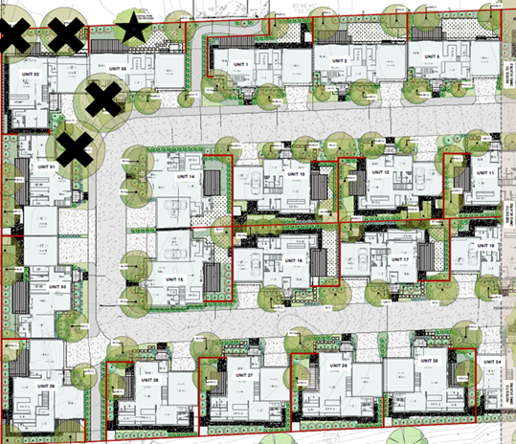 | 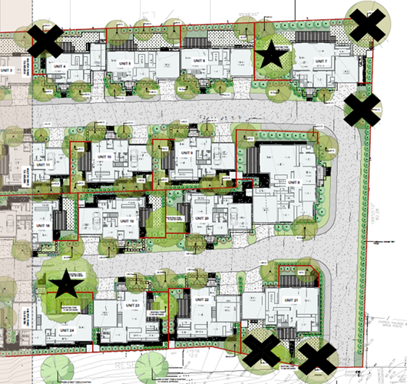
The proposed tall trees are marked with a cross and the trees that we believe can be retained in this design are marked with a star.
- The crosses are the nine trees that could reach heights of 15-20m. They are on the site’s perimeter. Four are in narrow areas of secluded private open space on the northern boundary. We consider these are not appropriate in these locations due to their height. The centre of the site is devoid of tall canopy trees, except for the existing 17m tall Spotted Gum. This is problematic, particularly when we were informed by the council that two tall Red Gums (approximately 16m tall) have recently been removed.
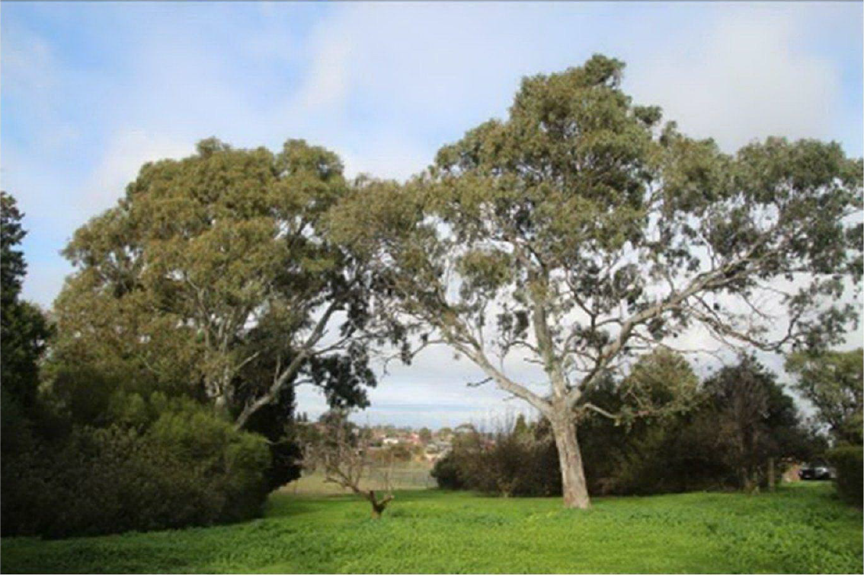
The two Red Gums removed from the site
- We consider this does not reflect the neighbourhood character objective of NRZ4, nor does it reflect or complement the tree canopy of the surrounding residential area. We find it is an unacceptable character outcome associated with the design response.

Conclusions on the design response
- This is a difficult site to develop at the densities one might desire. We consider a more spacious setting is required to avoid the amenity impacts and lack of tall canopy trees throughout the site that we have found to be fatal flaws.
- The shallow lot depth cannot be significantly altered if a site layout with four dwellings across the site is used. Thus, more responsive built form that genuinely responds to the site’s slope, the mature trees and the shallow lot depth would be required if the Applicant pursued this lot layout. Even with these changes, particular attention would need to be paid to changes in level between the accessways and future units.
- We find the over-reliance on lots of 300sqm is fatal on grounds of spaciousness, tree retention, good urban design, and tall canopy tree planting throughout the site.

Is access from the site safe and convenient?
- We find that the intersection of the proposed accessway and Police Road East is not safe enough to be regarded as acceptable. Our finding is informed by the opposing evidence of Mr Furness and Ms Marshall.
- In short, we prefer the evidence of Mr Furness, particularly noting it is Mr Furness’s evidence that the site can be safely accessed from Katoomba Drive.
- Before elaborating on this finding, we will describe the differences of opinion between the traffic experts.

Mr Furness’ evidence
- Mr Furness believes the intersection is too close to the intersection of Police Road East and Gladstone Road. He says that the site access does not comply with AS2890.1:2004 for the location of vehicle accessways proximate to intersections. It his opinion the design outcome fails to meet this standard because it is well within 6m of the tangent point of the end of the Police Road/Gladstone Road intersection.
- He believes that this failure leads to the following points of conflict:
- Between vehicles turning left into the site and vehicles turning left from Police Road West or right from Gladstone Road; and
- Between vehicles turning right from the site into the traffic lane of Police Road East and vehicles entering Police Road East from Police Road West or Gladstone Road.
- Elaborating on (a), Mr Furness observed drivers regularly ‘cutting the corner’ on the north side of the intersection by crossing the mountable concrete apron to maintain a higher speed. He believes there is potential for vehicles turning left into the site to be ‘rear ended’ by any vehicle travelling close behind them. He says that there is not enough time to alert the driver of the second vehicle of the first driver’s intention to enter the site.
- Elaborating on (b), Mr Furness believes there is potential for vehicles exiting the site to prop over the centre line of Police Road East when queuing to enter the Police Road/Gladstone Road intersection. He believes this may conflict with vehicles turning either left or right into Police Road East. On this point, he contends that:
- Vehicles queuing to exit Police Road East will block views of vehicles turning right from Gladstone Road; and
- Vehicles on Police Road West would not see a vehicle propping over the centre line of Police Road East early enough to take appropriate precautions.
- Aside from these issues, he raises concern over the sightline to Police Road West for vehicles leaving the site but believes this concern can be addressed by minor works in the Police Road West road reserve. Ms Marshall concurs with this view.
- Due to these potential conflicts, Mr Furness says the proposed intersection is not satisfactory. He says this arrangement would not be supported on a greenfield site and should not be supported here. From a purely traffic engineering perspective, he recommends that sole vehicle access to the site should be via Katoomba Drive.
- In support of his opinion, Mr Furness contemplates an alternative of entry only from Police Road and exit via Katoomba Drive. He believes this would strike a balance between traffic engineering considerations and amenity impacts on existing residents of Katoomba Drive.
- During cross-examination, he acknowledged that the site had access from Police Road East and Katoomba Drive only because the two lots comprising the site were proposed to be developed as one. He accepts that access via Police Road East would be necessary for the eastern lot if it was not part of this consolidated site.

Ms Marshall’s evidence
- Ms Marshall believes the proposed intersection design of the accessway and Police Road East is satisfactory.
- She believes that vehicles turning left into the site are unlikely to be rear-ended because all vehicles entering Police Road East are travelling at slow speeds (20kph or so).
- She contends that the standard regarding distances from a tangent point relates to sightlines rather than the potential for rear-end collisions. She says that minor works in the Police Road West road reserve would improve sightlines but believes the existing sightlines are adequate.
- She believes that vehicles turning left from Police Road West would be visible because they are on higher land and believes that vehicles at the intersection of Gladstone Road and Police Road East are visible to drivers exiting the site. She says there is an additional level of safety for right turning vehicles because they can prop entirely in the central median when making that turn.
- Ms Marshall considers that the risk of vehicles exiting the site and propping across the median on Police Road East is very low. When a vehicle is already waiting to turn out of Police Road East, she believes there is adequate room for a vehicle leaving the site to tuck in behind it and be entirely within the driving lane of Police Road East. She says that there is only a 5% likelihood of two cars being in the queue waiting to turn out of Police Road East.
- During cross-examination, she said that she took comfort from Transport for Victoria’s lack of objection to the proposed access.

Our reasons
- Based on Mr Furness’ evidence and our site inspection, we find that the proposed access to the site is not safe enough to be acceptable. This is due to its proximity to the intersection of Police Road West/Gladstone Road and the existing road conditions described in Mr Furness’s evidence.
- Further to this, we do not support the option of restricting vehicle movements to entry from Police Road and exit to Katoomba Drive. This would halve the number of vehicle movements on Katoomba Drive, but does not resolve one of the safety issues at Police Road East. We acknowledge the Council’s traffic department’s concern that this option would provide an emergency exit if the sole accessway was blocked. Yet consider that the benefit of disallowing access or egress from Police Road East outweighs this concern.
- We acknowledge Ms Marshall’s evidence that the standard regarding distances from a tangent point relates to sightlines rather than the potential for rear-end collisions. However, standards are general statements that cannot envisage all situations. This is a ‘non-standard’ situation due to the significant slope of the land, the curved right-angle bend on the main road network, the mountable kerb that opens the intersection, and the accessway serving 33 dwellings, i.e., the equivalent of a local road. On this point, like Mr Furness, we observed many drivers ‘cutting the corner’ by driving over the mountable apron and doing so at relatively high speeds.
- We are also not persuaded that a single vehicle queuing at Police Road East to turn right will always leave enough space for a vehicle leaving the site to tuck in behind it and be entirely within the driving lane of Police Road East. Our impression is that this is an optimal situation, which cannot be guaranteed.
- As indicated at the hearing, we do not take comfort from the lack of objection from Transport for Victoria. It identifies that the accessway intersects with the part of Police Road that is a municipal road (Local Road) that is under the Council’s management. On this point, Transport for Victoria says:
Police Road east of the west boundary of the land to be developed is a Municipal road (Local Road); the southern frontage of the subject land abuts a local road, not Road Zone Category 1.
- Put otherwise, Transport for Victoria does not regard the proposed accessway as intersecting with a road that it manages, and it leaves the assessment of the intersection to the Council.
- We observe that the risks associated with this difficult intersection would remain throughout the life of this development (at least 50 years, if not longer). We do not see the value in this given that the site can be safely accessed from Katoomba Drive.
- We acknowledge that the Applicant did not pursue a previous proposal based on access from Katoomba Drive due to objections from local residents. We accept that the Applicant then investigated access from Police East and were advised by independent traffic consultants that such access was satisfactory.
- However, these actions do not change our decision. We note that the Council’s traffic department did not oppose the access from Katoomba Drive in a previous proposal for 26 dwellings on the larger of the two lots that form this consolidated site. It said that:
The predicted traffic generation of 13-17 vehicles/peak hour is low and is expected to have a negligible impact on the local traffic network.
- We agree with the Council’s traffic engineers and consider that their conclusion continues to apply even though there are 7 more lots in the current proposal. In our view and based on Mr Furness’s evidence, Katoomba Drive has ample capacity to accommodate the vehicle movements from this proposal. The estimated number of vehicle movements at peak hour equates to a vehicle driving by existing residents’ properties every two to three minutes. This is not a significant impost on existing residents of Katoomba Drive.
- Apart from this, it appears that Katoomba Drive was expected to continue into the larger of the two consolidated lots. We find it reasonable for this to occur.
- In conclusion, we find that there is a greater net community benefit in providing access via Katoomba Drive than via Police Road East due to the safety issues associated with solely relying on the Police Road East access as proposed.

Conclusion
- For the reasons given above, the decision of the responsible authority is affirmed. No permit is granted.

Michael Nelthorpe  Presiding Member |  | Peter Gaschk  Member

Plans substituted at the hearing amended the proposal from 41 to 33 dwellings with one single and 32 double storey dwellings.
The submissions and evidence of the parties, any supporting exhibits and the statements of grounds filed have all been considered in the determination of the proceeding. In accordance with the practice of the Tribunal, not all of this material will be cited or referred to in these reasons.
At clauses 55.04-3 and 55.04-6.
The phrases ‘required setbacks’ and ‘required dimensions’ are used with reference to the varied standard of Schedule 4 to the Neighbourhood Residential Zone.
Trees Numbered 80, 137, 145, 150, 175 and 187 on landscape plans.
See Arborist Report – 501-515 Police Road, Mulgrave, prepared by Blue Gum Version 07/19.
Clause 2 of Schedule 4 to the Neighbourhood Residential Zone.
In statutory terms, clause 55.02 activates clause 55.01.
What the Applicant described as an ‘owners corporation’ model.
The diagrams in Planning Practice Note 27 suggest this is the case. Separately, we note that Standard B5 of Clause 55.02-5 – ‘Integration with the street objective’ includes that ‘Development should be oriented to front existing and proposed streets.’ However, this does not apply here because this proposal creates no new ‘streets’ which instead are identified as ‘common areas’ under the owners corporation development model.
While views were dismissed by the Applicant during the hearing, they are a feature to describe and respond to in clause 55.01-1.
The opportunity to have lot sizes smaller than 300sqm would have provided the flexibility to achieve a reasonable yield while being site responsive. A ‘build to rent’ option exists but we consider it could not be imposed on the Applicant because it is not the intent of the mandatory subdivision control.
We have used the term ‘Units’ rather than ‘dwellings’ in this section to ensure consistency with the images taken from the plans.
We acknowledge that Units 1 to 6 step down to access the laundry and garage.
At clause 16.
At page 29 of the Blue gum Arborist Report.
At page 22 of the Blue gum Arborist Report.
From the Bluegum Arborist Report.
We acknowledge that the parties disagree on whether this tree removal required a permit.
From page 24 of the Blue Gum Arborist Report.
We observed this during our site inspection.
From our review of the file, we note that the Quantum Traffic Report that accompanied the permit application also referred to the lack of objection from Transport for Victoria.
Transport for Victoria’s referral response dated 16 October 2020.
Section 1.4 – Page 10 of the Officers’ Report to the Council meeting of 24 September 2019.
Based on Mr Furness’ evidence at page 27.

