VICTORIAN CIVIL AND ADMINISTRATIVE TRIBUNAL
planning and environment LIST | vcat reference No. P1502/2020  Permit Application no. TPA/50685
CATCHWORDS
Monash Planning Scheme; GRZ3; Proposal for four 2-storey dwellings; Neighbourhood character; Internal and on-site amenity; Landscaping adequacy; Driveway design and access.

Applicant | Guo Q Hou

Responsible Authority | Monash City Council
Referral AuthoritIES | Vic Roads, Head Transport for Victoria
SUBJECT LAND | 695 High Street Road  GLEN WAVERLEY VIC 3150
HEARING TYPE | Hearing
DATE OF HEARING | 29 June 2021
DATE OF ORDER | 24 August 2021
CITATION | Hou v Monash CC [2021] VCAT 976

Order

Amended permit application
- Pursuant to clause 64 of Schedule 1 of the Victorian Civil & Administrative Tribunal Act 1998, the permit application is amended by substituting for the permit application plans, the following plans filed with the Tribunal:
- Prepared by: | Jesse Ant Architects
- Drawing numbers: | TP00, TP01 to TP10 inclusive, Amendment C
- Dated: | 12 May 2021

No permit granted
- In application P1502/2020 the decision of the responsible authority is affirmed.
- In planning permit application TPA/50685 no permit is granted.

Mary-Anne Taranto
Member

Appearances
For applicant | Mr John Joiner, town planner of Melbourne Planning Outcomes.  He called the following witnesses:  - Mr Matthew Harridge, traffic engineer of O’Brien traffic  - Mr Robert Thomson, landscape architect of Habitat
For responsible authority | Ms Sally Moser, principal planner

Information
Description of proposal | Construction of four 2-storey dwellings in two attached pairs (three x 3-bedrooms and 1 x 2-bedrooms). Units 1 and 2 are designed in a reverse living layout and have balconies facing the street. Units 3 and 4 are to have a conventional internal layout with secluded private open space at ground level on their north side.  Garaging is centrally configured within the site and is to be accessed via a common driveway along the east side boundary.  Contemporary design elements are proposed which includes the use of parapet walls, skillion roof forms and external materials and finishes that comprise face brick and rendered brick.
Nature of proceeding | Application under section 77 of the Planning and Environment Act 1987 – to review the refusal to grant a permit.
Zone and overlays | General Residential Zone – Schedule 3 (GRZ3)  High Street Road is in a Road Zone Category 1.  No overlay controls apply.
Permit requirements | Clause 32.08-6 – Construction of two or more dwellings on a lot in GRZ3
Key scheme policies and provisions | Clauses 11, 15, 16, 21.01, 21.04, 22.01, 52.06, 52.29, 55, 65 and 71.02
Land description | This 735sqm rectangular shaped site located on the north side of High Street Road between Springvale and Blackburn Roads, has a 16.76m frontage and depth of 43.28m. The site is encumbered with a 2.44m wide drainage and sewerage easement which runs along north boundary and for a distance of 9.14m along the west boundary. The land is developed with a single storey dwelling with a cross-over on its east side and some scattered planting. A large street tree is located on the front nature strip next to a bus stop.  There is a restrictive covenant on the land which in essence requires that no buildings are to be constructed on the land other than buildings with walls of brick or brick veneer.
Tribunal inspection | Unaccompanied before the hearing

Reasons

Nature of proceeding
- Guo Q Hou (the applicant) is seeking a review of Monash City Council’s decision to refuse to grant a permit for four 2-storey dwellings configured in two separate pairs at 695 High Street Road, Glen Waverley.
- The applicant has prepared amended plans which I substituted at the start of the hearing. The council maintains its opposition to the proposal but no longer relies on a ground of refusal that it would breach the covenant on the title.
- It was common ground that the site is a suitable candidate for some form of medium density housing. The parties also concur that the proposal would not cause unacceptable residential amenity impacts by way of overlooking or overshadowing in relation to neighbours. I agree.
- The key issues in this case are whether the proposal is acceptable in relation to the following considerations:
- Internal and on-site amenity.
- Car parking and access arrangements.
- Landscaping adequacy.
- The scale, mass and siting of the development and its response to neighbourhood character.
- I have formed the view that the proposal would not be an acceptable one and have decided that a permit must not be granted. This is principally due to the configuration, functionality and appearance of the internal streetscape, the internal layout and amenity of some dwellings and their side setbacks.
- My reasons follow.

The Physical context
- The broader locational context of the site is shown in the image below extracted from the council’s submission.
- The subject land is located in an established and predominantly residential context opposite Wesley College, roughly 850m west of the Glen Waverley Major Activity Centre. Syndal railway station is located about 750m away to the south-west. Bus services run along High Street Road.

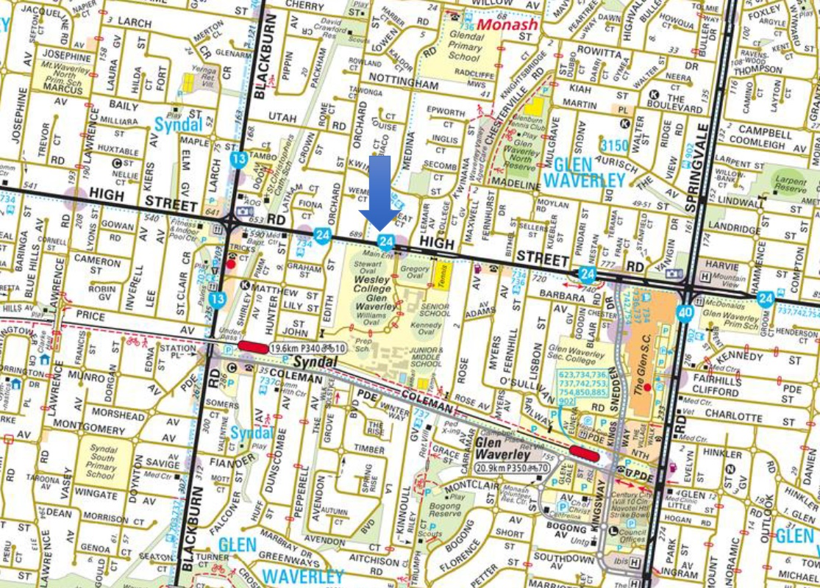
- In terms of its more immediate context, the review site has abuttals with four other properties, including four multi-dwellings in an attached form to the east at No. 697 High Street Road as shown below.

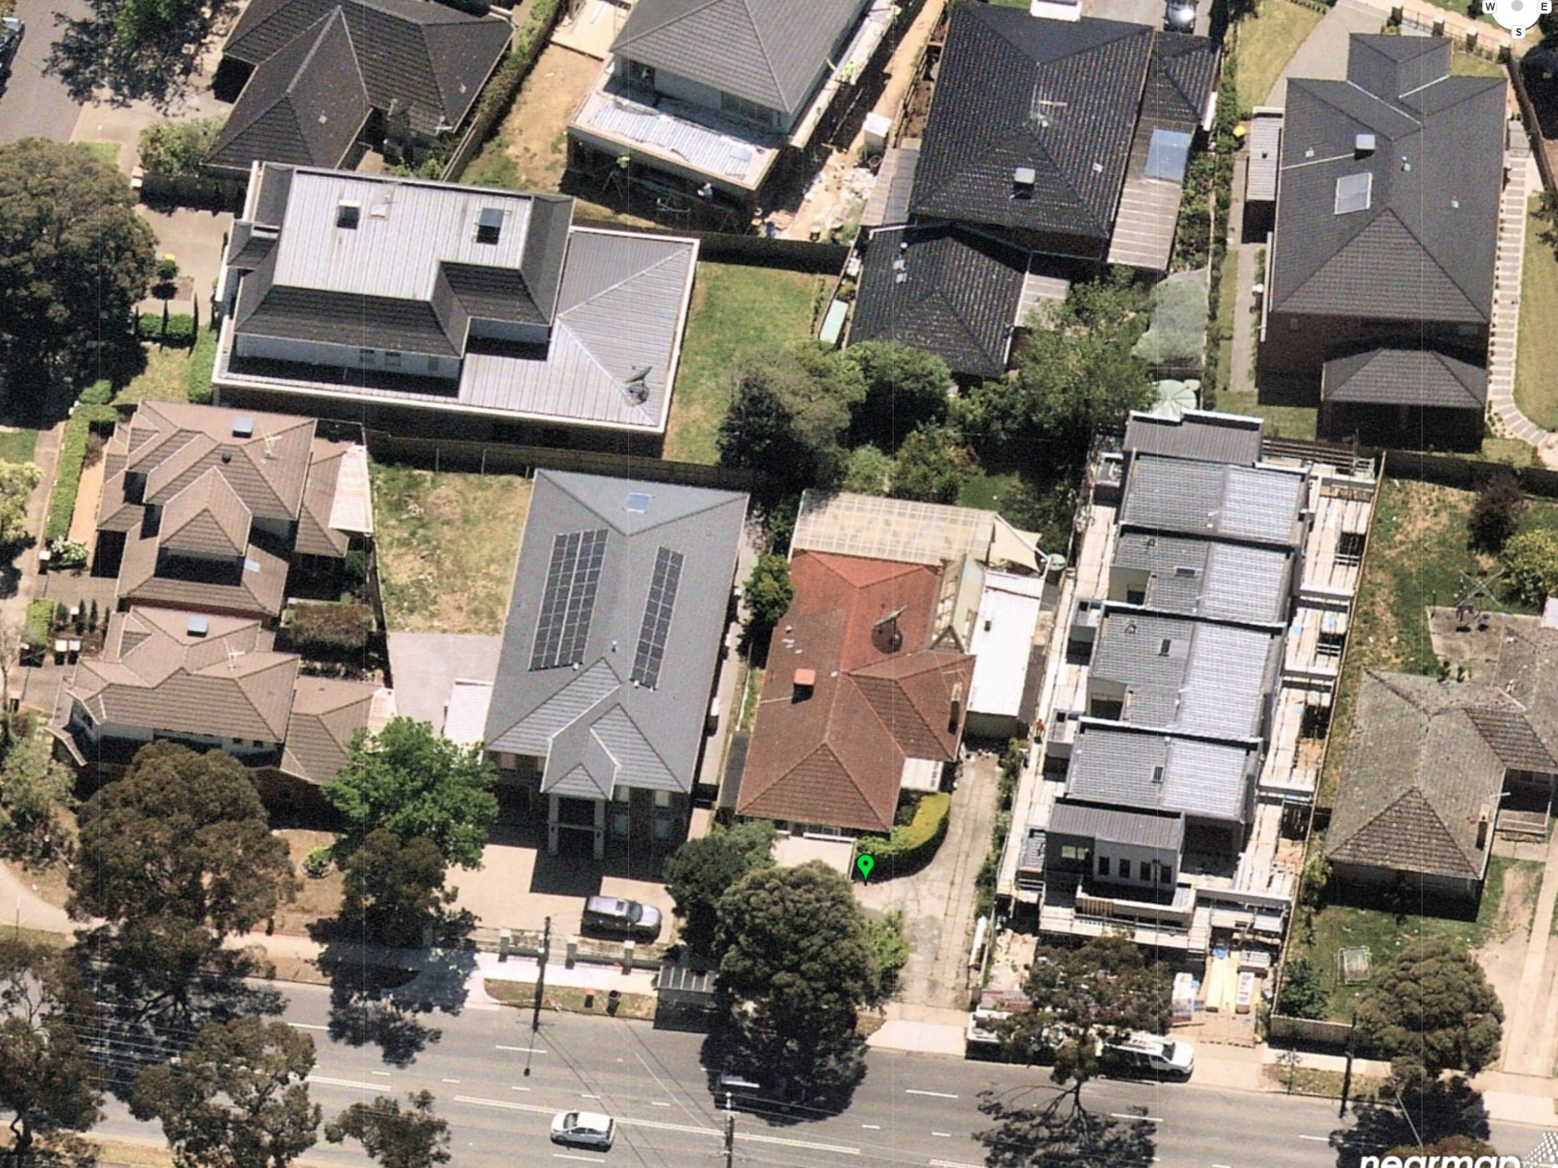
Source: Nearmap – Image captured 29 April 2021.
- In February 2018, the permit for the multi-dwellings at No. 697 High Street Road was directed to be issued by a different division of the Tribunal in the matter of Jesse Ant Architects v Monash CC [2018] VCAT 106 (Jesse Ant). These are configured in an attached formation, one behind the other with a common driveway and garaging on their east side.
- An older style single storey dwelling is located east again.
- The abutting dwelling to the west at No. 693 High Street Road is developed with a large 2-storey detached dwelling and to its west on the corner of Medina Road are two further double storey dwellings in the nature of a dual occupancy.
- Abutting lots to the rear are developed with detached double storey dwellings.

Overview of submissions

Summary of the council’s position
- In summary, the council submits that the proposed development does not achieve an acceptable response to the preferred character and the features of the site and its surrounds. More particularly, it says that the proposal:
- fails to offer acceptable levels of building articulation to the upper levels of the dwellings, particularly given the extent of the upper level footprint relative to the ground floor footprint;
- would not respect the prevailing built form character in its streetscape presentation due to the side-by-side configuration of Units 1 and 2, the proposed skillion room form and design detailing which is described as repetitive and incongruous with surrounding development;
- would not provide an acceptable landscape response due to:
  - the fragmented front garden area with dual pathways and a third pathway to the west side of Unit 1;
  - the narrow width of planting beds on each side of the driveway;
  - the absence of any meaningful planting between the two building modules central to the site;
  - the width of side setbacks on the west side of Units 1 and 3 and east side of Unit 4 which were said to be too narrow and too constrained by other service related features including storage sheds and pathways;
  - the presence of an easement along the north boundary and proposed siting of trees too close to the north side of Units 3 and 4;
  - inadequate setbacks for planting;
- The council acknowledges that the character of this area is changing with the emergence of larger 2-storey dwellings in the area, particularly along this main road corridor carrying high volumes of traffic.
- In relation to the abutting multi-dwellings to the east at No. 697 High Street Road, the circumstances were said to be distinguishable from the proposal given:
- its former inclusion in the GRZ2;
- its approval that pre-dated the current planning scheme controls affecting the land following the gazettal of Amendment C125 (Part 2);
- the larger side setbacks and the appearance of the development in the streetscape which reads with the breadth of one single dwelling;
- greater opportunities for landscaping throughout the site albeit with some problems identified in the driveway area;
- higher degrees of building articulation;
- visibility of front entrances in a way that variously enables better levels of address and surveillance of the internal streetscape from the street and from within the development;
- better levels of internal amenity due to more favourable orientation of habitable rooms and balconies; and
- the provision of service yards at ground level supplemented by balconies.
- The council also asserts that the proposal would not provide acceptable levels of on-site amenity in terms of the internal layout and size of some main living areas and the design and appearance of internal driveway areas. It also says that:
- the extent of screening to habitable room windows is excessive;
- the southerly orientation of living areas and balconies for Units 1 and 2 and their exposure to traffic noise associated with high vehicle volumes along High Street Road offers poor amenity; and
- the level of address, transitional space to dwelling entries of Units 3 and 4 and surveillance of the internal driveway areas is poor.
- The council submits that vehicle access arrangements within the site are too constrained with little margin for error while also necessitating correcting manoeuvres.
- It also takes issue with the 2.7m width of a portion of the driveway adjacent to Unit 2. It does not agree with this lesser width and says that it should be 3m wide to accord with the design standards at clause 52.06-9 for accessways. In doing so, it highlights the extent to which the narrower driveway width adjoins 1m wide garden beds that are relied upon to meet the mandatory garden area requirement which is presently 35.6% or equivalent to 0.6% more than the minimum required for the GRZ3.
- Overall, the council says that the shortcomings with the proposal are indicative of an overdevelopment.

The applicant’s contentions
- The applicant contends that this site in this location is one that is suited to the form, scale and appearance of four double storey dwellings given:
- The main road location where older housing stock comprising mostly single dwellings is nearing the end of its economic life which are being progressively redeveloped with larger 2-storey single and multi-dwellings; and
- The presence of large two storey dwelling forms on either side of the site in High Street Road including the four attached dwellings to the east.
- The applicant highlights the substantial levels of compliance with the varied clause 55 standards that apply to land in the GRZ3 and the lack of any objections from neighbours as relevant considerations that weigh in favour of the grant of a permit.
- It says that that as far as built form character outcomes expressed for this area go, there are numerous examples of larger two storey buildings either as detached single dwellings or multi-dwellings. Although arguably departing from the council’s current strategic aspirations for land in the GRZ3, it is said that in many respects, the ‘tide has already turned’ and that these larger dwellings nearby strongly influence the existing built form character. Thus, it says that council’s opposition to the proposal is not one based on tangible impacts but one that is ‘paper based’ and without a sound rationale.
- The applicant submits that council’s refusal of the proposal in relation to Units 1 and 2 at least, which are attached and face the street, is due to its fundamental dislike of dwellings that adopt a reverse living typology which rely upon balconies rather than ground level areas of open space.
- This typology is said to be a legitimate one and logical in the circumstances, allowing views towards the playing fields of Wesley college opposite. Further, it says that Units 1 and 2 respond appropriately to the features of the site and surrounds and that these dwellings:
- Will provide a suitable outlook towards the sports oval in the school opposite;
- Can include double glazing to south facing windows to limit the effects of traffic noise;
- Will allow some light entry to south facing upper level windows;
- Results in the complementary grouping of bedrooms of Units 1 and 2 and Units 3 and 4 opposite each other in a way that achieves quiet zones central to the site
- Levels of internal amenity are also said to be acceptable. Mr Joyner explained that the internal layout of the dwellings have been modified so that they are broadly consistent with the apartment design standards in the planning scheme at clauses 55.07 and similarly at clause 55.08 (noting that these do not strictly apply but which are said to provide some suitable guidance).
- On traffic and parking, it says that correcting movements are not unreasonable and relies on Mr Harridge’s traffic evidence. He also says that a 2.7m wide driveway is acceptable.

the Planning context
- The site is within the General Residential Zone and Schedule 3 titled ‘Garden City Suburbs’ applies.
- Under schedule 3 there are varied clause 55 standards including those for:
- Standard B6 – minimum street setback (7.6m required to front street);
- Standard B8 – site coverage (maximum 50%);
- Standard B9 – permeability (at least 30%);
- Standard B13 – landscaping;
- Standard B17 – side and rear setbacks (5m to the rear boundary);
- Standard B28 – private open space (75sqm with a secluded area of at least 35sqm and with a minimum dimension of 5m. Balconies are to be 10sqm with a minimum width of 2m. Both are to have convenient access from a living room); and
- Standard B32 – front fence height (maximum 1.2m).
- For landscaping, the requirement is that new development should provide or retain:
- At least one canopy tree, plus at least one canopy tree per 5 metres of site width;
- A mixture of vegetation including indigenous species;
- Vegetation in the front, side and rear setbacks; and
- Vegetation on both sides of accessways.
A canopy tree should reach a mature height at least equal to the maximum building height of the new development.
- Together, these support neighbourhood character objectives specified in this schedule, which amongst other things seek:
To promote the preferred garden city character by minimising hard paving throughout the site by limiting the length and width of accessways and limiting paving within open space areas.
To promote the preferred garden city character by minimising hard paving throughout the site by limiting the length and width of accessways and limiting paving within open space areas
To support new development that minimises building mass and visual bulk in the streetscape through generous front and side setbacks, landscaping in the front setback and breaks and recesses in the built form.
- Decision guidelines are also specified and these refer to the ability for development to transition to built-form on adjoining sites, the impact of the shape and dimensions of the lot on the ability of the development to meet any requirements of this schedule, the robustness of proposed materials and finishes and the location, quantity and species of vegetation provided.
- Policies for residential development in Monash identify the site as being within an area which is suitable for incremental change – Category 8: Garden City suburbs. This is consistent with its inclusion in Schedule 3 to the GRZ and is identified in the Residential Development Framework plan at clause 21.04-1, the relevant portion of which is enlarged and extracted below.

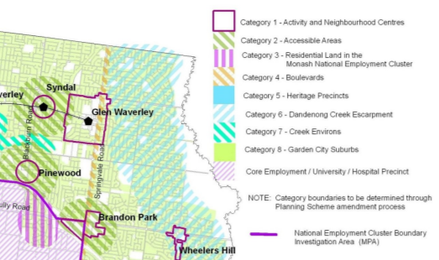
Review site

- In this framework plan, the site is also overlaid with green hatching described as ‘Category 2 – Accessible area’ for the Syndal activity centre.
- This framework plan derives from the Monash Housing Strategy (2014).
- The Council’s Residential Development and Character Policy at clause 22.01 also applies. Its objectives, amongst others, seek to encourage the provision of a variety of housing types:
- To build upon the important contribution that landscaping makes to the garden city character of Monash.
- To encourage new development to achieve architectural and urban design outcomes that positively contribute to neighbourhood character having particular regard to the applicable preferred future character statement for the area. …
- To direct residential growth to neighbourhood and activity centres, the Monash National Employment Cluster and the boulevards (Springvale Road and Princes Highway).
- It provides a suite of policies with design guidance that apply across the municipality. I have taken these into account and refer to them later in these reasons.
- The site is within the Garden City Suburbs (Northern) area.
- The preferred character statement for this area acknowledges that there will be changes to some of the houses within this area, including the development of well-designed and sensitive unit development and, on suitable sites, some apartment development. It is intended that these will take place ‘within a pleasant leafy framework of well-vegetated front and rear gardens and large canopy trees.’
- According to this statement, setbacks ‘will also be generous and consistent within individual streets and architecture, including new buildings and extensions, will usually be secondary in visual significance to the landscape of the area when viewed from the street. New development will be screened from the street and neighbouring properties by well planted gardens that will ensure the soft leafy nature of the street is retained.’

Neighbourhood character considerations

Introduction
- In-principle, there is no real dispute that redevelopment of the site with multi-dwellings is a reasonable expectation. What lies at the heart of this dispute is whether the design response is acceptable having regard to the particularities of this site and the form and character of development in the surrounding area – including the four dwelling development next door at No. 697 High Street Road.
- I begin with some observations about the current planning scheme settings that apply.
- First, I accept council’s submission that the site, being covered by Schedule 3 rather than Schedule 2 to the GRZ, is subject to different development outcomes desired by the planning scheme than those which apply to the GRZ2.
- I also accept that while the framework plan above shows the site at the periphery of the Syndal accessible area, this categorisation is subject to the note in the legend which reads ‘Category boundaries to be determined through Planning Scheme amendment process’. In the case of the subject land, this is now included in Schedule 3 to the GRZ following gazettal of Amendment C125 (Part 2) on 14 November 2019, noting that both the Monash Housing Strategy (2014) and Framework’s plan introduction in the planning scheme pre-dated the gazettal of this amendment. Unlike their Schedule 2 counterparts, land in Schedule 3 is said to be excluded from the accessible areas category. I accept these submissions.
- In comparative terms, it is particularly relevant that in GRZ3 larger rear setbacks (minimum 5m), lower levels of site coverage (maximum 50%) and greater levels of permeability (minimum 30%) are sought than in the GRZ2 where the default standards of clause 55 continue to apply. Variations to the landscaping standard also apply in the GRZ3 with reference to canopy trees, mixture of vegetation, vegetation on both sides of accessways and in front, side and rear setbacks.
- In essence, my reading these modified clause 55 standards reflect a strategic aspiration for the provision of more space (particularly to the rear of sites) and for more landscaping around buildings, and within the internal streetscape in locations more distant from designated activity centres in Monash.
- Being more distant from activity centres, application of these strategic settings does, it seems, lend more weight to the achievement of neighbourhood character objectives rather than increased housing densities.
- Second, the gazettal of Amendment C125 (Part 2) occurred nearly 2 years after the Tribunal made its decision in Jesse Ant. It is true that the council’s adoption of the amendment is referenced in that decision. However, the GRZ2 was the applicable zone at the time. Thus, the varied clause 55 standards in the GRZ3 and accompanying policy settings that I must now apply to the subject site did not apply to the neighbouring land at the time of the Tribunal’s decision in Jesse Ant. Further, on my reading of that decision, the GRZ3 was not and could not have been given equal or more weight than the planning scheme as it stood in its gazetted form at that time with the land included in the GRZ2.
- It is also true that there has clearly been an emergence of larger 2-storey dwellings in recent years. The review site is also one that has reasonably good access to surrounding activity centres including the Glen Waverley Major Activity Centre. These are unquestionably relevant contextual considerations.
- So too are the particular features of this site which must also be considered, being mindful that no two sites are ever equal in terms of their physical characteristics.
- An obvious example of the latter in the present case is the constraint posed by the L- shaped easement along the rear and part of the site’s west boundary. It is not a condition that is present to the same extent on the land at No. 697 High Street Road.
- Third, I do not read the relevant planning scheme controls, provisions and policies that now apply in a way that support reduced levels of liveability including standards of residential amenity, design quality or sustainability as a consequence of new development since the Jesse Ant decision and gazettal of Amendment C125 (Part 2).
- In summary, the current strategic settings for this part of Monash within the GRZ3 represent the starting point of my assessment and must still be applied with some rigour rather than adopting or replicating ‘what has gone before’. While contextual features will to some extent influence the degree to which a departure from these settings is appropriate, future development of other sites in this area of GRZ3 will inevitably occur.
- Importantly, decision makers are reminded by clause 71.02-2 that the consistent application of planning policy over time should achieve a desired outcome.
- I have approached my assessment of this proposal with these considerations in mind.

Design features that are acceptable
- I do not share council’s concerns with the streetscape presentation of Units 1 and 2 including their attached configuration and reliance upon skillion roof forms.
- I consider that these elements of the design can be absorbed acceptably into the surrounding built form context. The angled parapet form to the front façade, would in my view, achieve an acceptable and contemporary transition between the hipped form of the dwelling to the west and the flat roof forms to the east.
- While there is some repetition of design detailing to the front facades of Units 1 and 2, I do not regard this response as one that is so at odds with the predominant form of development as to be fatal. The attachment of these dwellings combined, create a building form whose presentation and proportions in the streetscape are broadly consistent with the prevailing development pattern in the surrounding area.
- The proposed front setback complies with the varied clause 55 standard and the amount of space available for landscaping in the front setback of Units 1 and 2 is acceptable despite the necessary provision of pedestrian pathways to each dwelling’s front entry. Two medium sized canopy trees (Eucalypts) which are said to reach a height of 10m are proposed in this location. These are to be supplemented by additional planting depicted in Mr Thomson’s landscape plan which I consider will achieve an acceptable response in streetscape terms, as long as no dividing fence or one that is only low and open is provided between the dwellings and the front boundary.
- The provision of just one driveway and the concept of providing garaging at the rear of buildings so as not to be dominant in the streetscape is also consistent with relevant policies.
- I similarly find that the provision of three canopy trees in the secluded private open space (SPOS) for Units 3 and 4 together with the northerly orientation of these areas and main living areas are all positive and acceptable aspects of the design.
- The overall amount and amenity of private and SPOS for Units 3 and 4 would meet the service and recreational needs of residents for Units 3 and 4.
- I also acknowledge that the overall height of buildings and side and varied rear setbacks achieve high levels of compliance with the relevant clause 55 standards.

Design features that are not acceptable
- Balanced against these positive aspects of the design, I find that there are a number of matters that I do not regard as acceptable.
- These principally relate to the appearance and function of the internal streetscape and the internal layout of dwellings.

Internal streetscape
- The central part of the site is dominated by a large expanse of hard paving associated with vehicle reversing areas. This will read as a harsh internal streetscape bereft of meaningful landscaping. The design response arises from the concentration and siting of four garages, three of which are double garages, in a way which is not responsive to the width of the site.
- In addition to expansive areas of hard paving, the presentation of built form this area will also be dominated by garage doors. As a consequence, the front entries to Units 3 and 4 do not present with good levels of address and transitional space. This is contrary to the dwelling entry objective at clause 55.05-2 and standard B31 at clause 55.06-1 which asks that garages are to be visually compatible with the development. Levels of surveillance from dwellings would also be poor given the absence of habitable rooms at ground level and the proposed screening of upper level bedroom windows.
- The proposed response would also be inconsistent with the neighbourhood character objective in Schedule 3 to the GRZ which seeks to promote the preferred garden city character by minimising hard paving throughout the site by limiting the length and width of accessways.
- I regard these features of the design response as fundamental flaws that cannot be fully cured with any of the modifications suggested in the course of the hearing, although I acknowledge that removing screening from the north facing upper level bedroom windows of Units 1 and 2 would improve surveillance to some extent.
- I also find the following features of the proposal as unacceptable which when combined with the internal streetscape leads me to conclude that the proposal is simply seeking to extract too much from this site and is not site responsive.

Vehicle access
- Despite the large amount of paving within the central circulation space, and the 2.7m proposed driveway width east of Unit 2, access arrangements are very tight. Correcting manoeuvres are needed on either entering or exiting each garage and even then, available tolerances are low, necessitating a high degree of precision to execute the required movements.
- I also have concerns about the longevity and practical retention of proposed planting in the narrow 0.5m wide spaces on the west boundary between units 1 and 3 and along the east boundary south of Unit 1’s entry. This is due to the very tight spaces available for vehicles manoeuvring in these locations. For example, Mr Harridge confirmed that the tyres of vehicles would come within 100mm of the driveway pavement’s edge south of Unit 4.
- For a site that is effectively a blank canvas, I find that the proposed access arrangements are poor, the design and location of car parking is not of a high standard and would not enable their easy and efficient use. This is contrary to the purposes set out at clause 52.06 for car parking.

Internal amenity of dwellings
- Beginning with Units 1 and 2, in-principle, the reverse-living typology is not one that I oppose but the reliance on this typology does give rise to additional design challenges that if not executed in a way that responds appropriately to contextual features, may not be acceptable. Such is the case here.
- I should also add that the particular contextual features of this site are very different from those which the applicant relied upon by reference to the decision of another division of the Tribunal for land at 2 Shirley Avenue, Glen Waverley. The reverse living typology for that site was a corner lot with balconies facing north in a quiet residential setting removed from any main road.
- I accept that there is some logic in orienting the balconies towards the street to avoid the need for screening and to benefit from views towards the school’s sports oval opposite. I also appreciate that this response has been relied upon in an attempt to address other design concerns with the proposal in an earlier iteration of plans. However, the particular design response on the south side of these dwellings together with their exposure to traffic noise along High Street Road, comes at the expense of the amenity they will offer the occupants of these dwellings.
- The balconies are either fully overhung by a roof element in the case of Unit 1, or substantially so in the case of Unit 2.
- Further, Unit 2’s living room is solely reliant on south facing windows and a door which lead to the overhung balcony.
- The living rooms of these dwelling have not been designed to maximise their solar access to north facing windows and in so doing would not meet the energy efficiency objective at clause 55.03-5.
- The applicant also submitted that the internal layout of the dwellings is well thought out and would offer acceptable levels of internal amenity. In support of these submissions, it was said that the dimensions of rooms in every dwelling have now been designed to better accord with the standards that would be applied to apartment developments – noting that these provisions do not technically apply to dwellings of the kind in this proposal but nonetheless offer a useful benchmark for assessment.
- I agree that the relevant standards offer a useful benchmark but I have not undertaken an assessment of every dwelling. Suffice to say, applying this approach for the only living area for Unit 3, I find that the internal layout of this dwelling which contains three bedrooms, would not offer acceptable levels of internal amenity.
- The following extract of the plan shows the living area shaded purple, based on the minimum dimensions and area suggested for a three bedroom dwelling in an apartment typology.
- Given the spaces required for the kitchen and dining area and circulation associated with these rooms and the WC, I find that this layout is too cramped for a three bedroom dwelling and is poorly resolved. It would appear that the response has been driven by the provision of a three bedroom dwelling despite the constraints posed by the easement in the site’s north-west corner.

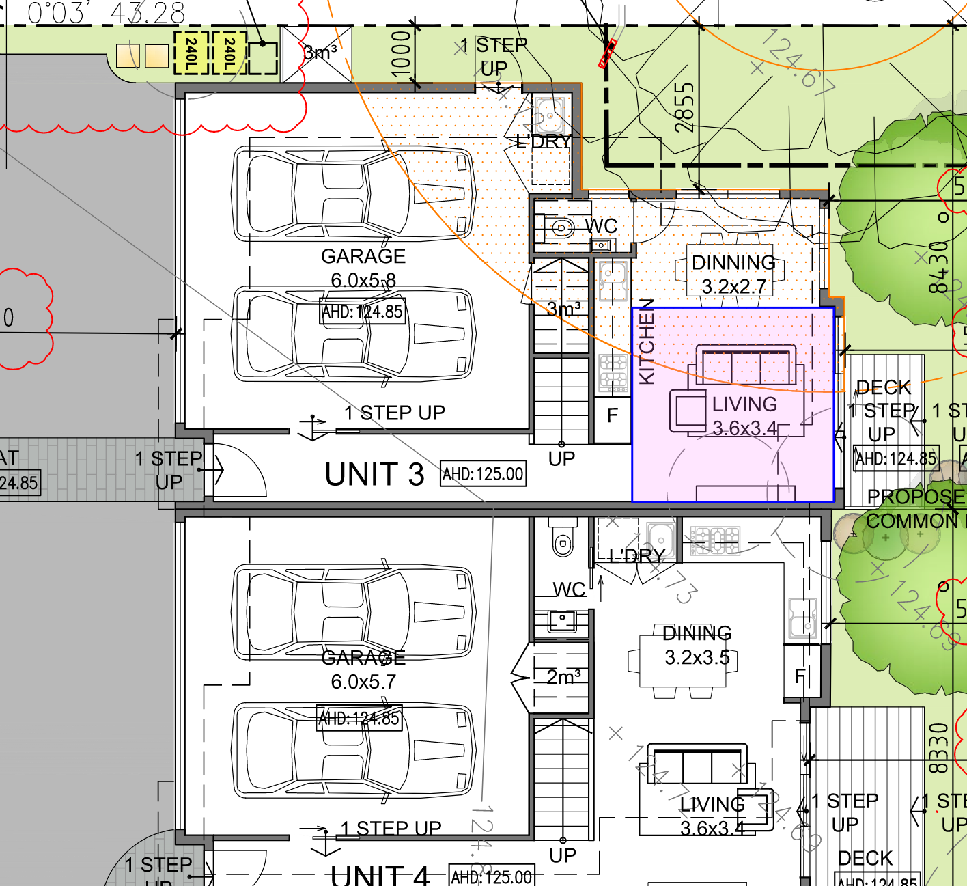

Bulk and siting of buildings
- As I have mentioned, I accept that 2-storey dwellings, many with large footprints are an emerging part of the area’s built form character. In-principle, I also do not have any difficulty with the construction of 2-storey dwellings on this land.
- However, while two storey dwellings are present on abutting lots, the setbacks and space around these dwellings is evidently greater and predominantly ranges from 2m to the west and 3.1m to the east.
- I consider that the siting of the dwellings, namely the setbacks to the west side of Unit 1 and Unit 3’s garage and the east side of Unit 4 would not provide for a suitable landscape response relative to the surrounding development pattern and the proposal’s bulk and mass.
- The width of these spaces combined with their intended use for pathways, service related facilities such as external storage sheds, clotheslines, bins and water tanks limits meaningful landscaping that would not allow the provision of suitable shrub and canopy trees.
- The response is one that runs counter to the varied landscaping standard in GRZ3 for vegetation in front, side and rear setbacks, its decision guidelines and the general policies for landscaping and side and rear setbacks at clause 22.01. The latter two refer to the provision of large trees and canopy trees in all setbacks including side setbacks and ‘minimising visual bulk to neighbouring properties through suitable setbacks from adjacent secluded private open space to enable the provision of screening trees’.

Conclusion
- While the proposal has met the varied clause 55 standards in the GRZ3 which refer to a 7.6m front setback and 5m rear setback including the provision of canopy trees in these areas and provides for suitably dimensioned private open space, the achievement of these metrics has not been done in a way that results in acceptable levels of on-site amenity and high quality design.
- The particular response chosen has also come at the expense of a suitable landscaping response elsewhere on the site and convenient and efficient vehicle access arrangements.
- I am left with the impression that the proposal has been designed as a ‘tick the box’ exercise with an emphasis on dwelling yield and the achievement of three bedroom dwellings for three out of four dwellings. It has done so without responding in an acceptable way to the particular constraints of the site and other planning scheme aspirations for multi-dwelling development in this location within the GRZ3.
- For the reasons given above, the decision of the responsible authority is affirmed.
- No permit is granted.

Mary-Anne Taranto
Member

The submissions and evidence of the parties, supporting exhibits given at the hearing, and the statements of grounds filed; have all been considered in the determination of the proceeding. In accordance with the practice of the Tribunal, not all of this material will be cited or referred to in these reasons.
Heard by M Carew.
Schedules 3, 5 and 6 to the GRZ were given effect through this amendment.
Clause 22.01-3.
If I were granting a permit, I would have required the width of the driveway to be increased from 2.7m to 3m to limit the likelihood of vehicles traversing over garden beds. The effect of doing so would however, need to be considered in the context of meeting the garden area requirement which at 35.6% (0.6% above the 35% minimum) may be breached by such a modification.
Jesse Ant Architects v Monash CC [2016] VCAT 1478 (30 August 2016) heard by SM Liston.
Under identically drafted clauses 55.07-12 and Table B46 and clause 58.07-1 and Table D8. Living area dimensions refer to a minimum width of 3.6m and minimum area of 12sqm.

