VICTORIAN CIVIL AND ADMINISTRATIVE TRIBUNAL
planning and environment list | vcat reference No. P842/2021  Permit Application no. TPA/52034
CATCHWORDS
Monash Planning Scheme; Section 77 of the Planning and Environment Act 1987; Proposal for four 2-storey dwellings; Neighbourhood character.

APPLICANT | Sherry Chen
responsible authority | Monash City Council
RESPONDENT | Kathryn Maartensz and others
SUBJECT LAND | 8 Juniper Avenue, Glen Waverley
WHERE HELD | Melbourne
BEFORE | Mary-Anne Taranto, Member
HEARING TYPE | Hearing
DATE OF HEARING | 3 September 2021
DATE OF ORDER | 13 December 2021
CITATION | Chen v Monash CC [2021] VCAT 1510

Order

No permit granted
- In application P842/2021 the decision of the responsible authority is affirmed.
- In planning permit application TPA/52034 no permit is granted.

Mary-Anne Taranto
Member

Appearances

For applicant | Mr Russell Hocking, town planner of Cityshire Planning
For responsible authority | Ms Sally Moser, town planner
For respondent | Ms Kathryn Maartensz

Information
Description of proposal | Construction of four 2-storey dwellings – three with three bedrooms and one with four bedrooms. The dwellings are configured so that each has its own street frontage and separate driveways for a tandem car space and single garage.  The dwellings are designed with pitched tiled roofs and would have external materials that include face brick and render.
Nature of proceeding | Application under section 77 of the Planning and Environment Act 1987 – to review the refusal to grant a permit.
Zone and overlays | General Residential Zone – Schedule 3 (GRZ3)  No overlay controls apply
Permit requirements | Clause 32.08-6 – Construction of two or more dwellings on a lot in GRZ3
Relevant scheme policies and provisions | Clauses 11, 15, 16, 21.01, 21.04, 22.01, 52.06, 52.29, 55, 65 and 71.02
Land description | This roughly rectangular 766.9sqm site is located on the south-west corner of Juniper Avenue and Fraser Street with frontages of 17.53m and 34.44m respectively. The land is developed with a single storey brick dwelling set within established gardens characterised by ornamental shrub planting. A 2.4m wide drainage and sewerage easement runs along the site’s southern boundary and the land falls by about 1m from the south-east to the north-west.
Tribunal inspection | Unaccompanied subsequent to the hearing

Reasons

nature of proceeding
- Sherry Chen (the applicant) is seeking a review of Monash City Council’s decision to refuse to grant a permit for four 2-storey dwellings on a corner lot of 766.9sqm in Glen Waverley.
- There was general agreement that the site is suitable for some form of medium density housing.
- The key areas of difference between the applicant on the one hand, and the council and Ms Maartensz (the respondent) on the other, are whether the design is one that responds in an acceptable way to the preferred character and the features of the site and its context.
- In essence, opponents of the proposal say that the development is too intense for this context and would be visually intrusive and dominant in the streetscape.
- This is refuted by the applicant who highlights the proposal’s level of compliance with the numeric standards of clause 55 including varied standards such as those that apply to private open space, landscaping, setbacks, site coverage and permeability. The deign response is also said to be one that will fit in with newly emerging dwellings that are frequently 2-storeys in scale and large.
- A number of other issues that I regard as secondary in nature to the above were variously raised at the hearing including works near a street tree, overlooking and traffic and parking.
- The determinative issues distil down to a consideration of whether the particular features of design proposed would achieve an acceptable neighbourhood character response in the context of the planning and physical contexts that apply here.
- In my reasons that follow, I have formed the view that the proposal would not produce an acceptable neighbourhood character response.

the physical context
- The review site and its surrounding context are shown in the aerial photograph below.
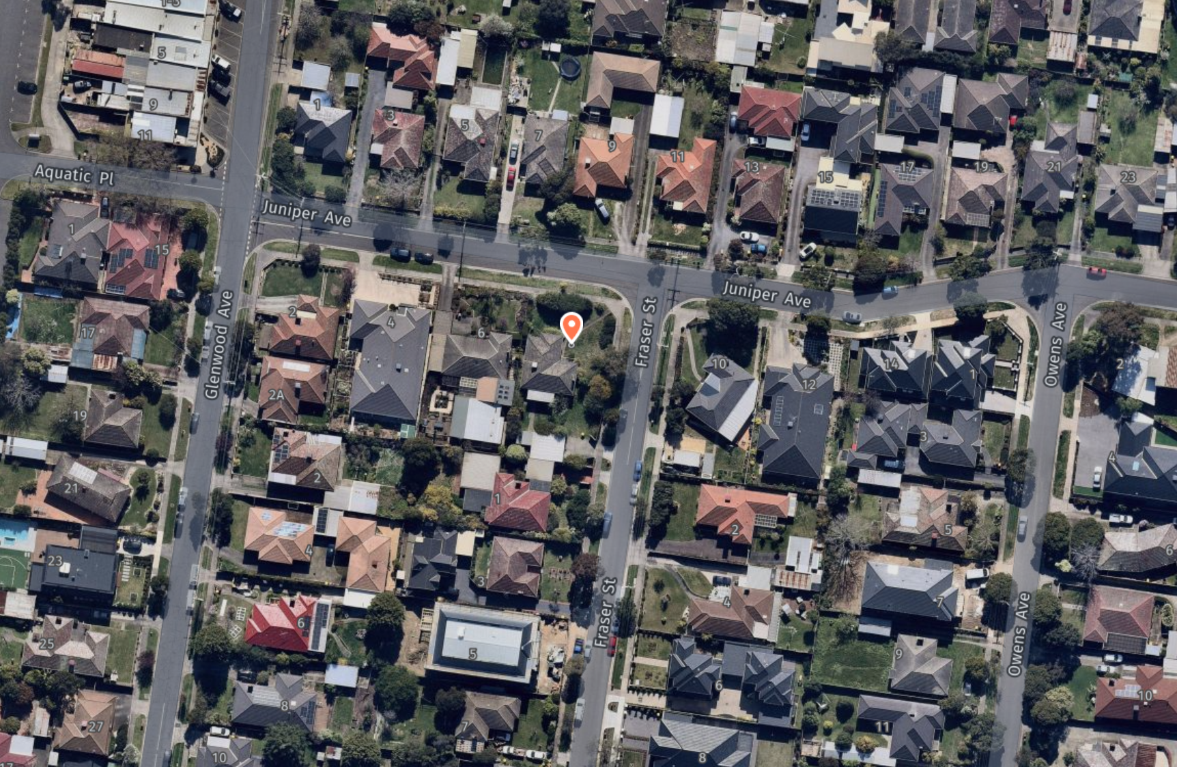
Source: Nearmap – Image captured 1 September 2021

- The site is within an established, predominantly residential area south of Waverley Road between Glenwood Avenue and Springvale Road. It has abuttals with two single storey detached dwellings. These typify much of the modest, existing, original housing stock.
- Two-storey single detached dwellings and multi-dwellings are also emerging in the area. Examples nearby are to be found at No 5, 6 and 8 Fraser Street and at 1 Owens Avenue, the latter comprising two 2-storey dwellings variously referred to in submissions by the parties at the hearing. Endorsed plans of the latter development forming part of the permit granted by the council were also tabled at the hearing.
- Further west in Glenwood Avenue is a small group of shops to the west beyond which is an aquatic and recreation centre. In the opposite direction further east, there is a complex of sporting reserves with frontages to Waverley and Springvale Roads.
- Further north, about 1.8km away is The Glen Waverley Major Activity Centre.

The planning context
- The site and surrounding land is within the General Residential Zone and Schedule 3 titled ‘Garden City Suburbs’ applies (GRZ3).
- Under schedule 3 there are varied clause 55 standards including those for:
- Standard B6 – minimum street setback (7.6m required to front street);
- Standard B8 – site coverage (maximum 50%);
- Standard B9 – permeability (at least 30%);
- Standard B13 – landscaping;
- Standard B17 – side and rear setbacks (5m to the rear boundary);
- Standard B28 – private open space (75sqm with a secluded area of at least 35sqm and with a minimum dimension of 5m and balconies are to be 10sqm with a minimum width of 2m, all of which are required to have convenient access from a living room); and
- Standard B32 – front fence height (maximum 1.2m).
- For landscaping, the requirement is that new development should provide or retain:
- At least one canopy tree, plus at least one canopy tree per 5 metres of site width;
- A mixture of vegetation including indigenous species;
- Vegetation in the front, side and rear setbacks; and
- Vegetation on both sides of accessways.
A canopy tree should reach a mature height at least equal to the maximum building height of the new development.
- Together, these support neighbourhood character objectives specified in this schedule, which amongst other things seek:
To promote the preferred garden city character by minimising hard paving throughout the site by limiting the length and width of accessways and limiting paving within open space areas.
To support new development that minimises building mass and visual bulk in the streetscape through generous front and side setbacks, landscaping in the front setback and breaks and recesses in the built form.
To support new development that locates garages and carports behind the front walls of buildings. [My underlining]
- Decision guidelines are also specified and these refer to the ability for development to transition to built-form on adjoining sites, the impact of the shape and dimensions of the lot on the ability of the development to meet any requirements of this schedule, the robustness of proposed materials and finishes and the location, quantity and species of vegetation provided.
- Policies for residential development in Monash identify the need for a diverse range of housing to cater for the population and its changing needs including an ageing population and a reduction in household size.
- Eight categories classified according to their development potential, comprising areas with ‘Future development potential’ in which the greatest change is envisaged, followed by ‘Incremental change’ and lastly, areas with ‘Limited development potential’.
- The site is within an area for incremental change – Category 8: Garden City suburbs. This is consistent with its inclusion in Schedule 3 to the GRZ and is identified in the Residential Development Framework plan at clause 21.04-1.
- While policies encourage the provision of a variety of housing types and sizes that will accommodate a diversity of future housing needs and preferences, these are to complement and enhance the garden city character of the city. A high standard of architectural design and landscaping associated with residential development that takes into account environmentally sustainable development are further objectives.
- Strategies, amongst others, refer to development that achieves high levels of amenity, enhances the garden city and landscaped streetscape character of the neighbourhood, responds to the features of the site and surrounding area, promotes good streetscape design and maintains the predominantly single detached dwelling character in suburban areas. The provision of single storey and purpose built housing to cater for Monash’s ageing population is also sought.
- The Council’s Residential Development and Character Policy at clause 22.01 provides further guidance. Its objectives, amongst others, seek to encourage the provision of a variety of housing types:
- To build upon the important contribution that landscaping makes to the garden city character of Monash.
- To encourage new development to achieve architectural and urban design outcomes that positively contribute to neighbourhood character having particular regard to the applicable preferred future character statement for the area. …
- To direct residential growth to neighbourhood and activity centres, the Monash National Employment Cluster and the boulevards (Springvale Road and Princes Highway).
- It provides a suite of policies with design guidance that apply across the municipality at clause 22.01-3 under various headings that include street setbacks, side and rear setbacks and landscaping.
- The following are particularly relevant:
- Recess walls on boundaries from the facade of the building to reflect spacings between dwellings in the neighbourhood and to ensure the appearance of new and existing buildings is not compromised.
- Provide side setbacks that maintain an open, spacious streetscape character and separation of dwellings.
- Design buildings to reflect the spacing and rhythm of existing streetscapes.
- Provide a separation between dwellings constructed on the same site to break up built form and support additional landscaping.
- Ensure development on corner blocks incorporates side street setbacks that provide an appropriate transition to the street setback of adjoining buildings.
- Ensure development is adequately set back from existing and proposed trees to ensure their protection and longevity
- The site is within the Garden City Suburbs (Northern) area.
- The preferred character statement for this area acknowledges that there will be changes to some of the houses within this area, including the development of well-designed and sensitive unit development and, ‘on suitable sites, some apartment development.’ It is intended that development ‘will take place within a pleasant leafy framework of well-vegetated front and rear gardens and large canopy trees’ and that it ‘will complement the established buildings through consistent siting, articulated facades and use of materials’.
- According to this statement, setbacks ‘will also be generous and consistent within individual streets’ and ‘architecture, including new buildings and extensions, will usually be secondary in visual significance to the landscape of the area when viewed from the street. New development will be screened from the street and neighbouring properties by well planted gardens that will ensure the soft leafy nature of the street is retained.’

acceptability of the design response

Overview of contentions
- In summary, the council asserts that:
- the scale, mass and bulk of the development is excessive; and
- the siting and configuration of the dwellings does not provide sufficient space around buildings that allows a comfortable streetscape fit and an appropriate response to the preferred character.
- The council also says that the proposed response is inconsistent with the preferred character and policy outcomes sought for this area and the GRZ3. It describes this area as a hinterland location where neighbourhood character outcomes are to take precedence over housing diversity and intensification.
- These views are also supported by the respondent. It is further submitted that the unacceptable built form is a product of endeavouring to fit too many dwellings on the land and the number of bedrooms proposed within each.
- The applicant asserts that the site, being a corner lot is highly suited to multi-dwelling development. The applicant also contends that while single storey homes have historically existed, larger 2-storey dwellings are emerging, including single dwellings and these now inform the evolving neighbourhood character. Within this evolving character, it is submitted that a 2-storey development of the kind proposed is a reasonable expectation.
- The applicant also contends that the proposal’s high levels of compliance with the numeric standards of clause 55 including those varied by Schedule 3 to the GRZ represent a good starting point from which to find that this proposal is an acceptable one. It is further asserted that it is not realistic to expect that every policy set out in clause 22.03 will be met by every proposal.
- Although the dwellings are all fully attached at ground level with a 3m gap between units 2 and 3, it is said that the dwellings have acceptable levels of articulation and provide suitable space around them for landscaping.
- It was Mr Thomson’s landscape evidence that the space for planting and number and species of vegetation proposed, including canopy trees will make an appropriate contribution to Monash’s garden city character aspirations.

Tribunal’s findings
- I agree in-principle with submissions put for the applicant, that corner sites are often suited for medium density development. This is typically due to the opportunities provided by a lesser number of abuttals with neighbouring properties and thus a lesser potential for off-site amenity impacts. I find that to be the case here.
- I also accept that a 2-storey scale of development is also one that can be reasonably expected in most residential contexts and this is also true here. New development, comprising both large, detached dwellings and multi-dwellings are emerging throughout this area interspersed amongst more modest, single storey traditional housing forms.
- The key questions are whether the bulk, scale and mass of the development and the landscape response are acceptable. In approaching my assessment task, I consider that both the built form response and landscaping must each be acceptable in their own right.
- In terms of the landscaping response, I broadly accept that landscaping in the front setbacks and in proposed areas of private open space is generally consistent with Monash’s garden city policy aspirations and the varied landscaping standard that applies to the GRZ3. The exception to this is the narrow 0.5m garden beds between the driveways and west and south boundaries where Pyrus trees with a mature height of 8m and canopy spread of 3.5m are proposed. Given the size of these trees relative to the limited space provided for them adjacent to driveways where obstructions are unlikely to be tolerated by future residents, I am not persuaded that these narrower spaces would facilitate the sustainable maintenance of these trees in the long term.
- In terms of the built form response, the primary concern that I have with this proposal is with the attached siting and form of the proposed dwellings. I have found that their design and siting would not respond in an acceptable way to the neighbourhood character policies described in the Residential Development and Character Policy of clause 22.01, the preferred policy directions of maintaining the detached character of housing and the neighbourhood character objectives specified in Schedule 3 to the GRZ.
- While larger infill building forms are emerging nearby, and these will over time result in an incremental change to the existing modest scale character of housing, there remains a relatively consistent and cohesive pattern of spacing and development rhythm in the streetscape, typified by open and spacious front gardens with both traditional and newer single storey dwellings that contribute to the prevailing character. I note for example that the recently built 2-storey dual occupancy development on the corner of 1 Owens Avenue is provided with recessed upper levels and space around these dwellings.
- Moreover, the strategic settings for this location are not one where substantial change is sought. Buildings are to be designed to reflect the spacing and rhythm of existing streetscapes. A ‘transition’ to built form on adjoining sites is also sought.
- I find that the proposal has not been designed in a way that is consistent with the neighbourhood character objective in the GRZ3 of minimising building mass and visual bulk in the streetscape. The proposed building setbacks to the upper levels of the proposed dwellings are not ‘generous’ and nor are sufficient ‘breaks and recesses in the built form’ provided.
- The upper level footprint of the proposed dwellings have only a minimal degree of recession from the ground floor walls below and these would have an overtly bulky appearance from both Fraser Street and Juniper Avenue. To illustrate, in Juniper Avenue, the attached upper levels of Units 1 and 2, which span a distance of around 15m are to be setback between 200mm to 300mm from the front wall of the ground level. The extent of attached built form with minimal recession across the Juniper Avenue frontage will have a particularly dominant visual impact in an otherwise open, low scale streetscape setting.
- Although greater variability in setbacks is proposed to the Fraser Street frontage with a 3m gap between the upper levels of Units 3 and 4, the upper level footprints relative to ground level walls are also quite modest. These range from around 0.1m to 0.7m.
- The resultant bulk and building mass will be appreciable in front on views in both streets and also in oblique views. This is particularly so from the south-east in Fraser Street and from the north-west in Juniper Avenue where garages are sited on boundaries and 2-storey forms extend forward of the dwellings on both adjoining lots.
- I do not regard this design response as one that aligns with the neighbourhood character objective of providing ‘generous front … setbacks … and breaks and recesses in the built form’ to achieve development that minimises building mass and visual bulk in the streetscape. Nor would the proposal be secondary in visual significance to the landscape of the area when viewed from the street. It is a response that would stand in contrast to the prevailing spacing, rhythm and character of surrounding development. An appropriate transition to built form on adjoining sites would not be achieved
- I should add that I agree with the applicant’s submissions that it is not the number of dwellings but the amount of built form or intensity of development that is the more important consideration. However, I observe that in the particular circumstances of this proposal and this planning context, both the proposed size of the dwellings and the number of them are factors that when combined, have influenced the ability to achieve an acceptable planning outcome.
- In saying this I have given some thought to whether modifications could be made to the plans to reduce the bulk of these dwellings and create space around them in a way that is consistent with neighbourhood character policies and the objectives in the GRZ3 while also meeting the varied clause 55 standards, particularly standard B28 for private open space. I have come to the conclusion however, that significant plan modifications would be required if there is a desire to maintain dwellings of the size proposed and if an acceptable planning outcome is to be achieved. This may well necessitate a reduction in the number of dwellings.
- I find that the shortcomings with this proposal cannot be cured with further plan modifications through permit conditions. I therefore conclude that a permit cannot be granted.

other issues
- In light of my findings above, I make only brief findings on other matters raised at the hearing.

Impact on street tree
- The council expressed concerns with the proximity of the proposed northern most crossover in Fraser Street near a street tree (Tree No 3). Having considered the Tree Protection Zone (TPZ) for this tree of 2m – a TPZ which is no longer refuted by the council – and the proposed 2.43m distance from the cross-over, I do not share this concern.

Overlooking
- The possibility of overlooking from upper level bedroom windows towards the secluded private open space and habitable room windows of dwellings to the west and south was also highlighted. I consider however that this issue could be managed with permit conditions.

Traffic and parking
- The creation of additional traffic and parking as a consequence of the proposal were also raised as concerns by the respondent.
- The proposal is provided with the required number of parking spaces for residents under clause 52.06 of the planning scheme.
- While I accept that this proposal will add to existing traffic and at times, parking demands within the local street network, there is no evidence before me to conclude that this would be of such a magnitude as to warrant refusal of this proposal.

conclusion
- For the reasons given above, the decision of the responsible authority is affirmed.
- No permit is to be granted.

Mary-Anne Taranto
Member

The submissions and evidence of the parties, any supporting exhibits given at the hearing, and the statements of grounds filed; have all been considered in the determination of the proceeding. In accordance with the practice of the Tribunal, not all of this material will be cited or referred to in these reasons.
Clause 21.04-3.
Clause 21.04-3.

