Nude Food Top Tips!
Nude food is food without excess packaging (single- use plastics, foil wrap, cling wrap). It is great because it reduces waste going to landfill, keeps the school tidy and reduces the school’s waste costs. It is also a great way to save money at home!

It is great to have kids involved in food preparation, having portion sizes to your child’s needs, and thinking of ways to help the environment. It can be a challenging transition, but we ask to try your best!
Here are our top tips to go nude food:

- Have a good lunch box with compartments!
Check if you already have one lying around. If not, ask family and friends if they have a spare. Otherwise, visit your local op shop and look for Tupperware containers that could be used as a lunch box (this will save you some money).

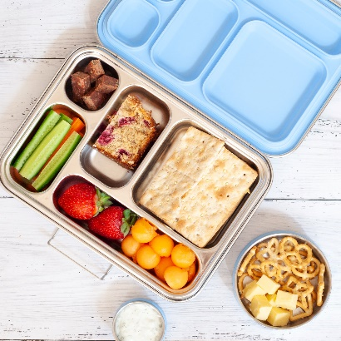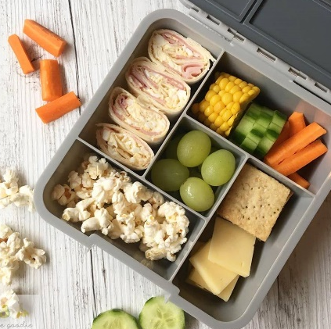

If you do need to purchase a new lunch box, look to buy one that is good quality, will last and will wash up well. Remember to label all your reusable items (lunchbox, thermos, forks and spoons, drink bottles) so they all come home!

- Instead of purchasing small single-portion packets of snacks (such as biscuits or potato chips) purchase a large/bulk packet and place some of the snacks in a compartment of the lunch box or re-usable Tupperware.
Better!
Best!
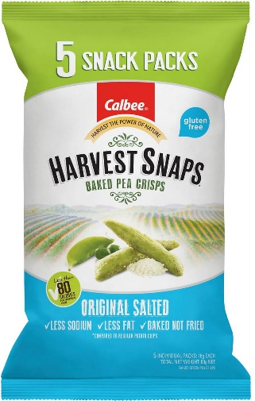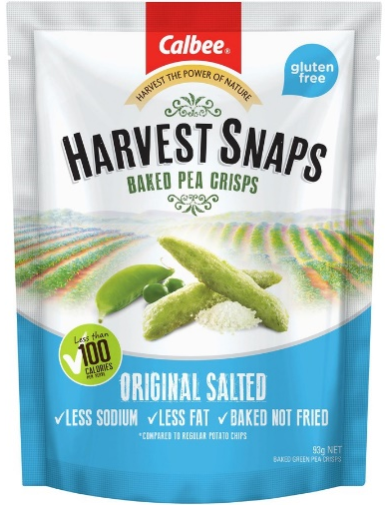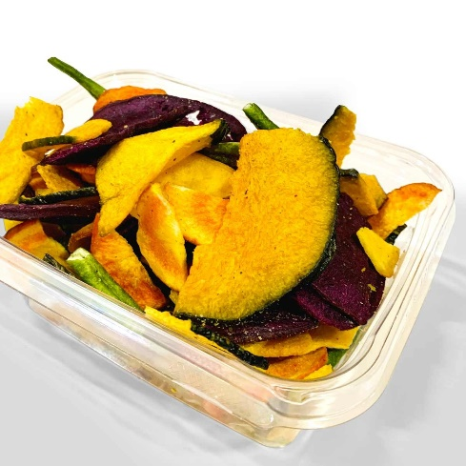

You can also purchase snacks from bulk food stores with your own jars/containers and fill then fill the lunchbox with no waste! By shopping in bulk, you’ll save money and time in the long run, plus cut down on product packaging significantly.

- Use beeswax wrap, reusable zip-lock bags and cloth pouches instead of cling wrap and foil. Depending on the lunchbox, you may not need any wrap for the sandwich or other food item as the lunchbox may be airtight and hold it securely in place.
Link to make your own beeswax: Plastic Wrap Alternatives & How To Make Cotton Beeswax Wraps | 1 Million Women

- Make a little extra dinner and use this for the next day’s lunch! This may include giving your child rice, pasta, noodles or soup which would be best kept warm. In this case, check your local Op-Shop for a Thermos or invest in a high-quality Thermos to keep food warm. This is also a great money and time saver!

- Use reusable drink bottles for water rather than cans, plastic bottles and juice boxes. Filling a drink bottle with water from the tap is free and healthy! Remember: Juice boxes cannot be recycled due to the plastic lining, so these are destined for landfill.

As a parent, you know your child best so involve them in the conversation as to why nude food is important and make sure they still enjoy the food in their lunches. Remember, a few small changes can make a big difference for our environment!

